# Australian COmmission on Safety and Quality in Health Care logo with Radar imageOn the Radar

Issue 417

20 May2019

*On the Radar* is a summary of some of the recent publications in the areas of safety and quality in health care. Inclusion in this document is not an endorsement or recommendation of any publication or provider. Access to particular documents may depend on whether they are Open Access or not, and/or your individual or institutional access to subscription sites/services. Material that may require subscription is included as it is considered relevant.

*On the Radar* is available online, via email or as a PDF or Word document from <https://www.safetyandquality.gov.au/publications-resources/on-the-radar/>

If you would like to receive *On the Radar* via email, you can subscribe on our website <https://www.safetyandquality.gov.au/> or by emailing us at H[Umail@safetyandquality.gov.auU](mailto:mail@safetyandquality.gov.au).   
You can also send feedback and comments to H[Umail@safetyandquality.gov.auU](mailto:mail@safetyandquality.gov.au).

For information about the Commission and its programs and publications, please visit <https://www.safetyandquality.gov.au>

You can also follow us on Twitter @ACSQHC.

**On the Radar**

Editor: Dr Niall Johnson [niall.johnson@safetyandquality.gov.au](mailto:niall.johnson@safetyandquality.gov.au)

Contributors: Niall Johnson, Ruth Daniels

**Antimicrobial Use and Resistance in Australia 2019: Third Australian report on antimicrobial use and resistance in human health**

Australian Commission on Safety and Quality in Health Care

Sydney: ACSQHC; 2019. p. 274.

<https://www.safetyandquality.gov.au/antimicrobial-use-and-resistance-in-australia/aura-2019/>

The Australian Commission on Safety and Quality in Health Care has released *Antimicrobial Use and Resistance in Australia 2019: Third Australian report on antimicrobial use and resistance in human health* (AURA 2019). This report highlights a number of resistant bacteria as major healthcare problems. It 2019 provides a comprehensive picture of antimicrobial resistance and antimicrobial use and the appropriateness of antimicrobial prescribing in Australia in hospitals, aged care, general practice and the community and provides analyses of antimicrobial resistance and antimicrobial use data, primarily from 2016 and 2017; and CARAlert data from 2018.

The report warns that **antimicrobial resistance shows little sign of abating** and poses an **ongoing risk to patient safety**, with common pathogens such as *E. coli*, *Salmonella*, *Neisseria gonorrhoeae* and *Neisseria meningitidis* becoming increasingly resistant to major drug classes, and some organisms resistant to last-resort treatments.

AURA 2019 found that overall use of antibiotics in the community fell between 2015 and 2017 – the first decline in 20 years. This suggests ongoing and coordinated campaigns targeting GPs and consumers on the risks of using antibiotics inappropriately are beginning to cut through.

Despite these gains, almost half the samples of enterococci tested across Australia were resistant to the antibiotic vancomycin – a level higher than seen in any European country. It was also found that community-associated methicillin-resistant *Staphylococcus aureus* (MRSA) has become the most common type of MRSA infection, particularly in aged care homes and remote regions.

**The report found that in 2017, more than 10 million Australians had a least one antibiotic dispensed in the community and more than 26.5 million prescriptions for antimicrobials were dispensed.**

AURA 2019 showed a substantial burden of infection and colonisation with multidrug-resistant organisms among people living in aged care homes in Australia and there are high levels of unnecessary antimicrobial prescribing and inappropriate antimicrobial use. Enhanced infection prevention and control, and antimicrobial stewardship efforts in aged care homes and hospitals will help to reduce transmission between these settings and improve the safety of care provided to residents.

Sustained efforts in infection prevention and control, and antimicrobial stewardship are required to ensure that trends in antimicrobial resistance in acute hospital, multi-purpose service, aged care and other community settings are addressed.

The report and its companion documents including a Consumer Summary and Information Sheets are at: [www.safetyandquality.gov.au/aura2019](http://www.safetyandquality.gov.au/aura2019)

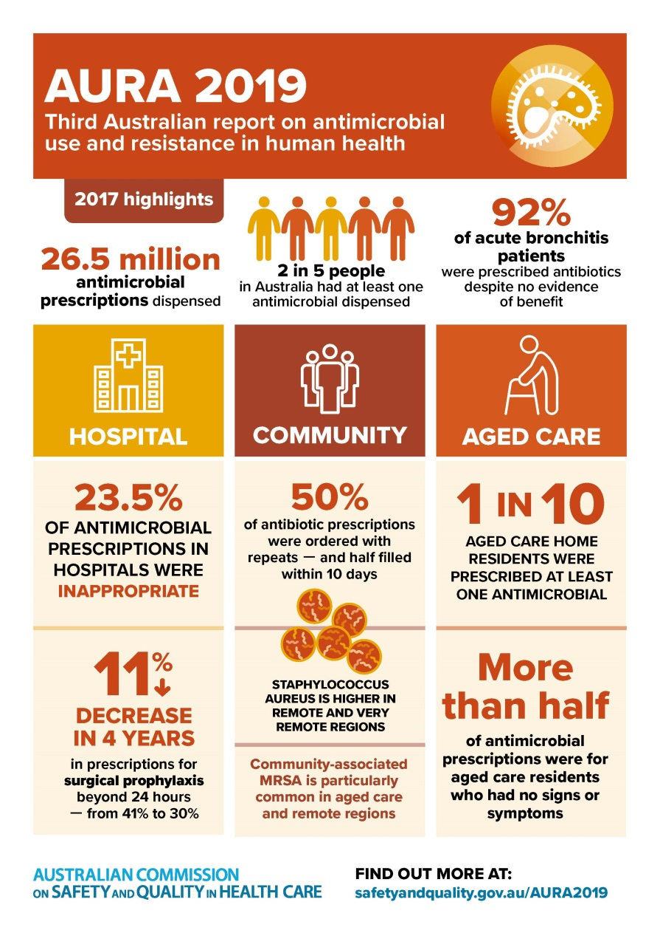

**Reports**

*The improvement journey: Why organisation-wide improvement in health care matters, and how to get started*

Jones B, Horton T, Warburton W

London: The Health Foundation; 2019.

|  |  |
| --- | --- |
| URL | <https://www.health.org.uk/publications/reports/the-improvement-journey> |
| Notes | The Health Foundation in the UK has produced this report as a practical guide to developing an organisation-wide approach to improvement. It summarises the benefits of such an approach and outlines the key elements and steps that leaders should adopt when pursuing this agenda. The authors emphasise that building an organisation-wide approach to improvement is a journey that can take several years and requires corporate investment in infrastructure, staff capability and culture over the long-term. They note that an essential early step is securing the support and commitment of the board/governance structure for a long-term programme, including their willingness to finance the skills and infrastructure development needed to implement it. The report includes case studies of three English NHS trusts that have implemented an organisational approach to improvement.  [\\central.health\dfsuserenv\Users\User_07\JOHNNI\Downloads\2019-THF_Improvement_journey_visual.jpg](https://www.health.org.uk/publications/reports/the-improvement-journey) |

*Indication-Based Pricing (IBP) Discussion Paper: Should drug prices differ by indication?*

Consultation Briefing

Cole A, Towse A, Zamora B

London: Office of Health Economics; 2019. p. 16.

|  |  |
| --- | --- |
| URL | <https://www.ohe.org/publications/indication-based-pricing-ibp-discussion-paper-should-drug-prices-differ-indication> |
| Notes | The Office of Health Economics (a British company the conducts research and provides consultancy services on health economics) has released this discussion paper (and survey) that seeks to outline the key potential benefits and drawbacks of indication-based pricing (IBP), along with considerations for implementation. IBP would permit the setting of different prices for a medication based on indication or use. It has been argued that IBP may be a way to better link price with value. |

**Journal articles**

*Association Between Hospital Safety Culture and Surgical Outcomes in a Statewide Surgical Quality Improvement Collaborative*

Odell DD, Quinn CM, Matulewicz RS, Johnson J, Engelhardt KE, Stulberg JJ, et al

Journal of the American College of Surgeons. 2019 [epub].

*The Relationship Between Culture of Safety and Rate of Adverse Events in Long-Term Care Facilities*

Abusalem S, Polivka B, Coty M-B, Crawford TN, Furman CD, Alaradi M

Journal of Patient Safety. 2019 [epub].

|  |  |
| --- | --- |
| DOI | Odell et al <https://doi.org/10.1016/j.jamcollsurg.2019.02.046>  Abusalem et al <https://doi.org/10.1097/PTS.0000000000000587> |
| Notes | Further to recent items on culture and outcomes, are these pieces.  Odell et al surveyed administrators, quality improvement teams, nurses, anaesthesiologists, and surgeons from 49 hospitals in Illinois that had participated in the Illinois Surgical Quality Improvement Collaborative. They report finding that the clinicians had somewhat less positive views on safety culture and that there was an **association between improved safety culture** as measured by the Safety Attitudes Questionnaire **and reduced risk of postoperative morbidity and death**.  Abusalem et al used data of safety culture surveys of staff (registered nurses, licensed practical nurses (LPNs), nursing assistants, administrators/managers, administrative support, and rehabilitation staff) at five long-term care facilities and found an **association between improved safety culture scores and a decreased risk of a range of adverse events**, including risk of falls, long stay urinary tract infections, and short stay ulcers.. |

*American Journal of Medical Quality*

Volume: 34, Number: 3 (May/June 2019)

|  |  |
| --- | --- |
| URL | <https://journals.sagepub.com/toc/ajmb/34/3> |
| Notes | A new issue of the *American Journal of Medical Quality* has been published. Articles in this issue of the *American Journal of Medical Quality* include:   * Effect of Audit and Feedback on Physician **Adherence to Clinical Practice Guidelines** for Pneumonia and Sepsis (Stacy A Trent, Edward P Havranek, Adit A Ginde, and Jason S Haukoos) * Improved **Supervision and Safety of Discharges** Through Formal Discharge Education (Lily L Ackermann, Emily A Stewart, and J M Riggio) * Lessons Learned in Providing **Claims-Based Data** to Participants in **Health Care Innovation Models** (Martin F Cohen, Sarah M Irie, C Allison Russo, Veronika Pav, Shannon L O’Connor, and Suzanne G Wensky) * Patient Satisfaction Is Associated With **Dialysis Facility Quality** and Star Ratings (Abhijit V Kshirsagar, Amir Alishahi Tabriz, H Bang, S-Y D Lee) * A Guide to **Evaluation of Quality Improvement and Patient Safety Educational Programs**: Lessons From the VA Chief Resident in Quality and Safety Program (R L Butcher, K L Carluzzo, B V Watts, K E Schifferdecker) * Training to Improve **Communication Quality**: An Efficient Interdisciplinary Experience for Emergency Department Clinicians (Emily L Aaronson, B A White, L Black, D F Brown, T Benzer, A Castagna, A S Raja, J Sonis, E Mort) * **MyVA Access**: An Evaluation of Changes in Access for a System-Wide Program Implemented in the Veterans Health Administration (Janice L Pringle, Aleksandra S Milićević, Jaime A Fawcett, Jerrold H May, Shannon M Kearney, Youxu C Tjader, D L Vargas, L G Vargas, J P Radack, P L Alaigh) * Changes in Care After Implementing a Multifaceted Intervention to **Improve Preventive Cardiology Practice** in Rheumatoid Arthritis (Darcy S Majka, Ji Young Lee, Y A Peprah, D Lipiszko, E Friesema, E M Ruderman, S D Persell) * **Impact of Hearing Loss on Patient–Provider Communication** Among Hospitalized Patients: A Systematic Review (Aishwarya Shukla, Carrie L Nieman, Carrie Price, Michael Harper, Frank R Lin, and Nicholas S Reed) * **Innovative Implementation Studies** Conducted in US Safety Net Health Care Settings: A Systematic Review (Courtney R Lyles, Margaret A Handley, S L Ackerman, D Schillinger, P Williams, M Westbrook, G Gourley, U Sarkar) * **Patient- and Family-Centered Care as a Dimension of Quality** (Ravi Dhurjati, Krista Sigurdson, and Jochen Profit) * **Taking the Patient Out of Patient-Centered Care?** (Harjot Uppal) * Improvement of **Specialist Referral Follow-up**: One University Health Service Improvement Success Story (Beth Kotarski) * Promoting High-Value Change by Addressing the Structure of **Order Sets**: Lessons From the Cardiac Catheterization Lab (Nagendra Pokala, Shruti Singh, Gene Hu, Timothy J Brown, Ambarish Pandey, Sandeep R Das, and Arjun Gupta) * U.S. News and World Report **Top-Ranked Children’s Hospitals and Academic Productivity** (Don Hayes, Jr) * **Improving Pediatric Sepsis Treatment** Using a Novel, Guideline-Based Pro Forma (Ahmed Hussain, Pratap Harbham, and Mohamad Zeina) |

*International Journal for Quality in Health Care* online first articles

|  |  |
| --- | --- |
| URL | <https://academic.oup.com/intqhc/advance-articles> |
| Notes | *International Journal for Quality in Health Care* has published a number of ‘online first’ articles, including:   * The **30-day unplanned readmission rate and hospital volume**: a national population-based study in South Korea (Hoo-Yeon Lee; Jae Yong Shin; Sang Ah Lee; Yeong Jun Ju; Eun-Cheol Park) * **EuroGTP II: a tool to assess risk, safety and efficacy of substances of human origin** (Esteve Trias; Richard Lomas; Jaime Tabera; A Rita Piteira; Kelly Tilleman; Ricardo P Casaroli-Marano; Akila Chandrasekar on behalf of EuroGTP II Study Group) * A RCT evaluating a pragmatic in-hospital service to increase the **quality of discharge prescriptions** (Lea D Brühwiler; Patrick E Beeler; Fabienne Böni; Rebekka Giger; Peter G Wiedemeier; Kurt E Hersberger; Monika Lutters) * Applying the **triple bottom line of sustainability to healthcare research**—a feasibility study (Francis Vergunst; Helen L Berry; Jorun Rugkåsa; Tom Burns; Andrew Molodynski; Daniel L Maughan) |

**Online resources**

*[USA] Effective Health Care Program reports*

<https://effectivehealthcare.ahrq.gov/>

The US Agency for Healthcare Research and Quality (AHRQ) has an Effective Health Care (EHC) Program. The EHC has released the following final reports and updates:

* *Management of* ***Infertility*** <https://effectivehealthcare.ahrq.gov/topics/infertility/research>
* *Pharmacologic and Nonpharmacologic Treatments for* ***Posttraumatic Stress Disorder***<https://effectivehealthcare.ahrq.gov/topics/ptsd-pharm-treatment/research>

**Disclaimer**

On the Radar is an information resource of the Australian Commission on Safety and Quality in Health Care. The Commission is not responsible for the content of, nor does it endorse, any articles or sites listed. The Commission accepts no liability for the information or advice provided by these external links. Links are provided on the basis that users make their own decisions about the accuracy, currency and reliability of the information contained therein. Any opinions expressed are not necessarily those of the Australian Commission on Safety and Quality in Health Care.