
On the Radar
Issue 423
1 July 2019

On the Radar is a summary of some of the recent publications in the areas of safety and quality in health care. Inclusion in this document is not an endorsement or recommendation of any publication or provider. Access to particular documents may depend on whether they are Open Access or not, and/or your individual or institutional access to subscription sites/services. Material that may require subscription is included as it is considered relevant.

On the Radar is available online, via email or as a PDF or Word document from https://www.safetyandquality.gov.au/publications-resources/on-the-radar/

If you would like to receive On the Radar via email, you can subscribe on our website https://www.safetyandquality.gov.au/ or by emailing us at HUmail@safetyandquality.gov.auU.
You can also send feedback and comments to HUmail@safetyandquality.gov.auU.

For information about the Commission and its programs and publications, please visit https://www.safetyandquality.gov.au
You can also follow us on Twitter @ACSQHC.
On the Radar
Editor: Dr Niall Johnson niall.johnson@safetyandquality.gov.au
Contributors: Niall Johnson

Reports

A recipe for action: Using wider evidence for a healthier UK
A collection of essays exploring why we need trans-disciplinary approaches to improve the public's health
The Health Foundation
London: The Health Foundation; 2019. p. 82.
URL | https://www.health.org.uk/publications/a-recipe-for-action-using-wider-evidence-for-a-healthier-uk
Notes | Health can have an impact on essentially every aspect of our lives. The essays in this collection (reflecting on child obesity) demonstrate that using a wide range of perspectives and sources to consider and address (public) health issues can be beneficial. While different disciplines and professional practices may conceptualise issues and evidence and move from evidence to action in varying ways, they may also share similar goals. These essays together suggest that current public health challenges need to be viewed as social, economic, political and cultural phenomena and thus need a wider set of disciplines to be engaged to understand and address the challenges effectively.

The Financial and Human Cost of Medical Error...and How Massachusetts Can Lead the Way on Patient Safety
Betsy Lehman Center for Patient Safety
Boston: Betsy Lehman Center for Patient Safety; 2019. p. 41.
URL | https://www.betsylehmancenterma.gov/research/costofme
Notes | Report from the Betsy Lehman Center of the Massachusetts state government draws together sets of research findings while offering possible means of reducing the incidence and impact of “medical errors”.  Research had identified 61,982 errors and calculated excess insurance claim costs due to medical errors of more than $617 million over a 12-month period. The report also notes that these are likely to be under-estimates of incidence and cost. The Center had also conducted a patient survey exploring harms from medical errors in which participants had reported loss of trust and suboptimal disclosure practices. Many of the patients can suffer long-lasting physical, emotional, behavioural and financial impacts. Where there had been more open communication around the error, patients report less emotional harm and health care avoidance.  The Betsy Lehman Center will convene aHealth Care Safety and Quality Consortium to manage a process through which providers, funders, patient safety organizations, researchers, policymakers and patients will develop a “Roadmap to Safety and Quality” —a framework that establishes a vision and goals for improving safety in all health care settings.  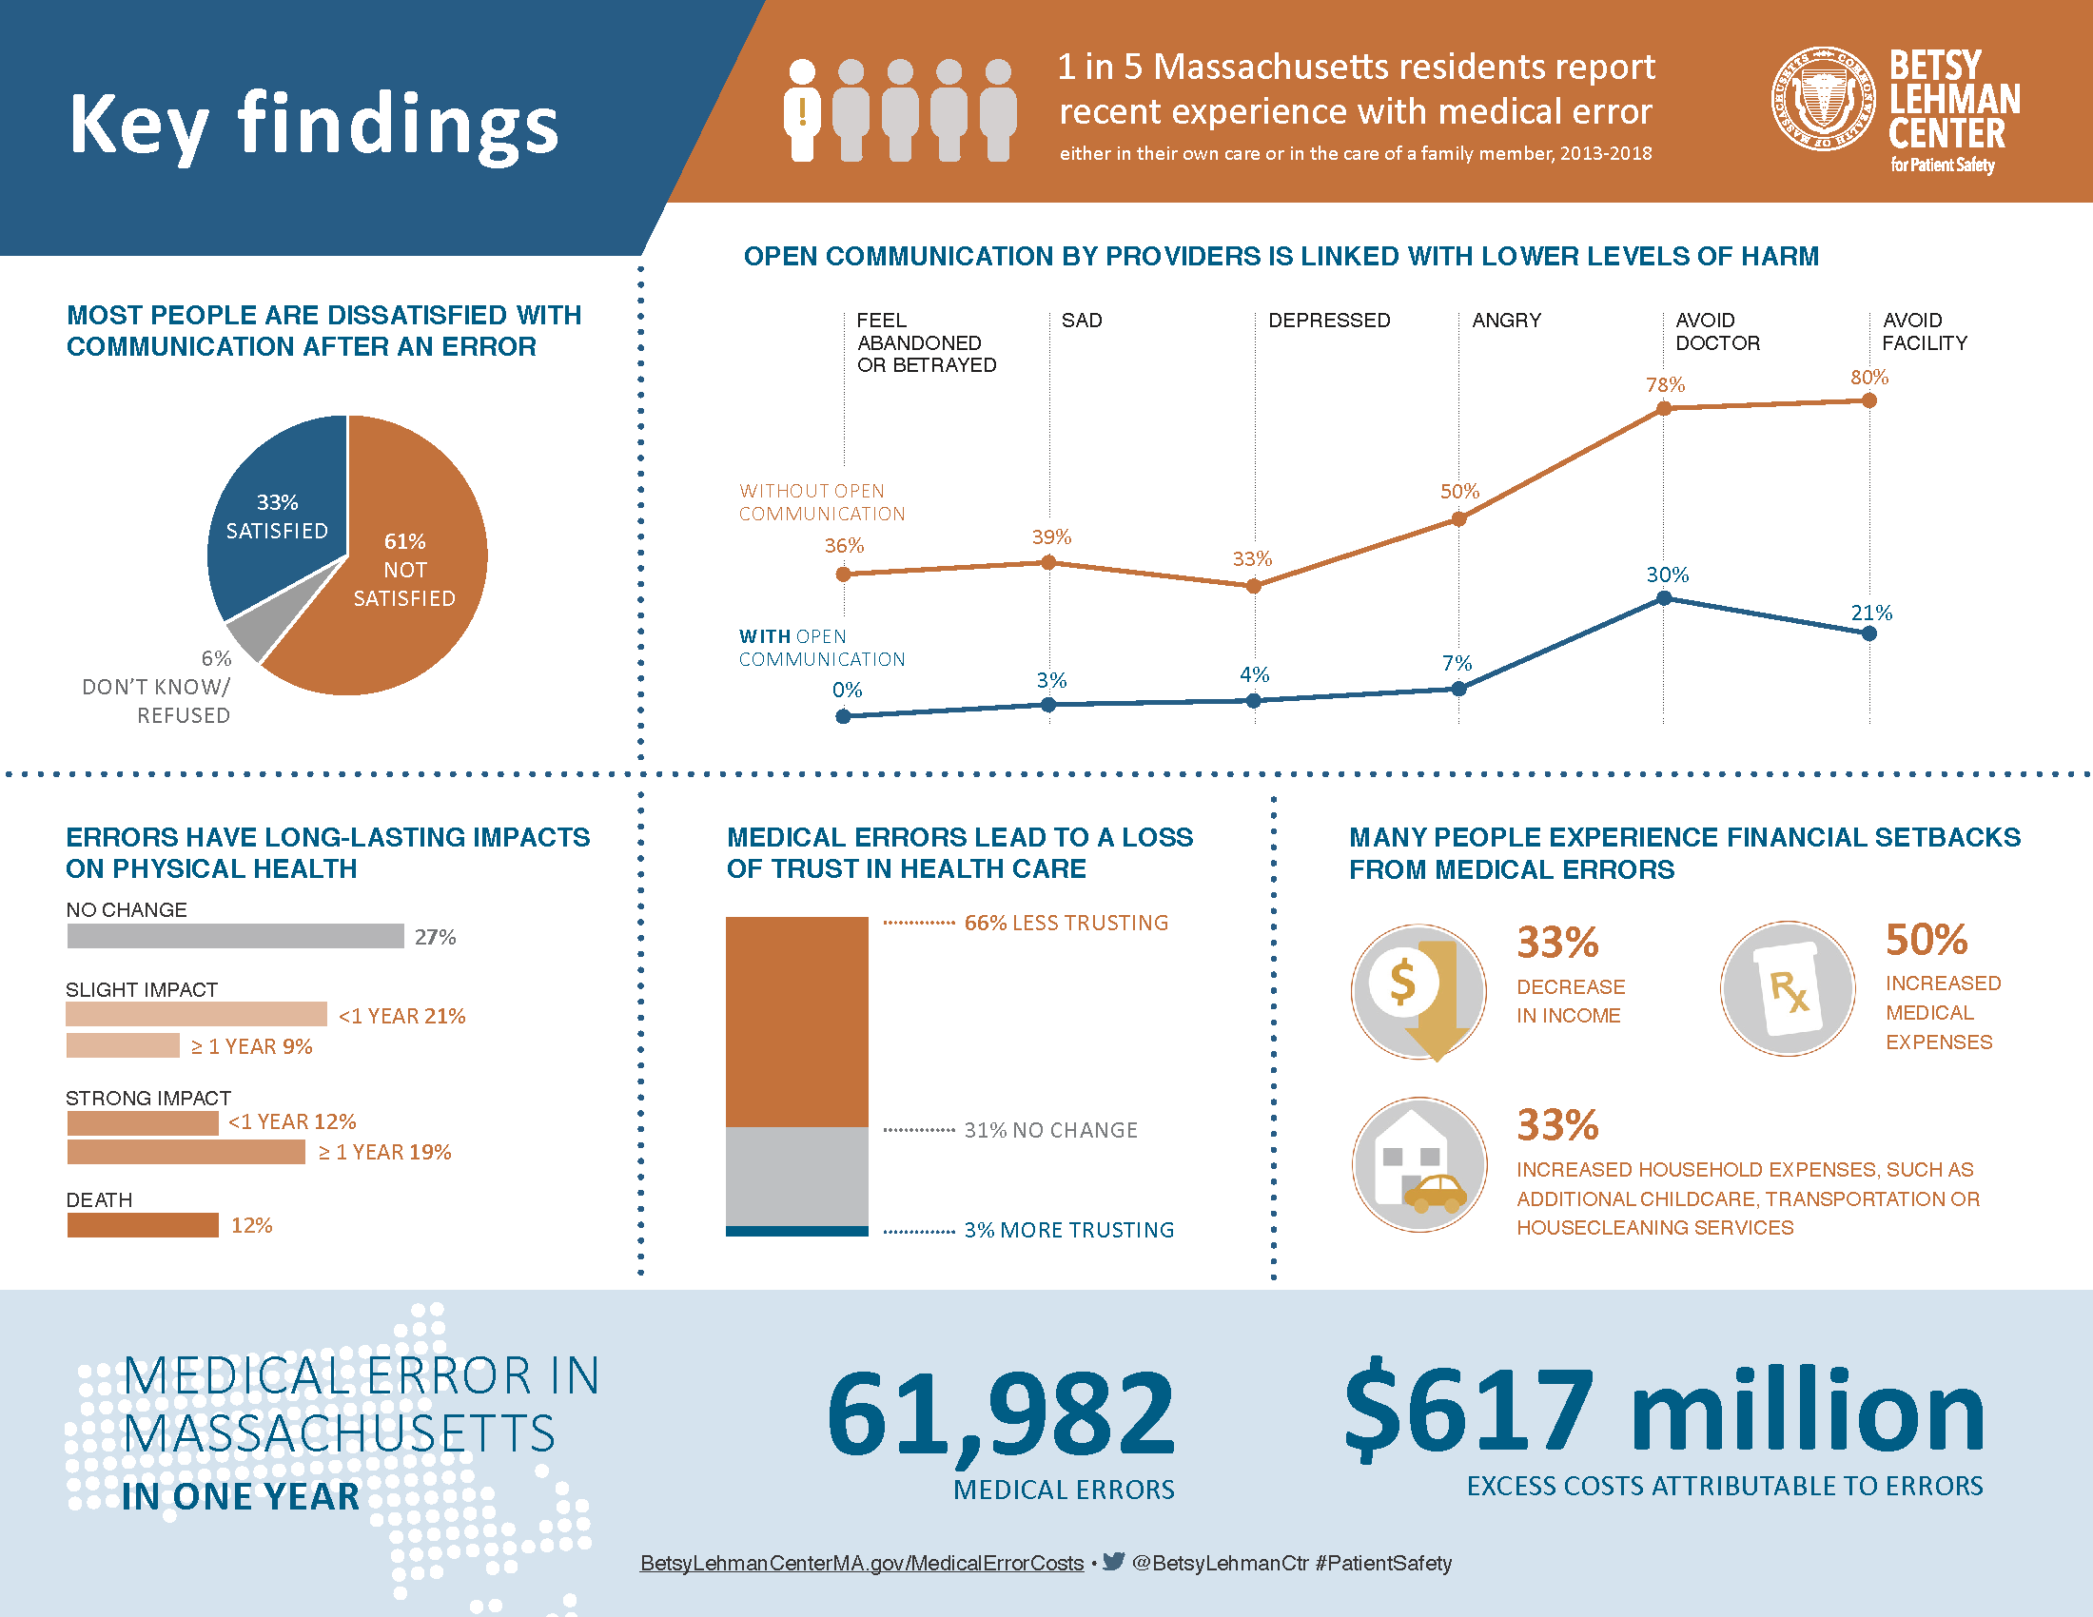

Journal articles

Associations between Care for low back pain: can health systems deliver?
Traeger AC, Buchbinder R, Elshaug AG, Croft PR, Maher CG
Bulletin of the World Health Organization. 2019;97:423-33.
DOI | https://dx.doi.org/10.2471/BLT.18.226050
Notes | Low back pain is the leading cause of years lived with disability globally. There have been calls for greater attention on the burden of low back pain and the need to avoid excessively medical solutions. Clinical guidelines now often recognise that many people with low back pain require little or no formal treatment and where treatment is required the recommended approach is to discourage use of pain medication, steroid injections and spinal surgery, and instead promote physical and psychological therapies. However, many health systems are not designed to support this approach. This paper examines why care for low back pain that is concordant with guidelines requires system-wide changes. Key challenges include the financial interests of pharmaceutical and other companies; outdated payment systems that favour medical care over patients’ self-management; and deep-rooted medical traditions and beliefs about care for back pain among physicians and the public. The authors offer examples of solutions and policies and practices for health systems and suggest that, by shifting resources from unnecessary care to guideline-concordant care, could be cost-neutral and have widespread impact.

Magnitude and modifiers of the weekend effect in hospital admissions: a systematic review and meta-analysis
Chen Y-F, Armoiry X, Higenbottam C, Cowley N, Basra R, Watson SI, et al
BMJ Open. 2019;9(6):e025764.
DOI | http://doi.org/10.1136/bmjopen-2018-025764
Notes | This latest addition to the literature on the “weekend effect” is a systematic review that incorporated 68 studies (70 articles) covering more than 640 million patient admissions. The authors report pooled odds ratio for weekend mortality of 1.16. They also observe that the weekend effect in these studies was more pronounced for elective rather than unplanned admissions. Their conclusion is rather cautious in observing that ‘The weekend effect is unlikely to have a single cause, or to be a reliable indicator of care quality at weekends. Further work should focus on underlying mechanisms and examine care processes in both hospital and community.’

Association of Coworker Reports About Unprofessional Behavior by Surgeons With Surgical Complications in Their Patients
Cooper WO, Spain DA, Guillamondegui O, Kelz RR, Domenico HJ, Hopkins J, et al
JAMA Surgery. 2019 [epub].
DOI | https://doi.org/10.1001/jamasurg.2019.1738
Notes | Paper reporting on a study that sought to ‘test the hypothesis that patients of surgeons with higher numbers of reports from coworkers about unprofessional behaviors are at greater risk for postoperative complications than patients whose surgeons generate fewer coworker reports.’ This study was a retrospective cohort study used data from two US academic hospitals covering 13,653 patients undergoing surgery by 202 surgeons. The authors report that ‘Patients whose surgeons had higher numbers of coworker reports about unprofessional behavior in the 36 months before the patient’s operation appeared to be at increased risk of surgical and medical complications.’ The authors note ‘These findings suggest that organizations interested in ensuring optimal patient outcomes should focus on addressing surgeons whose behavior toward other medical professionals may increase patients’ risk for adverse outcomes.’
Gabapentinoids and suicidal behaviour, unintentional overdoses, injuries, road traffic incidents, and violent crime: population based cohort study in Sweden
Molero Y, Larsson H, D’Onofrio BM, Sharp DJ, Fazel S
BMJ. 2019;365:l2147.

Gabapentinoids linked to new risks, including suicidal behaviour
Tracy DK
BMJ. 2019;365:l4021.
DOI | Molero et al https://doi.org/10.1136/bmj.l2147  Tracy https://doi.org/10.1136/bmj.l4021
Notes | In part as a response to the “opioid epidemic”, there has been an increase in the use of gabapentinoids (primarily gabapentin and pregabalin). These drugs are indicated for epilepsy and neuropathic pain, while pregabalin is also used for anxiety disorders. Off-label use has occurred for a range of conditions, including restless leg syndrome, migraine, menopausal flushes, and alcohol dependency. Side effects can include motor incoordination, dizziness, cognitive impairment, and suicidal ideation. Less well-known have been the longer term effects. This study by Molero et al sought to examine associations between gabapentinoids and adverse outcomes related to coordination disturbances (head or body injuries, or both and road traffic incidents or offences), mental health (suicidal behaviour, unintentional overdoses), and criminality. Using data on nearly 200,000 people from the Swedish Prescribed Drug Register who collected prescriptions for gabapentinoids (pregabalin or gabapentin) during 2006 to 2013 they report finding that ‘gabapentinoids are associated with an increased risk of suicidal behaviour, unintentional overdoses, head/body injuries, and road traffic incidents and offences. Pregabalin was associated with higher hazards of these outcomes than gabapentin.’ The related editorial (Tracy) observes that age was an important factor and the young adults ‘aged 15-24 were the most vulnerable group.’

For information on the Commission’s work on medication safety, see https://www.safetyandquality.gov.au/our-work/medication-safety/

Journal of Patient Safety and Risk Management
Volume 24, Issue 3 (June 2019)
URL | https://journals.sagepub.com/toc/cric/24/3
Notes | A new issue of the Journal of Patient Safety and Risk Management has been published. Articles in this issue of the Journal of Patient Safety and Risk Management include:  - Editorial and Commentary: Time to take a breath: Rebalancing the human and technical aspects of patient safety (Albert W Wu)  - Editorial and Commentary: Moving towards a safety II approach (Suzette Woodward)  - Improving hand hygiene compliance with patient zone demarcation: More than just lines on the floor (Shanqing Yin, Phaik Kooi Lim, and Yoke Hwee Chan)  - Second victims and mindfulness: A systematic review (Courtney S Miller, Susan D Scott, and Mary Beck)  - Responding to health information technology reported safety events: Insights from patient safety event reports (Katharine T Adams, Tracy C Kim, Allan Fong, Jessica L Howe, Kathryn M Kellogg, and Raj M Ratwani)  - Should surrogacy arrangement illegal in UK be recoverable in damages? XX v Whittington Hospital NHS Trust (Court of Appeal, 19 December 2018) (John Mead)  - Rethinking high reliability in healthcare: The role of error management theory towards advancing high reliability organizing (Oren Guttman, Joseph R Keebler, Elizabeth H Lazzara, William Daniel, and Gary Reed)

Healthcare Quarterly
Volume 22, Number 1
URL | https://www.longwoods.com/publications/healthcare-quarterly/25833/1/vol.-22-no.-1-2019
Notes | A new issue of Healthcare Quarterly has been published. Articles in this issue of Healthcare Quarterly include:  - Cataract Surgery Quality and Capacity (Robert J Campbell, Martin W ten Hove, Sherif R El-Defrawy and Philip L Hooper)  - Opioids in Canada (Vera Grywacheski, Allison Sabad, Lyubov Kushtova, Michele Bender, Nicole Rennie, Roger Cheng and Krista Louie)  - Frailty and Aging: How the Danish Experience Might Inform Canada (John Muscedere, Carol Barrie, Karen Chan, Bruce Cooper, Kim Critchley, Perry Kim, Amanda Lorbergs, Isobel Mackenzie, Cynthia Martineau, Tom Noseworthy, Maureen O'Neil, Joyce Resin, Samir Sinha and Russell Williams)  - How Do Older Adults Decide to Visit the Emergency Department? Patient and Caregiver Perspectives (Sharon Marr, Loretta M Hillier, Diane Simpson, Sigrid Vinson, Sarah Goodwill and David Jewell)  - Aging at Home: A Portrait of Home-Based Primary Care across Canada (Sabrina Akhtar, Mayura Loganathan, Mark Nowaczynski, Samir Sinha, Amanda Condon, Vivian Ewa, John C Kirk and Thuy-Nga Pham)  - Innovation in Ontario’s Family Health Teams: How Palliative and Coordinated Care Programs Are Filling Service Gaps and Keeping Patients at Home (Monica Aggarwal, Helen Cluett, Heather Campbell, Debbie Korzeniowski, Cindy Jones, Linsey O'Donnell and Kavita Mehta)  - Impact of a Primary Care After-Hours Clinic on Avoidable Emergency Department Visits and Costs (Jessica Moe, Ryan Oland and Grace Moe)  - Integrated (Enterprise) Risk Management in Canadian Healthcare Organizations – Common Barriers and a Shared Solution for Effective and Efficient Implementation in Canada (Polly Stevens, J Willcox and L Borovoy)  - Executive Coaching for Leadership Development: Experience of Academic Physician Leaders (Valerie G. Kirk, Ania Kania-Richmond and Katie Chaput)  - Overcoming Challenges to Support Clinician-Scientist Roles in Canadian Academic Health Sciences Centres (Sue Bookey-Bassett, Andria Bianchi, Joy Richards and Helen Kelly)

Nursing Leadership
Volume. 32, Number 1
URL | https://www.longwoods.com/publications/nursing-leadership/25846/1/vol.-32-no.-1-2019
Notes | A new issue of Nursing Leadership has been published. Articles in this issue of Nursing Leadership include:  - Editorial: Being a Nurse – More Than Just Tasks (Lynn M Nagle)  - Rural and Remote Licensed Practical Nurses' Perception of Working Below Their Legislated Scope of Practice (Martha L P MacLeod, Norma J Stewart, Julie G Kosteniuk, K L Penz, J Olynick, C P Karunanayake, D Banner, E Wilson, J C Kulig, M E Labrecque, P Moffitt, S Jahner and L Garraway)  - Rural and Remote Registered Nurses' Perception of Working Beyond Their Legislated Scope of Practice (Martha L P MacLeod, Norma J Stewart, Julie G Kosteniuk, K L Penz, J Olynick, C P Karunanayake, K Kilpatrick, J C Kulig, R Martin-Misener, I Koren, L V Zimmer, L Van Pelt and L Garraway)  - Getting Comfortable with "It Depends": Embracing the Impermanence of Scope of Practice (Sara Lankshear and Dianne Martin)  - Optimizing Licensed Practical Nurses in Home Care: Their Role, Scope and Opportunities (Kimberly Fraser, Neelam S Punjani, B Wilkey, S Labonte, S Lartey, J Gubersky, K Nickoriuk, S Joseph, S Younus and J Miklavcic)  - Guidance for Ethical Leadership in Nursing Codes of Ethics: An Integrative Review (Kara Schick-Makaroff and Janet L. Storch)  - Process and Initial Outcomes of an Initiative to Engage Nurses at a Mental Health and Addictions Hospital (Zohra Surani, Gillian Strudwick, Linda Purushuttam and Rani Srivastav)

BMJ Quality and Safety online first articles
URL | https://qualitysafety.bmj.com/content/early/recent
Notes | BMJ Quality and Safety has published a number of ‘online first’ articles, including:  - Stepped-wedge randomised trial to evaluate population health intervention designed to increase appropriate anticoagulation in patients with atrial fibrillation (Shirley V Wang, James R Rogers, Yinzhu Jin, David DeiCicchi, Sara Dejene, Jean M Connors, David W Bates, Robert J Glynn, M A Fischer)

Online resources

[UK] NICE Guidelines and Quality Standards
https://www.nice.org.uk/guidance
The UK’s National Institute for Health and Care Excellence (NICE) has published new (or updated) guidelines and quality standards. The latest reviews or updates are:
- NICE Guideline NG133 Hypertension in pregnancy: diagnosis and management https://www.nice.org.uk/guidance/ng133
- NICE Guideline NG134 Depression in children and young people: identification and management https://www.nice.org.uk/guidance/ng134

[USA] To Care is Human Podcast
https://www.theberylinstitute.org/page/PXPodcast
The Beryl Institute is a US entity focused on patient experience, including publishing the Patient Experience Journal (PXJ). They have also started producing a weekly podcast entitled To Care is Human.

Disclaimer
On the Radar is an information resource of the Australian Commission on Safety and Quality in Health Care. The Commission is not responsible for the content of, nor does it endorse, any articles or sites listed. The Commission accepts no liability for the information or advice provided by these external links. Links are provided on the basis that users make their own decisions about the accuracy, currency and reliability of the information contained therein. Any opinions expressed are not necessarily those of the Australian Commission on Safety and Quality in Health Care.

