# Australian COmmission on Safety and Quality in Health Care logo with Radar imageOn the Radar

Issue 432

2 September 2019

*On the Radar* is a summary of some of the recent publications in the areas of safety and quality in health care. Inclusion in this document is not an endorsement or recommendation of any publication or provider. Access to particular documents may depend on whether they are Open Access or not, and/or your individual or institutional access to subscription sites/services. Material that may require subscription is included as it is considered relevant.

*On the Radar* is available online, via email or as a PDF or Word document from <https://www.safetyandquality.gov.au/publications-and-resources/newsletters/radar>

If you would like to receive *On the Radar* via email, you can subscribe on our website <https://www.safetyandquality.gov.au/publications-and-resources/newsletters>   
or by emailing us at H[Umail@safetyandquality.gov.auU](mailto:mail@safetyandquality.gov.au).   
You can also send feedback and comments to H[Umail@safetyandquality.gov.auU](mailto:mail@safetyandquality.gov.au).

For information about the Commission and its programs and publications, please visit <https://www.safetyandquality.gov.au>

You can also follow us on Twitter @ACSQHC.

**On the Radar**

Editor: Dr Niall Johnson [niall.johnson@safetyandquality.gov.au](mailto:niall.johnson@safetyandquality.gov.au)

Contributors: Niall Johnson

**Reports**

*The causal effect of hospital volume on health gains from hip replacement surgery*

CHE Research Paper 168.

Rachet-Jacquet L, Gutacker N, Siciliani L

York: Centre for Health Economics, University of York; 2019. p. 32.

|  |  |
| --- | --- |
| URL | <https://www.york.ac.uk/che/news/news-2019/che-research-paper-168/> |
| Notes | The volume effect on surgical performance and outcome has been observed – and debated – for some time. This UK study sought to examine the causal effect of hospital volume on health gains from planned hip replacement surgery in the English National Health Service. The study used a dataset that linked routine hospital records and patient-reported outcome measures (PROMs) for all public hospitals in England. The PROMs assess patients’ health along dimensions of pain and mobility shortly before and six months after the surgery. The study investigated whether higher hospital volume increases patient health six months post-surgery, conditioning on pre-surgery health and other patient medical and socioeconomic indicators. The authors examined possible reverse-causality bias due to hospital demand being responsive to quality by constructing a measure of predicted hospital volumes based on a patient choice model. The results suggest that the observed **volume-outcome effect in hip replacement surgery is clinically small** and no longer statistically significant once adjusted for volume endogeneity due to reverse causality (i.e. hospitals with higher quality attract more patients). |

**Journal articles**

*How to start an antimicrobial stewardship programme in a hospital*

Mendelson M, Morris AM, Thursky K, Pulcini C

Clinical Microbiology and Infection. 2019 [epub].

|  |  |
| --- | --- |
| DOI | <https://doi.org/10.1016/j.cmi.2019.08.007> |
| Notes | This paper seeks to provide **a step-by-step pragmatic guide to setting up and implementing a hospital antimicrobial stewardship programme** in high-income or low- and middle-income countries. The authors describe how health care professionals can start an antimicrobial stewardship programme in their hospital, the components of such a programme, and the evidence base for its implementation.  For those in Australia, the Commission’s work on antimicrobial stewardship, including the *Antimicrobial Stewardship in Australian Health Care 2018* publication may be more directly applicable. The *Antimicrobial Stewardship in Australian Health Care 2018* publication is designed to provide clinicians and managers working in all healthcare sectors with the evidence, expert guidance and tools they need to initiate and sustain AMS activities in a diverse range of practice settings – hospitals (public and private, metropolitan and rural), primary care and aged care homes. The publication is available at <https://www.safetyandquality.gov.au/our-work/antimicrobial-stewardship> |

*Reducing pressure ulcers across multiple care settings using a collaborative approach*

Wood J, Brown B, Bartley A, Margarida Batista Custódio Cavaco A, Roberts AP, Santon K, et al

BMJ Open Quality. 2019;8(3):e000409.

|  |  |
| --- | --- |
| DOI | <http://dx.doi.org/10.1136/bmjoq-2018-000409> |
| Notes | Pressure injuries/ulcers remain unfortunately common and are considered largely preventable. This improvement paper reports on how one NHS Region in the UK set about reducing the incidence and severity of pressure injuries. The North East and North Cumbria region was identified as having an incidence of pressure ulcers higher than the national average. A 2-year Pressure Ulcer Collaborative was implemented, involving secondary care, community services, care homes and the ambulance service, with the aim of reducing the percentage of pressure ulcers developed by patients within their care. The intervention saw **pressure ulcers reduced by 36%** in year 1, and in year 2 by 33%, demonstrating an estimated cost saving during the Collaborative of £513 000, and a reduction in the number of bed days between 220 and 352. |

For information on the Commission’s work on pressure injuries, refer to the *Comprehensive Care Standard* in the National Safety and Quality Health Service (NSQHS) Standards <https://www.safetyandquality.gov.au/standards/nsqhs-standards/comprehensive-care-standard>

*Associations between patient experiences and clinical outcomes: a cross-sectional data linkage study of the Australian private healthcare sector*

Prang K-H, Canaway R, Bismark M, Dunt D, Kelaher M

BMJ Open Quality. 2019;8(3):e000637.

|  |  |
| --- | --- |
| DOI | <http://dx.doi.org/10.1136/bmjoq-2019-000637> |
| Notes | Australian study examined associations between patient experience (survey) data and clinical outcomes using data covering approximately 4,000 patients largely in private hospitals (88.6% of the sample with 11.4% treated in public hospitals). The experience data covered 11 domains using 25 questions while the clinical outcomes included 14-day readmission, 28-day readmission, any of a series of hospital acquired complications, and length of stay. The study found little significant associations and, as the authors observe:  *The absence of many associations between patient experience domains and clinical outcomes in our study, with the exception of two, suggests that* ***patient experiences should not be viewed as a surrogate marker of good clinical outcomes****.* ***Patient experience appears to be a separate quality measure that does not neccessarily reflect the safety and effectiveness of care delivered by a hospital.*** *It appears that patients can be satisfied with their care yet experience adverse outcomes such as complication or readmission after discharge that would be classified as non-favourable outcomes and largely considered by funders (insurers/government) to be an indicator of a performance failure.*  This ‘failure’ of experience measures, along with satisfaction measures, to show clear associations with clinical outcomes has led to the interest in outcome measures, including patient-reported outcome measures (PROMs). |

For information on the Commission’s work on patient experience measurement, see <https://www.safetyandquality.gov.au/our-work/indicators-measurement-and-reporting/australian-hospital-patient-experience-question-set>

For information on the Commission’s work on hospital-acquired complications (HACS), see <https://www.safetyandquality.gov.au/our-work/indicators/hospital-acquired-complications>

For information on the Commission’s work on patient-reported outcome measures (PROMS), see <https://www.safetyandquality.gov.au/patient-reported-outcome-measures>

*Measuring patient-centred system performance: a scoping review of patient-centred care quality indicators*

Santana M-J, Ahmed S, Lorenzetti D, Jolley RJ, Manalili K, Zelinsky S, et al

BMJ Open. 2019;9(1):e023596.

|  |  |
| --- | --- |
| DOI | <https://doi.org/10.1136/bmjopen-2018-023596> |
| Notes | The development of meaningful indicators can be laborious and time-consuming (as can be their collection, collation and analysis). This review paper sought to identify quality indicators that can be used to measure patient-centred care (PCC). From an initial list of 184 peer-reviewed studies, the review focused on 9 studies. To this a further 8 documents from the non-peer reviewed literature were added. The authors report that most patient-centred quality indicators (PC-QIs) ‘were presented as PCC measures and identified as guidelines, surveys or recommendations, and therefore cannot be classified as actual PC-QIs. Out of 502 ways to measure PCC, only 25 were considered to be actual PC-QIs. None of the identified articles implemented the quality indicators in care settings.’ This led them to state that ‘The identification of PC-QIs is a key first step in laying the groundwork to develop evidence-based PC-QIs. Research is needed to continue the development and implementation of PC-QIs for healthcare quality improvement.’ |

For information on the Commission’s work on person-centred care, see <https://www.safetyandquality.gov.au/our-work/partnering-consumers/person-centred-care>

*Creating a just culture: the Ottawa Hospital's experience*

Forster AJ, Hamilton S, Hayes T, Légaré R

Healthcare Management Forum. 2019;32(5):266-71.

|  |  |
| --- | --- |
| DOI | <http://doi.org/10.1177/0840470419853303> |
| Notes | Culture provides the setting in which healthcare is enacted. It is thought that a positive, just culture enables the delivery of better, safer care and provides a better environment for patients and healthcare workers.  This paper describes one Canadian hospital’s experience in attempting to produce such a just cultural environment. Prompted by two events that ‘called into question our hospital's safety culture’ the hospital undertook a ‘a deliberate and methodical organization-wide approach to change’. The work included ‘generating **leadership commitment**, incorporating the efforts within its corporate strategy, obtaining **stakeholder engagement**, developing and delivering an **education program**, and …efforts to improve **safety systems**. The authors believe that in attempting to ‘develop an **increased focus on safety—for staff, visitors, and patients**’ the hospital has had demonstrable success, but recognise that there will need to be ‘ongoing efforts to ensure the culture shift is sustained.’ |

*Effect of High-Dose Vitamin D Supplementation on Volumetric Bone Density and Bone Strength*

*A Randomized Clinical Trial*

Burt LA, Billington EO, Rose MS, Raymond DA, Hanley DA, Boyd SK

JAMA. 2019;322(8):736-45.

|  |  |
| --- | --- |
| DOI | <https://doi.org/10.1001/jama.2019.11889> |
| Notes | Vitamin D testing and supplementation has increased markedly in many nations in recent years. This paper reports on a 3-year randomised clinical trial that examined the effect of 3 daily doses of vitamin D (400 IU, 4000 IU, and 10 000 IU) in 311 healthy adults (without osteoporosis) aged 55 to 70 years. The RCT failed to find a positive effect of vitamin D on volumetric bone mineral density and estimated bone strength. The authors concluded that ‘**Among healthy adults, supplementation with higher doses of vitamin D did not result in improved bone health**; further research would be needed to determine whether it is harmful.’ |

*Journal of Patient Safety and Risk Management*

Volume: 24, Number: 4 (August 2019)

|  |  |
| --- | --- |
| URL | <https://journals.sagepub.com/toc/cric/24/4> |
| Notes | A new issue of the *Journal of Patient Safety and Risk Management* has been published. Articles in this issue of the *Journal of Patient Safety and Risk Management* include:   * Editorial: What will you do on 17 September 2019, the first **World Patient Safety Day**? (Albert W Wu and Neelam Dhingra-Kumar) * We need to talk: **Provider conversations** with peers and patients about a **medical error** (Tejaswini Dhawale, Jennifer Zech, Sarah M Greene, Douglas W Roblin, Karen Berg Brigham, Thomas H Gallagher, and K M Mazor) * Preoccupation with failure and adherence to shared baselines: **Measuring high-reliability organizational culture** (Jason M Etchegaray, Eric J Thomas, and Jochen Profit) * **Bariatric surgery**: Navigating the medicolegal maze (Myutan Kulendran, Marcus Reddy, Raluca Belchita, Arnold Kincius, and Omar Khan) * Use of a public health law framework to improve **medication safety by anesthesia providers** (Ronald S Litman) * Patient safety professionals as the **third victims of adverse events** (Julie Holden and Alan J Card) |

*BMJ Quality and Safety* online first articles

|  |  |
| --- | --- |
| URL | <https://qualitysafety.bmj.com/content/early/recent> |
| Notes | *BMJ Quality and Safety* has published a number of ‘online first’ articles, including:   * **Community pharmacy medication review, death and re-admission after hospital discharge**: a propensity score-matched cohort study (Lauren Lapointe-Shaw, Chaim M Bell, Peter C Austin, Lusine Abrahamyan, Noah M Ivers, Ping Li, Petros Pechlivanoglou, Donald A Redelmeier, Lisa Dolovich) * A mixed-methods study of challenges experienced by clinical teams in **measuring improvement** (T Woodcock, E G Liberati, M Dixon-Woods) * The value of **Facebook in nation-wide hospital quality assessment**: a national mixed-methods study in Norway (Oyvind Bjertnaes, Hilde Hestad Iversen, Katrine Damgaard Skyrud, Kirsten Danielsen) * Editorial: Mind the gap: how **vulnerable patients fall through the cracks of cancer quality metrics** (Christopher Manz, Katharine Rendle, J Bekelman) |

**Online resources**

*2019 Lowitja Institute International Indigenous Health and Wellbeing Conference statement*

<https://www.conference2019.lowitja.org.au/2019-conference-statement>

The Lowitja Institute International Indigenous Health and Wellbeing Conference 2019 was held in Darwin in June 2019. Based on deliberations under the theme Thinking. Speaking. Being: First Nations Solutions for Global Change, 760 national and international conference delegates published a conference statement on indigenous peoples, health and healthcare systems.

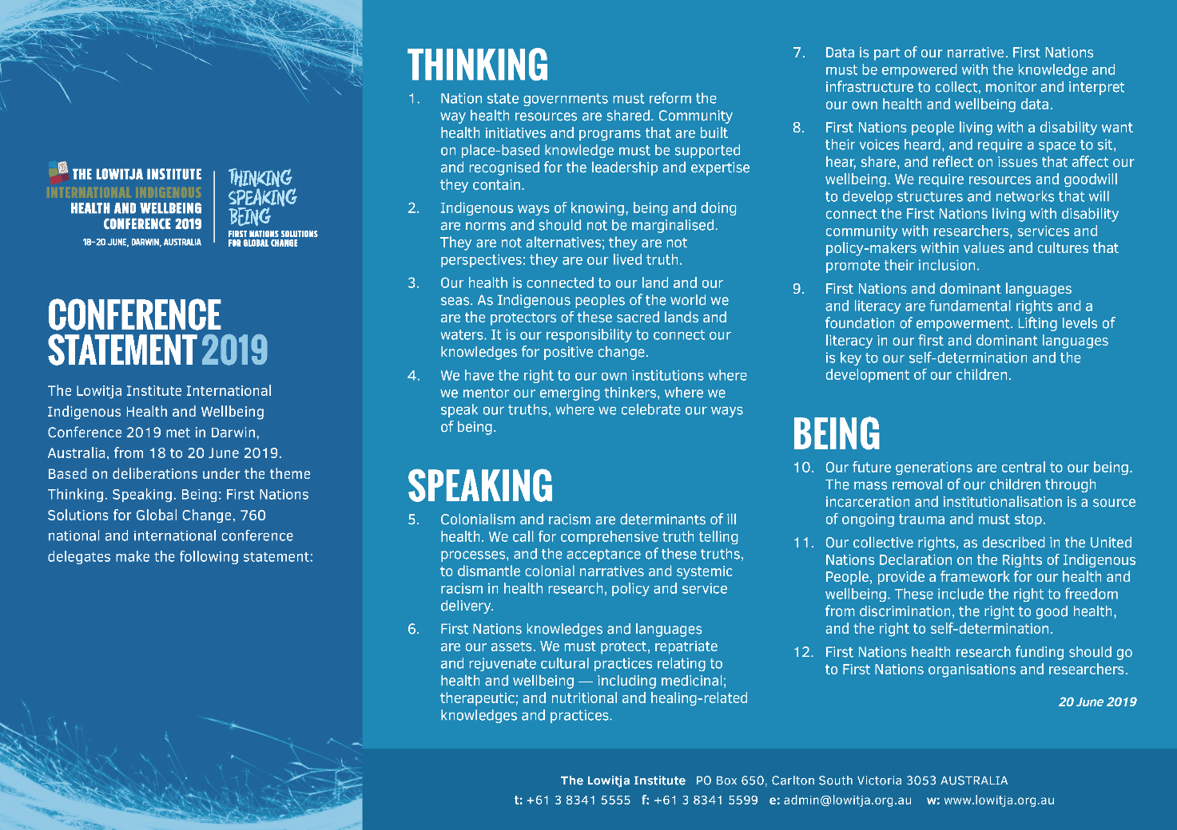

 *World Patient Safety Day*

<https://www.who.int/campaigns/world-patient-safety-day/2019>

World Patient Safety Day is 17 September 2019. The World Health Organization’s theme for World Patient Safety Day is "**Patient Safety: A Global Health Priority**" with the slogan "**Speak Up for Patient Safety**"



*[UK] NICE Guidelines and Quality Standards*

<https://www.nice.org.uk/guidance>

The UK’s National Institute for Health and Care Excellence (NICE) has published new (or updated) guidelines and quality standards. The latest reviews or updates are:

* NICE Guideline NG28 ***Type 2 diabetes*** *in adults: management* <https://www.nice.org.uk/guidance/ng28>
* NICE Guideline NG136 ***Hypertension*** *in adults: diagnosis and management* <https://www.nice.org.uk/guidance/ng136>

*[UK] National Institute for Health Research*

<https://discover.dc.nihr.ac.uk/portal/search/signals>

The UK’s National Institute for Health Research (NIHR) Dissemination Centre has released the latest ‘Signals’ research summaries. This latest release includes:

* Closer links between police and health services can improve experiences for **people in mental health crisis**
* Packages of care interventions ‘not effective’ to reduce repeat admissions for **COPD**
* Surgery for a **deviated nasal septum** improves quality of life more than non-surgical approaches
* Adding behavioural support to drug treatment helps more people **quit smoking**
* Virtual reality can help reduce the pain and anxiety of **stressful medical procedures for children**
* **Physician associates** appear to make a positive contribution to inpatient care
* On balance, **antiplatelet drugs** may be restarted for **stroke survivors** who have bled into the brain
* Reminders to assess **clotting risk** increase the use of preventive measures
* Robot-assisted training offers little useful improvement in **severe arm weakness and function after stroke**
* **Cardiac rehabilitation for heart failure** can improve quality of life and fitness.

**Disclaimer**

On the Radar is an information resource of the Australian Commission on Safety and Quality in Health Care. The Commission is not responsible for the content of, nor does it endorse, any articles or sites listed. The Commission accepts no liability for the information or advice provided by these external links. Links are provided on the basis that users make their own decisions about the accuracy, currency and reliability of the information contained therein. Any opinions expressed are not necessarily those of the Australian Commission on Safety and Quality in Health Care.