# Australian COmmission on Safety and Quality in Health Care logo with Radar imageOn the Radar

Issue 440

11 November 2019

*On the Radar* is a summary of some of the recent publications in the areas of safety and quality in health care. Inclusion in this document is not an endorsement or recommendation of any publication or provider. Access to particular documents may depend on whether they are Open Access or not, and/or your individual or institutional access to subscription sites/services. Material that may require subscription is included as it is considered relevant.

*On the Radar* is available online, via email or as a PDF or Word document from <https://www.safetyandquality.gov.au/publications-and-resources/newsletters/radar>

If you would like to receive *On the Radar* via email, you can subscribe on our website <https://www.safetyandquality.gov.au/publications-and-resources/newsletters>   
or by emailing us at H[Umail@safetyandquality.gov.auU](mailto:mail@safetyandquality.gov.au).   
You can also send feedback and comments to H[Umail@safetyandquality.gov.auU](mailto:mail@safetyandquality.gov.au).

For information about the Commission and its programs and publications, please visit <https://www.safetyandquality.gov.au>

You can also follow us on Twitter @ACSQHC.

**On the Radar**

Editor: Dr Niall Johnson [niall.johnson@safetyandquality.gov.au](mailto:niall.johnson@safetyandquality.gov.au)

Contributors: Niall Johnson, Jennifer Caldwell, Helen Dowling

***Clostridium difficile* infection 2017 Data Snapshot**

Australian Commission on Safety and Quality in Health Care

Sydney: ACSQHC; 2019. p. 10.

<https://www.safetyandquality.gov.au/publications-and-resources/resource-library/clostridium-difficile-infection-2017-data-snapshot>

*Clostridium difficile* (also referred to as *Clostridioides difficile*) is an anaerobic, spore-forming, gram-positive bacillus typically associated with gastrointestinal disease. The rate of healthcare-associated *Clostridium difficile* infection (CDI) in a hospital is often considered as another measure of the effectiveness of the hospital’s infection prevention and control program, particular with regards to environmental cleaning and antimicrobial use. The Australian Commission on Safety and Quality in Health Care (the Commission) annually monitors the prevalence of CDI in Australian public hospitals. The 2017 Data Snapshot report is the second Data Snapshot report published by the Commission. Patient administrative data from the 2016-2017 and 2017-2018 Admitted Patient Care National Minimum Data Set (APC NMDS) has been utilised to generate this report.

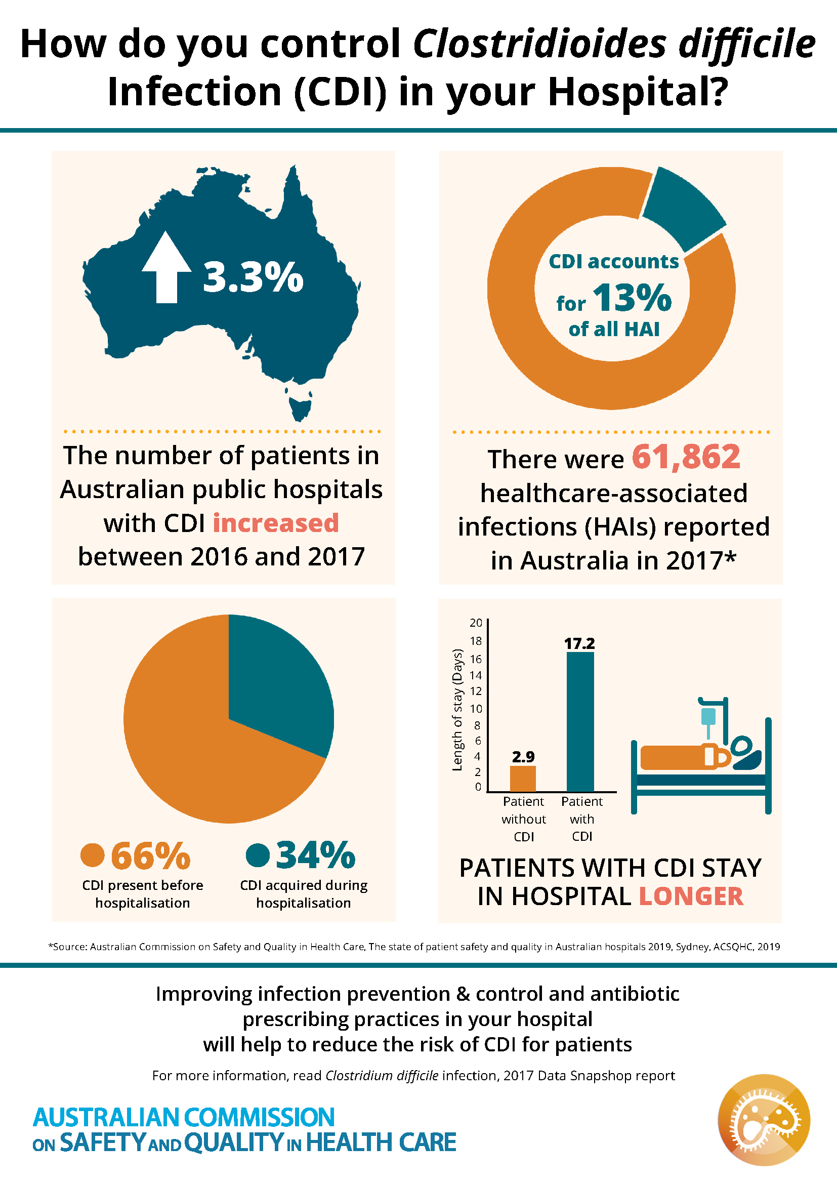

**National Hand Hygiene Initiative update**

<https://www.safetyandquality.gov.au/nhhi>

The National Hand Hygiene Initiative (NHHI) is one of a suite of initiatives to prevent and reduce healthcare-associated infections in Australia. Health service organisations have implemented and maintained hand hygiene programs that are consistent with the NHHI, in accordance with the National Safety and Quality Health Service (NSQHS) Standards.

Since commencing the NHHI in 2008, the Commission has contracted Hand Hygiene Australia (HHA) to provide support resources to assist in the implementation and maintenance of local hand hygiene programs.

From 1 November 2019, the NHHI transitioned from HHA to the Commission. All resources to support the Learning Management System (LMS) and the Hand Hygiene Compliance Application (HHCApp) have been published on the Commission’s website, and are available from NHHI webpage [www.safetyandquality.gov.au/nhhi](http://www.safetyandquality.gov.au/nhhi)

Access to the HHCApp and the learning modules has not changed. Training resources to support the audits will be available on the Commission’s website and arrangements for future GSA training workshops are being finalised. In the interim, local GSAs will still be able to train auditors.

The Commission will continue to provide regular advice to states, territories and the private sector during the transition period whilst permanent arrangements are finalised.

Information regarding contact points is now available on the Commission’s website, and there is a redirection on the HHA website.

NHHI helpdesk: Monday – Friday (Business days)

Email: [handhygiene@safetyandquality.gov.au](mailto:handhygiene@safetyandquality.gov.au)

Phone: (02) 9126 3511

**Reports**

*Dying well: Improving palliative and end of life care for people with dementia*

Dementia Discussion Paper 1

Dementia Australia

Melbourne: Dementia Australia; 2019. p. 16.

|  |  |
| --- | --- |
| URL | <https://www.dementia.org.au/files/documents/DA%20Dying%20Well%20Discussion%20Paper%20FINAL%20for%20online.pdf> |
| Notes | Dementia Australia (formerly Alzheimer’s Australia) has released this brief discussion paper calling for better palliative and end of life care for those living with dementia. The report argues that comprehensive palliative care for people living with dementia should be available when and where it is needed, including community or home based care, residential aged care, hospice care, and acute care settings. The authors argue that there is a need to improve the provision of palliative care services for people living with dementia in each of these settings, and to increase the ability of health professionals, staff, families and the community to meet the specific palliative care needs of people living with dementia. The report includes a number of recommendations and calls for action around workforce, advanced care planning, funding, access, coordination and awareness. |

*A Guide to Medication Reviews for NSW Health Services*

Clinical Excellence Commission

Sydney: CEC; 2019

|  |  |
| --- | --- |
| URL | <http://www.cec.health.nsw.gov.au/patient-safety-programs/medication-safety/continuity-of-medication-management/medication-review> |
| Notes | The Clinical Excellence Commission in New South Wales has developed *A Guide to Medication Reviews for NSW Health Services* as a resource to assist hospitals and clinicians to develop systems and processes for medication reviews for patients in line with the requirements of Action 4.10 of the National Safety and Quality Health Service (NSQHS) Medication Safety Standard. |

For information on the National Safety and Quality Health Service (NSQHS) Standards, see <https://www.safetyandquality.gov.au/standards/nsqhs-standards>

**Journal articles**

*Patient and family engagement as a potential approach for improving patient safety: A systematic review*

Park M, Giap T-T-T

Journal of Advanced Nursing. 2019 [epub].

|  |  |
| --- | --- |
| DOI | <https://doi.org/10.1111/jan.14227> |
| Notes | In recent years there has developed a sizeable literature on the (potential and/or real) contribution of patients, carers, families and consumers to patient safety. This has ranged from the use of complaints through to prolonged engagement, participation, and co-design of health service delivery. This paper reports on a systematic review that examined 42 studies that examined patient and family engagement. These studies covered a broad range of activities and levels of engagement and found ‘positive effects of the interventions on patient safety’, while recognising gaps and barriers. The authors suggests that ‘Policymakers should issue guidelines for implementing patient and family engagement in healthcare systems which would enable healthcare providers to implement patient and family engagement and improve patient safety appropriately and effectively.’  On a similar theme, an Australian research project is investigating how social media may be used by hospitals as a tool for facilitating patient/consumer engagement in health service design and quality improvement activities. The research project seeks to interview consumer representatives and public hospital employees who are in communications, quality improvement and/or consumer engagement roles about people’s experiences of, and opinions about, using social media. To participate or to get further information, see the project page at <https://latrobe.edu.au/social-media-use-in-hospitals> |

For information on the Commission’s work on partnering with consumers, see <https://www.safetyandquality.gov.au/our-work/partnering-consumers>

*Interventions for improving teamwork in intrapartem care: a systematic review of randomised controlled trials*

Wu M, Tang J, Etherington N, Walker M, Boet S

BMJ Quality & Safety. 2019 [epub].

|  |  |
| --- | --- |
| DOI | <https://doi.org/10.1136/bmjqs-2019-009689> |
| Notes | Health care is seen a team sport with effective teamwork often being a significant factor in shaping the safety and quality of care. This review, covering nine randomised control trials, examined interventions designed to enhance teamwork in this setting and found that ‘**simulation-based teamwork interventions appear to improve team performance and patient morbidity in labour and delivery care**’. |

*Understanding the factors influencing doctors’ intentions to report patient safety concerns: a qualitative study*

Rich A, Viney R, Griffin A

Journal of the Royal Society of Medicine. 2019;112(10):428-437.

|  |  |
| --- | --- |
| DOI | <https://doi.org/10.1177/0141076819877542> |
| Notes | The ability to speak up is considered a key factor in ensuring an environment that is alert to safety and quality lapses and acting when they occur. This study examined factors that enable or constrain doctors’ intentions to raise a patient safety concern. Based on focus groups and interviews in various parts of England, the authors report that ‘While **raising a concern** was considered an **appropriate professional behaviour**, there were **multiple barriers** to raising a concern…Negative attitudes operated due to a **fear of the consequences**, such as becoming professionally isolated. **Disapproval** for raising a concern was encountered at an interpersonal and organisational level. Organisational constraints of **workload** and **culture** significantly undermined the raising of a concern. Responses about concerns were often side-lined or **not taken seriously**, leading to demotivation to report. This was reinforced by high-profile cases in the media and the negative treatment of whistle-blowers. While regulator guidance acted as an enabler to justify raising a concern, doctors felt disempowered to raise a concern about people in positions of greater power, and ceased to report concerns due to a perceived lack of action about concerns raised previously.’ These results ‘.point to implications for policymakers, including the need to **publicise positive stories** of whistle-blowers and providing **greater support to doctors**.’ |

*Decreases in antimicrobial use associated with multihospital implementation of electronic antimicrobial stewardship tools*

Graber CJ, Jones MM, Goetz MB, Madaras-Kelly K, Zhang Y, Butler JM, et al

Clinical Infectious Diseases. 2019 [epub].

*A Collaborative Multicenter QI Initiative To Improve Antibiotic Stewardship in Newborns*

Dukhovny D, Buus-Frank ME, Edwards EM, Ho T, Morrow KA, Srinivasan A, et al

Pediatrics. 2019:e20190589.

|  |  |
| --- | --- |
| DOI | Graber et al <https://doi.org/10.1093/cid/ciz941>  Dukhovny et al <https://doi.org/10.1542/peds.2019-0589> |
| Notes | A pair of items reporting on the implementation of antimicrobial stewardship programs.  Graber at el report on a program in eight US Veterans health facilities that used comparative data visualisation tools, including an interactive web-based antimicrobial dashboard and a standardised antimicrobial usage report updated at user-selected intervals, to help inform antimicrobial use. Use of these tools ‘was associated with significant reductions in overall antimicrobial and anti-pseudomonal use relative to uninvolved facilities.’  Dukhovny et al report on a larger intervention, involving multidisciplinary teams from 146 NICUs who participated in Choosing Antibiotics Wisely. The study sought to determine if those teams participating had increased compliance with the Centers for Disease Control and Prevention (CDC) core elements for antibiotic stewardship and demonstrated reductions in antibiotic use (AU) among newborns. From the January 2016 to December 2017 audit, the authors report that ‘the percentage of **NICUs implementing the CDC core elements increased in each of the 7 domains** (leadership: 15.4%–68.8%; accountability: 54.5%–95%; drug expertise: 61.5%–85.1%; actions: 21.7%–72.3%; tracking: 14.7%–78%; reporting: 6.3%–17.7%; education: 32.9%–87.2%; P < .005 for all measures). The **median AU rate decreased from 16.7% to 12.1%** (P for trend < .0013), a 34% relative risk reduction.’ |

For information on the Commission’s work on antimicrobial stewardship, see <https://www.safetyandquality.gov.au/our-work/antimicrobial-stewardship>

*Patient Experience Journal (PXJ)*

Volume 6, Issue 3 (2019)

|  |  |
| --- | --- |
| URL | <https://pxjournal.org/journal/vol6/iss3/> |
| Notes | A new issue of the *Patient Experience Journal (PXJ)* has been published. Articles in this issue of the *Patient Experience Journal (PXJ)* include:   * Editorial: The **future of patient experience**: Five thoughts on where we must go from here (Jason A Wolf) * Awakening from a medical mystery: one patient’s **experience of being undiagnosed** (Dwane UnRuh) * **Is it fair to compare?** A patient and family experience of two healthcare systems and neurosurgical teams within a two-week period (Laura Miller) * **Engaging under- and/or never-engaged populations in health services**: A systematic review (Lesley Moody, Erica Bridge, Vidhi Thakkar, Naomi Peek, Tanvi Patel, Suman Dhanju, and Simron Singh) * **Refugees' perceptions of primary care**: What makes a good doctor's visit? (Anne Mutitu, Bev -. Zabler, and Jeana M. Holt * From diagnosis to routine care in **type 1 diabetes in children**: Parents’ experiences (Géraldine Heilporn, Maude Laberge, André Côté, and M Rekik) * **Service user interview panels for recruitment** to UK child and adolescent mental health services: A questionnaire study exploring the experiences of young people, staff and candidates (Sophie M Allan and Emma Travers-Hill) * Using patient experience in optimizing the **total knee arthroplasty patient journey** (Nienke Wolterbeek, Dieuwertje J Hiemstra, Fiona A van der Hoeven, and Kiem G Auw Yang) * **Patient-initiated second opinions** during acute hospital care (Roni Gagin, Neta HaGani, Esti Zigelboim, and Shiri Shinan-Altman) * **Patient perspectives: Four pillars of professionalism** (Laura Yvonne Bulk; Donna Drynan; Sue Murphy; Patricia Gerber; R Bezati; S Trivett; and T Jarus) * Conceptual frameworks and degrees of **patient engagement in the planning and designing of health services**: A scoping review of qualitative studies (Umair Majid and Anna Gagliardi) * **Enhancing emergency care environments**: Supporting suicidal distress and self-harm presentations through environmental safeguards and the built environment (Stephanie Liddicoat) * **Volunteer contributions in the emergency department**: A scoping review (Sophie Glanz, Brittany Ellis, Shelley L. McLeod, Cameron Thompson, Don Melady, and Michelle Nelson) * Effect of change in the **CG CAHPS survey** instrument recall period on patient experience scores on healthcare utilization (Kimberley Marshall-Aiyelawo; Richard Bannick; Sharon Beamer; Melissa Gliner; Terry McDavid; Daniel Muraida; Janice Ellison; Beatrice Abiero; A Roshwalb; and M Andrews) * Are you my doctor? Utilizing **personalized provider cards to improve patient/doctor connections** (Jessica Colyer, Tina Halley, Melissa Winter, Jennifer Coldren, and Martha Parra) * Seven steps to successful change: How a large academic medical center **prepared patients for organizational change** (Brian Carlson, Madison Agee, Terrell Smith, Paul Sternberg Jr, and Jason Morgan) |

*Health Affairs*

Volume 38, No. 11

|  |  |
| --- | --- |
| URL | <https://www.healthaffairs.org/toc/hlthaff/38/11> |
| Notes | A new issue of *Health Affairs* has been published with the themes “**Household Costs, Food & More**”. Articles in this issue of *Health Affairs* include:   * **Age-Friendly Care** At The Emergency Department (Michele Cohen Marill) * **Integrating Pediatric Care** And Taking On Risk To Improve Health (Rebecca Gale) * Changes In The **Equity Of US Health Care Financing** In The Period 2005–16 (Paul D Jacobs, and Thomas M Selden) * **Financial Hardships Of Medicare Beneficiaries** With Serious Illness (Michael A Kyle, R J Blendon, J M Benson, M K Abrams, and E C Schneider) * The Effect Of The **Supplemental Nutrition Assistance Program** On Mortality (Colleen M Heflin, Samuel J Ingram, and James P Ziliak) * Evaluating A USDA Program That Gives SNAP Participants Financial Incentives To **Buy Fresh Produce** In Supermarkets (Pasquale E Rummo, Danton Noriega, Alex Parret, Matthew Harding, O Hesterman, and B E Elbel) * Cost-Effectiveness Of The **Sugar-Sweetened Beverage Excise Tax** In Mexico (Ana Basto-Abreu, Tonatiuh Barrientos-Gutiérrez, Dèsirée Vidaña-Pérez, M Arantxa Colchero, Mauricio Hernández-F., Mauricio Hernández-Ávila, Zachary J Ward, Michael W Long, and Steven L Gortmaker) * **Noncommunicable Diseases Attributable To Tobacco Use** In China: Macroeconomic Burden And Tobacco Control Policies (Simiao Chen, Michael Kuhn, Klaus Prettner, and David E Bloom) * Did **Hospital Readmissions** Fall Because Per Capita Admission Rates Fell? (J Michael McWilliams, M L Barnett, E T Roberts, P Hamed, and A Mehrotra) * Medicaid Expansion Associated With Reductions In **Preventable Hospitalizations** (Hefei Wen, Kenton J Johnston, L Allen, and T M Waters) * Are **Patients Electronically Accessing Their Medical Records**? Evidence From National Hospital Data (Sunny C Lin, Courtney R Lyles, Urmimala Sarkar, and Julia Adler-Milstein) * **Hospital-Acquired Condition Reduction Program** Is Not Associated With Additional Patient Safety Improvement (Kyle H Sheetz , Justin B Dimick , Michael J Englesbe , and Andrew M Ryan) * **Frequent Emergency Department Users**: Focusing Solely On Medical Utilization Misses The Whole Person (Hemal K Kanzaria, Matthew Niedzwiecki, Caroline L Cawley, Carol Chapman, Sarah H Sabbagh, Emily Riggs, Alice Hm Chen, Maria X Martinez, and Maria C Raven) * Potential Unintended Consequences Of Recent **Shared Decision Making** Policy Initiatives (Jennifer Blumenthal-Barby, Douglas J Opel, Neal W Dickert, Daniel B Kramer, Brownsyne Tucker Edmonds, Keren Ladin, Monica E Peek, Jeff Peppercorn, and Jon Tilburt) * **Biosimilar Filgrastim** Uptake And Costs Among Commercially Insured, Medicare Advantage (Pinar Karaca-Mandic, Jessica Chang, Ronald Go, Stephen Schondelmeyer, Daniel Weisdorf, and Molly Moore Jeffery) * California’s New Gold Rush: Marketplace Enrollees Switch To **Gold-Tier Plans** In Response To Insurance Premium Changes (Petra W Rasmussen, Thomas Rice, and Gerald F Kominski) * **Measles, Mumps, And Communion**: A Vision For Vaccine Policy (Joshua T B Williams) |

*BMJ Quality and Safety* online first articles

|  |  |
| --- | --- |
| URL | <https://qualitysafety.bmj.com/content/early/recent> |
| Notes | *BMJ Quality and Safety* has published a number of ‘online first’ articles, including:   * **Obstetric care navigation**: results of a quality improvement project to provide accompaniment to women for facility-based maternity care in rural Guatemala (Kirsten Austad, Michel Juarez, Hannah Shryer, Cristina Moratoya, Peter Rohloff) * **Do bedside whiteboards enhance communication** in hospitals? An exploratory multimethod study of patient and nurse perspectives (Anupama Goyal, Hanna Glanzman, Martha Quinn, Komalpreet Tur, Sweta Singh, Suzanne Winter, Ashley Snyder, Vineet Chopra) * Editorial: **Inappropriate ED visits**: patient responsibility or an attribution bias? (Krisda Chaiyachati, Shreya Kangovi) * Improving **end-of-rotation transitions of care among ICU patients** (Joshua Lee Denson, Julie Knoeckel, Sara Kjerengtroen, Rachel Johnson, Bryan McNair, Olivia Thornton, Ivor S Douglas, M E Wechsler, R E Burke) |

**Online resources**

*Guidance on use of bed rails*

<https://www.bettersafercare.vic.gov.au/resources/clinical-guidance/older-people/guidance-on-use-of-bed-rails>

Safer Care Victoria has released this guidance (and a flowchart and a consumer information sheet) to aid in the safe use of bed rails in the care of older patients.

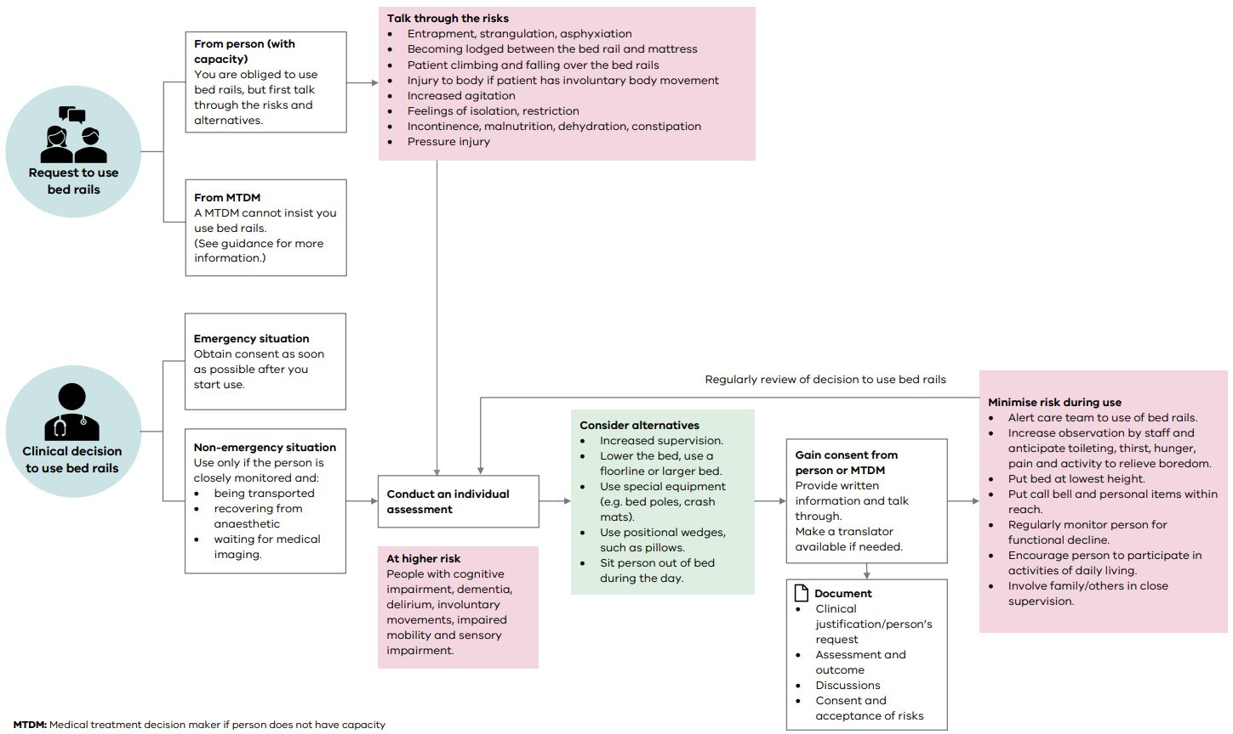

*[NZ] Who me – biased? He ngākau haukume tōku?*

<https://www.hqsc.govt.nz/our-programmes/patient-safety-week/news-and-events/news/3867/>

The Health Quality & Safety Commission New Zealand included a focus on bias in its Patient Safety Week 2019 (<https://www.hqsc.govt.nz/our-programmes/patient-safety-week/psw-2019/>). The Commission has developed learning modules on **Understanding bias in health care**. The modules are available at [www.hqsc.govt.nz/understanding-bias](http://www.hqsc.govt.nz/understanding-bias)

*[UK] NICE Guidelines and Quality Standards*

<https://www.nice.org.uk/guidance>

The UK’s National Institute for Health and Care Excellence (NICE) has published new (or updated) guidelines and quality standards. The latest reviews or updates are:

* NICE Guideline NG143 ***Fever in under 5s****: assessment and initial management* <https://www.nice.org.uk/guidance/ng143>

*[USA] Antimicrobial Resistance Surveillance*

<http://www.cidrap.umn.edu/asp/surveillance>

The Center for Infectious Disease Research and Policy (CIDRAP) at the University of Minnesota has added this page to their resources. The page covers surveillance-related resources from around the world that monitor trends in antimicrobial resistance and antimicrobial use from human, animal, and environmental sources.

**Disclaimer**

On the Radar is an information resource of the Australian Commission on Safety and Quality in Health Care. The Commission is not responsible for the content of, nor does it endorse, any articles or sites listed. The Commission accepts no liability for the information or advice provided by these external links. Links are provided on the basis that users make their own decisions about the accuracy, currency and reliability of the information contained therein. Any opinions expressed are not necessarily those of the Australian Commission on Safety and Quality in Health Care.