

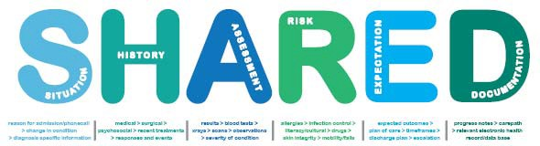

# A Framework to support Clinical Communication

### Mater Health Services Brisbane



**Acknowledgements**

* The support and funding provided by the Australian Commission for Safety and Quality in Health Care (ACSQHC) for the clinical handover project.
* All nursing, midwifery and medical staff who have participated in the project.
* The Mater Health Services Clinical Handover Steering Committee (Mr Michael Scott, Ms Susie Wilson, Ms Mish Hill, Ms Cheryl Clayton, Dr Julie Hudson, Dr Don Cave, Dr Paul Devenish-Meares, Dr Paul Bretz, Ms Maree Reynolds, Dr Claire Morgan, Ms Vicki Flenady, Ms Julie Macphail, Ms Judy Hunter).
* The Clinical Handover Project Team (Ms Sara Hatten-Masterson and Ms Marnie Griffiths).

The primary contact person for this project is: Ms Sara Hatten-Masterson

Project Manager

Mater Health Services Brisbane Limited Raymond Terrace, South Brisbane

Qld 4101

Tel: 61 (0) 7 3163 8111

Email: [sara.hatten-ma](mailto:sara.hatten-masterson@mater.org.au)[sterson@mater.org.au](mailto:sterson@mater.org.au)

***“The greatest problem in communication is the illusion that it has been accomplished.”*** *George Bernard Shaw*

#### Introduction

Patient safety is now recognised as a priority for any health care system. The effective transfer of information between healthcare practitioners (handover) is a fundamental element of patient care and is an “important consideration in maintaining patient safety, work flow and quality care”.1 (p1), 2, 3 (p6) The Australian Commission on Quality and Safety in Health Care (ACSQHC) has identified improving clinical handover as an important factor in ensuring that safe, continuous care is provided to patients within the Australian health care system.

***Clinical Handover*** *relates to and is defined as “the transfer of professional responsibility and accountability for some or all aspects of care for a patient, or group of patients, to another person or professional group on a temporary or permanent basis”.1 (p8), 11*

Clinical handover offers the opportunity for clinicians to provide a clear picture of a patient’s current condition or circumstances.1, 8, 9, 11, 19 There is a general consensus in the literature that the purpose and primary objective of any clinical handover is the exchange of relevant, accurate patient-specific information and knowledge along with authority and responsibility for patient care.1, 7, 14-16 The accuracy of this information and the style of handover used are identified as vital to the success of the handover process.14,15

*Problems with communication are identified as one of the top five contributing factors to sentinel events in Australia and worldwide.4*

*In Queensland communication failure has been identified as a contributing factor in 20% of all reported public hospital sentinel events with staff to staff communication failure a sub-category in 13.7% of all sentinel events during 2005-2006. 4*

Poor communication and handovers between clinicians can lead to patients receiving the wrong treatment; delays in diagnosis and life threatening adverse events, as well as an increase in patient complaints, health care expenditure and length of hospital stay. 1, 4, 5, 7, 8-10, 13, 17, 19-23

*The risk for communication breakdown is increased where multiple care providers interact with a single patient.1, 18*

Staff to staff interactions across disciplines, units or hospitals; staff to patient communication; and staff to family/carer/advocate exchanges have all been identified as contributors to clinical incidents and sentinel events. “Hierarchy, gender, ethnic background and differences in communication styles between nurses and doctors”,2 (p508) medical or technical language problems; patient consent issues; and cultural diversity issues have also been identified as potential contributors to communication breakdown, misunderstandings and error.

Historically no ‘best practice’ for improving hand-over communication within the health care setting existed. The SHARED Framework has therefore been developed to support clinical handover within Mater Health Services.

*The SHARED Framework for Clinical Handover outlines and explains the essential components of clinical handover. These components are essential for the provision of safe and effective healthcare. The SHARED Framework assists clinicians to participate in comprehensive, appropriate and safe clinical communication irrespective of clinical setting.*

Successful communication strategies, such as the SHARED Framework, and handover techniques are those that include a structured approach and the use of tools that are “sufficiently robust to cover the important data elements”.8 (p27), 11, 25 Additionally, the inclusion of a written component to what has traditionally been a verbal process is shown to be beneficial for any clinical

handover process.

Pothier, Monteiro, Mooktiar & Shaw (2005) demonstrate this in their pilot study which measured the amount of data lost during five consecutive handover cycles between nurses encompassing three different styles of handover. They showed that minimal data over five consecutive cycles of handover was lost when verbal and printed forms of handover were utilised simultaneously. All data was lost after three consecutive handover cycles when a verbal handover was used alone and 69% of data was lost after five cycles when a note-taking style of handover was used.15

*A number of attributes for effective clinical handover are identified:*

* ***Face to face communication*** *is the best means for ensuring*

*responsibility for patient care is handed over appropriately.. Face to face*

*communication assists handover to be an interactive, two way process*

*where opportunity for questioning and verification is enabled between the giver and receiver of the information.7, 8, 11, 13*

* *The allocation of* ***sufficient time*** *for the handover and communication of up-to-date information is essential.7, 8, 13, 31*
* *The use of* ***common language and a standardised approach*** *are crucial, particularly for communicating critical information..7, 8, 30, 31 The*

*discipline of using common language and a standardised approach*

*“under routine circumstances” assists “health professionals to normalise*

*and organise their communication in a way that ensures greater*

*understanding”, particularly when time pressure and urgency demand accurate and reliable information exchange to ensure patient safety”.20, 31*

*(p462)*

* ***Forms and checklists*** *are extremely useful as they can be physically passed from one caregiver to another and filed in a patient’s chart.13, 31*
* *It is important to recognise the need for and* ***place of the narrative***

*understanding and representation of a clinical situation in conjunction*

*with a formalised approach and minimum data set for clinical*

*communication (The SHARED Framework).*



##### SITUATION reason for admission/phone call > change in condition > diagnosis specific information

**Who are you? Why are you communicating? Who are you communicating about?**

**HISTORY medical > surgical > psychosocial > recent treatments > responses and events**

**Important information relevant to the patient’s current presentation.**

**ASSESSMENT results > blood tests > x-rays > scans > observations > condition severity**

**Relevant to the patient’s current presentation; Observations, tests, assessments & results.**

**RISK allergies > infection control > literacy/cultural > drugs > skin integrity > mobility/falls**

**Relevant & important information to keep the patient safe.**

**EXPECTATION expected outcomes > plan of care > timeframes > d/c plan > escalation**

**What needs to be done? In what time frame & by whom? Anticipated responses & outcomes.**

**DOCUMENTATION progress notes > care path**

##### Important & relevant information written in the appropriate clinical record.

**Application**

* 1. It is appropriate for SHARED to be integrated into all clinical settings and situations to support clinical handover across and between all disciplines.
  2. The identified support tools (or locally developed tools where appropriate) will further facilitate this implementation/integration.
  3. The framework aims to reduce gaps in patient care and safety that occur as a result of inadequate communication.

**The Medical Record and Documentation**

The role of the medical record is to provide a concise and appropriate record of a patients care. What is appropriate is defined through a number of policies and standards and in some cases legislation.

Clinical communication occurs habitually throughout the patients’ journey. When this communication surrounds a change in a patients’ condition or critical situation documentation of this exchange is imperative to support the provision of safe healthcare and to record the event.

The medical record (and bedside chart) should be reviewed in conjunction with the receipt of a verbal handover to allow the identification of additional safety concerns.



# Support Tools

### Examples

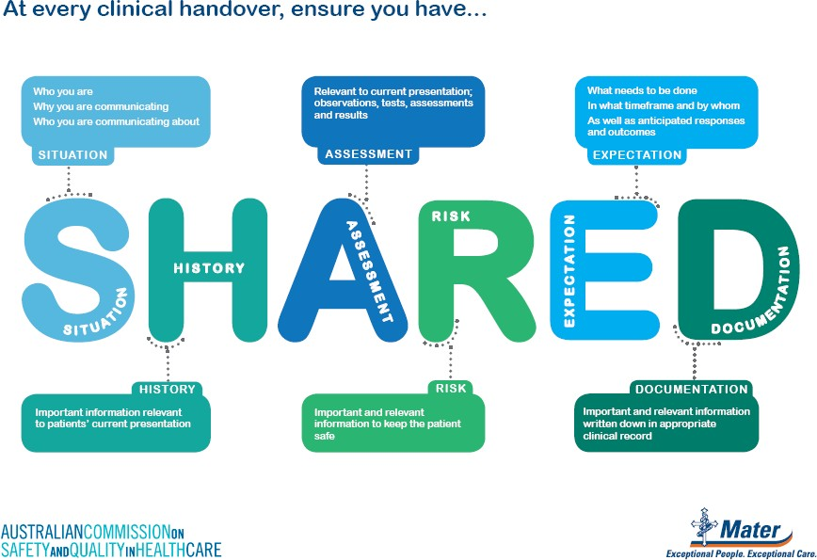**Poster -**

The poster provides a prompt for you within your clinical work area. It is anticipated that you will use  in every instance of clinical handover.

The poster provides a reminder for you to collect up to date information, observations and assessments relevant to your patients’ current condition prior to contacting the doctor in any handover situation.

It is also expected that the poster acts as a trigger for you to document your clinical communication following every instance of phone or verbal handover.

**Swing Tag -**



Who are you?

Why are you communicating?

Who are you communicating about?

Important information relevant to patient’s current presentation.

Relevant to current presentation; Observations, tests, assessments & their results.

Relevant & important information to keep the patient safe.

What needs to be done? In what timeframe & by whom? Anticipated responses & outcomes

Important & relevant information written in the appropriate clinical record

**For further information or assistance:**

**Clinical Safety & Quality Unit ph. 3163 2858**

SITUATION reason for admission/phonecall

* change in condition > diagnosis specific information

HISTORY medical > Surgical > psychosocial

* recent treatments > responses and events

ASSESSMENT results > blood tests > xrays

* scans > observations > condition severity RISK allergies > infection control > literacy/cultural > drugs > skin integrity > mobility/falls

EXPECTATION expected outcomes > plan of care > timeframes > d/c plan > escalation

DOCUMENTATION progress notes > care path > Electronic Health record/Database

The swing tag provides you with access to the  framework and its components at all times throughout your working day. It provides an easy to carry, easy to read double sided prompt.

One side of the swing tag offers examples of the types of information that you should seek for each component of . The opposing side offers the same information as the  poster displayed within your clinical area.

## Phone Handover Guide –

The  phone handover guide can be found at the front of every end of bed chart and close to staff telephones within each ward area.

The  phone handover guide is for you to use as a prompt to the information you should gather and provide as part of your communication of a critical situation or change in patient condition handover to the DOCTOR.

The  phone handover guide may also be a useful preparatory prompt for face to face situations as well.

Clinical Communication Framework 13



**Framework for communicating a critical situation, or change in patient condition**

**Before calling the Doctor:**

1. Assess the patient
2. Review the chart and identify who you should call
3. Read the most recent progress notes, care path & assessments from the previous shift
4. Have available when speaking to the Doctor the end of bed chart

|  |  |  |
| --- | --- | --- |
|  | **S** I T U A T I  O N | * Identify the situation you are calling about * Identify yourself – name, designation & where you are * Identify your patient |
|  | **H** I S T O R Y | * Any relevant history – obstetric/antenatal, medical, surgical, psychosocial * Anything from the current admission including any treatments, responses and events |
|  | **A** S S E S S M E N  T | * Your assessment * Recent vital signs, trends and/or anomalies * Recent tests and results – bloods, urine etc. * Response to any treatment or intervention so far |
|  | **R** I S K | * Be aware of any risk the patient has * Allergies * Infection control * Medications |
|  | **E** X P E C T A T I  O N | * What do you and your patient expect to happen * What does the VMO expect to happen * By whom and by when   **Know what to do or who to speak to if any of these expectations aren’t met! SPEAKING UP FOR SAFETY** |
|  | **D** O C U M E N T A T I O  N | Complete an “I have SHARED” sticker and place in the progress notes. Document the specifics of the communication including information you provided and any outcomes including drugs, plan of care, review or follow-up etc.  **All telephone orders must be written and read back to the Doctor, drug orders must be heard and signed by two RN’s or RM’s.** |

## I Shared Sticker –



The ”I ….” sticker should be completed and placed in the patients’ chart below your documentation of any clinical handover communication that occurs between yourself and a DOCTOR.

It is important for you to remember to include both a summary of the information you communicated to the DOCTOR as well as the changes that the DOCTOR requests are made to the patient’s plan of care as a consequence of your clinical handover communication.

## Carepath Inserts -

Each time you collect a patient from recovery you should complete a  Recovery Room Handover carepath insert.

You should use the  Recovery Room Handover insert as a tool to support the transfer of your patient from recovery.

The  Recovery Room Handover insert is designed to capture and act as a prompt for the information handed over to the transfer midwife/nurse/primary carer from the recovery room midwife/nurse.

The  Recovery Room Handover insert is designed to assist you to provide safe, effective post operative care.

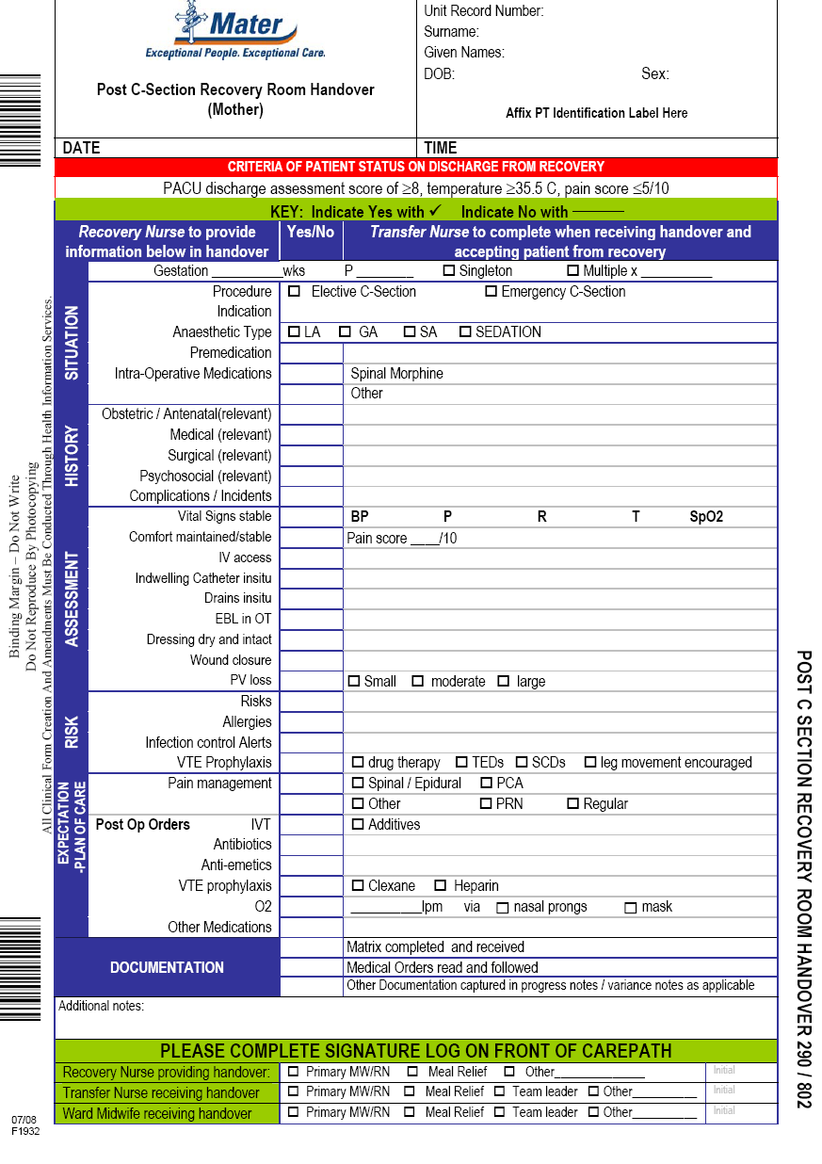

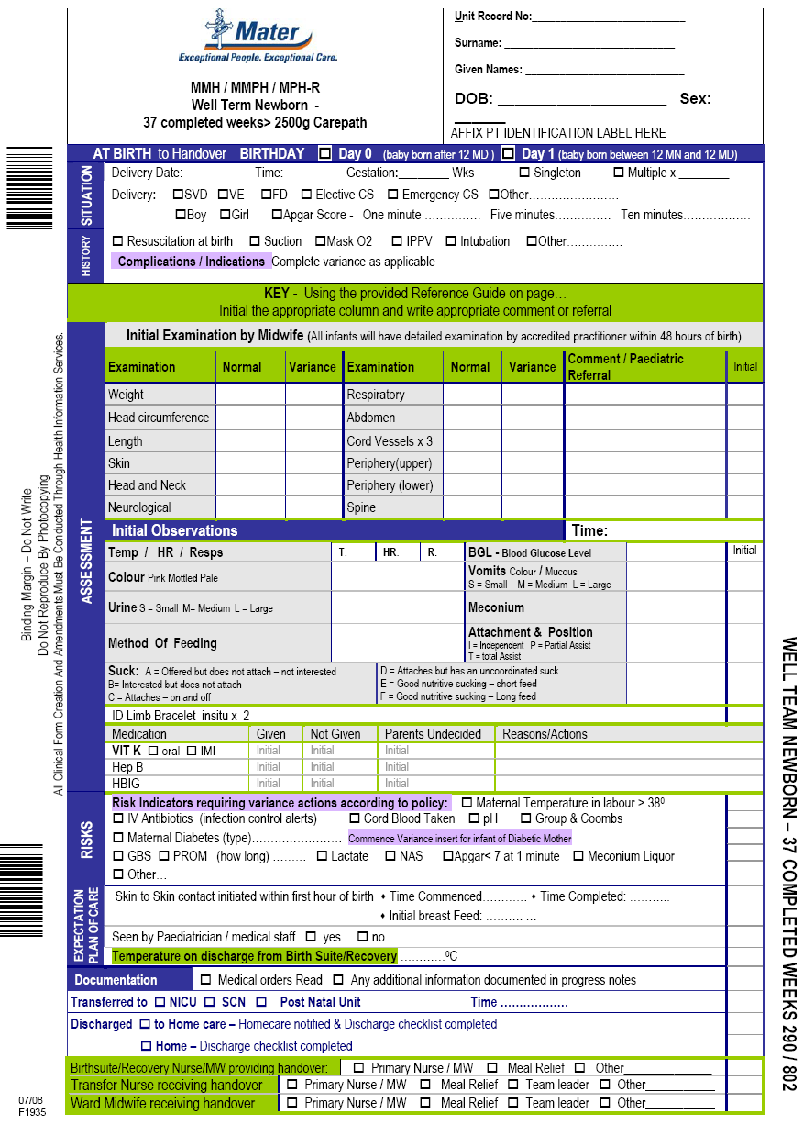

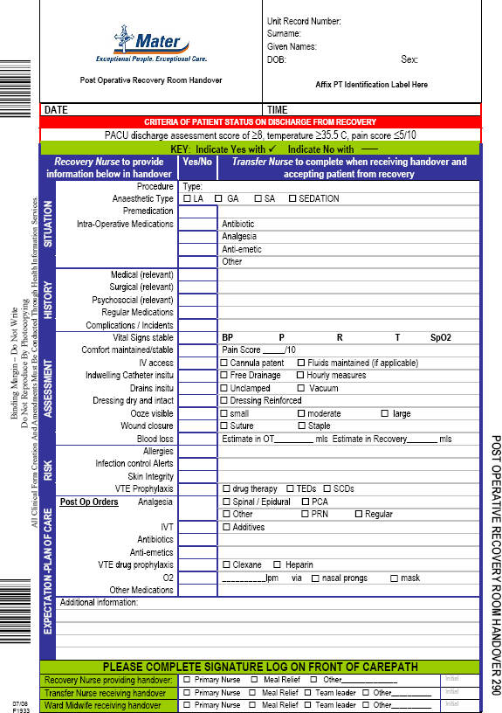

#### References

1. Australian Council for Safety and Quality in Health Care. Clinical handover and patient safety: literature review report. Canberra, ACT: Australian Government, Department of Health and Ageing; 2005 March.
2. Ottewill M, Urben J, Elson D. Safe hand-over: safe care. Midwives. 2007;10(11):508-9.
3. World Health Organization. World alliance for patient safety: forward programme. 2005; France. World Health Organization; 2005. p. 1-27.
4. Queensland Health. Patient safety: from learning to action. First Queensland Health report on clinical incidents and sentinel events. In: Queensland Health, editor. Brisbane; 2007. p. 3-49.
5. Arnaudova A, Jakubowski E. Eighth futures forum on governance of patient safety. In: Broyart A, Hafner V, Langenegger M, Norblad A, Riesberg A, editors.; 2005 28-29 April; Erpfendorf, Austria. WHO - Europe; 2005. p. 1- 38.
6. Australian Institute of Health and Welfare & Australian Commission on Safety and Quality on Healthcare. Sentinel events reported in Australian public hospitals, 2004-05. Canberra: AIHW; 2007. Report No.: HSE.51.
7. WHO Collaborating Centre for Patient Safety Solutions. Communication during patient hand-overs. Geneva, Switzerland: World Health Organisation; 2007. p. 1-4.
8. Department of Defense Patient Safety Program. Healthcare communications toolkit to improve transitions in care. In: Department of Defense, editor. Falls Church, VA: Department of Defense,. 2005. p. 1-79.
9. Haig K, Sutton S, Whittington J. National patient safety goals. SBAR: A shared mental model for improving communication between clinicians. Jt Comm J Qual Saf. March 2006:167-75.
10. Joint Commission Perspectives on Patient Safety. The SBAR technique: improves communication, enhances patient safety. Joint Commission on Accreditation of Healthcare Organisations; 2005. p. 1-2,8.
11. Australian Medical Association. Safe handover: safe patients. Guidance on clinical handover for clinicians and managers. Kingston: Australian Medical Association; 2006.
12. Joint Commission International Center for Patient Safety. Engaging physicians in patient safety: a handbook for leaders. Joint Commission International Center for Patient Safety,. 2006 [updated 2006; cited 2008 25th February ]; Available from: [http://www.jcipatientsafety.org/15414/.](http://www.jcipatientsafety.org/15414/)
13. Association of Perioperative Registered Nurses. Research in the healthcare industry. AORN; 2008 [updated 2008; cited 2008 February 20]; Available from: <http://www.aorn.org/docs_assets/55B250E0-9779-5C0D->

1DDC8177C9B4C8EB/44F5C9F4-17A4-49A8-

86EC6BE101B523B0/HandOFF_Research.pdf.

1. Association of Perioperative Registered Nurses. "Hand-off" toolkit to improve transitions in care within the perioperative environment. AORN; 2008 [updated 2008; cited 2008 February 20]; Available from: <http://www.aorn.org/docs_assets/55B250E0-9779-5C0D-> 1DDC8177C9B4C8EB/44F40E88-17A4-49A8- 86B64CAA80F91765/HandOff_Executive.pdf.
2. Pothier D, Monteiro P, Mooktiar M, Shaw A. Pilot study to show the loss of important data in nursing handover. Br J Nurs. 2005 Nov10- 23;14(20):1090-3.
3. Sabir N, Yentis S, Holdcroft A. A national survey of obstetric anaesthetic handovers. Anaesthesia. 2006;61:376-80.
4. Manning M. Improving clinical communication through structured conversation. Nurs Econ. 2007;24(5):268-71.
5. Karvonen K. AORN tool kits provide practical resources for patient safety. Journal [serial on the Internet]. 2008 [cited 2008 19th February]; 86 (Supp 1): Available from: [http://www.aornjournal.org/issues/contents.](http://www.aornjournal.org/issues/contents)
6. Behara R, Wears R, Perry S, Eisenberg E, Murphy L, Vanderhoef M, et al. A conceptual framework for studying the safety transitions in emergency care. Adv Patient Safety.2:309-21.
7. Brown JP. Closing the communication loop: using readback/hearback to support patient safety. Journal [serial on the Internet]. 2004 [cited 2008 February 15]; 30(8): Available from: <http://www.ncbi.nlm.nih.gov/entrez/query.fcgi?cmd=Retrieve&db=PubMed&do> pt=Citation&list_uids=15357137
8. Department of Human Services. Sentinel event program: annual report 2006-2007. In: Department of Human Services, editor. Melbourne: Rural and Regional Health and Aged Care Service Division,. 2007. p. 1-42.
9. NSW Department of Health. Patient safety and quality program: third report on incident management in the NSW public health system 2005-2006. In: NSW Department of Health, editor. Sydney: NSW Department of Health,. 2006. p. 4-39.
10. Safety and Quality, Clinical Systems, Public Health and Clinical Coordination,. Improving the system: South Australian patient safety report 2004-2005. In: Department of Health, editor. Adelaide: Government of South Australia,. 2007. p. 1-35.
11. Patient Safety Centre. Clinical Handover. Brisbane: Queensland Government; 2007 [updated 2007 16th February 2007; cited 2008 5th February]; Available from: [http://www.health.qld.gov.au/patientsafety/webpages/clinhand.asp.](http://www.health.qld.gov.au/patientsafety/webpages/clinhand.asp)
12. The Victorian Quality Council. Clinical handover: a challenge for patient safety. In: Services Department of Human Services, editor. Victoria: The Victorian Quality Council,. 2006. p. 1.
13. Hand-off Communications. Journal [serial on the Internet]. 2007 [cited 2008 February 14]; 86(Suppl 1): Available from: <http://download.journals.elsevierhealth.com/pdfs/journals/0001-> 2092/PIIS0001209207007089.pdf.
14. Scalise D. Clinical communication and patient safety. Hospitals & Health Networks. 2006.
15. Association of Perioperative Registered Nurses. Sample patient hand- off tools. AORN; 2008 [updated 2008; cited 2008 February 20]; Available from: <http://www.aorn.org/docs_assets/55B250E0-9779-5C0D-> 1DDC8177C9B4C8EB/44F6B4B2-17A4-49A8- 86F218EDBF23516A/HandOff_SampleTools.pdf.
16. Joint Commission International Center for Patient Safety. Sharing information at transfers: proven technique to aid handoff communications. Journal [serial on the Internet]. 2005 [cited 2008 February 20]; 5(9): Available from: [http://www.jcipatientsafety.org/23267/.](http://www.jcipatientsafety.org/23267/)
17. Association of Perioperative Registered Nurses. Recommendations. AORN; 2008 [updated 2008; cited 2008 February 20]; Available from: <http://www.aorn.org/docs_assets/55B250E0-9779-5C0D-> 1DDC8177C9B4C8EB/44F543CC-17A4-49A8- 865FDDF56132C37B/HandOff_Recommendations.pdf.
18. Joint Commission International Center for Patient Safety. Improving hand-off communications: meeting National Patient Safety Goal 2E. Journal [serial on the Internet]. 2006 [cited 2008 February 27]; 2(9): Available from: [http://www.jcipatientsafety.org/15427/.](http://www.jcipatientsafety.org/15427/)