# Australian COmmission on Safety and Quality in Health Care logo with Radar imageOn the Radar

Issue 475

3 August 2020

*On the Radar* is a summary of some of the recent publications in the areas of safety and quality in health care. Inclusion in this document is not an endorsement or recommendation of any publication or provider. Access to particular documents may depend on whether they are Open Access or not, and/or your individual or institutional access to subscription sites/services. Material that may require subscription is included as it is considered relevant.

*On the Radar* is available online, via email or as a PDF or Word document from <https://www.safetyandquality.gov.au/publications-and-resources/newsletters/radar>

If you would like to receive *On the Radar* via email, you can subscribe on our website <https://www.safetyandquality.gov.au/publications-and-resources/newsletters>   
or by emailing us at H[Umail@safetyandquality.gov.auU](mailto:mail@safetyandquality.gov.au).   
You can also send feedback and comments to H[Umail@safetyandquality.gov.auU](mailto:mail@safetyandquality.gov.au).

For information about the Commission and its programs and publications, please visit <https://www.safetyandquality.gov.au>

You can also follow us on Twitter @ACSQHC.

**On the Radar**

Editor: Dr Niall Johnson [niall.johnson@safetyandquality.gov.au](mailto:niall.johnson@safetyandquality.gov.au)

Contributors: Niall Johnson

**COVID-19 resources**

https://www.safetyandquality.gov.au/covid-19

The Australian Commission on Safety and Quality in Health Care has developed a number of resources to assist healthcare organisations, facilities and clinicians. These and other material on COVID-19 are available at <https://www.safetyandquality.gov.au/covid-19>

The latest additions include:

* **Medicines Management COVID-19** <https://www.safetyandquality.gov.au/our-work/medication-safety/medicines-management-covid-19>, including position statements on medicine-related issues
  + ***Managing fever associated with COVID-19***
  + ***Managing a sore throat associated with COVID-19***
  + ***ACE inhibitors and ARBs in COVID-19***
  + ***Clozapine in COVID-19***
  + ***Management of patients on oral anticoagulants during COVID-19***
  + ***Ascorbic Acid: Intravenous high dose in COVID-19***
  + ***Treatment in acute care, including oxygen therapy and medicines to support intubation***
  + ***Nebulisation and COVID-19***
  + ***Managing intranasal administration of medicines during COVID-19***
  + ***Ongoing medicines management in high-risk patients***
  + ***Medicines shortages***
* ***Potential medicines to treat COVID-19***   
  <https://www.safetyandquality.gov.au/publications-and-resources/resource-library/potential-medicines-treat-covid-19>
* ***Break the chain of infection: Stopping COVID-19*** poster<https://www.safetyandquality.gov.au/publications-and-resources/resource-library/break-chain-poster-a3>  
  **[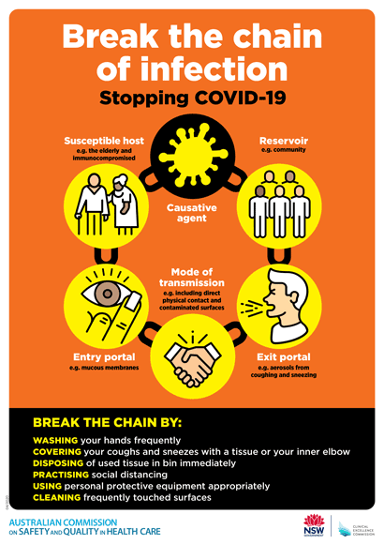](https://www.safetyandquality.gov.au/publications-and-resources/resource-library/break-chain-poster-a3https:/www.safetyandquality.gov.au/publications-and-resources/resource-library/break-chain-poster-a3)**
* ***COVID-19: Elective surgery and infection prevention and control precautions*** <https://www.safetyandquality.gov.au/publications-and-resources/resource-library/covid-19-elective-surgery-and-infection-prevention-and-control-precautions>
* ***FAQs for clinicians on elective surgery*** <https://www.safetyandquality.gov.au/node/5724>
* ***FAQs for consumers on elective surgery*** <https://www.safetyandquality.gov.au/node/5725>
* ***Infection prevention and control Covid-19 PPE*** poster <https://www.safetyandquality.gov.au/publications-and-resources/resource-library/infection-prevention-and-control-covid-19-personal-protective-equipment>
* ***Special precautions for Covid-19 designated zones*** poster <https://www.safetyandquality.gov.au/publications-and-resources/resource-library/special-precautions-covid-19-designated-zones>
* **FAQs on community use of face masks** <https://www.safetyandquality.gov.au/faqs-community-use-face-masks>
* **COVID-19 and face masks – Information for consumers** <https://www.safetyandquality.gov.au/publications-and-resources/resource-library/covid-19-and-face-masks-information-consumers>

[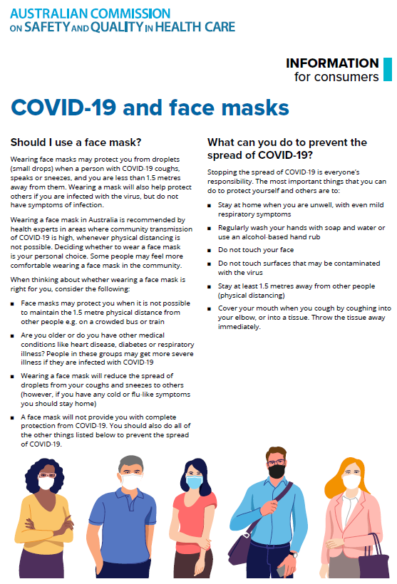](https://www.safetyandquality.gov.au/sites/default/files/2020-07/covid-19_and_face_masks_-_information_for_consumers.pdf)

**Books**

*The Cut*

Kennedy M

Melbourne: Arex Press; 2020.

*The Point of Care*

Balding C

Ashburton: Cathy Balding Qualityworks; 2018.

|  |  |
| --- | --- |
| URL | The Cut <https://marcuskennedy.net/>  The Point of Care <https://www.cathybalding.com/the-point-of-care> |
| Notes | *The Cut* is an ‘educational novel’ written by a retired Emergency Physician. The story focuses on an emergency physician that explores issues of health care in a ‘medicopolitical drama’. Among the issues raised are health governance, quality, safety philosophies of health, etc. The proceeds of the e-book sales are to be donated to programs supporting health promotion and well-being for emergency department staff.  This ‘educational novel’ brought to mind Cathy Balding’s book, *The Point of Care*. That was in a similar vein, using a fictional story as a vehicle for communicating about safety and quality and health care delivery. Here the story revolves around the CEO of a rural health service who has just taken over the helm of an organisation that ranks last in the state for both consumer and staff satisfaction. |

**Journal articles**

*The safety of health care for ethnic minority patients: a systematic review*

Chauhan A, Walton M, Manias E, Walpola RL, Seale H, Latanik M, et al

International Journal for Equity in Health. 2020;19(1):118.

|  |  |
| --- | --- |
| DOI | <http://doi.org/10.1186/s12939-020-01223-2> |
| Notes | Safety and quality issues affect everyone, but some patients may be more vulnerable than others for a number of factors. This review examined safety issues in terms of ethnic minorities, from how ethnic minority populations are conceptualised in the international literature through the evidence of patient safety events arising among ethnic minority healthcare consumers and to the individual, service and system factors that contribute to unsafe care. Based on 45 studies, the authors report:   1. ‘those from ethnic minority backgrounds were conceptualised variably; 2. people from ethnic minority backgrounds had **higher rates** of **hospital acquired infections**, **complications**, **adverse drug events** and **dosing errors** when compared to the wider population; and 3. factors including **language proficiency**, **beliefs** about illness and treatment, formal and informal **interpreter use**, **consumer engagement**, and **interactions** with health professionals contributed to increased risk of safety events amongst these populations.’ |

*Sideline guilt*

Reuben DB

JAMA Internal Medicine. 2020.

|  |  |
| --- | --- |
| DOI | <https://doi.org/10.1001/jamainternmed.2020.2746> |
| Notes | Perspective piece in *JAMA Internal Medicine* reflecting on how some clinicians may be experiencing ‘sideline guilt’ during the COVID-19 pandemic as they are not personally delivering frontline care to pandemic patients. Somewhat akin to survivor guilt, sideline guilt ‘is a feeling of dysphoria because I am not doing all I possibly could do on the front line of care delivery’. The author offers some advice, including:   1. Acknowledging it as a normal reaction 2. Supporting colleagues who are on the front line 3. Recognising that what you do is contributing 4. Supporting frontline colleagues by being an information conduit and helping the inpatient team 5. Staying away. |

*Prevalence and Nature of Medication Errors and Medication-Related Harm Following Discharge from Hospital to Community Settings: A Systematic Review*

Alqenae FA, Steinke D, Keers RN

Drug Safety. 2020;43(6):517-537.

|  |  |
| --- | --- |
| DOI | <https://doi.org/10.1007/s40264-020-00918-3> |
| Notes | Medication errors are acknowledged to be among the most common of errors. This systematic review, based on 54 studies, found that **more than half of patients experienced a medication error or unintentional medication discrepancy after hospital discharge**. The review found that the ‘Drug classes most commonly implicated with adverse drug events were **antibiotics**, **antidiabetics**, **analgesics** and **cardiovascular drugs**.’ |

*Medication Order Errors at Hospital Admission Among Children With Medical Complexity*

Blaine K, Wright J, Pinkham A, O’Neill M, Wilkerson S, Rogers J, et al

Journal of Patient Safety. 2020 [epub].

|  |  |
| --- | --- |
| DOI | <https://doi.org/10.1097/PTS.0000000000000719> |
| Notes | This prospective cohort study was undertaken at 2 children’s hospitals and examined 1233 hospitalisations for children with medical complexity. The study sought to characterize the nature and prevalence of medication order errors (MOE) occurring at admission. In this cohort of 1233, 75 (**6.1%**) had ≥1 **medication order error occurring at admission** (with a total of 112 errors). The most common MOEs were **incorrect dose** (41.1%) and **omitted medication** (34.8%). **Baclofen** and **clobazam** were the medications most commonly associated with MOEs. |

*Predictors of Serious Opioid-Related Adverse Drug Events in Hospitalized Patients*

Minhaj FS, Rappaport SH, Foster J, Gashlin LZ

Journal of Patient Safety. 2020 [epub].

|  |  |
| --- | --- |
| DOI | <https://doi.org/10.1097/PTS.0000000000000735> |
| Notes | This study looked at adverse events involving opioids in hospitalized patients. This retrospective case-control study involved 275 cases and 592 control patients as it sought to o identify risk factors that predispose inpatients to develop opioid-related adverse drug events requiring the use of naloxone. The authors report that ‘Variables that were associated with greater odds of naloxone administration included **age** of 65 years or older, **female**, **length of stay**, **pulmonary diagnoses**, **use of gabapentinoids**, and **patient-controlled analgesia use**.’ |

For information on the Commission’s work on medication safety, see <https://www.safetyandquality.gov.au/our-work/medication-safety>

*What Do Patients Want? A Qualitative Analysis of Patient, Provider, and Administrative Perceptions and Expectations About Patients’ Hospital Stays*

Nepal S, Keniston A, Indovina KA, Frank MG, Stella SA, Quinzanos-Alonso I, et al

Journal of Patient Experience. 2020:2374373520942403.

*What do consumers with chronic conditions expect from their interactions with general practitioners? A qualitative study of Australian consumer and provider perspectives*

Song HJ, Dennis S, Levesque J-F, Harris MF

Health Expectations. 2020 Jun;23(3):707-716.

|  |  |
| --- | --- |
| DOI | Nepal et al <https://doi.org/10.1177/2374373520942403>  Song et al <https://doi.org/10.1111/hex.13050> |
| Notes | A pair of articles using detailed interview responses to examine what patients/consumers want from their health care and the individuals and organisations delivering that care. Perhaps further examples of telling us what we (think) we know  Nepal et al report on a study that used semi-structured interviews with 45 hospitalised English and Spanish-speaking patients at a large, urban hospital in the USA. The authors report 4 main themes as being important to these patients:   1. the **hospital environment** including cleanliness and how hospital policies and procedures impact patients’ perceived autonomy 2. **whole-person care** 3. **communication** with and between care teams and utilizing words that patients can understand, and 4. **responsiveness and attentiveness** to needs.   Song et al interviewed 18 Australians living with chronic conditions about their interactions with general practitioners (GPs), along with 10 GPs and 3 GP registrars in order to ‘identify key consumer expectations in clinical interactions in Australian general practice based on consumer and GP perspectives.’ In this work the themes identified included:   1. the importance of **longevity and continuity** of the relationship 2. having good **rapport** 3. GP's **respect for consumer** opinions and expertise 4. having **effective communication**; and 5. addressing **mental health**. |

For information on the Commission’s work on person-centred care, see <https://www.safetyandquality.gov.au/our-work/partnering-consumers/person-centred-care>

*Maximum emergency department overcrowding is correlated with occurrence of unexpected cardiac arrest*

Kim J-s, Bae H-J, Sohn CH, Cho S-E, Hwang J, Kim WY, et al

Critical Care. 2020;24(1):305.

|  |  |
| --- | --- |
| DOI | <https://doi.org/10.1186/s13054-020-03019-w> |
| Notes | Some studies appear to draw conclusions that appear self-evident; but it can be useful to have the empirical evidence. In this case, over-crowded emergency departments (EDs) can have unwelcome outcomes. However, the authors of this study report that while maximum ED occupancy rates in this single site were correlated with in-hospital cardiac arrest, occupancy rates were not correlated with ED mortality. |

*The State of Health Care Quality Measurement in the Era of COVID-19: The Importance of Doing Better*

Austin JM, Kachalia A

Journal of the American Medical Association. 2020;324(4):333-334.

|  |  |
| --- | --- |
| DOI | <https://doi.org/10.1001/jama.2020.11461> |
| Notes | A number of otherwise routine activities, such as reporting quality measures and accreditation, have been in abeyance during the COVID-19 pandemics in many locations or jurisdictions. This Viewpoint piece in the *Journal of the American Medical Association*, speculates on health care quality measurement in the USA and how it could be improved in light of the pandemic. Lamenting the labour required, the lack of timeliness and standardisation in US quality reporting the authors call for these to be addressed so that timely, accurate and comparable data can be collected ‘during both times of stability and times of crisis. During a crisis, health care is still being delivered, and the need to understand the quality and safety of that care becomes more important as the care processes continue to rapidly change.’ |

*BMJ Quality & Safety* online first articles

|  |  |
| --- | --- |
| URL | <https://qualitysafety.bmj.com/content/early/recent> |
| Notes | *BMJ Quality &Safety* has published a number of ‘online first’ articles, including:   * Editorial: Leveraging big data to guide better **nurse staffing strategies** (Joanne Spetz) * Editorial: **Simulation**: a key tool for **refining guidelines** and demonstrating they produce the desired behavioural change (Mark Fan, Patricia Trbovich) |

*International Journal for Quality in Health Care* online first articles

|  |  |
| --- | --- |
| URL | <https://academic.oup.com/intqhc/advance-articles> |
| Notes | *International Journal for Quality in Health Care* has published a number of ‘online first’ articles, including:   * Improving the quality of **mortality review equity reporting**: Development of an Indigenous **Māori responsiveness rubric** (Denise Wilson, Sue Crengle, Fiona Cram) * Expanding frontiers of risk management: **care safety in nursing home during COVID-19 pandemic** (Matteo Scopetti, Alessandro Santurro, Riccardo Tartaglia, Paola Frati, Vittorio Fineschi) |

**Online resources**

*Future Leaders Communiqué*

<https://www.thecommuniques.com/post/future-leaders-communiqu%C3%A9-volume-5-issue-3-july-2020>

Volume 5 Issue 3 July 2020

This issue of the *Future Leaders Communiqué* focuses on how health care professionals can provide better care for individuals of culturally and linguistically diverse (CALD) backgrounds. The case presented h is a sobering example of patient harm due to communication failures. Given Australia’s diverse population our health care systems and professionals need to able to deliver culturally safe practice.

For information on the Commission’s work on communicating for safety, see <https://www.safetyandquality.gov.au/our-work/communicating-safety>

For resources, see the Communicating for Safety resource portal at <https://c4sportal.safetyandquality.gov.au/>

*National COVID-19 Clinical Evidence Taskforce*

<https://covid19evidence.net.au/>

The National COVID-19 Clinical Evidence Taskforce is a collaboration of peak health professional bodies across Australia whose members are providing clinical care to people with COVID-19. The taskforce is undertaking continuous evidence surveillance to identify and rapidly synthesise emerging research in order to provide national, **evidence-based guidelines and clinical flowcharts for the clinical care of people with COVID-19**. The guidelines address questions that are specific to managing COVID-19 and cover the full disease course across mild, moderate, severe and critical illness. These are ‘living’ guidelines, updated with new research in near real-time in order to give reliable, up-to-the minute advice to clinicians providing frontline care in this unprecedented global health crisis.

*[UK] NICE Guidelines and Quality Standards*

<https://www.nice.org.uk/guidance>

The UK’s National Institute for Health and Care Excellence (NICE) has published new (or updated) guidelines and quality standards. The latest reviews or updates are:

* NICE Guideline NG167 ***COVID-19 rapid guideline****:* ***rheumatological autoimmune, inflammatory and metabolic bone disorders*** <https://www.nice.org.uk/guidance/ng167>
* NICE Guideline NG179 ***COVID-19 rapid guideline****: arranging* ***planned care*** *in hospitals and diagnostic services* <https://www.nice.org.uk/guidance/ng179>
* Quality Standard QS195 ***Renal and ureteric stones*** <https://www.nice.org.uk/guidance/qs195>

*[USA] Effective Health Care Program reports*

<https://effectivehealthcare.ahrq.gov/>

The US Agency for Healthcare Research and Quality (AHRQ) has an Effective Health Care (EHC) Program. The EHC has released the following final reports and updates:

* ***Masks for Prevention of COVID-19*** *in Community and Healthcare Settings: A Living Rapid Review* <https://effectivehealthcare.ahrq.gov/products/masks-covid/rapid-review>

*[UK] NIHR Evidence alert*

<https://evidence.nihr.ac.uk/>

The UK’s National Institute for Health Research (NIHR) has posted new evidence alerts on its site. Evidence alerts are short, accessible summaries of health and care research which is funded or supported by NIHR. This is research which could influence practice and each Alert has a message for people commissioning, providing or receiving care. The latest alerts include:

* Combined drug and psychological therapies may be most effective for **depression**
* Loneliness in people with **dementia** is linked to social isolation and depression
* Most people caring for relatives with **dementia** experience loneliness
* Some antidepressants can help people **quit smoking**, but other medications may offer greater benefits
* New research supports the move to raise the **blood pressure target** for frail older people
* **Drug users** who lack access to clean water use dangerous alternatives to prepare injections
* **Asthma patients** with a history of opioid use have worse outcomes
* Most patients undergoing planned surgery do not need **compression stockings**.

**Disclaimer**

On the Radar is an information resource of the Australian Commission on Safety and Quality in Health Care. The Commission is not responsible for the content of, nor does it endorse, any articles or sites listed. The Commission accepts no liability for the information or advice provided by these external links. Links are provided on the basis that users make their own decisions about the accuracy, currency and reliability of the information contained therein. Any opinions expressed are not necessarily those of the Australian Commission on Safety and Quality in Health Care.