# Australian COmmission on Safety and Quality in Health Care logo with Radar imageOn the Radar

Issue 477

17 August 2020

*On the Radar* is a summary of some of the recent publications in the areas of safety and quality in health care. Inclusion in this document is not an endorsement or recommendation of any publication or provider. Access to particular documents may depend on whether they are Open Access or not, and/or your individual or institutional access to subscription sites/services. Material that may require subscription is included as it is considered relevant.

*On the Radar* is available online, via email or as a PDF or Word document from <https://www.safetyandquality.gov.au/publications-and-resources/newsletters/radar>

If you would like to receive *On the Radar* via email, you can subscribe on our website <https://www.safetyandquality.gov.au/publications-and-resources/newsletters>   
or by emailing us at H[Umail@safetyandquality.gov.auU](mailto:mail@safetyandquality.gov.au).   
You can also send feedback and comments to H[Umail@safetyandquality.gov.auU](mailto:mail@safetyandquality.gov.au).

For information about the Commission and its programs and publications, please visit <https://www.safetyandquality.gov.au>

You can also follow us on Twitter @ACSQHC.

**On the Radar**

Editor: Dr Niall Johnson [niall.johnson@safetyandquality.gov.au](mailto:niall.johnson@safetyandquality.gov.au)

Contributors: Niall Johnson, Jennifer Caldwell, Kathy Meleady

**COVID-19 resources**

https://www.safetyandquality.gov.au/covid-19

The Australian Commission on Safety and Quality in Health Care has developed a number of resources to assist healthcare organisations, facilities and clinicians. These and other material on COVID-19 are available at <https://www.safetyandquality.gov.au/covid-19>

The latest additions include:

* ***Infection prevention and control Covid-19 PPE*** poster <https://www.safetyandquality.gov.au/publications-and-resources/resource-library/infection-prevention-and-control-covid-19-personal-protective-equipment>
* ***Special precautions for Covid-19 designated zones*** poster <https://www.safetyandquality.gov.au/publications-and-resources/resource-library/special-precautions-covid-19-designated-zones>
* ***COVID-19 infection prevention and control risk management – Guidance*** <https://www.safetyandquality.gov.au/publications-and-resources/resource-library/covid-19-infection-prevention-and-control-risk-management-guidance> The Commission has prepared this guidance to support health service organisations to undertake COVID-19 risk assessment and develop a comprehensive Risk Management Plan. The guidance acknowledges the ongoing risks associated with COVID-19 in Australia. Health service organisations are required to prepare and implement an organisation-wide Risk Management Plan to manage and reduce the risks related to the transmission of COVID-19.
* ***Safe care for people with cognitive impairment during COVID-19***<https://www.safetyandquality.gov.au/our-work/cognitive-impairment/cognitive-impairment-and-covid-19>
* **Medicines Management COVID-19** <https://www.safetyandquality.gov.au/our-work/medication-safety/medicines-management-covid-19>, including position statements on medicine-related issues
  + ***Managing fever associated with COVID-19***
  + ***Managing a sore throat associated with COVID-19***
  + ***ACE inhibitors and ARBs in COVID-19***
  + ***Clozapine in COVID-19***
  + ***Management of patients on oral anticoagulants during COVID-19***
  + ***Ascorbic Acid: Intravenous high dose in COVID-19***
  + ***Treatment in acute care, including oxygen therapy and medicines to support intubation***
  + ***Nebulisation and COVID-19***
  + ***Managing intranasal administration of medicines during COVID-19***
  + ***Ongoing medicines management in high-risk patients***
  + ***Medicines shortages***
* ***Potential medicines to treat COVID-19***   
  <https://www.safetyandquality.gov.au/publications-and-resources/resource-library/potential-medicines-treat-covid-19>
* ***Break the chain of infection: Stopping COVID-19*** poster<https://www.safetyandquality.gov.au/publications-and-resources/resource-library/break-chain-poster-a3>  
  **[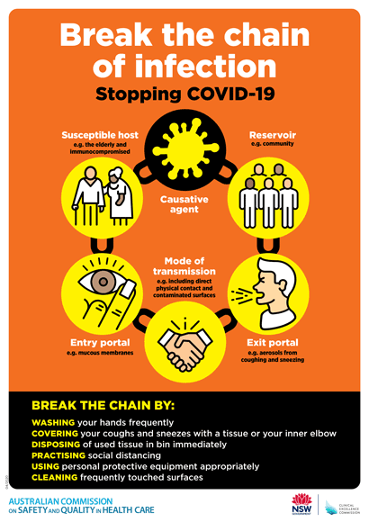](https://www.safetyandquality.gov.au/publications-and-resources/resource-library/break-chain-poster-a3https:/www.safetyandquality.gov.au/publications-and-resources/resource-library/break-chain-poster-a3)**
* ***COVID-19: Elective surgery and infection prevention and control precautions*** <https://www.safetyandquality.gov.au/publications-and-resources/resource-library/covid-19-elective-surgery-and-infection-prevention-and-control-precautions>
* ***FAQs for clinicians on elective surgery*** <https://www.safetyandquality.gov.au/node/5724>
* ***FAQs for consumers on elective surgery*** <https://www.safetyandquality.gov.au/node/5725>
* ***FAQs on community use of face masks***   
  <https://www.safetyandquality.gov.au/faqs-community-use-face-masks>
* ***COVID-19 and face masks – Information for consumers*** <https://www.safetyandquality.gov.au/publications-and-resources/resource-library/covid-19-and-face-masks-information-consumers>

[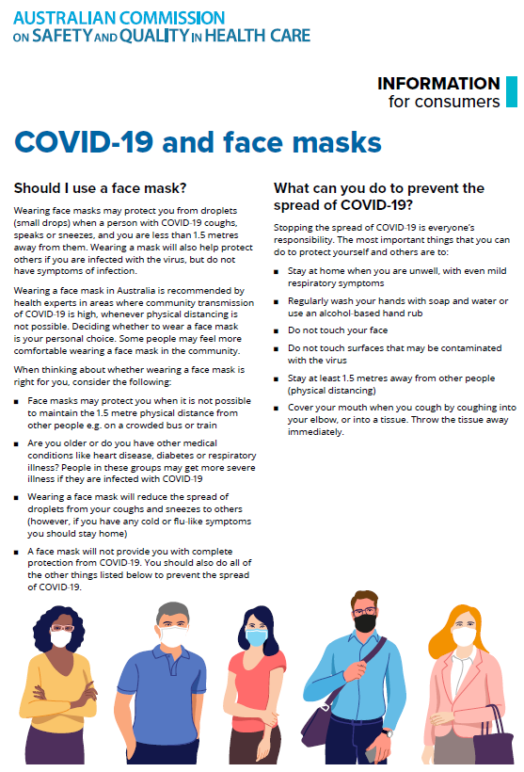](https://www.safetyandquality.gov.au/sites/default/files/2020-07/covid-19_and_face_masks_-_information_for_consumers.pdf)

***Environmental Cleaning and Infection Prevention and Control***

[www.safetyandquality.gov.au/environmental-cleaning](http://www.safetyandquality.gov.au/environmental-cleaning)

The Australian Commission on Safety and Quality in Health Care has produced a suite of environmental cleaning resources to support health service organisations in their infection prevention and control activities, particularly during COVID-19. These resources, including two factsheets, are the first in a series of environment cleaning resources to support Action 3.11 of the *Preventing and Controlling Healthcare-Associated Infection Standards* and the implementation of the environmental cleaning requirements of the *Australian Guidelines for the Prevention and Control of Infection in Healthcare.*

The first factsheet (*Principles of Environmental Cleaning Product Selection*) outlines the key principles of environmental cleaning product selection to support jurisdictions and health service organisations in their decisions on procurement of environmental cleaning products. <https://www.safetyandquality.gov.au/publications-and-resources/resource-library/principles-environmental-cleaning-product-selection-july-2020-fact-sheet>

The second factsheet (*Principles of Environmental Cleaning Auditing*) outlines the key principles of environmental cleaning auditing in acute care settings to support jurisdictions and health service organisations to update and optimise existing auditing programs. <https://www.safetyandquality.gov.au/publications-and-resources/resource-library/principles-environmental-cleaning-auditing-july-2020-fact-sheet>

These two factsheets, along with an **infographic poster** on the benefits of environmental cleaning and **flow chart** detailing the process and product selection for routine environmental cleaning, are available from the Commission’s website at [www.safetyandquality.gov.au/environmental-cleaning](http://www.safetyandquality.gov.au/environmental-cleaning)

[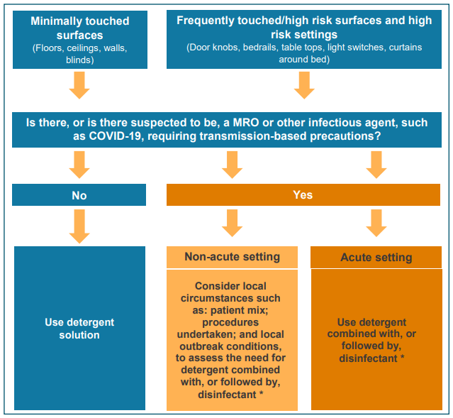](https://www.safetyandquality.gov.au/publications-and-resources/resource-library/process-and-product-selection-routine-environmental-cleaning-flowchart)

***Implementation Guide for the Surveillance of* Clostridioides difficile *infection***

Australian Commission on Safety and Quality in Health Care

Sydney: ACSQHC; 2020. p. 17.

<https://www.safetyandquality.gov.au/our-work/healthcare-associated-infection/consultation-on-clostridium-difficile>

The Australian Commission on Safety and Quality in Health Care has updated the *Implementation Guide for the Surveillance of* Clostridioides difficile *infection*. The purpose of the Guide is to support the implementation of hospital-identified *Clostridioides difficile* infection (CDI) surveillance in Australian public and private hospitals, and enable the collection of nationally consistent CDI data. This update ensures the Guide is consistent with the 2020 US Centers for Disease Control and Prevention (CDC) National Healthcare Safety Network Patient Safety Manual CDI case definition, and the 2016 Public Health Laboratory Network (PHLN) CDI Laboratory case definition.

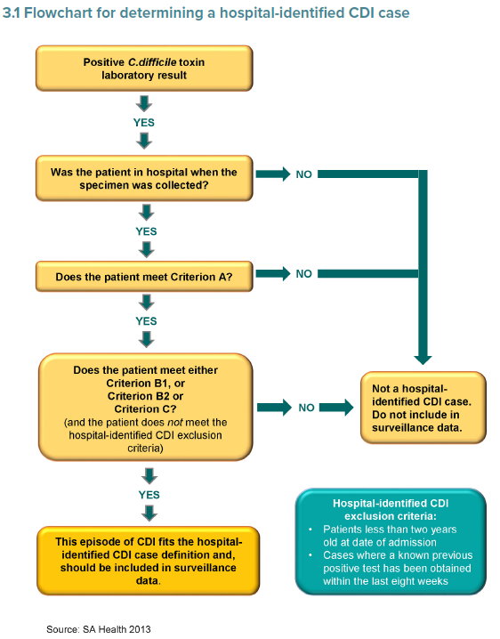

***Staphylococcus aureus (SAB) Prevention***

[www.safetyandquality.gov.au/sab](http://www.safetyandquality.gov.au/sab)

Healthcare-associated *Staphylococcus aureus* bacteraemia (SAB) infections are commonly associated with significant morbidity and mortality. Preventing these infections is a critical activity for health service organisations.

The Australian Health Ministers Advisory Council (AHMAC) has endorsed a revised national benchmark for healthcare-associated Staphylococcus aureus bacteraemia (SAB) of 1.0 per 10,000 patient days for public hospitals, for the purpose of national reporting. The revised benchmark was implemented from 1 July 2020 to promote ongoing and sustained local safety and quality improvements.

The Commission has drawn together a range of resources that support the prevention of SAB infections in healthcare in areas such as: hand hygiene; insertion, management and removal of intravascular devices; perioperative antimicrobial prophylaxis and antimicrobial stewardship; and, surgical site management.

The resources are available at [www.safetyandquality.gov.au/sab](http://www.safetyandquality.gov.au/sab)

If you have any enquiries about the resources, please contact the team at [HAI@safetyandquality.gov.au](mailto:HAI@safetyandquality.gov.au)

**Reports**

*The effective and sustainable adoption of virtual health care*

Australian Healthcare and Hospitals Association

Canberra: AHHA; 2020. p. 12.

|  |  |
| --- | --- |
| URL | <https://ahha.asn.au/sites/default/files/docs/policy-issue/ahha_blueprint_supplement_-_adoption_of_virtual_health_care_-_july_2020.pdf> |
| Notes | The Australian Healthcare and Hospitals Association (AHHA) has issued this addendum or supplement to their 2017 *Healthy people, healthy systems* blueprint for Australian health care. In this supplement, the AHHA outlines key issues in the use of tele and virtual health based on the extension of their use in the pandemic and how they may figure in the longer term. The supplement identifies a number of key areas, including:   * **Patient-centredness**, including codesign with patients, and measuring what matters to patients; * **Equity**, including proactive efforts to ensure affordability, equitable access to technology and digital literacy; * **Cross-sector leadership and governance**, across jurisdictions and the primary and acute care sectors, and in partnership with industry and researchers; * **Digitally-capable health workforce development**, prioritising team-based care and new roles needed to optimise integration of technology into health care; * **Interoperability**, standards and quality assured technology; and * **Funding** for reforms, including better use of data and evaluation. |

**Journal articles**

*Communication with Patients and Families Regarding Health Care–Associated Exposure to Coronavirus 2019: A Checklist to Facilitate Disclosure*

Sivashanker K, Mendu ML, Wickner P, Hartley T, Desai S, Fiumara K, et al

The Joint Commission Journal on Quality and Patient Safety. 2020;46(8):483-488.

|  |  |
| --- | --- |
| DOI | <http://doi.org/10.1016/j.jcjq.2020.04.010> |
| Notes | Given how infectious the SARS-CoV-2 virus is and the possibility of transmission in health settings, this article describes a US approach in developing ‘a pragmatic COVID-19 exposure disclosure checklist to standardize the disclosure process and ensure that all key areas are considered in every conversation’. The authors identified are five core competencies that ‘are critical to facilitating an effective COVID-19 exposure disclosure conversation: clinical, infectious disease, risk management, language, and psychosocial’. |

For information on the Commission’s work on open disclosure, including the *Australian Open Disclosure Framework*, see <https://www.safetyandquality.gov.au/our-work/clinical-governance/open-disclosure>

*Association of Nursing Home Ratings on Health Inspections, Quality of Care, and Nurse Staffing With COVID-19 Cases*

Figueroa JF, Wadhera RK, Papanicolas I, Riley K, Zheng J, Orav EJ, et al

Journal of the American Medical Association. 2020.

*Is There a Link between Nursing Home Reported Quality and COVID-19 Cases? Evidence from California Skilled Nursing Facilities*

He M, Li Y, Fang F

Journal of the American Medical Directors Association. 2020;21(7):905-908.

|  |  |
| --- | --- |
| DOI | Figueroa et al <https://doi.org/10.1001/jama.2020.14709>  He et al <https://doi.org/10.1016/j.jamda.2020.06.016> |
| Notes | Questions around the safety and quality of care in long term care are not new but have heightened interest in the pandemic as some facilities how experience much higher rates of infection and mortality than others. These two pieces examine aspects of these facilities and the relationship with the pandemic experience.  Figueroa et al used data from 8 US state health departments on COVID-19 cases in nursing homes and linked those data with performance rating data form the US Centers for Medicare & Medicaid Services. They report finding that ‘Across 8 states, high-performing NHs for **nurse staffing** had fewer COVID-19 cases than low-performing NHs.’  He et al used cross-sectional data from 1223 California skilled nursing facilities with reported quality and longitudinal data of COVID-19 cases to examine whether COVID-19 cases and deaths were related to the nursing home reported quality. They report **lower ratings** and **higher proportions** of **‘residents from different racial and ethnicity groups** were significantly (P < .01) related to **increased probability of having a COVID-19 residents’ case or death**’. |

*Australian Journal of Primary Health*

Volume 26 Number 4 2020

|  |  |
| --- | --- |
| URL | <https://www.publish.csiro.au/py/issue/9749> |
| Notes | A new issue of the *Australian Journal of Primary Health* has been published. Articles in this issue of the *Australian Journal of Primary Health* include:   * Celebrating **diversity and adaptability in academic primary care** (Lauren Ball and Elizabeth Sturgiss) * Learning from COVID-19 to improve **access to physiotherapy** (Jessica Stanhope and Philip Weinstein) * Primary care initiatives focused on the **secondary prevention and management of chronic pain**: a scoping review of the Australian literature (Pippy Walker, Simone De Morgan, D Sanders, M Nicholas and F M Blyth) * **Cardiovascular disease risk assessment in an Aboriginal community-controlled health service**: comparing algorithms (Xavier Fitzgerald, Ana Herceg, Kirsty Douglas and Nadeem Siddiqui) * **Visual impairment among Aboriginal and Torres Strait Islander patients** attending an Australian Indigenous primary health service: a cross-sectional study (Prabha Lakhan, U L Osuagwu, D Askew, N Hayman and G Spurling) * Quality and targeting of new referrals for **ocular complications of diabetes** from primary care to a public hospital ophthalmology service in Western Sydney, Australia (Belinda Ford, Lisa Keay, Blake Angell, Stephanie Hyams, Paul Mitchell, Gerald Liew and Andrew White) * **Grey nomads with diabetes**: the experience of rural and remote diabetes educators in South Australia (Anita De Bellis, Pauline Hill, Wendy Abigail, Jane Giles and Christine McCloud) * Long-term follow up of **older people on diabetes medications**: observational study using linked health databases (Katharine A. Wallis, Susan Wells, Vanessa Selak and Katrina Poppe) * Middle-aged Australians’ perceptions of **support to reduce lifestyle risk factors**: a qualitative study (Christine Ashley, Elizabeth Halcomb, Susan McInnes, Karin Robinson, Elizabeth Lucas, Susan Harvey and Sarah Remm) * ‘I’m over the moon!’: **patient-perceived outcomes of hepatitis C treatment** (D Pourmarzi, A Smirnov, L Hall, G FitzGerald and T Rahman) * Using the Tailoring Immunization Programmes guide to improve **child immunisation** in Umina, New South Wales: we could still do better (Katarzyna Bolsewicz, Susan Thomas, Donna Moore, Colleen Gately, Andrew Dixon, Paul Cook and Peter Lewis) * **Commissioning for health and community sector reform**: perspectives on change from Victoria (Kate Silburn and Virginia Lewis) * **HealthPathways**: a detailed analysis of utilisation trends in the northern Sydney region (Kimberly E. Lind, M Jorgensen, C Stowers and M Brookes) * Patient-centred method to evaluate the **spatial accessibility of primary health care** in a case study in Shanghai (Xuechen Xiong and Li Luo) |

*Pediatric Quality & Safety*

Vol. 5, No. 4, July/August 2020

|  |  |
| --- | --- |
| URL | <https://journals.lww.com/pqs/toc/2020/07000> |
| Notes | A new issue of *Pediatric Quality & Safety* has been published. Articles in this issue of *Pediatric Quality & Safety* include:   * Reducing **Point-of-care Blood Gas Testing** in the Intensive Care Unit through Diagnostic Stewardship: A Value Improvement Project (Michael J Tchou, Sally May, John Holcomb, Ethan Tanner-Edwards, Kathy Good, Matthew Frazier, Erika L Stalets, Maya Dewan, on behalf of the Cincinnati Children’s Hospital Medical Center Diagnostic Stewardship Committee) * A Quality Improvement Project to Improve **First Case On-time Starts in the Pediatric Operating Room** (Dinesh S Pashankar, Anna M Zhao, Rebecca Bathrick, Cindy Taylor, Heidi Boules, R A Cowles, M Grossman) * Reducing **Antibiotic Prescription Errors in the Emergency Department**: A Quality Improvement Initiative (K E Kasmire, C Cerrone, E C Hoppa) * Reducing **Opioid Exposure in a Level IV Neonatal Intensive Care Unit** (Raymond C Stetson, Brandi N Smith, Nicole L Sanders, Megan A Misgen, LaRae J Ferrie, Virginia S Schuning, A R Schuh, J L Fang, J E Brumbaugh) * A Quality Improvement Project to **Standardize Surfactant Delivery** in the Era of Noninvasive Ventilation (Jeong Eun Kim, Mariana Brewer, Regina Spinazzola, Elfriede Wallace, J Casatelli, J Beachy, B Weinberger, S Perveen) * Vaccinating in the Emergency Department, a Novel Approach to Improve **Influenza Vaccination Rates** via a Quality Improvement Initiative (Shannon H Baumer-Mouradian, Abigail Kleinschmidt, Ashley Servi, Brian Jaworski, K Lazarevic, M Kopetsky, M Nimmer, T Hanson, M P Gray, A L Drendel) * Compassionate Design: Utilizing Design Thinking to Preserve **Sanctity, Dignity, and Personhood When Children Die** (Daniel H Grossoehme, Melissa S Mark, Blake Lane, Allison Rednour, Rachel Thienprayoon) * **Reducing Outpatient Infant Blood Draws** with Transcutaneous Measurement of Bilirubin (Keira C Kilmartin, Emily J McCarty, Catherine D Shubkin, Alison Volpe Holmes) * Improving Patient Handoffs and Transitions through Adaptation and Implementation of **I-PASS Across Multiple Handoff Settings** (L J Blazin, J Sitthi-Amorn, J M Hoffman, J D Burlison, for the I-PASS Working Group) * Implementation of a Modified **Neonatal Early-onset Sepsis Calculator** in Well-baby Nursery: a Quality Improvement Study (Michael Zayek, Jayalakshmi Bhat, Katie Bonner, Michelle Blake, Keith Peevy, O P Jha, R Gulati, R Bhat) * Could It Be Pneumonia? **Lung Ultrasound in Children With Low Clinical Suspicion for Pneumonia** (Eric Scheier, Nadine Levick, Julia Peled, U Balla) * A Quality Initiative for Reducing **Postoperative Hypothermia for Neonatal Intensive Care Unit Surgical Patients** (Jessica A Cronin, Lamia Soghier, Kara Ryan, Christine Shen, Sopnil Bhattarai, Sohel Rana, R Shah, E Heitmiller) * Improving **Accuracy of Handoff** by Implementing an Electronic Health Record–generated Tool: An Improvement Project in an Academic Neonatal Intensive Care Unit (Jenny K Koo, Laurel Moyer, Michael A Castello, Y Arain) * The Road to **Transfusion-free Craniosynostosis Repair** in Children Less Than 24 Months Old: A Quality Improvement Initiative (Amy B Beethe, Rachel A Spitznagel, Jane A Kugler, Jessica K Goeller, Marcellene H Franzen, Ryan J Hamlin, T J Lockhart, E R Lyden, K R Glogowski, M M LeRiger) * Incorporating the Voice of Community Based Pediatricians to Improve **Discharge Communication** (Lindsay Weiss, Anthony Cooley, Evan Orenstein, Matthew Levy, Mary Edmond, Emily Wong, H Hua, N Hames) * Improving **Point-of-Care Ultrasound Documentation** and Billing Accuracy in a Pediatric Emergency Department (Carrie Ng, Asha S Payne, Amit K Patel, Rosemary Thomas-Mohtat, Angela Maxwell, Alyssa Abo) * A Quality Initiative to Improve Appropriate Use of **Initial Outpatient Echocardiography Among Pediatric Cardiologists** (Erik L Frandsen, Soultana Kourtidou, Joel S Tieder, Erin Alberda, Brian D Soriano) * **Methadone-based Multimodal Analgesia** Provides the Best-in-class Acute Surgical Pain Control and Functional Outcomes With Lower Opioid Use Following Major Posterior Fusion Surgery in Adolescents With **Idiopathic Scoliosis** (Jian Ye, Karen Myung, Senthil Packiasabapathy, Jeffrey S Yu, J E Jacobson, S C Whittaker, P Castelluccio, M D Jackson, S Sadhasivam) * **Safety in Pediatric Hospice and Palliative Care**: A Qualitative Study (Teresa Pestian, R Thienprayoon, D Grossoehme, S Friebert, L Humphrey) * Enhancing **Safe Sleep Counseling** by Pediatricians through a Quality Improvement Learning Collaborative (Emily K Scott, Stephen M Downs, Amy K Pottenger, James P Bien, Michele S Saysana) * **Cold Debriefings after In-hospital Cardiac Arrest** in an International Pediatric Resuscitation Quality Improvement Collaborative (Heather A Wolfe, Jesse Wenger, Robert Sutton, Roopa Seshadri, Dana E Niles, V Nadkarni, J Duval-Arnould, A I Sen, A Cheng, on behalf of the pediRES-Q Investigators) * **Quality Improvement in a Pandemic** (Ashley A Foster, Anne M Stack) * Introduction of the **EMR-integrated I-PASS ICU Handoff Tool** (Thomas J Caruso, Felice Su, Ellen Wang) |

*BMJ Quality & Safety* online first articles

|  |  |
| --- | --- |
| URL | <https://qualitysafety.bmj.com/content/early/recent> |
| Notes | *BMJ Quality &Safety* has published a number of ‘online first’ articles, including:   * Associations between **double-checking and medication administration errors**: a direct observational study of paediatric inpatients (Johanna I Westbrook, Ling Li, Magdalena Z Raban, Amanda Woods, Alain K Koyama, Melissa Therese Baysari, Richard O Day, Cheryl McCullagh, Mirela Prgomet, Virginia Mumford, Luciano Dalla-Pozza, Madlen Gazarian, Peter J Gates, Valentina Lichtner, Peter Barclay, Alan Gardo, Mark Wiggins, Leslie White) * **Variation in timely surgery for hip fracture** by day and time of presentation: a nationwide prospective cohort study from the National Hip Fracture Database for England, Wales and Northern Ireland (Anjali Shah, Gulraj S Matharu, Dominic Inman, Elizabeth Fagan, Antony Johansen, Andrew Judge) |

*International Journal for Quality in Health Care* online first articles

|  |  |
| --- | --- |
| URL | <https://academic.oup.com/intqhc/advance-articles> |
| Notes | *International Journal for Quality in Health Care* has published a number of ‘online first’ articles, including:   * **Bundle interventions including nontechnical skills for surgeons** can reduce operative time and improve patient safety (Daisuke Koike, Yukihiro Nomura, Motoki Nagai, Takashi Matsunaga, Ayuko Yasuda) * Psychometric evaluation of instruments measuring the **work environment of healthcare professionals in hospitals**: a systematic literature review (Susanne M Maassen, Anne Marie J W Weggelaar Jansen, Gerard Brekelmans, Hester Vermeulen, Catharina J van Oostveen) * Human Factors/Ergonomics support for the design and testing of **Rapidly Manufactured Ventilators in the UK during the COVID-19 pandemic** (Sue Hignett, Janette Edmonds, Tracey Herlihey, Laura Pickup, Richard Bye, Emma Crumpton, Mark Sujan, Fran Ives, Daniel P Jenkins, Miranda Newbery, David Embrey, Paul Bowie, Chris Ramsden, Noorzaman Rashid, Alastair Williamson, Anne-Marie Bougeard, Peter MacNaughton) * From Intensive Care to Step-Down Units: **Managing Patients Throughput in Response to COVID-19** (Vanni Agnoletti, Emanuele Russo, Alessandro Circelli, Marco Benni, Giuliano Bolondi, Costanza Martino, P Domenico, Santonastas, Etrusca Brogi, Beniamino Praticò, Federico Coccolini, Paola Fugazzola, Luca Ansaloni, Emiliano Gamberini) * **Reengineer Health Care**: A Human Factors and Ergonomics Framework to Improve the Socio-Technical System (Raquel Santos) * **Hospital Accreditation Impact on Healthcare Quality Dimensions**: A Systematic Review (Claudia A S Araujo, Marina Martins Siqueira, Ana Maria Malikn) * **MRI safety management in patients with cardiac implantable electronic devices**: Utilizing failure mode and effects analysis for risk optimization (James W Ryan, Aoife S Murray, Paddy J Gilligan, James M Bisset, Chris Nolan, Audrey Doyle, Barry Emerson, Joseph M Galvin, John G Murray) |

**Online resources**

*National COVID-19 Clinical Evidence Taskforce*

<https://covid19evidence.net.au/>

The National COVID-19 Clinical Evidence Taskforce is a collaboration of peak health professional bodies across Australia whose members are providing clinical care to people with COVID-19. The taskforce is undertaking continuous evidence surveillance to identify and rapidly synthesise emerging research in order to provide national, **evidence-based guidelines and clinical flowcharts for the clinical care of people with COVID-19**. The guidelines address questions that are specific to managing COVID-19 and cover the full disease course across mild, moderate, severe and critical illness. These are ‘living’ guidelines, updated with new research in near real-time in order to give reliable, up-to-the minute advice to clinicians providing frontline care in this unprecedented global health crisis.

*COVID-19 Critical Intelligence Unit*

<https://www.aci.health.nsw.gov.au/covid-19/critical-intelligence-unit>

The Agency for Clinical Innovation (ACI) in New South Wales has developed this page summarising rapid, evidence-based advice during the COVID-19 pandemic. Its operations focus on systems intelligence, clinical intelligence and evidence integration. The content includes a daily evidence digest and evidence checks on a discrete topic or question relating to the current COVID-19 pandemic.

*[UK] NICE Guidelines and Quality Standards*

<https://www.nice.org.uk/guidance>

The UK’s National Institute for Health and Care Excellence (NICE) has published new (or updated) guidelines and quality standards. The latest reviews or updates are:

* *NICE Guideline NG160* ***COVID-19 rapid guideline****:* ***dialysis*** *service delivery* <https://www.nice.org.uk/guidance/ng160>
* *Quality Standard QS194* ***Decision making*** *and mental capacity* <https://www.nice.org.uk/guidance/qs194>

*[USA] Patient Safety Primers*

<https://psnet.ahrq.gov/primers/>

The Patient Safety Primers from the (US) Agency for Healthcare Research and Quality (AHRQ) discuss key concepts in patient safety. Each primer defines a topic, offers background information on its epidemiology and context, and provides links to relevant materials.

* ***COVID-19 and Dentistry: Challenges and Opportunities for Providing Safe Care*** –This primer summarizes best practices for infection control and prevention in the dental office setting, reviews US Department of Health and Human Services (HHS) guidance on treating dental patients with suspected or confirmed COVID-19, discusses access issues for patients needing oral healthcare, and offers various Federal and professional resources to support the reconfiguration of dental practice, the implementation of teledentistry, and the prioritization of dental care needs after practices reopen.   
  <https://psnet.ahrq.gov/primer/covid-19-and-dentistry-challenges-and-opportunities-providing-safe-care>

**Disclaimer**

On the Radar is an information resource of the Australian Commission on Safety and Quality in Health Care. The Commission is not responsible for the content of, nor does it endorse, any articles or sites listed. The Commission accepts no liability for the information or advice provided by these external links. Links are provided on the basis that users make their own decisions about the accuracy, currency and reliability of the information contained therein. Any opinions expressed are not necessarily those of the Australian Commission on Safety and Quality in Health Care.