# Australian COmmission on Safety and Quality in Health Care logo with Radar imageOn the Radar

Issue 483

28 September 2020

*On the Radar* is a summary of some of the recent publications in the areas of safety and quality in health care. Inclusion in this document is not an endorsement or recommendation of any publication or provider. Access to particular documents may depend on whether they are Open Access or not, and/or your individual or institutional access to subscription sites/services. Material that may require subscription is included as it is considered relevant.

*On the Radar* is available online, via email or as a PDF or Word document from <https://www.safetyandquality.gov.au/publications-and-resources/newsletters/radar>

If you would like to receive *On the Radar* via email, you can subscribe on our website <https://www.safetyandquality.gov.au/publications-and-resources/newsletters>   
or by emailing us at H[Umail@safetyandquality.gov.auU](mailto:mail@safetyandquality.gov.au).   
You can also send feedback and comments to H[Umail@safetyandquality.gov.auU](mailto:mail@safetyandquality.gov.au).

For information about the Commission and its programs and publications, please visit <https://www.safetyandquality.gov.au>

You can also follow us on Twitter @ACSQHC.

**On the Radar**

Editor: Dr Niall Johnson [niall.johnson@safetyandquality.gov.au](mailto:niall.johnson@safetyandquality.gov.au)

Contributors: Niall Johnson

**COVID-19 resources**

https://www.safetyandquality.gov.au/covid-19

The Australian Commission on Safety and Quality in Health Care has developed a number of resources to assist healthcare organisations, facilities and clinicians. These and other material on COVID-19 are available at <https://www.safetyandquality.gov.au/covid-19>

The latest additions include:

* ***COVID-19: Aged care staff infection prevention and control precautions*** *poster*<https://www.safetyandquality.gov.au/publications-and-resources/resource-library/covid-19-aged-care-staff-infection-prevention-and-control-precautions-poster>  
    
  [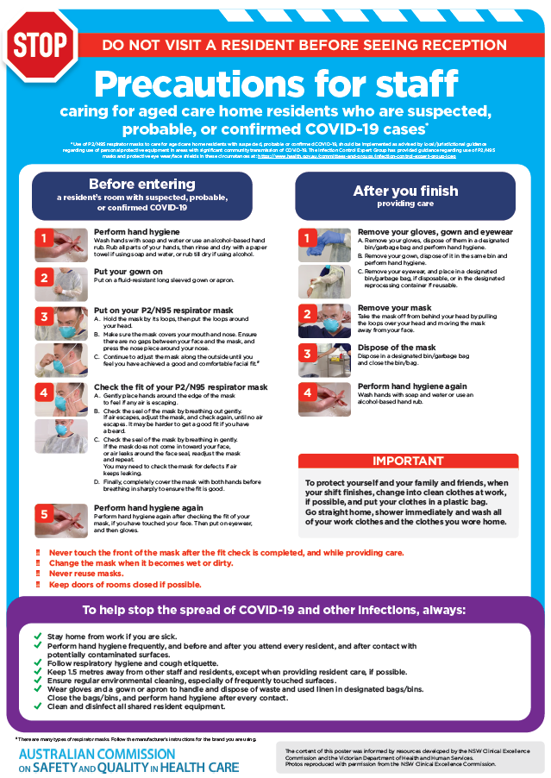](https://www.safetyandquality.gov.au/publications-and-resources/resource-library/covid-19-aged-care-staff-infection-prevention-and-control-precautions-poster)
* ***Environmental Cleaning and Infection Prevention and Control*** [www.safetyandquality.gov.au/environmental-cleaning](http://www.safetyandquality.gov.au/environmental-cleaning)
* ***Infection prevention and control Covid-19 PPE*** poster <https://www.safetyandquality.gov.au/publications-and-resources/resource-library/infection-prevention-and-control-covid-19-personal-protective-equipment>
* ***Special precautions for Covid-19 designated zones*** poster <https://www.safetyandquality.gov.au/publications-and-resources/resource-library/special-precautions-covid-19-designated-zones>
* ***COVID-19 infection prevention and control risk management – Guidance*** <https://www.safetyandquality.gov.au/publications-and-resources/resource-library/covid-19-infection-prevention-and-control-risk-management-guidance>
* ***Safe care for people with cognitive impairment during COVID-19***<https://www.safetyandquality.gov.au/our-work/cognitive-impairment/cognitive-impairment-and-covid-19>
* **Medicines Management COVID-19** <https://www.safetyandquality.gov.au/our-work/medication-safety/medicines-management-covid-19>, including position statements on medicine-related issues
  + ***Managing fever associated with COVID-19***
  + ***Managing a sore throat associated with COVID-19***
  + ***ACE inhibitors and ARBs in COVID-19***
  + ***Clozapine in COVID-19***
  + ***Management of patients on oral anticoagulants during COVID-19***
  + ***Ascorbic Acid: Intravenous high dose in COVID-19***
  + ***Treatment in acute care, including oxygen therapy and medicines to support intubation***
  + ***Nebulisation and COVID-19***
  + ***Managing intranasal administration of medicines during COVID-19***
  + ***Ongoing medicines management in high-risk patients***
  + ***Medicines shortages***
  + ***Conserving medicines***
  + ***Intravenous medicines administration in the event of an infusion pump shortage***
* ***Potential medicines to treat COVID-19***   
  <https://www.safetyandquality.gov.au/publications-and-resources/resource-library/potential-medicines-treat-covid-19>
* ***Break the chain of infection: Stopping COVID-19*** poster<https://www.safetyandquality.gov.au/publications-and-resources/resource-library/break-chain-poster-a3>  
  **[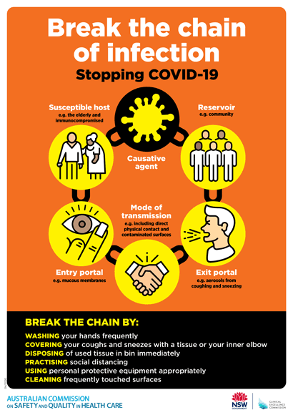](https://www.safetyandquality.gov.au/publications-and-resources/resource-library/break-chain-poster-a3https:/www.safetyandquality.gov.au/publications-and-resources/resource-library/break-chain-poster-a3)**
* ***COVID-19: Elective surgery and infection prevention and control precautions*** <https://www.safetyandquality.gov.au/publications-and-resources/resource-library/covid-19-elective-surgery-and-infection-prevention-and-control-precautions>
* ***FAQs for clinicians on elective surgery*** <https://www.safetyandquality.gov.au/node/5724>
* ***FAQs for consumers on elective surgery*** <https://www.safetyandquality.gov.au/node/5725>
* ***FAQs on community use of face masks***   
  <https://www.safetyandquality.gov.au/faqs-community-use-face-masks>
* ***COVID-19 and face masks – Information for consumers*** <https://www.safetyandquality.gov.au/publications-and-resources/resource-library/covid-19-and-face-masks-information-consumers>

[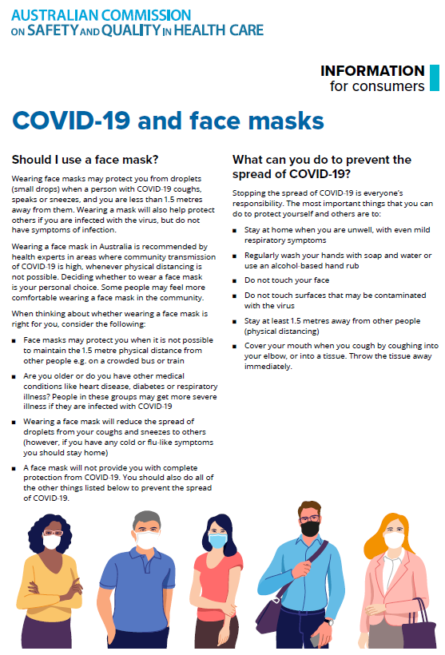](https://www.safetyandquality.gov.au/sites/default/files/2020-07/covid-19_and_face_masks_-_information_for_consumers.pdf)

**Antimicrobial medicines dispensing from 2013–14 to 2017–18**

<https://www.safetyandquality.gov.au/our-work/healthcare-variation/antimicrobial-medicines-dispensing-2013-14-2017-18>

The Australian Commission on Safety and Quality in Health Care has released a new report on antimicrobial medicines use in Australia that has revealed a sustained pattern of high use in some of the most disadvantaged areas of major cities.

The *Antimicrobial Medicines Dispensing from 2013–14 to 2017–18* report also has some encouraging findings, with a downward trend in national antimicrobial dispensing rates, which fell 13.3% over five years.

For the first time, the new-format interactive report analyses antimicrobial dispensing over five years at a range of levels – national, state and territory, Primary Health Network (PHN) and local area. The report builds on the findings of the *Third Australian Atlas of Healthcare Variation*, which examined antimicrobial medicines dispensing from 2013–14 to 2016–17.

Data from the interactive report can be used by health service organisations, PHNs, general practitioners and other clinicians to review rates of antimicrobial dispensing in their local area and compare them with the rates for similar areas.

The report helps identify areas that may benefit from further investigation and targeted strategies to improve appropriate prescribing of antimicrobial medicines.

Australia’s antimicrobial prescription rate remains high by international standards, and is double that of comparable OECD countries such as The Netherlands and Sweden. While there has been a modest decline in antimicrobial use over the past five years, the report indicates potential overuse in some geographical areas. Outer areas of Sydney, Brisbane and Melbourne were found to have the highest rates of antimicrobial dispensing year after year.

[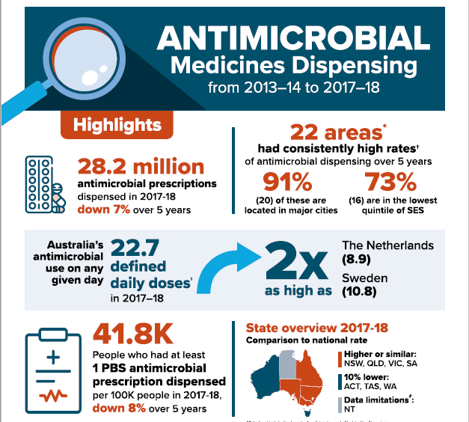](https://safetyandquality.cmail20.com/t/j-l-aoltly-zkylhjic-j/)

**Reports**

*What influences improvement processes in healthcare? A rapid evidence review*

Ali G-C, Altenhofer M, Gloinson ER, Marjanovic S

Santa Monica and Cambridge: RAND Corporation; 2020. p. 106.

|  |  |
| --- | --- |
| URL | <https://www.rand.org/pubs/research_reports/RRA440-1.html> |
| Notes | The Healthcare Improvement Studies (THIS) Institute at the University of Cambridge commissioned RAND Europe to conduct a rapid review of academic reviews and grey literature covering the influences on improvement processes in healthcare. Based on 38 academic and 16 grey literature publications, the review found six key factors influence the implementation of improvement efforts:   * Leadership * Relationships and interactions that support an improvement culture * Skills and competencies * Use of data * Patient and public involvement, engagement and participation * Working as an interconnected system of individuals and organisations, influenced by internal and external contexts. |

*Patient and Family Advisory Council Leaders' Guide for Diagnostic Quality and Safety*

Society to Improve Diagnosis in Medicine

Evanston: Society to Improve Diagnosis in Medicine; 2020. p. 17.

*Patient and Family Advisory Council Guide for Hospital and Health System Leaders for Diagnostic Quality and Safety*

Society to Improve Diagnosis in Medicine

Evanston: Society to Improve Diagnosis in Medicine; 2020. p. 16.

|  |  |
| --- | --- |
| URL | <https://www.improvediagnosis.org/pfac-guides/> |
| Notes | With the continuing interest in issues around diagnosis (see below for some of the most recent literature), these two guides have been produced by the (US) Society to Improve Diagnosis in Medicine. According to the Society’s webpage, these guides are intended to serve as compendia of best and promising practices for use by Patient and Family Advisory Councils (PFACs) and for leadership in the hospitals and health systems that have PFACs. Each guide provides foundational education about diagnostic errors and tangible ideas and suggestions for PFACs and their hospital or health system leadership to employ as they work to tackle diagnostic quality and safety. |

**Journal articles**

*Prevalence and characterisation of diagnostic error among 7-day all-cause hospital medicine readmissions: a retrospective cohort study*

Raffel KE, Kantor MA, Barish P, Esmaili A, Lim H, Xue F, et al

BMJ Quality & Safety. 2020 [epub].

|  |  |
| --- | --- |
| DOI | <http://doi.org/10.1136/bmjqs-2020-010896> |
| Notes | This addition to diagnostic error literature used a retrospective cohort study to examine 376 adult patients readmitted to a US teaching hospital within 7 days of hospital discharge. The study found that over a year (2018), 5.6% of readmissions had at least one diagnostic error during the index admissions. The diagnostic errors were largely to diagnostic reasoning, including failure to order needed tests, erroneous interpretation of tests, and failure to consider the correct diagnosis. The majority of the diagnostic errors resulted in some form of clinical impact, including short-term morbidity and readmissions. |

*Diagnostic error: incidence, impacts, causes and preventive strategies*

Scott IA, Crock C

Medical Journal of Australia. 2020 [epub].

|  |  |
| --- | --- |
| DOI | <https://doi.org/10.5694/mja2.50771> |
| Notes | This Perspectives piece summarises the current thinking around diagnostic error, and starts by citing some of the more eye-catching figures from the literature. For example:   * Some form of diagnostic error occurs in up to one in seven clinical encounters, and most are preventable. * Diagnostic error comprising missed, wrong or delayed diagnoses affects between 8% and 15% of all hospital admissions in the United States, with similar rates among patients with common diseases attending outpatient clinics. * As many as 1.1% of adult hospital admissions will involve diagnostic error that causes harm to patients. * Nearly a third of all preventable deaths in acute hospitals in the United Kingdom are attributed to diagnostic error. * In Australia, an estimated 140 000 cases of diagnostic error occur each year, with 21 000 cases of serious harm and 2000–4000 deaths. * Almost one in two malpractice claims against general practitioners involves diagnostic error. * More than 80% of diagnostic errors are deemed preventable.   The piece proceeds to provide brief statements on types of diagnostic error, theories of diagnostic reasoning, and strategies for preventing diagnostic error. The piece also notes the establishment of an Australian and New Zealand Affiliate of the US Society to Improve Diagnosis in Medicine (ANZA-SIDM). |

*Communication tools in the COVID-19 era and beyond which can optimise professional practice and patient care*

Clement KD, Zimmermann EF, Bhatt NR, Light A, Gao C, Kulkarni M, et al

BMJ Innovations. 2020 [epub].

|  |  |
| --- | --- |
| DOI | <https://doi.org/10.1136/bmjinnov-2020-000465> |
| Notes | The COVID-19 pandemic has seen many changes brought in rapidly. This piece looks at how communications has changed and may continue to be changed. The authors aim to ‘summarise the variety of electronic communication platforms and tools available for clinicians and patients, detailing their utility, pros and cons, and some 'tips and tricks' from our experience’. Among the observations and advice, the authors offer their ‘Seven Ps for a successful virtual clinic’: Practice, Patient-centred, Professional, Plan and prepare, Perform the consultation, Perfect and Precision’.  [Table 1. Seven Ps for a successful virtual clinic’: Practice, Patient-centred, Professional, Plan and prepare, Perform the consultation, Perfect and Precision](https://doi.org/10.1136/bmjinnov-2020-000465) |

*Well spotted: but now you need to do something*

Hamblin R, Shuker C

BMJ Quality & Safety. 2020 [epub].

|  |  |
| --- | --- |
| DOI | <https://doi.org/10.1136/bmjqs-2019-010659> |
| Notes | Editorial that in reflecting on an article on using routinely available data for early warning of service failure then proceeds to consider not only the causes of safety and quality lapses, how to detect them but also the need to be able to adequately understand and respond to (or prevent) such failures.  [Figure 1 from Hambin and Shuker: Why things go wrong and how to address them.](https://doi.org/10.1136/bmjqs-2019-010659) |

*Hospital- and system-wide interventions for health care-associated infections: A systematic review*

Maurer NR, Hogan TH, Walker DM

Medical Care Research and Review. 2020:1077558720952921.

|  |  |
| --- | --- |
| DOI | <http://doi.org/10.1177/1077558720952921> |
| Notes | Paper reporting on a systematic review of interventions to address healthcare-associated infections (HAI). Based on 96 studies published between 2008 and 2019, the review found the ‘literature’s methodologic and reporting quality was generally poor’. However, the review did identify a number of strategies for reducing HAIs, including enhanced environmental cleaning; electronic health record implementation; infection control programs; hand hygiene promotion; and hospital-wide cultural transformations. |

For information on the Commission’s work on healthcare-associated infection, see <https://www.safetyandquality.gov.au/our-work/healthcare-associated-infection>

*Opioid Stewardship Program and Postoperative Adverse Events: A Difference-in-differences Cohort Study*

Barreveld AM, McCarthy RJ, Elkassabany N, Mariano ER, Sites B, Ghosh R, et al

Anesthesiology. 2020;132(6):1558-1568.

|  |  |
| --- | --- |
| DOI | <http://doi.org/10.1097/aln.0000000000003238> |
| Notes | Paper reporting on the implementation and impact of an opioid stewardship program. The 6-month opioid use educational program consisting of webinars on pain assessment, postoperative and multimodal pain opioid management, safer opioid use, and preventing addiction coupled with on-site coaching and monthly assessments reports was implemented in 31 hospitals with outcomes compared with 33 control hospitals for 12 months before and after the intervention. The study found the ‘intervention did not reduce opioid adverse events or alter opioid use in hospitalized patients’. |

For information on the Commission’s work on medication safety, see <https://www.safetyandquality.gov.au/our-work/medication-safety>

*Emergency department monitor alarms rarely change clinical management: An observational study*

Fleischman W, Ciliberto B, Rozanski N, Parwani V, Bernstein SL

The American Journal of Emergency Medicine. 2020;38(6):1072-1076.

|  |  |
| --- | --- |
| DOI | <http://doi.org/10.1016/j.ajem.2019.158370> |
| Notes | Paper reporting on a prospective, observational study conducted in an urban, academic emergency department (ED) in which an ED physician completed 53 hours of observation, recording patient characteristics, alarm type, staff response, whether the alarm was likely real or false, and whether it changed clinical management. In the 53 hours, there were 1049 alarms associated with 146 patients and these alarms changed clinical management in just 8 out of 1049 observed alarms in 5 out of the 146 patients. Staff did not observably respond to most alarms (63%). |

*Association of Intra-arrest Transport vs Continued On-Scene Resuscitation With Survival to Hospital Discharge Among Patients With Out-of-Hospital Cardiac Arrest*

Grunau B, Kime N, Leroux B, Rea T, Van Belle G, Menegazzi JJ, et al

JAMA. 2020;324(11):1058-1067.

|  |  |
| --- | --- |
| DOI | <https://doi.org/10.1001/jama.2020.14185> |
| Notes | Apparently, different locations have differing approaches to handling cardiac arrests that happen in the community. In some locations emergency responders will take little action on the spot, opting for rapid transportation to hospital (the “scoop and run” approach) while in others the standard response is to treat the patient at the scene (“stay and play’). This article reports on a cohort study that examined 27,705 patients who suffered out-of-hospital cardiac arrests in the USA and Canada. The study found that ‘intra-arrest transport compared with continued on-scene resuscitation had a probability of survival to hospital discharge of 4.0% vs 8.5%, a difference that was statistically significant.’ |

*BMJ Quality & Safety*

October 2020 - Volume 29 - 10

|  |  |
| --- | --- |
| URL | <https://qualitysafety.bmj.com/content/29/10> |
| Notes | A new issue of *BMJ Quality & Safety* has been published. Many of the papers in this issue have been referred to in previous editions of *On the Radar* (when they were released online). Articles in this issue of *BMJ Quality & Safety* include:   * Editorial: **Whiteboards**: important part of the toolbox for improving **patient understanding during hospitalisation** (Sara Dunbar, Kathlyn E Fletcher) * Editorial: **Social emotion and patient safety**: an important and understudied intersection (Jane Heyhoe, Rebecca Lawton) * Editorial: Choosing quality problems wisely: identifying **improvements worth developing and sustaining** (Christine Soong, Hyung J Cho, K G Shojania) * **Do bedside whiteboards enhance communication in hospitals?** An exploratory multimethod study of patient and nurse perspectives (Anupama Goyal, Hanna Glanzman, Martha Quinn, Komalpreet Tur, Sweta Singh, Suzanne Winter, Ashley Snyder, Vineet Chopra) * **Emotionally evocative patients in the emergency department**: a mixed methods investigation of providers’ reported emotions and implications for patient safety (Linda M Isbell, Julia Tager, Kendall Beals, Guanyu Liu) * **What do emergency department physicians and nurses feel?** A qualitative study of emotions, triggers, regulation strategies, and effects on patient care (Linda M Isbell, Edwin D Boudreaux, Hannah Chimowitz, Guanyu Liu, Emma Cyr, Ezekiel Kimball) * Impact of an education and multilevel social comparison–based intervention bundle on **use of routine blood tests in hospitalised patients** at an academic tertiary care hospital: a controlled pre-intervention post-intervention study (Anshula Ambasta, Irene Wai Yan Ma, Stephen Woo, Kevin Lonergan, Elizabeth Mackay, Tyler Williamson) * The discontinuation of contact precautions for **methicillin-resistant *Staphylococcus aureus* and vancomycin-resistant Enterococcus**: Impact upon patient adverse events and hospital operations (Gregory M Schrank, Graham M Snyder, Roger B Davis, Westyn Branch-Elliman, Sharon B Wright) * Impact **of multidisciplinary team huddles on patient safety**: a systematic review and proposed taxonomy (Brian J Franklin, Tejal K Gandhi, David W Bates, Nadia Huancahuari, Charles A Morris, Madelyn Pearson, Michelle Beth Bass, Eric Goralnick) * **Effects of CPOE-based medication ordering on outcomes**: an overview of systematic reviews (Joanna Abraham, Spyros Kitsiou, Alicia Meng, Shirley Burton, Haleh Vatani, Thomas Kannampallil) * **Empowering patients** and reducing inequities: is there potential in **sharing clinical notes**? (Charlotte Blease, Leonor Fernandez, Sigall K Bell, Tom Delbanco, Catherine DesRoches) * **Resilience and regulation**, an odd couple? Consequences of Safety-II on governmental regulation of healthcare quality (Ian Leistikow, Roland A Bal) |

*Health Expectations*

Vol. 23, No. 4, August 2020

|  |  |
| --- | --- |
| URL | <https://onlinelibrary.wiley.com/toc/13697625/2020/23/4> |
| Notes | A new issue of *Health Expectations* has been published. Articles in this issue of *Health Expectations* include:   * Utilizing **patient advocates in Parkinson’s disease**: A proposed framework for patient engagement and the modern metrics that can determine its success (Megan Feeney, Christiana Evers, D Agpalo, L Cone, J Fleisher, K Schroeder) * A systematic review of factors associated with **side‐effect expectations from medical interventions** (Louise E Smith, Rebecca K Webster, G James Rubin) * The reported impact of **public involvement in biobanks**: A scoping review (Lidia Luna Puerta, Will Kendall, Bethan Davies, Sophie Day, Helen Ward) * Patient and Public **Involvement of young people with a chronic condition in projects in health** **and social care**: A scoping review (Femke van Schelven, Hennie Boeije, Veerle Mariën, Jany Rademakers) * **Public acceptability of public health policy to improve population health**: A population‐based survey (Catherine A Sharp, Mark A Bellis, Karen Hughes, Kat Ford, Lisa C G Di Lemma) * Appropriating and asserting **power on inflammatory arthritis teams**: A social network perspective (Wendy Hartford, Catherine Backman, Linda C Li, Annette McKinnon, Laura Nimmon) * A co‐designed framework to support and sustain **patient and family engagement in health‐care decision making** (Tamara L McCarron, Thomas Noseworthy, Karen Moffat, Gloria Wilkinson, Sandra Zelinsky, Deborah White, Derek Hassay, Diane L Lorenzetti, Nancy J Marlett) * Falling into a deep dark hole: **Tongan people’s perceptions of being at risk of developing type 2 diabetes** (Julienne Faletau, Vili Nosa, Rosie Dobson, Maryann Heather, Judith McCool) * Patient and clinician perspectives on a **patient‐facing dashboard that visualizes patient reported outcomes in rheumatoid arthritis** (Lucy H Liu, Sarah B Garrett, Jing Li, Dana Ragouzeos, Beth Berrean, Daniel Dohan, Patricia P Katz, Jennifer L Barton, Jinoos Yazdany, Gabriela Schmajuk) * **Children's rights** as law in Sweden–every health‐care encounter needs to meet the child's needs (Sofia Sahlberg, Katarina Karlsson, Laura Darcy) * 'It just wasn’t going to be heard’: A mixed methods study to compare different ways of **involving people with diabetes and health‐care professionals in health intervention research** (Emmy Racine, Fiona Riordan, Eunice Phillip, Grainne Flynn, Sheena McHugh, Patricia M Kearney) * **Genetic testing for hereditary cancer syndromes**: patient recommendations for improved risk communication (Samantha Pollard, Steve Kalloger, Deirdre Weymann, Sophie Sun, Jennifer Nuk, Kasmintan A Schrader, Dean A Regier) * **Patient participation in gastrointestinal endoscopy** — From patients' perspectives (Hanna Dubois, Johan Creutzfeldt, M Törnqvist, M Bergenmar) * The revised **Patient Perception of Patient‐Centeredness Questionnaire**: Exploring the factor structure in French‐speaking patients with multimorbidity (Tu Ngoc Nguyen, Patrice Alain Ngangue, Bridget L Ryan, Moira Stewart, Judith Belle Brown, Tarek Bouhali, Martin Fortin) * Mainstreaming **public involvement in a complex research collaboration**: A theory‐informed evaluation (Fiona Ward, Jennie Popay, Ana Porroche‐Escudero, Dorcas Akeju, Saiqa Ahmed, Jane Cloke, Koser Khan, Shaima Hassan, Esmaeil Khedmati‐Morasae) * Training in **health coaching skills for health professionals** who work with people with progressive neurological conditions: A realist evaluation (Freya Davies, Fiona Wood, Alison Bullock, Carolyn Wallace, Adrian Edwards) * A qualitative study of **health‐care experiences and challenges faced by ageing homebound adults** (Joyce M Cheng, George P Batten, Thomas Cornwell, Nengliang Yao) * **Patient involvement in interprofessional education**: A qualitative study yielding recommendations on incorporating the patient’s perspective (Sjim Romme, Matthijs H Bosveld, Marloes A Van Bokhoven, Jascha De Nooijer, Hélène Van den Besselaar, Jerôme J J Van Dongen) * Engagement of community stakeholders to develop a framework to guide **research dissemination to communities** (Jennifer Cunningham‐Erves, Tilicia Mayo‐Gamble, Yolanda Vaughn, Jim Hawk, Mike Helms, Claudia Barajas, Yvonne Joosten) |

*BMJ Quality & Safety* online first articles

|  |  |
| --- | --- |
| URL | <https://qualitysafety.bmj.com/content/early/recent> |
| Notes | *BMJ Quality &Safety* has published a number of ‘online first’ articles, including:   * Editorial: **Well spotted: but now you need to do something** (Richard Hamblin, Carl Shuker) * Differences in t**ransitional care processes** among high-performing and low-performing hospital-SNF pairs: a rapid ethnographic approach (Kirstin A Manges, Roman Ayele, Chelsea Leonard, Marcie Lee, Emily Galenbeck, Robert E Burke) * International recommendations for a **vascular access minimum dataset**: a Delphi consensus-building study (Jessica Schults, Tricia Kleidon, Vineet Chopra, Marie Cooke, Rebecca Paterson, Amanda J Ullman, Nicole Marsh, Gillian Ray-Barruel, Jocelyn Hill, İlker Devrim, Fredrik Hammarskjold, Mavilde L Pedreira, Sergio Bertoglio, Gail Egan, Olivier Mimoz, Ton van Boxtel, Michelle DeVries, M Magalhaes, C Hallum, S Oakley, C M Rickard) |

*International Journal for Quality in Health Care* online first articles

|  |  |
| --- | --- |
| URL | <https://academic.oup.com/intqhc/advance-articles> |
| Notes | *International Journal for Quality in Health Care* has published a number of ‘online first’ articles, including:   * Effect of referral systems on **costs and outcomes after hip fracture surgery** in Taiwan (Bo-Lin Chiou, Yu-Fu Chen, Hong-Yaw Chen, Cheng-Yen Chen, Shu-Chuan Jennifer Yeh, Hon-Yi Shi) |

**Online resources**

*National COVID-19 Clinical Evidence Taskforce*

<https://covid19evidence.net.au/>

The National COVID-19 Clinical Evidence Taskforce is a collaboration of peak health professional bodies across Australia whose members are providing clinical care to people with COVID-19. The taskforce is undertaking continuous evidence surveillance to identify and rapidly synthesise emerging research in order to provide national, **evidence-based guidelines and clinical flowcharts for the clinical care of people with COVID-19**. The guidelines address questions that are specific to managing COVID-19 and cover the full disease course across mild, moderate, severe and critical illness. These are ‘living’ guidelines, updated with new research in near real-time in order to give reliable, up-to-the minute advice to clinicians providing frontline care in this unprecedented global health crisis.

*COVID-19 Critical Intelligence Unit*

<https://www.aci.health.nsw.gov.au/covid-19/critical-intelligence-unit>

The Agency for Clinical Innovation (ACI) in New South Wales has developed this page summarising rapid, evidence-based advice during the COVID-19 pandemic. Its operations focus on systems intelligence, clinical intelligence and evidence integration. The content includes a daily evidence digest and evidence checks on a discrete topic or question relating to the current COVID-19 pandemic.

[*UK] NICE Guidelines and Quality Standards*

<https://www.nice.org.uk/guidance>

The UK’s National Institute for Health and Care Excellence (NICE) has published new (or updated) guidelines and quality standards. The latest reviews or updates are:

* NICE Guideline NG59 ***Low back pain*** *and* ***sciatica*** *in over 16s: assessment and management* <https://www.nice.org.uk/guidance/ng59>
* NICE Guideline NG182 ***Insect bites*** *and stings:* ***antimicrobial prescribing*** <https://www.nice.org.uk/guidance/ng182>

**Disclaimer**

On the Radar is an information resource of the Australian Commission on Safety and Quality in Health Care. The Commission is not responsible for the content of, nor does it endorse, any articles or sites listed. The Commission accepts no liability for the information or advice provided by these external links. Links are provided on the basis that users make their own decisions about the accuracy, currency and reliability of the information contained therein. Any opinions expressed are not necessarily those of the Australian Commission on Safety and Quality in Health Care.