Information

for you

# COVID-19 and face masks

## Do I need to wear a face mask?

In some places, COVID-19 spreads much more easily. Doctors say to wear a face mask when you are in places with lots of people.

Face masks may protect you from COVID-19 when people cough, sneeze, speak or are less than 1.5 metres away from you. Some people don’t know they have COVID-19. If you have COVID-19 but don’t know it, face masks will keep other people safe.

Important points about face masks:

* Face masks keep you safe when you can’t stay 1.5 metres apart from other people. For example, on buses, trains or in shops
* If you are old or have heart disease, diabetes or trouble breathing, COVID-19 can be a lot more dangerous
* If you feel unwell or have a cold, you must stay home
* Sometimes face masks are not enough. You should also do other things to stop the spread of COVID-19.

## Important things you can do to stop the spread of COVID-19.

Stopping the spread of COVID-19 is everyone’s responsibility. The most important things that you can do to protect yourself and others are to:

* Always stay at home if you are unwell
* Wash your hands with soap and water or use hand sanitiser
* Do not touch your face
* Try not to touch surfaces when you are out
* Stay 1.5 metres away from other people. This is called physical or social distancing
* Cover your mouth when you cough. Use your bent elbow or a tissue. Throw the tissue out straight away.

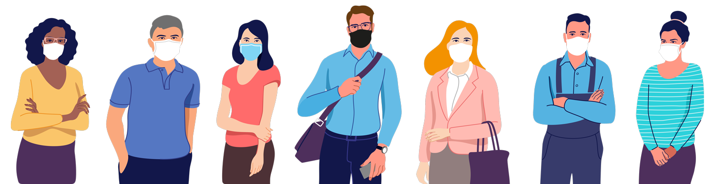

## When you wear a face mask some things to remember are:

HOW TO PUT ON A FACE MASK 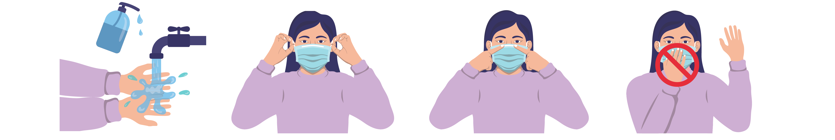

1 2 3 4

1. Wash your hands with soap and water or sanitiser.
2. Hold the mask by the sides. Tie the mask up behind your head or loop the ties around your ears.
3. Make sure the mask covers your mouth and nose. Press the nose piece around your nose to make sure there are no gaps.
4. Never touch the front of the mask.

HOW TO TAKE OFF A FACE MASK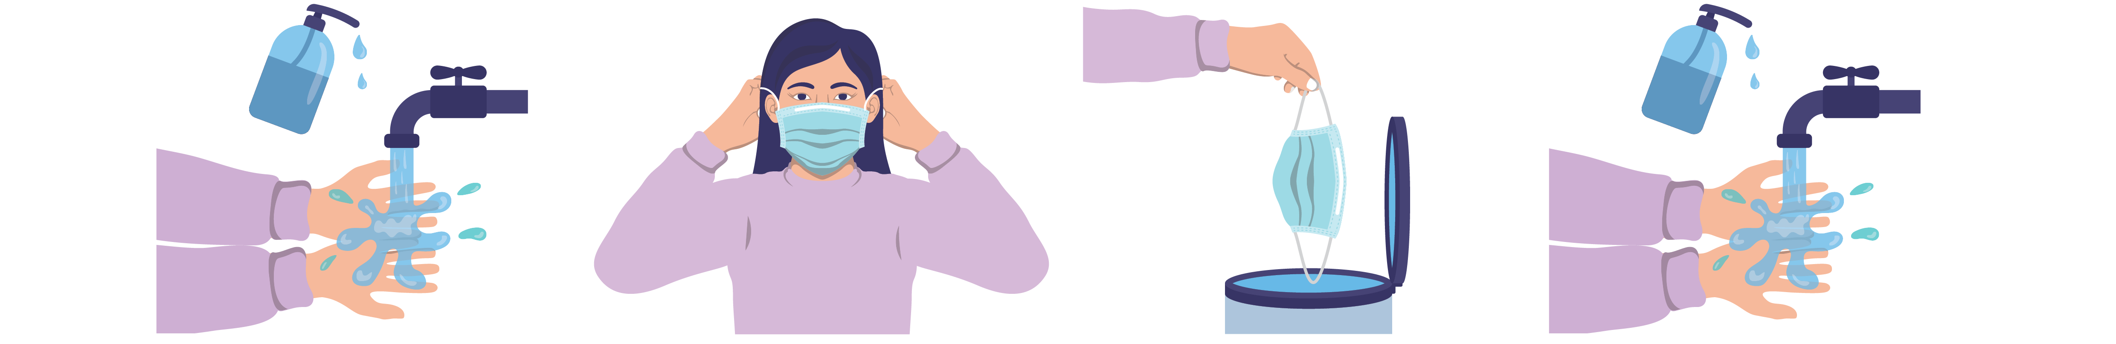

1 2 3 4

1. Wash your hands with soap and water or sanitiser.
2. Pull the ties or loops straight forward, away from your face. Take the mask off.
3. If your mask is disposable, throw it in the bin.
4. Wash your hands with soap and water or sanitiser one more time.

## Choosing a mask

You can use a cloth mask or a disposable mask. Remember that you can only use a disposable mask once. You can use a cloth mask more than once but you need to wash it. Masks are better than scarves for keeping you safe.

You can buy a mask or make your own cloth mask. It should cover your nose and mouth completely. You can also use a face shield.

Wash your hands before putting on or taking off a mask. Try not to touch your face.

More information about COVID-19:

<https://www.health.gov.au/resources/collections/novel-coronavirus-2019-ncov-resources> or <https://www.safetyandquality.gov.au/covid-19>

More information about face masks:

<https://www.dhhs.vic.gov.au/face-masks-covid-19>

<https://www.health.gov.au/news/health-alerts/novel-coronavirus-2019-ncov-health-alert/how-to-protect-yourself-and-others-from-coronavirus-covid-19/masks>

<https://www.who.int/emergencies/diseases/novel-coronavirus-2019/advice-for-public/when-and-how-to-use-masks>

[safetyandquality.gov.au](http://www.safetyandquality.gov.au)

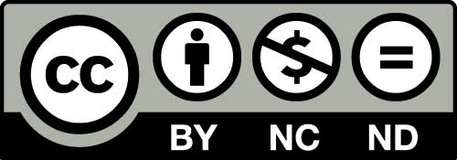

© Australian Commission on Safety and Quality in Health Care 2020