# Australian COmmission on Safety and Quality in Health Care logo with Radar imageOn the Radar

Issue 485

12 October 2020

*On the Radar* is a summary of some of the recent publications in the areas of safety and quality in health care. Inclusion in this document is not an endorsement or recommendation of any publication or provider. Access to particular documents may depend on whether they are Open Access or not, and/or your individual or institutional access to subscription sites/services. Material that may require subscription is included as it is considered relevant.

*On the Radar* is available online, via email or as a PDF or Word document from <https://www.safetyandquality.gov.au/publications-and-resources/newsletters/radar>

If you would like to receive *On the Radar* via email, you can subscribe on our website <https://www.safetyandquality.gov.au/publications-and-resources/newsletters>   
or by emailing us at H[Umail@safetyandquality.gov.auU](mailto:mail@safetyandquality.gov.au).   
You can also send feedback and comments to H[Umail@safetyandquality.gov.auU](mailto:mail@safetyandquality.gov.au).

For information about the Commission and its programs and publications, please visit <https://www.safetyandquality.gov.au>

You can also follow us on Twitter @ACSQHC.

**On the Radar**

Editor: Dr Niall Johnson [niall.johnson@safetyandquality.gov.au](mailto:niall.johnson@safetyandquality.gov.au)

Contributors: Niall Johnson

**COVID-19 resources**

https://www.safetyandquality.gov.au/covid-19

The Australian Commission on Safety and Quality in Health Care has developed a number of resources to assist healthcare organisations, facilities and clinicians. These and other material on COVID-19 are available at <https://www.safetyandquality.gov.au/covid-19>

The latest additions include:

* ***COVID-19: Aged care staff infection prevention and control precautions*** *poster*<https://www.safetyandquality.gov.au/publications-and-resources/resource-library/covid-19-aged-care-staff-infection-prevention-and-control-precautions-poster>  
    
  [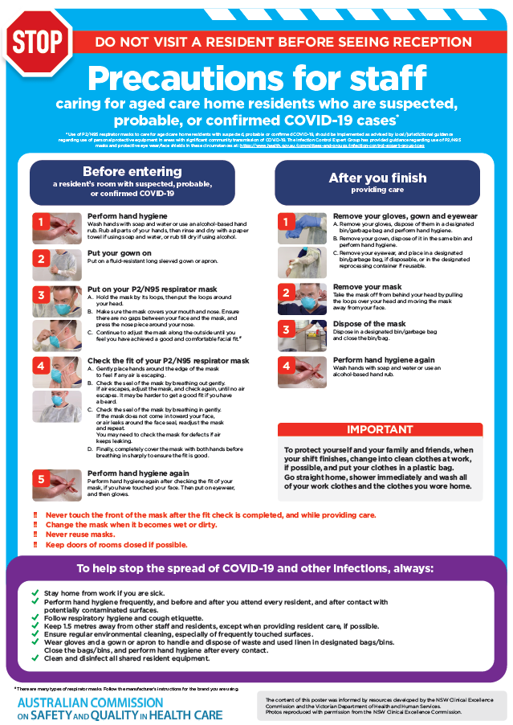](https://www.safetyandquality.gov.au/publications-and-resources/resource-library/covid-19-aged-care-staff-infection-prevention-and-control-precautions-poster)
* ***Environmental Cleaning and Infection Prevention and Control*** [www.safetyandquality.gov.au/environmental-cleaning](http://www.safetyandquality.gov.au/environmental-cleaning)
* ***Infection prevention and control Covid-19 PPE*** poster <https://www.safetyandquality.gov.au/publications-and-resources/resource-library/infection-prevention-and-control-covid-19-personal-protective-equipment>
* ***Special precautions for Covid-19 designated zones*** poster <https://www.safetyandquality.gov.au/publications-and-resources/resource-library/special-precautions-covid-19-designated-zones>
* ***COVID-19 infection prevention and control risk management – Guidance*** <https://www.safetyandquality.gov.au/publications-and-resources/resource-library/covid-19-infection-prevention-and-control-risk-management-guidance>
* ***Safe care for people with cognitive impairment during COVID-19***<https://www.safetyandquality.gov.au/our-work/cognitive-impairment/cognitive-impairment-and-covid-19>
* **Medicines Management COVID-19** <https://www.safetyandquality.gov.au/our-work/medication-safety/medicines-management-covid-19>, including position statements on medicine-related issues
  + ***Managing fever associated with COVID-19***
  + ***Managing a sore throat associated with COVID-19***
  + ***ACE inhibitors and ARBs in COVID-19***
  + ***Clozapine in COVID-19***
  + ***Management of patients on oral anticoagulants during COVID-19***
  + ***Ascorbic Acid: Intravenous high dose in COVID-19***
  + ***Treatment in acute care, including oxygen therapy and medicines to support intubation***
  + ***Nebulisation and COVID-19***
  + ***Managing intranasal administration of medicines during COVID-19***
  + ***Ongoing medicines management in high-risk patients***
  + ***Medicines shortages***
  + ***Conserving medicines***
  + ***Intravenous medicines administration in the event of an infusion pump shortage***
* ***Potential medicines to treat COVID-19***   
  <https://www.safetyandquality.gov.au/publications-and-resources/resource-library/potential-medicines-treat-covid-19>
* ***Break the chain of infection: Stopping COVID-19*** poster<https://www.safetyandquality.gov.au/publications-and-resources/resource-library/break-chain-poster-a3>  
  **[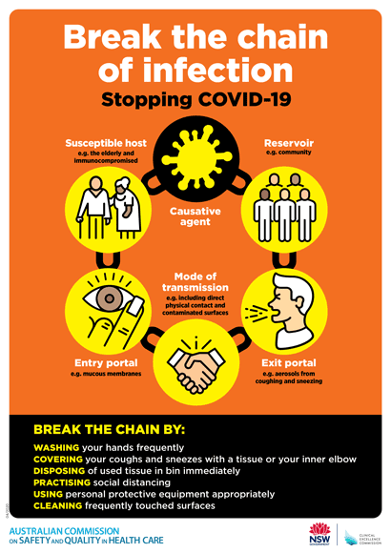](https://www.safetyandquality.gov.au/publications-and-resources/resource-library/break-chain-poster-a3https:/www.safetyandquality.gov.au/publications-and-resources/resource-library/break-chain-poster-a3)**
* ***COVID-19: Elective surgery and infection prevention and control precautions*** <https://www.safetyandquality.gov.au/publications-and-resources/resource-library/covid-19-elective-surgery-and-infection-prevention-and-control-precautions>
* ***FAQs for clinicians on elective surgery*** <https://www.safetyandquality.gov.au/node/5724>
* ***FAQs for consumers on elective surgery*** <https://www.safetyandquality.gov.au/node/5725>
* ***FAQs on community use of face masks***   
   <https://www.safetyandquality.gov.au/faqs-community-use-face-masks>
* ***COVID-19 and face masks – Information for consumers*** <https://www.safetyandquality.gov.au/publications-and-resources/resource-library/covid-19-and-face-masks-information-consumers>

[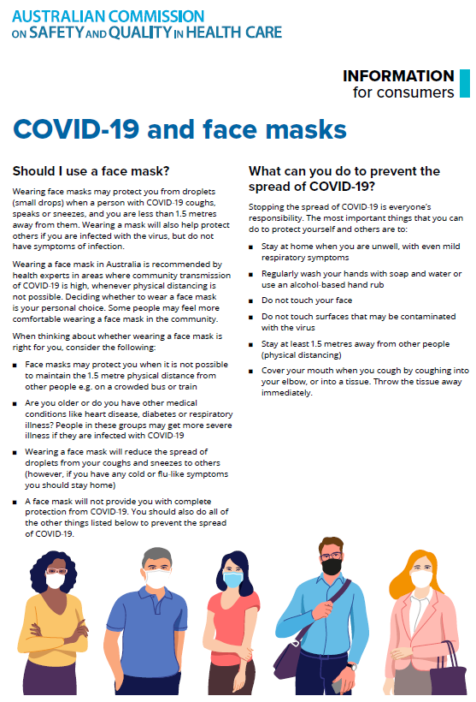](https://www.safetyandquality.gov.au/sites/default/files/2020-07/covid-19_and_face_masks_-_information_for_consumers.pdf)

**Journal articles**

*Individual, health system, and contextual barriers and facilitators for the implementation of clinical practice guidelines: a systematic metareview*

Correa VC, Lugo-Agudelo LH, Aguirre-Acevedo DC, Contreras JAP, Borrero AMP, Patiño-Lugo DF, et al.

Health Research Policy and Systems. 2020;18(1):74.

|  |  |
| --- | --- |
| DOI | <https://doi.org/10.1186/s12961-020-00588-8> |
| Notes | The translation of evidence into practice is known to be rather slow. One mechanism for this translation is the use of that evidence in developing and revising clinical practice guidelines. However, the existence of a guideline does not mean that there will be an automatic and immediate change in practice. This metareview examined 25 systematic reviews looking at the barriers and facilitators that affect the uptake of clinical practice guidelines. The metareview found:   * The relevant barriers in the social-political context were the **absence of a leader**, difficulties with **teamwork** and a lack of agreement with **colleagues**. * Relevant barriers in the health system were a lack of **time**, **financial** problems and a lack of specialised **personnel**. * Barriers of the CPGs included a **lack of clarity** and a **lack of credibility** in the evidence. * Regarding the health professional, a **lack of knowledge** about the CPG and **confidence** in oneself were relevant. * Regarding patients, a negative **attitude** towards implementation, a lack of **knowledge** about the CPG and sociocultural **beliefs** played a role. * Some of the most frequent **facilitators** were **consistent leadership**, **commitment** of the members of the team, **administrative support** of the institution, existence of **multidisciplinary teams**, application of **technology** to improve the practice and **education** regarding the guidelines. |

*Analysis of Risk Factors for Patient Safety Events Occurring in the Emergency Department*

Alsabri M, Boudi Z, Zoubeidi T, Alfaki IA, Levy P, Oneyji C, et al

Journal of Patient Safety. 2020 [epub].

|  |  |
| --- | --- |
| DOI | <https://doi.org/10.1097/PTS.0000000000000715> |
| Notes | Paper reporting on a retrospective study of 6 years of data covering 383,586 visits to examine risk factors for patient safety events in an emergency department (ED). In this study, the events included defined as adverse events, preventable AEs, and near-miss events. The papers reports on analyses that found a number of risk factors, including ‘ED waiting time, boarding time, ED length of stay (LOS), ED disposition. The odds of a patient safety event occurring ‘increased by 0.2% for each additional minute increase in the ED waiting time, by 5.2% for each additional boarding hour, and by 4.5% for each ED LOS hour.’ |

*Health Affairs*

Volume 39, No. 10, October 2020

|  |  |
| --- | --- |
| URL | <https://www.healthaffairs.org/toc/hlthaff/39/10> |
| Notes | A new issue of *Health Affairs* has been published with the theme of ‘**Children’s Health**’. Articles in this issue of *Health Affairs* include:   * How **COVID-19 Threatens The Safety Net For US Children** (J Bylander) * A **Statewide Approach To Improving Child Health** And Health Care (Rebecca Gale) * **Principles And Policies To Strengthen Child And Adolescent Health** And Well-Being (James M Perrin, Greg Duncan, Angela Diaz, and K Kelleher) * What We Say And What We Do: Why US **Investments In Children’s Health** Are Falling Short (Janet Currie) * **Racial And Ethnic Inequities In Children’s Neighborhoods**: Evidence From The New Child Opportunity Index 2.0 (Dolores Acevedo-Garcia, Clemens Noelke, Nancy McArdle, Nomi Sofer, Erin F Hardy, Michelle Weiner, Mikyung Baek, Nick Huntington, Rebecca Huber, and Jason Reece) * Measuring Equity From The Start: **Disparities In The Health Development Of US Kindergartners** (Neal Halfon, Efren Aguilar, Lisa Stanley, Emily Hotez, Eryn Block, and Magdalena Janus) * Childhood Origins Of **Intergenerational Health Mobility** In The United States (Jason Fletcher, and Katie Jajtner) * Child Health As A National Security Issue: **Obesity And Behavioral Health Conditions Among Military Children** (Tracey Pérez Koehlmoos, Amanda Banaag, Cathaleen King Madsen, and Terry Adirim) * Deconstructing The Rise In **Mental Health–Related ED Visits Among Children And Youth** In Ontario, Canada (Maria Chiu, Evgenia Gatov, Kinwah Fung, Paul Kurdyak, and Astrid Guttmann) * **Children And The Opioid Epidemic**: Age-Stratified Exposures And Harms (Kelby W Brown, Kayla Carlisle, Sudha R Raman, Peter Shrader, Megan Jiao, Michael J Smith, Lisa M Einhorn, and Charlene A Wong) * **Children’s Health Insurance Coverage**: Progress, Problems, And Priorities For 2021 And Beyond (Joan C Alker, G M Kenney, and S Rosenbaum) * Spreading Fear: The Announcement Of The Public Charge Rule Reduced Enrollment In **Child Safety-Net Programs** (Jeremy Barofsky, Ariadna Vargas, Dinardo Rodriguez, and Anthony Barrows) * **Children’s Oral Health**: Progress, Policy Development, And Priorities For Continued Improvement (James J Crall, and Marko Vujicic) * Variation In State Medicaid Implementation Of The ACA: The Case Of **Concurrent Care For Children** (Jessica Laird, Melanie J Cozad, Jessica Keim-Malpass, Jennifer W Mack, and Lisa C Lindley) * Changing The Face Of **Health Care Delivery: The Importance Of Youth Participation** (Linda S Sprague Martinez, Catalina Tang Yan, Astraea Augsberger, Uchenna J Ndulue, Emanuel Ayinde Libsch, Ja’Karri S Pierre, Elmer Freeman, and Katherine Gergen Barnett) * **Economy-Sensitive Conditions**: Are Some Pediatric Hospitalizations Triggered By Economic Recessions? (Jeffrey D Colvin, Troy Richardson, Donna K Ginther, Matt Hall, and Paul J.Chung) * A Novel Health-Transportation Partnership Paves The Road For **Young Driver Safety** Through Virtual Assessment (Elizabeth A Walshe, Daniel Romer, Venkatesh Kandadai, and Flaura K. Winston) * **Pediatric Drug Policies** Supporting Safe And Effective Use Of Therapeutics In Children: A Systematic Analysis (Mary Carmack, Thomas Hwang, and Florence T Bourgeois) * Trends In **Orphan Drug Spending And Out-Of-Pocket Spending Among US Children**, 2013–18 (Kao-Ping Chua, and Rena M Conti) * **Severe Staffing And Personal Protective Equipment Shortages Faced By Nursing Homes During The COVID-19 Pandemic** (Brian E McGarry, David C Grabowski, and Michael L Barnett) * **COVID-19 Has Increased Medicaid Enrollment**, But Short-Term Enrollment Changes Are Unrelated To Job Losses (Chris Frenier, Sayeh S Nikpay, and Ezra Golberstein) * A Mother In Wonderland: Securing **Services For My Blind Child** (C Keirns) |

*Journal of Patient Experience*

Volume 7, Number 4 (August 2020)

|  |  |
| --- | --- |
| URL | <https://journals.sagepub.com/toc/jpxa/7/4> |
| Notes | A new issue of the *Journal of Patient Experience* has been published. Articles in this issue of the *Journal of Patient Experience* include:   * Editorial: **Microsuffering**: Lessons From a Pinky Finger (Laura Cooley) * **Am I a “COVID-19 Patient” or “a Patient With COVID-19”?** (Elapulli Sankaranarayanan Prakash) * **Digital Clinician–Patient Consultation** for Dermatology Care in Stressful COVID-19 Environment (Karin Milleni Araujo and Rafael Denadai) * Visitor Restrictions During COVID-19 Pandemic May Impact **Surrogate Medical Decision-Making** (Rachel Bronsther) * Why **Companion Animals** Are Beneficial During COVID-19 Pandemic (Unnati G Hunjan and Jayasankara Reddy) * Mental Health and COVID-19: Implications for the Future of **Telehealth** (Emily Pfender) * **Safety-Net Hospitals** as Community Anchors in COVID-19 (Lucia Calthorpe, Eric Isaacs, and Anna Chang) * **Thalassemia**: With the “Red” in the Bag Amid COVID-19 Reflections (Veeresh Pavate) * The Unique Challenges and Lessons Imparted by the **Cystic Fibrosis** Community in the Time of COVID-19 Pandemic (Sigrid Ladores) * These Are Still Good Days to Heal: **Cancer Care and the Covid-19 Pandemic** (Lance Isidore G Catedral) * **Long-Term Care and COVID-19**, What’s Next? (Judith Hold, Mary Dioise Ramos, and Rita Mahmoud) * A **Patient Experience Course Syllabus**: Integrating Service Sciences Research to Enhance Health-Care Delivery (Priyanka D Joshi, Stowe Shoemaker, Corrin C Sullivan, and Neelesh R Soman) * From Surveys to Skill Sets: **Improving Patient Experience by Supporting Clinician Well-Being** (Jeffrey H Millstein) * A **Cancer Patient’s Experience With a Rare But Serious Adverse Event** (Amlan RayChaudhury) * **The Other Side of the Bedside** (Jessica A Schmitt) * **What Will Keep Me Coming Back to the Clinic**: Factors Identified by Filipino Colorectal Cancer Patients Seen at a National Academic Referral Center (Danielle Benedict Sacdalan, Josephine Anne Lucero, Frederic Ivan Ting, and Dennis Lee Sacdalan) * **Patient Complaints**: Patients’ and Physicians’ Interaction in Handling Complex Requests of Care (Sanna Ryynänen) * **Satisfaction With Services** Among Attendees of Physiotherapy Outpatient Clinics in Tertiary Hospitals in Lagos State (Ijeoma Jane Odumodu, Tolulope Florence Olufunlayo, Babatunde Enitan Ogunnowo, and Michael Ebe Kalu) * Exploring the **Provider Preferences of Multiracial Patients** (Cyndy R Snyder and Anjali R Truitt) * Feasibility of **Collecting Multiple Patient-Reported Outcome Measures** Alongside the Dutch Arthroplasty Register (Claire Tilbury, Claudia S Leichtenberg, Bart L Kaptein, Lennard A Koster, Suzan H M Verdegaal, Ron Onstenk, Henrike M J van der Linden-van der Zwaag, Rover Krips, Herman H Kaptijn, Stephan B W Vehmeijer, Willem-Jan C M Marijnissen, Jorit J L Meesters, Stephanie M van Rooden, Ronald Brand, Rob G H H Nelissen, Maaike G J Gademan, and Thea P M Vliet Vlieland) * Water on Fire: The Patients’ Lived Experience of **Primary Percutaneous Coronary Intervention** (Nazila Javadi-Pashaki, Arsalan Salari, and Abdolhosein Emami Sigaroudi) * Assessment of **Written Patient Information** Pertaining to Cirrhosis and Its Complications: A Pilot Study (Lea Ladegaard Grønkjær, Kirsten Berg, Rikke Søndergaard, and Majbritt Møller) * **Improper Communication** Makes for Squat: A Qualitative Study of the Health-Care Processes Experienced By Older Adults in a Clinical Trial for Back Pain (Breanne M Wells, Stacie A Salsbury, Lia M Nightingale, Dustin C Derby, Dana J Lawrence, and Christine M Goertz) * Peoples’ Experiences With Pouches (PEWP) Study: **Ostomate–Provider Interactions** (Leslie Riggle Miller and B Mitchell Peck) * A Multifaceted Approach to Improve **Physician Communication Scores** (Ryan McCaffrey, Dane Hale, Schawan Kunupakaphun, Laura Kaufman, and Pracha Eamranond) * **Patient Views of Behavioral Health Providers in Primary Care**: A Qualitative Study of 2 Southeastern Clinics (Aubry N Koehler, Grisel Trejo, Joanne C Sandberg, Brittany H Swain, Gail S Marion, and Julienne K Kirk) * Translating **Provider and Staff Engagement** Results to Actionable Planning and Outcomes (Roberto Cardarelli, Madeline Slimack, Ginny Gottschalk, Michael Ruszkowski, Jessica Sass, Kristen Brown, Rachel Kikendall, John J Allard, Kelly Burgess, Maggie Luoma, and Wanda Gonsalves) * **Obtaining Patient Priorities** in a Multiple Sclerosis Comprehensive Care Center: Beyond Patient-Reported Outcomes (Deborah M Miller, Brandon Moss, Susannah Rose, Hong Li, David Schindler, Malory Weber, Sarah M Planchon, Jay Alberts, Adrienne Boissy, and Robert Bermel) * Wait Times in Musculoskeletal Patients: What Contributes to **Patient Satisfaction** (Georgina Glogovac, Mark E Kennedy, Maria R Weisgerber, Rafael Kakazu, and Brian M Grawe) * The Influence of In-Group Membership on **Trust in Health-Care Professionals** in Kazakhstan (Brett J Craig, Gulaiim Almatkyzy, and Yuliya Yurashevich) * **Caregivers’ Experiences Regarding Training and Support** in the Post-Acute Home Health-Care Setting (Jo-Ana D Chase, David Russell, Meridith Rice, Carmen Abbott, Kathryn H Bowles, and David R Mehr) * Telling the Story of **Childhood Cancer**—The Experience of Families After Treatment (Penelope J Slater) * “I Wish Someone Had Told Me That Could Happen”: A Thematic Analysis of Patients’ Unexpected Experiences With **End-Stage Kidney Disease Treatment** (Nicole DePasquale, Ashley Cabacungan, Patti L Ephraim, LaPricia Lewis-Boyér, Clarissa J Diamantidis, Neil R Powe, and L E Boulware) * Health-Care Reform in Saudi Arabia: **Patient Experience at Primary Health-Care Centers** (Mohammed Senitan and James Gillespie) * Mixed Messages: I. The Consequences of **Communicating Negative Statements** Within Emotional Support Messages to Cancer Patients (Colter D Ray, Kory Floyd, Cris J Tietsort, Alaina M Veluscek, Christopher D Otmar, Emi C Hashi, and Rosalie Fisher) * Measurement of **Perceived Physician Empathy** in Orthopedic Patients (Mark Hendrik Franciscus Keulen, Teun Teunis, Joost Teunis Pieter Kortlever, Gregg Alan Vagner, David Ring, and Lee Matthew Reichel) * **Rural Disparities in Hospital Patient Satisfaction**: Multilevel Analysis of the Massachusetts AHA, SID, and HCAHPS Data (Yu (Sunny) Kang, Huey-Ming Tzeng, and Ting Zhang) * Experiences of **Patient Incivility**: A Qualitative Study (Emily A Vargas and Ramaswami Mahalingam) * Recognizing the Dying Patient, When Less Could be More: A Diagnostic Framework for **Shared Decision-Making at the End of Life** (Dilraj Kalsi, Joel Ward, Regent Lee, Bee Wee, Kenneth WM Fulford, and Ashok Handa) |

*BMJ Quality & Safety* online first articles

|  |  |
| --- | --- |
| URL | <https://qualitysafety.bmj.com/content/early/recent> |
| Notes | *BMJ Quality &Safety* has published a number of ‘online first’ articles, including:   * Use of **telecritical care for family visitation to ICU** during the COVID-19 pandemic: an interview study and sentiment analysis (Farzan Sasangohar, Atiya Dhala, Feibi Zheng, Nima Ahmadi, Bita Kash, Faisal Masud) * Effects of **night surgery on postoperative mortality and morbidity**: a multicentre cohort study (Friederike C Althoff, Luca J Wachtendorf, Paul Rostin, Peter Santer, Maximilian S Schaefer, Xinling Xu, Stephanie D Grabitz, Hovig Chitilian, Timothy T Houle, Gabriel A Brat, Oluwaseun Akeju, Matthias Eikermann) * A realist synthesis of **quality improvement curricula in undergraduate and postgraduate medical education**: what works, for whom, and in what contexts? (Allison Brown, Kyle Lafreniere, David Freedman, Aditya Nidumolu, Matthew Mancuso, Kent Hecker, Aliya Kassam) * **Continuous quality improvement in statistical code**: avoiding errors and improving transparency (Thomas S Valley, Neil Kamdar, Wyndy L Wiitala, Andrew M Ryan, Sarah M Seelye, Akbar K Waljee, Brahmajee K Nallamothu) |

*International Journal for Quality in Health Care* online first articles

|  |  |
| --- | --- |
| URL | <https://academic.oup.com/intqhc/advance-articles> |
| Notes | *International Journal for Quality in Health Care* has published a number of ‘online first’ articles, including:   * Changes in compensation claim contents following **reorganization of emergency hospital care** (Søren Birkeland, Mikkel Brabrand, Kim Lyngby Mikkelsen, Søren Bie Bogh) |

**Online resources**

*Clinical Communiqué*

<https://www.thecommuniques.com/post/clinical-communiqu%C3%A9-volume-7-issue-3-september-2020>

Volume 7 Issue 3, September 2020

This issue of *Clinical Communiqué* focuses on the safety of health care workers (HCW), particularly in light of the COVID-19 pandemic. The focus is on the issue of **psychological safety for health care workers** during the COVID-19 pandemic, and includes the importance of acting now to reduce harm in the long term. This issue features four expert commentaries from clinical leaders in their fields, who offer practical and persuasive guidance on strategies to address the significant risks to health care workers of working in a COVID-19 environment.

*National COVID-19 Clinical Evidence Taskforce*

<https://covid19evidence.net.au/>

The National COVID-19 Clinical Evidence Taskforce is a collaboration of peak health professional bodies across Australia whose members are providing clinical care to people with COVID-19. The taskforce is undertaking continuous evidence surveillance to identify and rapidly synthesise emerging research in order to provide national, **evidence-based guidelines and clinical flowcharts for the clinical care of people with COVID-19**. The guidelines address questions that are specific to managing COVID-19 and cover the full disease course across mild, moderate, severe and critical illness. These are ‘living’ guidelines, updated with new research in near real-time in order to give reliable, up-to-the minute advice to clinicians providing frontline care in this unprecedented global health crisis.

*COVID-19 Critical Intelligence Unit*

<https://www.aci.health.nsw.gov.au/covid-19/critical-intelligence-unit>

The Agency for Clinical Innovation (ACI) in New South Wales has developed this page summarising rapid, evidence-based advice during the COVID-19 pandemic. Its operations focus on systems intelligence, clinical intelligence and evidence integration. The content includes a daily evidence digest and evidence checks on a discrete topic or question relating to the current COVID-19 pandemic. Recent evidence checks include:

* ***Elective surgical procedures, non-surgical alternatives and shared decision-making***
* ***Waste from personal protective equipment.***

[*UK] NICE Guidelines and Quality Standards*

<https://www.nice.org.uk/guidance>

The UK’s National Institute for Health and Care Excellence (NICE) has published new (or updated) guidelines and quality standards. The latest reviews or updates are:

* NICE GuidelineNG170 *COVID-19 rapid guideline:* ***cystic fibrosis*** <https://www.nice.org.uk/guidance/ng170>
* NICE Guideline NG183 ***Behaviour change****: digital and mobile health interventions* <https://www.nice.org.uk/guidance/ng183>

*[USA] Effective Health Care Program reports*

<https://effectivehealthcare.ahrq.gov/>

The US Agency for Healthcare Research and Quality (AHRQ) has an Effective Health Care (EHC) Program. The EHC has released the following final reports and updates:

* ***Resource Allocation and Pandemic Response****: An Evidence Synthesis To Inform Decision Making* <https://effectivehealthcare.ahrq.gov/products/allocation-scarce-resources/rapid-review>
* *No-Touch Modalities for* ***Disinfecting Patient Rooms in Acute Care Settings****: A Rapid Review* <https://effectivehealthcare.ahrq.gov/products/no-touch-disinfection/rapid-research>

**Disclaimer**

On the Radar is an information resource of the Australian Commission on Safety and Quality in Health Care. The Commission is not responsible for the content of, nor does it endorse, any articles or sites listed. The Commission accepts no liability for the information or advice provided by these external links. Links are provided on the basis that users make their own decisions about the accuracy, currency and reliability of the information contained therein. Any opinions expressed are not necessarily those of the Australian Commission on Safety and Quality in Health Care.