# Australian COmmission on Safety and Quality in Health Care logo with Radar imageOn the Radar

Issue 494

14 December 2020

*On the Radar* is a summary of some of the recent publications in the areas of safety and quality in health care. Inclusion in this document is not an endorsement or recommendation of any publication or provider. Access to particular documents may depend on whether they are Open Access or not, and/or your individual or institutional access to subscription sites/services. Material that may require subscription is included as it is considered relevant.

*On the Radar* is available online, via email or as a PDF or Word document from <https://www.safetyandquality.gov.au/publications-and-resources/newsletters/radar>

If you would like to receive *On the Radar* via email, you can subscribe on our website <https://www.safetyandquality.gov.au/publications-and-resources/newsletters>   
or by emailing us at H[Umail@safetyandquality.gov.auU](mailto:mail@safetyandquality.gov.au).   
You can also send feedback and comments to H[Umail@safetyandquality.gov.auU](mailto:mail@safetyandquality.gov.au).

For information about the Commission and its programs and publications, please visit <https://www.safetyandquality.gov.au>

You can also follow us on Twitter @ACSQHC.

**On the Radar**

Editor: Dr Niall Johnson [niall.johnson@safetyandquality.gov.au](mailto:niall.johnson@safetyandquality.gov.au)

Contributors: Niall Johnson, Kathy Meleady, Angela Kim

**COVID-19 resources**

https://www.safetyandquality.gov.au/covid-19

The Australian Commission on Safety and Quality in Health Care has developed a number of resources to assist healthcare organisations, facilities and clinicians. These and other material on COVID-19 are available at <https://www.safetyandquality.gov.au/covid-19>

The latest additions include:

* ***COVID-19: Aged care staff infection prevention and control precautions*** *poster*<https://www.safetyandquality.gov.au/publications-and-resources/resource-library/covid-19-aged-care-staff-infection-prevention-and-control-precautions-poster>  
    
  [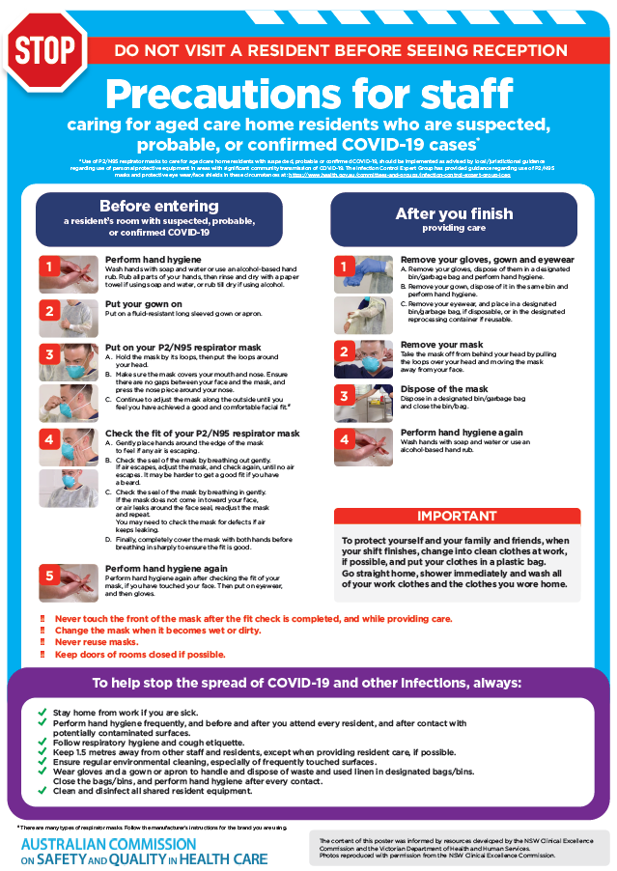](https://www.safetyandquality.gov.au/publications-and-resources/resource-library/covid-19-aged-care-staff-infection-prevention-and-control-precautions-poster)
* ***Environmental Cleaning and Infection Prevention and Control*** [www.safetyandquality.gov.au/environmental-cleaning](http://www.safetyandquality.gov.au/environmental-cleaning)
* ***Infection prevention and control Covid-19 PPE*** poster <https://www.safetyandquality.gov.au/publications-and-resources/resource-library/infection-prevention-and-control-covid-19-personal-protective-equipment>
* ***Special precautions for Covid-19 designated zones*** poster <https://www.safetyandquality.gov.au/publications-and-resources/resource-library/special-precautions-covid-19-designated-zones>
* ***COVID-19 infection prevention and control risk management – Guidance*** <https://www.safetyandquality.gov.au/publications-and-resources/resource-library/covid-19-infection-prevention-and-control-risk-management-guidance>
* ***Safe care for people with cognitive impairment during COVID-19***<https://www.safetyandquality.gov.au/our-work/cognitive-impairment/cognitive-impairment-and-covid-19>
* **Medicines Management COVID-19** <https://www.safetyandquality.gov.au/our-work/medication-safety/medicines-management-covid-19>, including position statements on medicine-related issues
  + ***Managing fever associated with COVID-19***
  + ***Managing a sore throat associated with COVID-19***
  + ***ACE inhibitors and ARBs in COVID-19***
  + ***Clozapine in COVID-19***
  + ***Management of patients on oral anticoagulants during COVID-19***
  + ***Ascorbic Acid: Intravenous high dose in COVID-19***
  + ***Treatment in acute care, including oxygen therapy and medicines to support intubation***
  + ***Nebulisation and COVID-19***
  + ***Managing intranasal administration of medicines during COVID-19***
  + ***Ongoing medicines management in high-risk patients***
  + ***Medicines shortages***
  + ***Conserving medicines***
  + ***Intravenous medicines administration in the event of an infusion pump shortage***
* ***Potential medicines to treat COVID-19***   
  <https://www.safetyandquality.gov.au/publications-and-resources/resource-library/potential-medicines-treat-covid-19>
* ***Break the chain of infection: Stopping COVID-19*** poster<https://www.safetyandquality.gov.au/publications-and-resources/resource-library/break-chain-poster-a3>  
  **[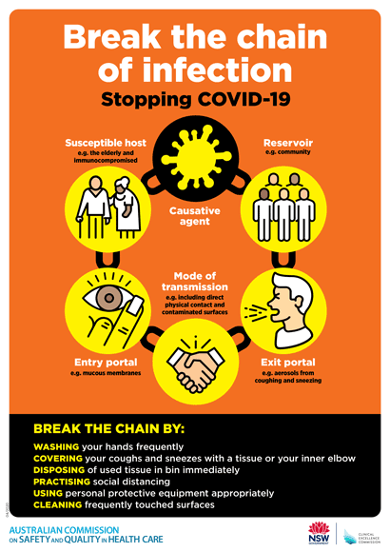](https://www.safetyandquality.gov.au/publications-and-resources/resource-library/break-chain-poster-a3https:/www.safetyandquality.gov.au/publications-and-resources/resource-library/break-chain-poster-a3)**
* ***COVID-19: Elective surgery and infection prevention and control precautions*** <https://www.safetyandquality.gov.au/publications-and-resources/resource-library/covid-19-elective-surgery-and-infection-prevention-and-control-precautions>
* ***FAQs for clinicians on elective surgery*** <https://www.safetyandquality.gov.au/node/5724>
* ***FAQs for consumers on elective surgery*** <https://www.safetyandquality.gov.au/node/5725>
* ***FAQs on community use of face masks***   
   <https://www.safetyandquality.gov.au/faqs-community-use-face-masks>
* ***COVID-19 and face masks – Information for consumers*** <https://www.safetyandquality.gov.au/publications-and-resources/resource-library/covid-19-and-face-masks-information-consumers>  
  The Commission’s fact sheet on use of face masks in the community to reduce the spread of COVID-19 is now available in Easy English and 10 other community languages from <https://www.safetyandquality.gov.au/wearing-face-masks-community>.  
  The factsheet was developed to help people understand when it is important to wear a mask to reduce the risk of the spread of COVID-19, and to explain how to safely put on and remove face masks. It also reinforces the importance of staying home if you have symptoms, physical distancing, hand hygiene and cough etiquette.

[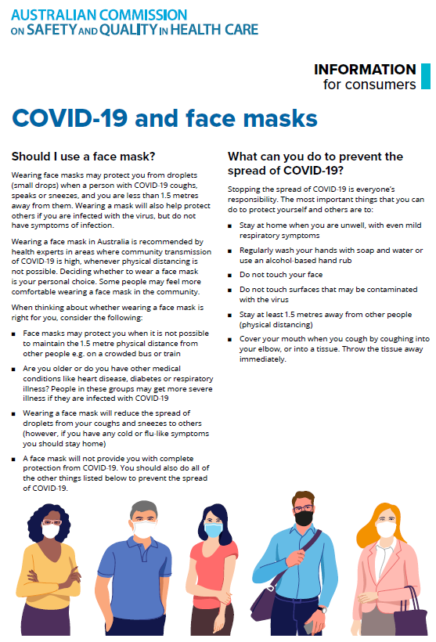](https://www.safetyandquality.gov.au/sites/default/files/2020-07/covid-19_and_face_masks_-_information_for_consumers.pdf)

**Patient Placement Guide – Infection Prevention and Control**

Australian Commission on Safety and Quality in Health Care

Sydney: ACSQHC; 2020. p. 4.

<https://www.safetyandquality.gov.au/IPC-patient-placement>

The Australian Commission on Safety and Quality in Health Care has developed this additional resource to support infection prevention and control. This resource is aimed at supporting decision-making regarding appropriate bed allocation, particularly when local infection prevention and control (IPC) advice may not be available.

Patients are potentially at risk of acquiring, and transmitting, infectious conditions to other patients and healthcare workers. Patients should be assessed on, and during admission, to ensure that their bed allocation is both appropriate and timely. Patient placement is an important element of transmission-based precautions, along with the use of dedicated equipment, the use of appropriate PPE, and effective environmental cleaning.

Common infectious conditions in both the adult and paediatric populations have been considered, providing a framework for health services in metropolitan, rural and remote areas. Local adaptation is recommended to appropriately consider individual circumstances.

The guidance is based on the *Australian Guidelines for the Prevention and Control of Infection in Healthcare*.

[](https://www.safetyandquality.gov.au/our-work/mental-health/escalation-mapping-template)

**Escalation Mapping Template**

Australian Commission on Safety and Quality in Health Care

Sydney: ACSQHC; 2020.

<https://www.safetyandquality.gov.au/our-work/mental-health/escalation-mapping-template>

The Australian Commission on Safety and Quality in Health Care has released an *Escalation Mapping Template* (EMT) to assist health service organisations to assess the efficacy of their systems for recognising and responding to deterioration in a person’s mental state.

The EMT is a quality improvement tool to support health service organisations to identify existing processes for recognising and responding to deterioration in a person’s mental state. The EMT supports services to map the alignment of their local processes to the systemic recognition and response model and to evaluate if their processes are effective. It contains links to resources currently used in clinical practice in health settings across Australia.

The EMT will also support services to implement actions in the National Safety and Quality Health Service (NSQHS) Standards.

The EMT is available on the Commission’s website and can be accessed at <https://www.safetyandquality.gov.au/our-work/mental-health/escalation-mapping-template>

Please contact [mentalhealth@safetyandquality.gov.au](mailto:mentalhealth@safetyandquality.gov.au) if you have any enquiries in relation to this resource.

**Reports**

*The Life and Death of Elizabeth Dixon: A Catalyst for Change. Report of the Independent Investigation*

Kirkup B

London: Her Majesty's Stationery Office; 2020. p. 120.

|  |  |
| --- | --- |
| URL | <https://www.gov.uk/government/publications/the-life-and-death-of-elizabeth-dixon-a-catalyst-for-change> |
| Notes | Tragic cases can be instructive and transformational. This independent report into the death of a young child in London in 2001 reveals lapses in care and has led to a series of recommendations.  Elizabeth Dixon was a child with special health needs. She had been born prematurely at Frimley Park Hospital in England on 14 December 2000. Following treatment and care at the specialist paediatric Great Ormond Street Hospital in London and a children’s hospice she was nursed at home under a care package. As a result of a failure to clear a tracheostomy tube she asphyxiated and was pronounced dead at Frimley Park hospital on 4 December 2001.  The chair of the investigation makes the observation that ‘Elizabeth’s profound disability and death could have been avoided had basic clinical principles been followed. There were failures of care by every organisation that looked after her, none of which was admitted at the time, nor properly investigated then or later.’ Specific errors included missed diagnosis, errors in treatment, failure to recognise and respond appropriately and inadequate clinician expertise.  The recommendations contained in the report address a number of issues, including guidance and protocols, community care, clinical governance, training, open disclosure, accountability, complaints, etc. |

**Journal articles**

*Association of Display of Patient Photographs in the Electronic Health Record With Wrong-Patient Order Entry Errors*

Salmasian H, Blanchfield BB, Joyce K, Centeio K, Schiff GB, Wright A, et al

JAMA Network Open. 2020;3(11):e2019652-e2019652.

|  |  |
| --- | --- |
| DOI | <https://doi.org/10.1001/jamanetworkopen.2020.19652> |
| Notes | Medication errors are among the most common of medical errors and the potential for harm ranges from trivial to mortal. This article suggests a relatively simple solution to the issue of misidentification of patients and the creation of wrong-patient order entry (WPOE) errors. The paper reports on a study in the emergency department of a large hospital in the USA that displayed a patient’s photograph in the electronic health record. In the study period, 2,558,746 orders were entered fir 71,851 patient and the authors report that ‘The risk of WPOE errors was significantly lower when the patient’s photograph was displayed in the EHR (odds ratio, 0.72; 95% CI, 0.57-0.89). After this risk was adjusted for potential confounders using multivariable logistic regression, the effect size remained essentially the same (odds ratio, 0.57; 95% CI, 0.52-0.61). Risk of error was significantly lower in patients with higher acuity levels and among patients whose race was documented as White.’ This may appear a simple solution to a common issue. However, could it raise other issues, such as consent, privacy concerns and security and currency of those images. |

For information on the Commission’s work on medication safety, including electronic medication management, see <https://www.safetyandquality.gov.au/our-work/medication-safety>

*Public Health Research & Practice*

Volume 30 Issue 4 December 2020

|  |  |
| --- | --- |
| URL | <https://www.phrp.com.au/issues/december-2020-volume-30-issue-4/> |
| Notes | A new issue of *Public Health Research & Practice* has been published with a focus on **Extreme events: how do public health systems learn and adapt?** Articles in this issue of *Public Health Research & Practice* include:   * Editorial: **Extreme events: how do public health systems learn and adapt?** (Jean-Frédéric Levesque, Mark Harris_ * The **Australian health system response to COVID-19** from a resilient health care perspective: what have we learned? (Robyn Clay-Williams, Frances Rapport, Jeffrey Braithwaite) * **How has COVID-19 impacted cancer screening?** Adaptation of services and the future outlook in Australia (Eleonora Feletto, Paul Grogan, Carolyn Nickson, Megan Smith, Karen Canfell) * Reflections on **a highly unusual summer: bushfires, COVID-19 and mosquito-borne disease** in NSW, Australia (Cameron E Webb) * **Converging crises: public interest journalism, the pandemic and public health** (Melissa A Sweet, Megan Williams, Ruth Armstrong, Janine Mohamed, Summer May Finlay, Amy Coopes) * **Black Summer** in the Shoalhaven, NSW: what was it like and what could we do better? A resident’s perspective (Debbie Killian) * **Impact of COVID-19 on healthcare activity** in NSW, Australia (Kim Sutherland, Julia Chessman, Jiaying Zhao, Grant Sara, Amith Shetty, Sharon Smith, Allan Went, Sophie Dyson, Jean-Frédéric Levesque) * **Health literacy and disparities in COVID-19**–related knowledge, attitudes, beliefs and behaviours in Australia (Kirsten J McCaffery, Rachael H Dodd, Erin Cvejic, Julie Ayre, Carys Batcup, Jennifer MJ Isautier, Tessa Copp, Carissa Bonner, Kristen Pickles, Brooke Nickel, Thomas Dakin, Samuel Cornell, Michael S Wolf) * A **mass mortality event in bats caused by extreme heat**: surprising public health challenges (Lea Merone, Carlie Thirlwell, Juliet Esmonde, Richard Gair) * **High community burden of smoke-related symptoms** in the Hunter and New England regions during the 2019–2020 Australian bushfires (Zachary L Howard, Sandra J Carlson, Zoe Baldwin, Fay Johnston, David N Durrheim, Craig B Dalton) |

*Journal of Patient Safety and Risk Management*

Volume: 25, Number: 6 (December 2020)

|  |  |
| --- | --- |
| URL | <https://journals.sagepub.com/toc/cric/25/6> |
| Notes | A new issue of the *Journal of Patient Safety and Risk Management* has been published. Articles in this issue of the *Journal of Patient Safety and Risk Management* include:   * Editorial: In a time of crisis, reaching for **tools to improve patient safety** (Albert W Wu ) * **Guidance vs. guidelines**: the role of **evidence-based medicine in the COVID-19 pandemic** (Lisa M Kodadek, Jonathan C Berger, and E R Haut) * What is the **role of technology in improving patient safety**? A French, German and UK healthcare professional perspective (Alain Astier, Jean Carlet, Torsten Hoppe-Tichy, Ann Jacklin, Annette Jeanes, Steve McManus, Mathias W Pletz, Harald Seifert, and Ray Fitzpatrick) * Improved handoff quality and reduction in adverse events following implementation of a Spanish-language version of the **I-PASS bundle for pediatric hospitalized patients** in Argentina (Facundo Jorro Barón, Celina Diaz Pumara, María Agustina Janer Tittarelli, Agustina Raimondo, Marcela Urtasun, and Lucila Valentini) * Improving the quality of the daily ward round in a Plastic Surgery unit by adapting the **SAFE Ward Round Tool** of the Royal College of Surgeons of Edinburgh (Harry D Koumoullis, Martin Shapev, Gabriel Wong, Sophie Gerring, Goerge Patrinios, Ivan Depasquale, and Jamil S Ahmed) * Characterising the types of **paediatric adverse events** detected by the global trigger tool – CareTrack Kids (Peter D Hibbert, William B Runciman, Andrew Carson-Stevens, Peter Lachman, Gavin Wheaton, Andrew R Hallahan, Adam Jaffe, Les White, Stephen Muething, Louise K Wiles, Charlotte J Molloy, Anita Deakin, and Jeffrey Braithwaite) * **Measuring patient safety culture**: A study at a teaching hospital in Ghana (Musilimu Muftawu and Ece Ugurluoglu Aldogan) * A review and commentary on the report of the **Gosport Independent Panel** (Justin Valentine) |

*Health Affairs*

Volume 39, No. 12, December 2020

|  |  |
| --- | --- |
| URL | <https://www.healthaffairs.org/toc/hlthaff/39/12> |
| Notes | A new issue of *Health Affairs* has been published with the theme of ‘**Climate & Health**’. Articles in this issue of *Health Affairs* include:   * Pressured By Students, **Medical Schools Grapple With Climate Change** (Michele Cohen Marill) * **Health Risks Due To Climate Change**: Inequity In Causes And Consequences (Kristie L Ebi and Jeremy J Hess) * **Adding A Climate Lens To Health Policy** In The United States (Renee N Salas, Tynan H Friend, Aaron Bernstein, and Ashish K Jha) * **Health Care Pollution And Public Health Damage** In The United States: An Update (Matthew J Eckelman, Kaixin Huang, Robert Lagasse, Emily Senay, Robert Dubrow, and Jodi D Sherman) * Health Care Sustainability Metrics: Building **A Safer, Low-Carbon Health System** (Martin Hensher and Forbes McGain) * **Transforming The Medical Device Industry**: Road Map To A Circular Economy (Andrea J MacNeill, Harriet Hopf, Aman Khanuja, Saed Alizamir, Melissa Bilec, Matthew J Eckelman, Lyndon Hernandez, Forbes McGain, Kari Simonsen, Cassandra Thiel, Steven Young, Robert Lagasse, and J D Sherman) * Estimating The Costs Of Inaction And The Economic Benefits Of Addressing The **Health Harms Of Climate Change** (Vijay S Limaye, Wendy Max, Juanita Constible, and Kim Knowlton) * **Valuing Health Impacts In Climate Policy**: Ethical Issues And Economic Challenges (Noah Scovronick, M Ferranna, F Dennig, and M Budolfson) * Measuring The **Impact Of Air Pollution On Health Care Costs** (Howard G Birnbaum, Christopher D Carley, Urvi Desai, Susan Ou, and P R Zuckerman) * Scrambling For Safety In The Eye Of Dorian: **Mental Health Consequences Of Exposure To A Climate-Driven Hurricane** (James M Shultz, Duane E Sands, Nadia Holder-Hamilton, William Hamilton, Sandeep Goud, Krista Marie Nottage, Zelde Espinel, S Friedman, C Fugate, J P Kossin, and S Galea) * **Mitigating Health Disparities After Natural Disasters**: Lessons From The RISK Project (Ethan J Raker, Mariana C Arcaya, Sarah R Lowe, Meghan Zacher, Jean Rhodes, and Mary C Waters) * Management Of **Chronic Noncommunicable Diseases After Natural Disasters** In The Caribbean: A Scoping Review (Saria Hassan, Mytien Nguyen, Morgan Buchanan, Alyssa Grimshaw, Oswald P Adams, Trevor Hassell, LaVerne Ragster, and Marcella Nunez-Smith) * Alignment Of US School Lunches With The **EAT-Lancet Healthy Reference Diet’s Standards For Planetary Health** (Mary Kathryn Poole, Aviva A Musicus, and Erica L Kenney) * **How Indigenous Communities Are Adapting To Climate Change**: Insights From The Climate-Ready Tribes Initiative (Paul J Schramm, Angelica L Al Janabi, Larry W Campbell, Jamie L Donatuto, and Shasta C Gaughen) * **Using Implementation Science For Health Adaptation**: Opportunities For Pacific Island Countries (Christopher J Boyer, Kathryn Bowen, Virginia Murray, Johnny Hadley, Jimmy Jaghoro Hilly, Jeremy J Hess, and K L Ebi) * Using Detection And Attribution To Quantify **How Climate Change Is Affecting Health** (Kristie L Ebi, Christofer Åström, Christopher J Boyer, Luke J Harrington, Jeremy J Hess, Yasushi Honda, Eileen Kazura, Rupert F Stuart-Smith, and Friederike E L Otto) * **Multisolving Innovations For Climate And Health**: Message Framing To Achieve Broad Public Support (James W Dearing and Maria Lapinski) * Developing A **Definition Of Climate And Health Literacy** (Vijay S Limaye, Maggie L Grabow, Valerie J Stull, and Jonathan A Patz) * **Training Clinical And Public Health Leaders In Climate And Health** (Jay Lemery, John Balbus, Cecilia Sorensen, Caitlin Rublee, Caleb Dresser, Satchit Balsari, and Emile Calvello Hynes) * **COVID-19 Emergency Sick Leave** Has Helped Flatten The Curve In The United States (Stefan Pichler, Katherine Wen, and Nicolas R Ziebarth) * **Climate Migration And The Future Of Health Care** (Katharine Lawrence) |

*Healthcare Papers*

Volume 19 Number 3 2020

|  |  |
| --- | --- |
| URL | <https://www.longwoods.com/publications/healthcarepapers/26367> |
| Notes | A new issue of *Healthcare Papers* has been published with a theme of **Healthcare’s environmental harms**. Articles in this issue of *Healthcare Papers* include:   * **Environmental Sustainability** Must Be on Our Agenda for Healthcare (Neil Stuart) * **Toward a Sustainable Health System**: A Call to Action (Fiona A Miller and Edward Xie) * The UK National Health Service Is World Leader in **Sustainable Healthcare**: Recommendations for Canada (Brett Duane) * Reframing **Resource Stewardship and Sustainability** as Professionalism: What Can Efforts for a Net-Zero Health System Learn from Choosing Wisely campaigns? (Karen Born and Wendy Levinson) * Making Practical Progress on **Climate Change in Healthcare**: Seizing Opportunities (Kathleen Morris) * **Toward a Sustainable Health System**: The Changing Economic Paradigm (Martin Hensher) * Opportunities for Action toward a **Sustainable Health System** (Jennifer Zelmer) * **Sustainable Health Systems**: Who Will Answer the Call to Action, and How? (Eddy Nason) * Creating an **Environmentally Sustainable Health System** Demands a Socially Accountable Approach in a Post-COVID World (Anne Andermann, Yassen Tcholakov, Reggie Tomatuk and Sandy Buchman) * Beyond Engagement: Realizing **Nurses’ Capacity to Lead Sustainable Health Systems** (Quinn Grundy, Olga Krasik, Nicole Meleca, Nicole Mills, Shugri Nour and Emma Whalen) * Leveraging Our Strengths to **Achieve Sustainable Healthcare** (Edward Xie and Fiona A Miller) |

*Health Services Research*

Volume 55, Issue S3

|  |  |
| --- | --- |
| URL | <https://onlinelibrary.wiley.com/toc/14756773/2020/55/S3> |
| Notes | A new special issue of *Health Services Research* has been published with the theme of **Comparative Health System Performance**. Articles in this issue of *Health Services Research* include:   * The **promise and peril of health systems** (Richard Kronick) * **Making integration work** (David Blumenthal) * **Care integration within and outside health system boundaries** (Sara J Singer, Anna D Sinaiko, Maike V Tietschert, Michaela Kerrissey, Russell S Phillips, Veronique Martin, Grace Joseph, Hassina Bahadurzada, Denis Agniel) * The importance of understanding and measuring **health system structural, functional, and clinical integration** (M Susan Ridgely, Christine Buttorff, Laura J Wolf, E L Duffy, A K Tom, C L Damberg, D P Scanlon, M E Vaiana) * **Health system integration** with physician specialties varies across markets and system types (Rachel M Machta, James D Reschovsky, David J Jones, Laura Kimmey, Michael F Furukawa, Eugene C Rich) * Evolution of the **home health care market**: The expansion and quality performance of multi‐agency chains (Fangli Geng, Sarah Mansouri, David G Stevenson, David C Grabowski) * **Organizational integration, practice capabilities, and outcomes in clinically complex medicare beneficiaries** (Carrie Colla, Wendy Yang, A J Mainor, E Meara, M H Ouayogode, V A Lewis, S Shortell, E Fisher) * **Primary care quality and cost** for privately insured patients in and out of US Health Systems: Evidence from four states (Ruohua Annetta Zhou, Nancy D Beaulieu, David Cutler) * **Racial and ethnic disparities in care** for health system‐affiliated physician organizations and non‐affiliated physician organizations (Justin W Timbie, Ashley M Kranz, Maria DeYoreo, Blen Eshete‐Roesler, Marc N Elliott, José J Escarce, Mark E Totten, Cheryl L Damberg) * Health system affiliation of physician organizations and quality of care for **Medicare beneficiaries who have high needs** (Ashley M Kranz, Maria DeYoreo, Blen Eshete‐Roesler, Cheryl L Damberg, Mark Totten, José J Escarce, Justin W Timbie) * Are health systems **redesigning how health care is delivered**? (Dennis P Scanlon, Jillian B Harvey, Laura J Wolf, Jocelyn M Vanderbrink, Bethany Shaw, Yunfeng Shi, Yasmin Mahmud, M Susan Ridgely, Cheryl L Damberg) * Understanding how health systems facilitate **primary care redesign** (Jillian B Harvey, Jocelyn Vanderbrink, Yasmin Mahmud, Erin Kitt‐Lewis, Laura Wolf, Bethany Shaw, M Susan Ridgely, Cheryl L Damberg, Dennis P Scanlon) |

*BMJ Quality & Safety* online first articles

|  |  |
| --- | --- |
| URL | <https://qualitysafety.bmj.com/content/early/recent> |
| Notes | *BMJ Quality &Safety* has published a number of ‘online first’ articles, including:   * **Patient-centred care delivered by general practitioners**: a qualitative investigation of the experiences and perceptions of patients and providers (Bryce Brickley, Lauren T Williams, Mark Morgan, Alyson Ross, Kellie Trigger, Lauren Ball) * Association between **paediatric intraoperative anaesthesia handover** and adverse postoperative outcomes (Thomas Kannampallil, Daphne Lew, Ethan E Pfeifer, Anshuman Sharma, Joanna Abraham) |

*International Journal for Quality in Health Care* online first articles

|  |  |
| --- | --- |
| URL | <https://academic.oup.com/intqhc/advance-articles> |
| Notes | *International Journal for Quality in Health Care* has published a number of ‘online first’ articles, including:   * **Monitoring Operating Room Performance With Control Charts**: Findings From A Greek Public Hospital (Loukas K Tsironis, Sotirios G Dimitriadis, Evangelos Kehris) * Psychometric evaluation of the **Arabic version of the patient-centered communication instrument** for adult cancer patients. (Mukhlid Alshammari, Jed Duff, Michelle Guilhermino) * **Health Care Inequality in Compensation Claims** Concerning Acute Hospital Services– A Danish Register-Based Study (Søren Birkeland, Lars Morsø, Marianne Fløjstrup, Kim Lyngby Mikkelsen, Søren Bie Bogh) |

**Online resources**

*National COVID-19 Clinical Evidence Taskforce*

<https://covid19evidence.net.au/>

The National COVID-19 Clinical Evidence Taskforce is a collaboration of peak health professional bodies across Australia whose members are providing clinical care to people with COVID-19. The taskforce is undertaking continuous evidence surveillance to identify and rapidly synthesise emerging research in order to provide national, **evidence-based guidelines and clinical flowcharts for the clinical care of people with COVID-19**. The guidelines address questions that are specific to managing COVID-19 and cover the full disease course across mild, moderate, severe and critical illness. These are ‘living’ guidelines, updated with new research in near real-time in order to give reliable, up-to-the minute advice to clinicians providing frontline care in this unprecedented global health crisis.

*COVID-19 Critical Intelligence Unit*

<https://www.aci.health.nsw.gov.au/covid-19/critical-intelligence-unit>

The Agency for Clinical Innovation (ACI) in New South Wales has developed this page summarising rapid, evidence-based advice during the COVID-19 pandemic. Its operations focus on systems intelligence, clinical intelligence and evidence integration. The content includes a daily evidence digest and evidence checks on a discrete topic or question relating to the current COVID-19 pandemic. The latest updates include:

* ***Aged care facilities and COVID-19***
* ***Deployment and vaccination plan for COVID-19***
* ***Routine border screening evidence check.***

*[USA] Effective Health Care Program reports*

<https://effectivehealthcare.ahrq.gov/>

The US Agency for Healthcare Research and Quality (AHRQ) has an Effective Health Care (EHC) Program. The EHC has released the following final reports and updates:

* *Outcome Measure Harmonization and Data Infrastructure for* ***Patient-Centered Outcomes Research in Depression*** *- Report on Registry Configuration* <https://effectivehealthcare.ahrq.gov/products/registry-of-patient-registries/outcome-measure-harmonization>

**Disclaimer**

On the Radar is an information resource of the Australian Commission on Safety and Quality in Health Care. The Commission is not responsible for the content of, nor does it endorse, any articles or sites listed. The Commission accepts no liability for the information or advice provided by these external links. Links are provided on the basis that users make their own decisions about the accuracy, currency and reliability of the information contained therein. Any opinions expressed are not necessarily those of the Australian Commission on Safety and Quality in Health Care.