# Australian COmmission on Safety and Quality in Health Care logo with Radar imageOn the Radar

Issue 498

8 February 2021

*On the Radar* is a summary of some of the recent publications in the areas of safety and quality in health care. Inclusion in this document is not an endorsement or recommendation of any publication or provider. Access to particular documents may depend on whether they are Open Access or not, and/or your individual or institutional access to subscription sites/services. Material that may require subscription is included as it is considered relevant.

*On the Radar* is available online, via email or as a PDF or Word document from <https://www.safetyandquality.gov.au/publications-and-resources/newsletters/radar>

If you would like to receive *On the Radar* via email, you can subscribe on our website <https://www.safetyandquality.gov.au/publications-and-resources/newsletters>   
or by emailing us at H[Umail@safetyandquality.gov.auU](mailto:mail@safetyandquality.gov.au).   
You can also send feedback and comments to H[Umail@safetyandquality.gov.auU](mailto:mail@safetyandquality.gov.au).

For information about the Commission and its programs and publications, please visit <https://www.safetyandquality.gov.au>

You can also follow us on Twitter @ACSQHC.

**On the Radar**

Editor: Dr Niall Johnson [niall.johnson@safetyandquality.gov.au](mailto:niall.johnson@safetyandquality.gov.au)

Contributors: Niall Johnson

**COVID-19 resources**

https://www.safetyandquality.gov.au/covid-19

The Australian Commission on Safety and Quality in Health Care has developed a number of resources to assist healthcare organisations, facilities and clinicians. These and other material on COVID-19 are available at <https://www.safetyandquality.gov.au/covid-19>

These resource include:

* ***COVID-19: Aged care staff infection prevention and control precautions*** *poster*<https://www.safetyandquality.gov.au/publications-and-resources/resource-library/covid-19-aged-care-staff-infection-prevention-and-control-precautions-poster>  
    
  [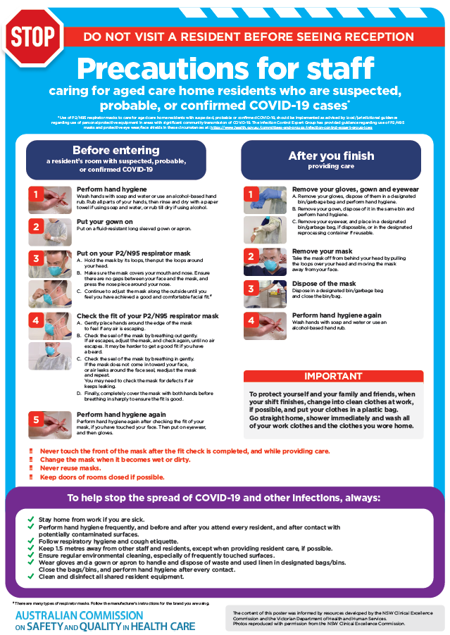](https://www.safetyandquality.gov.au/publications-and-resources/resource-library/covid-19-aged-care-staff-infection-prevention-and-control-precautions-poster)
* ***Environmental Cleaning and Infection Prevention and Control*** [www.safetyandquality.gov.au/environmental-cleaning](http://www.safetyandquality.gov.au/environmental-cleaning)
* ***Infection prevention and control Covid-19 PPE*** poster <https://www.safetyandquality.gov.au/publications-and-resources/resource-library/infection-prevention-and-control-covid-19-personal-protective-equipment>
* ***Special precautions for Covid-19 designated zones*** poster <https://www.safetyandquality.gov.au/publications-and-resources/resource-library/special-precautions-covid-19-designated-zones>
* ***COVID-19 infection prevention and control risk management – Guidance*** <https://www.safetyandquality.gov.au/publications-and-resources/resource-library/covid-19-infection-prevention-and-control-risk-management-guidance>
* ***Safe care for people with cognitive impairment during COVID-19***<https://www.safetyandquality.gov.au/our-work/cognitive-impairment/cognitive-impairment-and-covid-19>
* **Medicines Management COVID-19** <https://www.safetyandquality.gov.au/our-work/medication-safety/medicines-management-covid-19>, including position statements on medicine-related issues
  + ***Managing fever associated with COVID-19***
  + ***Managing a sore throat associated with COVID-19***
  + ***ACE inhibitors and ARBs in COVID-19***
  + ***Clozapine in COVID-19***
  + ***Management of patients on oral anticoagulants during COVID-19***
  + ***Ascorbic Acid: Intravenous high dose in COVID-19***
  + ***Treatment in acute care, including oxygen therapy and medicines to support intubation***
  + ***Nebulisation and COVID-19***
  + ***Managing intranasal administration of medicines during COVID-19***
  + ***Ongoing medicines management in high-risk patients***
  + ***Medicines shortages***
  + ***Conserving medicines***
  + ***Intravenous medicines administration in the event of an infusion pump shortage***
* ***Potential medicines to treat COVID-19***   
  <https://www.safetyandquality.gov.au/publications-and-resources/resource-library/potential-medicines-treat-covid-19>
* ***Break the chain of infection: Stopping COVID-19*** poster<https://www.safetyandquality.gov.au/publications-and-resources/resource-library/break-chain-poster-a3>  
  **[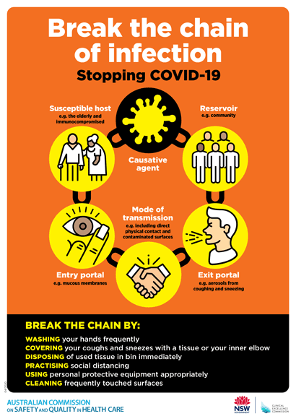](https://www.safetyandquality.gov.au/publications-and-resources/resource-library/break-chain-poster-a3https:/www.safetyandquality.gov.au/publications-and-resources/resource-library/break-chain-poster-a3)**
* ***COVID-19: Elective surgery and infection prevention and control precautions*** <https://www.safetyandquality.gov.au/publications-and-resources/resource-library/covid-19-elective-surgery-and-infection-prevention-and-control-precautions>
* ***FAQs for clinicians on elective surgery*** <https://www.safetyandquality.gov.au/node/5724>
* ***FAQs for consumers on elective surgery*** <https://www.safetyandquality.gov.au/node/5725>
* ***FAQs on community use of face masks***   
   <https://www.safetyandquality.gov.au/faqs-community-use-face-masks>
* ***COVID-19 and face masks – Information for consumers*** <https://www.safetyandquality.gov.au/publications-and-resources/resource-library/covid-19-and-face-masks-information-consumers>  
  The Commission’s fact sheet on use of face masks in the community to reduce the spread of COVID-19 is now available in Easy English and 10 other community languages from <https://www.safetyandquality.gov.au/wearing-face-masks-community>.  
  The factsheet was developed to help people understand when it is important to wear a mask to reduce the risk of the spread of COVID-19, and to explain how to safely put on and remove face masks. It also reinforces the importance of staying home if you have symptoms, physical distancing, hand hygiene and cough etiquette.

[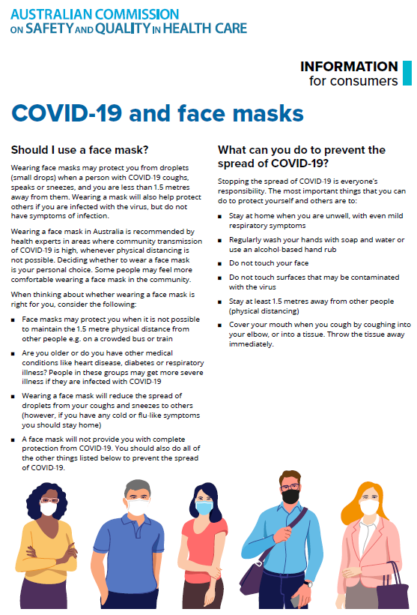](https://www.safetyandquality.gov.au/sites/default/files/2020-07/covid-19_and_face_masks_-_information_for_consumers.pdf)

*National COVID-19 Clinical Evidence Taskforce*

<https://covid19evidence.net.au/>

The National COVID-19 Clinical Evidence Taskforce is a collaboration of peak health professional bodies across Australia whose members are providing clinical care to people with COVID-19. The taskforce is undertaking continuous evidence surveillance to identify and rapidly synthesise emerging research in order to provide national, **evidence-based guidelines and clinical flowcharts for the clinical care of people with COVID-19**. The guidelines address questions that are specific to managing COVID-19 and cover the full disease course across mild, moderate, severe and critical illness. These are ‘living’ guidelines, updated with new research in near real-time in order to give reliable, up-to-the minute advice to clinicians providing frontline care in this unprecedented global health crisis.

*COVID-19 Critical Intelligence Unit*

<https://www.aci.health.nsw.gov.au/covid-19/critical-intelligence-unit>

The Agency for Clinical Innovation (ACI) in New South Wales has developed this page summarising rapid, evidence-based advice during the COVID-19 pandemic. Its operations focus on systems intelligence, clinical intelligence and evidence integration. The content includes a daily evidence digest and evidence checks on a discrete topic or question relating to the current COVID-19 pandemic. There is also a ‘Living evidence’ section summarising key studies and emerging evidence on **COVID-19 vaccines** and **SARS-CoV-2 variants**.

**Reports**

*Supporting school aged children with Developmental Language Disorder (DLD)*

Deeble Institute Evidence Brief No. 22

Walker C, Haddock R

Canberra: Australian Healthcare and Hospitals Association; 2021. p. 16.

|  |  |
| --- | --- |
| URL | <https://ahha.asn.au/publication/health-policy-evidence-briefs/evidence-brief-no-22-supporting-school-aged-children> |
| Notes | This Evidence Brief from the Australian Healthcare and Hospitals Association’s Deeble Institute is their third brief on the topic of Developmental Language Disorder (DLD). This one looks at how school-aged children with DLD could be supported. Currently there is much variation in both awareness and the provision of supports (such as speech and language therapy, particularly at transition points including preschool to primary school, primary school to high school and high school to further education). |

**Journal articles**

*Delivering exceptionally safe transitions of care to older people: a qualitative study of multidisciplinary staff perspectives*

Baxter R, Shannon R, Murray J, O’Hara JK, Sheard L, Cracknell A, et al

BMC Health Services Research. 2020;20(1):780.

|  |  |
| --- | --- |
| DOI | <https://doi.org/10.1186/s12913-020-05641-4> |
| Notes | Transitions of care (or handoffs or handovers) are recognised as having potential for risk of harm. This paper reports on a qualitative study conducted in six general practices and four hospital specialties that demonstrated exceptionally low or reducing readmission rates over time. The study explored staff perceptions of how high performing general practice and hospital specialty teams deliver safe transitional care to older people as they transition from hospital to home. The authors report that ‘Across healthcare contexts, staff perceived three key themes to facilitate safe transitions of care: **knowing the patient, knowing each other, and bridging gaps in the system.**’ |

For information on the Commission’s work on clinical handover, see <https://www.safetyandquality.gov.au/our-work/communicating-safety/clinical-handover>

*Ensuring Quality in the Era of Virtual Care*

Herzer KR, Pronovost PJ

JAMA. 2021;325(5):429-430.

|  |  |
| --- | --- |
| DOI | <https://doi.org/10.1001/jama.2020.24955> |
| Notes | The ‘pivot to telehealth’ that was brought about by the COVID-19 pandemic has seen many benefits for patients, but a change in care delivery can also bring new or different risks. This short Viewpoint piece offers three principles to guide the development of ‘virtual care’, namely that it has to be **safe and effective**, **efficient and timely** and **patient-centred and equitable**. While these principles hold for care irrespective of delivery modality, the authors point out some of the particular risks or benefits that may be associated with virtual delivery. |

*Outcomes from Wake Up Safe, the pediatric anesthesia quality improvement initiative*

Haché M, Sun LS, Gadi G, Busse J, Lee AC, Lorinc A, et al

Pediatric Anesthesia. 2020;30(12):1348-1354.

|  |  |
| --- | --- |
| DOI | <https://doi.org/10.1111/pan.14044> |
| Notes | Anaesthesia is by-and-large a safe element to modern healthcare. This papers reports on the Wake Up Safe initiative that collects data on serious adverse events in order to help address issues that are identified. This paper reviews all events occurring between 2010 and 2015 in the Wake Up Safe registry data. The data covers 19 participating institutions and the authors report that ‘Of all reported adverse events (2544 events), the most common were **cardiac arrests** (646, 31.6%), **respiratory complications** (598, 29.2%), and **medication events** (345, 16.9%). Of all anesthesia‐related events (612 events), medication events were the most common (239, 31.9%), followed by respiratory complications (181, 24.1%), and cardiac arrests (139, 18.5%). Overall, **85% of anesthesia‐related serious adverse events were deemed somewhat or almost certainly preventable.**’ |

*Acting between guidelines and reality- an interview study exploring the strategies of first line managers in patient safety work*

Hedsköld M, Sachs MA, Rosander T, von Knorring M, Pukk Härenstam K

BMC Health Services Research. 2021;21(1):48.

|  |  |
| --- | --- |
| DOI | <https://doi.org/10.1186/s12913-020-06042-3> |
| Notes | This Swedish study examined the role of frontline managers and their role in patient safety. Based on interviews with managers in intensive care units in 8 hospitals, the piece looks at how the managers can organise for safety and foster a culture of safety. Among the strategies that managers used to promote patient safety and patient safety culture within their units were:   * Valuing and developing healthcare professionals expertise * Organizing for resilience * Being present and setting a good example in daily work * Encouraging individual and organizational learning from incidence reporting and * Balancing adherence to and questioning of standardized operative procedures. |

*The Association Between Health Care Staff Engagement and Patient Safety Outcomes: A Systematic Review and Meta-Analysis*

Janes G, Mills T, Budworth L, Johnson J, Lawton R

Journal of Patient Safety. 2021.

|  |  |
| --- | --- |
| DOI | <https://doi.org/10.1097/PTS.0000000000000807> |
| Notes | It’s said that safety is everyone’s business. This paper presents a review and meta-analysis of the literature into the relationship between staff engagement and patient safety outcomes. The study found 14 studies met their inclusion criteria, with 11 suitable for meta-analysis. The authors report that ‘Meta-analyses indicated a **small but consistent, statistically significant relationship between staff engagement and patient safety** (all outcomes; 11 studies; r = 0.22; 95% confidence interval [CI], 0.07 to 0.36; n = 30,490) and 2 patient safety outcome categories: patient safety culture (7 studies; r = 0.22; 95% CI, 0.01 to 0.41; n = 27,857) and errors/adverse events (4 studies; r = −0.20; 95% CI, −0.26 to −0.13; n = 2633).’ They observe that ‘Despite a limited and evolving evidence base, we cautiously conclude that increasing staff engagement could be an effective means of enhancing patient safety.’ |

*Australian Health Review*

Volume 45 Number 1 2021

|  |  |
| --- | --- |
| URL | <https://www.publish.csiro.au/ah/issue/10145> |
| Notes | A new issue of *Australian Health Review* has been published. Articles in this issue of *Australian Health Review* include:   * Editorial: **Reducing emissions and waste in the health sector**: the long sleep is over – time for the hare to get running! (Tarun Weeramanthri) * Editorial: Reflections on **climate change and the Australian health system** (Sotiris Vardoulakis) * Editorial: What does **climate change** have to do with **bushfires**? (Bin Jalaludin and Geoffrey G. Morgan) * Victorian public healthcare Chief Executive Officers' views on **renewable energy supply** (Hayden Burch and Forbes McGain) * **Quality adjusted life years in the time of COVID-19** (Jane Hall and Rosalie Viney) * **Private versus public? Examining hospital use by a privately insured population** in New South Wales, Australia, using data linkage (Joanna Khoo, Helen Hasan and Kathy Eagar) * Using **governance and patient flow strategies to improve healthcare service efficiency** (Amanda Kivic and Laureen Hines) * Differential access to **continuity of midwifery care** in Queensland, Australia (Roslyn E Donnellan-Fernandez, Debra K Creedy, Emily J Callander, Jenny Gamble and Jocelyn Toohill) * How often are patients with clinically apparent **inguinal hernias** referred to a surgeon accompanied with an ultrasound? A prospective multicentre study (Prashanth Naidoo, Kate Levett, Sally Lord, Alan Meagher, Nicholas Williams and Thomas Aczel) * **Community-based integrated care versus hospital outpatient care for managing patients with complex type 2 diabetes**: costing analysis (Maria Donald, Claire L Jackson, Joshua Byrnes, Bharat Phani Vaikuntam, Anthony W Russell and Samantha A Hollingworth) * Quantifying the e**conomic benefit of the personal alarm and emergency response system** in Australia: a cost analysis of the reduction in ambulance attendances (Yun Wang, Velandai Srikanth, David A Snowdon, Sonya Ellmers, Richard Beare, Chris Moran, Dean Richardson, Peter Lotz and N E Andrew) * Evaluating the economic effects of **genomic sequencing of pathogens to prioritise hospital patients** competing for isolation beds (Thomas M Elliott, Nicole Hare, Krispin Hajkowicz, Trish Hurst, Michelle Doidge, Patrick N Harris and Louisa G Gordon) * Factors affecting **procurement of wound care products**: a qualitative study of hospital managers and clinicians (Elizabeth McInnes, Gill Harvey, Janet E Hiller, Rosemary Phillips, Tamara Page and Rick Wiechula) * A purple patch for **evidence-based health policy**? (Mark Cormack, Anne-marie Boxall, Carolyn Hullick, Mark Booth and Russell L Gruen) * **Complementary medicines advertising** policy Part I: unethical conduct in the Australian market before July 2018 (Malcolm Vickers and Ken Harvey) * **Complementary medicines advertising** policy Part II: unethical conduct in the Australian market after July 2018 (Ken Harvey, Malcolm Vickers and Bruce Baer Arnold) * Exploring the measure of **potentially avoidable general practitioner-type presentations to the emergency department** in regional Queensland using linked, patient-perspective data (Mary O'Loughlin, Jane Mills, Robyn McDermott and Linton R Harriss) * Using a computerised database (REDCap) to monitor **influenza vaccination coverage of healthcare workers and staff** in South Eastern Sydney Local Health District (Thomas Gadsden, Catherine R Bateman-Steel, Sandra Chaverot, Kelly-Anne Ressler, Karen Chee, Lisa Redwood and Mark J Ferson) * **Patient satisfaction** with physiotherapists is not inferior to surgeons in an **arthroplasty review clinic**: non-inferiority study of an expanded scope model of care (Michael Thomas Murphy and John Radovanovic) * Developing a model of **bereavement care** in an adult tertiary hospital (Matthew Grant, Peter Hudson, Annie Forrest, Anna Collins and Fiona Israel) * Inequalities in **end-of-life palliative care** by country of birth in New South Wales, Australia: a cohort study (Holger Möller, Hassan Assareh, Joanne M Stubbs, Bin Jalaludin and Helen M Achat) * Collaboration between the intensive care unit and organ donation agency to achieve routine consideration of **organ donation and comprehensive bereavement follow-up**: an improvement project in a quaternary Australian hospital (Nikki Yeok Kee Yeo, Benjamin Reddi, Mandy Kocher, Serena Wilson, Natalia Jastrzebski, Kerry Duncan and Stewart Moodie) |

*Health Affairs*

Volume 40, Number 2, February 2021

|  |  |
| --- | --- |
| URL | <https://www.healthaffairs.org/toc/hlthaff/40/2> |
| Notes | A new issue of *Health Affairs* has been published with the themes of “**Vital Directions, Quality and more**”. Articles in this issue of *Health Affairs* include:   * **American Indians’ Growing Presence** In The Health Professions (S Kwon) * **Vital Directions For Health And Health Care**: Priorities For 2021 (Victor J Dzau, Mark B McClellan, J Michael McGinnis, Jessica C Marx, Rebecca D Sullenger, and William El Laissi) * **Infectious Disease Threats**: A Rebound To Resilience (Peter Daszak, Gerald T Keusch, Alexandra L Phelan, Christine K Johnson, and M T Osterholm) * **Optimizing Health And Well-Being For Women And Children** (Elena Fuentes-Afflick, James M Perrin, Kelle H Moley, Ángela Díaz, Marie C McCormick, and Michael C Lu) * Actualizing **Better Health And Health Care For Older Adults** (Terry Fulmer, David B Reuben, John Auerbach, Donna Marie Fick, Colleen Galambos, and Kimberly S Johnson) * **Transforming Mental Health And Addiction Services** (Margarita Alegría, Richard G Frank, Helena B Hansen, J M Sharfstein, R S Shim, and M Tierney) * **Health Costs And Financing**: Challenges And Strategies For A New Administration (William H Shrank, Nancy-Ann DeParle, Scott Gottlieb, Sachin H Jain, Peter Orszag, Brian W Powers, and Gail R Wilensky) * Higher Medicare Advantage **Star Ratings Are Associated With Improvements In Patient Outcomes** (David J Meyers, Amal N Trivedi, Ira B Wilson, Vincent Mor, and Momotazur Rahman) * **Variation In Emergency Department Admission Rates** Among Medicare Patients: Does The Physician Matter? (Peter B Smulowitz, A James O’Malley, Lawrence Zaborski, J Michael McWilliams, and Bruce E Landon) * The Effect Of The **Affordable Care Act On Cancer Detection** Among The Near-Elderly (Fabian Duarte, S Kadiyala, G F Kominski, and A Riveros) * The Impact Of Medicare On **Access To And Affordability Of Health Care** (Paul D Jacobs) * Annual Out-Of-Pocket Spending Clusters Within Short Time Intervals: Implications For **Health Care Affordability** (Steven Chen, Paul R Shafer, Stacie B Dusetzina, and Michal Horný) * Beyond The High Prices Of **Prescription Drugs: A Framework To Assess Costs, Resource Allocation, And Public Funding** (Jonathan J Darrow and Donald W Light) * **Rural-Urban Disparities In All-Cause Mortality** Among Low-Income Medicare Beneficiaries, 2004–17 (Emefah Loccoh, Karen E Joynt Maddox, Jiaman Xu, C Shen, J F Figueroa, D S Kazi, R W Yeh, and R K Wadhera) * **Physicians’ Perceptions Of People With Disability** And Their Health Care (Lisa I Iezzoni, Sowmya R Rao, Julie Ressalam, Dragana Bolcic-Jankovic, Nicole D Agaronnik, Karen Donelan, Tara Lagu, and Eric G Campbell) * **Racial Disparities In Excess All-Cause Mortality During The Early COVID-19 Pandemic** Varied Substantially Across States (Maria Polyakova, Victoria Udalova, G Kocks, K Genadek, K Finlay, and A N Finkelstein) * Admission Practices And Cost Of Care For **Opioid Use Disorder** At Residential Addiction Treatment Programs In The US (Tamara Beetham, Brendan Saloner, Marema Gaye, S E Wakeman, R G Frank, and M L Barnett) * Institutions For Mental Diseases Medicaid Waivers: Impact On Payments For **Substance Use Treatment Facilities** (Johanna Catherine Maclean, Hefei Wen, Kosali I Simon, and Brendan Saloner) * Medicaid Payments For **Immediate Postpartum Long-Acting Reversible Contraception**: Evidence From South Carolina (Maria W Steenland, Lydia E Pace, Anna D Sinaiko, and Jessica L Cohen) * **Medicaid Physician Fees** Remained Substantially Below Fees Paid By Medicare In 2019 (Stephen Zuckerman, Laura Skopec, and Joshua Aarons) * Variation In **Telemedicine Use And Outpatient Care During The COVID-19 Pandemic** In The United States (Sadiq Y Patel, Ateev Mehrotra, Haiden A Huskamp, Lori Uscher-Pines, Ishani Ganguli, and M L Barnett) * **COVID-19 Through The Eyes Of A Black Medical Student** (Shuaibu Ali) |

*BMJ Quality & Safety* online first articles

|  |  |
| --- | --- |
| URL | <https://qualitysafety.bmj.com/content/early/recent> |
| Notes | *BMJ Quality &Safety* has published a number of ‘online first’ articles, including:   * Editorial: **Healthcare-associated infections**: where we came from and where we are headed (Daniel Escobar, David Pegues) * Editorial: **Accreditation in health care**: does it make any difference to patient outcomes? (Natalie Bracewell, David E Winchester) * Adherence to guideline-recommended HbA1c testing frequency and better outcomes in patients with **type 2 diabetes**: a 5-year retrospective cohort study in Australian general practice (Chisato Imai, Ling Li, Rae-Anne Hardie, Andrew Georgiou) * Editorial: Assuring safety and efficacy of nurse triage for electronic consultation to improve **access to specialty care** (Elizabeth J Murphy, Delphine S Tuot) |

*International Journal for Quality in Health Care* online first articles

|  |  |
| --- | --- |
| URL | <https://academic.oup.com/intqhc/advance-articles> |
| Notes | *International Journal for Quality in Health Care* has published a number of ‘online first’ articles, including:   * **Patient Satisfaction and Patient Experience** are not Interchangeable Concepts (Claudia Bull) * Time and Predictors of Treatment for **Aneurysmal Subarachnoid Haemorrhage** (ASAH): A Systematic Review (Thuy Phuong Nguyen, Sabah Rehman, Christine Stirling, Ronil Chandra, Seana Gall) * Prioritization and Management of **Calls from Older People to GP out-of-Hours** (Suzanne Smith, Lucia Carragher) * Developing a New Flexible Tool for **Handover** (Racheli Magnezi, Inbal Gazit, Arie Bass, Orna Tal) * The Value of **Federated Learning** During and Post COVID-19 (Feng Qian, Andrew Zhang) |

**Online resources**

*Future Leaders Communiqué*

<https://www.thecommuniques.com/post/future-leaders-communiqu%C3%A9-volume-6-issue-1-january-2021>

This issue of *Future Leaders Communiqué* focuses on **mental health**. The case study is that of the coroner’s inquest into the death of Melanie Tregonning; a talented illustrator whose suicide was preceded by a series of miscommunications and system failures from the health care community as she repeatedly sought assistance with a mental health emergency. Ms Tregonning took the initiative to seek help and did so on multiple occasions. However, none of her interactions with several different medical practitioners achieved the support or clinical care needed. Instead, the coroner described her experiences as being “lost in a labyrinth of miscommunication and redirection” which ultimately ended with her suicide. An outcome the coroner found to be preventable. The issue also has commentaries from Ms Tregonning’s sister and from senior clinicians on risks of error and care of the **acutely suicidal patient**.

**Disclaimer**

On the Radar is an information resource of the Australian Commission on Safety and Quality in Health Care. The Commission is not responsible for the content of, nor does it endorse, any articles or sites listed. The Commission accepts no liability for the information or advice provided by these external links. Links are provided on the basis that users make their own decisions about the accuracy, currency and reliability of the information contained therein. Any opinions expressed are not necessarily those of the Australian Commission on Safety and Quality in Health Care.