# Australian Commission on Safety and Quality in Health Care logo with Radar imageOn the Radar

Issue 504

22 March 2021

*On the Radar* is a summary of some of the recent publications in the areas of safety and quality in health care. Inclusion in this document is not an endorsement or recommendation of any publication or provider. Access to particular documents may depend on whether they are Open Access or not, and/or your individual or institutional access to subscription sites/services. Material that may require subscription is included as it is considered relevant.

*On the Radar* is available online, via email or as a PDF or Word document from <https://www.safetyandquality.gov.au/publications-and-resources/newsletters/radar>

If you would like to receive *On the Radar* via email, you can subscribe on our website <https://www.safetyandquality.gov.au/publications-and-resources/newsletters>   
or by emailing us at H[Umail@safetyandquality.gov.auU](mailto:mail@safetyandquality.gov.au).   
You can also send feedback and comments to H[Umail@safetyandquality.gov.auU](mailto:mail@safetyandquality.gov.au).

For information about the Commission and its programs and publications, please visit <https://www.safetyandquality.gov.au>

You can also follow us on Twitter @ACSQHC.

**On the Radar**

Editor: Dr Niall Johnson [niall.johnson@safetyandquality.gov.au](mailto:niall.johnson@safetyandquality.gov.au)

Contributors: Niall Johnson, Christina Lane

**COVID-19 resources**

https://www.safetyandquality.gov.au/covid-19

The Australian Commission on Safety and Quality in Health Care has developed a number of resources to assist healthcare organisations, facilities and clinicians. These and other material on COVID-19 are available at <https://www.safetyandquality.gov.au/covid-19>

These resource include:

* ***COVID-19: Aged care staff infection prevention and control precautions*** *poster*<https://www.safetyandquality.gov.au/publications-and-resources/resource-library/covid-19-aged-care-staff-infection-prevention-and-control-precautions-poster>  
    
  [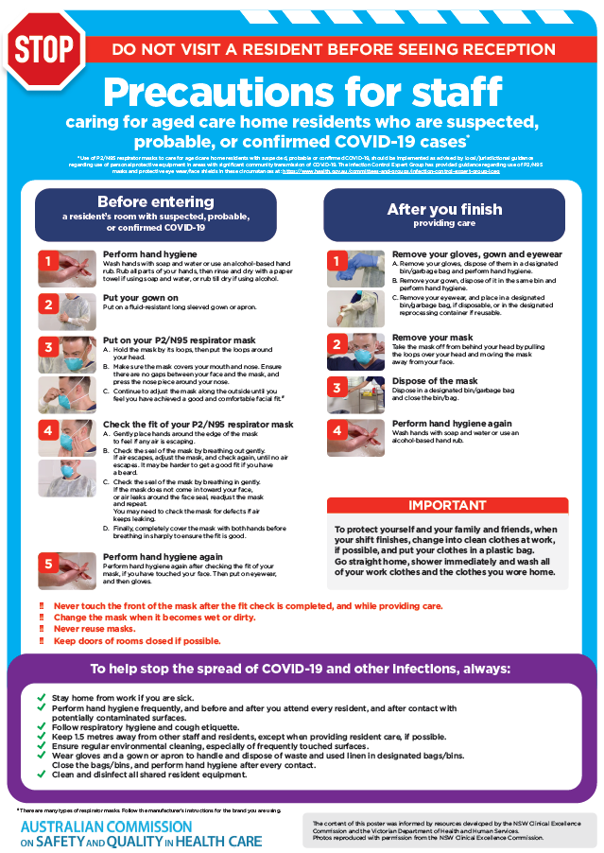](https://www.safetyandquality.gov.au/publications-and-resources/resource-library/covid-19-aged-care-staff-infection-prevention-and-control-precautions-poster)
* ***Environmental Cleaning and Infection Prevention and Control*** [www.safetyandquality.gov.au/environmental-cleaning](http://www.safetyandquality.gov.au/environmental-cleaning)
* ***Infection prevention and control Covid-19 PPE*** poster <https://www.safetyandquality.gov.au/publications-and-resources/resource-library/infection-prevention-and-control-covid-19-personal-protective-equipment>
* ***Special precautions for Covid-19 designated zones*** poster <https://www.safetyandquality.gov.au/publications-and-resources/resource-library/special-precautions-covid-19-designated-zones>
* ***COVID-19 infection prevention and control risk management – Guidance*** <https://www.safetyandquality.gov.au/publications-and-resources/resource-library/covid-19-infection-prevention-and-control-risk-management-guidance>
* ***Safe care for people with cognitive impairment during COVID-19***<https://www.safetyandquality.gov.au/our-work/cognitive-impairment/cognitive-impairment-and-covid-19>
* **Medicines Management COVID-19** <https://www.safetyandquality.gov.au/our-work/medication-safety/medicines-management-covid-19>, including position statements on medicine-related issues
  + ***Managing fever associated with COVID-19***
  + ***Managing a sore throat associated with COVID-19***
  + ***ACE inhibitors and ARBs in COVID-19***
  + ***Clozapine in COVID-19***
  + ***Management of patients on oral anticoagulants during COVID-19***
  + ***Ascorbic Acid: Intravenous high dose in COVID-19***
  + ***Treatment in acute care, including oxygen therapy and medicines to support intubation***
  + ***Nebulisation and COVID-19***
  + ***Managing intranasal administration of medicines during COVID-19***
  + ***Ongoing medicines management in high-risk patients***
  + ***Medicines shortages***
  + ***Conserving medicines***
  + ***Intravenous medicines administration in the event of an infusion pump shortage***
* ***Break the chain of infection: Stopping COVID-19*** poster<https://www.safetyandquality.gov.au/publications-and-resources/resource-library/break-chain-poster-a3>  
  **[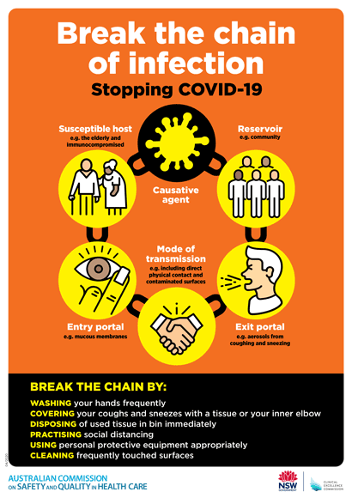](https://www.safetyandquality.gov.au/publications-and-resources/resource-library/break-chain-poster-a3https:/www.safetyandquality.gov.au/publications-and-resources/resource-library/break-chain-poster-a3)**
* ***COVID-19: Elective surgery and infection prevention and control precautions*** <https://www.safetyandquality.gov.au/publications-and-resources/resource-library/covid-19-elective-surgery-and-infection-prevention-and-control-precautions>
* ***FAQs for clinicians on elective surgery*** <https://www.safetyandquality.gov.au/node/5724>
* ***FAQs for consumers on elective surgery*** <https://www.safetyandquality.gov.au/node/5725>
* ***FAQs on community use of face masks***   
   <https://www.safetyandquality.gov.au/faqs-community-use-face-masks>
* ***COVID-19 and face masks – Information for consumers*** <https://www.safetyandquality.gov.au/publications-and-resources/resource-library/covid-19-and-face-masks-information-consumers>  
  The Commission’s fact sheet on use of face masks in the community to reduce the spread of COVID-19 is now available in Easy English and 10 other community languages from <https://www.safetyandquality.gov.au/wearing-face-masks-community>.  
  The factsheet was developed to help people understand when it is important to wear a mask to reduce the risk of the spread of COVID-19, and to explain how to safely put on and remove face masks. It also reinforces the importance of staying home if you have symptoms, physical distancing, hand hygiene and cough etiquette.

[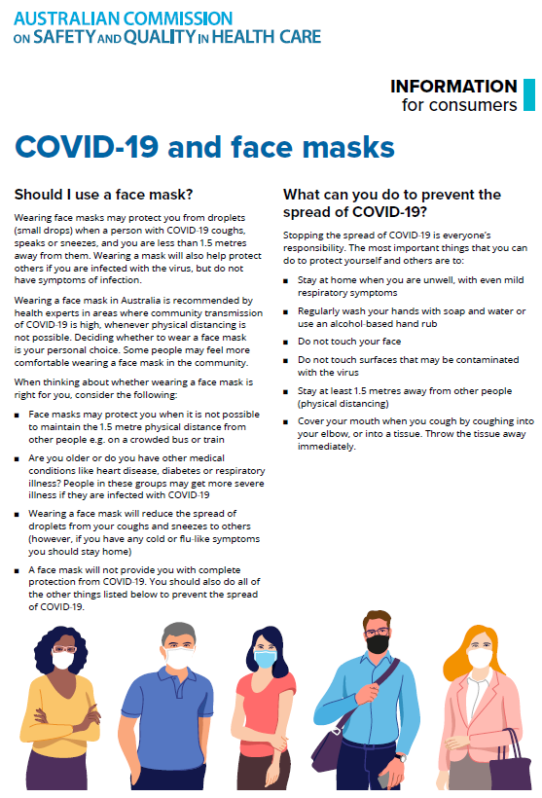](https://www.safetyandquality.gov.au/sites/default/files/2020-07/covid-19_and_face_masks_-_information_for_consumers.pdf)

*National COVID-19 Clinical Evidence Taskforce*

<https://covid19evidence.net.au/>

The National COVID-19 Clinical Evidence Taskforce is a collaboration of peak health professional bodies across Australia whose members are providing clinical care to people with COVID-19. The taskforce is undertaking continuous evidence surveillance to identify and rapidly synthesise emerging research in order to provide national, **evidence-based guidelines and clinical flowcharts for the clinical care of people with COVID-19**. The guidelines address questions that are specific to managing COVID-19 and cover the full disease course across mild, moderate, severe and critical illness. These are ‘living’ guidelines, updated with new research in near real-time in order to give reliable, up-to-the minute advice to clinicians providing frontline care in this unprecedented global health crisis.

*COVID-19 Critical Intelligence Unit*

<https://www.aci.health.nsw.gov.au/covid-19/critical-intelligence-unit>

The Agency for Clinical Innovation (ACI) in New South Wales has developed this page summarising rapid, evidence-based advice during the COVID-19 pandemic. Its operations focus on systems intelligence, clinical intelligence and evidence integration. The content includes a daily evidence digest and evidence checks on a discrete topic or question relating to the current COVID-19 pandemic. There is also a ‘Living evidence’ section summarising key studies and emerging evidence on **COVID-19 vaccines** and **SARS-CoV-2 variants**. Recent evidence check updates include:

* **AstraZeneca blood clots**
* **Endemicity of SARS-CoV-2.**

**[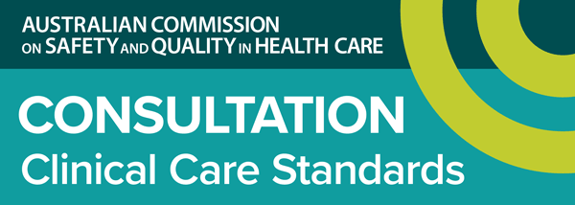](https://www.safetyandquality.gov.au/standards/clinical-care-standards/consultations-clinical-care-standards)**

**Draft Low Back Pain Clinical Care Standard consultation**

<https://www.safetyandquality.gov.au/standards/clinical-care-standards/consultations-clinical-care-standards>

The Australian Commission on Safety and Quality in Health Care has released the draft *Low Back Pain Clinical Care Standard* for public consultation.

This new clinical care standard will support a national approach to the treatment of low back pain to improve early assessment and management in primary care, emergency departments and other healthcare entry points. It covers the early assessment, non-surgical management, review and appropriate referral for secondary intervention of people with low back pain.

A number of supporting documents have been created to support this standard, including:

* Fact sheets for clinicians, consumers and health services
* Patient Information on how to manage low back pain
* A Quick Guide for GPs.

The Commission is seeking comments on the draft clinical care standard and supporting resources until midnight **Tuesday, 20 April 2021**.

Submissions are requested via online survey, or in writing. The survey link and further details are available at <https://www.safetyandquality.gov.au/standards/clinical-care-standards/low-back-pain-clinical-care-standard>

Australian Clinicians, Health Service Organisations and consumers are encouraged to provide feedback as part of the Consultation process. Please consider distributing the consultation details to anyone in your network who you think might be interested.

**Reports**

*Consumer Perspectives on Patient Experience 2021*

Wolf JA

Nashville: The Beryl Institute; 2021. p. 29.

|  |  |
| --- | --- |
| URL | <https://www.theberylinstitute.org/page/PXCONSUMERSTUDY> |
| Notes | The US-based Beryl Institute focuses on the patient experience and this report describes the findings on a survey of consumers on the patient experience. This follows up a previous survey (2018) and involved 2000 respondents (1000 in the USA and 250 each in Australia, UK, Canada and the Philippines). Many of the results are similar to the previous survey, just more so in times of a pandemic. These include the centrality of how having a good patient experience is, the importance of the focus being on the patient’s health, and how they are treated. |

For information on the Commission’s work on partnering with consumers, see <https://www.safetyandquality.gov.au/our-work/partnering-consumers>

**Journal articles**

*Assessing patients’ experiences with medical injury reconciliation processes: item generation for a novel survey questionnaire*

Schulz-Moore JS, Bismark M, Jenkinson C, Mello MM

The Joint Commission Journal on Quality and Patient Safety. 2021 [epub].

|  |  |
| --- | --- |
| DOI | <https://doi.org/10.1016/j.jcjq.2021.03.004> |
| Notes | Paper describing the development of a tool to assess injured patients’ experiences, particularly of resolution processes. The tool, the Medical Injury Reconciliation Experiences Survey (MIRES), was developed following previous studies, expert consultation and interviews with patients who has suffered harm. As one of the authors recently tweeted, the study was aimed at “Helping hospitals to do better at meeting the needs of patients and families when medical care causes unintended harm.” |

For information on the Commission’s work on open disclosure, including the *Australian Open Disclosure Framework*, see <https://www.safetyandquality.gov.au/our-work/clinical-governance/open-disclosure>

*The Effects of Harm Events on 30-Day Readmission in Surgical Patients*

Kandagatla P, Su W-TK, Adrianto I, Jordan J, Haeusler J, Rubinfeld I

The Journal for Healthcare Quality (JHQ). 2021;43(2):101-109.

|  |  |
| --- | --- |
| DOI | <https://doi.org/10.1097/JHQ.0000000000000261> |
| Notes | Readmission is quite commonly used as an indicator of safety and quality. This study sought to examine if inpatient harm events increased the likelihood of readmission in surgical patients. Examining data for a single health system between 2015 and 2017 that covered 37,048 surgical patient encounters, the study found 2,887 patients (7.69%) were readmitted. From the analysis, seven harm measures remained statistically significant and the three with the highest odds ratios were **mucosal pressure ulcer**, ***Clostridium difficile***, and **glucose <40**. |

*Reducing Medical Admissions and Presentations Into Hospital through Optimising Medicines (REMAIN HOME): a stepped wedge, cluster randomised controlled trial*

Freeman CR, Scott IA, Hemming K, Connelly LB, Kirkpatrick CM, Coombes I, et al

Medical Journal of Australia. 2021;214(5):212-217.

|  |  |
| --- | --- |
| DOI | <https://doi.org/10.5694/mja2.50942> |
| Notes | The role of pharmacists in working with other clinicians to ameliorate medication harms has been discussed in various contexts. This paper reports on a study undertaken in Queensland to investigate whether integrating pharmacists into general practices reduces the number of unplanned re‐admissions of patients recently discharged from hospital. This was a stepped wedge, cluster randomised trial in 14 general practices in which adults discharged from one of seven study hospitals during the seven days preceding recruitment (22 May 2017–14 March 2018) and prescribed five or more long term medicines, or having a primary discharge diagnosis of congestive heart failure or exacerbation of chronic obstructive pulmonary disease were enrolled. These patients were provided with a comprehensive face‐to‐face medicine management consultation with an integrated practice pharmacist within seven days of discharge, followed by a consultation with their general practitioner and further pharmacist consultations as needed.  The authors report that ‘by 12 months, there had been 282 re‐admissions among 177 control patients (incidence rate [IR], 1.65 per person‐year) and 136 among 129 intervention patients (IR, 1.09 per person‐year; fully adjusted IR ratio [IRR], 0.79; 95% CI, 0.52‒1.18). ED presentation incidence (fully adjusted IRR, 0.46; 95% CI, 0.22‒0.94) and combined re‐admission and ED presentation incidence (fully adjusted IRR, 0.69; 95% CI, 0.48‒0.99) were significantly lower for intervention patients. The estimated incremental net cost benefit of the intervention was $5072 per patient, with a benefit‒cost ratio of 31:1.’ |

For information on the Commission’s work on medication safety, see <https://www.safetyandquality.gov.au/our-work/medication-safety>

*The 2020 Australian guideline for prevention, diagnosis and management of acute rheumatic fever and rheumatic heart disease*

Ralph AP, Noonan S, Wade V, Currie BJ

Medical Journal of Australia. 2021;214(5):220-227.

*Otitis media guidelines for Australian Aboriginal and Torres Strait Islander children: summary of recommendations*

Leach AJ, Morris PS, Coates HLC, Nelson S, O'Leary SJ, Richmond PC, et al.

Medical Journal of Australia. 2021;214(5):228-233.

|  |  |
| --- | --- |
| DOI | Ralph et al <https://doi.org/10.5694/mja2.50851>  Leach et al <https://doi.org/10.5694/mja2.50953> |
| Notes | The current issue of the *Medical Journal of Australia* includes guidelines for two conditions that disproportionately affect Aboriginal and Torres Strait Islander people, particularly children.  Ralph et al describe the updated clinical guideline from RHDAustralia, the *2020 Australian guideline for prevention, diagnosis and management of acute rheumatic fever and rheumatic heart disease* (available from <https://www.rhdaustralia.org.au/arf-rhd-guideline>). They observe that the guideline ‘details best practice care for people with or at risk of ARF and RHD. It provides up‐to‐date guidance on primordial, primary and secondary prevention, diagnosis and management, preconception and perinatal management of women with RHD, culturally safe practice, provision of a trained and supported Aboriginal and Torres Strait Islander workforce, disease burden, RHD screening, control programs and new technologies.’ It’s also observed that this guideline has an emphasis on provision of culturally appropriate care.  Leach et al describe the 2020 update of the otitis media guidelines from the Centre of Research Excellence in Ear and Hearing Health of Aboriginal and Torres Strait Islander Children. The full guidelines, and the guidelines app OMapp, are available from <https://otitismediaguidelines.com/>  New guidelines in and of themselves will not remedy these gross inequities. This week has also seen the release of the latest Close the Gap report (<https://www.lowitja.org.au/page/services/resources/Cultural-and-social-determinants/culture-for-health-and-wellbeing/close-the-gap-report-2021>) which recognises that to address the health inequities there needs to be ‘large-scale systemic reform and a paradigm shift in our approach to truly empower Aboriginal and Torres Strait Islander peoples.’ |

*BMJ Quality & Safety*

April 2021 - Volume 30 - 4

|  |  |
| --- | --- |
| URL | <https://qualitysafety.bmj.com/content/30/4> |
| Notes | A new issue of *BMJ Quality & Safety* has been published. Many of the papers in this issue have been referred to in previous editions of *On the Radar* (when they were released online). Articles in this issue of *BMJ Quality & Safety* include:   * Editorial: Unravelling the magic of **latent safety threats** (Yadin David) * Editorial: Can we safely continue to offer **surgical treatments during the COVID-19 pandemic**? (Alex Fowler, Tom E F Abbott, Rupert M Pearse) * Work systems analysis of **sterile processing**: assembly (Myrtede Alfred, Ken Catchpole, Emily Huffer, Larry Fredendall, Kevin M Taaffe) * **Mortality and pulmonary complications in patients undergoing upper extremity surgery at the peak of the SARS-CoV-2 pandemic** in the UK: a national cohort study (Benjamin John Floyd Dean) * **Unnecessary antibiotic prescribing in children hospitalised for asthma exacerbation**: a retrospective national cohort study (Marcella J Jewell, JoAnna Leyenaar, Meng-Shiou Shieh, Penelope S Pekow, Mihaela Stefan, Peter K Lindenauer) * Limiting **surveillance imaging for patients with lymphoma in remission**: a mixed methods study leading to a Choosing Wisely recommendation (Ora Paltiel, Galor Raviv Sharabi, Reut Tzemach, Talya Rechavi, Estherina Trachtenberg, Neta Goldschmidt, Eldad J Dann, Rachel Bar-Shalom) * Work effort, readability and quality of **pharmacy transcription of patient directions from electronic prescriptions**: a retrospective observational cohort analysis (Yifan Zheng, Yun Jiang, Michael P Dorsch, Yuting Ding, V G Vinod Vydiswaran, Corey A Lester) * Associations between **double-checking and medication administration errors**: a direct observational study of paediatric inpatients (Johanna I Westbrook, Ling Li, Magdalena Z Raban, Amanda Woods, Alain K Koyama, Melissa Therese Baysari, Richard O Day, Cheryl McCullagh, Mirela Prgomet, Virginia Mumford, Luciano Dalla-Pozza, Madlen Gazarian, Peter J Gates, Valentina Lichtner, Peter Barclay, Alan Gardo, Mark Wiggins, Leslie White) * Vulnerability of the **medical product supply chain**: the wake-up call of COVID-19 (Fiona A Miller, Steven B Young, Mark Dobrow, Kaveh G Shojania) * A realist synthesis of **quality improvement curricula in undergraduate and postgraduate medical education**: what works, for whom, and in what contexts? (Allison Brown, Kyle Lafreniere, David Freedman, Aditya Nidumolu, Matthew Mancuso, Kent Hecker, Aliya Kassam) |

*BMJ Quality & Safety* online first articles

|  |  |
| --- | --- |
| URL | <https://qualitysafety.bmj.com/content/early/recent> |
| Notes | *BMJ Quality &Safety* has published a number of ‘online first’ articles, including:   * **Surgical service monitoring and quality control systems** at district hospitals in Malawi, Tanzania and Zambia: a mixed-methods study (Morgane Clarke, Chiara Pittalis, Eric Borgstein, Leon Bijlmakers, Mweene Cheelo, Martilord Ifeanyichi, Gerald Mwapasa, Adinan Juma, Henk Broekhuizen, Grace Drury, Chris Lavy, John Kachimba, Nyengo Mkandawire, Kondo Chilonga, Ruairí Brugha, Jakub Gajewski) * Improving the quality of **self-management support in ambulatory cancer care**: a mixed-method study of organisational and clinician readiness, barriers and enablers for tailoring of implementation strategies to multisites (Doris Howell, Melanie Powis, Ryan Kirkby, Heidi Amernic, Lesley Moody, Denise Bryant-Lukosius, Mary Ann O'Brien, Sara Rask, Monika Krzyzanowska) |

*International Journal for Quality in Health Care* online first articles

|  |  |
| --- | --- |
| URL | <https://academic.oup.com/intqhc/advance-articles> |
| Notes | *International Journal for Quality in Health Care* has published a number of ‘online first’ articles, including:   * Learning From **Safety Incidents in High Reliability Organizations**: A Systematic Review of **Learning Tools** That Could be Adapted and Used in Healthcare (N Serou, L M Sahota, A K Husband, S P Forrest, R D Slight, S P Slight) * Functional Decline in **Emergency Department Patients with Dyspnea**; a Register-Based Cohort (Karoline Stentoft Rybjerg Larsen, Marianne Lisby, Hans Kirkegaard, Annemette Krintel Petersen) * Content of Antenatal Care and Perception about Services Provided by **Primary Hospitals in Nepal**: A Convergent Mixed Methods Study (Yubraj Acharya, Nigel James, Rita Thapa, Saman Naz, Rishav Shrestha, Suresh Tamang) * Comparing **Length of Hospital Stay during COVID-19** Pandemic in the USA, Italy, and Germany (Babak Jamshidi, Shahriar Jamshidi Zargaran, Hakim Bekrizadeh, Mansour Rezaei, Farid Najafi) |

**Online resources**

*[UK] NICE Guidelines and Quality Standards*

<https://www.nice.org.uk/guidance>

The UK’s National Institute for Health and Care Excellence (NICE) has published new (or updated) guidelines and quality standards. The latest reviews or updates are:

* Quality Standard QS200 *Supporting* ***adult carers*** <https://www.nice.org.uk/guidance/qs200>

*[USA] AHRQ Perspectives on Safety*

The US Agency for Healthcare Research and Quality (AHRQ) publishes Perspectives on Safety essays. Recent essays include:

* ***Meaningful Measurement Patient and Family Engagement*** <https://psnet.ahrq.gov/perspective/meaningful-measurement-patient-and-family-engagement>
* ***Approach to Improving Patient Safety: Communication*** <https://psnet.ahrq.gov/perspective/approach-improving-patient-safety-communication>
* ***Antibody Response Following SARS-CoV-2 Infection and Implications for Immunity: A Living Rapid Review***<https://effectivehealthcare.ahrq.gov/products/immunity-after-covid/rapid-review>

*[USA] Patient Safety Primers*

<https://psnet.ahrq.gov/primers/>

The Patient Safety Primers from the (US) Agency for Healthcare Research and Quality (AHRQ) discuss key concepts in patient safety. Each primer defines a topic, offers background information on its epidemiology and context, and provides links to relevant materials.

* ***Medication Administration Errors*** – Medication administration errors are a persistent safety problem. Increasing the safety of medication administration requires a multifaceted system-level approach that spans all phases of primary, specialty, inpatient, and community-based care.   
  <https://psnet.ahrq.gov/primer/medication-administration-errors>

**Disclaimer**

On the Radar is an information resource of the Australian Commission on Safety and Quality in Health Care. The Commission is not responsible for the content of, nor does it endorse, any articles or sites listed. The Commission accepts no liability for the information or advice provided by these external links. Links are provided on the basis that users make their own decisions about the accuracy, currency and reliability of the information contained therein. Any opinions expressed are not necessarily those of the Australian Commission on Safety and Quality in Health Care.