# Australian COmmission on Safety and Quality in Health Care logo with Radar imageOn the Radar

Issue 507

19 April 2021

*On the Radar* is a summary of some of the recent publications in the areas of safety and quality in health care. Inclusion in this document is not an endorsement or recommendation of any publication or provider. Access to particular documents may depend on whether they are Open Access or not, and/or your individual or institutional access to subscription sites/services. Material that may require subscription is included as it is considered relevant.

*On the Radar* is available online, via email or as a PDF or Word document from <https://www.safetyandquality.gov.au/publications-and-resources/newsletters/radar>

If you would like to receive *On the Radar* via email, you can subscribe on our website <https://www.safetyandquality.gov.au/publications-and-resources/newsletters>   
or by emailing us at H[Umail@safetyandquality.gov.auU](mailto:mail@safetyandquality.gov.au).   
You can also send feedback and comments to H[Umail@safetyandquality.gov.auU](mailto:mail@safetyandquality.gov.au).

For information about the Commission and its programs and publications, please visit <https://www.safetyandquality.gov.au>

You can also follow us on Twitter @ACSQHC.

**On the Radar**

Editor: Dr Niall Johnson [niall.johnson@safetyandquality.gov.au](mailto:niall.johnson@safetyandquality.gov.au)

Contributors: Niall Johnson

[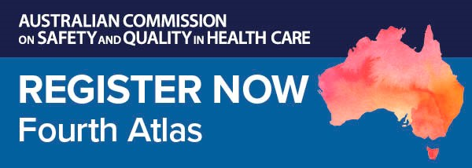](https://kapara.rdbk.com.au/landers/539292.html)

**Fourth Australian Atlas of Healthcare Variation launch**

Do all Australians receive the same evidence-based health care, no matter where they live? If not, where does it vary, and why?

Join us for the online launch of our *Fourth Australian Atlas of Healthcare Variation*.

Mapping healthcare use across the country, the new Atlas highlights variation across six clinical topics including early planned births and chronic disease and infection.

National healthcare leaders including Professor John Newnham AM, 2020 Senior Australian of the Year and Professor in Obstetrics & Gynaecology at The University of Western Australia, will share important findings from the new Atlas and what they reveal about the appropriateness and equity of healthcare delivery in Australia.

Date: Wednesday **28 April 2021**

Time: **12.00–1.00pm** (AEST)

Location: Online

Click [here](https://kapara.rdbk.com.au/landers/539292.html) to register.

Produced in partnership with the Australian Institute of Health and Welfare, our Atlas series identifies variation for a range of procedures, investigations, treatments and hospitalisations. With recommendations to reduce unwarranted variation, it provides opportunities to minimise low value care, improve the equity of care and improve patient outcomes.

Find out more about the Atlas series and healthcare variation on our website or email us at [atlas@safetyandquality.gov.au](mailto:atlas@safetyandquality.gov.au)

**Journal articles**

*Are operating room distractions, interruptions, and disruptions associated with performance and patient safety? A systematic review and meta-analysis*

McMullan RD, Urwin R, Gates P, Sunderland N, Westbrook JI

International Journal for Quality in Health Care. 2021.

|  |  |
| --- | --- |
| DOI | <https://doi.org/10.1093/intqhc/mzab068> |
| Notes | Recent years has seen research into how distractions and interruptions can affect patient safety, with much of that work focussing on medication safety and disruption of the dispensing and administration of medications. This paper presents a review and meta-analysis of the literature on distractions, interruptions and disruptions in the operating theatre. Based on 27 studies, the authors found that **distractions, interruptions and disruptions** [that they term “DIDs”] ‘were often defined, measured, and interpreted differently’. They did find that they were ‘were **significantly associated with**: **extended operative duration** (n=8), **impaired team performance** (n=6), **self-reported errors** by colleagues (n=1), **surgical errors** (n=1), increased risk and incidence of **surgical site infection** (n=4), and **fewer patient safety checks** (n=1)’. However, ‘current evidence is not sufficient to make recommendations about potentially useful interventions.’ |

*Journal of Patient Safety and Risk Management*

Volume: 26, Number: 2 (April 2021)

|  |  |
| --- | --- |
| URL | <https://journals.sagepub.com/toc/cric/26/2> |
| Notes | A new issue of the *Journal of Patient Safety and Risk Management* has been published. Articles in this issue of the *Journal of Patient Safety and Risk Management* include:   * Editorial: 1000 Days and 1000 nights – **Time to make childbirth safer** (Albert W Wu) * Covid-19 has made clear why all physicians need to know about **the business of healthcare** (Christopher G Myers, Anna T Mayo, Allen Kachalia, Daniel Polsky, and Kathleen M Sutcliffe) * **Risk perception on the labour ward**: A mixed methods study (Claire McCarthy, Sarah Meaney, Marie Rochford, and Keelin O’Donoghue) * To err is system; a comparison of methodologies for the **investigation of adverse outcomes in healthcare** (Peter Isherwood and Patrick Waterson) * **Beyond root cause analysis**: How **variation analysis** can provide a deeper understanding of causation in complex adaptive systems (Paul Stretton) * **How not to run out of oxygen**: Primary FRCA forcibly put into practice by COVID-19 to maintain patient safety (Daniel Lake, Matthew Henwood, Phil Eadie, Kevin Dagg, Peter Searle, Stephen Fenlon, and Francoise Iossifidis) |

*International Journal for Quality in Health Care*

Volume 33, Issue 1, 2021

|  |  |
| --- | --- |
| URL | <https://academic.oup.com/intqhc/issue/33/1> |
| Notes | A new issue of the *International Journal for Quality in Health* has been published with an astonishingly large number of articles. Many of the papers in this issue have been referred to in previous editions of On the Radar (when they were released online). Articles in this issue of the *International Journal for Quality in Health* include:   * From intensive care to step-down units: **Managing patients throughput in response to COVID-19** (Vanni Agnoletti, Emanuele Russo, Alessandro Circelli, Marco Benni, Giuliano Bolondi, Costanza Martino, D P Santonastaso, E Brogi, B Practicò, F Coccolini, P Fugazzola, L Ansaloni, E Gamberini) * Correlation between **compensated patient claims and 30-day mortality** (Katrine Damgaard Skyrud, Ida Rashida Khan Bukholm) * **Oral health promotion apps**: an assessment of message and behaviour change potential (Katherine H Kaczmarczyk, Kara A Gray-Burrows, Karen Vinall-Collier, Peter F Day) * **Healthcare cyber-attacks and the COVID-19 pandemic**: an urgent threat to global health (Menaka Muthuppalaniappan, Kerrie Stevenson) * Erratum to: How health care systems let our patients down: a systematic review into **suicide deaths** (Marianne Wyder, Manaan Kar Ray, Helena Roennfeldt, Michael Daly, David Crompton) * A novel method of **assessing clinical preparedness for COVID-19 and other disasters** (Harriet Fisher, Cherilyn Re, Jeffery A Wilhite, Kathleen Hanley, Lisa Altshuler, James Schmidtberger, Morris Gagliardi, Sondra Zabar) * Dealing with the **impact of the COVID-19 pandemic on a rapid response team** operation in Brazil: Quality in practice (Hermano Alexandre Lima Rocha, Antonia Célia de Castro Alcântara, Fernanda Colares de Borba Netto, Flavio Lucio Pontes Ibiapina, Livia Amaral Lopes, Sabrina Gabriele Maia Oliveira Rocha, Elias Bezerra Leite) * The **40 health systems, COVID-19 (40HS, C-19) study** (Jeffrey Braithwaite, Yvonne Tran, Louise A Ellis, Johanna Westbrook) * **Hospital medication errors**: a cross-sectional study (Anton N Isaacs, Kenneth Ch’Ng, Naaz Delhiwale, Kieran Taylor, Bethany Kent, A Raymond) * **Thirty-day readmission rate of COVID-19 patients** discharged from a tertiary care university hospital in Turkey: an observational, single-center study (Oğuz Abdullah Uyaroğlu, Nursel Çalik Başaran, Lale Özişik, Gülçİn Tellİ Dİzman, İmdat Eroğlu, Taha Koray Şahİn, Zahİt Taş, Ahmet Çağkan İnkaya, Mıne Durusu Tanriöver, Gökhan Metan, Gülay Saİn Güven, Serhat Ünal) * An in situ simulation program: a quantitative and qualitative prospective study identifying **latent safety threats** and examining participant experiences (Gunhild Kjaergaard-Andersen, Pernille Ibsgaard, C Paltved, H I Jensen) * **Measuring the quality of cancer care** in the Barwon South Western region, Victoria, Australia (L M Matheson, G Pitson, C H Yap, M Singh, I Collins, P Campbell, A Patrick, M J Rogers) * Algorithmic **prediction of failure modes in healthcare** (Ayala Kobo-Greenhut, Ortal Sharlin, Yael Adler, Nitza Peer, Vered H Eisenberg, Merav Barbi, Talia Levy, Izhar Ben Shlomo, Zimlichman Eyal) * **Provider–patient communication and hospital ratings**: perceived gaps and forward thinking about the effects of COVID-19 (Alan T Belasen, Jane Oppenlander, Ariel R Belasen, Attila J Hertelendy) * Factors associated with wide **variation in clinical litigation rates** across acute NHS trusts in England: a cross-sectional analysis (Beverley Griggs, Tristan Childs, Jamie Birkinshaw, Padmanabhan Badrinath) * **Chronic disease and medical spending** of Chinese elderly in rural region (Mi Zhou, Xiaotong Sun, Li Huang) * **Identifying new-onset conditions and pre-existing conditions** using lookback periods in Australian health administrative datasets (Dharmenaan Palamuthusingam, Gishan Ratnayake, Kym Kuenstner, Carmel M Hawley, Elaine M Pascoe, Matthew D Jose, David W Johnson, Magid Fahim) * International survey of **COVID-19 management strategies** (Riccardo Tartaglia, Micaela La Regina, Michela Tanzini, C Pomare, R Urwin, L A Ellis, V Fineschi, F Venneri, C Seghieri, P Lachman, J Westbrook, J Braithwaite) * **COVID-19: leadership on the frontline** is what matters when we support healthcare workers (Niki Obrien, Kelsey Flott, Mike Durkin) * The **context and influences of safety**: An exploration of social networks, actions, and behaviour (J O Wailling, Janet C Long, Iwona Stolarek) * COVID-19 is having a destructive impact on **health-care workers’ mental well-being** (Kris Vanhaecht, Deborah Seys, Luk Bruyneel, Bianca Cox, Gorik Kaesemans, Margot Cloet, Kris Van Den Broeck, Olivia Cools, Andy De Witte, Koen Lowet, Johan Hellings, Johan Bilsen, Gilbert Lemmens, S Claes) * **Communication in the intensive care unit during COVID-19**: early experience with the Nightingale Communication Method (Jonathan Shurlock, James Rudd, Annette Jeanes, Aphrodite Iacovidou, Antonio Creta, Vijayabharathy Kanthasamy, Richard Schilling, Eamonn Sullivan, Joanne Cooke, Colette Laws-Chapman, David Baxter, Malcolm Finlay) * **Healthcare inequality in compensation claims** concerning acute hospital services: a Danish register-based study (Søren Birkeland, Lars Morsø, Marianne Fløjstrup, Kim Lyngby Mikkelsen, Søren Bie Bogh) * Psychometric evaluation of the Arabic version of the **patient-centered communication instrument** for adult cancer patients (Mukhlid Alshammari, Jed Duff, Michelle Guilhermino) * **Monitoring operating room performance with control** charts: findings from a Greek public hospital (Loukas K Tsironis, Sotirios G Dimitriadis, Evangelos Kehris) * A comparative analysis: international **variation in PET-CT service provision in oncology**—an International Cancer Benchmarking Partnership study (Charlotte Lynch, Irene Reguilon, Deanna L Langer, Damon Lane, Prithwish De, Wai-Lup Wong, Fergus Mckiddie, Andrew Ross, Lorraine Shack, Thida Win, Christopher Marshall, M-E Revheim, B Danckert, J Butler, S Dizdarevic, C Louzado, C Mcgivern, A Hazlett, C Chew, M O’connell, S Harrison) * The validity and reliability of **self-reported satisfaction with healthcare as a measure of quality**: a systematic literature review (Valentyna Anufriyeva, Milena Pavolva, Tetiana Stepurko, Wim Groot) * **Paediatric surgery and COVID-19**: urgent lessons to be learned (Alexander M Turner, Sara Albolino, Antonino Morabito) * **Malta’s only acute public hospital service during COVID-19**: a diary of events from the first wave to transition phase (Sarah Cuschieri, Celia Falzon, Lina Janulova, S Aguis, W Busuttil, N Psaila, K Farrugia, J Debono, V Grech) * Patient and clinician experience with a **rapidly implemented large-scale video consultation program** during COVID-19 (Galia Barkai, Moran Gadot, Hadar Amirr, Michal Menashe, Lilach Shvimer-Rothschild, Eyal Zimlichman) * COVID-19 emergencies around the globe: **China’s experience in controlling COVID-19** and lessons learned (Hao Jin, L Lu, J Liu, M Cui) * **User and family satisfaction with nursing homes**: a systematic review (Verena Vassimon-Barroso, Camila Bianca Falasco Pantoni, Marisa Silvana Zazzetta, Daniela Lemes Ferreira, Fernando Augusto Vasilceac, J Hotta Ansai) * Effectiveness of health consumer representative involvement in implementation of **interventions to change health professional behaviour** (Jodi Oakman, Liana S Cahill, Samantha Clune, Cheryl Neilson, Nora Shields, Tamara Tse, Sophie O’keefe, Margarita Frederico, M Graco, A E Holland, L Jolliffe, L Carey, V Lewis, G Brown, N Cox, M E Morris, N A Lannin) * **Clinical handover and handoff** in healthcare: a systematic review of systematic reviews (Melissa Desmedt, Dorien Ulenaers, Joep Grosemans, Johan Hellings, Jochen Bergs) * ‘No more routine outpatient appointments in the NHS’: it is time to shift to **data-driven appointment** (Tasnia Chowdhury, Ramin Nilforooshan) * **Accreditation** in 2030 (Wendy Nicklin, Carsten Engel, Jacqui Stewart) * Developing a **charter of spiritual care for patients** (Akram Heidari, Abdolhasan Kazemi, Mohammad Abbasi, Seyed hasan Adeli, Hoda Ahmari Tehran, Narges Eskandari, Morteza Heidari, Zohre Khalajinia, S Yoosefee) * An evidence-based **oxytocin protocol for the third stage of labor** to improve hemorrhage outcomes (Sara C Gonzalez, Jeffrey Budge, Patricia D Butler, Maureen Higgs, Judd Whiting, Monica A Lutgendorf) * Beyond tokenism in quality management policy and programming: moving from participation to **meaningful involvement of people with HIV** in New York State (Freda Coren, Margaret K Brown, Daniel J Ikeda, Daniel Tietz, Clemens Steinbock, Abigail Baim-Lance, Bruce D Agins) * Does implementation of a tailored intervention increase **adherence to a National Safety and Quality Standard**? A study to improve delirium care (Tarandeep Oberai, Kate Laver, Richard Woodman, Maria Crotty, Gino Kerkhoffs, Ruurd Jaarsma) * Looking for the right **balance between human and economic costs during COVID-19** outbreak (Chiara Seghieri, M La Regina, M Tanzini, R Tartaglia) * Developing a new flexible tool for **handover** (Racheli Magnezi, Inbal Gazit, Arie Bass, Orna Tal) * Time and predictors of time to treatment for **aneurysmal subarachnoid haemorrhage (aSAH)**: a systematic review (Thuy Phuong nguyen, Sabah Rehman, Christine Stirling, Ronil Chandra, Seana Gall) * Mitigating imperfect data validity in **administrative data PSIs**: a method for estimating true adverse event rates (Bastien Boussat, Hude Quan, Jose Labarere, Danielle Southern, Chantal M Couris, William A Ghali) * Hospital **nurses’ intention to report** near misses, patient safety culture and professional seniority (Orly Toren, Mohanad Dokhi, Freda Dekeyser Ganz) * Using the Systems Engineering Initiative for Patient Safety (SEIPS) model to describe the **planning and management of the COVID-19 pandemic in Hong Kong** (Wai-Man Kwan, Chun-Keung Mok, Yick-Ting Kwok, Hung Ling, Hon-Wai Lam, Tat-Hong Law, Pik-Man Leung, Man-Yu Mak, Tak-Lun Que, Chun-Hoi Kan, Yiu-Hang Tang) * **Patient-reported indicators in mental health care**: towards international standards among members of the OECD (Katherine de Bienassis, Solvejg Kristensen, Emily Hewlett, David Roe, Jan Mainz, Niek Klazinga) * Multi-method versus single method appraisal of **clinical quality indicators for the emergency medical services** (Ian Howard, Peter Cameron, Maaret Castrén, Lee Wallis, Veronica Lindström) * **Patient satisfaction with outpatient care in China**: a comparison of public secondary and tertiary hospitals (Jingjing Yan, Jiansen Yao, Dahai Zhao) * Intended and unintended changes in **length of stay following reconfiguration of emergency care departments** (Søren Bie Bogh, Marianne Fløjstrup, Sören Möller, Mickael Bech, Søren Paaske Johnsen, Daniel Pilsgaard Henriksen, Christian B Mogensen, A T Lassen, M Brabrand) * Differential impact of **on-site or telepharmacy in the intensive care unit**: a controlled before–after study (Joao Gabriel Rosa Ramos, Sandra Cristina Hernandes, Talita Teles Teixeira Pereira, Shana Oliveira, Denis de Melo Soares, Rogerio da Hora Passos, Juliana Ribeiro Caldas, Suzete Nascimento Farias Guarda, Paulo Benigno Pena Batista, Ana Verena Almeida Mendes) * Healthcare **handoffs among lay caregivers** (Janet Chastain, Anil R Kumar, Dan Nathan-Roberts) * Healthcare utilization associated with **adherence to antibiotics for abdominal surgeries** in Japan: cross-sectional analysis of administrative database (Shinobu Imai, Anna Kiyomi, Munetoshi Sugiura, Kiyohide Fushimi) * Variability in the **assessment of children’s primary healthcare in 30 European countries** (Daniela Luzi, Ilaria Rocco, Oscar Tamburis, Barbara Corso, Nadia Minicuci, Fabrizio Pecoraro) * The prevalence and underreporting of **needlestick injuries among hospital workers**: a cross-sectional study (Hilla Bahat, Adi Hasidov-gafni, Ilan Youngster, Michael Goldman, Osnat Levtzion-korach) * Measuring the impact of **delayed access to elective cholecystectomy** through patient’s cost-utility: an observational cohort study (Ahmer Karimuddin, Carmela Melina Albanese, T Crump, G Liu, J M Sutherland) * Prioritization and management of **calls from older people to GP out-of-hours services** (Suzanne Smith, Lucia Carragher) * Top four types of **sentinel events in Saudi Arabia** during the period 2016–19 (Nasser Altalhi, Haifa Alnaimi, Mafaten Chaouali, Falaa Alahmari, Noor Alabdulkareem, Tareef Alaama) * **Quality of maternal and newborn hospital care in Brazil**: a quality improvement cycle using the WHO assessment and quality tool (Emanuelle Pessa Valente, Fabio Barbone, Tereza Rebecca de Melo E Lima, Paula Ferdinanda Conceição de Mascena Diniz Maia, F Vezzini, G Tamburlini) * Impact of a prolonged **COVID-19 lockdown on patterns of admission, mortality and performance indicators in a cardiovascular intensive care unit** (Jorge Luis Szarfer, Luciana Puente, Leandro Bono, María Laura Estrella, Eugenia Doppler, Mariano Napoli Llobera, María Patricia Arce, Karina Alejandra Borri, Mariana Elisa Fiandesio, Marta Josefina Ferraris, J Gagliardi) * Uniform criteria for **total hip replacement surgery in patients with hip osteoarthritis**: a decision tool to guide treatment decisions (Femke Atsma, Olivier Molenkamp, H Bouma, S B Bolder, A S Groenewoud, G P Westert) * The **global challenges for quality improvement and patient safety** (Usman Iqbal, Hafsah Arshed Ali Khan, Yu-Chuan Jack Li) * Act now! **Covid-19 pandemic**: the coordinated support of the international community to **low- and middle-income countries** is needed immediately (Lucia Brugnara, Michael Marx) * **Human factors and ergonomics at time of crises**: the Italian experience coping with COVID-19 (Sara Albolino, Giulia Dagliana, Michela Tanzini, Giulio Toccafondi, Elena Beleffi, Francesco Ranzani, Elisabetta Flore) * **COVID-19: patient safety and quality improvement skills** to deploy during the surge (Anthony Staines, René Amalberti, Donald M Berwick, Jeffrey Braithwaite, Peter Lachman, Charles A Vincent) * **Perceived health-care quality in China**: a comparison of second- and third-tier hospitals (Hongmei Shi, Ming Fan, Hao Zhang, Shaoying Ma, Wenxin Wang, Zhigang Yan, Yuandong Chen, Hongjuan Fan, Ronghua Bi) * Demographics matter: the potentially disproportionate **effect of COVID-19 on hospital ratings** (Ariel R Belasen, Marlon R Tracey, Alan T Belasen) * Assessing the value of **second opinion pathology review** (Ayesha Farooq, Amrou Abdelkader, Nino Javakhishivili, Gustavo A Moreno, Pilar Kuderer, Marisa Polley, Bryan Hunt, Tamar A Giorgadze, Julie M Jorns) * **Fall prevention education for people with multiple sclerosis**: a randomized clinical trial (Daniella Cristina Chanes, Felipe Maia de Toledo Piza, Gustavo San Martin, Eliseth Ribeiro Leão, Oscar F Pavão Dos Santos) * Differences in organization of care are associated with mortality, severe complication and failure to rescue in **emergency colon cancer surgery** (Daniëlle D Huijts, Jan willem T Dekker, Leti van bodegom-vos, Julia T van groningen, Esther Bastiaannet, Perla J Marang-van de mheen) * **Accuracy and reliability of injury coding** in the national Dutch Trauma Registry (Eric Twiss, Pieta Krijnen, Inger Schipper) * The effect of **distraction on the quality of patient handoff**: a randomized study (Vashisht Persad, Rodney McLaren, Sophia Joslin-Roher, Sujatha Narayanamoorthy, Michael Silver, Howard Minkoff) * **COVID-19 in aged care homes**: a comparison of effects initial government policies had in the UK (primarily focussing on England) and Australia during the first wave (Daniel Kam Yin Chan, Mary-Louise Mclaws, D R Forsyth) * Feasibility of modifying the hospital environment to reduce the length of **amnesia after traumatic brain injury**: a pilot randomized controlled trial (Natasha A Lannin, Claire Galea, Megan Coulter, Russell Gruen, Laura Jolliffe, Tamara Ownsworth, Julia Schmidt, Carolyn Unsworth) * **Common general surgical never events**: analysis of NHS England never event data (Islam Omar, Rishi Singhal, Michael Wilson, Chetan Parmar, Omar Khan, Kamal Mahawar) * Assessment of the reliability of the **IHI Global Trigger Tool**: new perspectives from a Brazilian study (Sara Monteiro Moraes, Teresa Cristina Abreu Ferrari, Natália Mansur Pimentel Figueiredo, Thaís Novaes Costa Almeida, Caio César Lôbo Sampaio, Yane Cristine Pereira Andrade, Regina Oliveira Benedito, Alline Maria Beleigoli) * Effects of Computerised Clinical Decision Support on Adherence to **VTE Prophylaxis Clinical Practice Guidelines** among Hospitalised Patients (Maher A Titi, Hadil A Alotair, Amel Fayed, Maram Baksh, Faisal Abdullah Abdulaziz Alsaif, Z Almomani, M Atallah, A F Alsharif, A A Jamal, Y S Amer) * Functional decline in **emergency department patients with dyspnea**: a register-based cohort (Karoline Stentoft Rybjerg Larsen, Marianne Lisby, Hans Kirkegaard, Annemette Krintel Petersen) * Consecutive cycles of **accreditation and quality of in-hospital care**: a Danish population-based study (Anne Mette Falstie-Jensen, Søren Bie Bogh, Søren Paaske Johnsen) * Effect of **barcode technology on medication preparation safety**: a quasi-experimental study (Kaspar Küng, Katrin Aeschbacher, Adrian Rütsche, Jeannette Goette, Simeon Zürcher, Jürg Schmidli, René Schwendimann) * Comparing **length of hospital stay during COVID-19** pandemic in the USA, Italy and Germany (Babak Jamshidi, Shahriar Jamshidi Zargaran, Hakim Bekrizadeh, Mansour Rezaei, Farid Najafi) * Measurement and monitoring **patient safety in prehospital care**: a systematic review (Paul O’connor, Roisin O’malley, Anne-Marie Oglesby, Kathryn Lambe, Sinéad Lydon) * **Learning from safety incidents in high-reliability organizations**: a systematic review of learning tools that could be adapted and used in healthcare (Naresh Serou, Lauren M Sahota, Andy K Husband, Simon P Forrest, Robert D Slight, Sarah P Slight) * Erratum to: Patient characteristics and quality dimensions related to **patient satisfaction** (Mikael Rahmqvist, Ana-Claudia Bara) * Measuring patient voice matters: setting the scene for **patient-reported indicators** (Katherine de Bienassis, Solvejg Kristensen, Emily Hewlett, David Roe, Jan Mainz, Niek Klazinga) * **Crisis standards of care in a pandemic**: navigating the ethical, clinical, psychological and policy-making maelstrom (Attila J Hertelendy, Gregory R Ciottone, Cheryl L Mitchell, Jennifer Gutberg, Frederick M Burkle) * **Climate change, environmental sustainability and health care quality** (Hans C Ossebaard, Peter Lachman) * **Quality and safety in the time of Coronavirus**: design better, learn faster (John Fitzsimons) * **COVID-19 pandemic: a time for collaboration and a unified global health** front (Dominique Vervoort, Xiya Ma, Jessica G Y Luc) * Expanding frontiers of risk management: **care safety in nursing home during COVID-19** pandemic (Matteo Scopetti, Alessandro Santurro, Riccardo Tartaglia, Paola Frati, Vittorio Fineschi) |

*Healthcare Quarterly*

Volume 24, Number 1, 2021

|  |  |
| --- | --- |
| URL | <https://www.longwoods.com/publications/healthcare-quarterly/26414/1/vol.-24-no.-1-2021> |
| Notes | A new issue of *Healthcare Quarterly* has been published with a theme of ‘Responding to the Covid-19 Pandemic’. Articles in this issue of *Healthcare Quarterly* include:   * Activating Patients and Families to **Improve Palliative Care**: The Waiting Room Revolution (Hsien Seow and Samantha Winemaker) * **How Children and Youth with Medical Complexity Use Hospital and Emergency Department Care** across Canada (Katherine McKenzie, Alexey Dudevich, Alicia Costante, Xi-Kuan Chen and Andrea D Foebel) * Advancing **Family Presence Policies and Practices** in the Canadian Health and Care Context: COVID-19 and Beyond (Carol Fancott, Arbella Yonadam, Jessie Checkley, Julie Drury, Shoshana Hahn-Goldberg, Haley Warren, Ashlee Biggs and Maria Judd) * An Analysis of the **Long-Term Care Policy Mandates** Implemented in Canada during the First Wave of the **COVID-19** Pandemic (Danielle T Just and Caroline Variath) * An **Evidence-Based Strategy to Scale Vaccination** in Canada (Anne W Snowdon, Alexandra Wright and Michael Saunders) * Key Characteristics of a **Fragile Healthcare Supply Chain**: Learning from a Pandemic (Anne W Snowdon, Michael Saunders and Alexandra Wright) * In Their Own Words: **What do Healthcare Workers Want from Their Organization during the COVID-19 Pandemic?** (Andrea Flynn and Chandlee C Dickey) * Promoting Safety: **Behavioural Emergency Response during the COVID-19 Pandemic** (Stephanie Lucchese, Daniela Bellicoso, Kien Dang and I Witz) * Implementation of the Good Life with OsteoArthritis in Denmark (GLA:D) Program across Canada for the **Management of Hip and Knee Osteoarthritis** (Michael G Zywiel, Kira Ellis, Christian J H Veillette, Søren T Skou and Rhona McGlasson) * Implementing **Advance Care Planning Tools** in Practice: A Modified World Café to Elicit Barriers and Recommendations from Potential Adopters (Michelle Howard, Dawn Elston, Brian De Vries, Sharon Kaassalainen, Gloria Gutman, Marilyn Swinton, Rachel Z. Carter, Tamara Sussman, Doris Barwich, Robin Urquhart, Dev Jayaraman, Peter Munene and John J. You) * “This Is ME”: Promoting **Person-Centred Care within the Digital Health Environment** (Lydia Sequeira, Colin Chu, Aileen Sprott, Rani Srivastava, John Strauss and Gillian Strudwick) |

*BMJ Quality & Safety* online first articles

|  |  |
| --- | --- |
| URL | <https://qualitysafety.bmj.com/content/early/recent> |
| Notes | *BMJ Quality &Safety* has published a number of ‘online first’ articles, including:   * Approach to **authorship for quality improvement and implementation research** (Kaitlyn Philips, Michael L Rinke, Ethan Cowan) * Virtual learning collaboratives to **improve** **urine culturing and antibiotic prescribing in long-term care**: controlled before-and-after study (Andrea Chambers, Cynthia Chen, Kevin Antoine Brown, Nick Daneman, Bradley Langford, Valerie Leung, Kwaku Adomako, Kevin L Schwartz, Julia E Moore, Jacquelyn Quirk, Sam MacFarlane, Tim Cronsberry, Gary E Garber) |

*International Journal for Quality in Health Care* online first articles

|  |  |
| --- | --- |
| URL | <https://academic.oup.com/intqhc/advance-articles> |
| Notes | *International Journal for Quality in Health Care* has published a number of ‘online first’ articles, including:   * **Medication Adherence as Mandatory Indicator** in Healthcare Safety (Muhammad Amir, Zeeshan Feroz, Anwar Ejaz Beg) * **Are operating room distractions, interruptions, and disruptions associated with performance and patient safety?** A systematic review and meta-analysis (Ryan D McMullan, Rachel Urwin, Peter Gates, Neroli Sunderland, Johanna I Westbrook) * A Cost-Effectiveness Analysis of the **Chronic Disease Management Program** in Patients With Hypertension in Korea (Woorim Kim, Sang Ah Lee, Sung-Youn Chun) * **Telemedicine usage** via WeChat for Children with Congenital Heart Disease Preoperatively **During COVID-19 Pandemic**: A Retrospective Analysis (Qi-Liang Zhang, Wen-Peng Xie, Yu-Qing Lei, Hua Cao, Qiang Chen) |

**Online resources**

*Clinical Communiqué*

<https://www.thecommuniques.com/post/clinical-communiqu%C3%A9-volume-8-issue-1-march-2021>

Volume 8 Issue 1, March 2020

This issue of *Clinical Communiqué* examines two cases involving deaths due to **carbon monoxide** (CO) poisoning. According to the authors, carbon monoxide is often referred to as the ‘silent killer’ and as a ‘great imitator’ of many common disease processes. The expert commentary provides a concise and practical overview of the pathophysiology, clinical features, and treatment of patients with carbon monoxide toxicity. Carbon monoxide poisoning is an entirely preventable illness, and if identified early enough, is wholly reversible. Recognising the signs and symptoms of CO poisoning is vital to keeping patients and those around them safe.

*[UK] NICE Guidelines and Quality Standards*

<https://www.nice.org.uk/guidance>

The UK’s National Institute for Health and Care Excellence (NICE) has published new (or updated) guidelines and quality standards. The latest reviews or updates are:

* NICE Guideline NG169 *COVID-19 rapid guideline:* ***dermatological conditions*** *treated with drugs affecting the immune response* <https://www.nice.org.uk/guidance/ng169>
* NICE Guideline NG172 *COVID-19 rapid guideline:* ***gastrointestinal and liver conditions*** *treated with drugs affecting the immune response* <https://www.nice.org.uk/guidance/ng172>

**COVID-19 resources**

https://www.safetyandquality.gov.au/covid-19

The Australian Commission on Safety and Quality in Health Care has developed a number of resources to assist healthcare organisations, facilities and clinicians. These and other material on COVID-19 are available at <https://www.safetyandquality.gov.au/covid-19>

These resource include:

* ***COVID-19: Aged care staff infection prevention and control precautions*** *poster*<https://www.safetyandquality.gov.au/publications-and-resources/resource-library/covid-19-aged-care-staff-infection-prevention-and-control-precautions-poster>  
    
  [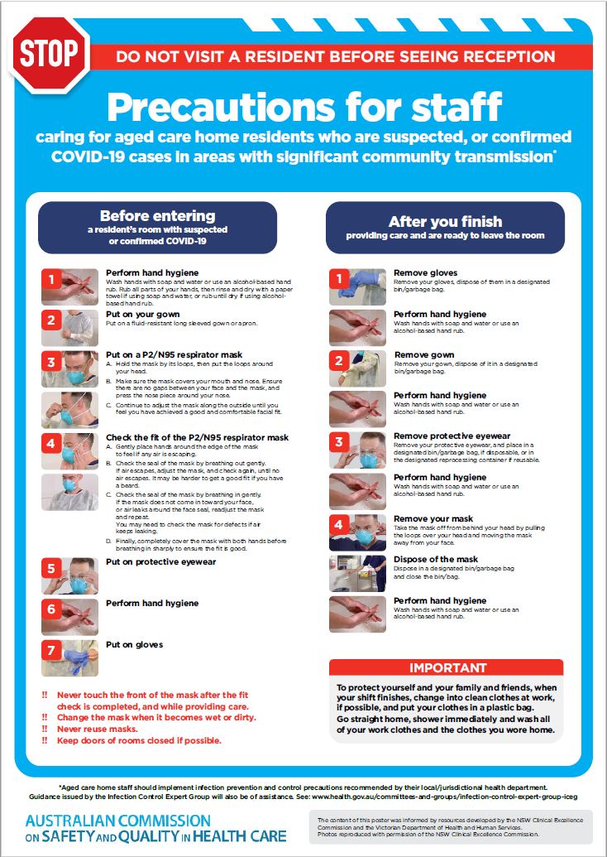](https://www.safetyandquality.gov.au/publications-and-resources/resource-library/covid-19-aged-care-staff-infection-prevention-and-control-precautions-poster)
* ***Environmental Cleaning and Infection Prevention and Control*** [www.safetyandquality.gov.au/environmental-cleaning](http://www.safetyandquality.gov.au/environmental-cleaning)
* ***Infection prevention and control Covid-19 PPE*** poster <https://www.safetyandquality.gov.au/publications-and-resources/resource-library/infection-prevention-and-control-covid-19-personal-protective-equipment>
* ***Special precautions for Covid-19 designated zones*** poster <https://www.safetyandquality.gov.au/publications-and-resources/resource-library/special-precautions-covid-19-designated-zones>
* ***COVID-19 infection prevention and control risk management – Guidance*** <https://www.safetyandquality.gov.au/publications-and-resources/resource-library/covid-19-infection-prevention-and-control-risk-management-guidance>
* ***Safe care for people with cognitive impairment during COVID-19***<https://www.safetyandquality.gov.au/our-work/cognitive-impairment/cognitive-impairment-and-covid-19>
* **Medicines Management COVID-19** <https://www.safetyandquality.gov.au/our-work/medication-safety/medicines-management-covid-19>, including position statements on medicine-related issues
  + ***Managing fever associated with COVID-19***
  + ***Managing a sore throat associated with COVID-19***
  + ***ACE inhibitors and ARBs in COVID-19***
  + ***Clozapine in COVID-19***
  + ***Management of patients on oral anticoagulants during COVID-19***
  + ***Ascorbic Acid: Intravenous high dose in COVID-19***
  + ***Treatment in acute care, including oxygen therapy and medicines to support intubation***
  + ***Nebulisation and COVID-19***
  + ***Managing intranasal administration of medicines during COVID-19***
  + ***Ongoing medicines management in high-risk patients***
  + ***Medicines shortages***
  + ***Conserving medicines***
  + ***Intravenous medicines administration in the event of an infusion pump shortage***
* ***Break the chain of infection: Stopping COVID-19*** poster<https://www.safetyandquality.gov.au/publications-and-resources/resource-library/break-chain-poster-a3>  
  **[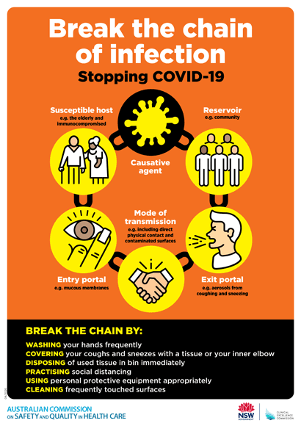](https://www.safetyandquality.gov.au/publications-and-resources/resource-library/break-chain-poster-a3https:/www.safetyandquality.gov.au/publications-and-resources/resource-library/break-chain-poster-a3)**
* ***COVID-19: Elective surgery and infection prevention and control precautions*** <https://www.safetyandquality.gov.au/publications-and-resources/resource-library/covid-19-elective-surgery-and-infection-prevention-and-control-precautions>
* ***FAQs for clinicians on elective surgery*** <https://www.safetyandquality.gov.au/node/5724>
* ***FAQs for consumers on elective surgery*** <https://www.safetyandquality.gov.au/node/5725>
* ***FAQs on community use of face masks***   
   <https://www.safetyandquality.gov.au/faqs-community-use-face-masks>
* ***COVID-19 and face masks – Information for consumers*** <https://www.safetyandquality.gov.au/publications-and-resources/resource-library/covid-19-and-face-masks-information-consumers>  
  The Commission’s fact sheet on use of face masks in the community to reduce the spread of COVID-19 is now available in Easy English and 10 other community languages from <https://www.safetyandquality.gov.au/wearing-face-masks-community>.  
  The factsheet was developed to help people understand when it is important to wear a mask to reduce the risk of the spread of COVID-19, and to explain how to safely put on and remove face masks. It also reinforces the importance of staying home if you have symptoms, physical distancing, hand hygiene and cough etiquette.

[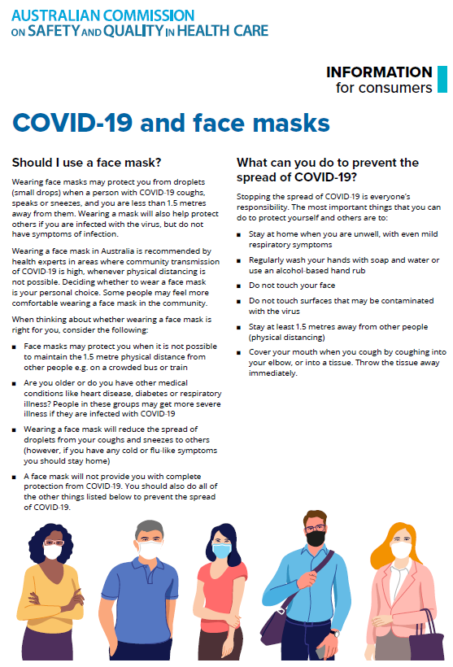](https://www.safetyandquality.gov.au/sites/default/files/2020-07/covid-19_and_face_masks_-_information_for_consumers.pdf)

*National COVID-19 Clinical Evidence Taskforce*

<https://covid19evidence.net.au/>

The National COVID-19 Clinical Evidence Taskforce is a collaboration of peak health professional bodies across Australia whose members are providing clinical care to people with COVID-19. The taskforce is undertaking continuous evidence surveillance to identify and rapidly synthesise emerging research in order to provide national, **evidence-based guidelines and clinical flowcharts for the clinical care of people with COVID-19**. The guidelines address questions that are specific to managing COVID-19 and cover the full disease course across mild, moderate, severe and critical illness. These are ‘living’ guidelines, updated with new research in near real-time in order to give reliable, up-to-the minute advice to clinicians providing frontline care in this unprecedented global health crisis.

*COVID-19 Critical Intelligence Unit*

<https://www.aci.health.nsw.gov.au/covid-19/critical-intelligence-unit>

The Agency for Clinical Innovation (ACI) in New South Wales has developed this page summarising rapid, evidence-based advice during the COVID-19 pandemic. Its operations focus on systems intelligence, clinical intelligence and evidence integration. The content includes a daily evidence digest and evidence checks on a discrete topic or question relating to the current COVID-19 pandemic. There is also a ‘Living evidence’ section summarising key studies and emerging evidence on **COVID-19 vaccines** and **SARS-CoV-2 variants**. Recent evidence check updates include:

* ***Quarantine measures***

**Disclaimer**

On the Radar is an information resource of the Australian Commission on Safety and Quality in Health Care. The Commission is not responsible for the content of, nor does it endorse, any articles or sites listed. The Commission accepts no liability for the information or advice provided by these external links. Links are provided on the basis that users make their own decisions about the accuracy, currency and reliability of the information contained therein. Any opinions expressed are not necessarily those of the Australian Commission on Safety and Quality in Health Care.