# Australian COmmission on Safety and Quality in Health Care logo with Radar imageOn the Radar

Issue 508

26 April 2021

*On the Radar* is a summary of some of the recent publications in the areas of safety and quality in health care. Inclusion in this document is not an endorsement or recommendation of any publication or provider. Access to particular documents may depend on whether they are Open Access or not, and/or your individual or institutional access to subscription sites/services. Material that may require subscription is included as it is considered relevant.

*On the Radar* is available online, via email or as a PDF or Word document from <https://www.safetyandquality.gov.au/publications-and-resources/newsletters/radar>

If you would like to receive *On the Radar* via email, you can subscribe on our website <https://www.safetyandquality.gov.au/publications-and-resources/newsletters>   
or by emailing us at H[Umail@safetyandquality.gov.auU](mailto:mail@safetyandquality.gov.au).   
You can also send feedback and comments to H[Umail@safetyandquality.gov.auU](mailto:mail@safetyandquality.gov.au).

For information about the Commission and its programs and publications, please visit <https://www.safetyandquality.gov.au>

You can also follow us on Twitter @ACSQHC.

**On the Radar**

Editor: Dr Niall Johnson [niall.johnson@safetyandquality.gov.au](mailto:niall.johnson@safetyandquality.gov.au)

Contributors: Niall Johnson, Gillian Giles, Alice Bhasale, Meredith Page

[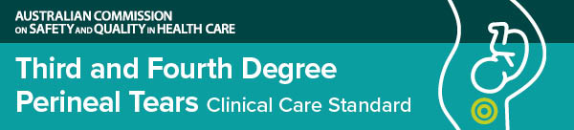](https://www.safetyandquality.gov.au/standards/clinical-care-standards/third-and-fourth-degree-perineal-tears-clinical-care-standard)

**Third and Fourth Degree Perineal Tears Clinical Care Standard**

Australian Commission on Safety and Quality in Health Care

Sydney: ACSQHC; 2021. p. 46.

<https://www.safetyandquality.gov.au/standards/clinical-care-standards/third-and-fourth-degree-perineal-tears-clinical-care-standard>

The Australian Commission on Safety and Quality in Health Care, in consultation with consumers and health professionals working in maternity care, has developed the *Third and Fourth Degree Perineal Tears Clinical Care Standard*.

Perineal tears are common among women giving birth in Australia. While most perineal tears heal well, some women experience more serious tears that can have significant physical and psychological impact.

The new standard will help to reduce the risk of a serious tear and ensure that women receive appropriate treatment and support throughout their birthing experience.

The *Third and Fourth Degree Perineal Tears Clinical Care Standard* includes seven quality statements and a set of indicators for safe and appropriate care.

[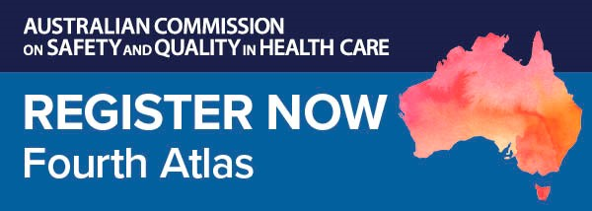](https://kapara.rdbk.com.au/landers/539292.html)

**Fourth Australian Atlas of Healthcare Variation launch**

Do all Australians receive the same evidence-based health care, no matter where they live? If not, where does it vary, and why?

Join us for the online launch of the *Fourth Australian Atlas of Healthcare Variation*. Mapping healthcare use across the country, the new Atlas highlights variation across six clinical topics including early planned births and chronic disease and infection.

The Hon Greg Hunt MP will officially launch the Atlas and speak about what it means for the Australian health system. Professor John Newnham AM, 2020 Senior Australian of the Year and Professor in Obstetrics & Gynaecology at The University of Western Australia, will speak about the findings on early caesarean section births, and why reducing avoidable early births should be a national priority. Professor Paul Kelly, Chief Medical Officer, Australian Government Department of Health, will speak on the significant differences in hospitalisation rates for people with chronic diseases across Australia.

Date: Wednesday **28 April 2021**

Time: **12.00–1.00pm** (AEST)

Location: Online

Click [here](https://kapara.rdbk.com.au/landers/539292.html) to register.

Produced in partnership with the Australian Institute of Health and Welfare, our Atlas series identifies variation for a range of procedures, investigations, treatments and hospitalisations. With recommendations to reduce unwarranted variation, it provides opportunities to minimise low value care, improve the equity of care and improve patient outcomes.

Find out more about the Atlas series and healthcare variation on our website or email us at [atlas@safetyandquality.gov.au](mailto:atlas@safetyandquality.gov.au)

**Journal articles**

*Better understanding the downsides of low value healthcare could reduce harm*

Brownlee SM, Korenstein D

BMJ. 2021;372:n117.

|  |  |
| --- | --- |
| DOI | <https://doi.org/10.1136/bmj.n117> |
| Notes | The arguments against low value care are numerous. These include that lack of clinical benefit, the waste, the increased expenditure, the potential of harm to patients through unnecessary activity, the opportunity cost of unnecessary care that means patients who might otherwise be treated and benefit are not treated, etc. The authors of this piece in the *BMJ* consider that there has been a lack of ‘attention on the physical and psychological harms of overuse has hampered efforts to reduce it’. They observed that ‘Harm from overuse of low value services is entirely preventable, at least theoretically: avoid delivering the ineffective or inappropriate service and it cannot hurt the patient.’  The authors identify their key messages as being:   * Overuse of low value healthcare services has often been cast primarily as a problem of waste; it is also a source of preventable physical and psychological harm to patients * Emphasising overuse as waste might signal to patients that efforts to avoid unnecessary services are an attempt to ration needed care * Understanding the scope of preventable harm caused by overuse could provide both patients and clinicians with incentives to avoid it * Few national or international databases collect data on how often adverse events occur during delivery of unnecessary services, how many patients are involved, or how serious the harms are * Quantifying harm from overuse will require new research methods and better collection of harms data from clinical studies.   [Information needed to determine harms of overused services](https://doi.org/10.1136/bmj.n117) |

*Promise and perils of patient decision aids for reducing low-value care*

Thompson R, Muscat DM, Jansen J, Cox D, Zadro JR, Traeger AC, et al

BMJ Quality & Safety. 2021;30(5):407-411.

|  |  |
| --- | --- |
| DOI | <http://dx.doi.org/10.1136/bmjqs-2020-012312> |
| Notes | A means of addressing low value care has been to attempt to make clinical decision making more sensitive to the issues. This Australian study examined the potential role of shared decision making and patient decision aids. Patient decision aids provide patients information about the treatment options Decision aids are not intended to encourage or discourage a particular option but rather to facilitate a choice based on a patient’s individual values and goal.  [Recommendations for mitigating unintended consequences when a decision aid approach is thought to be worthwhile.](http://dx.doi.org/10.1136/bmjqs-2020-012312) |

For information on the Commission’s work on shared decision making, see <https://www.safetyandquality.gov.au/our-work/partnering-consumers/shared-decision-making>

For information on the Commission’s work on decision support tools for patients, see <https://www.safetyandquality.gov.au/our-work/partnering-consumers/shared-decision-making/decision-support-tools-patients>

*Measuring the economic impact of hospital-acquired complications on an acute health service*

Fernando-Canavan L, Gust A, Hsueh A, Tran-Duy A, Kirk M, Brooks P, et al.

Australian Health Review. 2021;45(2):135-142.

|  |  |
| --- | --- |
| DOI | <https://doi.org/10.1071/AH20126> |
| Notes | This paper presents the economic impact of 16 hospital-acquired complications (HACs) in one Australian health service for the period 1 July 2016 to 30 June 2017. A hospital-acquired complication (HAC) refers to a complication for which clinical risk mitigation strategies may reduce (but not necessarily eliminate) the risk of that complication occurring. There are 16 agreed, high priority HACs. This paper reports on a retrospective cohort study using a deidentified patient dataset containing 93 056 in-patient separations (for 49 809 individuals) in Northern Health (Victoria, Australia). The authors report that ‘**1700 separations involving HACs (1.83%) were identified**. The **most common HAC** was **health care-associated infections**. **Most HACs were associated with a statistically significant risk of increased cost** (15/16 HACs) **and LOS** [length of stay] (11/16 HACs). HACs involving **falls** resulting in fracture or other intracranial injury were associated with the **highest additional cost (**A$17 173). The **biggest increase in additional LOS was unplanned admissions to the intensive care unit** (5.42 days).’ |

For information on the Commission’s work on hospital-acquired complications (HACs), see <https://www.safetyandquality.gov.au/our-work/indicators/hospital-acquired-complications>

*Smartphone distraction during nursing care: Systematic literature review*

Fiorinelli M, Di Mario S, Surace A, Mattei M, Russo C, Villa G, et al

Applied Nursing Research. 2021;58:151405.

*A mixed methods systematic review of the effects of patient online self-diagnosing in the 'smart-phone society' on the healthcare professional-patient relationship and medical authority*

Farnood A, Johnston B, Mair FS

BMC Medical Informatics and Decision Making. 2020;20(1):253.

|  |  |
| --- | --- |
| DOI | Fiorinelli et al <https://doi.org/10.1016/j.apnr.2021.151405>  Farnood et al <https://doi.org/10.1186/s12911-020-01243-6> |
| Notes | Our phones are ubiquitous; we are rarely without them. These two pieces look at the role of the smartphone.  Fiorinelli et al examined the literature on the use of smartphones by nurses when working. Their review found pros and cons about smartphone use during nursing care. Based on 16 articles, the review found that ‘About 80% of nurses use the smartphone in the workplace both for personal purposes and as a useful support to improve the quality of care.’   * Mobile devices support nurses in carrying out research, clinical activity and health education. * The smartphone can improve the quality of communication processes among nurses. * The smartphone can improve the exchange of information between team members. * Smartphones can have consequences on nurses-patients relationship: dehumanization and depersonalization of care and can have serious consequences on patient safety.   The authors suggest ‘the application of regulations and policies by healthcare facilities is desirable to avoid inappropriate use of these devices by nurses.’  Farnood et al. sought to examine the relationship between the patient and clinician and the impact of smartphone use by patients to self-diagnose. Based on 25 articles, the authors found that patients ‘value healthcare professionals as a source of medical advice more than the internet’ and that patients consider the internet ‘a complementary information source’. The authors suggest that ‘online health information seeking can potentially improve the patient-healthcare professional relationship as patients reported they usually conducted an online search to form a partnership with the healthcare professional as opposed to trying to prove them wrong.’ |

*BMJ Quality & Safety*

May 2021 - Volume 30 - 5

|  |  |
| --- | --- |
| URL | <https://qualitysafety.bmj.com/content/30/5> |
| Notes | A new issue of *BMJ Quality & Safety* has been published. Many of the papers in this issue have been referred to in previous editions of *On the Radar* (when they were released online). Articles in this issue of *BMJ Quality & Safety* include:   * Editorial: Harnessing **choice architecture** to improve medical care (Donald A Redelmeier, Mian-Mian Kao) * Editorial: Advancing **health equity in patient safety**: a reckoning, challenge and opportunity (Marshall H Chin) * **Choice architecture in physician–patient communication**: a mixed-methods assessments of physicians’ competency (Joanna Hart, Kuldeep Yadav, Stephanie Szymanski, Amy Summer, Aaron Tannenbaum, Julian Zlatev, David Daniels, Scott D Halpern) * **Inpatient patient safety events in vulnerable populations**: a retrospective cohort study (Lucy B Schulson, Victor Novack, Patricia H Folcarelli, Jennifer P Stevens, Bruce E Landon) * Reporting **incidents involving the use of advanced medical technologies by nurses in home care**: a cross-sectional survey and an analysis of registration data (Ingrid ten Haken, Somaya Ben Allouch, Wim H van Harten) * **Variation in tonsillectomy** cost and revisit rates: analysis of administrative and billing data from US children’s hospitals (Sanjay Mahant, Troy Richardson, Ron Keren, Rajendu Srivastava, Jeremy Meier) * **Distance travelled to hospital for emergency laparotomy** and the effect of travel time on mortality: cohort study (Tom Salih, Peter Martin, Tom Poulton, Charles M Oliver, Mike G Bassett, S Ramani Moonesinghe) * Promise and perils of **patient decision aids for reducing low-value care** (Rachel Thompson, Danielle M Muscat, Jesse Jansen, Darlene Cox, Joshua R Zadro, Adrian C Traeger, Kirsten McCaffery) * It’s time to consider **national culture when designing team training** initiatives in healthcare (Julie Rice, Lina Daouk-Öyry, Eveline Hitti) * A realist synthesis of **pharmacist-conducted medication reviews in primary care** after leaving hospital: what works for whom and why? (Karen Luetsch, Debra Rowett, Michael J Twigg) * **Nurses and nursing support matter**: interpreting the evidence (Jack Needleman, Patricia W Stone) |

*Pediatric Quality & Safety*

Volume 6, Number 2, March/April 2021)

|  |  |
| --- | --- |
| URL | <https://journals.lww.com/pqs/toc/2021/03000> |
| Notes | A new issue of *Pediatric Quality & Safety* has been published. Articles in this issue of *Pediatric Quality & Safety* include:   * Incremental Improvements Can Reduce **Alarm Fatigue in the Neonatal Intensive Care Unit** (Schlegel, Amy B; Shepherd, Edward G) * Stewardship Intervention to Optimize **Central Venous Catheter Utilization in Critically Ill Children** (Blumenthal, Jennifer A; Ormsby, Jennifer A; Mirchandani, Dimple; Petti, Chonel A; Carpenter, Jane; Geller, Maggie; Harding, Stephanie N; O’Brien, Mary; Sandora, Thomas J; Kleinman, Monica E; Priebe, Gregory P; Mehta, Nilesh M) * The Impact of Demographics on **Child and Parent Ratings of Satisfaction with Hospital Care** (Waldron, Mia K; Wathen, Kourtney; Houston, Sasha; Coleman, Lael; Mason, Janice J; Wang, Yunfei; Hinds, Pamela S) * Reducing Employee Injury Rates with a **Hospital-wide Employee Safety Program** (Fink, Alia; Merkeley, Kathryn; Tolliver, Charika; McLeese, Raven; Mason, Janice J.; Mantasas, Nikolas; Cheng, Jenhao Jacob; Roberts-Turner, Reneè; Fahey, Lisbeth; Parra, Martha; Talley, Linda; Cady, R; Shah, R K) * Implementation and Maintenance of a **Pediatric Severe Burn Guidelines** Quality Improvement Project (Dolan, Kristin J; Flint, Jennifer L; Benton, Tara C; Miller, Mikaela; Miller, Jenna O) * Comprehensive Care Improvement for **Oncologic Fever and Neutropenia** from a Pediatric Emergency Department (Kuehnel, Nicholas A; McCreary, Erin; Henderson, Sheryl L; Vanderloo, Joshua P; Hoover-Regan, Margo L; Sharp, Brian; Ross, Joshua) * **Reducing Alarm Burden** in a Level IV Neonatal Intensive Care Unit (McCauley, Kortany E; Schroeder, Alissa A; DeBoth, Tawney K; Wiebe, Alexander M; Bosley, Christopher L; Ballweg, Diane D; Fang, Jennifer L) * Sustained Improvement in the Performance of **Rapid Sequence Intubation** Five Years after a Quality Improvement Initiative (Kerrey, Benjamin T; Mittiga, Matthew R; Boyd, Stephanie; Frey, Mary; Geis, Gary L; Rinderknecht, Andrea S; Ahaus, Karen; Varadarajan, Kartik R; Luria, Joseph W; Iyer, S B) * Bladder and Bowel Dysfunction Network: Improving the Management of **Pediatric Bladder and Bowel Dysfunction** (Pokarowski, Martha; Rickard, Mandy; Kanani, Ronik; Mistry, Niraj; Saunders, Megan; Rockman, Rebecca; Sam, Jonathan; Varghese, Abby; Malach, Jessica; Margolis, Ivor; Roushdi, Amani; Levin, Leo; Singh, Manbir; Lopes, Roberto Iglesias; Farhat, Walid A; Koyle, Martin A.; Dos Santos, Joana) * Integration of a Lean Daily Management System into an **Antimicrobial Stewardship** Program (Wirtz, Ann L; Monsees, Elizabeth A; Gibbs, Kate A; Myers, Angela L; Burns, Alaina N; Lee, Brian R; El Feghaly, Rana E; Weddle, Gina M; Day, James C; Purandare, Amol V; Goldman, Jennifer L) * A **Patient Navigator Intervention** Supporting Timely Transfer Care of Adolescent and Young Adults of Hispanic Descents Attending an Urban Primary Care Pediatrics Clinic (Allende-Richter, Sophie; Glidden, Patricia; Maloyan, Mariam; Khoury, Zana; Ramirez, Melanie; O’Hare, Kitty) * Care Does Not Stop Following ROSC: A Quality Improvement Approach to **Postcardiac Arrest Care** (Pfeiffer, Stephen; Zackoff, Matthew; Bramble, Katelyn; Jacobs, L; Ruehlmann, K; Stalets, E L; Tegtmeyer, K; Dewan, M) * Utilizing a Behavioral Health Bundle to Improve **Patient and Clinician Safety for Hospitalized Children** (Nicome, Roger; Lo, Huay-Ying; Gupta, Sheena; Khan, Adrita; Lee, Alice; Molchen, Wallis; Neubauer, Hannah; Ramgopal, Veena; Lyn, Michelle; Weber, Emily; Vachani, Joyee) * Decreasing Inappropriate Use of Antireflux Medications by Standardizing **Gastroesophageal Reflux Disease Management in NICU** (Shakeel, Fauzia M.; Crews, Jacquelyn; Jensen, Preceous; Ritchey, Andrea; Allen, Megan; Mateus, Jazmine; Machry, Joana) * Evidence-based Standardization of **Constipation Management in the Emergency Department**: A Quality Improvement Study (Lipshaw, Matthew J; Zamor, Ronine L; Carson, Rebecca; Mallon, Daniel; Sobolewski, Brad; Vukovic, Adam A; Kurowski, Eileen Murtagh) * **Reducing Pediatric ED Length of Stay by Reducing Diagnostic Testing**: A Discrete Event Simulation Model (McKinley, Kenneth W; Chamberlain, James M; Doan, Quynh; Berkowitz, Deena) * Vaccinating in the Emergency Department, a Model to Overcome **Influenza Vaccine Hesitancy** (Baumer-Mouradian, Shannon H; Servi, Ashley; Kleinschmidt, Abigail; Nimmer, Mark; Lazarevic, Kimberly; Hanson, Thomas; Jastrow, Jena; Jaworski, Brian; Kopetsky, Matthew; Drendel, Amy L) |

*Australian Journal of Primary Health*

Volume 27 Number 2 2021

|  |  |
| --- | --- |
| URL | <https://www.publish.csiro.au/py/issue/10183> |
| Notes | A new issue of the *Australian Journal of Primary Health* has been published with a theme of “School-based Models of Primary Health Care”. Articles in this issue of the *Australian Journal of Primary Health* include:   * **Integrating primary health care and education** to improve outcomes for children (Sarah Dennis and Lauren Ball) * Embedding public health advocacy into the role of school-based nurses: addressing the **health inequities confronted by vulnerable Australian children and adolescent populations** (Debra Jones, Sue Randall, Danielle White, Lisa-Marie Darley, Gabrielle Schaefer, Jennifer Wellington, Anu Thomas and David Lyle) * **School-based integrated healthcare** model: how Our Mia Mia is improving health and education outcomes for children and young people (Antonio Mendoza Diaz, Andrew Leslie, Charlotte Burman, James Best, Kristie Goldthorp and Valsamma Eapen) * ‘We’re definitely that link’: the role of **school-based primary health care registered nurses** in a rural community (Catherine Sanford, Emily Saurman, Sarah Dennis and David Lyle) * Incorporating a **health team** as part of a disadvantaged high school’s **interconnected community learning model** (Ted Noon and G Zadkovich) * **Improving access to refugee-focused health services** for people from refugee-like backgrounds in south-eastern Melbourne through the education sector (Katrina M. Long, Shiva Vasi, Susannah Westbury, Sandy Shergill, Chloé Guilbert-Savary, Ashley Whitelaw, I-Hao Cheng and Grant Russell) * Exploring **adolescent and clinician perspectives on** Australia’s national digital health record, **My Health Record** (L Beaton, I Williams and L Sanci) * Using the National Mental Health Service Planning Framework to support an **integrated approach to regional mental health planning** in Queensland, Australia (Eryn Wright, Elizabeth Leitch, Kevin Fjeldsoe, Sandra Diminic, Kate Gossip, Patricia Hudson and Harvey Whiteford) * **Producing health information in consultation with health workers and the hepatitis B-affected** communities is worthwhile (Gabrielle Bennett, Jacqueline Richmond and Alexander J Thompson) * **Multimorbidity** through the lens of life-limiting illness: how helpful are Australian clinical practice guidelines to its **management in primary care**? (Raechel A Damarell, Deidre D Morgan, Jennifer J Tieman and D F Healey) * **Reducing health inequities for asylum seekers** with chronic non-communicable diseases: Australian context (Gloria Nkhoma, Chiao Xin Lim, Gerard A Kennedy and Ieva Stupans) * **Dementia risk reduction** in practice: the knowledge, opinions and perspectives of Australian healthcare providers (Lidan Zheng, Kali Godbee, Genevieve Z Steiner, Gail Daylight, Carolyn Ee, Thi Yen Hill, Mark I Hohenberg, Nicola T. Lautenschlager, Keith McDonald, Dimity Pond, Kylie Radford, Kaarin J Anstey and Ruth Peters) * Structured yet simple approaches to **primary care data quality improvements** can indeed strike gold (Abhijeet Ghosh, Elizabeth Halcomb, Sandra McCarthy and Christine Ashley) * ‘No-Frills Prils’: **GPs’ views on drug costs and therapeutic interchange of angiotensin-converting enzyme inhibitors**: a qualitative study (Hok Lim, Lena Sanci, Susan Webster, Alyce N Wilson and Phyllis Lau) * Primary healthcare clinicians’ positive perceptions of the **implementation of telehealth during the COVID-19 pandemic** using normalisation process theory (Kaye Ervin, Jennifer Weller-Newton and Jacque Phillips) |

*BMJ Quality & Safety* online first articles

|  |  |
| --- | --- |
| URL | <https://qualitysafety.bmj.com/content/early/recent> |
| Notes | *BMJ Quality &Safety* has published a number of ‘online first’ articles, including:   * **Is greater patient involvement associated with higher satisfaction?** Experimental evidence from a vignette survey (Søren Birkeland, Marie Bismark, Michael John Barry, Sören Möller) * Editorial: Timely testing: who needs to do what differently to improve **adherence to guideline-recommended glycaemic monitoring**? (Sheena McHugh, Kate O'Neill, Patricia M Kearney) * The effectiveness of **interruptive prescribing alerts in ambulatory CPOE** to change prescriber behaviour & improve safety (Oliver Cerqueira, Mohsain Gill, Bishr Swar, Katherine Ann Prentice, Shannon Gwin, Brent W Beasley) |

*International Journal for Quality in Health Care* online first articles

|  |  |
| --- | --- |
| URL | <https://academic.oup.com/intqhc/advance-articles> |
| Notes | *International Journal for Quality in Health Care* has published a number of ‘online first’ articles, including:   * Masked and Distanced: A Qualitative Study of **How Personal Protective Equipment and Distancing Affect Teamwork in Emergency Care** (Tuna C Hayirli, Nicholas Stark, Aditi Bhanja, James Hardy, Christopher R Peabody, Michaela J Kerrissey) * **From Accreditation to Quality Improvement** – the Danish National Quality Programme (Christian Uggerby, Solvejg Kristensen, Julie Mackenhauer, Søren Valgreen Knudsen, Paul Bartels, Søren Paaske Johnsen, Jan Mainz) |

**Online resources**

*[UK] NICE Guidelines and Quality Standards*

<https://www.nice.org.uk/guidance>

The UK’s National Institute for Health and Care Excellence (NICE) has published new (or updated) guidelines and quality standards. The latest reviews or updates are:

* Quality Standard QS37 ***Postnatal care*** <https://www.nice.org.uk/guidance/qs37>
* NICE Guideline NG194 ***Postnatal care*** <https://www.nice.org.uk/guidance/ng194>
* NICE Guideline NG195 ***Neonatal infection****: antibiotics for prevention and treatment* <https://www.nice.org.uk/guidance/ng195>

*[USA] Effective Health Care Program reports*

<https://effectivehealthcare.ahrq.gov/>

The US Agency for Healthcare Research and Quality (AHRQ) has an Effective Health Care (EHC) Program. The EHC has released the following final reports and updates:

* ***Maternal, Fetal, and Child Outcomes of Mental Health Treatments*** *in Women: A Systematic Review of Perinatal Pharmacologic Interventions*  
   <https://effectivehealthcare.ahrq.gov/products/mental-health-pregnancy/research>
* *Improving the Utility of* ***Evidence Synthesis for Decision Makers*** *in the Face of Insufficient Evidence* <https://effectivehealthcare.ahrq.gov/products/improving-evidence-synthesis/white-paper>

**COVID-19 resources**

https://www.safetyandquality.gov.au/covid-19

The Australian Commission on Safety and Quality in Health Care has developed a number of resources to assist healthcare organisations, facilities and clinicians. These and other material on COVID-19 are available at <https://www.safetyandquality.gov.au/covid-19>

These resource include:

* ***COVID-19: Aged care staff infection prevention and control precautions*** *poster*<https://www.safetyandquality.gov.au/publications-and-resources/resource-library/covid-19-aged-care-staff-infection-prevention-and-control-precautions-poster>  
    
  [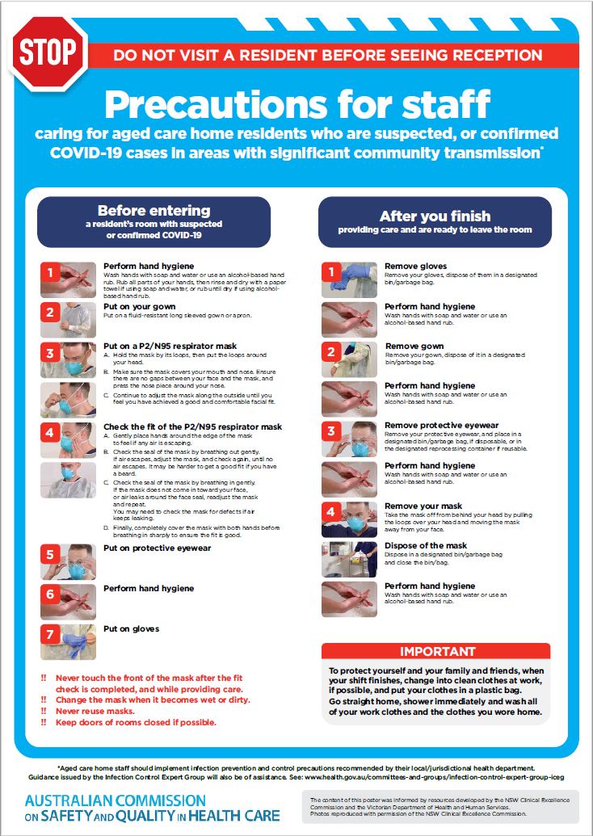](https://www.safetyandquality.gov.au/publications-and-resources/resource-library/covid-19-aged-care-staff-infection-prevention-and-control-precautions-poster)
* ***Environmental Cleaning and Infection Prevention and Control*** [www.safetyandquality.gov.au/environmental-cleaning](http://www.safetyandquality.gov.au/environmental-cleaning)
* ***Infection prevention and control Covid-19 PPE*** poster <https://www.safetyandquality.gov.au/publications-and-resources/resource-library/infection-prevention-and-control-covid-19-personal-protective-equipment>
* ***Special precautions for Covid-19 designated zones*** poster <https://www.safetyandquality.gov.au/publications-and-resources/resource-library/special-precautions-covid-19-designated-zones>
* ***COVID-19 infection prevention and control risk management – Guidance*** <https://www.safetyandquality.gov.au/publications-and-resources/resource-library/covid-19-infection-prevention-and-control-risk-management-guidance>
* ***Safe care for people with cognitive impairment during COVID-19***<https://www.safetyandquality.gov.au/our-work/cognitive-impairment/cognitive-impairment-and-covid-19>
* **Medicines Management COVID-19** <https://www.safetyandquality.gov.au/our-work/medication-safety/medicines-management-covid-19>, including position statements on medicine-related issues
  + ***Managing fever associated with COVID-19***
  + ***Managing a sore throat associated with COVID-19***
  + ***ACE inhibitors and ARBs in COVID-19***
  + ***Clozapine in COVID-19***
  + ***Management of patients on oral anticoagulants during COVID-19***
  + ***Ascorbic Acid: Intravenous high dose in COVID-19***
  + ***Treatment in acute care, including oxygen therapy and medicines to support intubation***
  + ***Nebulisation and COVID-19***
  + ***Managing intranasal administration of medicines during COVID-19***
  + ***Ongoing medicines management in high-risk patients***
  + ***Medicines shortages***
  + ***Conserving medicines***
  + ***Intravenous medicines administration in the event of an infusion pump shortage***
* ***Break the chain of infection: Stopping COVID-19*** poster<https://www.safetyandquality.gov.au/publications-and-resources/resource-library/break-chain-poster-a3>  
  **[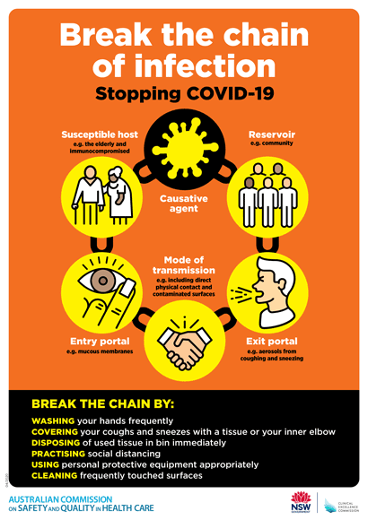](https://www.safetyandquality.gov.au/publications-and-resources/resource-library/break-chain-poster-a3https:/www.safetyandquality.gov.au/publications-and-resources/resource-library/break-chain-poster-a3)**
* ***COVID-19: Elective surgery and infection prevention and control precautions*** <https://www.safetyandquality.gov.au/publications-and-resources/resource-library/covid-19-elective-surgery-and-infection-prevention-and-control-precautions>
* ***FAQs for clinicians on elective surgery*** <https://www.safetyandquality.gov.au/node/5724>
* ***FAQs for consumers on elective surgery*** <https://www.safetyandquality.gov.au/node/5725>
* ***FAQs on community use of face masks***   
   <https://www.safetyandquality.gov.au/faqs-community-use-face-masks>
* ***COVID-19 and face masks – Information for consumers*** <https://www.safetyandquality.gov.au/publications-and-resources/resource-library/covid-19-and-face-masks-information-consumers>  
  The Commission’s fact sheet on use of face masks in the community to reduce the spread of COVID-19 is now available in Easy English and 10 other community languages from <https://www.safetyandquality.gov.au/wearing-face-masks-community>.  
  The factsheet was developed to help people understand when it is important to wear a mask to reduce the risk of the spread of COVID-19, and to explain how to safely put on and remove face masks. It also reinforces the importance of staying home if you have symptoms, physical distancing, hand hygiene and cough etiquette.

[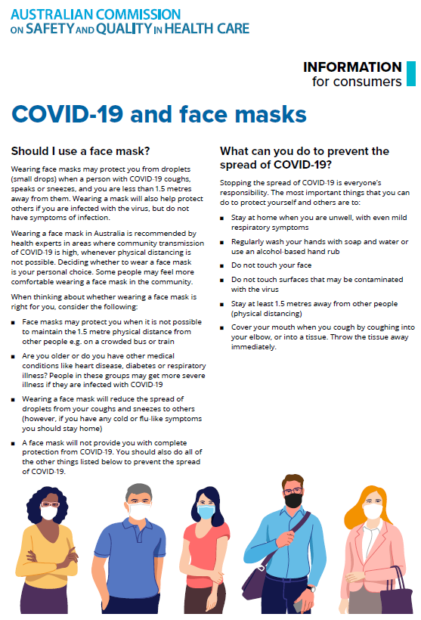](https://www.safetyandquality.gov.au/sites/default/files/2020-07/covid-19_and_face_masks_-_information_for_consumers.pdf)

*National COVID-19 Clinical Evidence Taskforce*

<https://covid19evidence.net.au/>

The National COVID-19 Clinical Evidence Taskforce is a collaboration of peak health professional bodies across Australia whose members are providing clinical care to people with COVID-19. The taskforce is undertaking continuous evidence surveillance to identify and rapidly synthesise emerging research in order to provide national, **evidence-based guidelines and clinical flowcharts for the clinical care of people with COVID-19**. The guidelines address questions that are specific to managing COVID-19 and cover the full disease course across mild, moderate, severe and critical illness. These are ‘living’ guidelines, updated with new research in near real-time in order to give reliable, up-to-the minute advice to clinicians providing frontline care in this unprecedented global health crisis.

*COVID-19 Critical Intelligence Unit*

<https://www.aci.health.nsw.gov.au/covid-19/critical-intelligence-unit>

The Agency for Clinical Innovation (ACI) in New South Wales has developed this page summarising rapid, evidence-based advice during the COVID-19 pandemic. Its operations focus on systems intelligence, clinical intelligence and evidence integration. The content includes a daily evidence digest and evidence checks on a discrete topic or question relating to the current COVID-19 pandemic. There is also a ‘Living evidence’ section summarising key studies and emerging evidence on **COVID-19 vaccines** and **SARS-CoV-2 variants**. Recent evidence check updates include:

* ***Deep cleans*** – Is deep cleaning necessary to limit the transmission of COVID-19?
* ***COVID-19 rapid testing*** – What is the efficacy of rapid, point-of-care tests for COVID-19?Quarantine measures.

**Disclaimer**

On the Radar is an information resource of the Australian Commission on Safety and Quality in Health Care. The Commission is not responsible for the content of, nor does it endorse, any articles or sites listed. The Commission accepts no liability for the information or advice provided by these external links. Links are provided on the basis that users make their own decisions about the accuracy, currency and reliability of the information contained therein. Any opinions expressed are not necessarily those of the Australian Commission on Safety and Quality in Health Care.