# Australian COmmission on Safety and Quality in Health Care logo with Radar imageOn the Radar

Issue 509

3 May 2021

*On the Radar* is a summary of some of the recent publications in the areas of safety and quality in health care. Inclusion in this document is not an endorsement or recommendation of any publication or provider. Access to particular documents may depend on whether they are Open Access or not, and/or your individual or institutional access to subscription sites/services. Material that may require subscription is included as it is considered relevant.

*On the Radar* is available online, via email or as a PDF or Word document from <https://www.safetyandquality.gov.au/publications-and-resources/newsletters/radar>

If you would like to receive *On the Radar* via email, you can subscribe on our website <https://www.safetyandquality.gov.au/publications-and-resources/newsletters>   
or by emailing us at H[Umail@safetyandquality.gov.auU](mailto:mail@safetyandquality.gov.au).   
You can also send feedback and comments to H[Umail@safetyandquality.gov.auU](mailto:mail@safetyandquality.gov.au).

For information about the Commission and its programs and publications, please visit <https://www.safetyandquality.gov.au>

You can also follow us on Twitter @ACSQHC.

**On the Radar**

Editor: Dr Niall Johnson [niall.johnson@safetyandquality.gov.au](mailto:niall.johnson@safetyandquality.gov.au)

Contributors: Niall Johnson, Gillian Giles, Meredith Page, Helen Francombe, Jan Gralton

**Fourth Australian Atlas of Healthcare Variation**

Australian Commission on Safety and Quality in Health Care and Australian Institute of Health and Welfare

Sydney: ACSQHC; 2021. p. 396.

<https://www.safetyandquality.gov.au/fourth-atlas-2021>

The *Fourth Australian Atlas of Healthcare Variation* was launched by The Hon Greg Hunt MP, Minister for Health and Aged Care, on 28 April 2021 with a keynote presentation by Professor John Newnham AM, Senior Australian of the Year 2020. The fourth Atlas examines variation in 17 healthcare items across six clinical areas: early planned birth, selected potentially preventable hospitalisations, lumbar spinal surgery, myringotomy and tonsillectomy in young people, gastrointestinal investigations, and medicines use in older people. It also looks at changes over time for 10 items: myringotomy, tonsillectomy, lumbar spinal surgery and the potentially preventable hospitalisation items.

The Atlas reports marked variation in most of the 17 items, and concerning patterns of use in some.

***Why investigate variation in clinical care?***

The Atlas series explores how healthcare use in Australia varies depending on where people live. It investigates reasons for variation that may be unwarranted, and provides specific achievable actions to reduce unwarranted variation.

The analyses includes caesarean section before 39 weeks’ gestation without an obstetric or medical indication, and potentially preventable hospitalisations for chronic diseases.

***Planned caesarean section before 39 weeks without a medical or obstetric indication***

Waiting until at least 39 weeks’ gestation is best for the baby if there are no medical or pregnancy-related reasons for an earlier birth. This is because planned caesarean section before 39 weeks’ gestation increases some risks for the newborn, including breathing problems and the need for neonatal intensive care. The risk of hospitalisation for infections in the first five years of life may also be increased in these children.

There is some evidence of long-term developmental problems, including poorer school performance and a higher risk of attention deficit hyperactivity disorder (ADHD) in children born before 39 weeks. Risks of early planned birth without a medical or obstetric indication are avoidable

The Atlas found high rates of early planned caesarean section without medical or obstetric indication for the seven states and territories for which data could be reported (excludes NT).

In 2017:

* 43–56% of planned caesarean section births performed before 39 weeks did not have a medical or obstetric indication
* 25–33% of planned caesarean section births performed before 38 weeks did not have a medical or obstetric indication
* 13–19% of planned caesarean section births performed before 37 weeks did not have a medical or obstetric indication.

Recommendations in the fourth Atlas to reduce early planned caesarean sections include:

* Health service organisations with maternity services, and clinicians, to implement systems to obtain informed patient consent that includes the provision of comparative information for prospective parents on the short- and long-term risks of early planned birth without a medical or obstetric indication.
* Health service organisations with maternity services to establish policies to cease booking planned births before 39 weeks from July 2022 and to review adherence to these policies.
* Medicare Benefits Schedule payment for births before 39 weeks without a medical or obstetric indication to cease from July 2022.

***Potentially preventable hospitalisations for chronic diseases***

Some hospitalisations for people with chronic diseases, such as diabetes and heart failure, can be prevented by appropriate management earlier in the disease and well-coordinated care.

After standardising to remove age and sex differences between populations, the Atlas found large differences in local rates of hospitalisations for:

* chronic obstructive pulmonary disease (COPD); the highest rate* was 1,013 per 100,000 in Katherine, NT, and the lowest rate was 56 per 100,000 in Pennant Hills-Epping, NSW. The rate was more than 18 times as high in the area with the highest rate compared with the area with the lowest rate
* cellulitis; the highest rate* was 1,393 per 100,000 in Far North, QLD, and the lowest rate was 90 per 100,000 in Burnside, SA. The rate was more than 15 times as high in the area with the highest rate compared with the area with the lowest rate
* diabetes complications; the highest rate* was 782 in Baw Baw, Victoria and the lowest rate was 64 per 100,000 in Mitcham, SA. The rate was more than 12 times as high in the area with the highest rate compared with the area with the lowest rate.

*non-volatile rates. Some SA3s had higher rates again, but they are volatile and not included in the magnitude of variation.

Healthcare investment must be redirected to create better coordination of different parts of the health system, such as primary care, specialists in the community, allied health care and hospital care, to reduce potentially preventable hospitalisations.

For all the conditions examined, hospitalisation rates were higher among Aboriginal and Torres Strait Islander peoples, people living in areas of socioeconomic disadvantage, and those living in remote areas. Better prevention and management of chronic diseases should be targeted to these groups as a priority to reduce their need for hospitalisation. The underlying reasons for higher rates of chronic diseases in these groups also need to be addressed, such as the social determinants of heath and, particularly, smoking.

***Online and interactive***

The fourth Atlas, available online and in print, includes interactive maps and graphs, data for sharing and download, clinical commentaries and recommendations for each chapter. Options for viewing the fourth Atlas are:

* Online – with interactive maps showing rates by local geographical Statistical Area Level 3 (SA3) with comparison rates for Primary Health Network PHNs, state and territories and the national rate, zoom in function for capital cities, and PHN/LHN boundaries; also with interactive graphs showing rates by state and territory, and by remoteness and socioeconomic status
* Additional interactive graphs for some clinical items, such as graphs showing rates by Aboriginal and Torres Strait Islander status, public or private funding, age and sex
* Download of the full Atlas as a PDF
* Download of individual chapters for each Atlas
* Download of data files for each clinical item that for most items include data by SA3, PHN, state and territory, remoteness and socioeconomic status
* The printed Atlas, which will be distributed widely throughout the health system.

Explore the Fourth Atlas <https://www.safetyandquality.gov.au/fourth-atlas-2021>

**[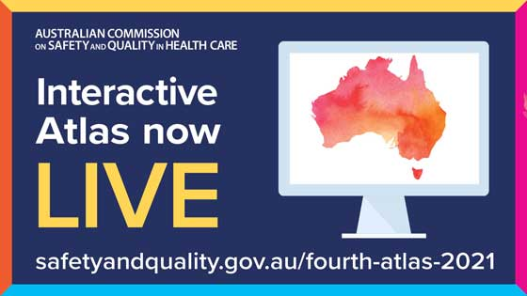](https://www.safetyandquality.gov.au/fourth-atlas-2021)**

**World Hand Hygiene Day**

<https://www.safetyandquality.gov.au/our-work/infection-prevention-and-control/national-hand-hygiene-initiative/world-hand-hygiene-day>

As part of the National Hand Hygiene Initiative (NHHI), the Commission would like to invite the readers to join us in celebrating World Hand Hygiene Day, 5 May 2021.

World Hand Hygiene Day is an annual initiative by the World Health Organization (WHO) as part of the Clean Care Saves Lives program. Each year the WHO has a theme for World Hand Hygiene Day to promote safe, clean care and educate healthcare workers on how hand hygiene is related to the care they provide. The theme for this year’s campaign is ‘Achieving hand hygiene at the point of care’.

The Commission has published a World Hand Hygiene Day webpage available [here](https://www.safetyandquality.gov.au/our-work/infection-prevention-and-control/national-hand-hygiene-initiative/world-hand-hygiene-day), which will feature a video message from the Commission's Acting Chief Medical Officer.

The Commission will also be releasing a series of tweets over the next week to support World Hand Hygiene Day. These tweets will be available at <https://twitter.com/ACSQHC>

**World Hand Hygiene Day 2021
Achieving hand hygiene at the point of care infographic**

**Reports**

*Quality improvement made simple. What everyone should know about health care quality improvement*

3rd ed

Jones B, Kwong E, Warburton W

London: The Health Foundation; 2021. p. 67.

|  |  |
| --- | --- |
| DOI | <https://doi.org/10.37829/HF-2021-I05> |
| Notes | The Health Foundation in the UK has produced an updated third edition of their *Quality improvement made simple* guide. According to the Health Foundation, improving quality is about making health care safe, effective, patient-centred, timely, efficient and equitable. It’s about giving the people closest to problems affecting care quality the time, permission, skills and resources they need to solve them. Quality improvement involves the use of a systematic and coordinated approach to solving a problem using specific methods and tools with the aim of bringing about a measurable improvement within a health care setting. This guide offers an explanation of some popular approaches used to improve quality, including where they have come from, their underlying principles and their efficacy and applicability within the healthcare arena. It also describes the factors that can help to ensure the successful use of these approaches and methods to improve the quality of care processes, pathways and services. |

*Shaping the future of digital technology in health and social care*

Maguire D, Honeyman M, Fenney D, Jabbal J

London: The King's Fund; 2021. p. 84.

|  |  |
| --- | --- |
| URL | <https://www.kingsfund.org.uk/publications/future-digital-technology-health-social-care> |
| Notes | The King’s Fund in the UK has produced this report, commission by the Health Foundation, summarising the evidence for how emerging technologies such as artificial intelligence, smartphones, wearable devices and the internet of things are being used within care settings around the world. The report looks at recent developments in digital technology in the health and care system before the COVID-19 pandemic, supplemented by evidence-gathering on how digital technologies have been used during the pandemic. The authors also outline three potential future scenarios for the health and care sector with regard to digital technology:   1. a ‘techlash’ against new tools resulting from a loss of trust in how patient data is used; 2. a continuation of the uneven spread of digital technology across the health and social care sector, with low-quality evidence stifling uptake of new tools; 3. a more optimistic view, where the support and quality of evidence outlined in the report develops within the sector and change happens at scale and speed. |

**Journal articles**

*Missed nursing care: An overview of reviews*

Chaboyer W, Harbeck E, Lee B-O, Grealish L

The Kaohsiung Journal of Medical Sciences. 2021;37(2):82-91.

|  |  |
| --- | --- |
| DOI | <https://doi.org/10.1002/kjm2.12308> |
| Notes | While much of the safety and quality of care literature focuses on medical care, the importance of nursing care should not understated. When nursing care is absent or missed this can have significant implications for patient care and safety. This review defines missed nursing care as ‘care that is delayed, partially completed, or not completed at all’. This ‘overview of reviews’ sought to identify the nursing care that is missed, the factors that influence missed nursing care and the outcomes from it. The overview included 7 systematic reviews. The authors report:   * Categories of care missed included: (a) communication and information sharing; (b) self‐management, autonomy, and education including care planning, discharge planning and decision; (c) fundamental physical care; and (d) emotional and psychological care including spiritual support. * Factors associated with missed care were related to staffing levels and/or labour resources skill mix, material resources not being available, patient acuity and teamwork/communication. * Outcomes of missed nursing care included: less/poorer quality of patient care, patient satisfaction, and nurses' job satisfaction, increased patient adverse events, and the organizational outcomes of increasing hospital length of stay and hospital readmission. |

*How Sharing Clinical Notes Affects the Patient-Physician Relationship*

Rubin R

JAMA. 2021;325(16):1596-1598.

|  |  |
| --- | --- |
| DOI | <https://doi.org/10.1001/jama.2021.4755> |
| Notes | The OpenNotes movement (<https://www.opennotes.org/>) has been advocating transparent communication in healthcare for many years. This article, noting that a new federal law in the United States that is designed to give patients and their healthcare providers secure access to health information (<https://www.healthit.gov/curesrule/>) now makes such sharing ‘the law of the land.’, reflects on how such sharing can improve the therapeutic relationship. This sharing of information should lead to shared conversations about conditions and treatment options, increased trust, more shared decision making, and overall more patient-centred care. In turn these are felt to lead to greater compliance and better, shared outcomes. |

For information on the Commission’s work on person centred care, see <https://www.safetyandquality.gov.au/our-work/partnering-consumers/person-centred-care>

For information on the Commission’s work on shared decision making, see <https://www.safetyandquality.gov.au/our-work/partnering-consumers/shared-decision-making>

*Diagnostic Errors in Pediatric Critical Care: A Systematic Review*

Cifra CL, Custer JW, Singh H, Fackler JC

Pediatric Critical Care Medicine. 2021 [epub].

|  |  |
| --- | --- |
| DOI | <https://doi.org/10.1097/PCC.0000000000002735> |
| Notes | Issues around diagnosis, including misdiagnosis, diagnostic error, delayed diagnosis, etc., have been garnering increased interest for a number of years. This attention is now focussing on diagnosis in particular areas of care, as in this instance looking at diagnostic errors in the paediatric intensive care units (PICU). Based on17 studies, the review found:   * Cardiovascular, infectious, congenital, and neurologic conditions were most commonly misdiagnosed * Systems factors (40–67%), cognitive factors (20–3%), and both systems and cognitive factors (40%) were associated with diagnostic error. * Limited information was available on the impact of misdiagnosis. |

*Critical Incidents Involving the Medical Emergency Team: A 5-Year Retrospective Assessment for Healthcare Improvement*

Danielis M, Destrebecq A, Terzoni S, Palese A

Dimensions of Critical Care Nursing. 2021;40(3):186-191.

|  |  |
| --- | --- |
| DOI | <https://doi.org/10.1097/DCC.0000000000000473> |
| Notes | Recent years have seen the adoption of medical emergency teams (MET) in many hospitals as a key response in dealing with recognising and responding to clinical deterioration. This study sought to examine critical incidents that occur ***during*** the MET response. The study examined MET activities in a single large academic hospital in Italy over a 5-year period. The authors found that in 5 years there were 17 critical incidents, with approximately 3 events per year and an incident rate of 1.7 for every 1000 MET interventions. These are rare events and were ‘mainly due to the lack of compliance with protocols and of training and supplies, which require appropriate educational and organizational strategies.’ |

For information on the Commission’s work on recognising and responding to deterioration, see <https://www.safetyandquality.gov.au/our-work/recognising-and-responding-deterioration>

*Patient Experience Journal*

Volume 8, Issue 1

|  |  |
| --- | --- |
| URL | <https://pxjournal.org/journal/vol8/iss1/> |
| Notes | A new issue of *Patient Experience Journal* (PXJ) has been published. Articles in this issue of *Patient Experience Journal* include:   * Editorial: A **call to action for human experience** (Jason A Wolf) * The paradoxical injunctions of partnership in care: **Patient engagement and partnership** between issues and challenges (Khayreddine Bouabida, Marie-Pascale Pomey, genevieve Cyr, Ursulla Aho-Glele, and Breitner G Chaves) * No visitors allowed: **How health systems can better engage patients’ families during a pandemic** (Jennifer Schlimgen and Amy Frye) * Reexamining “Defining Patient Experience”: The **human experience in healthcare** (Jason A Wolf, V Niederhauser, D Marshburn, and S L LaVela) * The influence of **COVID-19 visitation restrictions on patient experience and safety outcomes**: A critical role for subjective advocates (Geoffrey A Silvera, Jason A Wolf, Anthony Stanowski, and Quint Studer) * An evaluation of the effectiveness of a **unique patient experience response program** that provided virtual, visual and emotional connectivity to patients and families during the COVID-19 crisis (Diane Burshtein and D Powers) * An evidence-based tool (PE for PS) for healthcare managers to assess **patient engagement for patient safety in healthcare organizations** (Ursulla Aho-Glele, Marie-Pascale Pomey, Maiana Regina G de Sousa, and K Bouabida) * **Safety participation at the direct care level**: Results of a patient questionnaire (Lenora Duhn, Nathaniel Gumapac, and Jennifer Medves) * The association between an established **Chief Experience Officer role and hospital patient experience scores** (William Breen, Seongwon Choi, Kristina "Ria" Hearld, Stephen J O'Connor, Edward Rafalski, and Nancy Borkowski) * **Patients’ and family caregivers’ perceptions of doctor-to-doctor advice** and electronic referral notifications in Alberta (Yong Li and Annabelle Wong) * The **impact of patient shadowing on service design**: Insights from a family medicine clinic (Andrew S Gallan, Bruce Perlow, Riddhi Shah, and J Gravdal) * Delivery of **patient education and support** using an online digital platform for patients undergoing primary hip and knee replacement: The patient’s perspectives (Paul N Baker and Natalie L Clark) * Surveying **pediatric caregivers’ readiness for dyad isolation in the hospital during COVID-19** (Shanqing Yin, Mei Zi Quek, Celestine Mun Ting Yeo, Sylvia Mun, Ronghui Li, and Derrick Chan) * **Needle phobia**: How to improve the child's experience during blood drawing (Maria D Navarro, Helena Illera, Bonaventura Ruíz, Montserrat Naudó, Núria Serrallonga, Sonia Tordera, David Kornmehl, Lola Crevillén, Ana Bosque, David Nadal, and Mercedes Jabalera) * The experiences of **rural British Columbians accessing surgical and obstetrical care** (Aria Jazdarehee, Anshu Parajulee, and Jude Kornelsen) * Partnering with patients to design a **prehabilitation program for optimizing the patient experience through general surgery** (Jacqueline Francis-Coad, Dale Edgar, Caroline E Bulsara, Alix Barrett-Lennard, Kristine Owen, David Fletcher, Fiona Wood, and Anne-Marie Hill) * **Co-production of the quality of patient-centered outcomes research partnerships instrument** for people with mental health conditions (Karen L Fortuna, Amanda Myers, Jessica Brooks, Caroline Collins-Pisano, Skyla Marceau, Sarah Pratt, Kathy Lyons, Robert Walker, Shavon Thompson, Kaycie Greene, Willie Pringle, and Katina Carter) * Exploring mental health experience in **individuals living with temporomandibular disorders** (Wafaa Safour and Richard Hovey) * The value of **community psychiatric services for the elderly’s dementia caregiver group**: Exploring the perspectives of participants (Elise Greto) * Patient and provider perspectives regarding **criteria for patient prioritization in two specialized rehabilitation programs** (Julien Déry, Angel Ruiz, François Routhier, Marie-Pierre Gagnon, André Côté, Daoud Ait-Kadi, Valérie Bélanger, and Marie-Eve Lamontagne) * Testing of **Patients First** in a real-world setting, as a **patient experience accreditation tool** for hospitals and clinics (Carlos Bezos, Rosa M. Salazar, and María Caballero) |

*Healthcare Papers*

Volume 19, Number 4, April 2021

|  |  |
| --- | --- |
| URL | <https://www.longwoods.com/publications/healthcarepapers/26479/1/vol.-19-no.-4-2021-global-cooperation-in-public-health> |
| Notes | A new issue of *Healthcare Papers* has been published with a theme of ‘Global Cooperation in Public Health’. Articles in this issue of *Healthcare Papers* include:   * Why **Global Cooperation in Public Health Needs a Leader**\* (Jillian Clare Kohler) * **Global Cooperation in Public Health Needs to Centre Equity** (Erica Di Ruggiero) * **Global Cooperation to Reach Everyone, Everywhere** (Joseph Wong) * **Lessons Learned for Global Cooperation**: Public Good and Private Benefit Can Co-Exist (Inder Singh and Justin Greenberg) * Strong **Regional Integration Mechanisms** Should Be at the Core of New Global Health Coordination Models (Carlos E Durán, Carina Vance and Tatiana Andia) * **Reform, Rather than Discard the WHO** (Lisa Forman) * **Deployment of COVID-19 Vaccines**: Are We All In This Together? (Jillian Clare Kohler) |

*BMJ Quality & Safety* online first articles

|  |  |
| --- | --- |
| URL | <https://qualitysafety.bmj.com/content/early/recent> |
| Notes | *BMJ Quality &Safety* has published a number of ‘online first’ articles, including:   * **Handoff improvement and adverse event reduction programme implementation** in paediatric intensive care units in Argentina: a stepped-wedge trial (Facundo Jorro-Barón, Inés Suarez-Anzorena, Rodrigo Burgos-Pratx, Noelia De Maio, Matías Penazzi, Ana Paula Rodriguez, Gisela Rodriguez, Daniel Velardez, Luz Gibbons, Silvina Ábalos, Silvina Lardone, Rosario Gallagher, Joaquín Olivieri, Rocío Rodriguez, Juan Carlos Vassallo, Luis Martín Landry, Ezequiel García-Elorrio) * Editorial: **I-PASS handover system**: a decade of evidence demands action (David Shahian) * Effects of a refined **evidence-based toolkit and mentored implementation on medication reconciliation** at 18 hospitals: results of the MARQUIS2 study (Jeffrey L Schnipper, Harry Reyes Nieva, Meghan Mallouk, Amanda Mixon, Stephanie Rennke, Eugene Chu, Stephanie Mueller, Gregory (Randy) R Smith Jr, Mark V Williams, Tosha B Wetterneck, Jason Stein, Anuj Dalal, Stephanie Labonville, Anirudh Sridharan, Deonni P Stolldorf, E John Orav, Brian Levin, Marcus Gresham, Cathy Yoon, Jenna Goldstein, Sara Platt, Christopher Tugbéh Nyenpan, Eric Howell, Sunil Kripalani, and MARQUIS2 Site Leaders for the MARQUIS2 Study Group) |

*International Journal for Quality in Health Care* online first articles

|  |  |
| --- | --- |
| URL | <https://academic.oup.com/intqhc/advance-articles> |
| Notes | *International Journal for Quality in Health Care* has published a number of ‘online first’ articles, including:   * **Patient-Reported Outcome Measurement** is Feasible in Most Clinical Scenarios **in Palliative Care**: An Observational Study Involving Routinely Collected Data (Sabina Clapham, Barbara A Daveson, Samuel Allingham, Darcy Morris, Pippa Blackburn, Claire E Johnson, Kathy Eagar) * Discrepancy Between **Patient Reported and Clinician Documented Symptoms for Myocardial Perfusion Imaging**: Initial Findings from a Prospective Registry (Cody Schwartz, David E Winchester) |

**Online resources**

*[UK] NICE Guidelines and Quality Standards*

<https://www.nice.org.uk/guidance>

The UK’s National Institute for Health and Care Excellence (NICE) has published new (or updated) guidelines and quality standards. The latest reviews or updates are:

* NICE Guideline NG196 ***Atrial fibrillation****: diagnosis and management* <https://www.nice.org.uk/guidance/ng196>

*[USA] Patient Safety Primers*

<https://psnet.ahrq.gov/primers/>

The Patient Safety Primers from the (US) Agency for Healthcare Research and Quality (AHRQ) discuss key concepts in patient safety. Each primer defines a topic, offers background information on its epidemiology and context, and provides links to relevant materials.

* ***Nursing and Patient Safety –*** Nurses play a critically important role in ensuring patient safety while providing care directly to patients. Nurses are a constant presence at the bedside and regularly interact with other healthcare workers, families, and all other members of the health care team and are crucial to timely coordination and communication of the patient’s condition to the team. From a patient safety perspective, a nurse’s role includes monitoring patients for clinical deterioration, detecting errors and near misses, understanding care processes and weaknesses inherent in some systems, identifying and communicating changes in patient condition, and performing countless other tasks to ensure patients receive high-quality care.<https://psnet.ahrq.gov/primer/nursing-and-patient-safety>

*[UK] NIHR Evidence alert*

<https://evidence.nihr.ac.uk/>alerts/

The UK’s National Institute for Health Research (NIHR) has posted new evidence alerts on its site. Evidence alerts are short, accessible summaries of health and care research which is funded or supported by NIHR. This is research which could influence practice and each Alert has a message for people commissioning, providing or receiving care. The latest alerts include:

* **Dental check-ups** every six months are unnecessary for people at low risk of oral disease, research finds
* **Mental health care during pregnancy and afterwards**: women from some ethnic minority backgrounds face barriers to access
* **People who have survived torture** need joined-up care to address physical, psychological and social aspects of pain
* Digital games, apps and e-therapy show promise for **helping children manage obesity, anxiety and other long-term conditions**.

*[USA] PSNet*

<https://psnet.ahrq.gov/>

The Agency for Healthcare Research and Quality (AHRQ) in the USA has updated and re-designed their PSNet (Patient Safety Network). The site includes new navigation features and improved search functions will allow quicker and better access around the site. The site has a new landing page that is home to toolkits and the Patient Safety Innovations Exchange. A Classics section incorporates PSNet’s classic information combined into one area. Resources for those new to the patient safety landscape will now be collected in the Patient Safety 101 section which houses topic lists and Primers Starter Pack.

**COVID-19 resources**

https://www.safetyandquality.gov.au/covid-19

The Australian Commission on Safety and Quality in Health Care has developed a number of resources to assist healthcare organisations, facilities and clinicians. These and other material on COVID-19 are available at <https://www.safetyandquality.gov.au/covid-19>

These resource include:

* ***COVID-19: Aged care staff infection prevention and control precautions*** *poster*<https://www.safetyandquality.gov.au/publications-and-resources/resource-library/covid-19-aged-care-staff-infection-prevention-and-control-precautions-poster>  
    
  [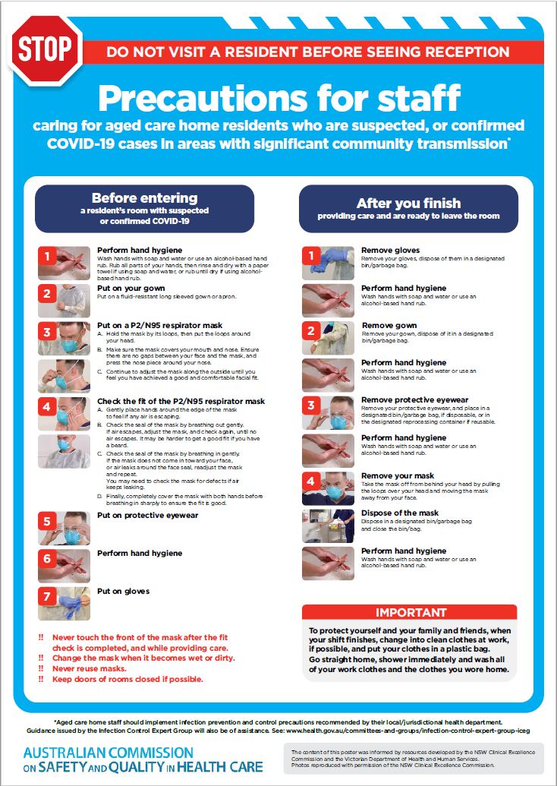](https://www.safetyandquality.gov.au/publications-and-resources/resource-library/covid-19-aged-care-staff-infection-prevention-and-control-precautions-poster)
* ***Environmental Cleaning and Infection Prevention and Control*** [www.safetyandquality.gov.au/environmental-cleaning](http://www.safetyandquality.gov.au/environmental-cleaning)
* ***Infection prevention and control Covid-19 PPE*** poster <https://www.safetyandquality.gov.au/publications-and-resources/resource-library/infection-prevention-and-control-covid-19-personal-protective-equipment>
* ***Special precautions for Covid-19 designated zones*** poster <https://www.safetyandquality.gov.au/publications-and-resources/resource-library/special-precautions-covid-19-designated-zones>
* ***COVID-19 infection prevention and control risk management – Guidance*** <https://www.safetyandquality.gov.au/publications-and-resources/resource-library/covid-19-infection-prevention-and-control-risk-management-guidance>
* ***Safe care for people with cognitive impairment during COVID-19***<https://www.safetyandquality.gov.au/our-work/cognitive-impairment/cognitive-impairment-and-covid-19>
* **Medicines Management COVID-19** <https://www.safetyandquality.gov.au/our-work/medication-safety/medicines-management-covid-19>, including position statements on medicine-related issues
  + ***Managing fever associated with COVID-19***
  + ***Managing a sore throat associated with COVID-19***
  + ***ACE inhibitors and ARBs in COVID-19***
  + ***Clozapine in COVID-19***
  + ***Management of patients on oral anticoagulants during COVID-19***
  + ***Ascorbic Acid: Intravenous high dose in COVID-19***
  + ***Treatment in acute care, including oxygen therapy and medicines to support intubation***
  + ***Nebulisation and COVID-19***
  + ***Managing intranasal administration of medicines during COVID-19***
  + ***Ongoing medicines management in high-risk patients***
  + ***Medicines shortages***
  + ***Conserving medicines***
  + ***Intravenous medicines administration in the event of an infusion pump shortage***
* ***Break the chain of infection: Stopping COVID-19*** poster<https://www.safetyandquality.gov.au/publications-and-resources/resource-library/break-chain-poster-a3>  
    
  **[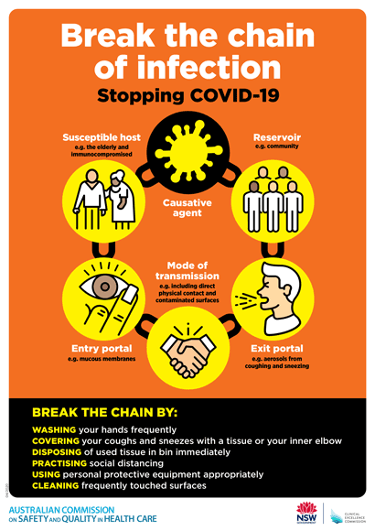](https://www.safetyandquality.gov.au/publications-and-resources/resource-library/break-chain-poster-a3https:/www.safetyandquality.gov.au/publications-and-resources/resource-library/break-chain-poster-a3)**
* ***COVID-19: Elective surgery and infection prevention and control precautions*** <https://www.safetyandquality.gov.au/publications-and-resources/resource-library/covid-19-elective-surgery-and-infection-prevention-and-control-precautions>
* ***FAQs for clinicians on elective surgery*** <https://www.safetyandquality.gov.au/node/5724>
* ***FAQs for consumers on elective surgery*** <https://www.safetyandquality.gov.au/node/5725>
* ***FAQs on community use of face masks***   
   <https://www.safetyandquality.gov.au/faqs-community-use-face-masks>
* ***COVID-19 and face masks – Information for consumers*** <https://www.safetyandquality.gov.au/publications-and-resources/resource-library/covid-19-and-face-masks-information-consumers>  
  The Commission’s fact sheet on use of face masks in the community to reduce the spread of COVID-19 is now available in Easy English and 10 other community languages from <https://www.safetyandquality.gov.au/wearing-face-masks-community>.  
  The factsheet was developed to help people understand when it is important to wear a mask to reduce the risk of the spread of COVID-19, and to explain how to safely put on and remove face masks. It also reinforces the importance of staying home if you have symptoms, physical distancing, hand hygiene and cough etiquette.

[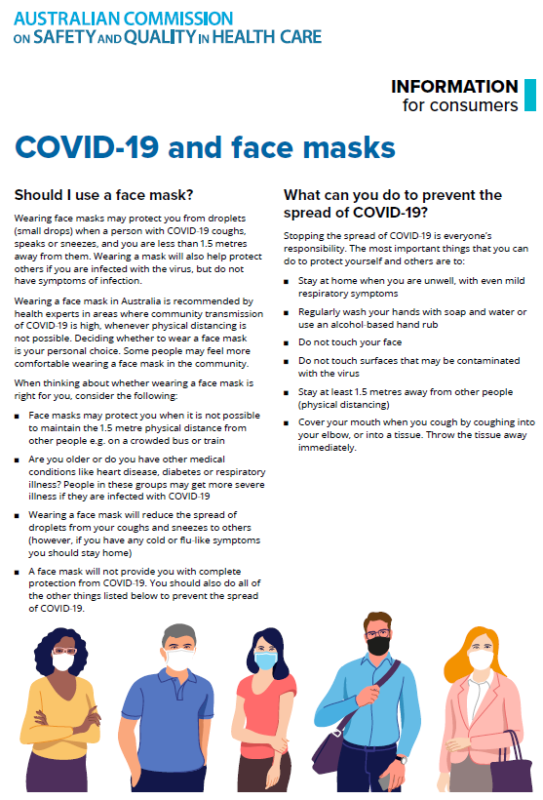](https://www.safetyandquality.gov.au/sites/default/files/2020-07/covid-19_and_face_masks_-_information_for_consumers.pdf)

*National COVID-19 Clinical Evidence Taskforce*

<https://covid19evidence.net.au/>

The National COVID-19 Clinical Evidence Taskforce is a collaboration of peak health professional bodies across Australia whose members are providing clinical care to people with COVID-19. The taskforce is undertaking continuous evidence surveillance to identify and rapidly synthesise emerging research in order to provide national, **evidence-based guidelines and clinical flowcharts for the clinical care of people with COVID-19**. The guidelines address questions that are specific to managing COVID-19 and cover the full disease course across mild, moderate, severe and critical illness. These are ‘living’ guidelines, updated with new research in near real-time in order to give reliable, up-to-the minute advice to clinicians providing frontline care in this unprecedented global health crisis.

*COVID-19 Critical Intelligence Unit*

<https://www.aci.health.nsw.gov.au/covid-19/critical-intelligence-unit>

The Agency for Clinical Innovation (ACI) in New South Wales has developed this page summarising rapid, evidence-based advice during the COVID-19 pandemic. Its operations focus on systems intelligence, clinical intelligence and evidence integration. The content includes a daily evidence digest and evidence checks on a discrete topic or question relating to the current COVID-19 pandemic. There is also a ‘Living evidence’ section summarising key studies and emerging evidence on **COVID-19 vaccines** and **SARS-CoV-2 variants**. Recent evidence check updates include:

* ***Immunocompromised patients and COVID-19 vaccines*** – What is the evidence on COVID-19 vaccination for immunocompromised patients including risks and adverse events, efficacy and advice from professional colleges?

**Disclaimer**

On the Radar is an information resource of the Australian Commission on Safety and Quality in Health Care. The Commission is not responsible for the content of, nor does it endorse, any articles or sites listed. The Commission accepts no liability for the information or advice provided by these external links. Links are provided on the basis that users make their own decisions about the accuracy, currency and reliability of the information contained therein. Any opinions expressed are not necessarily those of the Australian Commission on Safety and Quality in Health Care.