# Australian COmmission on Safety and Quality in Health Care logo with Radar imageOn the Radar

Issue 512

24 May 2021

*On the Radar* is a summary of some of the recent publications in the areas of safety and quality in health care. Inclusion in this document is not an endorsement or recommendation of any publication or provider. Access to particular documents may depend on whether they are Open Access or not, and/or your individual or institutional access to subscription sites/services. Material that may require subscription is included as it is considered relevant.

*On the Radar* is available online, via email or as a PDF or Word document from <https://www.safetyandquality.gov.au/publications-and-resources/newsletters/radar>

If you would like to receive *On the Radar* via email, you can subscribe on our website <https://www.safetyandquality.gov.au/publications-and-resources/newsletters>   
or by emailing us at H[Umail@safetyandquality.gov.auU](mailto:mail@safetyandquality.gov.au).   
You can also send feedback and comments to H[Umail@safetyandquality.gov.auU](mailto:mail@safetyandquality.gov.au).

For information about the Commission and its programs and publications, please visit <https://www.safetyandquality.gov.au>

You can also follow us on Twitter @ACSQHC.

**On the Radar**

Editor: Dr Niall Johnson [niall.johnson@safetyandquality.gov.au](mailto:niall.johnson@safetyandquality.gov.au)

Contributors: Niall Johnson

**Journal articles**

*Measuring safety in older adult care homes: a scoping review of the international literature*

Rand S, Smith N, Jones K, Dargan A, Hogan H

BMJ Open. 2021;11(3):e043206.

|  |  |
| --- | --- |
| DOI | <http://doi.org/10.1136/bmjopen-2020-043206> |
| Notes | The COVID-19 pandemic has seen care facilities that accommodate older people are particular vulnerable. It has also been seen that even in more routine times, these facilities can have dangerous lapses in safety and quality. This paper reports on a review of the literature on the measurement of safety that focused on 45 studies. The authors used the Safety Measurement and Monitoring Framework in healthcare (SMMF) to attempt to understand the coverage of different aspects of safety, as well as potential gaps in the literature. The authors report finding that ‘there are a range of available safety measures used for quality monitoring and improvement in older adult care homes’ and that they cover the five domains of safety in the SMMF. They also report identifying gaps, including ‘user experience, psychological harm related to the care home environment, abusive or neglectful care practice and the processes for integrated learning’. Furthermore ‘Some of these gaps may relate to challenges and feasibility of measurement in the care home context.’ |

*Targeted Ordering of Investigations Reduces Costs of Treatment for Surgical Inpatients*

Adhikari AN, Beck MD, Wykes JJ, Ashford BG

International Journal for Quality in Health Care. 2021 [epub].

|  |  |
| --- | --- |
| DOI | <https://doi.org/10.1093/intqhc/mzab083> |
| Notes | The ordering of diagnostic tests is a commonplace activity. But the vast quantities of tests ordered may not be useful, valuable or even necessary. The more appropriate ordering of diagnostics has been advocated for a number of reasons. This paper reports on implementation and impact of a new protocol targeting ordering of investigations within the General Surgical Teams of Wollongong Hospital. This was a quality improvement initiative that sought to reduce the number of ‘routine blood tests’. The new protocol involved regular review of the laboratory investigations being ordered for the following day with a senior team member. For this study, the medical records of all patients admitted under the General Surgery service were retrospectively reviewed over two ten-week periods in 2017 (838 patients) and 2018 (805 patients) (control and study) to identify whether there was a reduction in the number of ‘routine blood tests’ and associated costs following implementation of the new protocol. The authors report that 10,030 tests were covered in the control period, compared to 8,610 over the study period, a 16% reduction in ‘routine blood tests’ per patient, per day of admission and a 6% reduction in costs in the study group. The authors conclude that ‘Targeted ordering of investigations with personalised education and feedback to junior staff during review of clinical status of each patient as a part of normal workflow, can reduce inappropriate ordering of ‘routine blood tests’ and associated costs to the patient and the healthcare system.’ |

*Identifying and encouraging high-quality healthcare: an analysis of the content and aims of patient letters of compliment*

Gillespie A, Reader TW

BMJ Quality & Safety. 2021;30(6):484-492.

|  |  |
| --- | --- |
| DOI | <http://dx.doi.org/10.1136/bmjqs-2019-010077> |
| Notes | The analysis and use of patient complaints in the search of improved safety and quality is not unusual. This paper reports on a study of the more positive patient and consumer feedback, the compliments. While compliments are nice it’s not clear that systematic use has been made of them. This paper reports on a study that examined 1267 compliment letters received by 54 English hospitals. The analysis revealed that:   * The practices being complimented were in the relationship (77% of letters), clinical (50%) and management (30%) domains. * 39% of compliments focused on voluntary non-routine extra-role behaviours (e.g., extra-emotional support, staying late to run an extra test). * The aims of expressing gratitude were to acknowledge (80%), reward (44%) and promote (59%) the desired behaviour. * Front-line staff tended to receive compliments acknowledging behaviour, while senior management received compliments asking them to reward individual staff and promoting the importance of relationship behaviours.   The authors content that ‘compliment letters do more than merely identify desirable healthcare practices. By acknowledging, rewarding and promoting these practices, compliment letters can potentially contribute to healthcare services through promoting desirable behaviours and giving staff social recognition.’ |

For information on the Commission’s work on person centred care, see <https://www.safetyandquality.gov.au/our-work/partnering-consumers/person-centred-care>

For information on the Commission’s work on partnering with consumers, see <https://www.safetyandquality.gov.au/our-work/partnering-consumers>

*2020 Pennsylvania Patient Safety Reporting: An Analysis of Serious Events and Incidents from the Nation’s Largest Event Reporting Database*

Kepner S, Jones R.

Patient Safety. 2021;3(2):6-21.

*Rates of Serious Surgical Errors in California and Plans to Prevent Recurrence*

Cohen AJ, Lui H, Zheng M, Cheema B, Patino G, Kohn MA, et al

JAMA Network Open. 2021;4(5):e217058-e217058.

|  |  |
| --- | --- |
| DOI | Kepner and Jones <http://doi.org/10.33940/data/2021.6.1>  Cohen et al. <http://doi.org/10.1001/jamanetworkopen.2021.7058> |
| Notes | A pair of items reporting on serious events in US health care systems.  Kepner and Jones provide the annual update on serious events captured in the Pennsylvania Patient Safety Reporting System. In the USA, Pennsylvania is the only state that requires acute healthcare facilities to report all events of harm or potential for harm. This makes the Pennsylvania Patient Safety Reporting System (PA-PSRS) is the largest repository of patient safety data in the United States. In 2020, 278,548 patient safety event reports were submitted. The majority of the 2020 reports were Incidents (97.0%) rather than Serious Events (3.0%). For each of the last five years, the most frequently reported event type was **Error Related to Procedure/Treatment/Test**, accounting for 32.1% of all submitted acute care event reports in 2020. The next three most frequently reported event types were **Medication Error**, **Complication of Procedure/Treatment/Test**, and **Fall**, accounting for 16.7%, 16.2%, and 11.8% of submitted reports in 2020, respectively.  Cohen et al report on an analysis of142 surgical ‘never events’ reported to the California Department of Public Health. The 142 events were identified and summarised in the period 1 January 2007 to 31 December 2017. The most common surgical never events reported were **retained foreign objects** (94 of 141, 66.2%), **wrong site or patient surgery** (22 events, 15.5%), **surgical burns** (11, 7.7%), and other (15, 10.6%). |

*BMJ Quality & Safety*

June 2021 - Volume 30 - 6

|  |  |
| --- | --- |
| URL | <https://qualitysafety.bmj.com/content/30/6> |
| Notes | A new issue of *BMJ Quality & Safety* has been published. Many of the papers in this issue have been referred to in previous editions of *On the Radar* (when they were released online). Articles in this issue of *BMJ Quality & Safety* include:   * Editorial: **Safe care on maternity units**: a multidimensional balancing act (Emily White VanGompel, Elliott K Main) * Editorial: **Healthcare-associated infections**: where we came from and where we are headed (Daniel Escobar, David Pegues) * Seven features of **safety in maternity units**: a framework based on multisite ethnography and stakeholder consultation (Elisa Giulia Liberati, Carolyn Tarrant, Janet Willars, Tim Draycott, Cathy Winter, Karolina Kuberska, Alexis Paton, Sonja Marjanovic, Brandi Leach, Catherine Lichten, Lucy Hocking, Sarah Ball, Mary Dixon-Woods) * Association between **intrahospital transfer and hospital-acquired infection in the elderly**: a retrospective case–control study in a UK hospital network (Emanuela Estera Boncea, Paul Expert, Kate Honeyford, Anne Kinderlerer, Colin Mitchell, Graham S Cooke, Luca Mercuri, Céire E Costelloe) * Removing hospital-based triage from suspected **colorectal cancer pathways**: the impact and learning from a primary care-led electronic straight-to-test pathway (Philippa Orchard, Nitin Arvind, Alison Wint, James Kynaston, Ann Lyons, Eric Loveday, Anne Pullyblank) * **Changing hospital organisational culture for improved patient outcomes**: developing and implementing the leadership saves lives intervention (Erika Linnander, Zahirah McNatt, Kasey Boehmer, Emily Cherlin, Elizabeth Bradley, Leslie Curry) * Identifying and encouraging high-quality healthcare: an analysis of the content and aims of **patient letters of compliment** (Alex Gillespie, Tom W Reader) * Observational study assessing changes in **timing of readmissions around postdischarge day 30** associated with the introduction of the Hospital Readmissions Reduction Program (Ashwin S Nathan, Joseph R Martinez, Jay Giri, Amol S Navathe) * Weekly variation in quality of care for **acute ST-segment elevation myocardial infarction** by day and time of admission: a retrospective observational study (Chao Wang, Xi Li, Wantong Sun, Jingkun Li, Yupeng Wang, Xiaoqiang Bao, Meina Liu, Qiuju Zhang) * Systematically capturing and acting on **insights from front-line staff**: the ‘Bedside Learning Coordinator’ (Jenny Shand, Dominique Allwood, Nicole Lee, Noor Elahi, Iain McHenry, Karen Chui, Sophie Tang, Zoe Dawson-Couper, James Mountford, Richard Bohmer) * Systematic review and meta-analysis of interventions for **operating room to intensive care unit handoffs** (Joanna Abraham, Alicia Meng, Sanjna Tripathy, Michael S Avidan, Thomas Kannampallil) |

*BMJ Quality & Safety* online first articles

|  |  |
| --- | --- |
| URL | <https://qualitysafety.bmj.com/content/early/recent> |
| Notes | *BMJ Quality &Safety* has published a number of ‘online first’ articles, including:   * Primary care physician’s (PCP) perceived **value of patient-reported outcomes (PROs) in clinical practice**: a mixed methods study (Danny Mou, Daniel M Horn, Marilyn Heng, Manuel Castillo-Angeles, Keren Ladin, Daniel Frendl, Manraj Kaur, Marcela del Carmen, Thomas Dean Sequist, Rachel C Sisodia) * **Conceptualising interventions to enhance spread in complex systems**: a multisite comprehensive medication review case study (Laura Lennox, Susan Barber, Neil Stillman, Sophie Spitters, Emily Ward, Vanessa Marvin, Julie E Reed) * How does the effectiveness of **strategies to improve healthcare provider practices** in low-income and middle-income countries change after implementation? Secondary analysis of a systematic review (Catherine Arsenault, Samantha Y Rowe, Dennis Ross-Degnan, David H Peters, Sanam Roder-DeWan, Margaret E Kruk, Alexander K Rowe) * Editorial: Implementing **automated prognostic models to inform palliative care**: more than just the algorithm (Erin M Bange, Katherine R Courtright, Ravi B Parikh) * Editorial: **Sustaining quality improvement efforts**: emerging principles and practice (Robert E Burke, Perla J Marang-van de Mheen) * Improving **timeliness of hepatitis B vaccine administration** in an urban safety net level III NICU (Madoka Hayashi, Theresa R Grover, Steve Small, Tessa Staples, Genie Roosevelt) * Editorial: No one left behind: a case for more inclusivity in **authorship for quality improvement and implementation research** (Jennifer S Myers, Meghan Lane-Fall, Christine Soong) |

*International Journal for Quality in Health Care* online first articles

|  |  |
| --- | --- |
| URL | <https://academic.oup.com/intqhc/advance-articles> |
| Notes | *International Journal for Quality in Health Care* has published a number of ‘online first’ articles, including:   * **Is a Hospital Quality Policy Based on a Triad of Accreditation, Public Reporting and Inspection Evidence-Based?** A Narrative Review (Astrid Van Wilder, Luk Bruyneel, Dirk De Ridder, Deborah Seys, Jonas Brouwers, Fien Claessens, Bianca Cox, Kris Vanhaecht) * **Cost-effectiveness of Public Caseload Midwifery** Compared to Standard Care in an Australian Setting: a Pragmatic Analysis to Inform Service Delivery (Emily J Callander, Valerie Slavin, Jenny Gamble, Debra K Creedy, Hazel Brittain) * **Targeted Ordering of Investigations** Reduces Costs of Treatment for Surgical Inpatients (Ashim Nath Adhikari, Matthew Dylan Beck, James Justin Wykes, Bruce Graham Ashford) * Applying Health-Six-Sigma Principles Helps Reducing the **Variability of Length of Stay in the Emergency Department** (Ayala Kobo-Greenhut, Keren Holzman, Osnat Raviv, Izhar Ben Shlomo, Jakov Arad) |

**COVID-19 resources**

https://www.safetyandquality.gov.au/covid-19

The Australian Commission on Safety and Quality in Health Care has developed a number of resources to assist healthcare organisations, facilities and clinicians. These and other material on COVID-19 are available at <https://www.safetyandquality.gov.au/covid-19>

These resource include:

* ***COVID-19: Aged care staff infection prevention and control precautions*** *poster*<https://www.safetyandquality.gov.au/publications-and-resources/resource-library/covid-19-aged-care-staff-infection-prevention-and-control-precautions-poster>  
    
  [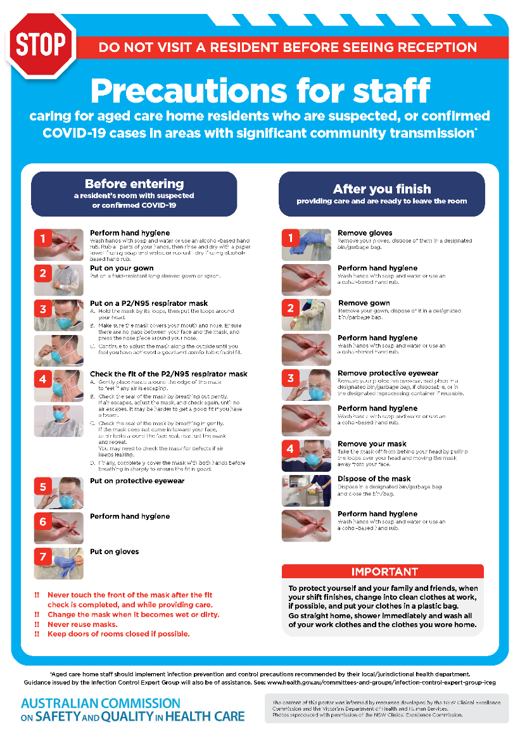](https://www.safetyandquality.gov.au/publications-and-resources/resource-library/covid-19-aged-care-staff-infection-prevention-and-control-precautions-poster)
* ***Environmental Cleaning and Infection Prevention and Control*** [www.safetyandquality.gov.au/environmental-cleaning](http://www.safetyandquality.gov.au/environmental-cleaning)
* ***Infection prevention and control Covid-19 PPE*** poster <https://www.safetyandquality.gov.au/publications-and-resources/resource-library/infection-prevention-and-control-covid-19-personal-protective-equipment>
* ***Special precautions for Covid-19 designated zones*** poster <https://www.safetyandquality.gov.au/publications-and-resources/resource-library/special-precautions-covid-19-designated-zones>
* ***COVID-19 infection prevention and control risk management – Guidance*** <https://www.safetyandquality.gov.au/publications-and-resources/resource-library/covid-19-infection-prevention-and-control-risk-management-guidance>
* ***Safe care for people with cognitive impairment during COVID-19***<https://www.safetyandquality.gov.au/our-work/cognitive-impairment/cognitive-impairment-and-covid-19>
* **Medicines Management COVID-19** <https://www.safetyandquality.gov.au/our-work/medication-safety/medicines-management-covid-19>, including position statements on medicine-related issues
  + ***Managing fever associated with COVID-19***
  + ***Managing a sore throat associated with COVID-19***
  + ***ACE inhibitors and ARBs in COVID-19***
  + ***Clozapine in COVID-19***
  + ***Management of patients on oral anticoagulants during COVID-19***
  + ***Ascorbic Acid: Intravenous high dose in COVID-19***
  + ***Treatment in acute care, including oxygen therapy and medicines to support intubation***
  + ***Nebulisation and COVID-19***
  + ***Managing intranasal administration of medicines during COVID-19***
  + ***Ongoing medicines management in high-risk patients***
  + ***Medicines shortages***
  + ***Conserving medicines***
  + ***Intravenous medicines administration in the event of an infusion pump shortage***
* ***Stop COVID-19: Break the chain of infection*** poster<https://www.safetyandquality.gov.au/publications-and-resources/resource-library/break-chain-poster-a3>  
    
  **[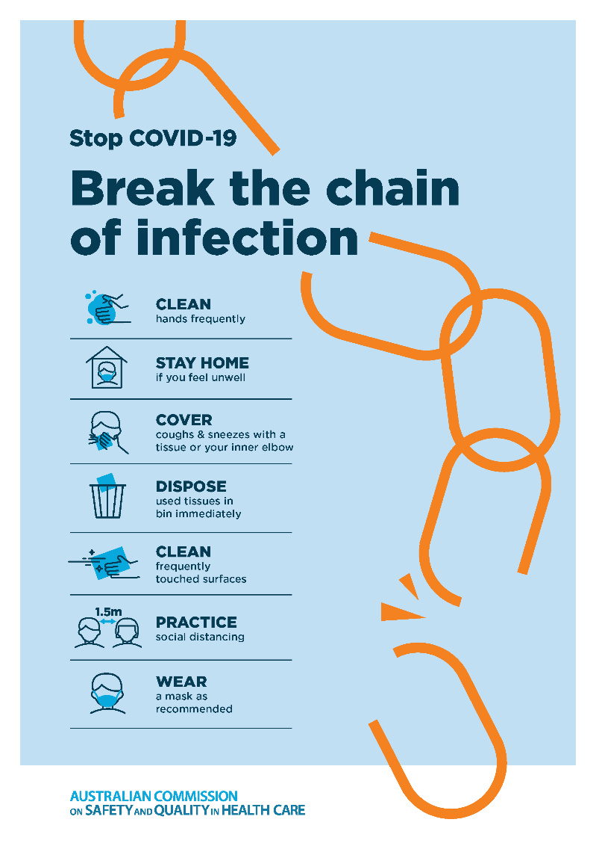](https://www.safetyandquality.gov.au/publications-and-resources/resource-library/break-chain-poster-a3https:/www.safetyandquality.gov.au/publications-and-resources/resource-library/break-chain-poster-a3)**
* ***COVID-19: Elective surgery and infection prevention and control precautions*** <https://www.safetyandquality.gov.au/publications-and-resources/resource-library/covid-19-elective-surgery-and-infection-prevention-and-control-precautions>
* ***FAQs for clinicians on elective surgery*** <https://www.safetyandquality.gov.au/node/5724>
* ***FAQs for consumers on elective surgery*** <https://www.safetyandquality.gov.au/node/5725>
* ***FAQs on community use of face masks***   
   <https://www.safetyandquality.gov.au/faqs-community-use-face-masks>
* ***COVID-19 and face masks – Information for consumers*** <https://www.safetyandquality.gov.au/publications-and-resources/resource-library/covid-19-and-face-masks-information-consumers>  
  The Commission’s fact sheet on use of face masks in the community to reduce the spread of COVID-19 is now available in Easy English and 10 other community languages from <https://www.safetyandquality.gov.au/wearing-face-masks-community>.  
  The factsheet was developed to help people understand when it is important to wear a mask to reduce the risk of the spread of COVID-19, and to explain how to safely put on and remove face masks. It also reinforces the importance of staying home if you have symptoms, physical distancing, hand hygiene and cough etiquette.

[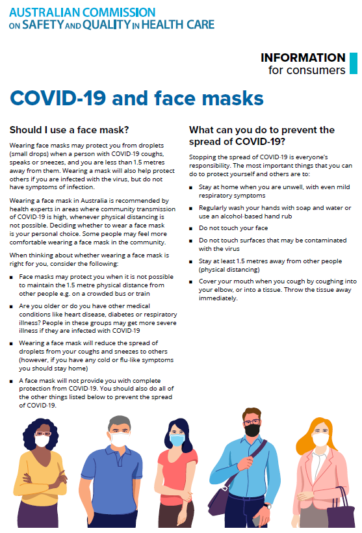](https://www.safetyandquality.gov.au/sites/default/files/2020-07/covid-19_and_face_masks_-_information_for_consumers.pdf)

*National COVID-19 Clinical Evidence Taskforce*

<https://covid19evidence.net.au/>

The National COVID-19 Clinical Evidence Taskforce is a collaboration of peak health professional bodies across Australia whose members are providing clinical care to people with COVID-19. The taskforce is undertaking continuous evidence surveillance to identify and rapidly synthesise emerging research in order to provide national, **evidence-based guidelines and clinical flowcharts for the clinical care of people with COVID-19**. The guidelines address questions that are specific to managing COVID-19 and cover the full disease course across mild, moderate, severe and critical illness. These are ‘living’ guidelines, updated with new research in near real-time in order to give reliable, up-to-the minute advice to clinicians providing frontline care in this unprecedented global health crisis.

*COVID-19 Critical Intelligence Unit*

<https://www.aci.health.nsw.gov.au/covid-19/critical-intelligence-unit>

The Agency for Clinical Innovation (ACI) in New South Wales has developed this page summarising rapid, evidence-based advice during the COVID-19 pandemic. Its operations focus on systems intelligence, clinical intelligence and evidence integration. The content includes a daily evidence digest and evidence checks on a discrete topic or question relating to the current COVID-19 pandemic. There is also a ‘Living evidence’ section summarising key studies and emerging evidence on **COVID-19 vaccines** and **SARS-CoV-2 variants**. Recent evidence check updates include:

* ***COVID-19 vaccine and elective surgery –*** What is the evidence on COVID-19 vaccination before elective surgery, including any recommendations regarding timing of vaccination?

**Disclaimer**

On the Radar is an information resource of the Australian Commission on Safety and Quality in Health Care. The Commission is not responsible for the content of, nor does it endorse, any articles or sites listed. The Commission accepts no liability for the information or advice provided by these external links. Links are provided on the basis that users make their own decisions about the accuracy, currency and reliability of the information contained therein. Any opinions expressed are not necessarily those of the Australian Commission on Safety and Quality in Health Care.