# Australian Commission on Safety and Quality in Health Care logo with Radar imageOn the Radar

Issue 516

21 June 2021

*On the Radar* is a summary of some of the recent publications in the areas of safety and quality in health care. Inclusion in this document is not an endorsement or recommendation of any publication or provider. Access to particular documents may depend on whether they are Open Access or not, and/or your individual or institutional access to subscription sites/services. Material that may require subscription is included as it is considered relevant.

*On the Radar* is available online, via email or as a PDF or Word document from <https://www.safetyandquality.gov.au/publications-and-resources/newsletters/radar>

If you would like to receive *On the Radar* via email, you can subscribe on our website <https://www.safetyandquality.gov.au/publications-and-resources/newsletters>  
or by emailing us at H[Umail@safetyandquality.gov.auU](mailto:mail@safetyandquality.gov.au).   
You can also send feedback and comments to H[Umail@safetyandquality.gov.auU](mailto:mail@safetyandquality.gov.au).

For information about the Commission and its programs and publications, please visit <https://www.safetyandquality.gov.au>

You can also follow us on Twitter @ACSQHC.

**On the Radar**

Editor: Dr Niall Johnson [niall.johnson@safetyandquality.gov.au](mailto:niall.johnson@safetyandquality.gov.au)

Contributors: Niall Johnson, Dr Jan Gralton

**Implementation Guide for the Surveillance of *Staphylococcus aureus* bloodstream infection**

Australian Commission on Safety and Quality in Health Care

Sydney: ACSQHC; 2021. p. 22.

<https://www.safetyandquality.gov.au/publications-and-resources/resource-library/implementation-guide-surveillance-staphylococcus-aureus-bloodstream-infection>

The Australian Commission on Safety and Quality in Health Care has undertaken a review and update of the *Implementation Guide for the Surveillance of Staphylococcus aureus bacteraemia infection*. The purpose of the Guide is to support standardised national surveillance and reporting of Staphylococcus aureus bloodstream infection (SABSI) in Australian public hospitals. The target audiences for this Guide are clinicians, infection prevention and control professionals and quality and safety managers who are responsible for healthcare-associated SABSI surveillance in their hospital.

As part of this review the following changes have been made to the case definition:

* A change in terminology to *Staphylococcus aureus* bloodstream infection (SABSI) to more accurately reflect the clinical disease
* Criterion A addressing infections detected 48 hours after admission or less than 48 hours after discharge has been separated into two sub criteria (A1 and A2) to clarify the concept of “incubating on admission”
* Criterion B2 addressing infection associated with surgery has been revised to include an extended surveillance period for deep incisional/organ space infections related to surgically implanted devices, recognising the possibility of a delay in presentation of infection
* Criterion B4 addressing infection associated with neutropenia has been revised to clarify that the application of the criteria is only for situations where the infection is not associated with an indwelling medical device (covered by Criterion B1).

[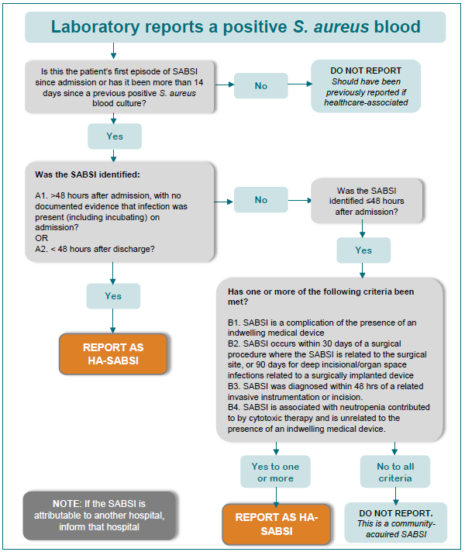](https://www.safetyandquality.gov.au/publications-and-resources/resource-library/implementation-guide-surveillance-staphylococcus-aureus-bloodstream-infection)

**Reports**

*Reablement interventions for community dwelling people living with dementia*

Deeble Institute Issues Brief No. 42

Rahja M, Haddock R

Canberra: Australian Healthcare and Hospitals Association; 2021. p. 56.

|  |  |
| --- | --- |
| URL | <https://ahha.asn.au/publication/health-policy-issue-briefs/deeble-issues-brief-no-42-reablement-interventions-community> |
| Notes | This health policy issues brief from the Australian Healthcare and Hospitals Association’s Deeble Institute examines the experience of people with dementia living in the community. Most people with dementia do live in the community rather than in institutionalised care. This means that they are usually dependent on family members providing care so that they can remain at home. This issues brief looks specifically at ‘reablement interventions’ – interventions that optimise function so that they can remain as independent as possible. Reablement is considered to be a person-centred, holistic approach to care regardless of age, capacity, diagnosis or setting. Reablement interventions aim to   * enhance, restore or maintain an individual's physical and/or other functioning * enhance, restore or maintain their independence in meaningful daily living activities at their place of residence, and * reduce their need for long-term services.   However, evidence-based reablement interventions targeted to people with dementia are not widely implemented in Australia. |

*The State of Patient Experience 2021: Transforming the Patient Experience*

Wolf JA

Nashville: The Beryl Institute; 2021. p. 32.

|  |  |
| --- | --- |
| URL | <https://www.theberylinstitute.org/page/PXBENCHMARKING> |
| Notes | The Beryl Institute in the USA has released their 2021 review of the state of patient experience. This review – influenced by the continuing COVID-19 pandemic – sees the need for patient experience to be prioritised even as care delivery has changed with the growing use of telehealth. This brief report identifies some key actions, including:   1. Underline and act on the integrated nature of experience. 2. Understand and engage in the opportunity to measure experience in new ways and act on what matters most. 3. Focus on identifying and engaging innovation and technology as a critical element of ensuring excellence. 4. Ensure any effort to achieve experience excellence is built on a foundation of equity and dismantles versus perpetuates the deep-rooted disparities still lingering in the foundation of healthcare itself. 5. Reinforce that a commitment to experience has a positive and lasting impact and brings value to healthcare, both in supporting the viability of our healthcare system and the outcomes we seek to achieve, in times of calm and crisis. |

**Journal articles**

*Incidence, origins and avoidable harm of missed opportunities in diagnosis: longitudinal patient record review in 21 English general practices*

Cheraghi-Sohi S, Holland F, Singh H, Danczak A, Esmail A, Morris RL, et al

BMJ Quality & Safety. 2021.

|  |  |
| --- | --- |
| DOI | <https://doi.org/10.1136/bmjqs-2020-012594> |
| Notes | This paper looks are two areas that have been rather neglected but are seeing increased interest: primary care safety and quality and diagnosis. The study sought to estimate the incidence, origins and avoidable harm of diagnostic errors in general practice. Here, diagnostic errors were defined as ‘missed opportunities to make a correct or timely diagnosis based on the evidence available (**missed diagnostic opportunities**, MDOs)’. The study was a retrospective medical record review that conducted case note reviews on 100 randomly selected adult consultations performed during 2013–2014 in 21 general practices in England. The review of the 2057 unique consultations found that ‘an MDO **was possible, likely or certain in 89 cases or 4.3%** (95% CI 3.6% to 5.2%) **of reviewed consultations**’. Of these, 37% were ‘rated as resulting in moderate to severe avoidable patient harm.’ The review identified ‘problems in the patient–practitioner encounter such as history taking, examination or ordering tests (main or secondary factor in 61 (68%) cases), performance and interpretation of diagnostic tests (31; 35%) and follow-up and tracking of diagnostic information’. |

*Estimating the economic cost of nurse sensitive adverse events amongst patients in medical and surgical settings*

Murphy A, Griffiths P, Duffield C, Brady NM, Scott AP, Ball J, et al

Journal of Advanced Nursing. 2021.

|  |  |
| --- | --- |
| DOI | <http://doi.org/10.1111/jan.14860> |
| Notes | Adverse events can have many impacts, obviously including the harm that patients can suffer. This study sought to identify the costs associated with nurse sensitive adverse events and the impact of these events on patients’ LOS. Nurse sensitive adverse events included eleven adverse event types considered sensitive to nurse staffing. The study was a retrospective patient record review that used administrative data from six acute adult wards at 3 Irish hospitals for the period July 2016–October 2017 for 5544 admitted patients. The review found that 16% (897 patients) per cent of the sample had at least one nurse sensitive adverse event during their episode of care. The study calculated that each adverse event was associated with an increase in the length of stay by 0.48 days and that the average cost associated with each nurse sensitive adverse event to be €694. Extrapolated this gave an economic cost of nurse sensitive adverse events to the health service in Ireland of €91.3 million annually. |

*Cultural And Structural Features Of Zero-Burnout Primary Care Practices*

Edwards ST, Marino M, Solberg LI, Damschroder L, Stange KC, Kottke TE, et al

Health Affairs. 2021;40(6):928-936.

|  |  |
| --- | --- |
| DOI | <https://doi.org/10.1377/hlthaff.2020.02391> |
| Notes | US study that sought to identify features of primary care practices that led to low levels of burnout among primary care clinicians. Using survey data from 715 small-to-medium-size primary care practices in the United States, the authors reported ‘zero-burnout practices had higher levels of psychological safety and adaptive reserve, a measure of practice capacity for learning and development. Compared with high-burnout practices, zero-burnout practices also reported using more quality improvement strategies, more commonly were solo and clinician owned, and less commonly had participated in accountable care organizations or other demonstration projects.’ |

*Journal of Patient Safety and Risk Management*

Volume: 26, Number: 3 (June 2021)

|  |  |
| --- | --- |
| URL | <https://journals.sagepub.com/toc/cric/26/3> |
| Notes | A new issue of the *Journal of Patient Safety and Risk Management* has been published. Articles in this issue of the *Journal of Patient Safety and Risk Management* include:   * Editorial: **Mitigating the July effect** (Albert W Wu, Charles Vincent, David W Shapiro, Shunzo Koizumi, Robert Francis, Reinhard Strametz, Teresa Tono, Alpana Mair, Ed Kelley, Peter Walsh, Peter J Pronovost, and Elliott R Haut) * **Second victim phenomenon** in the era of COVID-19 (Eric R Heinz and Jae Ho Kim) * Barriers in communicating **medication changes at hospital discharge**: Informing CancelRx design requirements (Yushi Yang, Samantha I Pitts, and Allen R Chen) * Barriers to and facilitators of **medication error reporting** from the viewpoints of nurses and midwives working in gynecology wards of Tabriz hospitals (Mojgan Mirghafourvand, Khadije Hajizadeh, Jafar Kondori, Mahin Kamalifard, and Ziba Bazaz Javid) * Impact of the **COVID-19 pandemic on acute surgical patients’ discharge summaries** – Experience of Wales worst-hit COVID-19 hospital (Rucira Ooi, Imogen Bambrough Stimson, and Gethin Williams) * Determinants of **patients’ safety culture practices** in a tertiary hospital in Nigeria (Chinomnso C Nnebue, Amaka Y Ezeuko, Ndidiamaka P Chukwujekwu, Stanley K Onah, Alphonsus C Obi-Okaro, and Emmanuel C Chukwu-Osodiuru) * **Advancing team cohesion**: Using an escape room as a novel approach (Tara N Cohen, Andrew C Griggs, Falisha F Kanji, Kate A Cohen, Elizabeth H Lazzara, Joseph R Keebler, and Bruce L Gewertz) * **Medical device error and failure reporting**: Learning from the car industry (Arkeliana Tase, Peter Buckle, Melody Z Ni, and George B Hanna) * Killer not able to bring **clinical negligence claim** in her own right: Ecila Henderson v. Dorset healthcare university NHS foundation trust (Supreme Court, 30 October 2020) (John Mead) |

*Pediatric Quality & Safety*

Volume 6, Number 3, May/June 2021

|  |  |
| --- | --- |
| URL | <https://journals.lww.com/pqs/toc/2021/05000> |
| Notes | A new issue of *Pediatric Quality & Safety* has been published. Articles in this issue of *Pediatric Quality & Safety* include:   * Intrawound Liposomal Bupivacaine in **Pediatric Chiari Decompression**: A Retrospective Study (Melissa A LoPresti, B Nathan Harrell, Eric Goethe, Samuel McClugage, Karla Wyatt, Sandi K Lam) * Implementing Volume-targeted Ventilation to Decrease **Hypocarbia in Extremely Low Birth Weight Infants** during the First Week of Life: A Quality Improvement Project (Uduak S Akpan, S Patel, P Driver, D Tumin) * Quality Improvement Methodology Optimizes Infliximab Levels in **Pediatric Patients with Inflammatory Bowel Disease** (Jennifer Hellmann, Renee K Etter, Lee A Denson, Phillip Minar, Denise Hill, Dana M Dykes, M J Rosen) * Improving Compliance with **Dyslipidemia Screening Guidelines** in a Single-center U.S. Outpatient Pediatric Cardiology Clinic (Sarah Pradhan, Andrew L Dodgen, Christopher S Snyder) * **Managing the COVID-19 Pandemic** Using Quality Improvement Principles: A New York City Pediatric Primary Care Experience (Suzanne Friedman, Margaret C Krause, Kalpana Pethe, Steve Caddle, Morgan Finkel, Melissa E Glassman, Connie Kostacos, Laura Robbins-Milne, Edith Bracho-Sanchez, Karen Soren, Melissa Stockwell, Mariellen Lane) * **Sleeping Safely!** A Quality Improvement Project to Minimize Nighttime Interruptions without Compromising Patient Care (Clifton C Lee, Nastassia M Savage, Emily K Wilson, Jennifer Brigle, Daniel Poliakoff, R Shah, T Lowerre) * Impact of Eliminating Local Anesthesia on **Immediate Postoperative Analgesia in Pediatric Ambulatory Adenotonsillectomy** (Kelsey A Loy, Austin S Lam, Amber M Franz, Lynn D Martin, Scott C Manning, Henry C Ou, Jonathan A Perkins, Sanjay R Parikh, Daniel K-W Low, John P Dahl) * Training the Trainers in Ultrasound-guided Access to Improve **Peripheral Intravenous Catheter Placement** among Children Presenting for Anesthesia (Vikas N O’Reilly-Shah, Amber Franz, Cornelius B Groenewald, Michael Collins, Lance S Patak) * **Reducing Time to First Dose of Antibiotic**: The Example of Asymptomatic Neonates Exposed to Chorioamnionitis (Samuel Ajayi, Folasade Kehinde, David Cooperberg, Suzanne M Touch) * Improving Administration of **Prehospital Corticosteroids for Pediatric Asthma** (Lauren C Riney, Hamilton Schwartz, Eileen Murtagh Kurowski, Lindsey Collett, Todd A Florin) * Improving Care for **Childhood Obesity**: A Quality Improvement Initiative (Komal F Satti, Susanne E Tanski, Yike Jiang, Auden McClure) * Development and Implementation of **Pediatric ICU-based Mobility Guidelines**: A Quality Improvement Initiative (Stefanie G Ames, Lauren J Alessi, Maddie Chrisman, Meg Stanger, Devin Corboy, Amit Sinha, E L Fink) * A Quality Improvement Initiative to Reduce **Blood Culture Contamination in the Neonatal Unit** (Elizabeth Allen, Angela Cavallaro, Amy K Keir) * **Parent Experience of Communication about Children’s Surgery**: A Qualitative Analysis (Lauren E Claus, Anne R Links, Janine Amos, Heather DiCarlo, Eric Jelin, Rahul Koka, Mary Catherine Beach, Emily F Boss) * Expanding **Hospital Capacity during the COVID-19 Pandemic**: The Family Voice Matters (Jean A Connor, Michelle Hurtig, Jennifer A Ormsby, Patricia A Hickey) * Translational Simulation Improves Compliance with the **NEAR4KIDS Airway Safety Bundle** in a Single-center PICU (Nora Colman, Jordan W Newman, Akira Nishisaki, Melinda Register, Scott E Gillespie, K B Hebbar) * A Resident-driven Initiative to Increase **Bedside Teaching on Interdisciplinary Rounds** (Andrew Becker, Olivia Frosch, Melissa Argraves, Bryn Carroll, Alicia Kamsheh, Polina Krass, Sanjiv Mehta, Elizabeth Salazar, April Taylor, Jessica Hart) |

*BMJ Quality & Safety* online first articles

|  |  |
| --- | --- |
| URL | <https://qualitysafety.bmj.com/content/early/recent> |
| Notes | *BMJ Quality &Safety* has published a number of ‘online first’ articles, including:   * Incidence, origins and avoidable harm of **missed opportunities in diagnosis**: longitudinal patient record review in 21 English general practices (Sudeh Cheraghi-Sohi, Fiona Holland, Hardeep Singh, Avril Danczak, Aneez Esmail, Rebecca Lauren Morris, Nicola Small, Richard Williams, Carl de Wet, Stephen M Campbell, David Reeves) * National cross-sectional cohort study of the **relationship between quality of mental healthcare and death by suicide** (Brian Shiner, Daniel J Gottlieb, Maxwell Levis, Talya Peltzman, Natalie B Riblet, Sarah L Cornelius, Carey J Russ, Bradley V Watts) * Reduced rate of **postpartum readmissions** among homeless compared with non-homeless women in New York: a population-based study using serial, cross-sectional data (Rie Sakai-Bizmark, Hiraku Kumamaru, Dennys Estevez, Sophia Neman, Lauren E M Bedel, Laurie A Mena, Emily H Marr, Michael G Ross) * Editorial: The need for **quality self-management support in cancer care** (Claire Foster) |

**Online resources**

*[UK] NICE Guidelines and Quality Standards*

<https://www.nice.org.uk/guidance>

The UK’s National Institute for Health and Care Excellence (NICE) has published new (or updated) guidelines and quality standards. The latest reviews or updates are:

* NICE Guideline NG197 ***Shared decision making***   
  <https://www.nice.org.uk/guidance/ng197>
* Clinical Guideline CG138 ***Patient experience*** *in adult NHS services: improving the experience of care for people using adult NHS services*   
  <https://www.nice.org.uk/guidance/cg138>
* Clinical Guideline CG170 ***Autism spectrum disorder*** *in under 19s: support and management* <https://www.nice.org.uk/guidance/cg170>

*[USA] Effective Health Care Program reports*

<https://effectivehealthcare.ahrq.gov/>

The US Agency for Healthcare Research and Quality (AHRQ) has an Effective Health Care (EHC) Program. The EHC has released the following final reports and updates:

* ***Prehospital Airway Management***<https://effectivehealthcare.ahrq.gov/products/prehospital-airway-management/research>
* *Radiation Therapy for* ***Brain Metastases***  
  <https://effectivehealthcare.ahrq.gov/products/radiation-therapy-brain-metastases/research>

**COVID-19 resources**

https://www.safetyandquality.gov.au/covid-19

The Australian Commission on Safety and Quality in Health Care has developed a number of resources to assist healthcare organisations, facilities and clinicians. These and other material on COVID-19 are available at <https://www.safetyandquality.gov.au/covid-19>

These resource include:

* ***COVID-19: Aged care staff infection prevention and control precautions*** *poster*<https://www.safetyandquality.gov.au/publications-and-resources/resource-library/covid-19-aged-care-staff-infection-prevention-and-control-precautions-poster>  
    
  [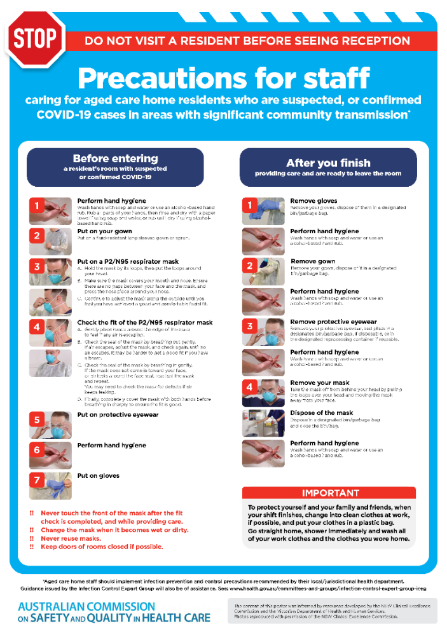](https://www.safetyandquality.gov.au/publications-and-resources/resource-library/covid-19-aged-care-staff-infection-prevention-and-control-precautions-poster)
* ***Environmental Cleaning and Infection Prevention and Control*** [www.safetyandquality.gov.au/environmental-cleaning](http://www.safetyandquality.gov.au/environmental-cleaning)
* ***Infection prevention and control Covid-19 PPE*** poster <https://www.safetyandquality.gov.au/publications-and-resources/resource-library/infection-prevention-and-control-covid-19-personal-protective-equipment>
* ***Special precautions for Covid-19 designated zones*** poster <https://www.safetyandquality.gov.au/publications-and-resources/resource-library/special-precautions-covid-19-designated-zones>
* ***COVID-19 infection prevention and control risk management – Guidance*** <https://www.safetyandquality.gov.au/publications-and-resources/resource-library/covid-19-infection-prevention-and-control-risk-management-guidance>
* ***Safe care for people with cognitive impairment during COVID-19***<https://www.safetyandquality.gov.au/our-work/cognitive-impairment/cognitive-impairment-and-covid-19>
* **Medicines Management COVID-19** <https://www.safetyandquality.gov.au/our-work/medication-safety/medicines-management-covid-19>, including position statements on medicine-related issues
  + ***Managing fever associated with COVID-19***
  + ***Managing a sore throat associated with COVID-19***
  + ***ACE inhibitors and ARBs in COVID-19***
  + ***Clozapine in COVID-19***
  + ***Management of patients on oral anticoagulants during COVID-19***
  + ***Ascorbic Acid: Intravenous high dose in COVID-19***
  + ***Treatment in acute care, including oxygen therapy and medicines to support intubation***
  + ***Nebulisation and COVID-19***
  + ***Managing intranasal administration of medicines during COVID-19***
  + ***Ongoing medicines management in high-risk patients***
  + ***Medicines shortages***
  + ***Conserving medicines***
  + ***Intravenous medicines administration in the event of an infusion pump shortage***
* ***Stop COVID-19: Break the chain of infection*** poster<https://www.safetyandquality.gov.au/publications-and-resources/resource-library/break-chain-poster-a3>  
  **[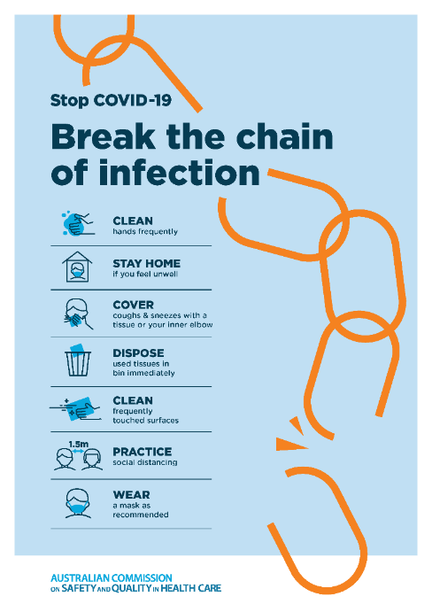](https://www.safetyandquality.gov.au/publications-and-resources/resource-library/break-chain-poster-a3https:/www.safetyandquality.gov.au/publications-and-resources/resource-library/break-chain-poster-a3)**
* ***COVID-19: Elective surgery and infection prevention and control precautions*** <https://www.safetyandquality.gov.au/publications-and-resources/resource-library/covid-19-elective-surgery-and-infection-prevention-and-control-precautions>
* ***FAQs for clinicians on elective surgery*** <https://www.safetyandquality.gov.au/node/5724>
* ***FAQs for consumers on elective surgery*** <https://www.safetyandquality.gov.au/node/5725>
* ***FAQs on community use of face masks***   
   <https://www.safetyandquality.gov.au/faqs-community-use-face-masks>
* ***COVID-19 and face masks – Information for consumers*** <https://www.safetyandquality.gov.au/publications-and-resources/resource-library/covid-19-and-face-masks-information-consumers>  
  The Commission’s fact sheet on use of face masks in the community to reduce the spread of COVID-19 is now available in Easy English and 10 other community languages from <https://www.safetyandquality.gov.au/wearing-face-masks-community>.  
  The factsheet was developed to help people understand when it is important to wear a mask to reduce the risk of the spread of COVID-19, and to explain how to safely put on and remove face masks. It also reinforces the importance of staying home if you have symptoms, physical distancing, hand hygiene and cough etiquette.

[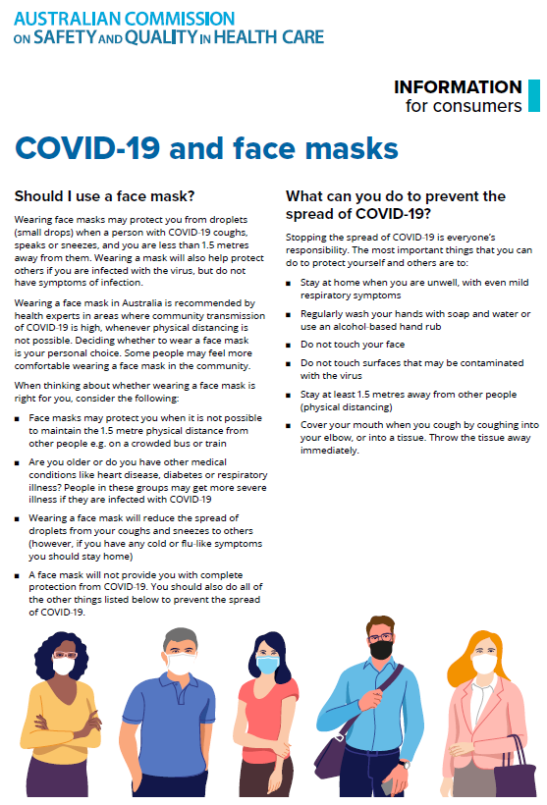](https://www.safetyandquality.gov.au/sites/default/files/2020-07/covid-19_and_face_masks_-_information_for_consumers.pdf)

*National COVID-19 Clinical Evidence Taskforce*

<https://covid19evidence.net.au/>

The National COVID-19 Clinical Evidence Taskforce is a collaboration of peak health professional bodies across Australia whose members are providing clinical care to people with COVID-19. The taskforce is undertaking continuous evidence surveillance to identify and rapidly synthesise emerging research in order to provide national, **evidence-based guidelines and clinical flowcharts for the clinical care of people with COVID-19**. The guidelines address questions that are specific to managing COVID-19 and cover the full disease course across mild, moderate, severe and critical illness. These are ‘living’ guidelines, updated with new research in near real-time in order to give reliable, up-to-the minute advice to clinicians providing frontline care in this unprecedented global health crisis.

*COVID-19 Critical Intelligence Unit*

<https://www.aci.health.nsw.gov.au/covid-19/critical-intelligence-unit>

The Agency for Clinical Innovation (ACI) in New South Wales has developed this page summarising rapid, evidence-based advice during the COVID-19 pandemic. Its operations focus on systems intelligence, clinical intelligence and evidence integration. The content includes a daily evidence digest and evidence checks on a discrete topic or question relating to the current COVID-19 pandemic. There is also a ‘Living evidence’ section summarising key studies and emerging evidence on **COVID-19 vaccines** and **SARS-CoV-2 variants**.

**Disclaimer**

On the Radar is an information resource of the Australian Commission on Safety and Quality in Health Care. The Commission is not responsible for the content of, nor does it endorse, any articles or sites listed. The Commission accepts no liability for the information or advice provided by these external links. Links are provided on the basis that users make their own decisions about the accuracy, currency and reliability of the information contained therein. Any opinions expressed are not necessarily those of the Australian Commission on Safety and Quality in Health Care.