Australian Commission on Safety and Quality in Health Care logo 


Trim: D20-7438

August 2020

*Clostridioides difficile* infection

# 2018 Data Snapshot

Published by the Australian Commission on Safety and Quality in Health Care  
Level 5, 255 Elizabeth Street, Sydney NSW 2000

Phone: (02) 9126 3600

Email: HAI@safetyandquality.gov.au   
Website: www.safetyandquality.gov.au

ISBN: 978-1-922563-26-2        

© Australian Commission on Safety and Quality in Health Care 2020

All material and work produced by the Australian Commission on Safety and Quality in Health Care (the Commission) is protected by copyright. The Commission reserves the right to set out the terms and conditions for the use of such material.

As far as practicable, material for which the copyright is owned by a third party will be clearly labelled. The Commission has made all reasonable efforts to ensure that this material has been reproduced in this publication with the full consent of the copyright owners.

With the exception of any material protected by a trademark, any content provided by third parties and where otherwise noted, all material presented in this publication is licensed under a [Creative Commons Attribution–NonCommercial–NoDerivatives 4.0 International licence](http://creativecommons.org/licenses/by-nc-nd/4.0/).



Enquiries about the licence and any use of this publication are welcome and can be sent to [communications@safetyandquality.gov.au](mailto:communications@safetyandquality.gov.au).

The Commission’s preference is that you attribute this publication (and any material sourced from it) using the following citation:

Australian Commission on Safety and Quality in Health Care. Clostridium difficile infection 2018 Data Snapshot. Sydney: ACSQHC; 2020

**Disclaimer**

The content of this document is published in good faith by the Commission for information purposes. The document is not intended to provide guidance on particular healthcare choices. You should contact your health care provider for information or advice on particular healthcare choices.

The Commission does not accept any legal liability for any injury, loss or damage incurred by the use of, or reliance on, this document.

# Background

*Clostridioides difficile[1]\** (*C. difficile*) is an anaerobic, spore-forming, gram-positive bacillus typically associated with gastrointestinal disease. The bacterium is ubiquitous in its spore form in the natural environment, as well as in built environments where there is the potential for it to spread from human and other animalcarriers to environmental surfaces. Transmission of *C. difficile* occurs by ingestion of spores either through person-to-person contact, animal-to-person contact or environment-to-person contact.1

Symptomatic *C. difficile* infection (CDI) is mediated through toxin production by the bacterium. Non-toxigenic strains of *C. difficile* are rarely associated with symptomatic illness.2 Production of toxin A and toxin B results in hyper-inflammation and necrosis of the gut lining.3 The spectrum of disease associated with *C. difficile* ranges from asymptomatic colonisation through to fulminant colitis and peritonitis.4 In addition to intracolonic symptoms, severe CDI is characterised by: fever (>38.5◦C), haemodynamic instability, elevated lactate, elevated creatinine, rigors, leucocytosis (>15x109/L, <20% neutrophils) and lowered albumin levels.5,6 Approximately 20% of patients with an initial infection will have at least one recurrent episode of symptomatic infection, usually within 21 days of the initial episode.7

Methods

The Australian Commission on Safety and Quality in Health Care (the Commission) has monitored the rate of CDI in Australian public hospitals since 2016. This 2018 Data Snapshot is the third in the series, published by the Commission. Patient administrative data from the 2017-2018 and 2018-2019 Admitted Patient Care National Minimum Data Set (APC NMDS) have been used in this report to estimate the rate of CDI in Australian public hospitals. Use of the APC NMDS for monitoring national CDI rates was established by the Commission in 2016 and supported by the Commission’s Inter-Jurisdictional Committee.

Exclusion and filtering criteria have not been applied to the APC NMDS. Data are based on the state or territory of the hospital that collected the data. For the purposes of this analysis, the diagnosis code A04.7 *Gastroenterocolitis* *caused by Clostridium difficile* was used to identify separations affected by CDI, and will be referred to as a CDI diagnosis in this report. Patient bed days were calculated by counting the total patient days of patients who separated during the specific period, including those admitted before the specific period. Separation days are episodes of patient care, in which care can include a total hospital stay (from admission to discharge, transfer or death), or a portion of a hospital stay beginning or ending in a change in type of care.8,9

CDI diagnoses are categorised as either a principal diagnosis or a non-principal diagnosis. A principal diagnosis describes the primary condition resulting in admission of an individual to hospital. This may include cases of CDI that develop in the community or may be attributed to a previous hospital admission. A non-principal diagnosis describes a condition that may have contributed to the admission, but is not the main reason for admission to hospital.This category of patients may include cases of CDI that develop during an inpatient admission. 9,10

Non-principal CDI diagnoses have been further classified by Conditional Onset Flags (COFs). These are as follows:

* COF 1: refers to a condition that has arisen during the episode of admitted care that would not have been present or suspected on admission.
* COF 2: refers to a condition previously existing or suspected on admission such as the presenting problem, a comorbidity or chronic disease.11

Rates of antimicrobial usage patterns in Australian public and private hospitals were sourced from the National Antimicrobial Utilisation Surveillance Program (NAUSP).12 Data for four classes of antibiotic (fluoroquinolones, third- and fourth-generation cephalosporins and carbapenems) and the rate of CDI diagnosis between 2017 and 2018 were used to observe if changes in antimicrobial prescribing patterns and the rates of CDI diagnoses may be related. Rates of CDI are measured as rate per 10,000 pate bed days. Rates of antimicrobial usage are measured as defined daily doses (DDD) per 1,000 occupied bed days (OBDs).13

Limitations and considerations for the interpretation of data

Access to information in the APC NMDS is dependent on hospital-level data being submitted by the states and territories and the subsequent validation of the dataset. Currently there is an 18 month lag between documentation of diagnosis at the hospital and submission, validation and publication in the APC NMDS.

Patient administrative data is not sensitive enough to link co-morbidities to the COF codes or identify severity of disease, and the effects of these elements are not adjusted for in the methodology.

# Rate of CDI diagnoses

## **Figure 1: CDI (A04.7) diagnoses in Australian public hospitals (n=689), 2018**

## 

## **Table 1: Average yearly rate of CDI (A04.7) diagnoses, per 10,000 patient bed days, Australian public hospitals, 2012-2018**

|  |  |  |  |
| --- | --- | --- | --- |
| **Year** | **Principal CDI diagnoses (range)** | **Non-principal CDI**  **diagnoses (range)** | **All CDI hospital diagnoses (range)** |
| **2012** | 1.21 (0.98-1.72) | 3.10 (2.85-3.43) | 4.30 (3.91-5.04) |
| **2013** | 1.13 (1.01-1.30) | 2.80 (2.63-3.05) | 3.94 (3.70-4.31) |
| **2014** | 1.08 (0.89-1.23) | 2.74 (2.47-2.94) | 3.81 (3.42-4.17) |
| **2015** | 1.11 (1.00-1.35) | 2.74 (2.61-2.98) | 3.85 (3.64-4.20) |
| **2016** | 1.23 (1.02-1.41) | 2.68 (2.48-2.91) | 3.91 (3.54-4.32) |
| **2017** | 1.21 (1.05-1.50) | 2.71 (2.27-2.95) | 3.92 (3.43-4.40) |
| **2018** | 1.27 (1.10-1.54) | 2.79 (2.58-3.06) | 4.05 (3.69-4.46) |

## **Figure 2: Statistical process control chart for CDI (A04.7) diagnoses in Australian public hospitals, 2014-2018**

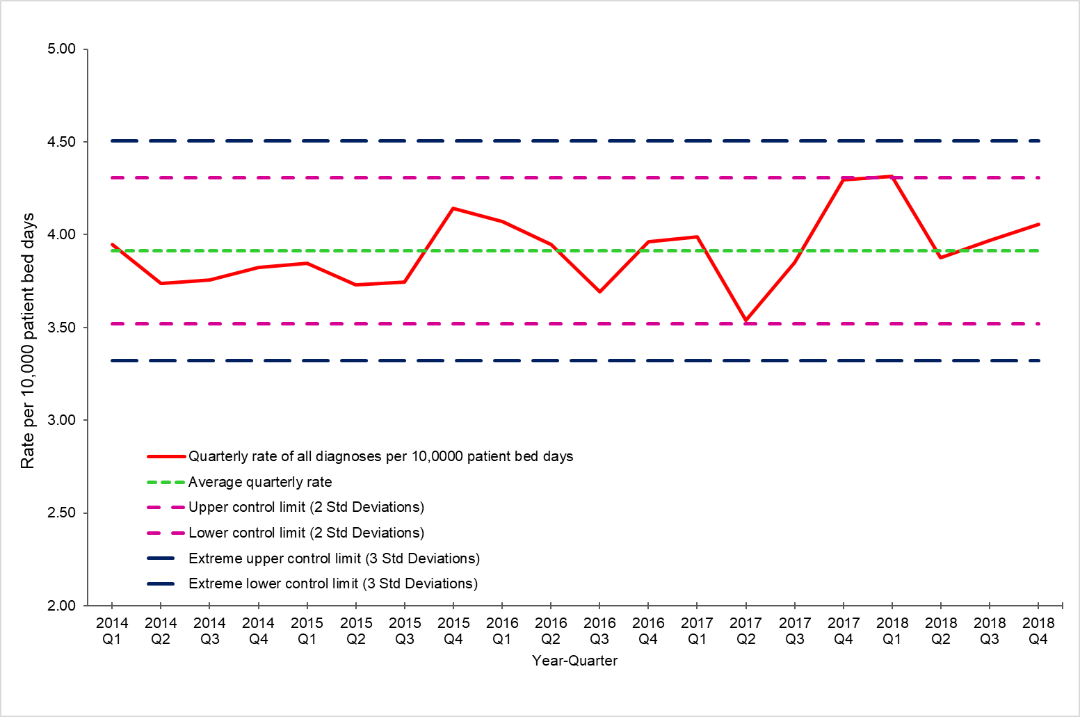

**Figure 3: Rate of CDI diagnoses and antibiotic usage for 2017 and 2018**

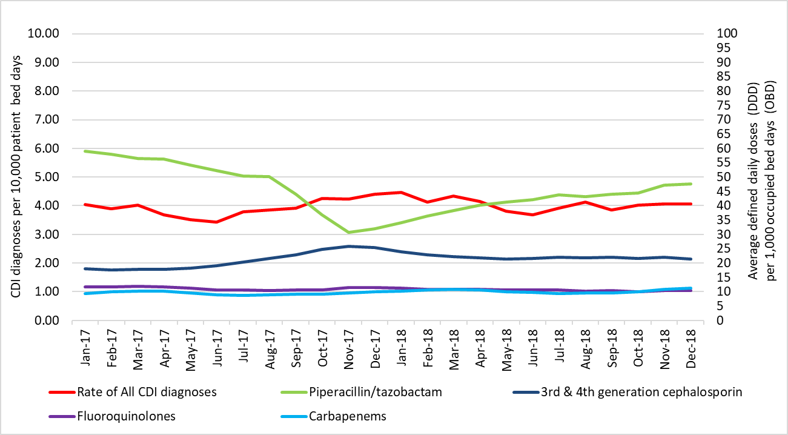

*Source NAUSP, 2018

# Commentary

### In 2018, principal CDI diagnoses accounted for 31% of all CDI diagnoses (Figure 1). The average rate of all CDI diagnoses in 2018 was 4.05 diagnoses per 10,000 patient bed days, with the range varying from 3.69 to 4.46 diagnoses per 10,000 patient bed days. The average yearly rate for all CDI diagnoses (principal and non-principal combined) in Australian public hospitals has been rising since 2016 (Table 1).

The overall monthly rate of all CDI diagnoses was highest in January 2018 (4.46 diagnoses per 10,000 patient bed days) (Figure 1). The highest rate for non-principal CDI diagnoses (3.06 CDI diagnoses per 10,000 patient bed days) was in March 2018. The rate of principal CDI diagnoses was highest in January 2018 (1.54 CDI diagnoses per 10,000 patient bed days) and remained relatively unchanged throughout the rest of the year (Figure 1).

The quarterly rate of CDI diagnoses from 2014 to 2018 is presented in Figure 2. The overall average quarterly rate of CDI diagnoses does not represent a benchmark or a desirable rate of CDI; control limits have been applied to assist in the identification of changes in rates and seasonal patterns of CDI diagnoses over time. The rates of CDI diagnoses in the last quarter of 2017 (4.29 diagnoses per 10,000 patient bed days)14 and in the first quarter of 2018 (4.31 diagnoses per 10,000 patient bed days) were equal to the upper control limit (Figure 2). The data suggests that there is an upward trend in the rate of CDI diagnoses over the five years, but this was not statistically significant. In the event that rates exceeded the upper control limit, further investigation is recommended to determine the probability of a CDI outbreak.

Usage rates for 2017 and 2018 of classes of antimicrobials known to be associated with CDI1 are presented with CDI diagnoses rates in Figure 3. Broad-spectrum antimicrobials are known to disrupt normal intestinal flora, which increases an individual’s susceptibility to *C. difficile* colonisation and infection.1,2 Antimicrobials, such as third-and fourth-generation cephalosporins, fluoroquinolones and carbapenems, are widely recognised as a risk factors for CDI.1,2 Specific narrow-spectrum antimicrobial agents remain the first line of treatment for CDI, however CDI is also predominately caused by antimicrobial use.15 Rates of CDI were observed to increase steeply in the second half 2017.14 This appeared to follow a steady increase in the use of third- and fourth-generation cephalosporins and a decline the use of piperacillin–tazobactam from mid-2017 onwards, in association with the supply shortage of piperacillin–tazobactam that occurred during the second half of 2017.13 During the shortage, third-and fourth-generation cephalosporins were the recommended alternative treatment for infections normally treated with piperacillin–tazobactam.16 Rates of CDI remained high throughout 2018, as did the rate of third- and fourth-generation cephalosporin usage. Whilst the rate of hospital use of third- and fourth-generation cephalosporins began to decline between January and May 2018, usage rates plateaued after May 2018 and did not return to the 2017 levels of use prior to the shortage. The reduction in third- and fourth-generation cephalosporin use did not continue once the availability of piperacillin–tazobactam resumed and usage rates of piperacillin–tazobactam started to increase.

# Rate of non-principal CDI diagnoses

# Figure 4: Rate of CDI (A04.7) non-principal diagnoses by Condition of Onset Flag (COF) in Australian public hospitals, 2018*

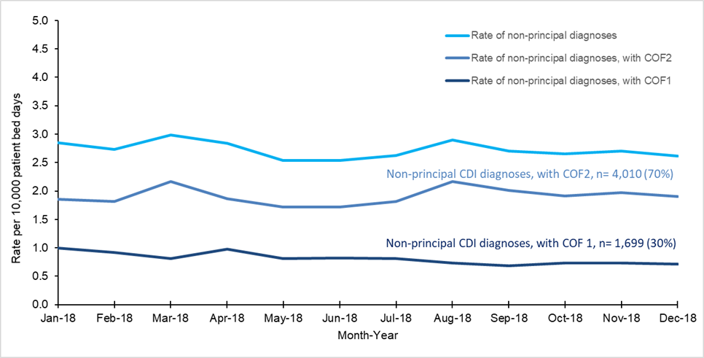

All non-principal CDI diagnoses, n= 5,709

*Based on hospitals with highly reliable COF coding only (2018 n=528)

# Figure 5: Estimated burden of pre-existing CDI (A04.7) presenting to hospitals, 2018*

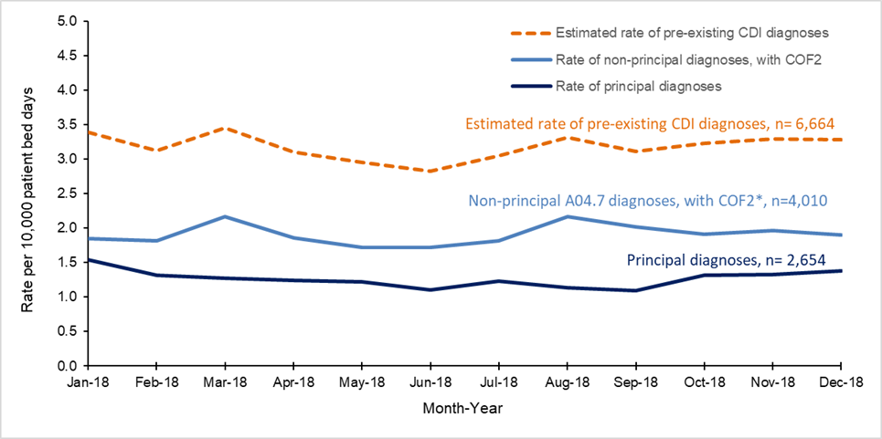

*Based on hospitals with highly reliable Condition Onset Flag (COF) coding (n=528)

Note: COF 1: Conditional Onset Flag 1, ‘refers to a condition that has arisen during the episode of admitted patient care that would not have been present or suspected on admission’.

COF 2: Condition Onset Flag 2, ‘refers to a condition previously existing or suspected on admission such as the presenting problem, a comorbidity or chronic disease’. 11 For further information on Conditional Onset Flags, see: Australian Institute of Health and Welfare. Episode of admitted patient care- condition onset flag, code N [online]: Available from: <https://meteor.aihw.gov.au/content/index.phtml/itemId/496512>

**Table 2: Number of CDI-related separations (A04.7) in Australian public hospitals**

**(n=689), 2016, 2017 and 2018**

|  |  |  |  |  |
| --- | --- | --- | --- | --- |
|  | **2016** | **2017** | **2018** | **Relative change between 2017 and 2018** |
| Number of separations in Australian public hospitals | 6,747,532 | 7,021,452 | 7,238,129 | **+3.08%** |
| Number of separations with a CDI diagnosis | 7,836 | 8,095 | 8,496 | **+4.95%** |
| Number of separations with a principal CDI diagnosis | 2,444 | 2,494 | 2,654 | **+6.42%** |
| Number of separations with a non-principal CDI diagnosis | 5,392 | 5,601 | 5,842 | **+4.30%** |
| Number of separations with a non-principal CDI diagnosis, with COF1* | 1,767 | 1,876 | 1,699 | **-9.43%** |
| Number of separations with a non-principal  CDI diagnosis, with COF2* | 3,476 | 3,600 | 4,010 | **+11.38%** |
| Estimated pre-existing burden  *Principal CDI+ non-principal CDI, COF2\** | 5,920 | 6,094 | 6,664 | **+9.35%** |

### **\*Based on hospitals with highly reliable COF coding only (2018 n=528)**

# Commentary

### The data presented in Figures 4 and 5 are from hospitals recognised to be highly reliable with regards to COF coding. The data have been filtered to exclude hospitals with an overall low volume of activity, hospitals where COF coding is very low for any condition, and hospitals with more than 10% of patient records where the COF was coded as unknown onset for any diagnosis.17

### Figure 4 shows the rates of non-principal CDI diagnoses for 2018. Of all non-principal CDI diagnoses, approximately 30% arose during an inpatient admission, and may be considered directly related to the health care provided during the separation for which a CDI diagnosis was assigned (COF1). There was little variation in the monthly rates of non-principal CDI diagnoses throughout 2018:

### The rate of all non-principal CDI diagnoses ranged from 2.58 to 3.06 diagnoses per 10,000 patient bed days; the average rate was 2.79 diagnoses per 10,000 patient bed days

* The average monthly rate of CDI non-principal diagnoses flagged as a COF1 was 0.81 diagnoses per 10,000 patient bed days, and ranged from 0.68 to 1.00 diagnoses per 10,000 patient bed days.
* The average monthly rate of CDI non-principal diagnoses flagged as a COF2 was 1.91 diagnoses per 10,000 patient bed days, and ranged from 1.72 to 2.17 diagnoses per 10,000 patient bed days.

Figure 5 describes the estimated burden of patients admitted to Australian public hospitals in 2018 with pre-existing CDI symptoms. At least 78% (n=6,664) of all patients with a CDI diagnosis had acquired *C. difficile* either in the community or during a previous health care admission, and their diagnosis was not related to the health care delivered during the separation for which the diagnosis was made. Therefore, of all patients diagnosed with CDI, only 22% might be considered true inpatient healthcare-acquired CDI.

A year on year comparison shows that, since 2016, the number of overall separations from Australian public hospitals has increased, as has the number of separations with a CDI diagnoses (2016 n= 7,836, 2017 n= 8,095, 2018 n=8,496). Between 2017 and 2018, the total number of hospital separations in Australia increased by 3.08% (Table 2). The total number of CDI diagnoses during this period increased by 4.95%. There was a 9.43% decline in the number of separations classified as a non-principal CDI diagnosis with a COF1 code, whereas the number of separations with a non-principal CDI diagnosis with a COF2 code increased by 11.38%. The estimated proportion of pre-existing CDI increased by 9.35% between 2017 and 2018. While the overall burden of CDI presenting to the health system appears to be increasing, the majority of this burden appears to not be healthcare-acquired. More detail on the year-on-year comparison of CDI rates from 2016, 2017 and 2018 will be included in an amalgam report to be published by the Commission in 2020.

# Hospital length of stay for patients with a CDI diagnoses

## **Table 3: Average length of stay (days) for patients with a CDI (A04.7) diagnosis in Australian public hospitals, 2012-2018**

|  |  |  |  |
| --- | --- | --- | --- |
| **Year** | **Length of stay (days) for principal CDI diagnosis** | **Length of stay (days) for non-principal CDI diagnosis** | **Length of stay (days) for any CDI diagnosis** |
| 2012 | 8.34 | 22.73 | 18.69 |
| 2013 | 7.91 | 20.91 | 17.17 |
| 2014 | 7.79 | 22.10 | 18.05 |
| 2015 | 7.60 | 20.68 | 16.91 |
| 2016 | 7.38 | 19.78 | 16.08 |
| 2017 | 7.76 | 19.99 | 16.16 |
| 2018 | 7.01 | 19.56 | 15.64 |
| Overall rate of change (slope for linear trend) | Slope = -0.17  (p=0.012) | Slope = -0.49  (p=0.009) | Slope = -0.47  (p=0.004) |

# Commentary

Table 3 shows the progressive and significant reduction in the length of stay each year since 2012 for patients admitted to Australian public hospitals with a diagnosis of CDI. Data for 2019 from the [Australian Institute of Health and Welfare](https://www.aihw.gov.au/reports-data/myhospitals/content/data-downloads) indicate that, in general, the average length of stay for any admission in an Australian public hospital has declined since 2014 (2014-2015 and 2015-2016 length of stay was 2.8 days, and 2017-2018 and 2018-2019 length of stay was 2.7 days).18 In 2018, the length of stay for each category of CDI diagnoses (principal, non-principal and any CDI diagnosis) was the lowest since 2012. In 2018, the average length of stay for patients with any CDI diagnosis (principal and non-principal CDI diagnosis) was 15.64 days.

A long length of stay can have a major impact on healthcare resources.19 The average length of stay for a patient with a principal CDI diagnosis was 7.01 days, which is less than half of the length of stay for a patient with a non-principal CDI diagnosis (19.56 days). Any association between length of stay and CDI should be interpreted with care. Length of stay is naturally impacted by many factors such as underlying co-morbidities, severity of disease and treatment modalities; as such, a prolonged separation cannot solely be attributed to the acquisition of CDI.19

There was a significant downward trend in length of stay associated with CDI between 2012 and 2018, whether as an admission diagnosis or as a complication of hospitalisation. A range of factors may be contributing to this trend, including earlier recognition and treatment, and the application of appropriate infection prevention and control strategies to prevent further transmission of CDI.

# Conclusion

In 2018, the average rate for all CDI diagnoses (principal and non-principal combined) was 4.05 diagnoses per 10,000 patient bed days. There was an upward trend in the average yearly rate for all CDI diagnoses since 2016. The highest monthly rate of CDI diagnoses was in January 2018 (4.46 diagnoses per 10,000 patient bed days). Rates of CDI diagnoses appeared to decline slightly until September 2018, when the monthly rates began to be increasing again (Figures 4 and 5).

Usage patterns for certain classes of antimicrobials, and rates of CDI appeared to follow a similar patterns in 2017 and 2018 when plotted together. There may be value in continuing to monitor usage or prescribing patterns for antimicrobials in conjunction with CDI or other healthcare-associated infection rates to better understand the effect of prescribing practices and antimicrobial shortages on CDI, along with other factors that may influence CDI rates.

Data from Australian public hospitals with reliable COFs indicated that 78% of patients with a CDI diagnosis were categorised as non-principal CDI diagnoses. Patients with a non-principal CDI diagnosis include those with pre-existing CDI symptoms (n=6,664), and may include those who developed CDI in the community, without recent hospital admission or from a previous hospital admission.

The number of separations from Australian public hospitals and the number of separations affected by CDI both increased in 2018. The number of separations in Australian public hospitals increased by 3.08%, and the separations affected by CDI increased by 4.95% in 2018; the increase in the CDI-affected separations, however, was not proportional to the overall increase in hospital separations.

The number of patients with a non-principal CDI diagnosis with a COF2 increased by 11.38% in 2018 (n=4,010) compared to 2017 (n=3,600). In 2018, the estimated burden of pre-existing CDI also increased by 9.35% (2018 n=6,664 compared to 2017 n=6,094).

In 2018, the overall length of stay for patients with CDI diagnoses was the lowest since 2012; the length of stay for a patient with a principal CDI diagnosis was 7.01 days. Overall the length of stay in Australian hospitals has declined over time from 2.8 days in 2014-2015 to 2.7 days in 2018-2019. This is an overall reduction in the average length of stay of 1.3%.18 The length of stay for all CDI diagnoses has also declined from 18.7 days in 2012 to 15.6 days in 2018, an overall reduction of 16.3%. Over recent years, there have been several improvements in the diagnosis and treatment of CDI, such as the use of fidaxomicin and faecal microbial transplant.20 Further investigation is required to establish if these changes have influenced the reduced length of stay observed for patients with CDI.

This report provides an overview of the current burden of CDI in Australian public hospitals, and the analyses should be interpreted with care in view of the limitations of the data.

The data presented in this report assists with retrospective review and assessment of the CDI burden nationally. States and territories and health service organisations should consider the use of timely local patient administrative data, such as the model presented in this report, in conjunction with other relevant surveillance information to evaluate the local epidemiology of CDI and inform local strategies for the control of potential CDI outbreaks.

An amalgam report that summarises the findings from the three CDI data snapshot reports from 2016, 2017 and 2018 as well as discussion on the case validation used for CDI surveillance and the future directions for CDI surveillance in Australia will be released later 2020.

References

1. NICE. *Clostridium difficile* infection: risk with broad-spectrum antibiotics,[Online]. 2015. [cited 5 August 2019] Available from: https://[www.nice.org.uk/advice/esmpb1/chapter/Key-points-from-the-evidence](http://www.nice.org.uk/advice/esmpb1/chapter/Key-points-from-the-evidence)

2. Natarajan M, Walk ST, Young VB and Aronoff DM. A clinical and epidemiological review of non-toxigenic *Clostridium difficile. Anaerobe.* 2013. 22: 1-5**.**

3. Awad MM, Johanesen PA, Carter GP, Rose E and Lyras D.*Clostridium difficile* virulence factors: Insights into an anaerobic spore-forming pathogen*. Gut Microbes,* 2014. 5: 579-93.

4. Napolitano LM and Edmiston CE. *Clostridium difficile* disease: Diagnosis, pathogenesis, and treatment update*. Surgery.* 2017. 162:325-48.

5. Trubiano JA, Cheng AC, Korman TM. et al, Australasian Society of Infectious Diseases updated guidelines for the management of *Clostridium difficile* infection in adults and children in Australia and New Zealand*.* *Internal Medicine Journal*. 2016. 46: 479-93.

6. Henrich TJ, Krakower D, Bitton A and Yokoe DS. Clinical risk factors for severe *Clostridium difficile*–associated disease*. Emerging Infectious Diseases.* 2009. 15: 415-22.

7. Kachrimanidou M and Malisiovas N. *Clostridium difficile* infection: A comprehensive review*.* *Critical Reviews in Microbiology.* 2011. 37: 178-87.

8. Australian Institute of Health and Welfare*.*  Admitted patient care NMDS 2016-17. 2016. [Online] 2016 [cited 5 August 2019]; Available from: <http://meteor.aihw.gov.au/content/index.phtml/itemId/612171>.

9. Australian Commission on Safety and Quality in Health Care. *Clostridium difficile* infection. Monitoring the national burden of *Clostridium difficile.*  2018. Sydney: ACSQHC.

10. Australian Institute of Health and Welfare. Principal diagnosis data cubes. 2017. [cited 5 August 2019]; Available from:<http://www.aihw.gov.au/hospitals-data/principal-diagnosis-data-cubes/>

11. Australian Institute of Health and Welfare. Episode of admitted patient care- condition

onset flag, code N [online]: Available from:

<https://meteor.aihw.gov.au/content/index.phtml/itemId/496512>

12. SA Health, Australian Commission on Safety and Quality in Health Care. Antimicrobial

use in Australian hospitals: biennial report of the National Antimicrobial Utilisation

Surveillance Program, 2017–2018,. 2020 [not published].

13. Australian Commission on Safety and Quality in Health Care. AURA 2019: Third Australian report on antimicrobial use and resistance in human health,. 2019, Sydney: ACSQHC.

14. Australian Commission on Safety and Quality in Health Care. *Clostridium difficile*

infection 2017 Data Snapshot report. 2019, Sydney: ACSQHC

15. Knight DR and Riley TV. Genomic Delineation of Zoonotic Origins of *Clostridium*

*difficile*. *Frontiers in Public Health.* 2019, 7:164 [Online] 2019 [cited 21 May 2020]

Available from: [www.frontiersin.org/article/10.3389/fpubh.2019.00164](http://www.frontiersin.org/article/10.3389/fpubh.2019.00164)

DOI:10.3389/fpubh.2019.00164

16. National Centre for Antimicrobial Stewardship*.*  Piperacillin-tazobactam - medication shortage. Fact Sheet – for adults in hospital and acute care facilities [online]. Melbourne Health, 2017. [Online] 2017 [cited 5 august 2019]; Available from: <https://www.ncas-australia.org/education>

17. Pricing and Funding for Safety and Quality – Risk Adjustment Model for Hospital

Acquired Complications – March 2019 [cited 28 July 28, 2020]; Available from:   
<https://www.ihpa.gov.au/sites/default/files/publications/pricing_and_funding_for_safety_and_quality_-_risk_adjustment_model_for_hospital_acquired_complications_2019-20.pdf>

18. Australian Institute of Health and Welfare.Admitted patient care 2018-2019 appendix

table. [cited 20 July 2020]; Available from: https://www.aihw.gov.au/reports-

data/myhospitals/content/data-downloads

19. Jeon CY, Neidell M, Jia H, Sinisi M and Larson E. On the role of length of stay in Healthcare-Associated Bloodstream Infection. *Infection Control and Hospital Epideminology*. 2012. 33(12): 1213-1218 doi:10.1086/668422

20. Ooijevaar RE, van Beurden YH, Terveer EM, et al. Update of treatment algorithms for *Clostridium difficile* infection, *Clinical Microbiology and Infection*, 2018. 24: 5, 452-462,[cited 23 July 2020] Available from: [http://www.sciencedirect.com/science/article/pii/S1198743X18300211](http://www.sciencedirect.com/science/article/pii/S1198743X18300211%20) doi.org/10.1016/j.cmi.2017.12.022.

1. \**Clostridioides difficile* was previously known as *Clostridium difficile.*

  