# Australian Commission on Safety and Quality in Health Care logo with Radar imageOn the Radar

Issue 518

5 July 2021

**11 years of On the Radar**

The first issue of *On the Radar* appeared on 5 July 2010. Initially produced as an internal resource for Commission personnel it quickly developed an audience beyond the Commission. Eleven years and 518 issues later my editorial task remains much the same – compiling a succinct synopsis of recent material relevant to safety and quality in health care. I hope you find it useful and relevant to your work.

Dr Niall Johnson

Editor

*On the Radar* is a summary of some of the recent publications in the areas of safety and quality in health care. Inclusion in this document is not an endorsement or recommendation of any publication or provider. Access to particular documents may depend on whether they are Open Access or not, and/or your individual or institutional access to subscription sites/services. Material that may require subscription is included as it is considered relevant.

*On the Radar* is available online, via email or as a PDF or Word document from <https://www.safetyandquality.gov.au/publications-and-resources/newsletters/radar>

If you would like to receive *On the Radar* via email, you can subscribe on our website <https://www.safetyandquality.gov.au/publications-and-resources/newsletters>  
or by emailing us at H[Umail@safetyandquality.gov.auU](mailto:mail@safetyandquality.gov.au).   
You can also send feedback and comments to H[Umail@safetyandquality.gov.auU](mailto:mail@safetyandquality.gov.au).

For information about the Commission and its programs and publications, please visit <https://www.safetyandquality.gov.au>

You can also follow us on Twitter @ACSQHC.

**On the Radar**

Editor: Dr Niall Johnson [niall.johnson@safetyandquality.gov.au](mailto:niall.johnson@safetyandquality.gov.au)

Contributors: Niall Johnson

**Reports**

*Ethics and governance of artificial intelligence for health: WHO guidance*

World Health Organization

Geneva: World Health Organization; 2021. p. 165.

|  |  |
| --- | --- |
| URL | <https://www.who.int/publications/i/item/9789240029200> |
| Notes | The World Health Organization has issued this guidance on the use of artificial intelligence in health care. The 150-page report sets out six principles for ethical use of AI, including:   1. **Protecting human autonomy**. Use of AI can lead to situations in which decision-making power could be transferred to machines. The principle of autonomy requires that the use of AI or other computational systems does not undermine human autonomy. In the context of health care, this means that humans should remain in control of health-care systems and medical decisions. 2. **Promoting human well-being and safety and the public interest**. AI technologies should not harm people. The designers of AI technologies should satisfy regulatory requirements for safety, accuracy and efficacy for well-defined use cases or indications. 3. **Ensuring transparency, explainability and intelligibility.** AI technologies should be intelligible or understandable to developers, medical professionals, patients, users and regulators. 4. **Fostering responsibility and accountability.** Humans require clear, transparent specification of the tasks that systems can perform and the conditions under which they can achieve the desired performance. Although AI technologies perform specific tasks, it is the responsibility of stakeholders to ensure that they can perform those tasks and that AI is used under appropriate conditions and by appropriately trained people. 5. **Ensuring inclusiveness and equity.** Inclusiveness requires that AI for health be designed to encourage the widest possible appropriate, equitable use and access, irrespective of age, sex, gender, income, race, ethnicity, sexual orientation, ability or other characteristics protected under human rights codes. 6. **Promoting AI that is responsive and sustainable.** |

*Switched on: How do we get the best out of automation and AI in health care?*

Hardie T, Horton T, Willis M, Warburton W

London: The Health Foundation; 2021. p. 76.

|  |  |
| --- | --- |
| DOI | <https://doi.org/10.37829/HF-2021-I03> |
| Notes | Also on the issue of AI in health care is this report from The Health Foundation in the UK. The report explores the opportunities for automation (for example, using software to automatically analyse patient feedback) and AI (such as using computers to assess X-ray images in order to spot illness or injury) in health care and the challenges of deploying them in practice. The report draws on Health Foundation research along with survey data from more than 4,000 British adults and more than 1,000 NHS staff. The report recognises that these technologies hold potential for improving care and productivity, but it will important ‘not to squeeze out the human dimension of health care, and must support the health and care workforce to adapt to and shape technological change’. The report’s authors assert that ‘it is critical that automation technologies are designed and used in ways that support and do not undermine person-centred care, and treat patients with dignity and respect.’ |

*Admin matters: the impact of NHS administration on patient care*

Ewbank L, Lamming L, Cream J, Wenzel L

London: The King's Fund; 2021.

|  |  |
| --- | --- |
| URL | <https://www.kingsfund.org.uk/publications/admin-matters-nhs-patient-care> |
| Notes | It’s sometimes said that the patient experience is all of us. That is, that the patient’s experience of health care is the sum of all their interactions within the health system from the receptionist, the administrative staff, the cleaning and maintenance staff, etc. through to all the clinicians. This report from The King’s Fund in the UK reflects on the potential for high-quality administration to improve patient experience, reduce inequalities, promote better care – and contribute to a better working environment for staff. They also recognise that it has seldom been a major focus for policy-makers and leaders. The report offers a framework for improving the quality of administration based on insight from patients, carers and NHS staff. |

*Leadership To Improve Diagnosis: A Call to Action*

Issue Brief 5

Rosen M, Ali KJ, Buckley BO, Goeschel C

Rockville: Agency for Healthcare Research and Quality; 2021. p. 16.

|  |  |
| --- | --- |
| URL | <https://www.ahrq.gov/patient-safety/reports/issue-briefs/leadership.html> |
| Notes | The Agency for Healthcare Research and Quality (AHRQ) in the USA has released this issue brief looking at how healthcare leaders can drive improvements in diagnostic safety. The issue brief examines ways leaders can promote a shared sense of responsibility for diagnostic safety through role clarity, responsibility, and feedback mechanisms and can use formal and informal learning strategies and processes to build capacity. It discusses a framework for cultivating a shared sense of responsibility, contribution, and control for diagnostic safety improvement among all formal and informal leaders.  [Figure 1. Location and impact of diagnostic failures. From "Leadership To Improve Diagnosis: A Call to Action"](https://www.ahrq.gov/patient-safety/reports/issue-briefs/leadership.html) |

**Journal articles**

*What I never consented to*

Lessing AJ

BMJ. 2021;373:n1294.

|  |  |
| --- | --- |
| DOI | <https://doi.org/10.1136/bmj.n1294> |
| Notes | The issue of incidental findings (often termed “incidentalomas”) has been known for a while. These can sometimes be significant but often are less important and can lead to unnecessary and time-consuming investigations. This piece offers a patient’s perspective on the impact of incidental findings. The author, Andrés Lessing, is a 41 year old with a complex medical history and experience of many tests, procedures, and surgeries, largely related to their neurofibromatosis type 1. Andrés observes that ‘Over the years, I have consented to seemingly endless risks that came with these procedures, including adverse reactions, infection, bleeding, nerve damage, function loss, and even death.’ However, one thing that has never been included in the consent forms or conversations is the possibility of an incidental finding. Given the potential impact, the author suggests that the ‘consent process should educate patients on the benefits and risks of treatment and should include discussing the possibility of incidental findings and possible responses, including watchful waiting rather than further tests and more surgeries.’ |

For information on the Commission’s work on informed consent, see <https://www.safetyandquality.gov.au/our-work/partnering-consumers/informed-consent>

For information on the Commission’s work on person-centred care, see <https://www.safetyandquality.gov.au/our-work/partnering-consumers/person-centred-care>

*Medication use and cognitive impairment among residents of aged care facilities*

Shafiee Hanjani L, Hubbard RE, Freeman CR, Gray LC, Scott IA, Peel NM

Internal Medicine Journal. 2021;51(4):520-532.

|  |  |
| --- | --- |
| DOI | <https://doi.org/10.1111/imj.14804> |
| Notes | Recent inquires and events have highlighted some of the concerns with care within residential aged care facilities (RACFs). It is been observed that polypharmacy (being on multiple medications) is common within RACFs. This study sought to examine if there was a link between inappropriate polypharmacy and cognitive status of the resident. Using de-identified data relating to 720 individuals, the study found that:   * The median number of medications was 10 (interquartile range (IQR) 8–14). * Cognitively intact residents were receiving significantly more medications (median (IQR) 13 (10–16)) than those with mild to moderate (10 (7–13)) or severe (9 (7–12)) cognitive impairment (P < 0.001). * Overall, 82% of residents received at least one anti-cholinergic/sedative medication and 26.9% were exposed to one or more potentially inappropriate medications, although the proportions of those receiving such medications were not significantly different across the groups. * Of 7658 medications residents were taking daily, 21.3% and 11.7% were classified as symptom control and preventive medications respectively with no significant difference among the groups in their use. |

For information on the Commission’s work on medication safety, see <https://www.safetyandquality.gov.au/our-work/medication-safety>

*Interventions to Reduce Pediatric Prescribing Errors in Professional Healthcare Settings: A Systematic Review of the Last Decade*

Koeck JA, Young NJ, Kontny U, Orlikowsky T, Bassler D, Eisert A

Pediatric Drugs. 2021;23(3):223-240.

|  |  |
| --- | --- |
| DOI | <https://doi.org/10.1007/s40272-021-00450-6> |
| Notes | Paper reporting on a systematic review that sought to ‘identify interventions to reduce prescribing errors and corresponding patient harm in pediatric healthcare settings and to evaluate their impact.’ The systematic review examined 45 studies and identified 70 interventions. The authors found that ‘**Interventions** to reduce pediatric prescribing errors are **more likely to be successful when implemented as part of a bundle of interventions**. Interventions including CPOE [computerised physician order entry] and CDS [clinical decision support] that substitute risks or provide engineering controls should be prioritized and implemented with appropriate administrative controls including expert consultation.’ |

*Journal for Healthcare Quality*

Volume 43, Number 4, July/August 2021

|  |  |
| --- | --- |
| URL | <https://journals.lww.com/jhqonline/toc/2021/08000> |
| Notes | A new issue of the *Journal for Healthcare Quality* has been published. Articles in this issue of the *Journal for Healthcare Quality* include:   * Implementation and Assessment of a **Proning Protocol for Nonintubated Patients With COVID-19** (Felicia R D'Souza, John P Murray, Sandeep Tummala, Frances Puello, David S Pavkovich, Daniel Ash, Stephanie B H Kelly, Albina Tyker, D Anderson, M A Francisco, N L Pierce, M T Cerasale) * **Postoperative Telehealth Visits Reduce Emergency Department Visits and 30-Day Readmissions** in Elective Thoracic Surgery Patients (Elwin Tham, Kulvir Nandra, Sung E Whang, Nathaniel R Evans, Scott W Cowan) * Defining **Best Practices for** **Interhospital Transfers** (Alyse Reichheld, Jesse Yang, Lauge Sokol-Hessner, Gene Quinn) * Boosting Perceived Customer Orientation as a Driver of **Patient Satisfaction** (Katrien Verleye, Arne De Keyser, Sophie Vandepitte, Jeroen Trybou) * Going Silent: Redesigning the Activation Process for **In-Hospital Cardiopulmonary Arrests** (Kyle R Stinehart, Carleen R Spitzer, Kimberly A Evans, Jeri Buehler, Talal Attar, Beth Besecker) * Use of Provider Scorecards to **Improve Early Postoperative Recovery**—Initial Implementation Study (Shradha D Khadge, Anthony Tanella, Francis Mtuke, Stacie Deiner, Jaime B Hyman) * Using Quality Improvement for Refining Program Materials for Exercise Promotion in **Comprehensive Multiple Sclerosis Care** (Matthew Fifolt, Emma V Richardson, Elizabeth A Barstow, Robert W Motl) * **Prediction of Adverse Outcomes Within 90 Days of Surgery** in a Heterogeneous Orthopedic Surgery Population (Ryan Dimentberg, Ian F Caplan, Eric Winter, Gregory Glauser, Stephen Goodrich, Scott D McClintock, Eric L Hume, Neil R Malhotra) * **Quality Changes Among Primary Care Clinicians** Participating in the Transforming Clinical Practice Initiative (Mingliang Dai, Lars E Peterson, Robert L Phillips) |

*Australian Journal of Primary Health*

Volume 27 Number 3 2021

|  |  |
| --- | --- |
| URL | <https://www.publish.csiro.au/py/issue/10185> |
| Notes | A new issue of the *Australian Journal of Primary Health* has been published. This issue is special issue with the theme ‘**Primary Health Care in an Ageing Society**’. Articles in this issue of the *Australian Journal of Primary Health* include:   * Primary health care in an ageing society (Hal Swerissen and Virginia Lewis) * Exploring the **‘grey nomad’ travelling population of Australia and its health**: an integrative literature review (Margaret Yates, Lin Perry, Jenny Onyx and Tracy Levett-Jones) * **Carers of older Australians**: unmet support needs and carer well-being (Jeromey Temple, Briony Dow and Leona Kosowicz) * **Self-management behaviours of older adults with chronic diseases**: comparative analysis based on the daily activity abilities (Dong Kong, Meiyun Zuo and Minder Chen) * Beyond multimorbidity: **primary care and the older person with complex needs** (Jennifer Mann, Fintan Thompson, Rachel Quigley, Robyn McDermott, Susan Devine and Edward Strivens) * **Frailty screening among older adults receiving home care packages**: a study of feasibility and prevalence (Amy Waller, Andrea Coda, Mariko Carey, Amy Davis and Matthew Clapham) * Recent trends in **health assessments for older Australians** (Eleanor K L Mitchell and Angelo D'Amore) * Attitudes of general practitioners and practice nurses regarding **older person health assessments** (Sai Ram Ramisetty, Angelo D'Amore and Eleanor K L Mitchell) * **Barriers to health care reported by carers of older Australians**: new evidence from the 2018 Survey of Disability, Ageing and Carers (Jeromey Temple, Frances Batchelor, Kerry Hwang, Jay Stiles and Lidia Engel) * Access to care: a qualitative study exploring the **primary care needs and experiences of older people needing assistance with daily living** (Marina Kunin, Jenny Advocat, Nilakshi Gunatillaka and Grant Russell) * **OPEN ARCH integrated care model**: experiences of older Australians and their carers (Rachel Quigley, Sarah Russell, Desley Harvey and Jennifer Mann) |

*BMJ Leader*

July 2021 - Volume 5 - 2

|  |  |
| --- | --- |
| URL | <https://bmjleader.bmj.com/content/5/2> |
| Notes | A new issue of *BMJ Leader* has been published. Articles in this issue of *BMJ Leader* include:   * **Coproduction and partnership** with people and communities (Catherine Wilton) * **Indigenous Health Leadership**: A Kaupapa Māori Perspective from Aotearoa – New Zealand (Divyansh Panesar, Jamie-Lee Rahiri, J Koea) * Hospital leadership perspectives on the **value of the 3 Wishes Project**: a qualitative study (Marilyn Swinton, Meredith Vanstone, Peter Phung, Thanh H Neville, Alyson Takaoka, Orla M Smith, Andrew Baker, Allana LeBlanc, Denise Foster, Vinay Dhingra, France J Clarke, Neala Hoad, Anne Woods, Anne Boyle, Feli Toledo, Deborah J Cook) * **What can we learn about systems leadership from the building of a Welsh surge hospital** and how might this be applied beyond the current COVID-19 response? (William Beharrell, Len Richards, M Driscoll, J Gray) * Experiences, challenges and lessons learnt in **medical staff redeployment** during response to COVID-19 (Anny Sykes, Meghana Pandit) * **AI-enabled suicide prediction tools**: ethical considerations for medical leaders (Daniel D’Hotman, Erwin Loh, Julian Savulescu) * **Leadership through crisis**: fighting the fatigue pandemic in healthcare during COVID-19 (Dale F Whelehan, Naomi Algeo, Darren A Brown) * **Gender-based disparities in medicine**: a theoretical framework for understanding opposition to equity and equality (Shannon M Ruzycki, Allison Brown, Aleem Bharwani, Georgina Freeman) * Critical factors for **successful management of VUCA times** (M Pandit) * **Prioritising surgical cases deferred by the COVID-19 pandemic**: an ethics-inspired algorithmic framework for health leaders (Amit Jain, Tinglong Dai, Christopher G Myers, Punya Jain, Shruti Aggarwal) * **Advocating for equity during the pandemic** (Onyinyechi F Eke, Alister Martin, Hazar Khidir, Onyeka Otugo, Andrew Marshall, Joanne C Suarez, Wendy L. Macias-Konstantopoulos) * **Balancing COVID-19 preparedness and ‘business as usual’ in hospitals**: lessons from executives in China, Norway and the UK (Umar Ikram, Hui Ren, Laura Shields-Zeeman, Jan Frich, Daniel Northam Jones, Jiong Wu, Ming Kuang, Yuanli Liu, Jing Ma) * **Role reconfiguration**: what ethnographic studies tell us about the implications of technological change for work and collaboration in healthcare (Heloise Agreli, Ruthanne Huising, Marina Peduzzi) |

*Nursing Leadership*

Volume 34, Number 2, June 2021

|  |  |
| --- | --- |
| URL | <https://www.longwoods.com/publications/nursing-leadership/26525/1/vol.-34-no.-2-2021> |
| Notes | A new issue of *Nursing Leadership* has been published. This issue has a special focus on **Nursing Leadership and the Mental Health of Nurses**. Articles in this issue of *Nursing Leadership* include:   * Editorial: Acknowledging **the Hidden Tsunami** (Joan Almost) * Introduction: Creating **Effective Ways to Support Nurses’ Mental Health** during COVID-19 (Joan Almost) * Nursing Leadership Has an Important Role in the **Management of Nurses’ Mental Health** (Andrea M. Stelnicki and R. Nicholas Carleton) * Mental Health and Addiction Response: **Supporting Nursing Resilience** in a Pandemic (Karima Velji and Elizabeth Brannon) * **Long-Term Care Nurse Leaders** Find Calm in Chaos: Reflections from a CEO during a Global Pandemic (Cindy Donovan) * Help Me Cope and Make It Easier: A Perspective from **Community Nursing** (Nancy Lefebre, Shirlee Sharkey and Tazim Virani) * Supporting the **Mental Health of Primary Care Nurses and Staff** through the Pandemic and Beyond (Christina Chant) * **Supporting Nurses in Provincial Corrections** (Linda Ogilvie) * An Academic Health Sciences Centre’s Strategy to **Enhance Nurse Resilience and Psychological Safety** (Lianne Jeffs, Jane Merkley, Rebecca Greenberg, Leanne Ginty, Nely Amaral, Robert Maunder, Lesley Wiesenfeld, Susan Brown, Paula Shing and Kara Ronald) * **Supporting the Mental Health of Nurses through Digital Tools** (Gillian Strudwick, Allison Crawford, Chantalle Clarkin, Iman Kassam and Sanjeev Sockalingam) * A Pandemic Leadership Program for Managers to **Enhance Staff Resiliency and Psychological Safety** during COVID-19 (Hamida Bhimani, Dorothy Dziunikowski, Valerie D’Paiva, N Jiwani-Ebrahim, J Roitenberg and R Yoon) * **Effects of COVID-19 on Healthcare Providers**: Opportunities for Education and Support (ECHOES) (Jacqueline Limoges, J Daniel Anzola and Nathan J Kolla) * Holistic **Supports for Street Nurses and Front-line Workers** during the COVID-19 Pandemic (Claire McMenemy, Danielle Rolfe, Kim Van Herk, Camille Wait, Bob Jamison, S Quesnel, C Laroque, W Muckle and W Gifford) |

*Milbank Quarterly*

Volume 99 Issue 2 June 2021

|  |  |
| --- | --- |
| URL | <https://www.milbank.org/quarterly/issues/june-2021/> |
| Notes | A new issue of *Milbank Quarterly* has been published. Articles in this issue of *Milbank Quarterly* include:   * **Rapid Transition to Telehealth and the Digital Divide**: Implications for Primary Care Access and Equity in a Post-COVID Era (Ji E Chang, Alden Yuanhong Lai, Avni Gupta, Ann M Nguyen, Carolyn A Berry, D R Shelley) * **Effects of COVID-19 Emergency and National Lockdown** on Italian Citizens’ Economic Concerns, Government Trust, and Health Engagement: Evidence From a Two-Wave Panel Study (Guendalina Graffigna, Lorenzo Palamenghi, Mariarosaria Savarese, Greta Castellini, Serena Barello) * Identifying Opportunities to Strengthen the **Public Health Informatics Infrastructure**: Exploring Hospitals’ Challenges with Data Exchange (Daniel M Walker, Valerie A Yeager, John Lawrence, Ann Scheck McAlearney) * International Collaboration to Ensure **Equitable Access to Vaccines for COVID-19**: The ACT-Accelerator and the COVAX Facility (Mark Eccleston-Turner, Harry Upton) * **Allocating a COVID-19 Vaccine**: Balancing National and International Responsibilities (Reidar Lie, Franklin Miller) * **Our Postpandemic World**: What Will It Take to Build a Better Future for People and Planet? (May C I Van Schalkwyk, Nason Maani, Jonathan Cohen, Martin McKee, Mark Petticrew) * The **Commercial Determinants of Three Contemporary National Crises**: How Corporate Practices Intersect with the COVID-19 Pandemic, Economic Downturn, and Racial Inequity (Nason Maani, May C I Van Schalkwyk, Mark Petticrew, Sandro Galea) * **Long COVID and Health Inequities: The Role of Primary Care** (Zackary Berger, Vivian Altiery De Jesus, Sabrina A. Assoumou, Trisha Greenhalgh) * The **Structure and Financing of Health Care Systems Affected How Providers Coped with COVID-**19 (Ruth Waitzberg, Wilm Quentin, Erin Webb, Sherry Glied) * **COVID-19: The Time for Collaboration between Long-Term Services and Supports, Health Care Systems, and Public Health Is Now** (Walter D Dawson, Nathan A Boucher, Robyn Stone, Courtney H Van Houtven) |

*Health Expectations*

Volume 24, Issue 3, June 2021

|  |  |
| --- | --- |
| URL | <https://onlinelibrary.wiley.com/toc/13697625/2021/24/3> |
| Notes | A new issue of *Health Expectations* has been published. Articles in this issue of *Health Expectations* include:   * Stakeholder perspectives on the **implementation and impact of Indigenous health interventions**: A systematic review of qualitative studies (Shingisai Chando, Allison Tong, Martin Howell, Michelle Dickson, Jonathan C Craig, Jack DeLacy, Sandra J Eades, Kirsten Howard) * A mapping and synthesis of tools for stakeholder and community engagement in **quality improvement initiatives for reproductive, maternal, newborn, child and adolescent health** (Jessie Spencer, Brynne Gilmore, Elsbet Lodenstein, Anayda Portela) * Conducting **public involvement in dementia research**: The contribution of the European Working Group of People with Dementia to the ROADMAP project (Ana Diaz, Dianne Gove, Mia Nelson, Michael Smith, Claire Tochel, Christophe Bintener, Amanda Ly, Christin Bexelius, Anders Gustavsson, Jean Georges, John Gallacher, Cathie Sudlow) * **Involving an individual with lived-experience** in a co-analysis of qualitative data (Laura Hemming, Daniel Pratt, Peer Bhatti, Jennifer Shaw, G Haddock) * **Opt-in or opt-out health-care communication?** A cross-sectional study (Vivien Tong, Ines Krass, Stephen Robson, Parisa Aslani) * ‘It's not magic’: A qualitative analysis of **geriatric physicians' explanations of cardio-pulmonary resuscitation** in hospital admissions (Anca-Cristina Sterie, Laura Jones, Ralf J Jox, Eve Rubli Truchard) * Innovative methods for **involving people with dementia and carers in the policymaking process** (Fiona Keogh, Patricia Carney, Eamon O’Shea) * 'A limpet on a ship': Spatio-temporal dynamics of **patient and public involvement in research** (Stan (Constantina) Papoulias, Felicity Callard) * **Patients' experiences of behaviour change interventions** delivered by general practitioners during routine consultations: A nationally representative survey (Chris Keyworth, Tracy Epton, Joanna Goldthorpe, Rachel Calam, Christopher J Armitage) * 'Reluctant pioneer': A qualitative study of **doctors' experiences as patients with long COVID** (Anna K Taylor, Tom Kingstone, Tracy A Briggs, Catherine A O'Donnell, Helen Atherton, David N Blane, C A Chew-Graham) * Determinants of **patient activation and its association with cardiovascular disease risk in chronic kidney disease**: A cross-sectional study (Thomas J Wilkinson, Katherine Memory, Courtney J Lightfoot, J Palmer, A C Smith) * Navigating **dietary advice for multiple sclerosis** (Rebecca D Russell, Lucinda J Black, Andrea Begley) * Shortening and validation of the **Patient Engagement In Research Scale (PEIRS)** for measuring meaningful patient and family caregiver engagement (Clayon B Hamilton, Alison M Hoens, Annette M McKinnon, Shanon McQuitty, Kelly English, Lisa D Hawke, Linda C Li) * **Involving people with type 2 diabetes in facilitating participation** in a cardiovascular screening programme (Marie Dahl, Susanne Friis Søndergaard, Axel Diederichsen, Jens Søndergaard, Trine Thilsing, Jes S Lindholt) * **Discharge processes and medicines communication from the patient perspective**: A qualitative study at an internal medicines ward in Norway (Stine Eidhammer Rognan, Sofia Kälvemark Sporrong, Kajsa Bengtsson, Helene Berg Lie, Yvonne Andersson, Morten Mowé, Liv Mathiesen) * The manifestation of **participation within a co-design process** involving patients, significant others and health-care professionals (Sebastian Lindblom, Maria Flink, Marie Elf, Ann Charlotte Laska, Lena von Koch, C Ytterberg) * **Shared decision making in consultations for hypertension**: Qualitative study in general practice (Rachel Johnson, K Turner, G Feder, H Cramer) * ‘No-one has listened to anything I’ve got to say before’: **Co-design with people who are sleeping rough** (Robyn M Mullins, Bridget E Kelly, Patrick ‘Spike’ Chiappalone, Virginia J Lewis) * Interactional practices in person-centred care: Conversation analysis of **nurse-patient disagreement during self-management support** (Emma Forsgren, Ida Björkman) * **Barriers to employment of Australian cancer survivors** living with geographic or socio-economic disadvantage: A qualitative study (Emma Kemp, Vikki Knott, Paul Ward, Suzana Freegard, Ian Olver, Julia Fallon-Ferguson, Jon Emery, Chris Christensen, Monique Bareham, B Koczwara) * Approaches to optimize **patient and family engagement in hospital planning and improvement**: Qualitative interviews (Natalie N Anderson, G. Ross Baker, Lesley Moody, Kerseri Scane, Robin Urquhart, Walter P Wodchis, Anna R Gagliardi) * The **psychological burden of waiting for procedures** and patient-centred strategies that could support the mental health of wait-listed patients and caregivers during the COVID-19 pandemic: A scoping review (Anna R Gagliardi, Cindy Y Y Yip, Jonathan Irish, Frances C Wright, Barry Rubin, Heather Ross, Robin Green, Susan Abbey, Mary P McAndrews, D E Stewart) * The story vs the storyteller: Factors associated with the effectiveness of brief video-recorded patient stories for **promoting opioid tapering** (Stephen G Henry, Bo Feng, Susan Verba, Richard L Kravitz, Ana-Maria Iosif) * **Diabetes care provided by national standards can improve patients' self-management skills**: A qualitative study of how people with type 2 diabetes perceive primary diabetes care (Rebecka Husdal, Eva Thors Adolfsson, Janeth Leksell, Lena Nordgren) * Alcohol use, cigarette smoking, vaping and number of sexual partners: A cross-sectional study of **sexually active, ethnically diverse, inner city adolescents** (Rosalie Bartholomew, Sarah Kerry-Barnard, Nicholas Beckley-Hoelscher, Rachel Phillips, Fiona Reid, Charlotte Fleming, Agata Lesniewska, Freya Yoward, Pippa Oakeshott) |

*BMJ Quality & Safety* online first articles

|  |  |
| --- | --- |
| URL | <https://qualitysafety.bmj.com/content/early/recent> |
| Notes | *BMJ Quality &Safety* has published a number of ‘online first’ articles, including:   * Complex interplay between **moral distress and other risk factors of burnout in ICU professionals**: findings from a cross-sectional survey study (Niek Kok, Jelle Van Gurp, Johannes G van der Hoeven, Malaika Fuchs, Cornelia Hoedemaekers, Marieke Zegers) |

*International Journal for Quality in Health Care* online first articles

|  |  |
| --- | --- |
| URL | <https://academic.oup.com/intqhc/advance-articles> |
| Notes | *International Journal for Quality in Health Care* has published a number of ‘online first’ articles, including:   * **Reducing Postoperative Opioid Pill Prescribing** via a Quality Improvement Approach (Kristian Stensland, Peter Chang, David Jiang, David Canes, Aaron Berkenwald, Adrian Waisman, Kortney Robinson, Gabriel Brat, Catrina Crociani, Kyle McAnally, Sarah Hyde, Brian Holiday, Jodi Mechaber, Analesa Baraka, Alireza Moinzadeh, Andrew A Wagner) * **Patient Coaching in Secondary Care**: Healthcare Professionals’ Views on Target Group, Intervention and Coach Profile (Irène M R Alders, Sandra van Dulmen, Carolien H M Smits, Anne Esther Marcus-Varwijk, Leontine Groen-van de Ven, Paul L P Brand) |

**Online resources**

*[USA] Toolkit To Improve Antibiotic Use in Long-Term Care*

<https://www.ahrq.gov/antibiotic-use/long-term-care/index.html>

The Agency for Healthcare Research and Quality (AHRQ) in the USA has released this toolkit that provides a step-by-step approach to help facilities start or revitalize an antibiotic stewardship program. Using the Four Moments of Antibiotic Decision Making approach, facilities can identify critical time periods to help prescribers make decisions about antibiotic therapy. The toolkit includes various tools and resources such as slide presentations with scripts, videos, and more to train staff and antibiotic stewardship teams to ensure antibiotics are used judiciously to prevent harm and keep residents safe.

*[UK] NIHR Evidence alert*

<https://evidence.nihr.ac.uk/>alerts/

The UK’s National Institute for Health Research (NIHR) has posted new evidence alerts on its site. Evidence alerts are short, accessible summaries of health and care research which is funded or supported by NIHR. This is research which could influence practice and each Alert has a message for people commissioning, providing or receiving care. The latest alerts include:

* GPs may help people at **risk of self-harm** by asking open questions, acknowledging distress, and exploring positive reasons for staying alive
* Low rates of **self-harm** do not mean low levels of distress in a disadvantaged London community
* **Drinks labels** with pictures and guidelines could improve public understanding of Government recommendations
* Misconceptions about **acne** lead to underuse of effective treatments; people need reliable information to manage the condition long-term
* **Breast cancer screening**: women with poor mental health are less likely to attend appointments
* Gabapentin does not reduce **long-term pelvic pain**, and has unpleasant side effects
* **Pelvic floor muscle training** can be delivered by appropriately trained non-specialists for women with prolapse
* GP referrals to **weight loss programmes** are accepted by men and women alike; research finds referrals reduce the gender gap
* Specific phrases about **weight management programmes** help GPs make successful referrals
* Nurses and pharmacists are key to improving access to **end of life medicines** for people being cared for at home
* Healthy lifestyles increase life expectancy in people with multiple conditions (**multimorbidity**) by as much as in other groups
* Surgery for hand disorder **Dupuytren’s disease** is effective, but repeat operations come with higher risks
* Practical changes in cancer care could reduce fear and confusion among people with **dementia**
* **Public involvement**: long-term partnerships with children and young people can improve research design.

**COVID-19 resources**

https://www.safetyandquality.gov.au/covid-19

The Australian Commission on Safety and Quality in Health Care has developed a number of resources to assist healthcare organisations, facilities and clinicians. These and other material on COVID-19 are available at <https://www.safetyandquality.gov.au/covid-19>

These resource include:

* ***COVID-19: Aged care staff infection prevention and control precautions*** *poster*<https://www.safetyandquality.gov.au/publications-and-resources/resource-library/covid-19-aged-care-staff-infection-prevention-and-control-precautions-poster>  
    
  [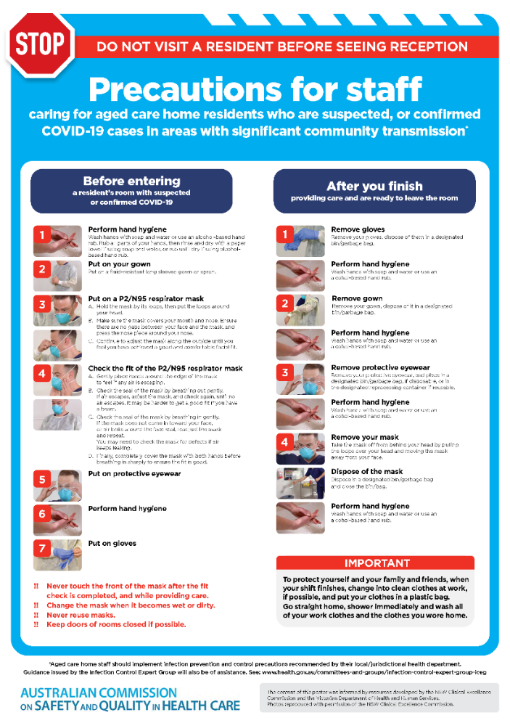](https://www.safetyandquality.gov.au/publications-and-resources/resource-library/covid-19-aged-care-staff-infection-prevention-and-control-precautions-poster)
* ***Environmental Cleaning and Infection Prevention and Control*** [www.safetyandquality.gov.au/environmental-cleaning](http://www.safetyandquality.gov.au/environmental-cleaning)
* ***Infection prevention and control Covid-19 PPE*** poster <https://www.safetyandquality.gov.au/publications-and-resources/resource-library/infection-prevention-and-control-covid-19-personal-protective-equipment>
* ***Special precautions for Covid-19 designated zones*** poster <https://www.safetyandquality.gov.au/publications-and-resources/resource-library/special-precautions-covid-19-designated-zones>
* ***COVID-19 infection prevention and control risk management – Guidance*** <https://www.safetyandquality.gov.au/publications-and-resources/resource-library/covid-19-infection-prevention-and-control-risk-management-guidance>
* ***Safe care for people with cognitive impairment during COVID-19***<https://www.safetyandquality.gov.au/our-work/cognitive-impairment/cognitive-impairment-and-covid-19>
* **Medicines Management COVID-19** <https://www.safetyandquality.gov.au/our-work/medication-safety/medicines-management-covid-19>, including position statements on medicine-related issues
  + ***Managing fever associated with COVID-19***
  + ***Managing a sore throat associated with COVID-19***
  + ***ACE inhibitors and ARBs in COVID-19***
  + ***Clozapine in COVID-19***
  + ***Management of patients on oral anticoagulants during COVID-19***
  + ***Ascorbic Acid: Intravenous high dose in COVID-19***
  + ***Treatment in acute care, including oxygen therapy and medicines to support intubation***
  + ***Nebulisation and COVID-19***
  + ***Managing intranasal administration of medicines during COVID-19***
  + ***Ongoing medicines management in high-risk patients***
  + ***Medicines shortages***
  + ***Conserving medicines***
  + ***Intravenous medicines administration in the event of an infusion pump shortage***
* ***Stop COVID-19: Break the chain of infection*** poster<https://www.safetyandquality.gov.au/publications-and-resources/resource-library/break-chain-poster-a3>  
  **[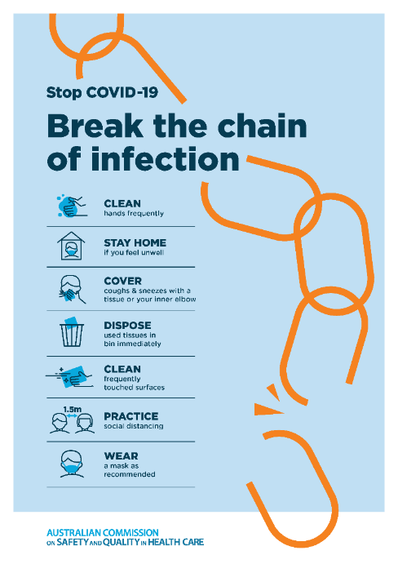](https://www.safetyandquality.gov.au/publications-and-resources/resource-library/break-chain-poster-a3https:/www.safetyandquality.gov.au/publications-and-resources/resource-library/break-chain-poster-a3)**
* ***COVID-19: Elective surgery and infection prevention and control precautions*** <https://www.safetyandquality.gov.au/publications-and-resources/resource-library/covid-19-elective-surgery-and-infection-prevention-and-control-precautions>
* ***FAQs for clinicians on elective surgery*** <https://www.safetyandquality.gov.au/node/5724>
* ***FAQs for consumers on elective surgery*** <https://www.safetyandquality.gov.au/node/5725>
* ***FAQs on community use of face masks***   
   <https://www.safetyandquality.gov.au/faqs-community-use-face-masks>
* ***COVID-19 and face masks – Information for consumers*** <https://www.safetyandquality.gov.au/publications-and-resources/resource-library/covid-19-and-face-masks-information-consumers>  
  The Commission’s fact sheet on use of face masks in the community to reduce the spread of COVID-19 is now available in Easy English and 10 other community languages from <https://www.safetyandquality.gov.au/wearing-face-masks-community>.  
  The factsheet was developed to help people understand when it is important to wear a mask to reduce the risk of the spread of COVID-19, and to explain how to safely put on and remove face masks. It also reinforces the importance of staying home if you have symptoms, physical distancing, hand hygiene and cough etiquette.

[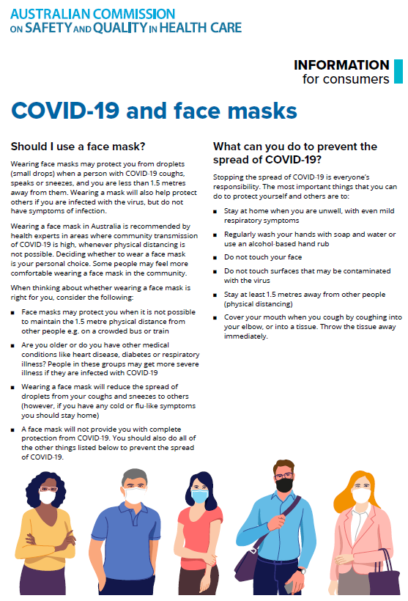](https://www.safetyandquality.gov.au/sites/default/files/2020-07/covid-19_and_face_masks_-_information_for_consumers.pdf)

*National COVID-19 Clinical Evidence Taskforce*

<https://covid19evidence.net.au/>

The National COVID-19 Clinical Evidence Taskforce is a collaboration of peak health professional bodies across Australia whose members are providing clinical care to people with COVID-19. The taskforce is undertaking continuous evidence surveillance to identify and rapidly synthesise emerging research in order to provide national, **evidence-based guidelines and clinical flowcharts for the clinical care of people with COVID-19**. The guidelines address questions that are specific to managing COVID-19 and cover the full disease course across mild, moderate, severe and critical illness. These are ‘living’ guidelines, updated with new research in near real-time in order to give reliable, up-to-the minute advice to clinicians providing frontline care in this unprecedented global health crisis.

*COVID-19 Critical Intelligence Unit*

<https://www.aci.health.nsw.gov.au/covid-19/critical-intelligence-unit>

The Agency for Clinical Innovation (ACI) in New South Wales has developed this page summarising rapid, evidence-based advice during the COVID-19 pandemic. Its operations focus on systems intelligence, clinical intelligence and evidence integration. The content includes a daily evidence digest and evidence checks on a discrete topic or question relating to the current COVID-19 pandemic. There is also a ‘Living evidence’ section summarising key studies and emerging evidence on **COVID-19 vaccines** and **SARS-CoV-2 variants**. Recent updates include:

* ***Facial hair, masks and COVID-19 transmission –*** Optimal use of respirator face masks such as N95 or filtering facepiece masks depends on a tight seal with the wearer's skin.
* ***Respirator fit testing evidence check –*** What is the effectiveness of fit testing (both qualitative and quantitative methods) and fit checking for testing the protection of a respirator and what are the factors influencing the outcomes of fit testing? What are the differences in outcomes between the qualitative and quantitative fit testing methods?

**Disclaimer**

On the Radar is an information resource of the Australian Commission on Safety and Quality in Health Care. The Commission is not responsible for the content of, nor does it endorse, any articles or sites listed. The Commission accepts no liability for the information or advice provided by these external links. Links are provided on the basis that users make their own decisions about the accuracy, currency and reliability of the information contained therein. Any opinions expressed are not necessarily those of the Australian Commission on Safety and Quality in Health Care.