# Australian Commission on Safety and Quality in Health Care logo with Radar imageOn the Radar

Issue 519

12 July 2021

*On the Radar* is a summary of some of the recent publications in the areas of safety and quality in health care. Inclusion in this document is not an endorsement or recommendation of any publication or provider. Access to particular documents may depend on whether they are Open Access or not, and/or your individual or institutional access to subscription sites/services. Material that may require subscription is included as it is considered relevant.

*On the Radar* is available online, via email or as a PDF or Word document from <https://www.safetyandquality.gov.au/publications-and-resources/newsletters/radar>

If you would like to receive *On the Radar* via email, you can subscribe on our website <https://www.safetyandquality.gov.au/publications-and-resources/newsletters>  
or by emailing us at H[Umail@safetyandquality.gov.auU](mailto:mail@safetyandquality.gov.au).   
You can also send feedback and comments to H[Umail@safetyandquality.gov.auU](mailto:mail@safetyandquality.gov.au).

For information about the Commission and its programs and publications, please visit <https://www.safetyandquality.gov.au>

You can also follow us on Twitter @ACSQHC.

**On the Radar**

Editor: Dr Niall Johnson [niall.johnson@safetyandquality.gov.au](mailto:niall.johnson@safetyandquality.gov.au)

Contributors: Niall Johnson, Kristin Xenos

**Antibiotics (Antimicrobials) and older people in aged care homes – what you should know**

<https://www.safetyandquality.gov.au/publications-and-resources/resource-library/antibiotics-antimicrobials-and-older-people-aged-care-homes-what-you-should-know>

Australian Commission on Safety and Quality in Health Care

Sydney: ACSQHC; 2021

This factsheet highlights the issues surrounding antimicrobial use in older people in aged care homes, providing information for older people, their families and their carers. Older people are more vulnerable to infections and can have different patterns of antimicrobial resistance than younger adults; are more likely to be taking other medication that can interact with antimicrobials; and, can experience more severe side effects from antimicrobials.

**Antimicrobial Stewardship in Australian Health Care – Chapter 16 – Antimicrobial stewardship in community and residential aged care**

<https://www.safetyandquality.gov.au/publications-and-resources/resource-library/ams-book-chapter-16-antimicrobial-stewardship-community-and-residential-aged-care>

Australian Commission on Safety and Quality in Health Care

Antimicrobial stewardship in community and residential aged care

*Antimicrobial Stewardship in Australian Health Care*

Sydney: ACSQHC; 2021

The content of the Commission’s *Antimicrobial Stewardship in Australian Health Care* book continues to grow, with the latest chapter dealing with AMS and community and residential aged care. Key elements include:

* Aged care services in Australia and infectious diseases and ageing
* Presentation of infections in older people
* Antimicrobial use and aged care services including specific areas of concern such as topical antimicrobial usage, asymptomatic bacteriuria and viral infections
* Antimicrobial stewardship program strategies including program governance, the AMS team, policies and prescribing guidelines, monitoring and surveillance, audit and feedback, education and training and preventing and managing infections
* Consideration of the barriers to implementation of AMS in the aged care setting in order to enhance effectiveness.

**Journal articles**

*Potentially preventable hospitalisations of people with intellectual disability in New South Wales*

Weise JC, Srasuebkul P, Trollor JN

Medical Journal of Australia. 2021;215(1):31-36.

*Improving access to community care for people with intellectual disability is needed to avert unnecessary hospitalisations*

Ben-Tovim DI, Vien K

Medical Journal of Australia. 2021;215(1):25-26.

|  |  |
| --- | --- |
| DOI | Weise et al <https://doi.org/10.5694/mja2.51088>  Ben-Tovim and Kim Vien <https://doi.org/10.5694/mja2.51113> |
| Notes | Safety and quality of care issues apply to everyone. However, some populations are more vulnerable and may require more attention in ensuring that their care is safe and appropriate. This paper reveals that this is true for one particular vulnerable population, people living with intellectual disability. Using data from a retrospective data linkage study of 92 542 people with intellectual disability in NSW, the study investigated rates of potentially preventable hospitalisation of people for this cohort and compared them with the total state population in 2001–. The study found:   * The annual age-standardised rate for people with intellectual disability ranged between 5286 and 6301 per 100 000 persons, and for the NSW population between 1278 and 1511 per 100 000 persons; * the rate ratio (RR) ranged between 3.5 in 2014–15 and 4.5 in 2002–03. * The difference was greatest for admissions with acute (RR range: 5.3 in 2014–15 to 8.1 in 2002–03) and vaccine-preventable conditions (RR range: 2.1 in 2007–08 to 3.4.   The authors concluded that ‘Rates of potentially preventable hospitalisation are higher in NSW for people with intellectual disability than for the general population, particularly hospitalisations for acute conditions, including convulsions and epilepsy.’ As a related editorial (Ben-Tovim and Vien) observed, ‘Admissions for treatment of convulsions and epilepsy were more than 22 times as frequent for people with intellectual disability as for the general population. While epilepsy is common in people with intellectual disability, the unacceptably higher rate of hospitalisation cannot be explained just by its prevalence, nor by problems with compliance with treatment, as differences in hospitalisation rates for other chronic conditions were unexceptional.’ |

*Medico-legal considerations of mandatory COVID-19 vaccination for high risk workers*

Kevat DAS, Panaccio DCA, Pang SC, Dean JM, Farmer CC, Mahar PD

Medical Journal of Australia. 2021;215(1):22-24.e21.

*COVID-19 Vaccination of Health Care Personnel as a Condition of Employment: A Logical Addition to Institutional Safety Programs*

Talbot TR

JAMA. 2021;326(1):23-24.

*Mandatory SARS-CoV-2 Vaccinations in K-12 Schools, Colleges/Universities, and Businesses*

Gostin LO, Shaw J, Salmon DA

JAMA. 2021;326(1):25-26.

|  |  |
| --- | --- |
| DOI | Kevat et al <https://doi.org/10.5694/mja2.51128>  Talbot <https://doi.org/10.1001/jama.2021.8901>  Gostin et al <https://doi.org/10.1001/jama.2021.9342> |
| Notes | The question of whether to make vaccination a requirement for those working in health facilities is one that recurs quite regularly. In light of the COVID-19 pandemic (and the continuing waves of infection) the question is being posed in terms of whether health workers (and aged care workers) should be required to have COVID-19 vaccination. These three articles are the most recent manifestation of this, with Gostin et al extending the range beyond health and aged care to look at education and and other settings. These questions tend to revolve around local/national legislation and whether there is an individual rights argument. There are also issues around (dis)incentives.  In the Australian context, Kevat et al suggest that ‘Australian employers of high risk workers (such as health care workers) could mandate COVID-19 vaccination. Such a direction may well be lawful and reasonable, excepting for those with relevant medical exemptions, for whom low risk roles must be sought if possible.’ |

*International Journal for Quality in Health Care*

Volume 33, Number 2, July/August 2021

|  |  |
| --- | --- |
| URL | <https://academic.oup.com/intqhc/issue/33/2> |
| Notes | A new issue of the *International Journal for Quality in Health Care* has been published. . Many of the papers in this issue have been referred to in previous editions of *On the Radar* (when they were released online). Articles in this issue of the *International Journal for Quality in Health Care* include:   * Outcomes of a multicomponent **safe surgery intervention** in Tanzania’s Lake Zone: a prospective, longitudinal study (Shehnaz Alidine, Gopal Menon, Steven J Staffa, Sakshie Alreja, David Barash, Erin Barringer, et al ) * Content of antenatal care and perception about services provided by **primary hospitals in Nepal**: a convergent mixed methods study (Yubraj Acharya, Nigel James, Rita Thapa, Saman Naz, Rishav Shrestha , Suresh Tamang) * **Conversion of a colorectal cancer guideline into clinical decision trees** with assessment of validity (Lotte Keikes, Milan Kos, Xander A A M Verbeek, Thijs Van Vegchel, Iris D Nagtegaal, Max J Lahaye, Alejandra Méndez Romero, Sandra De Bruijn, Henk M W Verheul, Heidi Rütten, Cornelis J A Punt, Pieter J Tanis, Martijn G H Van Oijen) * **Second victim support structures in anaesthesia**: a cross-sectional survey in Belgian anaesthesiologists (Kristof Nijs, Deborah Seys, Steve Coppens, Marc Van De Velde, Kris Vanhaecht) * Implementing **structured handoffs to verify operating room blood delivery** using a quality academy training program: an interrupted time-series analysis (Carly C Amon, Adina R Paley, Judith A Forbes, Leidy V Guzman, Aliysa A Rajwani, Agnieszka Trzcinka, R L Comenzo, D M Drzymalski) * Monitoring of three-phase variations in the **mortality of COVID-19 pandemic** using control charts: where does Pakistan stand? (Yasar Mahmood, Sunaina Ishtiaq, Michael B C Khoo, Sin Yin Teh, Hina Khan) * Development of the **perceptions of preventable adverse events assessment tool (PPAEAT)**: measurement properties and patients’ mental health status (Franziska Maria Keller, Christina Derksen, Lukas Kötting, Martina Schmiedhofer, Sonia Lippke) * **Telemedicine usage via WeChat for children with congenital heart disease** preoperatively during COVID-19 pandemic: a retrospective analysis (Qi-Liang Zhang, Wen-Peng Xie, Yu-Qing Lei, Hua Cao, Qiang Chen) * Masked and distanced: a qualitative study of **how personal protective equipment and distancing affect teamwork** in emergency care (Tuna C Hayirli, Nicholas Stark, Aditi Bhanja, James Hardy, Christopher R Peabody, * A cost-effectiveness analysis of the **Chronic Disease Management Program** in patients with hypertension in Korea (Woorim Kim, Sang Ah Lee, Sung-Youn Chun) * **Discrepancy between patient-reported and clinician-documented symptoms for myocardial perfusion imaging**: initial findings from a prospective registry (Cody Schwartz, David E Winchester) * **Effect of COVID-19 on hospital visits** in Ningbo, China: an interrupted time-series analysis (Zong-ming Yang, Meng-yin Wu, Jie-ming Lu, Tie-zheng Li, Peng Shen, Meng-ling Tang, Ming-juan Jin, Hong-Bo Lin, Li-ming Shui, Kun Chen, Jian-bing Wang) * **Patient-reported outcome measurement of symptom distress** is feasible in most clinical scenarios in palliative care: an observational study involving routinely collected data (Sabina Clapham, Barbara A Daveson, Samuel F Allingham, Darcy Morris, Pippa Blackburn, Claire E Johnson, Kathy Eagar) * A novel risk score for **in-hospital perioperative mortality** of five major surgeries (Hongxun Jia, Shan Wang, Jianchao Liu, Lin Li, Lihua Liu) * Improving **community care for patients discharged from hospital** through zone-wide implementation of a seamless care transition policy (Naveenjyote Boora, Shireen Surood, Jeff Coulombe, Surya Poudel, Vincent I O Agyapong) * **Healthcare quality assessments**: no guarantees of same outcomes for different socio-economic stroke patients (Jayeun Kim, Ki Hwa Yang, Ah Rum Choi, Mi Yeon Kang, Hyun Joo Kim, Hyejin Lee, Jin Yong Lee) * **Targeted ordering of investigations reduces costs** of treatment for surgical inpatients (Ashim Nath Adhikari, Matthew Dylan Beck, James Justin Wykes, Bruce Graham Ashford) * **Cost-effectiveness of public caseload midwifery** compared to standard care in an Australian setting: a pragmatic analysis to inform service delivery (Emily J Callander, Valerie Slavin, Jenny Gamble, Deera K Creedy, Hazel Brittain) * Safety concerns with **glass particle contamination**: improving the standard guidelines for preparing medication injections (Natthacha Chiannilkulchai, Siranee Kejkornkaew) * Applying health-six-sigma principles helps reducing the variability of **length of stay in the emergency department** (Ayala Kobo-Greenhut, Keren Holzman, Osnat Raviv, Jakov Arad, Izhar Ben Shlomo) * Benefits and risks of **non-slip socks in hospitals**: a rapid review (Dana Jazayeri, Hazel Heng, Susan C Slade, Brent Seymour, Rosalie Lui, Daniele Volpe, Cathy Jones, Meg E Morris) * **Are operating room distractions, interruptions and disruptions associated with performance and patient safety?** A systematic review and meta-analysis (Ryan D Mcmullan, Rachel Urwin, Peter Gates, Neroli Sunderland, Johanna I Westbrook) * Impact of the early phase of the **COVID pandemic on cancer treatment delivery and the quality of cancer care**: a scoping review and conceptual model (Melanie Powis, Carissa Milley-Daigle, Saidah Hack, Shabbir Alibhai, Simron Singh, Monika K Krzyzanowska) * Evaluating factors associated with the **cancellation and delay of elective surgical procedures**: a systematic review (Mona Koushan, Lincoln C Wood, Richard Greatbanks) * **Barriers to evidence-based practice implementation in physiotherapy**: a systematic review and meta-analysis (Matteo Paci, Gianni Faedda, Alessandro Ugolini, Leonardo Pellicciari) * **Medication adherence** as mandatory indicator in healthcare safety (Muhammad Amir, Zeeshan Feroz, Anwar Ejaz Beg) * **From accreditation to quality improvement**—The Danish National Quality Programme (Christian Uggerby, Solvejg Kristensen, Julie Mackenhauer, Søren Valgreen Knudsen, Paul Bartels, Søren Paaske Johnsen, Jan Mainz) * **Is a hospital quality policy based on a triad of accreditation, public reporting and inspection evidence-based?** A narrative review (Astrid Van Wilder, Luk Bruyneel, Dirk De Ridder, Deborah Seys, Jonas Brouwers, Fien Claessens, Bianca Cox, Kris Vanhaecht) |

*Health Affairs*

Volume 40, Number 7, July 2021

|  |  |
| --- | --- |
| URL | <https://www.healthaffairs.org/toc/hlthaff/40/7> |
| Notes | A new issue of *Health Affairs* has been published with the theme of “**Borders, Immigrants and Health**”. Articles in this issue of *Health Affairs* include:   * Health Policy Challenges Posed By **Shifting Demographics And Health Trends Among Immigrants** To The United States (Arturo Vargas Bustamante, Jie Chen, Lucía Félix Beltrán, and Alexander N Ortega) * **Life Expectancy At The US-Mexico Border**: Evidence Of Disparities By Place, Race, And Ethnicity (Keith P Gennuso, E A Pollock, and A M Roubal) * **Health Insurance Coverage In Mexico** Among Return Migrants: Differences Between Voluntary Return Migrants And Deportees (Rodrigo Dominguez-Villegas, and Arturo Vargas Bustamante) * Chilling Effects: US **Immigration Enforcement And Health Care Seeking** Among Hispanic Adults (Abigail S Friedman, and A S Venkataramani) * **Health Insurance Access Among US Citizen Children In Mexico**: National And Transborder Policy Implications (Sharon Borja, Jodi Berger Cardoso, Pedro Isnardo De La Cruz, Krista M Perreira, Natalia Giraldo-Santiago, and Martha Virginia Jasso Oyervides) * **California’s Health4All Kids** Expansion And Health Insurance Coverage Among Low-Income Noncitizen Children (Brandy J Lipton, Jefferson Nguyen, and Melody K Schiaffino) * **Noncitizen Children Face Higher Health Harms** Compared With Their Siblings Who Have US Citizen Status (Mariellen Jewers, and Leighton Ku) * Restoring An **Inclusionary Safety Net For Children In Immigrant Families**: A Review Of Three Social Policies (Dolores Acevedo-Garcia, Pamela K Joshi, Emily Ruskin, Abigail N Walters, and Nomi Sofer) * Understanding The **Health Landscapes Where Latinx Immigrants** Establish Residence In The US (Elizabeth Ackert, Sung Hee Hong, Jessica Martinez, Gabriel Van Praag, Pedro Aristizabal, and Robert Crosnoe) * The Other US Border: **Health Insurance Coverage Among Latino Immigrants** In Puerto Rico (Alexandra C Rivera-González, Jim P Stimpson, Dylan H Roby, Glorisa Canino, J Purtle, S L Bellamy, and A N Ortega) * **Health Care Spending And Use Among Hispanic Adults** With And Without Limited English Proficiency, 1999–2018 (Jessica Himmelstein, David U Himmelstein, Steffie Woolhandler, David H Bor, Adam Gaffney, Leah Zallman, Samuel Dickman, and Danny McCormick) * What Counts As ‘Safe?’: **Exposure To Trauma And Violence Among Asylum Seekers** From The Northern Triangle (C Nicholas Cuneo, Kara E Huselton, Nathan C Praschan, Altaf Saadi, and Matthew G Gartland) * A Content Analysis Of **US Sanctuary Immigration Policies**: Implications For Research In Social Determinants Of Health (Robin Ortiz, Dylan Farrell-Bryan, Gabriel Gutierrez, Courtney Boen, Vicky Tam, Katherine Yun, Atheendar S Venkataramani, and Diana Montoya-Williams) * **In-Transit Migrants And Asylum Seekers**: Inclusion Gaps In Mexico’s COVID-19 Health Policy Response (Ietza Bojorquez-Chapela, Cesar Infante, Silvana Larrea-Schiavon, and Isabel Vieitez-Martinez) * **COVID-19 Is Becoming A ‘9/11 Moment’ For Borders And Health** (Meghan Benton, and Demetrios G Papademetriou) * **‘Remain In Mexico’: Stories Of Trauma And Abuse** (Alfonso Mercado, Luz Garcini, Amanda Venta, and Manuel Paris) |

*BMJ Quality & Safety* online first articles

|  |  |
| --- | --- |
| URL | <https://qualitysafety.bmj.com/content/early/recent> |
| Notes | *BMJ Quality &Safety* has published a number of ‘online first’ articles, including:   * Effect of a health system **payment and quality improvement programme for tonsillectomy** in Ontario, Canada: an interrupted time series analysis (Sanjay Mahant, Jun Guan, Jessie Zhang, Sima Gandhi, Evan Jon Propst, Astrid Guttmann) * **Patient-level and hospital-level variation and related time trends in COVID-19 case fatality rates** during the first pandemic wave in England: multilevel modelling analysis of routine data (Alex Bottle, Puji Faitna, Paul P Aylin) |

*International Journal for Quality in Health Care* online first articles

|  |  |
| --- | --- |
| URL | <https://academic.oup.com/intqhc/advance-articles> |
| Notes | *International Journal for Quality in Health Care* has published a number of ‘online first’ articles, including:   * Characteristics of **Quality Activities in a Tertiary Teaching Hospital in Western Australia** (Qun Catherine Li, Jonathan Karnon, Simon Towler, Jim Codde) * Factors Associated With **Self-Reported Medical Errors Among Healthcare Workers**: A Cross-Sectional Study From Oman (Amal Ahmed Al Balushi, Mohamad Alameddine, Moon Fai Chan, Muna Al Sadoon, Karen Bou-Karroum, Samir Al-Adawi) * Research on **Obstetric Ward Planning** Combining Lean Thinking and Mixed Integer Programming (Dongmei Mu, Hua Li, Danning Zhao, , Yuanhong Ju, Yuewei Li) * Addressing Overestimation and Insensitivity in the **85% Target for Average bed Occupancy** (Adrian C Pratt, Richard M Wood) * Evaluating **Health Related Quality of Life and Emotions in Muslim and Jewish Kidney Transplant Patients** (Mahdi Tarabeih, Ya’arit Bokek-Cohen, Pazit Azuri) |

**Online resources**

*Clinical Communiqué*

<https://www.thecommuniques.com/post/clinical-communiqu%C3%A9-volume-8-issue-2-june-2021>

Volume 8 Issue 2, June 2020

This issue of *Clinical Communiqué* examines the issue of **access block**. The editor-in-chief of *Clinical Communiqué* considers access block to be ‘the single most serious issue facing emergency departments and the major contributor to emergency department overcrowding.’ This issue of *Clinical Communiqué* includes four cases that illustrate how the negative consequences of access block are far-reaching and can affect every stage of a patient’s journey through the healthcare system. There is also an expert commentary on access block that reflects on the lessons learned from the cases, and looks at the role every clinician can play in addressing such ‘a systemic and pervasive and preventable problem’.

**COVID-19 resources**

https://www.safetyandquality.gov.au/covid-19

The Australian Commission on Safety and Quality in Health Care has developed a number of resources to assist healthcare organisations, facilities and clinicians. These and other material on COVID-19 are available at <https://www.safetyandquality.gov.au/covid-19>

These resource include:

* ***COVID-19: Aged care staff infection prevention and control precautions*** *poster*<https://www.safetyandquality.gov.au/publications-and-resources/resource-library/covid-19-aged-care-staff-infection-prevention-and-control-precautions-poster>  
    
  [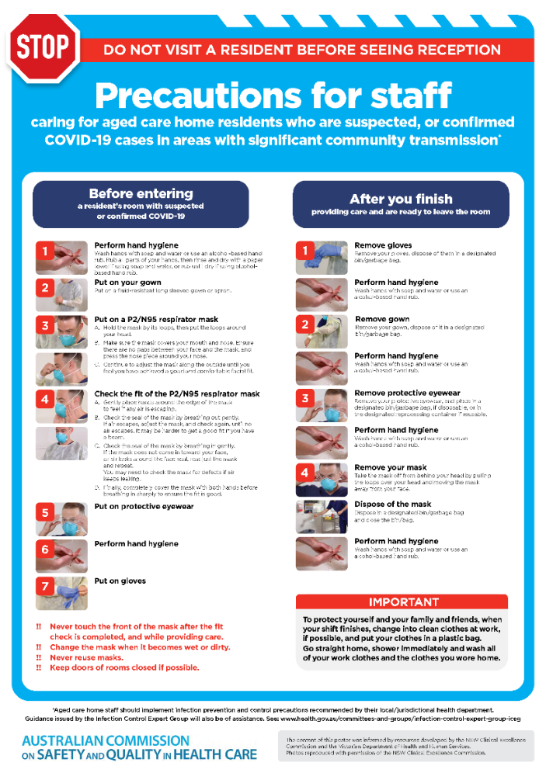](https://www.safetyandquality.gov.au/publications-and-resources/resource-library/covid-19-aged-care-staff-infection-prevention-and-control-precautions-poster)
* ***Environmental Cleaning and Infection Prevention and Control*** [www.safetyandquality.gov.au/environmental-cleaning](http://www.safetyandquality.gov.au/environmental-cleaning)
* ***Infection prevention and control Covid-19 PPE*** poster <https://www.safetyandquality.gov.au/publications-and-resources/resource-library/infection-prevention-and-control-covid-19-personal-protective-equipment>
* ***Special precautions for Covid-19 designated zones*** poster <https://www.safetyandquality.gov.au/publications-and-resources/resource-library/special-precautions-covid-19-designated-zones>
* ***COVID-19 infection prevention and control risk management – Guidance*** <https://www.safetyandquality.gov.au/publications-and-resources/resource-library/covid-19-infection-prevention-and-control-risk-management-guidance>
* ***Safe care for people with cognitive impairment during COVID-19***<https://www.safetyandquality.gov.au/our-work/cognitive-impairment/cognitive-impairment-and-covid-19>
* ***Stop COVID-19: Break the chain of infection*** poster<https://www.safetyandquality.gov.au/publications-and-resources/resource-library/break-chain-poster-a3>  
  **[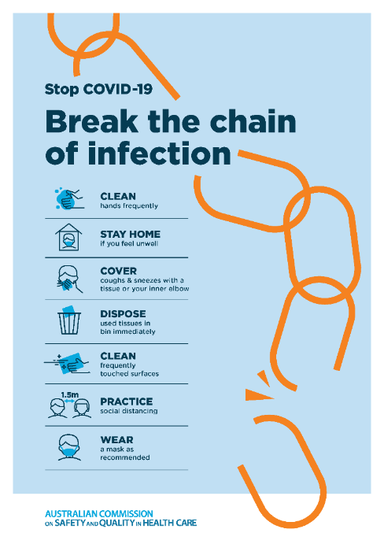](https://www.safetyandquality.gov.au/publications-and-resources/resource-library/break-chain-poster-a3https:/www.safetyandquality.gov.au/publications-and-resources/resource-library/break-chain-poster-a3)**
* ***COVID-19: Elective surgery and infection prevention and control precautions*** <https://www.safetyandquality.gov.au/publications-and-resources/resource-library/covid-19-elective-surgery-and-infection-prevention-and-control-precautions>
* ***FAQs for clinicians on elective surgery*** <https://www.safetyandquality.gov.au/node/5724>
* ***FAQs for consumers on elective surgery*** <https://www.safetyandquality.gov.au/node/5725>
* ***FAQs on community use of face masks***   
   <https://www.safetyandquality.gov.au/faqs-community-use-face-masks>
* ***COVID-19 and face masks – Information for consumers*** <https://www.safetyandquality.gov.au/publications-and-resources/resource-library/covid-19-and-face-masks-information-consumers>  
  The Commission’s fact sheet on use of face masks in the community to reduce the spread of COVID-19 is now available in Easy English and 10 other community languages from <https://www.safetyandquality.gov.au/wearing-face-masks-community>.  
  The factsheet was developed to help people understand when it is important to wear a mask to reduce the risk of the spread of COVID-19, and to explain how to safely put on and remove face masks. It also reinforces the importance of staying home if you have symptoms, physical distancing, hand hygiene and cough etiquette.

[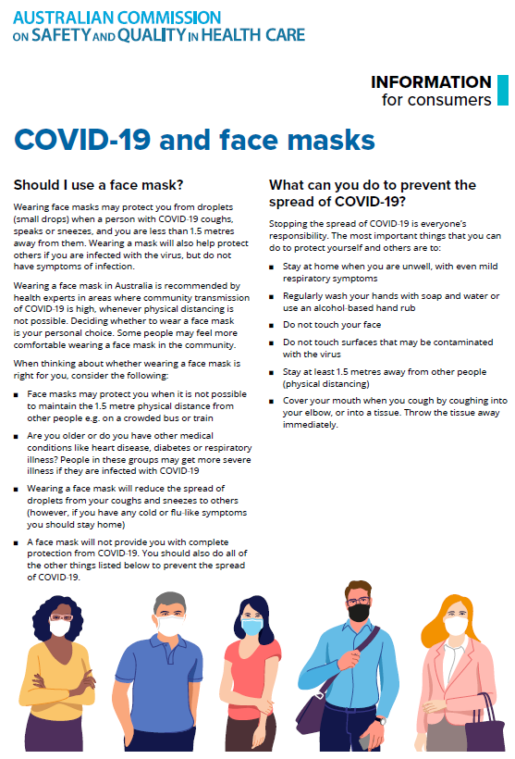](https://www.safetyandquality.gov.au/sites/default/files/2020-07/covid-19_and_face_masks_-_information_for_consumers.pdf)

*National COVID-19 Clinical Evidence Taskforce*

<https://covid19evidence.net.au/>

The National COVID-19 Clinical Evidence Taskforce is a collaboration of peak health professional bodies across Australia whose members are providing clinical care to people with COVID-19. The taskforce is undertaking continuous evidence surveillance to identify and rapidly synthesise emerging research in order to provide national, **evidence-based guidelines and clinical flowcharts for the clinical care of people with COVID-19**. The guidelines address questions that are specific to managing COVID-19 and cover the full disease course across mild, moderate, severe and critical illness. These are ‘living’ guidelines, updated with new research in near real-time in order to give reliable, up-to-the minute advice to clinicians providing frontline care in this unprecedented global health crisis.

*COVID-19 Critical Intelligence Unit*

<https://www.aci.health.nsw.gov.au/covid-19/critical-intelligence-unit>

The Agency for Clinical Innovation (ACI) in New South Wales has developed this page summarising rapid, evidence-based advice during the COVID-19 pandemic. Its operations focus on systems intelligence, clinical intelligence and evidence integration. The content includes a daily evidence digest and evidence checks on a discrete topic or question relating to the current COVID-19 pandemic. There is also a ‘Living evidence’ section summarising key studies and emerging evidence on **COVID-19 vaccines** and **SARS-CoV-2 variants**. Recent updates include:

* ***COVID-19 and maternity and newborn communities of practice*** –   
  What is the best practice management of a COVID-19 positive neonate?  
  What is the current evidence for vaccinating breastfeeding and pregnant women and women who are on oral contraceptive pill?  
  What are the current recommendations for infection control measures for group sessions in an indoor setting?

**Disclaimer**

On the Radar is an information resource of the Australian Commission on Safety and Quality in Health Care. The Commission is not responsible for the content of, nor does it endorse, any articles or sites listed. The Commission accepts no liability for the information or advice provided by these external links. Links are provided on the basis that users make their own decisions about the accuracy, currency and reliability of the information contained therein. Any opinions expressed are not necessarily those of the Australian Commission on Safety and Quality in Health Care.