# Australian Commission on Safety and Quality in Health Care logo with Radar imageOn the Radar

Issue 524

16 August 2021

*On the Radar* is a summary of some of the recent publications in the areas of safety and quality in health care. Inclusion in this document is not an endorsement or recommendation of any publication or provider. Access to particular documents may depend on whether they are Open Access or not, and/or your individual or institutional access to subscription sites/services. Material that may require subscription is included as it is considered relevant.

*On the Radar* is available online, via email or as a PDF or Word document from <https://www.safetyandquality.gov.au/publications-and-resources/newsletters/radar>

If you would like to receive *On the Radar* via email, you can subscribe on our website <https://www.safetyandquality.gov.au/publications-and-resources/newsletters>  
or by emailing us at H[Umail@safetyandquality.gov.auU](mailto:mail@safetyandquality.gov.au).   
You can also send feedback and comments to H[Umail@safetyandquality.gov.auU](mailto:mail@safetyandquality.gov.au).

For information about the Commission and its programs and publications, please visit <https://www.safetyandquality.gov.au>

You can also follow us on Twitter @ACSQHC.

**On the Radar**

Editor: Dr Niall Johnson [niall.johnson@safetyandquality.gov.au](mailto:niall.johnson@safetyandquality.gov.au)

Contributors: Niall Johnson

**Journal articles**

*The nature, severity and causes of medication incidents from an Australian community pharmacy incident reporting system: the QUMwatch study*

Khaled Adie, Romano A. Fois, Andrew J. McLachlan, Ramesh L. Walpola, Timothy F. Chen

British Journal of Clinical Pharmacology. 2021 [epub]

|  |  |
| --- | --- |
| DOI | <https://doi.org/10.1111/bcp.14924> |
| Notes | Medication errors are one of the most common forms of harm and can have many causes. This issue of *On the Radar* includes a number of items on medication errors.  Last week’s *On the Radar* included these notes but gave the publication details of a different paper from the same project. Today, we provide the correct publication details.  This paper reports on the nature and causes of medication incidents (MIs) in the community using a pharmacy incident reporting programme. The programme involved 30 community pharmacies in Sydney and saw 1013 incidents reported over 30 months, 831 of which were near misses while 165 reports involved patient harm. The programme found:   * The largest proportion of cases pertained to **patients aged >65 years** (35.7%). * Most incidents involved errors during the **prescribing** stage (**61.1%**), followed by **dispensing** (**25.7%**) and **administration** (**23.5%**), while some errors occurred at multiple stages (17.9%). * **Systemic antibacterials** (12.2%), **analgesics** (11.8%) and **renin–angiotensin medicines** (11.7%) formed the majority of implicated classes. * Participants identified diverse and interrelating contributing factors: those concerning healthcare providers included violations to procedures/guidelines (75.6%), rule-based mistakes (55.6%) and communication (50.6%); those concerning patients included cognitive factors (31.9%), communication (25.5%) and behaviour (6.1%). |

For information on the Commission’s work on medication safety, see <https://www.safetyandquality.gov.au/our-work/medication-safety>

*Medication incident recovery and prevention utilising an Australian community pharmacy incident reporting system: the QUMwatch study*

Adie K, Fois RA, McLachlan AJ, Chen TF

European Journal of Clinical Pharmacology. 2021 [epub].

|  |  |
| --- | --- |
| DOI | <https://doi.org/10.1007/s00228-020-03075-9> |
| Notes | This paper from the QUMwatch study provides an analysis of medication incident (MI) detection (how, where, when), minimising factors and remedy actions that were taken to reduce risk as well as preventive recommendations from the participants. Incident cases were also studied qualitatively to provide an additional triangulation approach to incident analysis. The programme involved 30 community pharmacies in Sydney participating in a 30-month prospective incident reporting program of MIs classified in the Advanced Incident Management System (AIMS). The study reports that   * **1013** incidents with **831 recovered near misses** and **165 purported patient harm**. * MIs were mainly initiated at the **prescribing** (68.2%) and **dispensing** (22.6%) stages, and most were resolved at the pharmacy (76.9%). * Detection was efficient within the first 24 h in 54.6% of MIs, but 26.1% required one month or longer; 37.2% occurred after the patient consumed the medicine. * The combination of specific actions/attributes (85.5%), appropriate interventions (81.6%) and effective communication (77.7%) minimised MIs. * An array of **remedial actions** were conducted by participants including **notification, referral, advice, modification of medication regimen, risk management and documentation corrections**. * Recommended **prevention strategies** involved espousal of **medication safety culture** (97.8%), better application of **policies/procedures** (84.6%) and improvements in healthcare providers’ **education** (79.9%). |

*A systematic review on pediatric medication errors by parents or caregivers at home*

Lopez-Pineda A, Gonzalez de Dios J, Guilabert Mora M, Mira-Perceval Juan G, Mira Solves JJ

Expert Opinion on Drug Safety. 2021 [epub].

|  |  |
| --- | --- |
| DOI | <http://doi.org/10.1080/14740338.2021.1950138> |
| Notes | Medications are used in almost all settings, from the home to the hospital. Many of the adverse drug events that lead to hospitalisation occur in the home. This systematic review examined medication errors (ME) affecting children that occur in the home. The literature revealed a variation in frequency of paediatric medication errors in the home of between 30 and 80%. The review found that the research ‘suggests the risk of making a ME in pediatric patients at home may depend on the characteristics of the caregiver and may increase if a prescription contains ≥3 drugs.’ The findings suggest ‘providing dosing tools more closely matched to prescribed dose volumes, recommending the use of syringes as a measurement tool, and educational intervention for caregivers could be useful to reduce MEs.’ |

*Prevalence, nature, severity and preventability of adverse drug events in mental health settings: findings from the MedicAtion relateD harm in mEntal health hospitals (MADE) study*

Alshehri GH, Ashcroft DM, Nguyen J, Hann M, Jones R, Seaton K, et al

Drug Safety. 2021;44(8):877-888.

|  |  |
| --- | --- |
| DOI | <http://doi.org/10.1007/s40264-021-01088-6> |
| Notes | The issues that affect ‘physical’ health care can take on a slightly different complexion in the mental health setting. This is true of medication errors and adverse drug events which is the focus of this study. Following some other recent papers on medication safety in mental health featured in *On the Radar*, this study was a retrospective record review conducted at three mental health trusts in England that examined 227 patient admissions comprising 10,164 patient-days of follow-up. The authors report:   * The adjusted rate of **confirmed ADEs** was **12.6 per 100 admissions** and **2.6 per 1000 patient-days**, with almost a fifth of these ADEs judged as **preventable 19.1%** (n = 9/47). * Majority of ADEs were of at least moderate clinical severity (29/47; 61.7%) * Medicines from the central nervous system class were most commonly implicated in ADEs (45/47; 95.7%) including antipsychotics (31/45; 68.8%) and antidepressants (7/45; 15.5%). * Patients with a hospital stay of more than 30 days and patients with a stay of 8–30 days were more likely to experience an ADE compared with patients with a stay of 1–7 days. |

*Pharmacist-led educational interventions provided to healthcare providers to reduce medication errors: a systematic review and meta-analysis*

Jaam M, Naseralallah LM, Hussain TA, Pawluk SA

PLOS ONE. 2021;16(6):e0253588.

|  |  |
| --- | --- |
| DOI | <http://doi.org/10.1371/journal.pone.0253588> |
| Notes | The integration of pharmacists into the treating team in various ways has been identified as a mechanism by which medication errors may be ameliorated. This review and meta-analysis sought to ‘describe and compare various pharmacist-led educational interventions delivered to healthcare providers and to evaluate their impact qualitatively and quantitatively on medication error rates’. Based on 12 studies that covered more than 115,000 participants, the authors found ‘**Pharmacist-led educational interventions directed to healthcare providers are effective at reducing medication error rates**. This review supports the implementation of pharmacist-led educational intervention aimed at reducing medication errors.’ |

*Mortality review as a tool to assess the contribution of healthcare-associated infections to death: results of a multicentre validity and reproducibility study, 11 European Union countries, 2017 to 2018.*

van der Kooi T, Lepape A, Astagneau P, Suetens C, Nicolaie MA, de Greeff S, et al

Eurosurveillance. 2021;26(23):2000052.

|  |  |
| --- | --- |
| DOI | <http://doi.org/10.2807/1560-7917.Es.2021.26.23.2000052> |
| Notes | Healthcare-associated infections (HAI) are also among the more common forms of iatrogenic harm. This paper reports on the development of three mortality review measures to measure the potential contribution of HAIs to patient death. The study used data from 24 hospitals in 11 European Union countries that submitted cases, collected during at least 7 months in the period April 2017 to February 2018. The authors report that the ‘study showed that the validity and reproducibility of the three evaluated mortality review measures was acceptable for use in European surveillance of HAI. The performance of the three measures was comparable and the perceived fit of the three outcomes was predominantly reasonable or good.’ |

*Australian Journal of Primary Health*

Volume 27(4) 2021

|  |  |
| --- | --- |
| URL | <https://www.publish.csiro.au/py/issue/10187> |
| Notes | A new issue of the *Australian Journal of Primary Health* been published. Articles in this issue of the *Australian Journal of Primary Health* include:   * **Self-management of diabetes and associated comorbidities in rural and remote communities**: a scoping review (Bodil Rasmussen, Karen Wynter, Helen A Rawson, Helen Skouteris, Nicola Ivory and Susan A. Brumby) * Upscaling **HIV and hepatitis C testing in primary healthcare** settings: stigma-sensitive practice (Emily Lenton, Jen Johnson and Graham Brown) * Patient-Chosen Gap Payment: an exploratory qualitative review of patients and general practitioner attitudes toward an **alternative funding model for general practice** (Daniel S Epstein, Christopher Barton, Pallavi Prathivadi and Danielle Mazza) * **Oral health care in urban general practice**: what are the support and training needs? (Thomas Fung, Penelope Abbott, Amit Arora, Ajesh George, Amy Villarosa and Jennifer Reath) * Increasing **general practitioner use of evidence-based medicine** in teaching and clinical practice through evidence-based journal clubs (Miriam Brooks, Jennifer Reath, Louise McDonnell and Penelope Abbott) * Knowledge, beliefs and attitudes of general practitioners and general practice nurses regarding **influenza vaccination for young children** (Haley Ruiz, Elizabeth Halcomb, Holly Seale, Alyssa Horgan and Joel Rhee) * Incorporation of **human papillomavirus self-sampling** into the revised National Cervical Screening Program: a qualitative study of GP experiences and attitudes in rural New South Wales (Yun Megan Foo, Pragya Goswami, James Grogin, Elizabeth Hargan, Meera Thangarajah, Tegan Dutton, Sandra Mendel and Jannine Bailey) * Correlation of **patient- and clinician-assessment of pain**: comparing physiotherapy and general practice (Sarah J White, Mark Butlin, Alicia Brown and Ross White) * **Termination of pregnancy in Tasmania**: access and service provision from the perspective of GPs (Kathryn Ogden, Emily Ingram, Joanna Levis, Georgia Roberts and Iain Robertson) * Population-based analysis of sociodemographic predictors, health-related quality of life and health service use associated with **obstructive sleep apnoea and insomnia in Australia** (E Hoon, D A González-Chica, A Vakulin, D McEvoy, N Zwar, R Grunstein, C Chai-Coetzer, L Lack, R Adams, P Hay, S Touyz and N Stocks) * Doctors identify regulatory barriers for their **patients with type 2 diabetes to access the nutritional expertise of dietitians** (George Siopis, Stephen Colagiuri and Margaret Allman-Farinelli) * Barriers and enablers to providing preventative and early intervention **diabetes-related foot care**: a qualitative study of primary care healthcare professionals' perceptions (Leanne Mullan, Karen Wynter, Andrea Driscoll and Bodil Rasmussen) * Implementation strategies to overcome barriers to **diabetes-related footcare delivery in primary care**: a qualitative study (Leanne Mullan, Karen Wynter, Andrea Driscoll and Bodil Rasmussen) |

*Patient Experience Journal*

Volume 8, Issue 2

|  |  |
| --- | --- |
| URL | <https://pxjournal.org/journal/vol8/iss2/> |
| Notes | A new issue of *Patient Experience Journal* (PXJ) has been published. Articles in this issue of *Patient Experience Journal* include:   * Editorial: Moving from talk to action: **A commitment to ensuring equity** must ground our efforts to transform the human experience (Jason A Wolf) * “I See What You Do”: A **patient’s view of equity** (Nikki (Charisse) Montgomery) * **His Story: “I would be better off dead”** (Ronald Wyatt) * **Breaking barriers to equity**: A conversation with Dr. Julia Iyasere (J A Wolf) * **A patient’s narrative of engaging HIV care**: Lessons learned to harness resources and improve access to care (David Lessard, Serge Vicente, Patrick Keeler, and Bertrand Lebouché) * **Sociodemographic characteristics and patient and family experience survey response biases** (Lauren N. Brinkman, Myra S Saeed, Andrew F Beck, Michael C Ponti-Zins, Ndidi I Unaka, Mary C Burkhardt, Jareen Meinzen-Derr, and Samuel P Hanke) * A closer look at the association between **African American men’s perceptions of healthcare providers’ cultural sensitivity and hypertension** (Kyvia Crisco) * Traversing **barriers to health care among LGBTQ+ Latinx emerging adults**: Utilizing patient experiences to model access (Rachel M Schmitz and Jennifer Tabler) * Measuring **cancer care experiences of Aboriginal and Torres Strait Islander people** in Australia: Trial of a new approach that privileges patient voices (Monica Green, Joan Cunningham, Kate Anderson, Kalinda Griffiths, and Gail Garvey) * The Right PREMTM: Rasch analysis of a new **patient reported experience measure** for use by older people in hospital (Louise Heuzenroeder, Jyoti Khadka, and Alison Kitson) * The experience, satisfaction, and Emergency Department utilization of **pediatric patients with sickle cell disease** during the Covid-19 pandemic (Alexandra E Kirsch and Nataly Apollonsky) * Building **patient participation in quality of care** through the healthcare stories project: A demonstration program in New York State HIV clinics (Abigail Baim-Lance, Freda Coren, Margaret Brown, Hazel Lever, Daniel Tietz, and Bruce Agins) * **Health equity and quantifying the patient experience**: A case study (Maria R Moreno, Brandon Sherrets, Danielle J Roberts, and Kristen Azar) |

*Pediatric Quality & Safety*

Vol. 6, No. 4, July/August 2021

|  |  |
| --- | --- |
| URL | <https://journals.lww.com/pqs/toc/2021/07000> |
| Notes | A new issue of *Pediatric Quality & Safety* has been published. Articles in this issue of *Pediatric Quality & Safety* include:   * **Reducing Time to Discharge after Chemotherapy** by Standardizing Workflow and Providing Outpatient Intravenous Hydration (Jitsuda Sitthi-Amorn, Allison Ast, Erin Harper, Brian Abbott, Yaser Alsaek, Wendy Bourland, Rachael Courtney, Arshia Madni, Aditya Sharma, Christopher Spencer, L McCurrach, S Morgan, J McCormick, D Wittman, La-M Johnson) * **Improving Blood Pressure Accuracy** in the Outpatient Adolescent Setting (Jennifer L Woods, Megan D Jacobs, Jeanelle L Sheeder) * **Improving Patient Experience Scores** in a Pediatric Emergency Department (Beth L Emerson, Erika Setzer, Kirsten Bechtel, M Grossman) * Improving Screening for **Social Determinants of Health in a Pediatric Resident Clinic**: A Quality Improvement Initiative (Suzanne Friedman, Steve Caddle, Joshua E Motelow, Dodi Meyer, Mariellen Lane) * **Reducing High-flow Nasal Cannula Overutilization** in Viral Bronchiolitis (Shaila Siraj, Brandy Compton, Brittney Russell, Shawn Ralston) * **Patient- and Family-centered Rounding**: A Single-site Look into the Room (Alexandra Rubin, Rachel R Osborn, Madeline J Nowicki, Kira Surber, Jamie L Rashty, Alanna Shefler, Kelly S Parent, K K Monroe, K P Mychaliska) * **Prevention of Latent Safety Threats**: A Quality Improvement Project to Mobilize a Portable CT (Julia F Lawrence, Rocky Tsang, George Fedee, Matthew A Musick, Royanne L Lichliter, Patricia Bastero, Nadia Pedroza McDonald, Kelly Wallin, Cara Doughty) * **Better Etiquette for Effective Paging** (B.E.E.P.)—Improving Daily In-hospital Communications in the Pediatric ICU (Harsha K Chandnani, Shana Fujimoto, Michele Wilson, Julie Fluitt, Janae Jones, Salem Dehom, Cynthia Tinsley, Merrick Lopez) * Increasing Use of **Ambulatory Video Visits for Pediatric Patients** by Using Quality Improvement Methods (Jennifer L Rosenthal, Ilana S Sigal, Rory Kamerman-Kretzmer, Daphne S Say, Bianca Castellanos, Stephanie Nguyen, Natasha A Nakra, Bibiana Restrepo, Stephanie S Crossen) * **Health Literacy–Related Safety Events**: A Qualitative Study of Health Literacy Failures in Patient Safety Events (Andrea K Morrison, Cori Gibson, Clarerita Higgins, Michael Gutzeit) * A Quality Improvement Initiative: Improving **First-hour Breastfeeding Initiation Rate** among Healthy Newborns (Neha Patyal, Poonam Sheoran, Jyoti Sarin, Jeevan Singh, Khurana Jesika, Jony Kumar, Kajal Banyal, Kamal Chauhan, Karamvir Tanwar, Komal Siani, Komalveer Kaur) * **Healthcare Worker Serious Safety Events**: Applying Concepts from Patient Safety to Improve Healthcare Worker Safety (Christine Foster, Lauren Doud, Tua Palangyo, Matthew Wood, R Majzun, J Bargmann-Losche, L F Donnelly) * Multidisciplinary Kaizen Event to Improve Adherence to a **Sepsis Clinical Care Guideline** (Kimberly S Denicolo, Jacqueline B Corboy, Norma-Jean E Simon, Kate J Balsley, Daniel J Skarzynski, Emily C Roben, E R Alpern) * Implementation of an **Intrahospital Transport Checklist for Emergency Department Admissions to Intensive Care** (April M-R Venn, Cecilia A Sotomayor, Sandip A Godambe, Turaj Vazifedan, Andrea D Jennings, Faiqa A Qureshi, Paul C Mullan) * Development and Implementation of a Real-time Bundle-adherence Dashboard for **Central Line-associated Bloodstream Infections** (Augustine Chemparathy, Martin G Seneviratne, Andrew Ward, Simran Mirchandani, Ron Li, Roshni Mathew, Matthew Wood, Andrew Y. Shin, Lane F Donnelly, David Scheinker, Grace M Lee) * **Simulation-based User-centered Design**: An Approach to Device Development during COVID-19 (Nora Colman, Christopher Saldana, Kentez Craig, Nicole Edwards, Jennifer McGough, Carrie Mason, Kiran B Hebbar) * Improving Delivery of Care through **Standardized Monitoring in Children with Eosinophilic Esophagitis** (Monica Shukla-Udawatta, John Russo, Lauren Gunderman, Haley Pearlstein, Eric Wood, Brendan Boyle, E Erwin) * Improving Compliance with a **Rounding Checklist** through Low- and High-technology Interventions: A Quality Improvement Initiative (Leah H Carr, Michael Padula, John Chuo, Megan Cunningham, John Flibotte, Theresa O’Connor, Beth Thomas, Ursula Nawab) * A Quality Improvement Approach to Influence Value-based **Mucolytic Use in the PICU** (Holly Catherine Gillis, Kevin Dolan, Cheryl L Sargel, R Zachary Thompson, Jeffrey E Lutmer) * **Standardized Neurodevelopmental Surveillance of High-risk Infants** Using Telehealth: Implementation Study during COVID-19 (Nathalie L Maitre, Kristen L Benninger, Mary Lauren Neel, Jennifer A Haase, Lindsay Pietruszewski, Katelyn Levengood, Kathleen Adderley, Nancy Batterson, Kaleigh Hague, Megan Lightfoot, Sarah Weiss, D J Lewandowski, H Larson) * A Quality Improvement Initiative to **Improve Discharge Timeliness and Documentation** (Annie Larrow, Amy Chong, Treavor Robison, Aarti Patel, Cynthia Kuelbs, Erin Fisher, Daniel Hershey, Heather Pierce) * Replacing Computed Tomography with **“Rapid” Magnetic Resonance Imaging for Ventricular Shunt Imaging** (Jennifer R Marin, Elizabeth C Tyler-Kabara, Casey Anderson, G Butler, S Charles, A Furtado, J R Rosen) * Implementing PDSA Methodology for **Pediatric Appendicitis** Increases Care Value for a Tertiary Children's Hospital (Martha-Conley E Ingram, Abbey Studer, Jamie Schechter, Sarah A Martin, Manisha Patel, Emily C Z Roben, Nicholas E Burjek, Patrick K Birmingham, Mehul V Raval) * Standardized **Headache Therapy in the Pediatric Emergency Department** Using Improvement Methodology (Adam A Vukovic, Selena Hariharan, M C Caruso, S M Zellner, M Kabbouche, S C Porter, E Murtagh-Kurowski) * **Quality Improvement Education** in the Era of COVID-19: A Pivot Toward Virtual Education (Jessica A Cronin, Anit Saha, Sopnil Bhattarai, Alia Fink, Lisbeth Fahey, Rahul Shah) * Testing the Use of **Data Drawn from the Electronic Health Record to Compare Quality** (Kathleen E Walsh, Hanieh Razzaghi, David M Hartley, Levon Utidjian, Shannon Alford, Rahul A Darwar, Elizabeth Shenkman, Susannah Jonas, Mary Goodick, Jonathan Finkelstein, Al Ozonoff, L Vandy Black, Michael Shapiro, Kathryn Shaw, Jennifer McCafferty-Fernandez, Keith Marsolo, Amy Kelly, Lloyd N Werk, Jordan Smallwood, Charles Bailey) * Quantifying **Discharge Medication Reconciliation Errors** at 2 Pediatric Hospitals (Keith E Morse, Whitney A Chadwick, Wendy Paul, Wren Haaland, Natalie M Pageler, Rod Tarrago) * The **Child Health PSO** at 10 Years: An Emerging Learning Network (Fiona H Levy, Katherine A Conrad, Carol Kemper, Michaeleen Green) |

*BMJ Quality & Safety* online first articles

|  |  |
| --- | --- |
| URL | <https://qualitysafety.bmj.com/content/early/recent> |
| Notes | *BMJ Quality &Safety* has published a number of ‘online first’ articles, including:   * Editorial: **Interruptive alerts**: only one part of the solution for **clinical decision support** (Yogini H Jani, Bryony Dean Franklin) * Editorial: Deconstructing **improvements and hospital variation in COVID-19 mortality rates** during the early pandemic wave: the effects of wave evolution and advances in testing, treatment, and hospital care quality (Chanu Rhee) |

*International Journal for Quality in Health Care* online first articles

|  |  |
| --- | --- |
| URL | <https://academic.oup.com/intqhc/advance-articles> |
| Notes | *International Journal for Quality in Health Care* has published a number of ‘online first’ articles, including:   * Implementation Research on **Measuring Quality in Primary Care**: Balancing National Needs With Learning From the Eastern Mediterranean Region (Mondher Letaief, Lisa R Hirschhorn, Sheila Leatherman, Alaa A Sayed, Aziz Sheikh, Sameen Siddiqi) * Combined **Lumbar Spine MRI and CT Appropriateness Checklist**: A Quality Improvement Project in Saskatchewan, Canada (Maryam Madani Larijani, Amir Azizian, Tracey Carr, Scott J Adams, Gary Groot) * Quo Vadis? **Face-to-Face Visits** (Paolo T Pianosi) * How to Effectively **Engage Patients and Families in Quality Improvement**: A Deep, Transparent Partnership (Meena Seshamani, Armando Nahum, Jeanne DeCosmo) * A Retrospective Single Site Data-Linkage Study Comparing Manual to Electronic Data Abstraction for Routine **Post-Operative Nausea and Vomiting Audit** (M Miller, E Strazdins, S Young, N Kalish, K Congreve) |

**Online resources**

*[UK] NICE Guidelines and Quality Standards*

<https://www.nice.org.uk/guidance>

The UK’s National Institute for Health and Care Excellence (NICE) has published new (or updated) guidelines and quality standards. The latest reviews or updates are:

* NICE Guideline NG9 ***Bronchiolitis*** *in children: diagnosis and management* <https://www.nice.org.uk/guidance/ng9>
* NICE Guideline NG191 *COVID-19 rapid guideline:* ***managing COVID-19***<https://www.nice.org.uk/guidance/ng191>

*[USA] Effective Health Care Program reports*

<https://effectivehealthcare.ahrq.gov/>

The US Agency for Healthcare Research and Quality (AHRQ) has an Effective Health Care (EHC) Program. The EHC has released the following final reports and updates:

* *Creating Efficiencies in the* ***Extraction of Data From Randomized Trials****: A Prospective Evaluation of a Machine Learning and Text Mining Tool*<https://effectivehealthcare.ahrq.gov/products/creating-efficiencies-extraction-data/methods-report>

**COVID-19 resources**

https://www.safetyandquality.gov.au/covid-19

The Australian Commission on Safety and Quality in Health Care has developed a number of resources to assist healthcare organisations, facilities and clinicians. These and other material on COVID-19 are available at <https://www.safetyandquality.gov.au/covid-19>

These resource include:

* ***COVID-19: Aged care staff infection prevention and control precautions*** *poster*<https://www.safetyandquality.gov.au/publications-and-resources/resource-library/covid-19-aged-care-staff-infection-prevention-and-control-precautions-poster>  
    
  [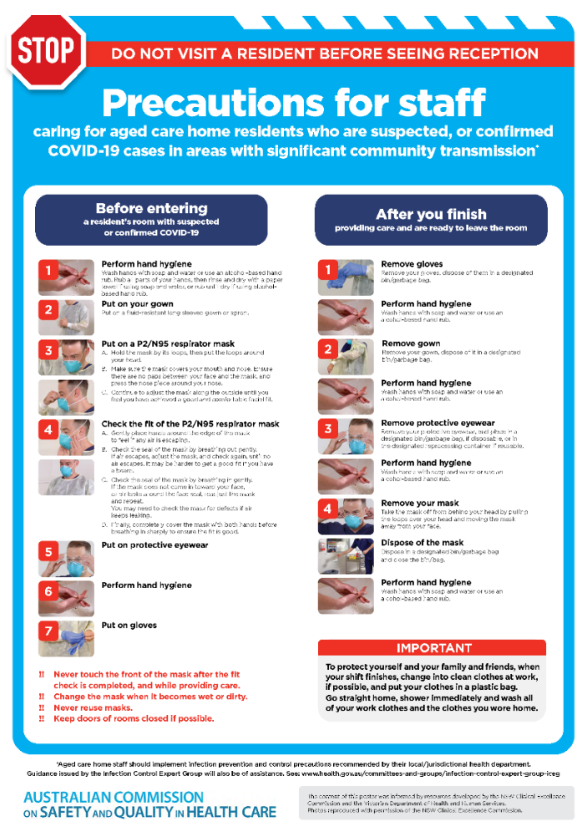](https://www.safetyandquality.gov.au/publications-and-resources/resource-library/covid-19-aged-care-staff-infection-prevention-and-control-precautions-poster)
* ***Environmental Cleaning and Infection Prevention and Control*** [www.safetyandquality.gov.au/environmental-cleaning](http://www.safetyandquality.gov.au/environmental-cleaning)
* ***Infection prevention and control Covid-19 PPE*** poster <https://www.safetyandquality.gov.au/publications-and-resources/resource-library/infection-prevention-and-control-covid-19-personal-protective-equipment>
* ***COVID-19 infection prevention and control risk management – Guidance*** <https://www.safetyandquality.gov.au/publications-and-resources/resource-library/covid-19-infection-prevention-and-control-risk-management-guidance>
* ***Safe care for people with cognitive impairment during COVID-19***<https://www.safetyandquality.gov.au/our-work/cognitive-impairment/cognitive-impairment-and-covid-19>
* ***Stop COVID-19: Break the chain of infection*** poster<https://www.safetyandquality.gov.au/publications-and-resources/resource-library/break-chain-poster-a3>  
  **[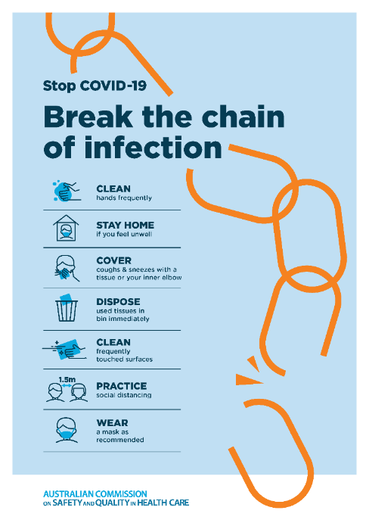](https://www.safetyandquality.gov.au/publications-and-resources/resource-library/break-chain-poster-a3https:/www.safetyandquality.gov.au/publications-and-resources/resource-library/break-chain-poster-a3)**
* ***COVID-19: Elective surgery and infection prevention and control precautions*** <https://www.safetyandquality.gov.au/publications-and-resources/resource-library/covid-19-elective-surgery-and-infection-prevention-and-control-precautions>
* ***FAQs for clinicians on elective surgery*** <https://www.safetyandquality.gov.au/node/5724>
* ***FAQs for consumers on elective surgery*** <https://www.safetyandquality.gov.au/node/5725>
* ***FAQs on community use of face masks***   
   <https://www.safetyandquality.gov.au/faqs-community-use-face-masks>
* ***COVID-19 and face masks – Information for consumers*** <https://www.safetyandquality.gov.au/publications-and-resources/resource-library/covid-19-and-face-masks-information-consumers>  
  The Commission’s fact sheet on use of face masks in the community to reduce the spread of COVID-19 is now available in Easy English and 10 other community languages from <https://www.safetyandquality.gov.au/wearing-face-masks-community>.  
  The factsheet was developed to help people understand when it is important to wear a mask to reduce the risk of the spread of COVID-19, and to explain how to safely put on and remove face masks. It also reinforces the importance of staying home if you have symptoms, physical distancing, hand hygiene and cough etiquette.

[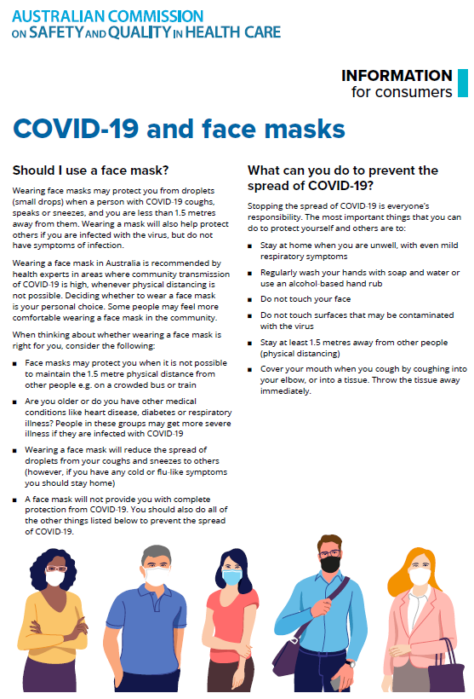](https://www.safetyandquality.gov.au/sites/default/files/2020-07/covid-19_and_face_masks_-_information_for_consumers.pdf)

*National COVID-19 Clinical Evidence Taskforce*

<https://covid19evidence.net.au/>

The National COVID-19 Clinical Evidence Taskforce is a collaboration of peak health professional bodies across Australia whose members are providing clinical care to people with COVID-19. The taskforce is undertaking continuous evidence surveillance to identify and rapidly synthesise emerging research in order to provide national, **evidence-based guidelines and clinical flowcharts for the clinical care of people with COVID-19**. The guidelines address questions that are specific to managing COVID-19 and cover the full disease course across mild, moderate, severe and critical illness. These are ‘living’ guidelines, updated with new research in near real-time in order to give reliable, up-to-the minute advice to clinicians providing frontline care in this unprecedented global health crisis.

*COVID-19 Critical Intelligence Unit*

<https://www.aci.health.nsw.gov.au/covid-19/critical-intelligence-unit>

The Agency for Clinical Innovation (ACI) in New South Wales has developed this page summarising rapid, evidence-based advice during the COVID-19 pandemic. Its operations focus on systems intelligence, clinical intelligence and evidence integration. The content includes a daily evidence digest and evidence checks on a discrete topic or question relating to the current COVID-19 pandemic. There is also a ‘Living evidence’ section summarising key studies and emerging evidence on **COVID-19 vaccines** and **SARS-CoV-2 variants**.

**Disclaimer**

On the Radar is an information resource of the Australian Commission on Safety and Quality in Health Care. The Commission is not responsible for the content of, nor does it endorse, any articles or sites listed. The Commission accepts no liability for the information or advice provided by these external links. Links are provided on the basis that users make their own decisions about the accuracy, currency and reliability of the information contained therein. Any opinions expressed are not necessarily those of the Australian Commission on Safety and Quality in Health Care.