# Australian Commission on Safety and Quality in Health Care logo with Radar imageOn the Radar

Issue 527

6 September 2021

*On the Radar* is a summary of some of the recent publications in the areas of safety and quality in health care. Inclusion in this document is not an endorsement or recommendation of any publication or provider. Access to particular documents may depend on whether they are Open Access or not, and/or your individual or institutional access to subscription sites/services. Material that may require subscription is included as it is considered relevant.

*On the Radar* is available online, via email or as a PDF or Word document from <https://www.safetyandquality.gov.au/publications-and-resources/newsletters/radar>

If you would like to receive *On the Radar* via email, you can subscribe on our website <https://www.safetyandquality.gov.au/publications-and-resources/newsletters>  
or by emailing us at H[Umail@safetyandquality.gov.auU](mailto:mail@safetyandquality.gov.au).   
You can also send feedback and comments to H[Umail@safetyandquality.gov.auU](mailto:mail@safetyandquality.gov.au).

For information about the Commission and its programs and publications, please visit <https://www.safetyandquality.gov.au>

You can also follow us on Twitter @ACSQHC.

**On the Radar**

Editor: Dr Niall Johnson [niall.johnson@safetyandquality.gov.au](mailto:niall.johnson@safetyandquality.gov.au)

Contributors: Niall Johnson, Kylie Mitchell, Jennifer Caldwell

[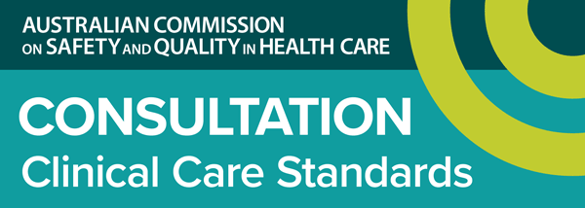](https://www.safetyandquality.gov.au/standards/clinical-care-standards/consultations-clinical-care-standards)

**Draft Opioid Analgesic Stewardship in Acute Pain Clinical Care Standard consultation** **Draft Opioid Analgesic Stewardship in Acute Pain Clinical Care Standard consultation**

<https://www.safetyandquality.gov.au/standards/clinical-care-standards/consultations-clinical-care-standards>

In collaboration with consumers, clinicians, researchers and health organisations, the Australian Commission on Safety and Quality in Health Care has developed a draft *Opioid Analgesic Stewardship in Acute Pain Clinical Care Standard*.

Clinical care standards can play an important role in guiding the delivery of appropriate care and reducing unwarranted variation, as they identify and define the care people should expect to be offered, regardless of where they are treated in Australia.

The Commission is seeking comments on the draft *Opioid Analgesic Stewardship in Acute Pain Clinical Care Standard* and associated resources until 11:59 pm Monday, **4 October 2021**.

Submissions are requested via online survey, or in writing. The survey link and further details are available at <https://www.safetyandquality.gov.au/standards/clinical-care-standards/consultations-clinical-care-standards>

**Technical report: Monitoring the national burden of Clostridioides difficile Infection in Australian public hospitals: 2016 to 2018**

Australian Commission on Safety and Quality in Health Care

Sydney: ACSQHC; 2021.

<https://www.safetyandquality.gov.au/our-work/infection-prevention-and-control/infection-prevention-and-control-technical-reports/clostridioides-difficile-infection-monitoring-australia>

The Australian Commission on Safety and Quality in Health Care (the Commission) has published the *Technical report: Monitoring the national burden of Clostridium difficile infections in Australian public hospitals, 2016 to 2018* and an accompanying [infographic](https://www.safetyandquality.gov.au/publications-and-resources/resource-library/clostridium-difficile-2021-infographic) to promote the importance of *Clostridium difficile* infections(CDI) in Australia.

The report summarises the findings from the 2016, 2017 and 2018 *Clostridioides difficile* infection (CDI) data snapshot reports, and includes discussion on the validation of patient administrative data for the monitoring of CDI and the utility of combining other surveillance datasets with CDI surveillance data. The key findings from the Technical Report include:

* The number of separations identified with a CDI diagnosis increased by 8.42% over the three year period
* A CDI diagnosis was associated with 24,247 separations during this time, with CDI symptoms present in 76.46% of these separations prior to hospital admission
* Patients who develop CDI symptoms during the course of their hospital admission account for around a third (32.52%) of all separations with a CDI diagnosis.

The Infographic was developed to highlight the key findings from the report and promote the preventative measures for CDI.

The report and infographic are available from the Commission’s website at <https://www.safetyandquality.gov.au/our-work/infection-prevention-and-control/infection-prevention-and-control-technical-reports/clostridioides-difficile-infection-monitoring-australia>

[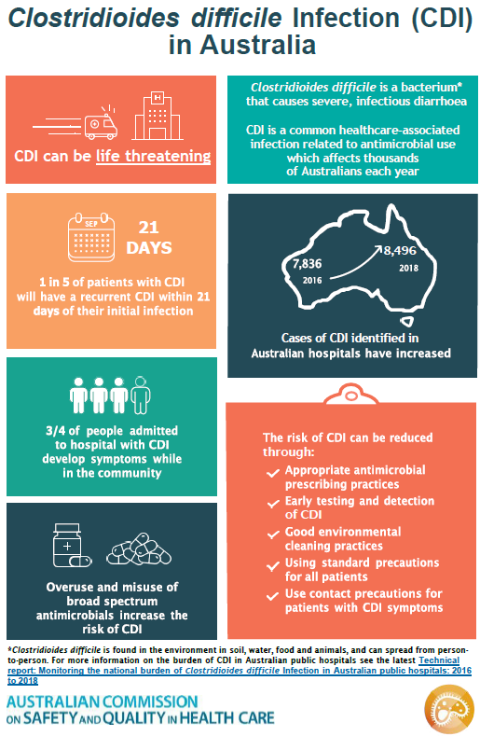](https://www.safetyandquality.gov.au/publications-and-resources/resource-library/clostridium-difficile-2021-infographic)

**Reports**

*Reducing diagnostic errors related to medical imaging*

Deeble Institute Issues Brief No. 44

Docking S, Haddock R

Canberra: Australian Healthcare and Hospitals Association; 2021. p. 60.

|  |  |
| --- | --- |
| URL | <https://ahha.asn.au/publication/health-policy-issue-briefs/deeble-issues-brief-no-44-reducing-diagnostic-errors-related> |
| Notes | This Issues Brief from the Australian Healthcare and Hospitals Association’s Deeble Institute examines various policies that have been implemented internationally to improve the use of diagnostic imaging and reduce the consequences of diagnostic errors in relation to the Australian context. The author notes that while the number of diagnostic imaging services provided and substantial expenditure there are few data on the incidence and consequences of diagnostic errors related to medical imaging.  The recommendations in the Issues Brief include   1. A national strategy to identify and prevent diagnostic errors related to medical imaging 2. Timely analysis of medical indemnity claims to measure the incidence and consequences of diagnostic errors 3. Support the development of performance indicators to assess the value diagnostic imaging 4. Improving communication throughout the diagnostic process 5. Investing in strategies to improve the appropriate requesting of diagnostic imaging. |

**Journal articles**

*Dimensions of safety culture: a systematic review of quantitative, qualitative and mixed methods for assessing safety culture in hospitals*

Churruca K, Ellis LA, Pomare C, Hogden A, Bierbaum M, Long JC, et al

BMJ Open. 2021;11(7):e043982.

|  |  |
| --- | --- |
| DOI | <https://doi.org/10.1136/bmjopen-2020-043982> |
| Notes | The culture within which care is delivered as seen as having a significant influence on the safety and quality of that care. The paper reports on a review that sought to ‘map methods to assess safety culture in hospitals, analyse the prevalence of these methods in the published research literature and examine the dimensions of safety culture captured through these processes.’ Based on 694 studies, the study used thematic analysis to identify 11 themes related to safety culture dimensions across the reported methods, with ‘Leadership’ being the most common. The study also assessed the extent to which safety culture dimensions mapped to specific quantitative and qualitative tools and methods of assessing safety culture. The authors report that no single method or tool appeared to measure all 11 themes of safety culture. |

*Improving diagnostic performance through feedback: the Diagnosis Learning Cycle*

Fernandez Branson C, Williams M, Chan TM, Graber ML, Lane KP, Grieser S, et al

BMJ Quality & Safety. 2021 [epub].

|  |  |
| --- | --- |
| DOI | <https://doi.org/10.1136/bmjqs-2020-012456> |
| Notes | Issues around diagnosis, including misdiagnosis, delayed diagnosis, etc. have attracted much attention in recent years. The paper describes the development of the Diagnosis Learning Cycle which in intended to aid clinicians in improving their diagnostic skills through peer feedback.  Depiction of the Diagnosis Learning Process and the Diagnosis Process Capture. |

*Journal for Healthcare Quality*

Vol. 43, No. 5, September/October 2021

|  |  |
| --- | --- |
| URL | <https://journals.lww.com/jhqonline/toc/2021/10000> |
| Notes | A new issue of the *Journal for Healthcare Quality* been published. Articles in this issue of the *Journal for Healthcare Quality* include:   * Editorial: The Profession of Healthcare Quality Focuses on **Improving Healthcare by Improving Workforce Competencies for Quality and Safety** (Mercado, Stephanie) * **Why Competency Standardization Matters for Improvement**: An Assessment of the Healthcare Quality Workforce (Miltner, Rebecca; Pesch, Lucie; Mercado, Stephanie; Dammrich, T; Stafford, T; Hunter, J; Stewart, G) * Rapid Expansion of the **Airway Response Team** to Meet the Needs of the COVID-19 Pandemic (Walsh, Elisa C; Kwo, Jean; Chang, Marvin G; Pino, Richard M; Bittner, Edward A) * **Role of Race in Short-Term Outcomes** for 1700 Consecutive Patients Undergoing **Brain Tumor Resection** (Haldar, Debanjan; Glauser, Gregory; Schuster, James M; Winter, Eric; Goodrich, Stephen; Shultz, Kaitlyn; Brem, Steven; McClintock, Scott D; Malhotra, Neil R) * The LACE Index: A Predictor of **Mortality and Readmission in Patients With Acute Myocardial Infarction** (Labrosciano, Clementine; Tavella, Rosanna; Air, Tracy; Zeitz, Christopher J; Worthley, Matthew; Beltrame, J F) * Value of **Interprofessional Education**: The VA Quality Scholars Program (Godwin, Kyler M; Narayanan, Anand; Arredondo, Kelley; Miltner, Rebecca (Suzie); Bowen, M E; Gilman, S; Shirks, A; Eng, J A; Naik, A D; Hysong, S J) * Increasing **Hepatitis C Screening** in a Federally Qualified Health Center: A Quality Improvement Initiative (Klein, Melissa D; Harrington, Bryna J; East, Joan; Cunningham, Jennifer; Ifill, Nicole; Santos, Jan Lee) * The Influence of **Physicians' Physical Activity Prescription** on Indicators of Health Service Quality (Asiamah, Nestor; Kouveliotis, Kyriakos; Opoku, E) * Reducing **Time to Surgery for Hip Fragility Fracture Patients**: A Resident Quality Improvement Initiative (Rubenstein, William; Barry, Jeffrey; Rogers, Stephanie; Grace, Trevor R; Tay, Bobby; Ward, Derek) |

*BMJ Quality & Safety* online first articles

|  |  |
| --- | --- |
| URL | <https://qualitysafety.bmj.com/content/early/recent> |
| Notes | *BMJ Quality &Safety* has published a number of ‘online first’ articles, including:   * Determining the skills needed by frontline NHS staff to **deliver quality improvement**: findings from six case studies (David Wright, John Gabbay, Andrée Le May) * Evaluating the safety of **mental health-related prescribing in UK primary care**: a cross-sectional study using the Clinical Practice Research Datalink (CPRD) (Wael Y Khawagi, Douglas Steinke, Matthew J Carr, Alison K Wright, Darren M Ashcroft, Anthony Avery, Richard Neil Keers) |

*International Journal for Quality in Health Care* online first articles

|  |  |
| --- | --- |
| URL | <https://academic.oup.com/intqhc/advance-articles> |
| Notes | *International Journal for Quality in Health Care* has published a number of ‘online first’ articles, including:   * North-South Inequalities in Healthcare Response to **Covid-19 in Italy** (Pasquale Gallina, Saverio Caini) |

**Online resources**

*[USA] Toolkit for Engaging Patients to Improve Diagnostic Safety*

<https://www.ahrq.gov/patient-safety/resources/diagnostic-safety/toolkit.html>

The Agency for Healthcare Research and Quality (AHRQ) in the USA has developed this toolkit to help patients, families, and health professionals work together to improve diagnostic safety. The toolkit contains two strategies, **Be The Expert On You** and **60 Seconds To Improve Diagnostic Safety**. Together, these strategies enhance communication and information sharing within the patient-provider encounter to improve diagnostic safety. Each strategy contains practical materials to support adoption of the strategy within office-based practices. A patient note sheet to help patients share their symptoms and several practice orientation and training tools to help clinicians foster deep listening and “presence” in the encounter are included.

*[UK] NICE Guidelines and Quality Standards*

<https://www.nice.org.uk/guidance>

The UK’s National Institute for Health and Care Excellence (NICE) has published new (or updated) guidelines and quality standards. The latest reviews or updates are:

* Quality Standard QS13 ***End of life care*** *for adults* <https://www.nice.org.uk/guidance/qs13>
* NICE Guideline NG191 *COVID-19 rapid guideline:* ***managing COVID-19*** <https://www.nice.org.uk/guidance/ng191>

*[UK] NIHR Evidence alerts*

<https://evidence.nihr.ac.uk/>alerts/

The UK’s National Institute for Health Research (NIHR) has posted new evidence alerts on its site. Evidence alerts are short, accessible summaries of health and care research which is funded or supported by NIHR. This is research which could influence practice and each Alert has a message for people commissioning, providing or receiving care. The latest alerts include:

* Group programmes for **weight loss** may be more effective than one-to-one sessions
* A simple blood test may give women with symptoms a personalised risk assessment for **ovarian cancer**
* Tourniquets increase the risk of serious complications in **knee replacement surgery**
* **Adopted children** may develop specific types of post-traumatic stress.

**COVID-19 resources**

https://www.safetyandquality.gov.au/covid-19

The Australian Commission on Safety and Quality in Health Care has developed a number of resources to assist healthcare organisations, facilities and clinicians. These and other material on COVID-19 are available at <https://www.safetyandquality.gov.au/covid-19>

These resource include:

* ***Poster - PPE use for aged care staff caring for residents with COVID-19*** <https://www.safetyandquality.gov.au/publications-and-resources/resource-library/poster-ppe-use-aged-care-staff-caring-residents-covid-19>

[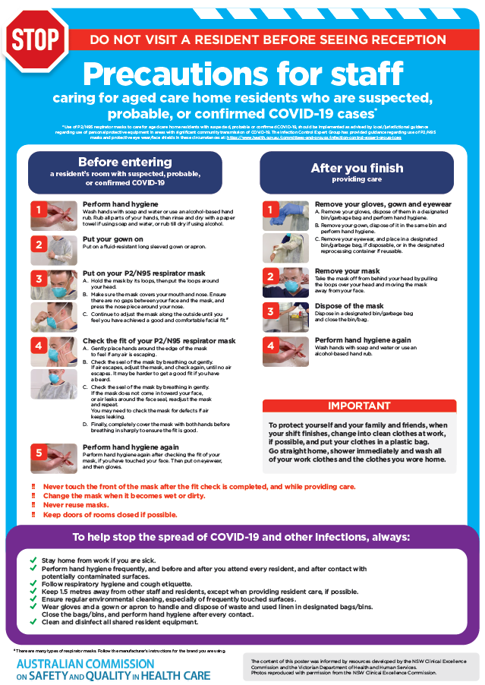](https://www.safetyandquality.gov.au/publications-and-resources/resource-library/poster-ppe-use-aged-care-staff-caring-residents-covid-19)

* ***Poster – Combined contact and droplet precautions*** <https://www.safetyandquality.gov.au/publications-and-resources/resource-library/poster-combined-contact-and-droplet-precautions>  
  [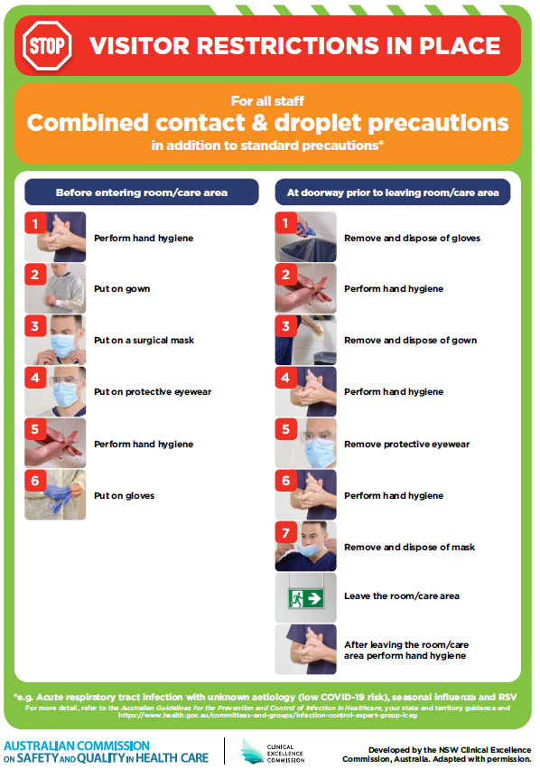](https://www.safetyandquality.gov.au/publications-and-resources/resource-library/poster-combined-contact-and-droplet-precautions)
* ***Poster – Combined airborne and contact precautions*** <https://www.safetyandquality.gov.au/publications-and-resources/resource-library/poster-combined-airborne-and-contact-precautions>   
  [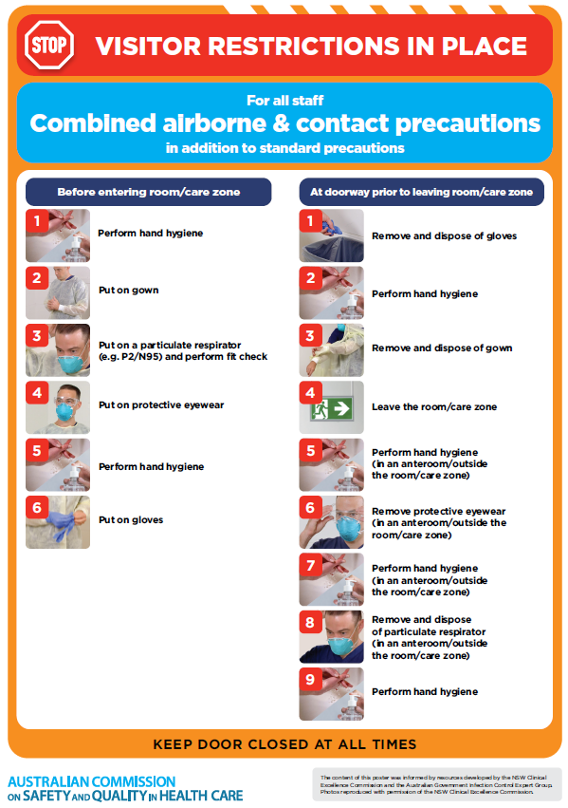](https://www.safetyandquality.gov.au/publications-and-resources/resource-library/poster-combined-airborne-and-contact-precautions)
* ***Environmental Cleaning and Infection Prevention and Control*** [www.safetyandquality.gov.au/environmental-cleaning](http://www.safetyandquality.gov.au/environmental-cleaning)
* ***Infection prevention and control Covid-19 PPE*** poster <https://www.safetyandquality.gov.au/publications-and-resources/resource-library/infection-prevention-and-control-covid-19-personal-protective-equipment>
* ***COVID-19 infection prevention and control risk management – Guidance*** <https://www.safetyandquality.gov.au/publications-and-resources/resource-library/covid-19-infection-prevention-and-control-risk-management-guidance>
* ***Safe care for people with cognitive impairment during COVID-19***<https://www.safetyandquality.gov.au/our-work/cognitive-impairment/cognitive-impairment-and-covid-19>
* ***Stop COVID-19: Break the chain of infection*** poster<https://www.safetyandquality.gov.au/publications-and-resources/resource-library/break-chain-poster-a3>  
  **[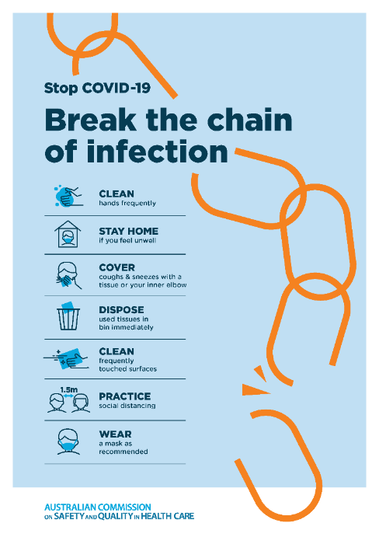](https://www.safetyandquality.gov.au/publications-and-resources/resource-library/break-chain-poster-a3https:/www.safetyandquality.gov.au/publications-and-resources/resource-library/break-chain-poster-a3)**
* ***FAQs for clinicians on elective surgery*** <https://www.safetyandquality.gov.au/node/5724>
* ***FAQs for consumers on elective surgery*** <https://www.safetyandquality.gov.au/node/5725>
* ***FAQs on community use of face masks***   
   <https://www.safetyandquality.gov.au/faqs-community-use-face-masks>
* ***COVID-19 and face masks – Information for consumers*** <https://www.safetyandquality.gov.au/publications-and-resources/resource-library/covid-19-and-face-masks-information-consumers>  
  The Commission’s fact sheet on use of face masks in the community to reduce the spread of COVID-19 is now available in Easy English and 10 other community languages from <https://www.safetyandquality.gov.au/wearing-face-masks-community>.  
  The factsheet was developed to help people understand when it is important to wear a mask to reduce the risk of the spread of COVID-19, and to explain how to safely put on and remove face masks. It also reinforces the importance of staying home if you have symptoms, physical distancing, hand hygiene and cough etiquette.

[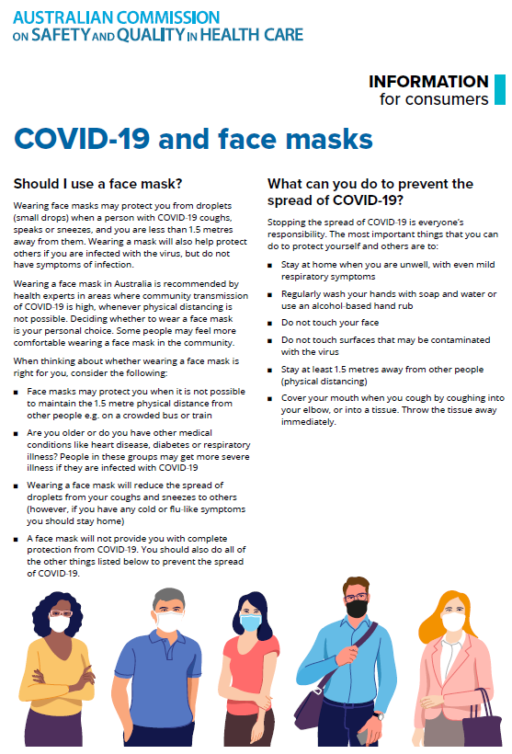](https://www.safetyandquality.gov.au/sites/default/files/2020-07/covid-19_and_face_masks_-_information_for_consumers.pdf)

*National COVID-19 Clinical Evidence Taskforce*

<https://covid19evidence.net.au/>

The National COVID-19 Clinical Evidence Taskforce is a collaboration of peak health professional bodies across Australia whose members are providing clinical care to people with COVID-19. The taskforce is undertaking continuous evidence surveillance to identify and rapidly synthesise emerging research in order to provide national, **evidence-based guidelines and clinical flowcharts for the clinical care of people with COVID-19**. The guidelines address questions that are specific to managing COVID-19 and cover the full disease course across mild, moderate, severe and critical illness. These are ‘living’ guidelines, updated with new research in near real-time in order to give reliable, up-to-the minute advice to clinicians providing frontline care in this unprecedented global health crisis.

*COVID-19 Critical Intelligence Unit*

<https://www.aci.health.nsw.gov.au/covid-19/critical-intelligence-unit>

The Agency for Clinical Innovation (ACI) in New South Wales has developed this page summarising rapid, evidence-based advice during the COVID-19 pandemic. Its operations focus on systems intelligence, clinical intelligence and evidence integration. The content includes a daily evidence digest and evidence checks on a discrete topic or question relating to the current COVID-19 pandemic. There is also a ‘Living evidence’ section summarising key studies and emerging evidence on **COVID-19 vaccines** and **SARS-CoV-2 variants**. The most recent updates include:

* ***Ocular transmission***
* ***Steroid use post COVID-19 vaccination***
* ***Ethics and duties of treating COVID-19 patients.***

**Disclaimer**

On the Radar is an information resource of the Australian Commission on Safety and Quality in Health Care. The Commission is not responsible for the content of, nor does it endorse, any articles or sites listed. The Commission accepts no liability for the information or advice provided by these external links. Links are provided on the basis that users make their own decisions about the accuracy, currency and reliability of the information contained therein. Any opinions expressed are not necessarily those of the Australian Commission on Safety and Quality in Health Care.