# Australian Commission on Safety and Quality in Health Care logo with Radar imageOn the Radar

Issue 531

Tuesday 5 October 2021

*On the Radar* is a summary of some of the recent publications in the areas of safety and quality in health care. Inclusion in this document is not an endorsement or recommendation of any publication or provider. Access to particular documents may depend on whether they are Open Access or not, and/or your individual or institutional access to subscription sites/services. Material that may require subscription is included as it is considered relevant.

*On the Radar* is available online, via email or as a PDF or Word document from <https://www.safetyandquality.gov.au/publications-and-resources/newsletters/radar>

If you would like to receive *On the Radar* via email, you can subscribe on our website <https://www.safetyandquality.gov.au/publications-and-resources/newsletters>  
or by emailing us at H[Umail@safetyandquality.gov.auU](mailto:mail@safetyandquality.gov.au).   
You can also send feedback and comments to H[Umail@safetyandquality.gov.auU](mailto:mail@safetyandquality.gov.au).

For information about the Commission and its programs and publications, please visit <https://www.safetyandquality.gov.au>

You can also follow us on Twitter @ACSQHC.

**On the Radar**

Editor: Dr Niall Johnson [niall.johnson@safetyandquality.gov.au](mailto:niall.johnson@safetyandquality.gov.au)

Contributors: Niall Johnson, Sandra Rigby, Kim Stewart

**Reports**

*Good for you, good for us, good for everybody: A plan to reduce overprescribing to make patient care better and safer, support the NHS, and reduce carbon emissions*

Department of Health and Social Care

London: Department of Health and Social Care; 2021. p. 85.

|  |  |
| --- | --- |
| DOI | <https://www.gov.uk/government/publications/national-overprescribing-review-report> |
| Notes | The UK Department of Health and Social Care has published this report into overprescribing. This review was established to develop recommendations to reduce overprescribing, which is where people are given medicines they don’t need or want, or which may do them harm. The review has found that overprescribing is a serious problem in health systems internationally that has grown dramatically over the last 25 years.  The report estimates **10% of items dispensed in primary care are overprescribed** with 15% of people taking 5 or more medicines a day, increasing the risk of adverse effects. The report observes that almost **20% of hospital admissions in over-65s are caused by the adverse effects of medicines**.  Two main categories of cause are given for this rate of overprescribing:   * systemic: key factors are single-condition clinical guidelines, a lack of alternatives to prescribing a medicine, a need for on-going review and deprescribing to be built into the process of prescribing, inability to access comprehensive patient records, the lack of digital interoperability, and pressure of time * cultural: a healthcare culture that favours medicines over alternatives and in which some patients struggle to be heard   The report identifies things that can reduce overprescribing: **shared decision-making** with patients; better **guidance and support for clinicians**; more alternatives to medicines, such as physical and social activities and talking therapies; and more Structured Medication Reviews (SMR) for those with long-term health conditions.  The key recommendations from the review include:   * the introduction of a new National Clinical Director for Prescribing to lead a 3-year programme to help enable effective prescribing * system-wide changes to improve patient records, improve handovers between primary and secondary care, develop a national toolkit and deliver training to help general practices improve the consistency of repeat prescribing processes * improving the evidence base for safely withdrawing inappropriate medication (deprescribing), and updated clinical guidance to support more patient-centred care. * cultural changes to reduce a reliance on medicines and support shared decision-making between clinicians and patients, including increasing the use of ‘social prescribing’. * providing clear information for patients about their medication and the creation of a platform for patients to be able to provide information about the effectiveness and the adverse effects of their medicines; and * the development of interventions to reduce waste and help deliver NHS’s net zero carbon emissions. |

For information on the Commission’s work on medication safety, see <https://www.safetyandquality.gov.au/our-work/medication-safety>

**Journal articles**

*Perspectives of Australian hospital leaders on the provision of safe care: implications for safety I and safety II*

Leggat SG, Balding C, Bish M

Journal of Health Organization and Management. 2021;35(5):550-560.

|  |  |
| --- | --- |
| DOI | <http://doi.org/10.1108/JHOM-10-2020-0398> |
| Notes | Paper reporting on a three-year longitudinal study of eight Australian hospitals that explored the perspectives of hospital leaders on the challenges of leading safe care. Based on focus groups of a representative sample of hospital leaders, comprising board members, senior and middle managers and clinical leaders that met twice a year from 2015 to 2017, the study found that these leaders primarily relied on staff to ensure patient safety, rather than relying on systems and processes to prevent errors. |

*The development of National Safety and Quality Digital Mental Health Standards*

Brown P, Prest B, Miles P, Rossi V

Australasian Psychiatry. 2021:10398562211042361.

|  |  |
| --- | --- |
| DOI | <https://doi.org/10.1177/10398562211042361> |
| Notes | The National Safety and Quality Digital Mental Health Standards (the Standards), developed by the Australian Commission on Safety and Quality in Health Care, aim to improve the quality of digital mental health service provision and protect service users from harm. The Standards were developed following an extensive public consultation process and pilot study; the latter featuring accrediting agencies who assessed service providers on how they met the Standards. The authors outline how the Standards provide a nationally consistent statement about the standard of care expected from a digital mental health service, and a quality assurance mechanism to improve digital mental health care in Australia. For further information on the National Safety and Quality Digital Mental Health Standards see <https://www.safetyandquality.gov.au/DMHS> |

*Interventions to improve communication at hospital discharge and rates of readmission: A systematic review and meta-analysis*

Becker C, Zumbrunn S, Beck K, Vincent A, Loretz N, Müller J, et al.

JAMA Network Open. 2021;4(8):e2119346

|  |  |
| --- | --- |
| DOI | <http://doi.org/10.1001/jamanetworkopen.2021.19346> |
| Notes | There have been various attempts to improve and/or standardise discharge communications, including discharge summaries. This review sought to examine whether patient communication at hospital discharge was associated with rates of hospital readmission. The review and meta-analysis examined 19 clinical trials that covered 3,953 patients and had some form of ‘communication intervention at hospital discharge’. The authors report finding that ‘**communication interventions** at discharge were significantly associated with **lower readmission rates, higher medication adherence, and higher patient satisfaction**.’ |

*Evolving factors in hospital safety: a systematic review and meta-analysis of hospital adverse events*

Sauro KM, Machan M, Whalen-Browne L, Owen V, Wu G, Stelfox HT

Journal of Patient Safety. 2021.

|  |  |
| --- | --- |
| DOI | <http://doi.org/10.1097/pts.0000000000000889> |
| Notes | Paper reporting on a review that sought to estimate the frequency of hospital adverse events (AEs) and explore the rate of AEs over time, and across and within hospital populations. The study included 94 studies representing 590 million admissions from 25 countries from 1961 to 2014. The authors report finding:   * The incidence of **hospital AEs was 8.6 per 100 patient admissions** (95% confidence interval [CI], 8.3 to 8.9; I2 = 100%, P < 0.001). * **Half of the AEs were preventable** (52.6%), and a third resulted in **moderate/significant harm (39.7%)**. * The most evaluated AEs were surgical AEs, drug-related AEs, and nosocomial infections. * The occurrence of AEs increased by year (95% CI, −0.05 to −0.04; P < 0.001) and patient age (95% CI = −0.15 to −0.14; P < 0.001), and varied by country income level and study characteristics. * Patient sex, hospital type, hospital service, and geographical location were not associated with AEs. |

*Barriers and facilitators to shared decisionmaking in hospitals from policy to practice: A systematic review*

Waddell A, Lennox A, Spassova G, Bragge P

Implementation Science. 2021;16(1):74.

|  |  |
| --- | --- |
| DOI | <https://doi.org/10.1186/s13012-021-01142-y> |
| Notes | Shared decision making (SDM) involves discussion and collaboration between a consumer and their healthcare provider. It is about bringing together the consumer's values, goals and preferences with the best available evidence about benefits, risks and uncertainties of treatment, in order to reach the most appropriate healthcare decisions for that person. This Australian review sought to review the literature exploring barriers and facilitators to implementing SDM in hospital settings from multiple stakeholder perspectives. Focusing on 14 studies, 12 of which were conducted in the last 4 years, the authors report finding that the reported barriers ‘specific to the hospital setting included noisy and busy ward environments and a lack of private spaces in which to conduct SDM conversations.’ |

For information on the Commission’s work on shared decision making, see <https://www.safetyandquality.gov.au/our-work/partnering-consumers/shared-decision-making>

*Emergency departments are higher-risk locations for wrong blood in tube errors*

Dunbar NM, Delaney M, Murphy MF, Pagano MB, Saifee NH, Seheult J, et al

Transfusion. 2021;61(9):2601-2610.

*Incidence of prescription errors in patients discharged from the emergency department*

Gregory H, Cantley M, Calhoun C, Hall GA, Matuskowitz AJ, Weant KA

The American Journal of Emergency Medicine. 2021;46:266-270.

|  |  |
| --- | --- |
| DOI | Dunbar et al <http://doi.org/10.1111/trf.16588>  Gregory et al <https://doi.org/10.1016/j.ajem.2020.07.061> |
| Notes | Emergency departments (EDs) can be by their very nature intense and complex places. The variety and intensity of activity can contribute to safety and quality issues. These two pieces both identify how the ED setting can see a higher incidence of lapses, in these instances in blood handling and medications.  Dunbar et al observe that what are termed WBIT (wrong blood in tube) errors can lead to mistransfusions. Using data on pretransfusion samples collected retrospectively by 39 transfusion services in nine countries in 2019, this study compared the proportion of WBIT errors made in emergency departments (EDs), inpatient wards, and outpatient clinics. From 1,394,862 samples, 143 WBIT errors were detected for an unadjusted aggregate WBIT proportion of 1.03/10,000 samples. However, the authors report that ‘the WBIT proportion in EDs was 1.7 times higher than inpatient wards and 5.1 times higher than outpatient clinics.’ They observed that ‘use of electronic positive patient identification (ePPID) systems was associated with a significantly lower WBIT proportion in the ED’.  Gregory et al sought to quantify and characterize the medication errors that occur in patients discharged from the ED. Recognising that EDs have characteristics, such as s unfamiliar patients, lack of continuity of care, increasing patient volumes, reliance on verbal orders, and fewer safety mechanisms, that may lend them to higher rates of errors. The study reviewed 115,933 prescriptions for patients discharged from the adult ED at US academic hospital from 2015 to 2018 and found a total of 20,498 errors were identified within 19,126 prescriptions |

For information on the Commission’s work on medication safety, see <https://www.safetyandquality.gov.au/our-work/medication-safety>

*Nursing Leadership*

Volume 34, Number 3, September 2021

|  |  |
| --- | --- |
| URL | <https://www.longwoods.com/publications/nursing-leadership/26526/1/vol.-34-no.-3-2021> |
| Notes | A new issue of *Nursing Leadership* has been published. Articles in this issue of *Nursing Leadership* include:   * Editorial: **We Need Not Wait to See What Others Do** (Lynn M. Nagle) * The **Canadian Academy of Nursing**: Why It Matters (Michael J Villeneuve) * Organizational Support for **Social Justice in Public Health Nursing Practice**: A Conceptual Framework (Angela L Matwick, Donna E Martin and Lynn S Scruby) * **Trauma-Informed Nursing Leadership**: Definitions, Considerations and Practices in the Context of the 21st Century (Angela Wignall) * Commentary: Exploring the Intersections between **Bullying and Racism in Nursing** (Kathy O’Flynn-Magee, Ranjit K Dhari, Patricia (Paddy) Rodney and Lynne Esson) * Coastal Mental Health and Substance Use Services’ **COVID-19 Response**: A Quality Improvement Initiative (Courtney Devane, Luc Saulnier and Linda Latham) * Multiorganizational Partnerships: A Mechanism for Increasing the **Employment of Internationally Educated Nurses** (Ruth Lee, Daniela Beckford, Livia Jakabne, Lesley Hirst, Charissa Cordon, Sarah Quan, Janice Collins , Andrea Baumann and Jennifer Blythe) * **Practice Patterns of Nurse Practitioners** in a Multi-Site Academic Healthcare Setting (Barbara Bailey, Faith Donald, Marijana Zubrinic, Kelly McNabb and Helen Kelly) |

*BMJ Leader*

Vol. 5 No. 3 September 2021

|  |  |
| --- | --- |
| URL | <https://bmjleader.bmj.com/content/5/3> |
| Notes | A new issue of *BMJ Leader* has been published. Articles in this issue of *BMJ Leader* include:   * Leading the **spread and adoption of innovation at scale**: an Academic Health Science Network’s perspective (Andrew Walker, Catherine Dale, Natasha Curran, Annette Boaz, Michael V Hurley) * View from the faculty: the importance of membership and fellowship of the **Faculty of Medical Leadership and Management** (Paul Evans) * **Do expert clinicians make the best managers?** Evidence from hospitals in Denmark, Australia and Switzerland (Agnes Bäker, Amanda H Goodall) * Realist analysis of **streaming interventions in emergency departments** (Mohammed Rashidul Anwar, Brian H Rowe, Colleen Metge, Noah D Star, Zaid Aboud, Sara Adi Kreindler) * **Optimising undergraduate medico-legal and professionalism teaching** through a student-selected component (Tej Pandya, Ferhan Muneeb, Jonathan Gibb, Neil H Metcalfe) * New ways of working: **COVID-19 as a catalyst for change in acute mental health services** (Kezanne Tong, Genevieve Crudden, Wen Xi Tang, David McGuinness, Margaret O'Grady, Anne M Doherty) * Principles of **effective altruism and ethical implications for physicians** (Ellery Altshuler) * **Leadership reflections a year on from the rapid roll-out of virtual clinics** due to COVID-19: a commentary (Anthony W Gilbert, Lucy Davies, John Doyle, Saroj Patel, Luke Martin, Deepak Jagpal, Joe C T Billany, John Bateson) * On the power of spontaneous collisions: **preserving culture and effectiveness in the pandemic** (James K Stoller) * In-programme **leadership development for psychiatric higher trainees**: The Royal College of Psychiatrists’ Leadership and Management Fellow Scheme (Deepa Bagepalli-Krishnan, Russell Gibson, Satnam Goyal, Ba Min (Adam) Ko, Alex Till, Helen Crimlisk) * **Compassionate leadership during COVID-19**: an ABC approach to the introduction of new medical graduates as Foundation interim Year 1s (FiY1s) (Claire Dougan, Sally-Anne Philips, Denise Hughes, Keith Gardiner) * **Leadership: an effective human factor during COVID-19** (Adeel Abbas Dhahri, Jonathan Refson) * **Evidence-based medical leadership development**: a systematic review (Oscar Lyons, Robynne George, Joao R Galante, Alexander Mafi, Thomas Fordwoh, Jan Frich, Jaason Matthew Geerts) * **Insights from behavioural economics for effective leadership** during the pandemic (Janet Schwartz, Aline Holzwarth) * 10 minutes with **Dr. Brian Anderson, Chief Digital Health Physician at the MITRE Corporation**, Massachusetts, USA (Tuna Hayirli, Brian Anderson) * Ten minutes with **Professor Erwin Loh, Chief Medical Officer and Group General Manager of Clinical Governance, St Vincent’s Health** Australia, Melbourne, Australia (Erwin Loh, Natasha Roya Matthews, Shona Mackinnon) |

*BMJ Quality & Safety* online first articles

|  |  |
| --- | --- |
| URL | <https://qualitysafety.bmj.com/content/early/recent> |
| Notes | *BMJ Quality &Safety* has published a number of ‘online first’ articles, including:   * Examining **organisational responses to performance-based financial incentive systems**: a case study using NHS staff influenza vaccination rates from 2012/2013 to 2019/2020 (Adiba Liaqat, Suzy Gallier, Katharine Reeves, Hannah Crothers, Felicity Evison, Kelly Schmidtke, Paul Bird, Samuel I Watson, Kamlesh Khunti, Richard Lilford) |

**Online resources**

*Clinical Communiqué*

<https://www.thecommuniques.com/post/clinical-communiqu%C3%A9-volume-8-issue-3-september-2021>

Volume 8 Issue 3, September 2020

This issue of *Clinical Communiqué* examines the issue of **paediatric appendicitis** – the most common cause of acute abdomen in children. This issue includes a couple of case studies where delays in diagnosis and treatment tragically resulted in death. The expert commentary offers a pragmatic and insightful approach to the assessment of children with abdominal pain, with key points that help to raise awareness of the most reliable red flags in diagnosing appendicitis.

*Pharmacists’ and Nurses’ Role in Antimicrobial Stewardship, Antimicrobial Resistance, and Sepsis Care*

<https://www.ismp.org/resources/pharmacists-and-nurses-role-antimicrobial-stewardship-antimicrobial-resistance-and-sepsis>

This short item from the Institute for Safe Medication Practices (ISMP) outlines roles for nurses and pharmacists in antimicrobial stewardship and sepsis care.

*GIN Public Toolkit: Patient and Public Involvement in Guidelines*

<https://g-i-n.net/toolkit/>

The Guidelines International Network (GIN) have launched their updated *GIN Public Toolkit: Patient and Public Involvement in Guidelines*. The Toolkit assembles international experiences and best practice examples of successful patient involvement and aims at supporting guideline developers who consider involving patients and public in guideline development or dissemination.

*[UK] NIHR Evidence alerts*

<https://evidence.nihr.ac.uk/>alerts/

The UK’s National Institute for Health Research (NIHR) has posted new evidence alerts on its site. Evidence alerts are short, accessible summaries of health and care research which is funded or supported by NIHR. This is research which could influence practice and each Alert has a message for people commissioning, providing or receiving care. The latest alerts include:

* **Carers of people with dementia** benefit from online help for anxiety and depression
* Biofeedback offers no additional benefit to **pelvic floor muscle training**
* People with **cognitive impairment** are missing out on sight and dental checks
* People with **dementia** need more involvement in decisions about their long-term care
* Home-based rehabilitation after a **knee replacement** is as effective as physiotherapy
* Extra emphasis on **care after cancer surgery** could increase survival worldwide
* **Schoolchildren who switch to walking or cycling** may have a healthier body weight
* **Stroke care** could be improved when patients, staff and researchers work together
* Working in partnership with a British South Asian community could improve control of **children’s asthma**
* Providers of the **Diabetes Prevention Programme** need to be more consistent, and offer flexibility and equality of access
* New screening pathways could improve NHS England’s **bowel cancer** programme
* Even low doses of steroids increase the risk of cardiovascular disease in people with **inflammatory diseases**
* A standing frame allows people with **severe multiple sclerosis** to enjoy a sense of normality
* Artificial intelligence tool rules out **COVID-19** within an hour in emergency departments
* **Self-testing for** **HIV** could increase diagnoses in the trans community
* What support do young people affected by **adverse childhood experiences** need?

**COVID-19 resources**

**COVID-19 – supporting the health system**

The Commission has updated guidance as part of its ongoing work to support health service organisations in assessing risks related to COVID-19 and developing a comprehensive ***Risk Management Plan*** available at <https://www.safetyandquality.gov.au/publications-and-resources/resource-library/covid-19-infection-prevention-and-control-risk-management-guidance>

The revised guidance reflects the most recent national advice regarding use of the hierarchy of controls and infection prevention and control systems to identify hazards and develop risk mitigation strategies. The updated guidance is on the Commission’s COVID-19 web page along with all of our other resources and links to state, territory and Australian Government web sites.

**COVID-19 resources**

https://www.safetyandquality.gov.au/covid-19

The Australian Commission on Safety and Quality in Health Care has developed a number of resources to assist healthcare organisations, facilities and clinicians. These and other material on COVID-19 are available at <https://www.safetyandquality.gov.au/covid-19>

These resource include:

* ***Poster - PPE use for aged care staff caring for residents with COVID-19*** <https://www.safetyandquality.gov.au/publications-and-resources/resource-library/poster-ppe-use-aged-care-staff-caring-residents-covid-19>

[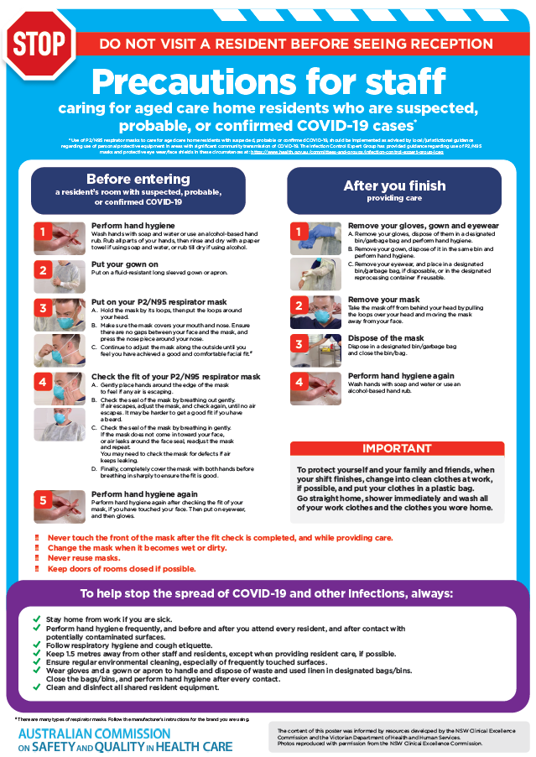](https://www.safetyandquality.gov.au/publications-and-resources/resource-library/poster-ppe-use-aged-care-staff-caring-residents-covid-19)

* ***Poster – Combined contact and droplet precautions*** <https://www.safetyandquality.gov.au/publications-and-resources/resource-library/poster-combined-contact-and-droplet-precautions>  
  [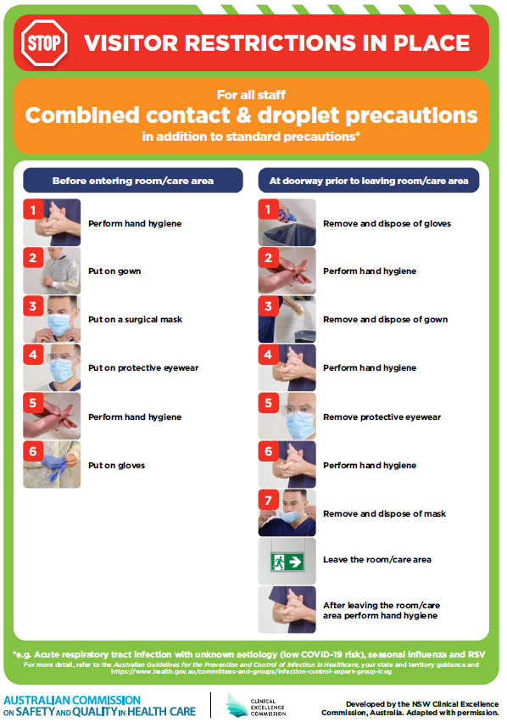](https://www.safetyandquality.gov.au/publications-and-resources/resource-library/poster-combined-contact-and-droplet-precautions)
* ***Poster – Combined airborne and contact precautions*** <https://www.safetyandquality.gov.au/publications-and-resources/resource-library/poster-combined-airborne-and-contact-precautions>   
  [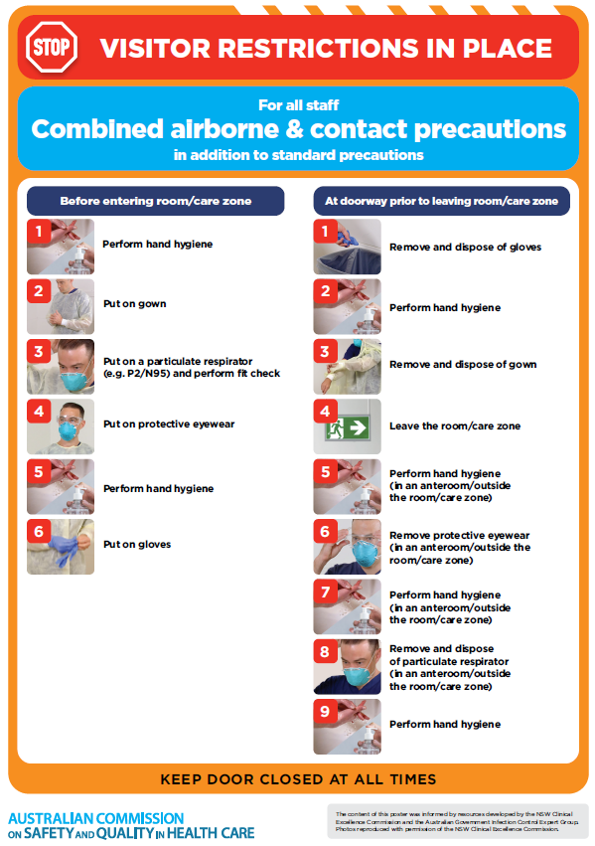](https://www.safetyandquality.gov.au/publications-and-resources/resource-library/poster-combined-airborne-and-contact-precautions)
* ***Environmental Cleaning and Infection Prevention and Control*** [www.safetyandquality.gov.au/environmental-cleaning](http://www.safetyandquality.gov.au/environmental-cleaning)
* ***Infection prevention and control Covid-19 PPE*** poster <https://www.safetyandquality.gov.au/publications-and-resources/resource-library/infection-prevention-and-control-covid-19-personal-protective-equipment>
* ***COVID-19 infection prevention and control risk management – Guidance*** <https://www.safetyandquality.gov.au/publications-and-resources/resource-library/covid-19-infection-prevention-and-control-risk-management-guidance>
* ***Safe care for people with cognitive impairment during COVID-19***<https://www.safetyandquality.gov.au/our-work/cognitive-impairment/cognitive-impairment-and-covid-19>
* ***Stop COVID-19: Break the chain of infection*** poster<https://www.safetyandquality.gov.au/publications-and-resources/resource-library/break-chain-poster-a3>  
  **[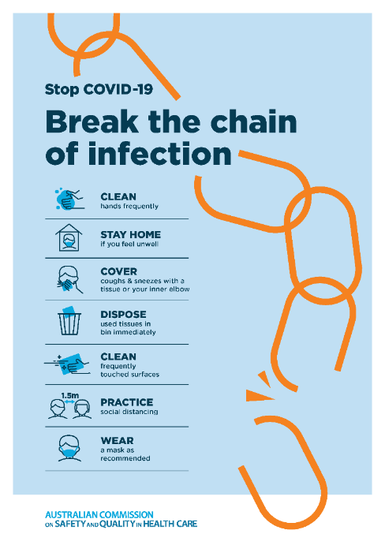](https://www.safetyandquality.gov.au/publications-and-resources/resource-library/break-chain-poster-a3https:/www.safetyandquality.gov.au/publications-and-resources/resource-library/break-chain-poster-a3)**
* ***FAQs for clinicians on elective surgery*** <https://www.safetyandquality.gov.au/node/5724>
* ***FAQs for consumers on elective surgery*** <https://www.safetyandquality.gov.au/node/5725>
* ***FAQs on community use of face masks***   
   <https://www.safetyandquality.gov.au/faqs-community-use-face-masks>
* ***COVID-19 and face masks – Information for consumers*** <https://www.safetyandquality.gov.au/publications-and-resources/resource-library/covid-19-and-face-masks-information-consumers>  
  The Commission’s fact sheet on use of face masks in the community to reduce the spread of COVID-19 is now available in Easy English and 10 other community languages from <https://www.safetyandquality.gov.au/wearing-face-masks-community>.  
  The factsheet was developed to help people understand when it is important to wear a mask to reduce the risk of the spread of COVID-19, and to explain how to safely put on and remove face masks. It also reinforces the importance of staying home if you have symptoms, physical distancing, hand hygiene and cough etiquette.

[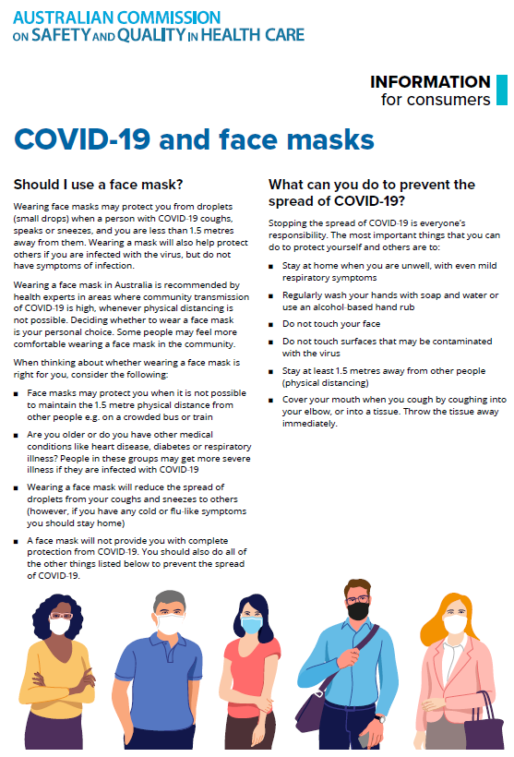](https://www.safetyandquality.gov.au/sites/default/files/2020-07/covid-19_and_face_masks_-_information_for_consumers.pdf)

*National COVID-19 Clinical Evidence Taskforce*

<https://covid19evidence.net.au/>

The National COVID-19 Clinical Evidence Taskforce is a collaboration of peak health professional bodies across Australia whose members are providing clinical care to people with COVID-19. The taskforce is undertaking continuous evidence surveillance to identify and rapidly synthesise emerging research in order to provide national, **evidence-based guidelines and clinical flowcharts for the clinical care of people with COVID-19**. The guidelines address questions that are specific to managing COVID-19 and cover the full disease course across mild, moderate, severe and critical illness. These are ‘living’ guidelines, updated with new research in near real-time in order to give reliable, up-to-the minute advice to clinicians providing frontline care in this unprecedented global health crisis.

*COVID-19 Critical Intelligence Unit*

<https://www.aci.health.nsw.gov.au/covid-19/critical-intelligence-unit>

The Agency for Clinical Innovation (ACI) in New South Wales has developed this page summarising rapid, evidence-based advice during the COVID-19 pandemic. Its operations focus on systems intelligence, clinical intelligence and evidence integration. The content includes a daily evidence digest and evidence checks on a discrete topic or question relating to the current COVID-19 pandemic. There is also a ‘Living evidence’ section summarising key studies and emerging evidence on **COVID-19 vaccines** and **SARS-CoV-2 variants**. The most recent updates include:

* ***Initiation of remdesivir treatment for COVID-19***– What is the evidence on timing of initiation of remdesivir treatment for COVID-19?
* ***Public health measures and COVID 19 vaccine rollout*** – Evidence in brief on public health measures and COVID-19 vaccine rollout
* ***Post acute and subacute COVID-19 care*** – What published advice and models of care are available regarding post-acute and subacute care for COVID-19 patients?
* ***Therapeutic sessions and personal protective equipment –*** How does the wearing of personal protective equipment (PPE) impact on therapeutic sessions with adults and children who have experienced domestic or family violence, sexual assault, abuse or neglect?
* ***COVID-19 vaccines in Australia - AstraZeneca and Pfizer*** – Evidence in brief on COVID-19 vaccines in Australia
* ***Oxygen saturation monitors/pulse oximeters for COVID-19*** – Evidence on oxygen saturation monitors/pulse oximeters for COVID-19
* ***Treatment for COVID-19 in pregnant people*** – Evidence check on treatment for COVID-19 in pregnant people
* ***Period of isolation relevant to vaccination status*** – Evidence check on period of isolation relevant to vaccination status
* ***Children and COVID-19 outcomes*** – Evidence in brief on children and COVID-19 outcomes
* ***Workforce reconfiguration evidence check*** – What is the evidence regarding temporary workforce reconfigurations such as splitting of teams and establishing social distancing protocols within teams to minimise staff exposure to COVID-19?

**Disclaimer**

On the Radar is an information resource of the Australian Commission on Safety and Quality in Health Care. The Commission is not responsible for the content of, nor does it endorse, any articles or sites listed. The Commission accepts no liability for the information or advice provided by these external links. Links are provided on the basis that users make their own decisions about the accuracy, currency and reliability of the information contained therein. Any opinions expressed are not necessarily those of the Australian Commission on Safety and Quality in Health Care.