# Australian Commission on Safety and Quality in Health Care logo with Radar imageOn the Radar

Issue 532

11 October 2021

*On the Radar* is a summary of some of the recent publications in the areas of safety and quality in health care. Inclusion in this document is not an endorsement or recommendation of any publication or provider. Access to particular documents may depend on whether they are Open Access or not, and/or your individual or institutional access to subscription sites/services. Material that may require subscription is included as it is considered relevant.

*On the Radar* is available online, via email or as a PDF or Word document from <https://www.safetyandquality.gov.au/publications-and-resources/newsletters/radar>

If you would like to receive *On the Radar* via email, you can subscribe on our website <https://www.safetyandquality.gov.au/publications-and-resources/newsletters>  
or by emailing us at H[Umail@safetyandquality.gov.auU](mailto:mail@safetyandquality.gov.au).   
You can also send feedback and comments to H[Umail@safetyandquality.gov.auU](mailto:mail@safetyandquality.gov.au).

For information about the Commission and its programs and publications, please visit <https://www.safetyandquality.gov.au>

You can also follow us on Twitter @ACSQHC.

**On the Radar**

Editor: Dr Niall Johnson [niall.johnson@safetyandquality.gov.au](mailto:niall.johnson@safetyandquality.gov.au)

Contributors: Niall Johnson

**Reports**

*When Costs Are a Barrier to Getting Health Care: Reports from Older Adults in the United States and Other High-Income Countries*

*Findings from the 2021 International Health Policy Survey of Older Adults*

Jacobson G, Cicchielli A, Shah A, Doty MM, Williams RD.

New York: Commonwealth Fund; 2021.

|  |  |
| --- | --- |
| URL | <https://www.commonwealthfund.org/publications/surveys/2021/oct/when-costs-are-barrier-getting-health-care-older-adults-survey>  <https://doi.org/10.26099/m7jm-2n91> |
| Notes | That healthcare costs are higher in the USA is well known. But the findings of this survey of 11 nations shows that Australia also has issues with costs being a barrier to healthcare. The Commonwealth Fund in the USA regularly surveys across a group of comparable nations and Australia typically compares well. However, in this year’s survey that looked at the out-of-pocket spending and care-seeking experiences of older adults, Australia was found to have a higher proportion of older adults reporting high out-of-pocket costs and skipping of dental care then in most of the other nations.  [Figure showing that a larger share of older adults in Switzerland, the United States, and Australia had high out-of-pocket health care costs compared to other high-income countries.](https://doi.org/10.26099/m7jm-2n91)  [Figure showing that about one of six older adults in the United States, Australia, Canada and New Zealand reported skipping a dental visit because of the cost.](https://doi.org/10.26099/m7jm-2n91) |

**Journal articles**

*Do expert clinicians make the best managers? Evidence from hospitals in Denmark, Australia and Switzerland*

Bäker A, Goodall AH

BMJ Leader. 2021;5(3):161-166.

|  |  |
| --- | --- |
| DOI | <http://dx.doi.org/10.1136/leader-2021-000483> |
| Notes | Starting with the premise, ‘Hospital quality rests on the morale and productivity of those who work in them’ this study sought to understand the kinds of team leaders that create high morale within hospitals. Using information from 3000 physicians in hospitals from Denmark, Australia and Switzerland the study suggests that ‘When led by managers with high clinical expertise, hospital physicians are (1) more satisfied with their jobs, (2) more satisfied with their supervisors’ effectiveness and (3) less likely to wish to quit their current job.’ The authors note that ‘It is not sufficient, it appears from this evidence, for leaders merely to be clinicians’ but are happiest when the managers are ‘drawn from the ranks of those who are themselves outstanding clinicians’. |

*Mental health services: quality, safety and suicide*

Kapur N, Gorman LS, Quinlivan L, Webb RT

BMJ Quality & Safety. 2021 [epub].

|  |  |
| --- | --- |
| DOI | <https://doi.org/10.1136/bmjqs-2021-013532> |
| Notes | In an editorial reflecting on a couple of items on mental health provision and suicide risk, the authors also reflect on how mental health services can be provided safely. This includes a recognition that ‘A safety focus needs to apply across the care pathway’. The key preventive approaches were summarised in the following diagram. The implementation of what is known is often the most challenging step. The authors suggest that ‘Focussing on areas of positive practice and fostering an optimal learning culture within services may also help to ensure that we provide the safest possible care to every patient who seeks help for their mental health problems.’  [Figure identifying 10 ways to improve safety in the provision of mental health.](https://doi.org/10.1136/bmjqs-2021-013532) |

For information on the Commission’s work on mental health, see <https://www.safetyandquality.gov.au/our-work/mental-health>

*Australian Health Review*

Volume 45, Number 5, October 2021

|  |  |
| --- | --- |
| URL | <https://www.publish.csiro.au/ah/issue/10153> |
| Notes | A new issue of *Australian Health Review* has been published. Articles in this issue of *Australian Health Review* include:   * Experiences of **patients with chronic diseases of access to multidisciplinary care during COVID-19** in South Australia (Sara Javanparast, Leigh Roeger and Richard L Reed) * Impact of the **COVID-19 pandemic on South Australia’s emergency departments**: evidence from two lockdowns (Laura M Boyle, Mark Mackay, Nigel Bean and Matthew Roughan) * Understanding **end-of-life care in Australian hospitals** (Imogen Mitchell, Jeanette Lacey, Matthew Anstey, Cathy Corbett, Carol Douglas, Christine Drummond, Michel Hensley, Amber Mills, Caroline Scott, Jo-Anne Slee, Jennifer Weil, Brett Scholz, Brandon Burke and Catherine D'Este) * Making the move to a **learning healthcare system**: has the pandemic brought us one step closer? (Tanya Symons, John Zalcberg and Jonathan Morris) * **Safety for women when accessing mental health services**: a scoping review of the link between safety and recovery (Karen Dixon, Ellie Fossey and Melissa Petrakis) * **Implementation of the Australian Hospital Patient Experience Question Set (AHPEQS)**: a consumer-driven patient survey (Cathy H Jones, Jeffrey Woods, Natasha K Brusco, Natalie Sullivan and Meg E Morris) * **Birthing in regional Australia**: women’s decision making surrounding birthplace (Alexa N Seal, Emma Hoban, Annette Panzera and Joe McGirr) * Innovative preclinic triage system to guide Australians to the **right mental health care first time** (Tracey A Davenport, Haley M LaMonica, Shelley Rowe, Julie Sturgess, Elizabeth M Scott, Grace Lee, Vanessa Wan Sze Cheng and Ian B Hickie) * Cross-sectional analysis of **dental treatment under general anaesthesia in hospitalised Western Australian children** in 2018–19 (Yosef Faraj Amer Alshehri, Wendy Nicholls, Nhu Quynh Mai, Joon Soo Park and Estie Kruger) * What is needed to mainstream **artificial intelligence in health care**? (Ian A Scott, Ahmad Abdel-Hafez, Michael Barras and Stephen Canaris) * An evaluation of **automated dispensing cabinets and inventory robots for centralised distribution of medication in an Australian hospital** (Emma Fox, Jeanie Misko, Angela Cheaib, Paula Caird, Kenneth Tam, Matthew Rawlins and Barry Jenkins) * Improving access to **ward-based respiratory failure management**: a case study in the development of a respiratory care unit at an Australian metropolitan health service (Gavin Fahey, Maureen Goodwin, Sanjeevan Muruganandan, Katharine See and Liam M Hannan) * It’s what’s under the hood that counts: comparing therapeutic outcomes when using **Australian versus UK-produced clinical materials in an Australian mental health program** (Anthony Venning, Tassia K. Oswald, Mary Barnes, Fiona Glover, Sharon Lawn, Leva Azadi, Nicci Tepper and Paula Redpath) * Prospective cohort study of an **Australian cancer care services-led model of emergent care** (Elise Button, Nicole C Gavin, Tracey Bates, Deka Ahmed, Gillian Nasato, David Wyld, Glen Kennedy, Eileen Fennelly, Michael Smith, Sarah Northfield and Patsy Yates) * **Obligations of Australian health services as employers during COVID-19** (Jessica M Dean, Danielle Panaccio, Dev Kevat, Caitlin C Farmer, Sam C Pang and Patrick D Mahar) * How well has **part-time work on return from maternity leave been accepted in the workplace**? Learnings from allied health professional managers in Queensland Health (Julie Hulcombe, S Capra and G Whitehouse) * Case study of a **stepped-care psychological service for healthcare professionals working in critical care** (C Galati, B Avard and L Ramsay) * The new dynamics of **residential aged care in Australia**: continuity and change (Mark Cooper-Stanbury and Anna L Howe) * Experienced general practitioners’ and practice nurses’ views on **the older-person health assessment forms** (Eleanor K L Mitchell and A D'Amore) |

*Journal of Patient Safety and Risk Management*

Vol. 26, No. 5, October 2021

|  |  |
| --- | --- |
| URL | <https://journals.sagepub.com/toc/cric/26/5> |
| Notes | A new issue of the *Journal of Patient Safety and Risk Management* has been published. Articles in this issue of the *Journal of Patient Safety and Risk Management* include:   * Editorial: **Having a patient in the room changes the discussion** (A W Wu) * Knowledge knows no bounds: **Patient Safety Learning and the hub** (Helen Hughes) * **Clinical negligence and its cost**. Should tort law apply to doctors and the NHS? (James Badenoch) * Communication regarding **adverse neonatal birth events**: Experiences of parents and clinicians (Davia Liba Loren, Anne Drapkin Lyerly, Lauren Lipira, Madelene Ottosen, Emily Namey, Thomas Benedetti, Benjamin S Dunlap, Eric J Thomas, Carolyn Prouty, and Thomas H Gallagher) * A **patient safety and quality improvement curriculum for child and adolescent psychiatry fellows** using the Learning from Defect Tool (Elizabeth K Reynolds, Cheryl Connors, J Lynn Taylor, and Roma A Vasa) * Implementation and evaluation of a good prescribing tip email to reduce **junior doctors' prescribing errors** (Suzanne M Cooper and R W Fitzpatrick) * When no news is bad news: **Improving diagnostic testing communication** through patient engagement (Terri Zomerlei, Amanda Carraher, Albert Chao, Shonda Vink, and Rajiv Chandawarkar) * Sins of Omission: Are **junior doctors failing to report clinical incidents**, and if so, how can we better support them to do so? (Ian Bertram, Jack Cantelo, William Hutton, Henry Kirkham, and Nicholas Scallan) |

*Health Affairs*

Volume 40, Number 10, October 2021

|  |  |
| --- | --- |
| URL | <https://www.healthaffairs.org/toc/hlthaff/40/10> |
| Notes | A new issue of *Health Affairs* has been published with the theme of “**Perinatal Mental Health & More**”. Articles in this issue of *Health Affairs* include:   * A Humane Approach To **Caring For New Mothers In Psychiatric Crisis** (April Dembosky) * Policy Opportunities To Improve **Prevention, Diagnosis, And Treatment Of Perinatal Mental Health Conditions**(Jennifer E Moore, Monica R McLemore, Nadia Glenn, and Kara Zivin) * **Perinatal Mental Health Care** In The United States: An Overview Of Policies And Programs (Adrienne Griffen, Lynne McIntyre, Jamie Z Belsito, J Burkhard, W Davis, M Kimmel, A Stuebe, C Clark, and S Meltzer-Brody) * Preventing **Pregnancy-Related Mental Health Deaths**: Insights From 14 US Maternal Mortality Review Committees, 2008–17 (Susanna L Trost, Jennifer L Beauregard, Ashley N Smoots, Jean Y Ko, Sarah C Haight, Tiffany A Moore Simas, Nancy Byatt, Sabrina A Madni, and David Goodman) * Meta-Analysis Of **Antenatal Depression And Adverse Birth Outcomes** **In US Populations**, 2010–20 (Shannon D Simonovich, Nichole L Nidey, Amelia R Gavin, María Piñeros-Leaño, Wan-Jung Hsieh, Marissa D Sbrilli, Lauren A Ables-Torres, Hsiang Huang, Kelli Ryckman, and Karen M Tabb) * Risk And Resilience Factors Influencing **Postpartum Depression And Mother-Infant Bonding During COVID-19** (Sara L Kornfield, Lauren K White, Rebecca Waller, Wanjiku Njoroge, Ran Barzilay, Barbara H Chaiyachati, Megan M Himes, Yuheiry Rodriguez, Valerie Riis, Keri Simonette, Michal A Elovitz, and Raquel E Gur) * **Mental Health Conditions Increase Severe Maternal Morbidity By 50 Percent** And Cost $102 Million Yearly In The United States (Clare C Brown, Caroline E Adams, Karen E George, and Jennifer E Moore) * Trends In **Primary Cesarean Section Rates Among Women With And Without Perinatal Mood And Anxiety Disorders** (Melissa K Zochowski, Giselle E Kolenic, Kara Zivin, Anca Tilea, Lindsay K Admon, Stephanie V Hall, Agatha Advincula, and Vanessa K Dalton) * **Reimagining Perinatal Mental Health**: An Expansive Vision For Structural Change (Vu-An Foster, Jessica M Harrison, Caitlin R Williams, Ifeyinwa V Asiodu, Sequoia Ayala, Jasmine Getrouw-Moore, Nastassia K Davis, Wendy Davis, Inas K Mahdi, Aza Nedhari, P Mimi Niles, Sayida Peprah, Jamila B Perritt, Monica R McLemore, and Fleda Mask Jackson) * Pathways To **Equitable And Antiracist Maternal Mental Health Care**: Insights From Black Women Stakeholders (Kay Matthews, Isabel Morgan, Kelly Davis, Tracey Estriplet, Susan Perez, and Joia A Crear-Perry) * Medicaid Expansion Associated With Some Improvements In **Perinatal Mental Health** (Claire E Margerison, Katlyn Hettinger, Robert Kaestner, Sidra Goldman-Mellor, and Danielle Gartner) * Patients’ Perceptions Of **Perinatal Depression Screening**: A Qualitative Study (Wan-Jung Hsieh, Marissa D Sbrilli, Wenhao David Huang, Tuyet-Mai Hoang, Brandon Meline, Heidemarie K Laurent, and Karen M Tabb) * The Association Between Continuity Of Marketplace **Coverage During Pregnancy And Receipt Of Prenatal Care** (Sarah H Gordon, Charlotte L Alger, Eugene R Declercq, and Melissa M Garrido) * **Access To Obstetric, Behavioral Health, And Surgical Inpatient Services** After Hospital Mergers In Rural Areas (Rachel Mosher Henke, Kathryn R Fingar, H Joanna Jiang, Lan Liang, and Teresa B Gibson) * **Self-Reported Health Status** Improved For Racial And Ethnic Minority Groups After Michigan **Medicaid Expansion** (Melinda Su-En Lee, Erin Beathard, Matthias Kirch, Erica Solway, Maryn Lewallen, Renu Tipirneni, Minal Patel, Zachary Rowe, and Susan D Goold * **COVID-19 Mortality At The Neighborhood Level**: Racial And Ethnic Inequalities Deepened In Minnesota In 2020 (Elizabeth Wrigley-Field, Sarah Garcia, Jonathon P Leider, and David Van Riper) * Firearm Relinquishment Laws Associated With Substantial Reduction In **Homicide Of Pregnant And Postpartum Women** (Maeve E Wallace, Dovile Vilda, Katherine P Theall, and Charles Stoecker) * **Perinatal Mental Illness Nearly Ended My Life** (Kara Zivin |

*Health Expectations*

Volume 24, Issue 5, October 2021

|  |  |
| --- | --- |
| URL | <https://onlinelibrary.wiley.com/toc/13697625/2021/24/5> |
| Notes | A new issue of *Health Expectations* been published. Articles in this issue of *Health Expectations* include:   * Reflections from the **COVID-19 pandemic on inequalities and patient and public involvement and engagement** (PPIE) in social care, health and public health research (Michael Clark, Esther van Vliet, Michelle Collins) * Mitigating **unintended consequences of co-design in health care** (Éidín Ní Shé, Reema Harrison) * Ethical issues in **participatory arts methods** for young people with adverse childhood experiences (Gabriela Pavarini Lindsay M Smith, Nicola Shaughnessy, Anna Mankee-Williams, J K Thirumalai, N Russell, K Bhui) * Tools to **evaluate medication management for caregivers** of people living with dementia: A systematic review (Melissa Gench, Mouna J Sawan, Aili Langford, Danijela Gnjidic) * Barriers and facilitators to **mobile health and active surveillance use among older adults with skin disease** (Austin Johnson, Neha Shukla, Meghan Halley, Vanessa Nava, Janya Budaraju, Lucy Zhang, Eleni Linos) * Reporting the whole story: Analysis of the ‘out-of-scope’ questions from the James Lind Alliance **Teenage and Young Adult Cancer Priority Setting Partnership Survey** (Faith Gibson, Lorna A Fern, Bob Phillips, Helen Gravestock, Sonia Malik, Amy Callaghan, Karen Dyker, Mike Groszmann, Leila Hamrang, Rachael Hough, Demi McGeachy, Sue Morgan, Sam Smith, Sheela Upadhyaya, Helen Veitch, Max Williamson, Jeremy Whelan) * ‘They're getting a taste of our world’: A qualitative study of **people with multiple sclerosis' experiences of accessing health care** during the COVID-19 pandemic in the Australian Capital Territory (Anne Parkinson, Janet Drew, Sally Hall Dykgraaf, Vanessa Fanning, Katrina Chisholm, Mark Elisha, Christian Lueck, Christine Phillips, Jane Desborough) * Our roles are not at ease: The work of engaging **a youth advisory council in a mental health services delivery organization** (Eugenia Canas, Nadine Wathen, Helene Berman, Paula Reaume-Zimmer, Srividya N Iyer) * Talking the same language on patient empowerment: Development and content validation of a **taxonomy of self-management interventions for chronic conditions** (Carola Orrego, Marta Ballester, Monique Heymans, Estela Camus, Oliver Groene, Ena Niño de Guzman, Hector Pardo-Hernandez, Rosa Sunol, COMPAR-EU Group) * A public and patient consultation process as an aid to design **a person-centred randomized clinical trial** (Jacqueline Rix, Sharon Docherty, Alexander C Breen, Philip Sewell, Jonathan Branney) * Stuff you think you can handle as a parent and stuff you can’t’. Understanding **parental health-seeking behaviour** when accessing unscheduled care: A qualitative study (Ciara Conlon, Emma Nicholson, Aoife De Brún, Therese McDonnell, Eilish McAuliffe) * Patient participation during primary health-care encounters among **adult patients with multimorbidity**: A cross-sectional study (Leila Paukkonen, Anne Oikarinen, Outi Kähkönen, Helvi Kyngäs) * A decision aid to **support family carers of people living with dementia towards the end-of-life**: Coproduction process, outcome and reflections (Nathan Davies, Elizabeth L Sampson, Emily West, Tanisha DeSouza, Jill Manthorpe, Kirsten Moore, Kate Walters, Karen H Dening, J Ward, G Rait) * The SWIM study: Ethnic minority women's ideas and preferences for a tailored intervention to promote **national cancer screening programmes**—A qualitative interview study (Camilla Rahr Tatari, Berit Andersen, Trine Brogaard, Sara Badre-Esfahani, Negin Jaafar, Pia Kirkegaard) * A **research agenda on oral health care** as a boundary object that unites the perspectives of patients and practitioners (Femke Hilverda, Puck van der Wouden, Geert J M G van der Heijden, Carina A C M Pittens) * The best possible self-intervention as a viable public health tool for the **prevention of type 2 diabetes**: A reflexive thematic analysis of public experience and engagement (Benjamin Gibson, K Umeh, I Davies, L Newson) * Information, deliberation, and decisional control preferences for **participation in medical decision-making and its influencing factors among Chinese cancer patients** (Lin Xiao, Meifang Peng, Yawei Liu, Lili Zhang) * Barriers and facilitators of **shared decision making in acutely ill inpatients with schizophrenia**—Qualitative findings from the intervention group of a randomised-controlled trial (Stefanie Becher, F Holzhüter, S Heres, J Hamann) * How do **health services engage culturally and linguistically diverse consumers**? An analysis of consumer engagement frameworks in Australia (Ashfaq Chauhan, Ramesh L Walpola, Elizabeth Manias, Holly Seale, Merrilyn Walton, Carlene Wilson, Allan B Smith, Jiadai Li, Reema Harrison) * Research- and health-related **youth advisory groups** in Canada: An environmental scan with stakeholder interviews (Michelle Chan, Shannon D Scott, Alyson Campbell, Sarah A Elliott, Hannah Brooks, Lisa Hartling) * **Shared decision-making in standardized cancer patient pathways** in Norway—Narratives of patient experiences (Tone Andersen-Hollekim, Line Melby, Kari Sand, Heidi Gilstad, Anita Das, Marit Solbjør) * Effectiveness of a structured short intervention against **stigmatisation in chronic visible skin diseases**: Results of a controlled trial in future educators (Natascha-Alexandra Weinberger, Sonja Mrowietz, Claudia Luck-Sikorski, Regina von Spreckelsen, Sven M John, R Sommer, M Augustin, U Mrowietz) * A qualitative research study on the **illness perception of chronic pruritus** in older Asian adults based on the Common-Sense Model of self-regulation (Aminath Shiwaza Moosa, Natasha Sheng Yeng Leng, Chui L Kum, N C Tan) * **Chronic and rare disease patients' access to healthcare** services during a health crisis: The example of the COVID-19 pandemic in Turkey (P Aktas) * The experiences of the caring dyad: (Un)articulated realities of living with **cardiometabolic risk, metabolic syndrome and related diseases in severe mental illness** (Dolly Sud, Ian Maidment, Eleanor Bradley, Jonathan Tritter) * **Preference-based patient participation** for most, if not all: A cross-sectional study of patient participation amongst persons with **end-stage kidney disease** (Caroline Martinsson, Fredrik Uhlin, Marika Wenemark, Ann C Eldh) * Development and validation of a **patient-reported outcome measure for patients with chronic respiratory failure**: The CRF-PROM scale (Hangzhi He, Hao Li, Xianhua Zeng, Hui Zhao, Yanbo Zhang) * **Community treatment orders and care planning**: How is engagement and decision-making enacted? (S Dawson, E Muir-Cochrane, A Simpson, S Lawn) * “Whilst you are here…” Acceptability of providing advice about **screening and early detection of other cancers as part of the breast cancer screening programme** (Suzanne E Scott, Betul Rauf, Jo Waller) * **Partnering with older people as peer researchers** (Jean Daly Lynn, Margy Washbrook, Assumpta Ryan, Brendan McCormack, Suzanne Martin) * Drawn from life: Cocreating narrative and graphic **vignettes of lived experience with people affected by dementia** (Andrea Capstick, Alison Dennison, Jan Oyebode, Lesley Healy, C Surr, S Parveen, C Sass, M Drury) |

*BMJ Quality & Safety* online first articles

|  |  |
| --- | --- |
| URL | <https://qualitysafety.bmj.com/content/early/recent> |
| Notes | *BMJ Quality &Safety* has published a number of ‘online first’ articles, including:   * Editorial: **Mental health services: quality, safety and suicide** (Nav Kapur, Louise S Gorman, Leah Quinlivan, Roger T Webb) * Cost-effectiveness of a quality improvement project, including simulation-based training, on reducing **door-to-needle times in stroke thrombolysis** (Soffien Chadli Ajmi, Martin W Kurz, Hege Ersdal, Thomas Lindner, Mayank Goyal, S Barry Issenberg, Corinna Vossius) * Should **electronic differential diagnosis support** be used early or late in the diagnostic process? A multicentre experimental study of Isabel (Matt Sibbald, Sandra Monteiro, Jonathan Sherbino, Andrew LoGiudice, Charles Friedman, Geoffrey Norman) * **COVID-19 hospital prevalence as a risk factor for mortality**: an observational study of a multistate cohort of 62 hospitals (Mohamad Ghazi Fakih, Allison Ottenbacher, Baligh Yehia, Richard Fogel, Collin Miller, Angela Winegar, Christine Jesser, Joseph Cacchione) * **Patient-centred outcomes of imaging tests**: recommendations for patients, clinicians and researchers (Matthew J Thompson, Monica Zigman Suchsland, Victoria Hardy, Danielle C Lavallee, Sally Lord, Emily Beth Devine, Jeffrey G Jarvik, Steven Findlay, Thomas A Trikalinos, Fiona M Walter, Roger Chou, Beverly B Green, Karen J Wernli, Annette L Fitzpatrick, Patrick M Bossuyt) * Editorial: Beyond improvement skills: what do clinicians, managers, patients and others need to do to **make improvement happen**? (Graham P Martin) |

*International Journal for Quality in Health Care* online first articles

|  |  |
| --- | --- |
| URL | <https://academic.oup.com/intqhc/advance-articles> |
| Notes | *International Journal for Quality in Health Care* has published a number of ‘online first’ articles, including:   * Are Clinicians Using **Routinely Collected Data to Drive Practice Improvement**? A Cross Sectional Survey (Julie Gawthorne, Oyebola Fasugba, Chris Levi, Elizabeth McInnes, Caleb Ferguson, John McNeil, Dominique A Cadilhac, Bronwyn Everett, Ritin Fernandez, Margaret Fry, Helen Goldsmith, Louise Hickman, Deborah Jackson, Jane Maguire, Edel Murray, Lin Perry, Sandy Middleton On behalf of the Maridulu Budyari Gumal Sydney Partnership for Health, Education, Research and Enterprise Nursing & Midwifery Implementation Science Academy) * Promoting **Systemic Incident Analysis in Healthcare** – Key Challenges and Ways Forward (Patrick Waterson) * Disparities in **Unmet Health Service Needs Among People with Disabilities in China** (Xintong Zhao, Hongchuan Wang) |

**Online resources**

*[UK] NICE Guidelines and Quality Standards*

<https://www.nice.org.uk/guidance>

The UK’s National Institute for Health and Care Excellence (NICE) has published new (or updated) guidelines and quality standards. The latest reviews or updates are:

* NICE Guideline NG191 *COVID-19 rapid guideline:* ***managing COVID-19***<https://www.nice.org.uk/guidance/ng191>
* Clinical Guideline CG181 ***Cardiovascular disease****: risk assessment and reduction, including lipid modification* <https://www.nice.org.uk/guidance/cg181>

**COVID-19 resources**

https://www.safetyandquality.gov.au/covid-19

The Australian Commission on Safety and Quality in Health Care has developed a number of resources to assist healthcare organisations, facilities and clinicians. These and other material on COVID-19 are available at <https://www.safetyandquality.gov.au/covid-19>

These resource include:

* ***COVID-19 infection prevention and control risk management*** <https://www.safetyandquality.gov.au/publications-and-resources/resource-library/covid-19-infection-prevention-and-control-risk-management-guidance>
* ***Poster - PPE use for aged care staff caring for residents with COVID-19*** <https://www.safetyandquality.gov.au/publications-and-resources/resource-library/poster-ppe-use-aged-care-staff-caring-residents-covid-19>

[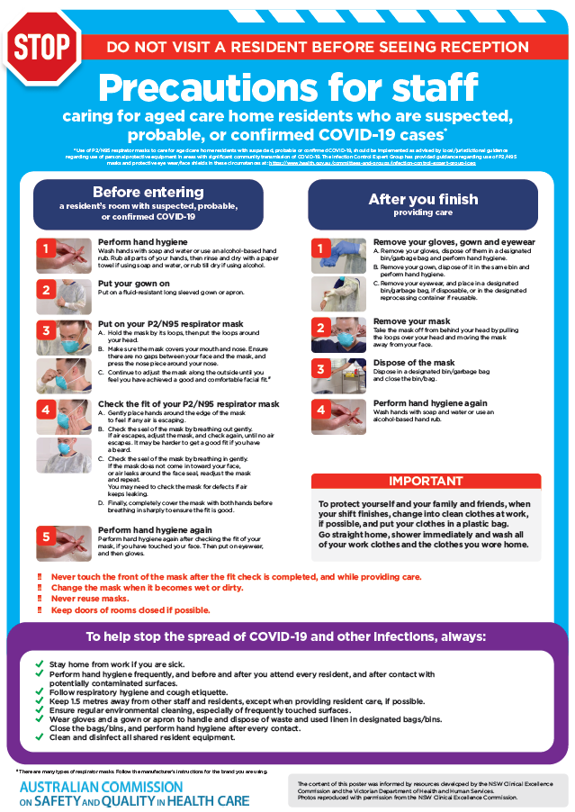](https://www.safetyandquality.gov.au/publications-and-resources/resource-library/poster-ppe-use-aged-care-staff-caring-residents-covid-19)

* ***Poster – Combined contact and droplet precautions*** <https://www.safetyandquality.gov.au/publications-and-resources/resource-library/poster-combined-contact-and-droplet-precautions>  
  [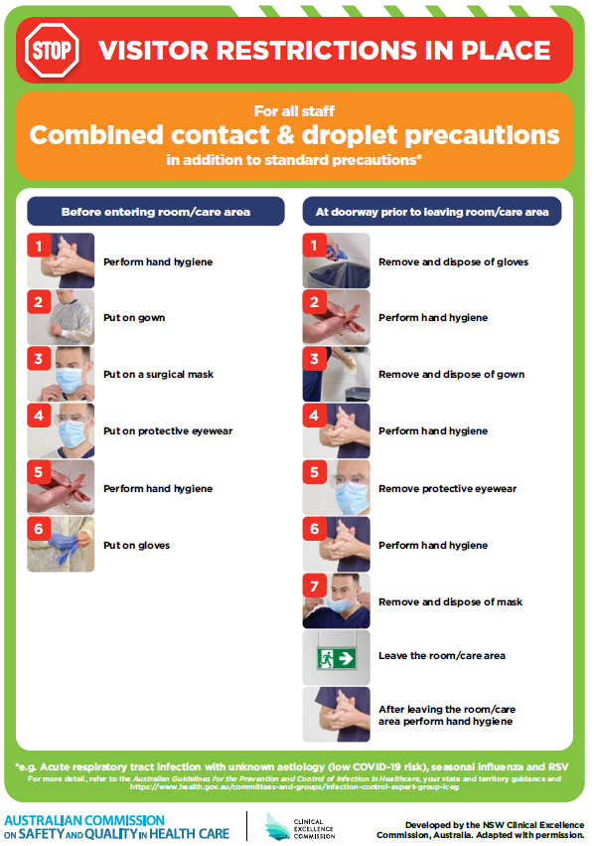](https://www.safetyandquality.gov.au/publications-and-resources/resource-library/poster-combined-contact-and-droplet-precautions)
* ***Poster – Combined airborne and contact precautions*** <https://www.safetyandquality.gov.au/publications-and-resources/resource-library/poster-combined-airborne-and-contact-precautions>   
  [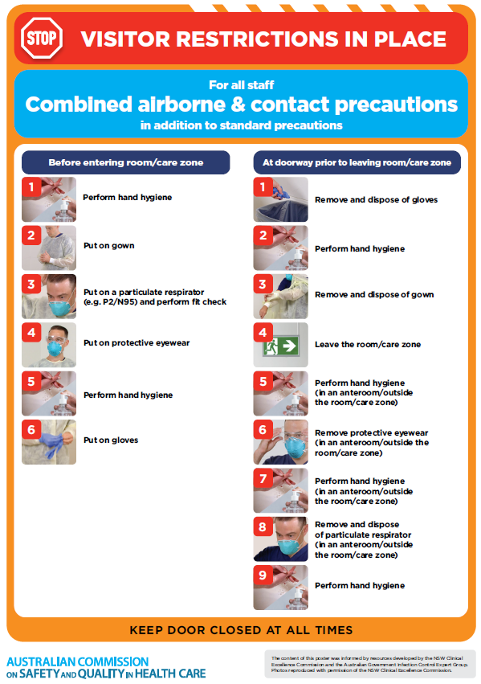](https://www.safetyandquality.gov.au/publications-and-resources/resource-library/poster-combined-airborne-and-contact-precautions)
* ***Environmental Cleaning and Infection Prevention and Control*** [www.safetyandquality.gov.au/environmental-cleaning](http://www.safetyandquality.gov.au/environmental-cleaning)
* ***Infection prevention and control Covid-19 PPE*** poster <https://www.safetyandquality.gov.au/publications-and-resources/resource-library/infection-prevention-and-control-covid-19-personal-protective-equipment>
* ***COVID-19 infection prevention and control risk management – Guidance*** <https://www.safetyandquality.gov.au/publications-and-resources/resource-library/covid-19-infection-prevention-and-control-risk-management-guidance>
* ***Safe care for people with cognitive impairment during COVID-19***<https://www.safetyandquality.gov.au/our-work/cognitive-impairment/cognitive-impairment-and-covid-19>
* ***Stop COVID-19: Break the chain of infection*** posterhttps://www.safetyandquality.gov.au/publications-and-resources/resource-library/break-chain-infection-poster-a3  
  **[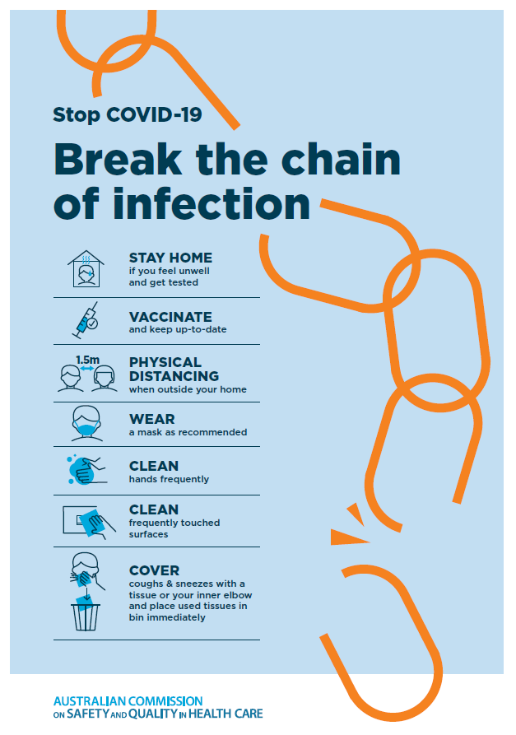](https://www.safetyandquality.gov.au/publications-and-resources/resource-library/break-chain-poster-a3https:/www.safetyandquality.gov.au/publications-and-resources/resource-library/break-chain-poster-a3)**
* ***FAQs for clinicians on elective surgery*** <https://www.safetyandquality.gov.au/node/5724>
* ***FAQs for consumers on elective surgery*** <https://www.safetyandquality.gov.au/node/5725>
* ***FAQs on community use of face masks***   
   <https://www.safetyandquality.gov.au/faqs-community-use-face-masks>
* ***COVID-19 and face masks – Information for consumers*** <https://www.safetyandquality.gov.au/publications-and-resources/resource-library/covid-19-and-face-masks-information-consumers>  
  The Commission’s fact sheet on use of face masks in the community to reduce the spread of COVID-19 is now available in Easy English and 10 other community languages from <https://www.safetyandquality.gov.au/wearing-face-masks-community>.  
  The factsheet was developed to help people understand when it is important to wear a mask to reduce the risk of the spread of COVID-19, and to explain how to safely put on and remove face masks. It also reinforces the importance of staying home if you have symptoms, physical distancing, hand hygiene and cough etiquette.

[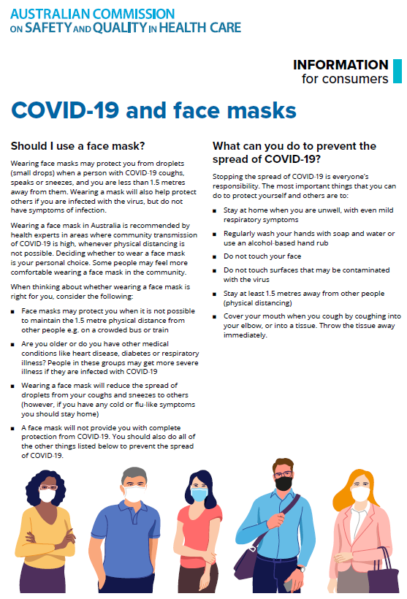](https://www.safetyandquality.gov.au/sites/default/files/2020-07/covid-19_and_face_masks_-_information_for_consumers.pdf)

*National COVID-19 Clinical Evidence Taskforce*

<https://covid19evidence.net.au/>

The National COVID-19 Clinical Evidence Taskforce is a collaboration of peak health professional bodies across Australia whose members are providing clinical care to people with COVID-19. The taskforce is undertaking continuous evidence surveillance to identify and rapidly synthesise emerging research in order to provide national, **evidence-based guidelines and clinical flowcharts for the clinical care of people with COVID-19**. The guidelines address questions that are specific to managing COVID-19 and cover the full disease course across mild, moderate, severe and critical illness. These are ‘living’ guidelines, updated with new research in near real-time in order to give reliable, up-to-the minute advice to clinicians providing frontline care in this unprecedented global health crisis.

*COVID-19 Critical Intelligence Unit*

<https://www.aci.health.nsw.gov.au/covid-19/critical-intelligence-unit>

The Agency for Clinical Innovation (ACI) in New South Wales has developed this page summarising rapid, evidence-based advice during the COVID-19 pandemic. Its operations focus on systems intelligence, clinical intelligence and evidence integration. The content includes a daily evidence digest and evidence checks on a discrete topic or question relating to the current COVID-19 pandemic. There is also a ‘Living evidence’ section summarising key studies and emerging evidence on **COVID-19 vaccines** and **SARS-CoV-2 variants**.

**Disclaimer**

On the Radar is an information resource of the Australian Commission on Safety and Quality in Health Care. The Commission is not responsible for the content of, nor does it endorse, any articles or sites listed. The Commission accepts no liability for the information or advice provided by these external links. Links are provided on the basis that users make their own decisions about the accuracy, currency and reliability of the information contained therein. Any opinions expressed are not necessarily those of the Australian Commission on Safety and Quality in Health Care.