# Australian Commission on Safety and Quality in Health Care logo with Radar imageOn the Radar

Issue 535

1 November 2021

*On the Radar* is a summary of some of the recent publications in the areas of safety and quality in health care. Inclusion in this document is not an endorsement or recommendation of any publication or provider. Access to particular documents may depend on whether they are Open Access or not, and/or your individual or institutional access to subscription sites/services. Material that may require subscription is included as it is considered relevant.

*On the Radar* is available online, via email or as a PDF or Word document from <https://www.safetyandquality.gov.au/publications-and-resources/newsletters/radar>

If you would like to receive *On the Radar* via email, you can subscribe on our website <https://www.safetyandquality.gov.au/publications-and-resources/newsletters>  
or by emailing us at H[Umail@safetyandquality.gov.auU](mailto:mail@safetyandquality.gov.au).   
You can also send feedback and comments to H[Umail@safetyandquality.gov.auU](mailto:mail@safetyandquality.gov.au).

For information about the Commission and its programs and publications, please visit <https://www.safetyandquality.gov.au>

You can also follow us on Twitter @ACSQHC.

**On the Radar**

Editor: Dr Niall Johnson [niall.johnson@safetyandquality.gov.au](mailto:niall.johnson@safetyandquality.gov.au)

Contributors: Niall Johnson

**Journal articles**

*Systematic review: Nurses' safety attitudes and their impact on patient outcomes in acute-care hospitals*

Alanazi FK, Sim J, Lapkin S

Nursing Open. 2021 [epub].

|  |  |
| --- | --- |
| DOI | <https://doi.org/10.1002/nop2.1063> |
| Notes | Paper reporting on a systematic review that sought to ‘synthesize the best available evidence on the impact of nurses' safety attitudes on patient outcomes in acute-care hospitals.’ Based on 9 studies, the authors report that ‘Nurses with positive safety attitudes reported fewer patient falls, medication errors, pressure injuries, healthcare-associated infections, mortality, physical restraints, vascular access device reactions and higher patient satisfaction.’ It’s recognised that culture and attitudes matter and the authors suggest that ‘Nurse managers can improve nurses' safety attitudes by promoting a non-punitive response to error reporting and promoting effective teamwork and good communication.’ |

*Digital technologies: a new determinant of health*

The Lancet Digital Health

The Lancet Digital Health. 2021;3(11):e684.

*The* Lancet *and* Financial Times *Commission on governing health futures 2030: growing up in a digital world*

Kickbusch I, Piselli D, Agrawal A, Balicer R, Banner O, Adelhardt M, et al.

The Lancet. 2021 [epub].

|  |  |
| --- | --- |
| DOI | *The Lancet Digital Health* <https://doi.org/10.1016/S2589-7500(21)00238-7>  Kickbusch et al <https://doi.org/10.1016/S0140-6736(21)01824-9> |
| Notes | Editorial in *The Lancet Digital Health* that reflects on *The Lancet* and *Financial Times* Commission (<https://doi.org/10.1016/S0140-6736(21)01824-9>) on governing health futures, that includes ‘recommendations for successful integration of digital technologies in health’. The editorial observes that ‘The bottom line of the Commission is that **weak governance of digital technologies is causing health inequities and compromising human rights**.’ Digital technologies, e-health, digital health offer potentials for improving the care we receive. However, there is a risk that the “digital divide” exacerbates health inequities. The editorial also touches on the face that the Commission focus many of their recommendations on the health future of children and many of these young people are offline and that there is a digital gender divide. Access and equity are considered by many as safety and quality issues and the editorial concludes by asserting that ‘Governments must provide comprehensive governance and leadership to define globally agreed rules on the sharing of health data for the future of equitable health care.’ |

*Building patient trust in hospitals: a combination of hospital-related factors and health care clinician behaviors*

Greene J, Samuel-Jakubos H

The Joint Commission Journal on Quality and Patient Safety. 2021 2021/09/12/.

|  |  |
| --- | --- |
| DOI | <https://doi.org/10.1016/j.jcjq.2021.09.003> |
| Notes | We apparently live in a world in which trust is diminished and there is an apparent need to rebuild trust. This paper reports on a qualitative study that examined patients’ perspectives on trust in hospitals and health care systems. The study is based on 38 semi-structured telephone interviews conducted in early 2020 with participants across the United States. The patients who participated identified three factors that impact their trust in hospitals: competence, caring, and communication. The authors conclude that ‘The findings underscore the importance of perceived quality of care and hospital safety/hygiene, as well as having an organizational culture that emphasizes caring and effective communication, for building patient trust.’  Onora O’Neill suggests that we worry not such much about trust, as trustworthiness. If we are considered trustworthy, then trust follows. It then becomes the demonstration of trustworthiness that is significant. O’Neill concluded ‘Trust requires an intelligent judgement of trustworthiness. So those who want others’ trust have to do two things. First, they have to be trustworthy, which requires competence, honesty and reliability. Second, they have to provide intelligible evidence that they are trustworthy, enabling others to judge intelligently where they should place or refuse their trust.’ (<https://blog.ted.com/how-to-trust-intelligently/>) |

*EMS non-conveyance: a safe practice to decrease ED crowding or a threat to patient safety?*

Paulin J, Kurola J, Koivisto M, Iirola T

BMC Emergency Medicine. 2021;21(1):115

|  |  |
| --- | --- |
| DOI | <https://doi.org/10.1186/s12873-021-00508-1> |
| Notes | This Finnish study into the decision of emergency medical services (EMS) to not convey patients used EMS re-contacts, primary health care or emergency department (ED) visits, and hospitalization within 48 hours to evaluate the decision. This was a cohort study that prospectively collected data on 11,861 non-conveyed EMS patients from three different regions in Finland between 1 June and 30 November 2018. The authors report that ‘Of the non-conveyed EMS patients (n = 11,861), 6.3% re-contacted the EMS, 8.3% attended a primary health care facility, 4.2% went to the ED, 1.6% were hospitalized, and 0.1% died 0–24 h after the EMS mission’. They noted that ‘Four in five non-conveyed patients did not have any re-contact in follow-up period’ and suggest that ‘EMS non-conveyance seems to be a relatively safe method of focusing ED resources and avoiding ED crowding.’ |

*Australian Journal of Primary Health*

Volume 27 Number 5 October 2021

|  |  |
| --- | --- |
| URL | <https://www.publish.csiro.au/py/issue/10189> |
|  | A new issue of the *Australian Journal of Primary Health* has been published. Articles in this issue of the *Australian Journal of Primary Health* include:   * Scoping review of **health outcomes for people with disabilities in user-led organisations** (Michael Crowe and Lorraine Sheppard) * **Moral distress in community health nursing practice** (Diana Guzys, Kathleen Tori and Carey Mather) * Evaluation of Australian **prescription drug monitoring programs** need a holistic approach (Sarah Haines and Pallavi Prathivadi) * **COVID-19 challenges faced by general practitioners** in Australia: a survey study conducted in March 2021 (Tessa Copp, Jennifer M J Isautier, Brooke Nickel, Kristen Pickles, Marguerite Tracy, Jenny Doust, Carissa Bonner, Rachael H Dodd, Julie Ayre, Erin Cvejic, Lyndal Trevena, Ramesh Manocha and Kirsten J McCaffery) * Understanding the general practice of **telemonitoring integrated care**: a qualitative perspective (Josephine S F Chow, Andrew Knight, Anna Disney, Friedbert Kohler, Justin Duggan, Nutan Maurya and Veronica Gonzalez-Arce) * Mixed-methods evaluation of **screening for hearing loss** using the hearScreen™ mobile health application in Aboriginal and Torres Strait Islander children presenting to an urban primary healthcare service (Geoffrey K Spurling, Claudette ‘Sissy' Tyson, Deborah Askew and Jennifer Reath) * **Quality of condition suggestions and urgency advice provided by the Ada symptom assessment app** evaluated with vignettes optimised for Australia (Stephen Gilbert, Matthew Fenech, Shubhanan Upadhyay, Paul Wicks and Claire Novorol) * **Refugee healthcare perceptions in regional northern Australia**: transition through engagement, access, trust, privacy, the old, and the new (Michael Au, Robyn Preston, Robin A Ray and Meg Davis) * Qualitative **experiences of primary health care and social care professionals with refugee-like migrants and former quota refugees** in New Zealand (Jonathan Kennedy, Helen Kim, Serena Moran and Eileen McKinlay) * Understanding the **research capacity and culture of a regional allied health workforce** (Angela Crombie, Donna Borkowski, Marcus Gardner, Kevin Masman and Owen Howlett) * Implications for clients **when nurses view weight as main cause of Type 2 diabetes** in primary care (Cynthia J Smith, Darlene A McNaughton and Samantha B Meyer) * Perspectives of Australian GPs on **tailoring fall risk management**: a qualitative study (Lynette Mackenzie, Jeannine Liddle, Lindy M Clemson, Amy C W Tan, Meryl Lovarini, Sabrina W Pit, Roslyn G Poulos, Chris Roberts, Constance D Pond and Karen Willis) * Patterns of **real-world opioid prescribing** in Australian general practice (2013–18) (Doreen Busingye, Benjamin Daniels, Jonathan Brett, Allan Pollack, Josephine Belcher, Kendal Chidwick and Suzanne Blogg) |

*Healthcare Quarterly*

Volume 24, Number 3, October 2021

|  |  |
| --- | --- |
| URL | <https://www.longwoods.com/publications/healthcare-quarterly/26613/1/vol.-24-no.-3-2021> |
| Notes | A new issue of *Healthcare Quarterly* has been published with the theme of ‘Resetting the Future of Healthcare Leadership’. Articles in this issue of *Healthcare Quarterly* include:   * Editorial: Resetting the **Future of Healthcare Leadership** (Anne Wojtak and Neil Stuart) * Reviewing the Evidence on Prenatal Opioid Exposure to Inform **Child Development Policy and Practice** (Andi Camden, Madeleine Harris, Sophia den Otter-Moore, Douglas M Campbell and Astrid Guttmann) * The **Impact of the COVID-19 Pandemic in Long-Term Care** in Canada (Raquel Betini, Sandra Milicic and Christina Lawand) * Commentary: **Moral and Ethical Leadership in the Age of Diversity, Equity, Inclusiveness and Social Accountability** (Alex Anawati and Sarita Verma) * Commentary: Laying the Groundwork to **Meaningfully Engage Indigenous Leadership** (Harmony Johnson, sɛƛakəs) * Leadership Perspective: **Addressing Canada’s Opioid Crisis** – Reducing the Harm of Leadership (Anne Wojtak and Neil Stuart) * Leveraging Innovative Leadership Models within Community and Healthcare Organizations to Support **Safe School Reopening during the COVID-19 Pandemic** (Catherine Yu, Karen Chu, Janine McCready, Sarah Downey and Thuy-Nga(Tia) Pham) * Impactful Approaches to **Leadership on the Front Lines of the COVID-19 Pandemic**: Lived Experiences of Canadian Paramedics (Lindsey Boechler, Cheryl Cameron, J Chris Smith, Polly Ford-Jones and Patrick Suthers) * Leadership during a Crisis: **Observations by Emerging Leaders during the COVID-19 Pandemic** (Wendy Nelson, Arlinda Ruco and Isser Dubinsky) * Leading through Crises: **Healthcare Supply Chain Strategies and Lessons Learned** from the COVID-19 Challenges (Roxanne Patel, Connor Schmidt, Karen Belaire, Tammy Quigley and Rebecca Repa) * Foundations, Functions and Current State of **Collaborative Leadership**: A Case of Newly Developing Integrated Care in Ontario (Shannon L Sibbald, Ruth E Hall, Gayathri Embuldeniya, Jennifer Gutberg and Walter P Wodchis) * Leadership Perspective: **Partnering with Patients to Co-Design Healthcare Systems** (Neil Stuart and Anne Wojtak) * Commentary: The **Future of Aging** in Canada (Cathy Szabo) * Building **Environmentally Sustainable Health Systems** in Canada: The Time Is Now for Emergent and Strategic Leadership (Danielle Toccalino, Anna Cooper Reed, Colin Sue-Chue-Lam, Anson Cheung and V Haldane) |

*BMJ Quality & Safety* online first articles

|  |  |
| --- | --- |
| URL | <https://qualitysafety.bmj.com/content/early/recent> |
| Notes | *BMJ Quality &Safety* has published a number of ‘online first’ articles, including:   * Editorial: **Outsourcing care to the private sector**: some reassuring evidence on patient outcomes (Alex Bottle, John Browne) * Editorial: Indirect effects of the **COVID-19 pandemic on people with type 2 diabetes**: time to urgently move into a recovery phase (Eszter P Vamos, Kamlesh Khunti) |

*International Journal for Quality in Health Care* online first articles

|  |  |
| --- | --- |
| URL | <https://academic.oup.com/intqhc/advance-articles> |
| Notes | *International Journal for Quality in Health Care* has published a number of ‘online first’ articles, including:   * An **Appraisal of Healthcare Accreditation Agencies and Programs**: Similarities, Differences, Challenges and Opportunities (David Greenfield, Usman Iqbal, Elaine O’Connor, Nicola Conlan, Heather Wilson) * **Patients Experience More Support, Information and Involvement After First-Time Hospital Accreditation:** A Before and After Study in the Faroe Islands (Maria Daniella Bergholt, Anne Mette Falstie-Jensen, Jan Brink Valentin, Peter Hibbert, Jeffrey Braithwaite, Søren Paaske Johnsen, Christian von Plessen) |

**Online resources**

*[USA] AHRQ Perspectives on Safety*

<https://psnet.ahrq.gov/psnet-collection/perspectives>

The US Agency for Healthcare Research and Quality (AHRQ) publishes Perspectives on Safety essays. Recent essays include:

* *The Role of* ***Community Pharmacists in Patient Safety***<https://psnet.ahrq.gov/perspective/role-community-pharmacists-patient-safety>

*[UK] NICE Guidelines and Quality Standards*

<https://www.nice.org.uk/guidance>

The UK’s National Institute for Health and Care Excellence (NICE) has published new (or updated) guidelines and quality standards. The latest reviews or updates are:

* NICE Guideline NG191 COVID-19 rapid guideline: managing COVID-19 <https://www.nice.org.uk/guidance/ng191>

*[UK] NIHR Evidence alerts*

<https://evidence.nihr.ac.uk/>alerts/

The UK’s National Institute for Health Research (NIHR) has posted new evidence alerts on its site. Evidence alerts are short, accessible summaries of health and care research which is funded or supported by NIHR. This is research which could influence practice and each Alert has a message for people commissioning, providing or receiving care. The latest alerts include:

* Why don’t **teenagers** seek help for **anxiety and depression**?
* Advice by mail is as effective as targeted interventions at **preventing fall-related injuries in older people**
* **Diabetes checks**: delays in treatment are reduced when support staff assess eye images
* How to improve information for people with **osteoporosis**
* **Statins** do not commonly cause muscle pain and stiffness
* Stressing the personal benefits of the **COVID-19 vaccine** could encourage more people to accept.

*[USA] Effective Health Care Program reports*

<https://effectivehealthcare.ahrq.gov/>

The US Agency for Healthcare Research and Quality (AHRQ) has an Effective Health Care (EHC) Program. The EHC has released the following final reports and updates:

* *Living Systematic Review on* ***Cannabis and Other Plant-Based Treatments for Chronic Pain*** <https://effectivehealthcare.ahrq.gov/products/plant-based-chronic-pain-treatment/living-review>

**COVID-19 resources**

https://www.safetyandquality.gov.au/covid-19

The Australian Commission on Safety and Quality in Health Care has developed a number of resources to assist healthcare organisations, facilities and clinicians. These and other material on COVID-19 are available at <https://www.safetyandquality.gov.au/covid-19>

These resource include:

* ***COVID-19 infection prevention and control risk management*** <https://www.safetyandquality.gov.au/publications-and-resources/resource-library/covid-19-infection-prevention-and-control-risk-management-guidance>
* ***Poster - PPE use for aged care staff caring for residents with COVID-19*** <https://www.safetyandquality.gov.au/publications-and-resources/resource-library/poster-ppe-use-aged-care-staff-caring-residents-covid-19>

[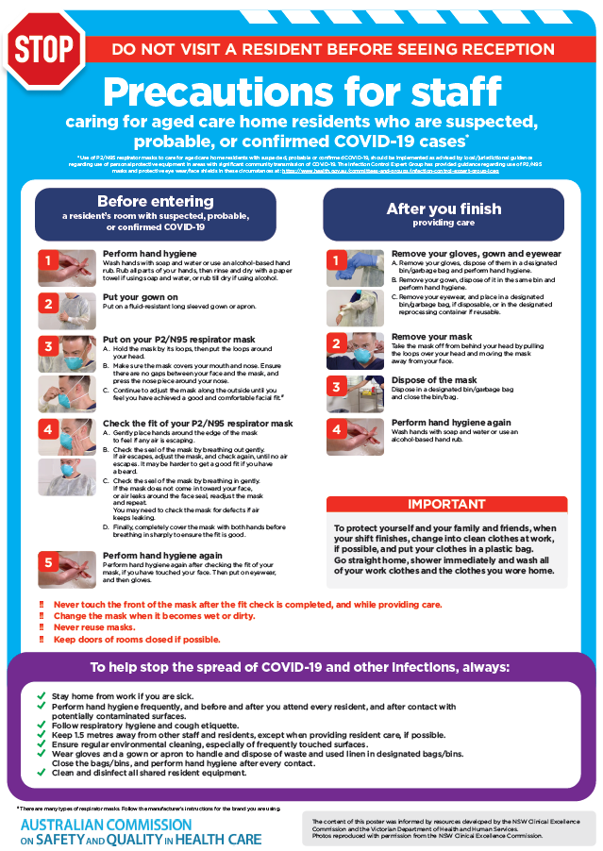](https://www.safetyandquality.gov.au/publications-and-resources/resource-library/poster-ppe-use-aged-care-staff-caring-residents-covid-19)

* ***Poster – Combined contact and droplet precautions*** <https://www.safetyandquality.gov.au/publications-and-resources/resource-library/poster-combined-contact-and-droplet-precautions>  
  [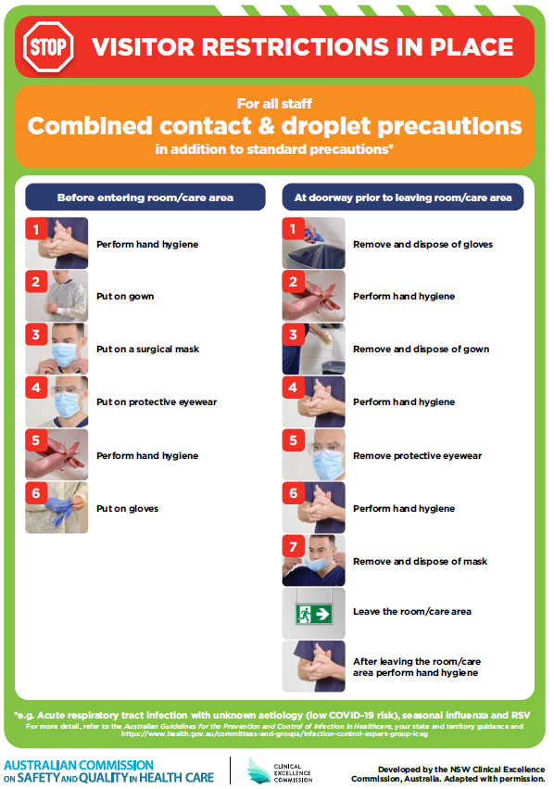](https://www.safetyandquality.gov.au/publications-and-resources/resource-library/poster-combined-contact-and-droplet-precautions)
* ***Poster – Combined airborne and contact precautions*** <https://www.safetyandquality.gov.au/publications-and-resources/resource-library/poster-combined-airborne-and-contact-precautions>   
  [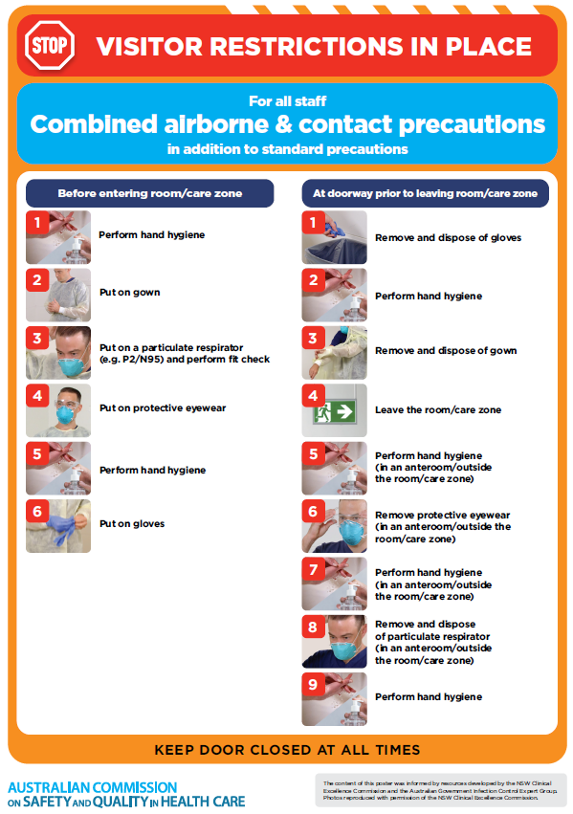](https://www.safetyandquality.gov.au/publications-and-resources/resource-library/poster-combined-airborne-and-contact-precautions)
* ***Environmental Cleaning and Infection Prevention and Control*** [www.safetyandquality.gov.au/environmental-cleaning](http://www.safetyandquality.gov.au/environmental-cleaning)
* ***COVID-19 infection prevention and control risk management – Guidance*** <https://www.safetyandquality.gov.au/publications-and-resources/resource-library/covid-19-infection-prevention-and-control-risk-management-guidance>
* ***Safe care for people with cognitive impairment during COVID-19***<https://www.safetyandquality.gov.au/our-work/cognitive-impairment/cognitive-impairment-and-covid-19>
* ***Stop COVID-19: Break the chain of infection*** posterhttps://www.safetyandquality.gov.au/publications-and-resources/resource-library/break-chain-infection-poster-a3  
  **[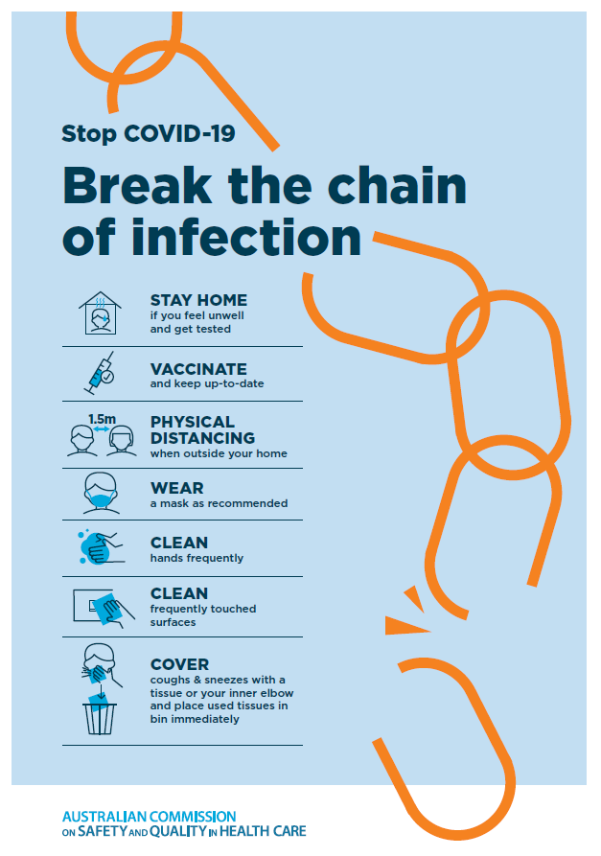](https://www.safetyandquality.gov.au/publications-and-resources/resource-library/break-chain-poster-a3https:/www.safetyandquality.gov.au/publications-and-resources/resource-library/break-chain-poster-a3)**
* ***FAQs for clinicians on elective surgery*** <https://www.safetyandquality.gov.au/node/5724>
* ***FAQs for consumers on elective surgery*** <https://www.safetyandquality.gov.au/node/5725>
* ***COVID-19 and face masks – Information for consumers*** <https://www.safetyandquality.gov.au/publications-and-resources/resource-library/covid-19-and-face-masks-information-consumers>

[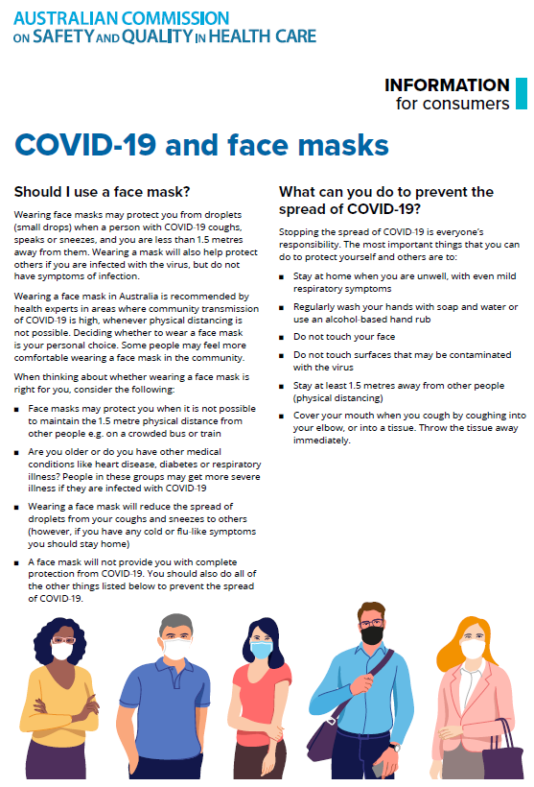](https://www.safetyandquality.gov.au/sites/default/files/2020-07/covid-19_and_face_masks_-_information_for_consumers.pdf)

*National COVID-19 Clinical Evidence Taskforce*

<https://covid19evidence.net.au/>

The National COVID-19 Clinical Evidence Taskforce is a collaboration of peak health professional bodies across Australia whose members are providing clinical care to people with COVID-19. The taskforce is undertaking continuous evidence surveillance to identify and rapidly synthesise emerging research in order to provide national, **evidence-based guidelines and clinical flowcharts for the clinical care of people with COVID-19**. The guidelines address questions that are specific to managing COVID-19 and cover the full disease course across mild, moderate, severe and critical illness. These are ‘living’ guidelines, updated with new research in near real-time in order to give reliable, up-to-the minute advice to clinicians providing frontline care in this unprecedented global health crisis.

*COVID-19 Critical Intelligence Unit*

<https://www.aci.health.nsw.gov.au/covid-19/critical-intelligence-unit>

The Agency for Clinical Innovation (ACI) in New South Wales has developed this page summarising rapid, evidence-based advice during the COVID-19 pandemic. Its operations focus on systems intelligence, clinical intelligence and evidence integration. The content includes a daily evidence digest, a COVID status monitor, a risk monitoring dashboard and evidence checks on a discrete topic or question relating to the current COVID-19 pandemic. There is also a ‘Living evidence’ section summarising key studies and emerging evidence on **COVID-19 vaccines** and **SARS-CoV-2 variants**. The most recent updates include:

* ***COVID-19 vaccines in Australia*** – What is the latest evidence on COVID-19 vaccines in Australia?

**Disclaimer**

On the Radar is an information resource of the Australian Commission on Safety and Quality in Health Care. The Commission is not responsible for the content of, nor does it endorse, any articles or sites listed. The Commission accepts no liability for the information or advice provided by these external links. Links are provided on the basis that users make their own decisions about the accuracy, currency and reliability of the information contained therein. Any opinions expressed are not necessarily those of the Australian Commission on Safety and Quality in Health Care.