# Australian Commission on Safety and Quality in Health Care logo with Radar imageOn the Radar

Issue 536

8 November 2021

*On the Radar* is a summary of some of the recent publications in the areas of safety and quality in health care. Inclusion in this document is not an endorsement or recommendation of any publication or provider. Access to particular documents may depend on whether they are Open Access or not, and/or your individual or institutional access to subscription sites/services. Material that may require subscription is included as it is considered relevant.

*On the Radar* is available online, via email or as a PDF or Word document from <https://www.safetyandquality.gov.au/publications-and-resources/newsletters/radar>

If you would like to receive *On the Radar* via email, you can subscribe on our website <https://www.safetyandquality.gov.au/publications-and-resources/newsletters>  
or by emailing us at H[Umail@safetyandquality.gov.auU](mailto:mail@safetyandquality.gov.au).   
You can also send feedback and comments to H[Umail@safetyandquality.gov.auU](mailto:mail@safetyandquality.gov.au).

For information about the Commission and its programs and publications, please visit <https://www.safetyandquality.gov.au>

You can also follow us on Twitter @ACSQHC.

**On the Radar**

Editor: Dr Niall Johnson [niall.johnson@safetyandquality.gov.au](mailto:niall.johnson@safetyandquality.gov.au)

Contributors: Niall Johnson

**Journal articles**

*Ticking the box of ‘cultural safety’ is not enough: why trauma-informed practice is critical to Indigenous healing*

Tujague NA, Ryan KLR

Rural and Remote Health. 2021;21(3):6411.

|  |  |
| --- | --- |
| DOI | <https://doi.org/10.22605/RRH6411> |
| Notes | Article calling for clinicians working with Aboriginal and Torres Strait Islander communities to ‘acknowledge and understand the impacts of trauma in order to engage in culturally safe practice’. The authors argue that ‘Recognising the role that historical and other traumas play in Indigenous people’s communities and lives is a prerequisite for respectful and safe practice.’ The authors consider that cultural safety training has been insufficient and that ‘To be truly culturally safe is to understand how the history of trauma suffered by Aboriginal and Torres Strait Islander Australians has led to social, emotional and economic disadvantage.’ |

*Diagnostic Excellence*

Yang D, Fineberg HV, Cosby K

JAMA. 2021 [epub].

*Diagnosis and the Illness Experience: Ways of Knowing*

Maitra A, Verghese A

JAMA. 2021 [epub]

|  |  |
| --- | --- |
| DOI | Yang et al <https://doi.org/10.1001/jama.2021.19493>  Maitra and Verghese <https://doi.org/10.1001/jama.2021.19496> |
| Notes | The *Journal of the American Medical Association* (JAMA) has launched a series on diagnostic excellence with these two Viewpoint pieces.  Yang et al observed that ‘Diagnosis is a fundamental part of clinical medicine and is a prerequisite for the delivery of high-quality, effective care. Despite its essential place in medical practice, diagnostic performance is understudied and unmeasured, excellence in diagnosis is assumed rather than demonstrated, and diagnostic acumen is often financially unrewarded.’ They proceed to state that ‘*Diagnostic excellence* refers to an optimal process to attain an accurate and precise explanation about a patient’s condition. An optimal process would be timely, cost-effective, convenient, and understandable to the patient. An accurate and precise diagnosis gains clinical value insofar as it leads to better choices in treatment.’ They offer the following key points for diagnostic excellence:   1. Diagnostic errors, delays, and miscommunication are a frequent source of substandard care. 2. Diagnostic excellence requires both an optimal process and an accurate understanding of a patient’s condition. 3. Diagnostic excellence embraces the 6 dimensions of health care quality enumerated by the Institute of Medicine—care that is safe, effective, patient-centered, timely, efficient, and equitable.   Maitra and Verghese reflect on the “meaning” of diagnosis, for both the clinician and the patient and across time, historically, currently and in the future. They suggest that ‘Diagnosis will need to be better, faster, less expensive, more precise, but it must also become a capacious art, one with room for kinship, multiplicity, subjective experience, and moral reckoning. Diagnosis must have room for not-knowing. Diagnosis must be person-centered, embracing the outward-facing human elements that are too easily relegated to the realm of illness.’ |

*Patient safety strategies in psychiatry and how they construct the notion of preventable harm: a scoping review*

Svensson J

Journal of Patient Safety. 2021 [epub].

|  |  |
| --- | --- |
| DOI | <http://doi.org/10.1097/pts.0000000000000885> |
| Notes | Paper reporting on a scoping review that sought to identify ‘patient safety strategies used in psychiatry and determine how they construct the notion of preventable harm’. Using literature published between 2000 and 2019, the review identified seven ‘focus areas’ of patient safety issues in the psychiatric literature. The seven being risk management, healthcare practitioners, patient observation, patient involvement, computerized methods, admission and discharge, and security.  The review’s author concludes that ‘The strategies that are supported in the literature to achieve safer psychiatry mainly arise from linear cause-effect models and rely on staff performance, competence, and compliance. Contemporary safety science acknowledges the performance variability of everyday normal work and sees risk as the dynamic migration of these daily activities. The field of psychiatry has not yet included this view of safety in the strategic actions to reduce preventable harm.’ |

For information on the Commission’s work on mental health, see <https://www.safetyandquality.gov.au/our-work/mental-health>

For information on the Commission’s work on National Safety and Quality Digital Mental Health Standards, see <https://www.safetyandquality.gov.au/standards/national-safety-and-quality-digital-mental-health-standards>

*Staffing levels and nursing-sensitive patient outcomes: Umbrella review and qualitative study*

Blume KS, Dietermann K, Kirchner-Heklau U, Winter V, Fleischer S, Kreidl LM, et al

Health Services Research. 2021;56(5):885-907.

|  |  |
| --- | --- |
| DOI | <https://doi.org/10.1111/1475-6773.13647> |
| Notes | The issue of staffing levels and the impact on the quality and safety of care has been much debated. This has included both generally and within specific settings, e.g. in aged care. The paper reports on a review that sought to derive a comprehensive list of nursing-sensitive patient outcomes (NSPOs). After screening 430 ‘potentially relevant records’, the study used 15 literature reviews to derive a list of NSPOs. This list was then extended based on expert input. The identified nursing-sensitive patient outcomes (NSPOs) include:   * Length of stay * Patient dissatisfaction * Poor quality of nurse-delivered care * Readmission * Failure to rescue * Medication error * Mortality * Pneumonia * Respiratory failure * Central nervous system (CNS) complications * Deep venous thrombosis (DVT) * Emergency Department visit * Infection with multi-resistant organism * Missed discharge preparation * Patient fall * Psychological/metabolic derangement * Pressure ulcer * Sepsis * Shock or cardiac arrest * Surgical wound infection * Upper gastrointestinal bleeding * Urinary tract infection (UTI). |

*Journal for Healthcare Quality*

Volume 43, Number 6, November/December 2021

|  |  |
| --- | --- |
| URL | <https://journals.lww.com/jhqonline/toc/2021/12000> |
|  | A new issue of the *Journal for Healthcare Quality (JHQ)* has been published. Articles in this issue of the *Journal for Healthcare Quality* include:   * Implementation of **Patient Safety Structures and Processes in the Patient-Centered Medical Home** (Tyler Oberlander, Sarah Hudson Scholle, Jill Marsteller, Michael S Barr, Sydney Morss Dy) * Quality-of-Care Implications of **Antimicrobial Prescription Patterns for Acute Respiratory Tract Infections** (Vansha Singh, Liron Sinvani, Bruce Hirsch, Kayla Finuf, Claire Popplewell, Michael Qiu, Michele Pisano, Nina Kohn, Renee Pekmezaris, Gisele Wolf-Klein) * Greater Compliance With **Early Sepsis Management** is Associated With Safer Care and Shorter Hospital Stay (Larissa G Rodriguez-Homs, Sabran J Masoud, Matthew J Mosca, Oliver K Jawitz, Cara O'Brien, Paul J Mosca) * **Quality Measurement and Patient Outcomes in Inpatient Behavioral Health**: Assessing the Current Framework (Rachel B Nowlin, Sarah K Brown, Jessica R Ingram, Johan R Smith) * Clinical Team Training and a Structured Handoff Tool to Improve **Teamwork, Communication, and Patient Safety** (Brett Neville, Rebecca S Miltner, Maria R Shirey) * Educational and Electronic-Based Tools to Mitigate the Risk of **Transfusion Adverse Events** (Jennifer Ding, Rebecca Krey, Laura Malone, VeRonika Merrill, Mona Krouss, Jennifer O'Brien, Magali J Fontaine) * Established Trauma Triage Score Predicts **Risk of Falling After Femoral Neck Fracture Arthroplasty Surgery** (Sanjit R Konda, Cody R Perskin, Rown Parola, Connor P Littlefield, Kenneth A Egol) |

*Patient Experience Journal*

Volume 8 Issue 3

|  |  |
| --- | --- |
| URL | <https://pxjournal.org/journal/vol8/iss3/> |
|  | A new issue of the *Patient Experience Journal (PXJ)* has been published. Articles in this issue of the *Patient Experience Journal* include:   * Editorial: In divided times, a **focus on human experience connects us** (Jason A Wolf) * Rebuilding a foundation of trust: A call to action in **creating a safe environment for everyone** (Cynda H Rushton, Laura J Wood, Karen Grimley, Jerry Mansfield, Barbara Jacobs, and Jason A Wolf) * How to address fear: A **patient’s perspective of seeking care during COVID-19** (Rosie Bartel, Sydney Hoel, Nasia Safdar, and Mary Jo Knobloch) * The “wreckage” left by the **COVID-19** passage: Thoughts of a **palliative care nurse** (Angela Simões) * **Focus on optimal health**, not ideal health (John M Roll) * Using **design-thinking to investigate and improve patient experience** (Jennifer Smiechowski, Megan Mercia, Kyle Kemp, Elizabeth Oddone Paolucci, Maria Santana, and Rahim Kachra) * **Co-production development of a decision support tool** for peers and service users to choose technologies to support recovery (Mbita Mbao, Yaara Zisman Ilani, Ali Gold, Amanda Myers, Robert Walker, and Karen L Fortuna) * **Consumer representative experiences of partnership** with health workers in Australia (Coralie R Wales, J A Lababedi, A Coles, P Lee, and E Clarke) * **Perceptions of the healthcare system** among stakeholders (Michael D Markee, Christine Ascencio, Laura Brugger, Renee Jonas, and Hisako Matsuo) * The tensions between **healthcare providers and patient and family advisory committees** (PFACs): A comparative health system analysis between England and Ontario (Umair Majid) * Comparing **patient experience survey scores between telehealth and in-person** ambulatory pediatric subspecialty visits (Sean T Bomher, Matthew Wood, Elizabeth Uhlhorn, Sandro Marques, Lee Kwiatkowski, Natasa Tekic, Cameron D'Alpe, Natalie M Pageler, and Lane F Donnelly) * The effect of **service excellence training**: Examining providers' patient experience scores (Katelyn J Cavanaugh, M A Johnson, and C L Holladay) * Implementing PODS (**Patient Oriented Discharge Summary**) in an acute medical urban health setting in Vancouver, Canada (Agnes T Black, Suzanne Nixon, MacLeod Meghan, Christine Wallsworth, Lena Cuthbertson, Beena Parappilly, Jay MacDonald, Kate McNamee, and Cheryl Prinzen) * **Patient satisfaction while enrolled in clinical trials**: A literature review (Ilufredo Y Tantoy, Andrea N Bright, Evan Paelmo, Emily I Moreland, Ashley N Trost, Joan Pasquesi, Charlotta Weaver, and Richard T D'Aquila) * Motivations, experiences, and aspirations in **patient engagement of people living with metastatic cancer** (Patricia L Stoop and Leslie Duran) * Patients’ experiences and satisfaction with health care in the **Salah Azaiez Institute of Cancer** in Tunisia in 2020 (Hyem Khiari, Marwa Chraiet, Rym Mallekh, Ines Cherif, and Mohamed Hsairi) * **Patient engagement in an academic community-based primary care practice’s management committee**: A case study (Emmanuelle Trépanier, Marie-Pascale Pomey, and Paule Lebel) * Using a multidisciplinary data approach to operationalize **an experience framework** (Kevin Spera, Garrett Holmes, and Sunni Barnes) |

*Journal of Health Services Research & Policy*

Volume: 26, Number: 4 (October 2021)

|  |  |
| --- | --- |
| URL | <https://journals.sagepub.com/toc/hsrb/26/4> |
|  | A new issue of the *Journal of Health Services Research & Policy* has been published. Articles in this issue of the *Journal of Health Services Research & Policy* include:   * Editorial: ‘**It has to be their choice**. We need to give them options’ (Hanni Stoklosa and Chris Ash) * The employment and mental health impact of **integrated Improving Access to Psychological Therapies**: Evidence on secondary health care utilization from a pragmatic trial in three English counties (Veronica Toffolutti, David Stuckler, Martin McKee, Ineke Wolsey, Judith Chapman, Theo J Pimm, Joanne Ryder, Heather Salt, and David M Clark) * Health system barriers to accessing **care for children with weight issues** in New Zealand: An interview-based study (Cervantée E K Wild, Ngauru Rawiri, Esther J Willing, Paul L Hofman, and Yvonne C Anderson) * Effects of an integrated respiratory service on **Chronic Obstructive Pulmonary Disease hospital admissions** in England: An interrupted time series analysis (Martha M C Elwenspoek, Tim Jones, and James W Dodd) * Challenges of using **asthma admission rates as a measure of primary care quality in children**: An international comparison (Irina Lut, Kate Lewis, Linda Wijlaars, Ruth Gilbert, Tiffany Fitzpatrick, Hong Lu, Astrid Guttmann, Sharon Goldfield, Shaoke Lei, Geir Gunnlaugsson, Stefán Hrafn Jónsson, Reli Mechtler, Mika Gissler, Anders Hjern, and Pia Hardelid) * A narrative account of the key drivers in the development of the **Learning from Deaths policy** (Mirza Lalani and Helen Hogan) * ‘Have you ever traded sex for money or drugs?’ Health care providers’ perspectives on **sex trafficking risk assessments in clinics** (Lara Gerassi and Anna Pederson) * Use of single-bed rooms may decrease the incidence of **hospital-acquired infections in geriatric patients**: A retrospective cohort study in Central Denmark region (Merete Gregersen, Anders Mellemkjær, Catherine H Foss, and Sif Blandfort) * The **effects of centralizing cancer surgery on postoperative mortality**: A systematic review and meta-analysis (Roberto Grilli, Federica Violi, Maria Chiara Bassi, and Massimiliano Marino) |

*Health Affairs*

Volume 40, Number 11, November 2021

|  |  |
| --- | --- |
| URL | <https://www.healthaffairs.org/toc/hlthaff/40/11> |
| Notes | A new issue of *Health Affairs* has been published with the theme of “Hospitals, ACA Marketplaces & More”. Articles in this issue of *Health Affairs* include:   * **Medicare Diabetes Prevention**: Enrollment Short Of Projections (H Meyer) * **Medicare Two-Midnight Rule** Accelerated Shift To Observation Stays (S J Poon, C J D Wallis, P Lai, L Podczerwinski, and M Beeuwkes Buntin) * **Private Equity Acquisition And Responsiveness To Service-Line Profitability** At Short-Term Acute Care Hospitals (Marcelo Cerullo, Kelly Kaili Yang, James Roberts, Ryan C McDevitt, and Anaeze C Offodile) * Increasing **Insurance Choices In The Affordable Care Act Marketplaces**, 2018–21 (David M Anderson, and Kevin N Griffith) * **ACA Marketplaces Became Less Affordable** Over Time For Many Middle-Class Families, Especially The Near-Elderly (Paul D Jacobs, and Steven C Hill) * Growth In **ACA-Compliant Marketplace Enrollment And Spending Risk** Changes During The COVID-19 Pandemic (John Hsu, Chia Yi Chin, Max Weiss, Michael Cohen, J Sastry, N Katz-Christy, J Bertko, and J P Newhouse) * The Association Between **Medicaid Adult Dental Coverage And Children’s Oral Health** (Brandy J Lipton, Tracy L Finlayson, Sandra L Decker, Richard J Manski, and Mingan Yang) * Many States Were Able To **Expand Medicaid Without Increasing Administrative Spending** (Casey P Balio, Justin Blackburn, Valerie A Yeager, Kosali I Simon, and Nir Menachemi) * Variation In Use And Content Of **Prescription Drug Step Therapy Protocols**, Within And Across Health Plans (Kelly L Lenahan, Donald E Nichols, Rebecca M Gertler, and James D Chambers) * Estimating The Appropriate Size Of **Global Pull Incentives For Antibacterial Medicines** (Kevin Outterson) * **Neonatal Opioid Withdrawal Syndrome** Is Associated With Infant Foster Care Entry At The County Level (Sarah F Loch, Bradley D Stein, Robin Ghertner, Elizabeth McNeer, William D Dupont, R Smart, and S W Patrick) * Association Of Neighborhood Disadvantage With **Racial Disparities In COVID-19 Positivity** In Chicago (Elizabeth L Tung, Monica E Peek, Marco A Rivas, Joyce P Yang, and Anna Volerman) * Disparities In **County COVID-19 Vaccination Rates** Linked To Disadvantage And Hesitancy (Matthew A Crane, R R Faden, and J A Romley) * In Nigeria, **Stillbirths And Newborn Deaths Increased During The COVID-19 Pandemic** (Edward N Okeke, Isa S Abubakar, and R De Guttry) * Opening Up About My Struggle With **Recurring Depression** (Nora Super) |

*BMJ Quality & Safety* online first articles

|  |  |
| --- | --- |
| URL | <https://qualitysafety.bmj.com/content/early/recent> |
| Notes | *BMJ Quality &Safety* has published a number of ‘online first’ articles, including:   * Editorial: **Physician variation in opioid prescribing**: the importance of sex and gender (Paula Rochon, Parya Borhani, Jennifer Akerman, Anamika Mishra) * Association of clinical competence, specialty and physician country of origin with **opioid prescribing for chronic pain**: a cohort study (Robyn Tamblyn, Nadyne Girard, John Boulet, Dale Dauphinee, Bettina Habib) |

*International Journal for Quality in Health Care* online first articles

|  |  |
| --- | --- |
| URL | <https://academic.oup.com/intqhc/advance-articles> |
| Notes | *International Journal for Quality in Health Care* has published a number of ‘online first’ articles, including:   * Organizational Capacity for **Patient and Family Engagement in Hospital Planning and Improvement**: Interviews With Patient/Family Advisors, Managers and Clinicians (Natalie N Anderson, G Ross Baker, Lesley Moody, Kerseri Scane, Robin Urquhart, Walter P Wodchis, Anna R Gagliardi) |

**Online resources**

*[UK] NICE Guidelines and Quality Standards*

<https://www.nice.org.uk/guidance>

The UK’s National Institute for Health and Care Excellence (NICE) has published new (or updated) guidelines and quality standards. The latest reviews or updates are:

* NICE Guideline NG206 ***Myalgic encephalomyelitis (or encephalopathy)/chronic fatigue syndrome****: diagnosis and management*   
  <https://www.nice.org.uk/guidance/ng206>
* Quality Standard QS60 ***Inducing labour***   
  <https://www.nice.org.uk/guidance/qs60>
* NICE Guideline NG207 ***Inducing labour***   
  <https://www.nice.org.uk/guidance/ng207>
* NICE Guideline NG191 *COVID-19 rapid guideline:* ***managing COVID-19***<https://www.nice.org.uk/guidance/ng191>

*[USA] Effective Health Care Program reports*

<https://effectivehealthcare.ahrq.gov/>

The US Agency for Healthcare Research and Quality (AHRQ) has an Effective Health Care (EHC) Program. The EHC has released the following final reports and updates:

* ***Integrated and Comprehensive Pain Management Programs****: Effectiveness and Harms* <https://effectivehealthcare.ahrq.gov/products/integrated-pain-management/research>
* ***Management of High-Need, High-Cost Patients****: A “Best Fit” Framework Synthesis, Realist Review, and Systematic Review*   
  <https://effectivehealthcare.ahrq.gov/products/high-utilizers-health-care/research>

**COVID-19 resources**

https://www.safetyandquality.gov.au/covid-19

The Australian Commission on Safety and Quality in Health Care has developed a number of resources to assist healthcare organisations, facilities and clinicians. These and other material on COVID-19 are available at <https://www.safetyandquality.gov.au/covid-19>

These resource include:

* ***COVID-19 infection prevention and control risk management*** <https://www.safetyandquality.gov.au/publications-and-resources/resource-library/covid-19-infection-prevention-and-control-risk-management-guidance>
* ***Poster - PPE use for aged care staff caring for residents with COVID-19*** <https://www.safetyandquality.gov.au/publications-and-resources/resource-library/poster-ppe-use-aged-care-staff-caring-residents-covid-19>

[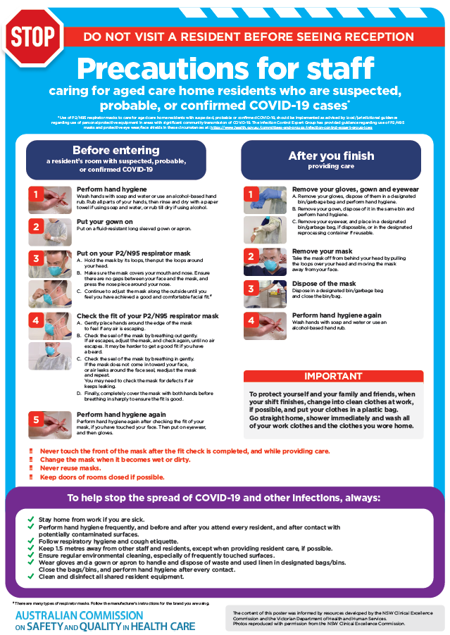](https://www.safetyandquality.gov.au/publications-and-resources/resource-library/poster-ppe-use-aged-care-staff-caring-residents-covid-19)

* ***Poster – Combined contact and droplet precautions*** <https://www.safetyandquality.gov.au/publications-and-resources/resource-library/poster-combined-contact-and-droplet-precautions>  
  [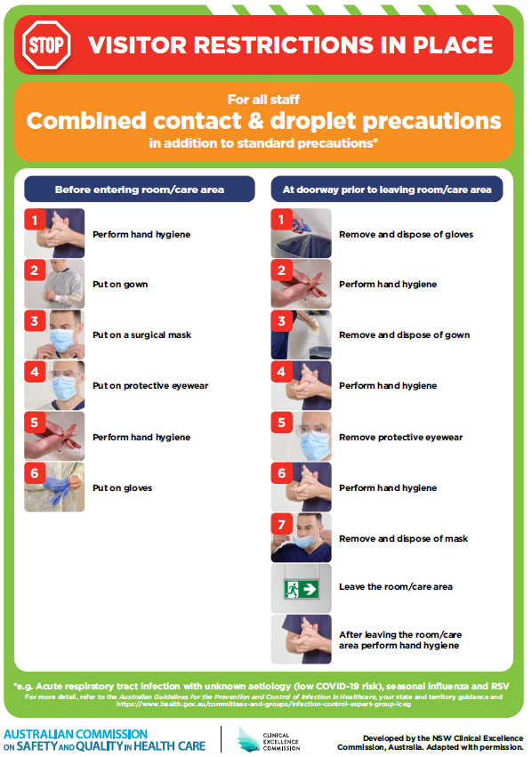](https://www.safetyandquality.gov.au/publications-and-resources/resource-library/poster-combined-contact-and-droplet-precautions)
* ***Poster – Combined airborne and contact precautions*** <https://www.safetyandquality.gov.au/publications-and-resources/resource-library/poster-combined-airborne-and-contact-precautions>   
  [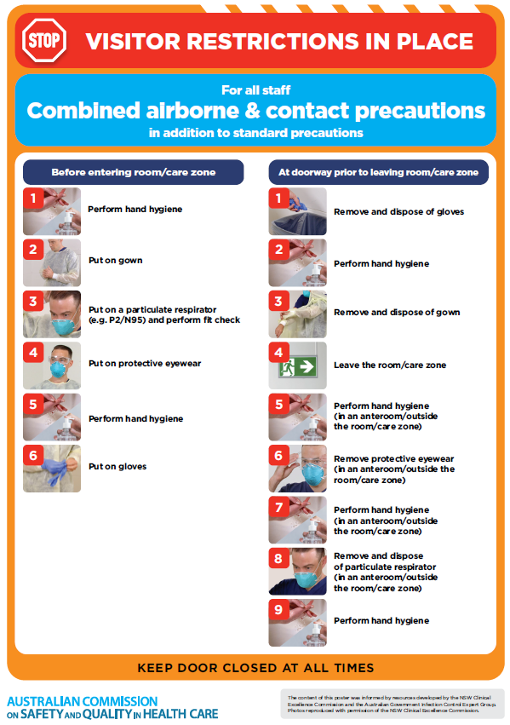](https://www.safetyandquality.gov.au/publications-and-resources/resource-library/poster-combined-airborne-and-contact-precautions)
* ***Environmental Cleaning and Infection Prevention and Control*** [www.safetyandquality.gov.au/environmental-cleaning](http://www.safetyandquality.gov.au/environmental-cleaning)
* ***COVID-19 infection prevention and control risk management – Guidance*** <https://www.safetyandquality.gov.au/publications-and-resources/resource-library/covid-19-infection-prevention-and-control-risk-management-guidance>
* ***Safe care for people with cognitive impairment during COVID-19***<https://www.safetyandquality.gov.au/our-work/cognitive-impairment/cognitive-impairment-and-covid-19>
* ***Stop COVID-19: Break the chain of infection*** posterhttps://www.safetyandquality.gov.au/publications-and-resources/resource-library/break-chain-infection-poster-a3  
  **[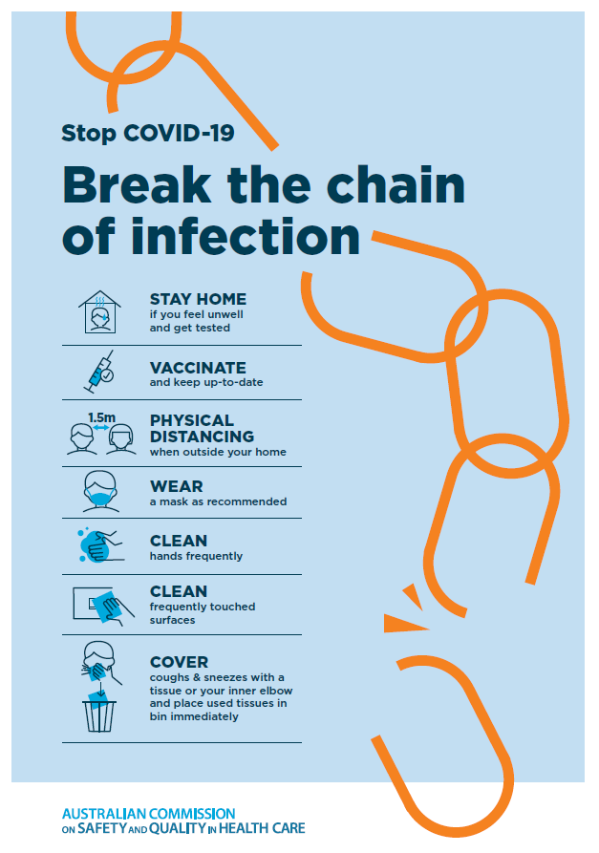](https://www.safetyandquality.gov.au/publications-and-resources/resource-library/break-chain-poster-a3https:/www.safetyandquality.gov.au/publications-and-resources/resource-library/break-chain-poster-a3)**
* ***FAQs for clinicians on elective surgery*** <https://www.safetyandquality.gov.au/node/5724>
* ***FAQs for consumers on elective surgery*** <https://www.safetyandquality.gov.au/node/5725>
* ***COVID-19 and face masks – Information for consumers*** <https://www.safetyandquality.gov.au/publications-and-resources/resource-library/covid-19-and-face-masks-information-consumers>

[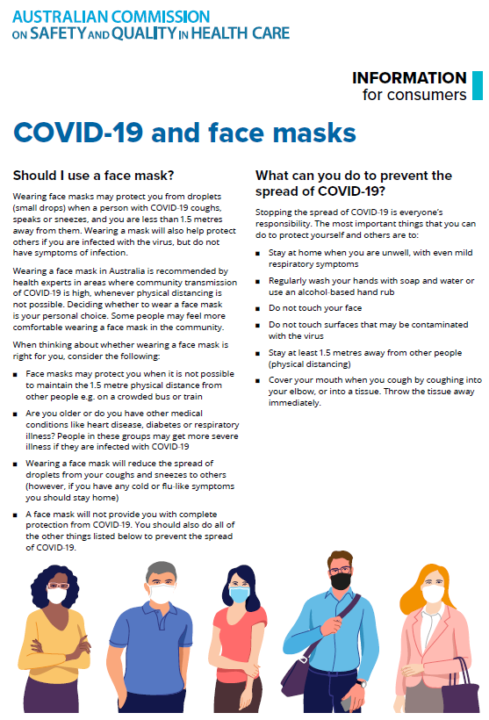](https://www.safetyandquality.gov.au/sites/default/files/2020-07/covid-19_and_face_masks_-_information_for_consumers.pdf)

*National COVID-19 Clinical Evidence Taskforce*

<https://covid19evidence.net.au/>

The National COVID-19 Clinical Evidence Taskforce is a collaboration of peak health professional bodies across Australia whose members are providing clinical care to people with COVID-19. The taskforce is undertaking continuous evidence surveillance to identify and rapidly synthesise emerging research in order to provide national, **evidence-based guidelines and clinical flowcharts for the clinical care of people with COVID-19**. The guidelines address questions that are specific to managing COVID-19 and cover the full disease course across mild, moderate, severe and critical illness. These are ‘living’ guidelines, updated with new research in near real-time in order to give reliable, up-to-the minute advice to clinicians providing frontline care in this unprecedented global health crisis.

*COVID-19 Critical Intelligence Unit*

<https://www.aci.health.nsw.gov.au/covid-19/critical-intelligence-unit>

The Agency for Clinical Innovation (ACI) in New South Wales has developed this page summarising rapid, evidence-based advice during the COVID-19 pandemic. Its operations focus on systems intelligence, clinical intelligence and evidence integration. The content includes a daily evidence digest, a COVID status monitor, a risk monitoring dashboard and evidence checks on a discrete topic or question relating to the current COVID-19 pandemic. There is also a ‘Living evidence’ section summarising key studies and emerging evidence on **COVID-19 vaccines** and **SARS-CoV-2 variants**. The most recent updates include:

* ***Respiratory therapies and COVID-19*** – What is the evidence for the use of respiratory therapies for the management of COVID-19?
* ***Hospitalisation and ICU admission relative risk*** – What is the evidence for the relative risk of hospitalisation and ICU admission for vaccinated versus unvaccinated people?
* ***Foetal and neonatal outcomes of COVID-19 in pregnancy*** – What evidence is available for adverse foetal and neonatal outcomes, for example miscarriage, stillbirth and neonatal death, associated with COVID-19 infection during pregnancy?
* ***De-isolation and risk of transmission*** – What is the evidence for de-isolation and the risk of COVID-19 transmission?
* ***Face masks and COVID-19 transmission in the community*** – What is the evidence for the effectiveness of face masks in community settings for reducing influenza-like illnesses, including COVID-19?
* ***COVID-19 vaccines in Australia*** – What is the evidence on COVID-19 vaccines in Australia?

**Disclaimer**

On the Radar is an information resource of the Australian Commission on Safety and Quality in Health Care. The Commission is not responsible for the content of, nor does it endorse, any articles or sites listed. The Commission accepts no liability for the information or advice provided by these external links. Links are provided on the basis that users make their own decisions about the accuracy, currency and reliability of the information contained therein. Any opinions expressed are not necessarily those of the Australian Commission on Safety and Quality in Health Care.