# Australian Commission on Safety and Quality in Health Care logo with Radar imageOn the Radar

Issue 540

6 December 2021

*On the Radar* is a summary of some of the recent publications in the areas of safety and quality in health care. Inclusion in this document is not an endorsement or recommendation of any publication or provider. Access to particular documents may depend on whether they are Open Access or not, and/or your individual or institutional access to subscription sites/services. Material that may require subscription is included as it is considered relevant.

*On the Radar* is available online, via email or as a PDF or Word document from <https://www.safetyandquality.gov.au/publications-and-resources/newsletters/radar>

If you would like to receive *On the Radar* via email, you can subscribe on our website <https://www.safetyandquality.gov.au/publications-and-resources/newsletters>  
or by emailing us at H[Umail@safetyandquality.gov.auU](mailto:mail@safetyandquality.gov.au).   
You can also send feedback and comments to H[Umail@safetyandquality.gov.auU](mailto:mail@safetyandquality.gov.au).

For information about the Commission and its programs and publications, please visit <https://www.safetyandquality.gov.au>

You can also follow us on Twitter @ACSQHC.

**On the Radar**

Editor: Dr Niall Johnson [niall.johnson@safetyandquality.gov.au](mailto:niall.johnson@safetyandquality.gov.au)

Contributors: Niall Johnson

**Reports**

*A Roadmap for Artificial Intelligence in Healthcare for Australia*

Australian Alliance for Artificial Intelligence in Healthcare

Sydney: Australian Alliance for Artificial Intelligence in Healthcare; 2021.

|  |  |
| --- | --- |
| URL | <https://aihealthalliance.org/2021/12/01/a-roadmap-for-ai-in-healthcare-for-australia/> |
| Notes | The Australian Alliance for Artificial Intelligence in Healthcare (AAAiH) has released their *Roadmap for Artificial Intelligence in Healthcare for Australia*. The Roadmap suggests the path that Australia should take to embrace the opportunities that Artificial Intelligence (AI) offers in healthcare. The Roadmap identifies the current gaps in Australia’s capability to translate AI into effective and safe clinical services and provides guidance on key issues such as workforce, industry capability, implementation, regulation, and cybersecurity, while also acknowledging the extensive work already undertaken. The AAAiH has developed the Roadmap through community consultation and a national survey conducted over July to August 2021.  The Roadmap ‘provides 24 recommendations across eight priority areas. The highest community priority identified was for healthcare AI to be safe for patients and developed and used ethically. AI privacy and data security was a major concern. Respondents also identified the need for genuine whole-of-nation leadership in the healthcare AI space as well as robust governance of the sector. Gaps in our workforce capability to build and use healthcare AI were clearly identified as was the need for consumers to be fully engaged in shaping the healthcare AI agenda. Respondents also rated the gaps in our capability to adopt AI into practice and the need to enhance local industry capability as issues needing clear attention.’ |

**Journal articles**

*Safety and Outcomes of Midline Catheters vs Peripherally Inserted Central Catheters for Patients With Short-term Indications: A Multicenter Study*

Swaminathan L, Flanders S, Horowitz J, Zhang Q, O’Malley M, Chopra V

JAMA Internal Medicine. 2021 [epub].

|  |  |
| --- | --- |
| DOI | <https://doi.org/10.1001/jamainternmed.2021.6844> |
| Notes | Study seeking to answer the question as to whether ‘In patients with difficult intravenous access or those who require short-term intravenous antibiotics, are midline catheters safer than peripherally inserted central catheters (PICCs)?’ This cohort study involved 10 863 patients across multiple hospitals who received 5758 PICCs and 5105 midlines for difficult access or short-term antibiotic therapy. The result included ‘patients who received PICCs had a greater risk of developing a major complication compared with those who received midlines (odds ratio, 1.99; 95% CI, 1.61-2.47). Reduction in complications stemmed from lower rates of occlusion (2.1% vs 7.0%; P < .001) and bloodstream infection (0.4% vs 1.6%; P < .001) in midlines vs PICCs’. The authors suggest that ‘Judicious use of midlines over PICCs may improve patient safety; randomized clinical trials to compare these devices appear necessary.’ |

For information on the *Management of Peripheral Intravenous Catheters Clinical Care Standard*, see <https://www.safetyandquality.gov.au/standards/clinical-care-standards/management-peripheral-intravenous-catheters-clinical-care-standard>

*Integrating shared decision-making into primary care: lessons learned from a multi-centre feasibility randomized controlled trial*

Yu CH, Medleg F, Choi D, Spagnuolo CM, Pinnaduwage L, Straus SE, et al

BMC Medical Informatics and Decision Making. 2021;21(1):323.

|  |  |
| --- | --- |
| DOI | <https://doi.org/10.1186/s12911-021-01673-w> |
| Notes | Piece describing a the integration of a diabetes shared decision aid (*MyDiabetesPlan*) into primary care while also assessing the feasibility of cluster randomised control trial of the aid. The project involved 10 ‘10 interprofessional primary care clinics with patients living with diabetes and at least two other comorbidities; half of the clinics were assigned to *MyDiabetesPlan* and half were assigned to usual care.’ *MyDiabetesPlan* is a described as ‘a web-based, interactive patient decision aid that facilitates patient-centred, diabetes-specific, goal-setting and shared decision-making (SDM) with interprofessional health care teams’. The project saw 213 patients participate, with 151 completing the study. While the of diabetes-specific appointments and use of *MyDiabetesPlan* was lower than anticipated, the authors argue that ‘An interprofessional approach to SDM using a decision aid was feasible’ and identified that the barriers to use ‘included clinician-related, patient-related, and technical factors’ and that ‘Addressing facilitators and barriers identified in this study will promote more seamless integration into clinical care.’ |

For information on the Commission’s work on shared decision making, see <https://www.safetyandquality.gov.au/our-work/partnering-consumers/shared-decision-making>

*Journal of Patient Safety and Risk Management*

Volume: 26, Number: 6 (December 2021)

|  |  |
| --- | --- |
| URL | <https://journals.sagepub.com/toc/cric/26/6> |
| Notes | A new issue of the *Journal of Patient Safety and Risk Management* has been published. Articles in this issue of the *Journal of Patient Safety and Risk Management* include:   * Editorial: **Patient safety in long-term care facilities and the COVID-19 pandemic** (Albert W Wu, John McIntyre) * Kendal at Ithaca **beats COVID-19** (Charles Wilcox) * **“We’re on our way:”** A message from the mountains (Annegret F Hannawa) * **Point of care testing** using rapid automated antigen testing **for SARS-COV-2 in care homes** – an exploratory safety, usability and diagnostic agreement evaluation (Massimo Micocci, Peter Buckle, Gail Hayward, A Joy Allen, Kerrie Davies, Patrick Kierkegaard, Karen Spilsbury, Carl Thompson, Anita Astle, Ros Heath, C Sharpe, C Akrill, D Lasserson, R Perera, R Body, A L Gordon) * **Improving self-reported empathy and communication skills** through harm in healthcare response training (Aimee Samuels, Marion E Broome, Timothy B McDonald, Chii-Hui Peterson, Julie A Thompson) * Differences in **adverse drug events and medication errors among pediatric inpatients** aged <3 and ≥3 years: The JADE study (Jiro Takeuchi, Mio Sakuma, Yoshinori Ohta, Hiroyuki Ida, Takeshi Morimoto) * **Consumer background and composition on state medical boards**: Who are these citizen members and do they adequately protect the public? (Doug Wojcieszak) |

*Journal of Patient Safety*

Vol. 17, No. 8, December 2021

|  |  |
| --- | --- |
| URL | <https://journals.lww.com/journalpatientsafety/toc/2021/12000> |
| Notes | A new issue of the *Journal of Patient Safety* has been published with an almost ridiculous number of articles. Is this a case of clearing the decks for the end of the year or the joys of digital publishing and freedom from page limits? The very long Table of Contents certainly includes many interesting articles. Articles in this issue of the *Journal of Patient Safety* include:   * Validation of the **Second Victim Experience and Support Tool**-Revised in the Neonatal Intensive Care Unit (Adrien M Winning, Jenna Merandi, Joseph R Rausch, Nancy Liao, James M Hoffman, J D Burlison, C A Gerhardt) * **Ranking Quality and Patient Safety Challenges**: A Nationwide Survey of Healthcare Quality Experts From General Hospitals in Spain (Cristina Gordo, Ricardo Mateo, Juana Labiano, Jorge M Núñez-Córdoba) * Can Routinely Collected, Patient-Reported Wellness Predict **National Early Warning Scores**? A Multilevel Modeling Approach (Abigail Albutt, Jane O’Hara, Mark Conner, Rebecca Lawton) * Does an Orthopedic **Ward Round Pro Forma Improve Inpatient Documentation**? (Danilo Vukanic, Enda G Kelly, Susan May Cleary) * **Inpatient Respiratory Arrest** Associated With Sedative and Analgesic Medications: Impact of Continuous Monitoring on Patient Mortality and Severe Morbidity (Susan P McGrath, Krystal M McGovern, Irina M Perreard, Viola Huang, Linzi B Moss, George T. Blike) * Defining the Epidemiology of **Safety Risks in Neonatal Intensive Care Unit Patients** Requiring Surgery (Daniel J France, Jason Slagle, Emma Schremp, Sarah Moroz, L Dupree Hatch, Peter Grubb, Timothy J Vogus, Matthew S Shotwell, Amanda Lorinc, Christoph U Lehmann, J Robinson, M Crankshaw, M Sullivan, T A Newman, T Wallace, M B Weinger, M L Blakely) * Risk Factors for **Adverse Events in Patients With Breast, Colorectal, and Lung Cancer** (Saul N Weingart, Coral L Atoria, David Pfister, David Classen, Aileen Killen, E Fortier, A S Epstein, C Anderson, A Lipitz-Snyderman) * UDI2Claims: Planning a Pilot Project to Transmit **Identifiers for Implanted Devices** to the Insurance Claim (Yasmin A Zerhouni, Dan C Krupka, Jove Graham, Adam Landman, Angela Li, Deepak L Bhatt, Louis L Nguyen, Kevin Capatch, Kevin Concheri, Amanda J Reich, Natalia Wilson, Joel S Weissman) * Evaluation of Automated Video Monitoring to Decrease the Risk of **Unattended Bed Exits in Small Rural Hospitals** (Katherine J Jones, Gleb Haynatzki, Lucas Sabalka) * Clinicians’ Attitudes and System Capacity Regarding **Transitional Care Practices Within a Health System**: Survey Results From the Partners-PCORI Transitions Study (Cherlie Magny-Normilus, Nyryan Nolido, Lipika Samal, Ryan Thompson, Gwen Crevensten, Jeffrey L Schnipper) * **Medical Error Disclosure**: Developing Evidence-Based Guidelines for Chinese Hospitals (Xiuzhu Gu, Mingming Deng) * The Impacts of Disclosure and a Proactive Compensation Offer on **Chinese Patients’ Actions After Medical Errors** (Xiuzhu Gu, Mingming Deng) * Patient and Physician Experience with **Interhospital Transfer**: A Qualitative Study (Stephanie K Mueller, Evan Shannon, A Dalal, J L Schnipper, P Dykes) * A Monte Carlo Simulation to Estimate the Additional Cost Associated With **Adverse Medication Events Leading to Intraoperative Hypotension and/or Hypertension** in the United States (Karen C Nanji, Sofia D Shaikh, Alireza Jaffari, Calvin Franz, David W Bates) * Improving **Patient Safety in Public Hospitals**: Developing Standard Measures to Track Medical Errors and Process Breakdowns (Sara L Ackerman, Gato Gourley, Gem Le, Pamela Williams, J Yazdany, U Sarkar) * Tackling **Ambulatory Safety Risks** Through Patient Engagement: What 10,000 Patients and Families Say About Safety-Related Knowledge, Behaviors, and Attitudes After Reading Visit Notes (Sigall K Bell, Patricia Folcarelli, Alan Fossa, Macda Gerard, Marvin Harper, Suzanne Leveille, Caroline Moore, Kenneth E Sands, Barbara Sarnoff Lee, Jan Walker, Fabienne Bourgeois) * Eyes and Ears on Patient Safety: **Sources of Notifications About the Health, Performance, and Conduct of Health Practitioners** (Marie Bismark, Holly Tibble, Jennifer Schulz Moore, Jennifer Michelle Morris, Ron Paterson, Martin Fletcher, David Studdert) * “The Invisible Staff”: A Qualitative Analysis of Environmental Service Workers’ Perceptions of the VA ***Clostridium difficile* Prevention Bundle** Using a Human Factors Engineering Approach (Eric Yanke, Helene Moriarty, Pascale Carayon, Nasia Safdar) * **Power Failures During Surgery**: A 2000–2019 Review of Reported Events in the Veterans Health Administration (Christina Soncrant, Peter D Mills, Lisa Zubkoff, Julia Neily, Lisa Mazzia, Lisa J Warner, William Gunnar) * Review of Reported **Adverse Events Occurring Among the Homeless Veteran Population** in the Veterans Health Administration (Christina Soncrant, Peter D Mills, Robin P Pendley Louis, William Gunnar) * A Machine Learning Approach to **Reclassifying Miscellaneous Patient Safety Event Reports** (Allan Fong, Shabnam Behzad, Z Pruitt, R M Ratwani) * Multicenter Test of an **Emergency Department Trigger Tool for Detecting Adverse Events** (Richard T Griffey, Ryan M Schneider, Brian R Sharp, Jeff Pothof, Marie C Vrablik, Nic Granzella, A A Todorov, L Adler) * Factors Related to **Medication Administration Incidents** in England and Wales Between 2007 and 2016: A Retrospective Trend Analysis (Marja Härkänen, Katri Vehviläinen-Julkunen, Bryony Dean Franklin, Trevor Murrells, Anne Marie Rafferty) * Avoidable Adverse Events Related to Ignoring the **Do-Not-Do Recommendations**: A Retrospective Cohort Study Conducted in the Spanish Primary Care Setting (José Joaquín Mira, Irene Carrillo, Pastora Pérez-Pérez, Maria Pilar Astier-Peña, Johanna Caro-Mendivelso, Guadalupe Olivera, Carmen Silvestre, Mª Angeles Nuín, Jesús M. Aranaz-Andrés, on behalf the SOBRINA Research Team) * **Patient-Reported Dental Safety Events**: A South African Perspective (Enihomo Obadan-Udoh, Sophy Van der Berg-Cloete, Rachel Ramoni, Elsbeth Kalenderian, John George White) * Perspectives of **Dental Patients About Safety Incident Reporting**: A Qualitative Pilot Study (Enihomo M Obadan-Udoh, Arti Gharpure, Joo Hyun Lee, Jason Pang, Anuradha Nayudu) * Qualitative Content Analysis of Coworkers’ Safety Reports of **Unprofessional Behavior by Physicians and Advanced Practice Professionals** (William Martinez, James W Pichert, Gerald B Hickson, Casey H Braddy, Amy J Brown, T F Catron, I N Moore, M R Stampfle, L E Webb, W O Cooper) * Health Systems Factors Associated With **Adverse Events Among Hospitalized Obstetric Clients** in a Tertiary Health Care Facility in Ghana (Elom Hillary Otchi, Reuben Kwasi Esena, Emmanuel Srofenyoh, Emmanuel Ogbada Ameh, Kwaku Asah-Opoku, Titus Beyuo, Sebastian Ken-Amoah, Frederick Oduro, Evans Kofi Agbeno, Kissinger Marfo) * A Review of **Adverse Event Reports From Emergency Departments** in the Veterans Health Administration (Sonia Gill, Peter D Mills, Bradley V Watts, Douglas E Paull, Anne Tomolo) * A Study on the Status and Contributory Factors of **Adverse Events Due to Negligence in Nursing Care** (Min Ji Kim, Seung Gyeong Jang, In Sook Kim, Won Lee) * **Retained Guidewires** in the Veterans Health Administration: Getting to the Root of the Problem (Leila Cherara, Gary L Sculli, Douglas E Paull, Lisa Mazzia, Julia Neily, Peter D Mills) * Applying **Intelligent Algorithms to Automate the Identification of Error Factors** (Haizhe Jin, Qingxing Qu, Masahiko Munechika, Masataka Sano, Chisato Kajihara, Vincent G Duffy, Han Chen) * Evidence That **Nurses Need to Participate in Diagnosis**: Lessons From Malpractice Claims (Kelly Therese Gleason, Rebecca Jones, Christopher Rhodes, Penny Greenberg, Gene Harkless, C Goeschel, M Cahill, M Graber) * Impact of **Patient Safety Incidents Reported by the General Public** in Korea (Jeehee Pyo, Won Lee, Seung Gyeong Jang, E Y Choi, M Ock, S-I Lee) * **Perception Gaps of Disclosure of Patient Safety Incidents** Between Nurses and the General Public in Korea (Eun Young Choi, Jeehee Pyo, Won Lee, Seung Gyeong Jang, Young-Kwon Park, Minsu Ock, Haeyoung Lee) * Validating a **Trigger Tool for Detecting Adverse Drug Events in Elderly Patients** With Multimorbidity (TRIGGER-CHRON) (María Dolores Toscano Guzmán, Mercedes Galván Banqueri, María José Otero, Susana Sánchez Fidalgo, Isabel Font Noguera, María Concepción Pérez Guerrero) * **Emergency Physician Perceptions of Electronic Health Record Usability and Safety** (Zoe M Pruitt, J L Howe, A Z Hettinger, R M Ratwani) * Identifying **Health Information Technology Usability Issues Contributing to Medication Errors** Across Medication Process Stages (K T Adams, Z Pruitt, S Kazi, A Z Hettinger, J L Howe, A Fong, R M Ratwani) * The **Effect of Clinical Volume on Annual and Per-Patient Encounter Medical Malpractice Claims Risk** (Adam C Schaffer, Astrid Babayan, Chihwen Winnie Yu-Moe, Luke Sato, Jonathan S Einbinder) * Registration and Management of **“Never Events” in Swiss Hospitals**—The Perspective of Clinical Risk Managers (David L B Schwappach, Y Pfeiffer) * **Training Situational Awareness for Patient Safety** in a Room of Horrors: An Evaluation of a Low-Fidelity Simulation Method (Chantal Zimmermann, Annemarie Fridrich, David L B Schwappach) * **Hypoglycemia While Driving** in Insulin-Treated Patients: Incidence and Risk Factors (Laura Lohan, Florian Clément, Claire Duflos, Maxime Villiet, Audrey Castet-Nicolas, Catherine Boegner, A Avignon, A Sultan, C Breuker) * **Adverse Drug Events Detected by Clinical Pharmacists in an Emergency Department**: A Prospective Monocentric Observational Study (Marion Laureau, Olivier Vuillot, Vincent Gourhant, Damien Perier, Véronique Pinzani, Laura Lohan, Marie Faucanie, Valérie Macioce, G Marin, I Giraud, A Jalabert, M Villiet, A Castet-Nicolas, M Sebbane, C Breuker) * **Burnout, Engagement, and Dental Errors Among U.S. Dentists** (Alfa Yansane, Oluwabunmi Tokede, Muhammad Walji, Enihomo Obadan-Udoh, Christine Riedy, Joel White, Elsbeth Kalenderian) * **Patient Safety in Hospitals**: What We Do and What We Need—Focus Groups With Stakeholders of Hospitals in Southern Germany (Julia Dinius, Rainer Gaupp, Sonja Becker, Anja S Göritz, Mirjam Körner) * Hydrophilic Polymer Embolism: Implications for Manufacturing, Regulation, and Postmarket Surveillance of **Coated Intravascular Medical Devices** (Rashi I Mehta, Rupal I Mehta) * Quantifying **Dental Office–Originating Adverse Events**: The Dental Practice Study Methods (Oluwabunmi Tokede, Muhammad Walji, Rachel Ramoni, Donald B Rindal, Donald Worley, Nutan Hebballi, Krishna Kumar, Claire van Strien, Mengxia Chen, S Navat-Pelli, H Liu, J Etolue, A Yansane, E Obadan-Udoh, C Easterday, C Enstad, S Kane, W Rush, E Kalenderian) * Characteristics of **Medical Professional Liability Claims in Pediatric Orthopedics** (Jessica Burns, M Wade Shrader, Carla Boan, Mohan Belthur) * Improving **Patient Safety Culture**: A Report of a Multifaceted Intervention (Tom Basson, Alfred Montoya, Julia Neily, Lisa Harmon, Bradley V Watts) * Application of a Healthcare Failure Modes and Effects Analysis to Identify and Mitigate Potential Risks in the Implementation of a **National Prehospital Pediatric Rapid Sequence Intubation Program** (Ian Howard, Nicholas Castle, Loua Asad Al Shaikh) * Prevalence and Factors Associated With **Polypharmacy Use Among Adult Patients** in Saudi Arabia (Bander Balkhi, Nasser AlQahtani, Monira Alwhaibi, Thamir M Alshammari, Tariq M Alhawassi, Mansour A Mahmoud, Mansour Almetwazi, Sondus Ata, Mada Basyoni, Hisham Aljadhey) * Rapid Response: To Scan or Not to Scan? The Utility of **Noncontrast CT Head for Altered Mental Status** (Purujit J Thacker, Mansha Sethi, Jonathan Sternlieb, Doron Schneider, Mary Naglak, Rajeshkumar R Patel) * “It Matters What I Think, Not What You Say”: Scientific Evidence for a **Medical Error Disclosure Competence (MEDC) Model** (Annegret F Hannawa, Richard M Frankel) * Maintaining Updated Patient’s Medication Records: Introduction of an **Order-on-Behalf Service by Pharmacists** (Chunliang Chen, Szu Liang Hie, Ai Shing Ng) * **Long-Term Impacts Faced by Patients and Families After Harmful Healthcare Events** (Madelene J Ottosen, Emily W Sedlock, Aitebureme O Aigbe, Sigall K Bell, Thomas H Gallagher, Eric J Thomas) * Validation of a **Falls Risk Screening Tool** Derived From InterRAI Acute Care Assessment (Nancye May Peel, Lee Vanessa Jones, Katherine Berg, Leonard Charles Gray) * **Patient-Reported Experience in the Pediatric Emergency Department**: What Matters Most? (Mher Barbarian, Andrea Bishop, Patricia Alfaro, Alain Biron, Daniel Adam Brody, Gabrielle Cunningham-Allard, A S Dubrovsky) * Trends and Determinants of **Polypharmacy and Potential Drug-Drug Interactions at Discharge From Hospital** Between 2009–2015 (Nazanin Abolhassani, Julien Castioni, Valérie Santschi, G Waeber, P Marques-Vidal) * What **Severe Medication Errors** Reported to Health Care Supervisory Authority Tell About Medication Safety? (Carita Linden-Lahti, Anna Takala, Anna-Riia Holmström, Marja Airaksinen) * Inconsistencies Between Two Cross-Cultural Adaptations of the **Hospital Survey on Patient Safety Culture** Into French (Bastien Boussat, Patrice François, Gérald Gandon, Joris Giai, A Seigneurin, T Perneger, J Labarère) * **Involvement in Root Cause Analysis and Patient Safety Culture** Among Hospital Care Providers (Bastien Boussat, Arnaud Seigneurin, Joris Giai, Kevin Kamalanavin, José Labarère, Patrice François) * **National Patient Safety Program in Brazil**: Incidents Reported Between 2014 and 2017 (Tássia Nery Faustino, Edenise Maria Santos da Silva Batalha, Silvana Lima Vieira, Andressa Garcia Nicole, Alexandre Souza Morais, Daisy Maria Rizatto Tronchin, Marta Maria Melleiro) * Assessing **Resident Safety Culture in Six Nursing Homes** in Belgium (Melissa Desmedt, Mirko Petrovic, Petra Beuckelaere, Dominique Vandijck) * Exploring and **Evaluating Patient Safety Culture in a Community-Based Primary Care** Setting (Melissa Desmedt, Jochen Bergs, Benjamin Willaert, Ward Schrooten, Annemie Vlayen, Johan Hellings, Neree Claes, D Vandijck) * A Library of Logic Models to Explain **How Interventions to Reduce Diagnostic Errors Work** (Maartje Kletter, G J Melendez-Torres, Richard Lilford, Celia Taylor) * Improving **Pediatric Drug Safety in Prehospital Emergency Care**—10 Years on (Jost Kaufmann, Stefanie Uhl, Eva Singer, Frank Eifinger, Tobias Klein, Alex Lechleuthner, Thomas Engelhardt, Frank Wappler, A Böhmer) * Satisfaction and Barriers of **Surgical Safety Checklist Implementation** in a Nonmandatory Adoption Resource-Limited Country (Nongyao Kasatpibal, Somjai Sirakamon, Yodying Punjasawadwong, Jittaporn Chitreecheur, Narain Chotirosniramit, Parichat Pakvipas, JoAnne D Whitney) * Incidence and Causes of **Adverse Events in Diagnostic Radiological Studies Requiring Anesthesia** in the Wake-Up Safe Registry (Asad A Khawaja, Dmitry Tumin, Ralph J Beltran, Joseph D Tobias, Joshua C Uffman) * **Double Reading of Outsourced CT/MR Radiology Reports**: Retrospective Analysis (Jean-François Vendrell, Julien Frandon, Bastien Boussat, François Cotton, G Ferretti, N Sans, J-P Tasu, J-P Beregi, A Larbi) * Characteristics of Inpatient Units Associated With **Sustained Hand Hygiene Compliance** (Jonathan D Wolfe, Henry J Domenico, Gerald B Hickson, Deede Wang, Marilyn Dubree, Nancye Feistritzer, Nancy Wells, T R Talbot) * **Encouraging Patients to Speak up** About Problems in Cancer Care (Kathleen M Mazor, Aruna Kamineni, Douglas W Roblin, Jane Anau, Brandi E Robinson, Benjamin Dunlap, Cassandra Firneno, Thomas H Gallagher) * Evolving Factors in Hospital Safety: A Systematic Review and Meta-Analysis of **Hospital Adverse Events** (Khara M Sauro, Matthew Machan, Liam Whalen-Browne, Victoria Owen, Guosong Wu, Henry T Stelfox) * Barriers and Facilitators to **Central Venous Catheter Insertion**: A Qualitative Study (Kenzie A Cameron, Elaine R Cohen, Joelle R Hertz, Diane B Wayne, Debi Mitra, Jeffrey H Barsuk) * Psychometric Analysis of a **Survey on Patient Safety Culture–Based Tool for Emergency Medical Services** (Remle P Crowe, Rebecca E Cash, Alex Christgen, Tina Hilmas, L Varner, A Vogelsmeier, W S Gilmore, A R Panchal) * **Magnetic Resonance Imaging in Neurocritically Ill Patients**: Who Fails and How? (Joong-Goo Kim, Myung-Ah Ko, Han-Bin Lee, Sang-Beom Jeon) * **Neurological Emergencies in Patients Hospitalized** With Nonneurological Illness (Sang-Beom Jeon, Han-Bin Lee, Yong Seo Koo, Hyunjo Lee, Jung Hwa Lee, Bobin Park, Soh Hyun Choi, Suyeon Jeong, Jun Young Chang, Sang-Bum Hong, Chae-Man Lim, Sang-Ahm Lee) * Improving **Venous Thromboembolism Prophylaxis** Administration in an Acute Surgical Unit (M G R Allaway, G D Eslick, G T Y Kwok, M R Cox) * Sustained Impact of a **Pediatric Resident-Led Patient Safety Council** (Victoria Parente, Colby Feeney, Laura Page, Shaina Johnson, Kelsey Porada, Ira Cheifetz, Alyssa Stephany) * Differences in **Safety Report Event Types Submitted by Graduate Medical Education Trainees** Compared With Other Healthcare Team Members (Sarah P Cohen, Heather S McLean, Judy Milne, Victoria Parente) * How to Identify **Organizational High-Alert Medications** (Lotta Schepel, Lasse Lehtonen, Marja Airaksinen, Outi Lapatto-Reiniluoto) * Improving Documentation of **Inpatient Problem List in Electronic Health Record**: A Quality Improvement Project (Prabi Rajbhandari, Moises Auron, Sarah Worley, Michelle Marks) * Improvement of the P**atient Safety Culture in the Primary Health Care** Corporation – Qatar (Mohamad El Zoghbi, Saad Farooq, Ali Abulaban, Heba Taha, Sajna Ajanaz, Jawaher Aljasmi, Shakil Ahmad, Hana Said) * **Patient Safety Incidents in Primary Care Dentistry** in England and Wales: A Mixed-Methods Study (Eduardo Ensaldo-Carrasco, Asiyah Sheikh, Kathrin Cresswell, Raman Bedi, Andrew Carson-Stevens, Aziz Sheikh) * Understanding the Types and Effects of **Clinical Interruptions and Distractions Recorded in a Multihospital Patient Safety Reporting System** (K M Kellogg, J S Puthumana, A Fong, K T Adams, R M Ratwani) * Cross-Cultural Adaptation and Psychometric Evaluation of a **Second Victim Experience and Support Tool (SVEST)** (Maria Victoria Brunelli, Silvina Estrada, Constanza Celano) * Development and Validation of an Evaluation Tool of **Consumers’ Knowledge and Confidence to Report Patient Deterioration in Hospitals** (Lindy King, Shahid Ullah, Ingrid Belan, Robyn A Clark, Tom Young, Hugh Grantham, Guy Peacock, Michael R Kidd) * You’re Worried, We’re Listening: Online Testing of the Effectiveness of Education Materials to Improve **Consumer Knowledge and Confidence in Reporting Patient Deterioration** (Lindy King, Shahid Ullah, Ingrid Belan, Robyn A Clark, Tom Young, Hugh Grantham, Guy Peacock, Michael R Kidd) * A Practical Guide for Building **Collaborations Between Clinical Researchers and Engineers**: Lessons Learned From a Multidisciplinary Patient Safety Project (Roshun R Sankaran, Jessica M Ameling, Amy E M Cohn, Cyril M Grum, Jennifer Meddings) * **Risk Management in the Ambulatory Care Process** in a Mutual Benefit Association Covering Work-Related Accidents and Diseases: Applying Modified Failure Mode and Effect Analysis (FMEA) Methodology (Norma Grau, Rafael Manzanera, Carola Orrego, Jordi Ortner, Albert Vives, Carme Saurí, Diego Moya, José Miguel Martínez) * **Interruptions to Intensive Care Nurses and Clinical Errors and Procedural Failures**: A Controlled Study of Causal Connection (Chiara Santomauro, Madeleine Powell, C Davis, D Liu, L M Aitken, P Sanderson) * Defining **Patient Safety Events in Inpatient Psychiatry** (Steven C Marcus, Richard C Hermann, Sara Wiesel Cullen) * **Extended Patient Alone Time in Emergency Department** Leads to Increased Risk of 30-Day Hospitalization (Adam J Van Deusen, Kalyan S Pasupathy, Todd R Huschka, Heather A Heaton, T R Hellmich, M Y Sir) * Does Free-Text Information in **Falls Incident Reports** Assist to Explain How and Why the Falls Occurred in a Hospital Setting? (Lex D de Jong, Jacqueline Francis-Coad, Nicholas Waldron, Katharine Ingram, Steven M McPhail, C Etherton-Beer, T P Haines, L Flicker, T Weselman, A-M Hill) * **Patients Own Safety Incidents Reports** to the Danish Patient Safety Database Possess a Unique but Underused Learning Potential in Patient Safety (Anders Bech Christiansen, Simon Simonsen, Gert Allan Nielsen) * **The Second Victim**: A Contested Term? (Mary-Elizabeth Tumelty) * Clinical, Economic, and Organizational Impact of the **Clinical Pharmacist in an Orthopedic and Trauma Surgery Department** (Pierre Renaudin, Annabelle Coste, Yohan Audurier, Julie Berbis, François Canovas, Anne Jalabert, Audrey Castet-Nicolas, G Mercier, M Villiet, L Dagneaux, C Breuker) * Examining Medical Office Owners and Clinicians Perceptions on **Patient Safety Climate** (Olena Mazurenko, Jason Richter, Abby S Kazley, E Ford) * The **Ambulatory Version of the Safety Attitude Questionnaire**: Psychometric Validation and Measurement Properties in Nigerian Clinical Setting (Daprim Samuel Ogaji, Mabel Emudiaga-Ohwerhi, A D Adesina) * The Association of the **Nurse Work Environment and Patient Safety in Pediatric Acute Care** (Eileen T Lake, Kathryn E Roberts, Paula D Agosto, Elizabeth Ely, Amanda P Bettencourt, Elizabeth S Schierholz, Warren D Frankenberger, Gianluca Catania, Linda H Aiken) * Establishing a **Culture of Patient Safety, Quality, and Service in Plastic Surgery:** Integrating the Fractal Model (Michele A Manahan, Jeffrey W Aston, R J Bello, C Siotos, R Demski, C M Cooney, P J Pronovost, G D Rosson) * **Health Information and the Quality and Safety of Care for People With Disability**: An Analysis of Australian Reports of Reviewable Deaths in Residential Care (Maria R Dahm, Andrew Georgiou, Susan Balandin, Sophie Hill, Bronwyn Hemsley) * Developing Evidence for New **Patient Safety Bundles** Through Multihospital Collaboration (Anne Lyren, Aaron Dawson, David Purcell, James M Hoffman, Lloyd Provost) * Predictors of **Serious Opioid-Related Adverse Drug Events in Hospitalized Patients** (Faisal Syed Minhaj, Stephen H Rappaport, Justin Foster, Lauren Z Gashlin) * Error Detection and Cost Savings With an Image-Based Workflow Management System Connected to a Computerized Prescription Order Entry Program for **Antineoplastic Compounding** (Maria Belén Marzal-Alfaro, Vicente Escudero-Vilaplana, Carmen G Rodríguez-González, E González-Haba, A Calvo, S Osorio, I Iglesias-Peinado, A Herranz, M Sanjurjo) * **Allergic Reactions Captured by Voluntary Reporting** (Kimberly G Blumenthal, Anna R Wolfson, Yu Li, Claire M. Seguin, Neelam A. Phadke, Aleena Banerji, Elizabeth Mort) * **Race Differences in Reported “Near Miss” Patient Safety Events** in Health Care System High Reliability Organizations (Angela D Thomas, Chinmay Pandit, Seth A Krevat) * Relationship Between **Work Experience and Safety Climate** in Veterans Affairs Nursing Homes Nationwide (Emma D Quach, Lewis E Kazis, Shibei Zhao, Sarah E McDannold, Valerie A Clark, Christine W Hartmann) * Nursing Home Senior Managers and Direct Care Staff: Are There Differences in Their **Perceptions of Safety Climate**? (Emma D Quach, Lewis E Kazis, Shibei Zhao, Sarah McDannold, Valerie Clark, Christine W Hartmann) * What Drives **Patients’ Complaints About Adverse Events in Their Hospital Care**? A Data Linkage Study of Australian Adults 45 Years and Older (Jennifer Case, Merrilyn Walton, Reema Harrison, Elizabeth Manias, Rick Iedema, Jennifer Smith-Merry) * Is **Physician Mentorship** Associated With the Occurrence of **Adverse Patient Safety Events**? (Reema Harrison, A Sharma, R Lawton, K Stewart) * Relationships Between **Nurses’ Work System, Safety-Related Performance, and Outcomes**: A Structural Equation Model (Jee-In Hwang, Sung Wan Kim, Hyeoun-Ae Park) * **Personality Traits and Traumatic Outcome Symptoms in Registered Nurses in the Aftermath of a Patient Safety Incident** (Mady C Stovall, Jenny Firkins, Lissi Hansen, Nathan F Dieckmann, Michelle van Ryn) * Systemic Causes of **In-Hospital Intravenous Medication Errors**: A Systematic Review (Sini Kuitunen, Ilona Niittynen, Marja Airaksinen, Anna-Riia Holmström) * Systemic Defenses to Prevent **Intravenous Medication Errors in Hospitals**: A Systematic Review (Sini Karoliina Kuitunen, Ilona Niittynen, Marja Airaksinen, Anna-Riia Holmström) * Pursuing **Patient Safety at the Intersection of Design, Systems Engineering, and Health Care Delivery Research**: An Ongoing Assessment (Kerm Henriksen, D Rodrick, E N Grace, M Shofer, P J Brady) * Psychometric Testing of the **Chinese Version of Second Victim Experience and Support Tool** (Xin Zhang, Jingli Chen, Shih-Yu Lee) * **High-Alert Medication Stratification Tool**—Revised Phase II: A Multisite Study Examining the Validity, Interrater Reliability, and Ease of Use of the High-Alert Medication Stratification Tool—Revised (McKenzie R Shenk, Natalie C Washburn, Sarah S Stephens, Gregory P Burger, James M Curtis, Jessalynn K Henney, Jamie L McCarthy, Kerri E Degenkolb, Andrew C Fritschle, Monica R Macik, Heather A Dossett, Todd A Walroth) * Next-of-Kin Involvement in **Regulatory Investigations of Adverse Events That Caused Patient Death**: A Process Evaluation (Part II: The Inspectors’ Perspective) (Siri Wiig, Lene Schibevaag, Rannveig Tvete Zachrisen, Einar Hannisdal, Janet E Anderson, Cecilie Haraldseid-Driftland) * Next of Kin Involvement in **Regulatory Investigations of Adverse Events That Caused Patient Death**: A Process Evaluation (Part I – The Next of Kin’s Perspective) (Siri Wiig, Cecilie Haraldseid-Driftland, Rannveig Tvete Zachrisen, Einar Hannisdal, Lene Schibevaag) * The Incidence and Nature of **Adverse Medical Device Events in Dutch Hospitals**: A Retrospective Patient Record Review Study (Petra J Porte, M Smits, L M Verweij, M C de Bruijne, C P M van der Vleuten, C Wagner) * Expert Consensus on Currently Accepted **Measures of Harm** (Merranda S Logan, Laura C Myers, Hojjat Salmasian, David Michael Levine, Christopher G Roy, Mark E Reynolds, Luke Sato, Carol Keohane, M L Frits, L A Volk, R N Akindele, J M Randazza, S M Dulgarian, D M Shahian, D W Bates, E Mort) * Knowledge, attitudes, and Expectations of Medical Staff Toward **Medical Error Management Policies** in Humanitarian Medicine: A Qualitative Study (Jean-Marc Biquet, Doris Schopper, Dominique Sprumont, Philippe Michel) * Content Analysis of **Patient Safety Incident Reports for Older Adult Patient Transfers, Handovers, and Discharges**: Do They Serve Organizations, Staff, or Patients? (Jason Scott, Pamela Dawson, Emily Heavey, Aoife De Brún, Andy Buttery, Justin Waring, Darren Flynn) * **Patients’ Perspectives of Diagnostic Error**: A Qualitative Study (Alden Y Sacco, Quinn R Self, Erica L Worswick, Cody J Couperus, Sree S Kolli, Sergio A Muñoz, Jan K Carney, Allen B Repp) * **Intersystem Medical Error Discovery**: A Document Analysis of Ethical Guidelines (Blake Duffy, Jacquelyn Miller, C Ann Vitous, Lesly A Dossett) * Safety Analysis of 13 **Suspicious Deaths in Intensive Care**: Ergonomics and Forensic Approach Compared (Riccardo Tartaglia, Stavros Prineas, Daniela Poli, Sara Albolino, T Bellandi, G Biancofiore, G Bertolini, G Toccafondi) * **In-Hospital Fall and Fracture Risk** With Conditions in the Elixhauser Comorbidity Index: An Analysis of State Inpatient Data (Jonathan Davis, Carri Casteel, Corinne Peek-Asa) * **Wheelchair Mobility–Related Injuries** Due to Inadvertent Lower Extremity Displacement on Footplates: Analysis of the FDA MAUDE Database From 2014 to 2018 (Maureen Whitford, Steven J Mitchell, George E Marzloff, Jennifer K Zindle, Mary Ann Richmond, Kath M Bogie, M Kristi Henzel) * **Patient Safety Threats** in Information Management Using Health Information Technology in **Ambulatory Cancer Care**: An Exploratory, Prospective Study (Yvonne Pfeiffer, C Zimmermann, D L B Schwappach) * Evaluation of Learning Teams Versus Root Cause Analysis for **Incident Investigation in a Large United Kingdom National Health Service Hospital** (Tim Robbins, Stephen Tipper, Justin King, Satya Krishna Ramachandran, Jaideep J Pandit, Meghana Pandit) * Psychometric Properties of the **Latin American Spanish Version of the Hospital Survey on Patient Safety Culture Questionnaire** in the Surgical Setting (Jose Andres Calvache, Edison Benavides, Sebastian Echeverry, Francisco Agredo, Robert Jan Stolker, Markus Klimek) * **Hospital-Acquired Conditions Reduction Program, Patient Safety, and Magnet Designation** in the United States (Hanadi Hamadi, S R Borkar, L Moody, A Tafili, J S Wilkes, P M Franco, D McCaughey, A Spaulding) * Prospective, Blinded Evaluation of **Template-Based Cesarean Documentation Error** in an Obstetric Training Program (William M Perez, Shilpa Babbar, Laura K Vricella) * Implementation of a Patient-Provider Agreement to Improve **Healthcare Delivery for** **Patients With Substance Use Disorder in the Inpatient Setting** (Alysse G Wurcel, Sun Yu, Deirdre Burke, Amy Lund, Kim Schelling, Saul N Weingart, Karen M Freund) * Proactive **Evaluation of an Operating Room Prototype**: A Simulation-Based Modeling Approach (Kevin Taaffe, Anjali Joseph, Amin Khoshkenar, Herminia Machry, David Allison, Scott T Reeves, RIPCHD.OR Study Group) * **Missed Nursing Care** in a Sample of High-Dependency Italian Nursing Home Residents: Description of Nursing Care in Action (Sara Campagna, Ines Basso, Elisa Vercelli, Marco Ranfone, A Dal Molin, V Dimonte, P Di Giulio) * Preventing **Operating Room Fires**: Impact of Surgical Drapes on Oxygen Contamination of the Operative Field (William C Culp, Jr, Kenisha W Muse) * The Effect of Padded Adhesive Dressing and Static Body Position on **Sacral Interface Pressure** (Michelle Seu, Deepa Bhat, Alison Wong, Michael Wong, Matthew Nojoomi, William Padula, Justin M Sacks) * The Impact of **Resident Holdover Admissions** on Length of Hospital Stay and Risk of Transfer to an Intensive Care Unit (Deepshikha Charan Ashana, Vincent K Chan, Sitaram Vangala, Douglas S Bell) * Association Between **Physicians’ Workload and Prescribing Quality** in One Tertiary Hospital in China (Xiaodong Guan, Bingyu Ni, Jingyuan Zhang, Dawei Zhu, Zheng Cai, Wenshuang Meng, Luwen Shi, Dennis Ross-Degnan) * Transforming the **Culture of Peer Review**: Implementation Across Three Departments in an Academic Health Center (Michele N Lossius, Eric I Rosenberg, Lindsay A Thompson, Janet Gerner, Carolyn K Holland) * Patient Deterioration in Australian Regional and Rural Hospitals: Is the **Queensland Adult Deterioration Detection System** the Criterion Standard? (Marie Danielle Le Lagadec, Trudy Dwyer, Matthew Browne) * **Patient Safety Education** 20 Years After the Institute of Medicine Report: Results From a Cross-sectional National Survey (Sonal Arora, Fiona Tsang, Zoltan Kekecs, Nisha Shah, Stephanie Archer, Jason Smith, Ara Darzi) * Economic and Epidemiological Impact of an Improvement Plan for the Decrease of **Ventilator-Associated Pneumonia** in a Tertiary Hospital in Mexico (Oscar Sosa-Hernández, Bernardina Matías-Téllez, Yefté Efraín Silva-López, Verónica Alarcón-Hernández, Juan Manuel Bello-López, Mónica Alethia Cureño-Díaz, Gustavo Esteban Lugo-Zamudio) * The Potential Role of **Smart Infusion Devices in Preventing or Contributing to Medication Administration Errors**: A Descriptive Study of 2 Data Sets (Yogini H Jani, Gillian M Chumbley, Dominic Furniss, Ann Blandford, Bryony Franklin) * “Disbelief and Sadness”: **First-Year Health Profession Students’ Perspectives on Medical Errors** (Beth P Davis, Carolyn Clevenger, Rebecca Dillard, Danielle Moulia, Douglas S Ander) * Predictors of **Seclusion and Restraint Following Injurious Assaults on Psychiatric Units** (Vincent S Staggs) * Caregiver’s Checklist for Value and Safety in **Primary Care Medication Management** (Brenda Shipley, Marie A. Smith) * An Operational Framework to Study **Diagnostic Errors in Emergency Departments**: Findings From A Consensus Panel (Prashant Mahajan, Cynthia Mollen, Elizabeth R Alpern, Kelly Baird-Cox, Richard C Boothman, James M Chamberlain, Karen Cosby, Helene M Epstein, Jennifer Gegenheimer-Holmes, Michael Gerardi, Traber D Giardina, Vimla L Patel, Richard Ruddy, Jason Saleem, Kathy N Shaw, Dean F Sittig, Hardeep Singh) * Body of Evidence: **Do Autopsy Findings Impact Medical Malpractice Claim Outcomes?** (Rajshri M Gartland, Laura C Myers, J Bryan Iorgulescu, Anthony T Nguyen, C Winnie Yu-Moe, Bianca Falcone, Richard Mitchell, Allen Kachalia, Elizabeth Mort) * Advancing Patient Safety Through the **Clinical Application of a Framework Focused on Communication** (Milisa Manojlovich, T P Hofer, S L Krein) * Benefits of **Patient/Caregiver Engagement in Adverse Drug Reaction Reporting** Compared With Other Sources of Reporting in the Inpatient Setting: A Systematic Review (Dhanuvarshini Prakasam, Adrian L Wong, Pamela L Smithburger, Mitchell S Buckley, Sandra L Kane-Gill) * What Do We Really Know About **Crew Resource Management in Healthcare**?: An Umbrella Review on Crew Resource Management and Its Effectiveness (M Buljac-Samardžić, C M Dekker-van Doorn, M T Maynard) * **A Transactional “Second-Victim” Model**—Experiences of Affected Healthcare Professionals in Acute-Somatic Inpatient Settings: A Qualitative Metasynthesis (Cornel Schiess, David Schwappach, René Schwendimann, Kris Vanhaecht, Melanie Burgstaller, Beate Senn) * Evaluation of the Effects of **Radio-Frequency Identification Technology on Patient Tracking in Hospitals**: A Systematic Review (Fahimeh Ebrahimzadeh, Ehsan Nabovati, Mohammad Reza Hasibian, Saeid Eslami) * A Systematic Review of Methods for **Medical Record Analysis to Detect Adverse Events in Hospitalized Patients** (Dorthe O Klein, Roger J M W Rennenberg, Richard P Koopmans, Martin H Prins) * An International Perspective on Definitions and Terminology Used to Describe **Serious Reportable Patient Safety Incidents**: A Systematic Review (Josephine Hegarty, Sarah Jane Flaherty, Mohamad M Saab, John Goodwin, Nuala Walshe, Teresa Wills, Vera J C McCarthy, Siobhan Murphy, Alana Cutliffe, Elaine Meehan, Ciara Landers, Elaine Lehane, Aoife Lane, Margaret Landers, Caroline Kilty, Deirdre Madden, Mary Tumelty, Corina Naughton) * The Association Between **Professional Burnout and Engagement With Patient Safety Culture and Outcomes**: A Systematic Review (Sarah E Mossburg, Cheryl Dennison Himmelfarb) * **Shared Leadership in Healthcare Action Teams**: A Systematic Review (Sarah Janssens, Robert Simon, Michael Beckmann, Stuart Marshall) * Interventions to Reduce Problems Related to the **Readability and Comprehensibility of Drug Packages and Labels**: A Systematic Review (Bruno Simas da Rocha, Cassia Garcia Moraes, Lucas Miyake Okumura, Fernanda da Cruz, Lisana Sirtori, Emilia da Silva Pons) * Infrastructure Design: A Critical Element in the **Care of the Patient With Obesity** (Vilma E Ortiz, Rick J Ottolino, M W Matz, R N Uppot, B Winters) * The Role of Education in **Developing a Culture of Safety Through the Perceptions of Undergraduate Nursing Students**: An Integrative Literature Review (Amie L Bedgood, Susan Mellott) * **Color Vision Deficiency Among Doctors**: Can We Make Useful Adaptations to the Color Codes Used in the Clinical Environment? (Peter B M Thomas, Nisha Nesaratnam, Prannoy Chaudhuri-Vayalambrone, J D Mollon) * A Call for the Application of **Patient Safety Culture in Medical Humanitarian Action**: A Literature Review (Jean-Marc Biquet, Doris Schopper, Dominique Sprumont, Philippe Michel) * **Hospital Adverse Event Reporting Systems**: A Systematic Scoping Review of Qualitative and Quantitative Evidence (Kelly Estrada-Orozco, Francy Cantor Cruz, Johana Benavides Cruz, Miguel Angel Ruiz-Cardozo, Andrea Marcela Suárez-Chacón, Jhon Alexánder Cortés Tribaldos, Miguel Alejandro Chaparro Rojas, Ricardo Andrés Rojas Contreras, Juan Esteban González-Camargo, Juan Camilo González Berdugo, Steffany Lorena Villate-Soto, Jaime Moreno-Chaparro, Andrea García López, María Fernanda Aristizábal Robayo, Iván Andrés Bonilla Regalado, Nathaly Liliana Castro Barreto, Leydi Ceballos-Inga, Hernando Gaitán-Duarte) * Editorial: Realizing the Power of **Text Mining and Natural Language Processing for Analyzing Patient Safety Event Narratives**: The Challenges and Path Forward (Allan Fong) * Editorial: Dissecting **Communication Barriers in Healthcare**: A Path to Enhancing Communication Resiliency, Reliability, and Patient Safety (Oren T Guttman, Elizabeth H Lazzara, Joseph R Keebler, Kristen L W Webster, Logan M Gisick, Anthony L Baker) * Practical Considerations in Use of **Trigger Tool Methodology in the Emergency Department** (Richard T Griffey, Ryan M Schneider, Brian R Sharp, Marie C Vrablik, Lee Adler) * **Antithrombotic Stewardship**: Assessing Use of Computerized Clinical Decision Support Tools to Enhance Safe Prescribing of Direct Oral Anticoagulants in Hospitalized Patients (Tania Ahuja, Veronica Raco, John Papadopoulos, David Green) * **Disclosure Coaching**: An Ask-Tell-Ask Model to Support Clinicians in Disclosure Conversations (Jo Shapiro, Lynne Robins, Pamela Galowitz, Thomas H. Gallagher, Sigall Bell) * Reflexive Spaces: **Leveraging Resilience Into Healthcare Regulation and Management** (Siri Wiig, Karina Aase, Roland Bal) |

*Healthcare Policy*

Volume 17, Number 2, 2021

|  |  |
| --- | --- |
| URL | <https://www.longwoods.com/publications/healthcare-policy/26653/1/vol.-17-no.-2-2021> |
| Notes | A new issue of *Healthcare Policy* has been published. Articles in this issue of *Healthcare Policy* include:   * Editorial: Confronting **Barriers to Improving Healthcare Performance** in Canada (Jason Sutherland) * Comparing the Attainment of the **Patient’s Medical Home Model** across Regions in Three Canadian Provinces: A Cross-Sectional Study (Sabrina T. Wong, Sharon Johnston, Fred Burge, Mehdi Ammi, John L. Campbell, Alan Katz, Ruth Martin-Misener, Sandra Peterson, Manpreet Thandi, Jeannie Haggerty and William Hogg) * A “Shock Test” to **Primary Care Integration: COVID-19 Lessons** from Alberta (Myles Leslie, Raad Fadaak, Nicole Pinto, Jan Davies, Lee Green, Judy Seidel, John Conly and Pierre-Gerlier Forest) * **Achieving Resilience in Primary Care during the COVID-19 Pandemic**: Competing Visions and Lessons from Alberta (Myles Leslie, Raad Fadaak, Nicole Pinto, Jan Davies, Lee Green, Judy Seidel, John Conly and Pierre-Gerlier Forest * The Delivery of Patient Care in Ontario’s **Family Health Teams during the First Wave of the COVID-19 Pandemic** (Rachelle Ashcroft, Catherine Donnelly, Sandeep Gill, Maya Dancey, Simon Lam, Allan K. Grill and Kavita Mehta) * The **Induced Productivity Decline Hypothesis**: More Physicians, Higher Compensation and Fewer Services (Shoo K Lee, Sukhy K Mahl and Brian H Rowe) * A Scoping Review of the **Implementation of Local Health and Social Services for Older Adults** (Alexandra Ethier and Annie Carrier) |

*Public Health Research & Practice*

December 2021 Vol. 31(5)

|  |  |
| --- | --- |
| URL | <https://www.phrp.com.au/issues/december-2021-volume-31-issue-5> |
| Notes | A new issue of *Public Health Research & Practice* has been published with the theme “Hearing: a public health approach for equitable, person-centred solutions”. Articles in this issue of *Public Health Research & Practice* include:   * Editorial: A public health approach to ensure **equitable, person-centred solutions to address ear disease, hearing loss and deafness** (Catherine M McMahon, Caitlin M Barr, Jessica Vitkovic, Bamini Gopinath) * Putting **age-related hearing loss** on the public health agenda in Australia (Kim M Kiely, Kaarin J Anstey) * How can we create **equitable access to hearing healthcare** in Australia? Interview with Prof. Tom Calma, Prof. Kelvin Kong and Hon. A/Prof. Boe Rambaldini (Tom Calma, Kelvin M Kong, Boe Rambaldini) * Viewing **the healthcare system through a deaf lens** (Sherrie Beaver, Breda Carty) * **Older adults’ perceptions of current and future hearing healthcare services** in Australia, England, US and Canada (Catherine M McMahon, Cornetta L Mosley, M Kathleen Pichora-Fuller, Adrian C Davis, Carolyn R Baylor, Kathryn M Yorkston, Kelly L Tremblay) * ‘Sometimes they’re gammin, playing tricks, but sometimes it’s ears.’ The perspectives of urban parents and carers of **young Aboriginal and Torres Strait Islander children on their journey to diagnosis of persistent ear health and hearing problems** (Samantha F Harkus, Kylie AJ Caso, Sharron T Hall, Carmen Kung, Toni N Manton (Worimi), Sarah J Murthy, Giselle AL Olive, Trumaine M Rankmore (Wiradjuri, Gomeroi and Ngemba), Nikkita L Roberts (Noongar, Yamadji and Garanjari), M L Ward, K M Kong (Worimi)) * Risk factors for Australian school-age children in socio-economically disadvantaged populations not passing **ear and hearing screening** (Catherine M McMahon, Jade McLennan, Neil J Orr, Kai Nash, Phillip Nakad) * Promoting **hearing loss support in general practice**: a qualitative concept-mapping study (Rebecca J Bennett, Caitlin M Barr, Nicole Conway, Susie Fletcher, Joel Rhee, Jessica Vitkovic) * Value of consultation in **establishing a public health research network**: lessons from APPRISE (Miranda Z Smith, Peter D Massey) * **Detailed breast cancer pathology data** for large-scale studies – access and completeness in NSW, Australia (Mark J Bartlett, Valerie Beral, Xenia Dolja-Gore, Toral Gathani, Bette Liu) * Changes in US **hearing aid regulations**: possible benefits and risks to Australia (Amber Willink, Nicholas S Reed, Isabelle Boisvert, Catherine M McMahon, Frank R Lin) |

*Health Expectations*

Volume 24, Issue 6, December 2021

|  |  |
| --- | --- |
| URL | <https://onlinelibrary.wiley.com/toc/13697625/2021/24/6> |
| Notes | A new issue of *Health Expectations* has been published. Articles in this issue of *Health Expectations* include:   * In the works: **Patient and public involvement and engagement in healthcare decision-making** (Bert de Graaff, Tineke Kleinhout-Vliek, Hester Van de Bovenkamp) * **Do patient engagement interventions work for all patients?** A systematic review and realist synthesis of interventions to enhance patient safety (Bronwyn Newman, Kathryn Joseph, Ashfaq Chauhan, Holly Seale, Jiadai Li, Elizabeth Manias, Merrilyn Walton, Stephen Mears, B Jones, R Harrison) * **Patient engagement in care**: A scoping review of recently validated tools assessing patients' and healthcare professionals' preferences and experience (Nathalie Clavel, Jesseca Paquette, Vincent Dumez, Claudio Del Grande, Djahanchah Philip (Sacha) Ghadiri, Marie-Pascale Pomey, Louise Normandin) * Doing involvement: A qualitative study exploring the ‘work’ of **involvement enacted by older people and their carers during transition from hospital** to home (Natasha Hardicre, Jenni Murray, Rosie Shannon, Laura Sheard, Yvonne Birks, Lesley Hughes, Alison Cracknell, Rebecca Lawton) * The CORE study—An adapted **mental health experience codesign intervention** to improve psychosocial recovery for people with severe mental illness: A stepped wedge cluster randomized-controlled trial (Victoria J Palmer, Patty Chondros, John Furler, Helen Herrman, David Pierce, Kali Godbee, Konstancja Densley, Jane M Gunn) * **Perceptions of recurrence risk and behavioural changes among first-ever and recurrent stroke survivors**: A qualitative analysis (Beilei Lin, Zhenxiang Zhang, Yunfei Guo, W Wang, Y Mei, S Wang, Y Tong, N Shuaib, D Cheung) * Access and communication for **deaf individuals in Australian primary care** (Phoebe H Lee, Catherine Spooner, Mark F Harris) * ‘It gives you the skills of how you can cope’: Exploring the **self-reported experience of patients receiving in-centre haemodialysis** on participating in chosen art activities (Francesca Taylor, Vari M Drennan, Marie-Louise Turner, Jeunita Jones, Joyce Popoola) * Exploring a collaborative approach to the **involvement of patients, carers and the public in the initial education and training of healthcare professionals**: A qualitative study of patient experiences (Lesley Scott, Jessica Hardisty, H Cussons, K Davison, H Driscoll, S Powell Masters, A Sturrock) * Social network participation towards enactment of **self-care in people with chronic obstructive pulmonary disease**: A qualitative meta-ethnography (Lindsay Welch, Euan Sadler, Anthony Austin, Anne Rogers) * Evaluation of Japanese people's perception of risk information for making decisions to receive **influenza and rubella vaccinations** (Natsuko Yasuhara, Sawako Okamoto, Miki Hamada, Keita Uehara MEng, N Obana, T Imamura) * Advancing understanding of influences on **cervical screening (non)-participation** among younger and older women: A qualitative study using the theoretical domains framework and the COM-B model (Bernadine O'Donovan, Therese Mooney, Ben Rimmer, Patricia Fitzpatrick, Grainne Flannelly, Lorraine Doherty, Cara Martin, J O'Leary, M O'Connor, L Sharp) * **Caring for a sick or injured child during the COVID-19 pandemic lockdown** in 2020 in the UK: An online survey of parents' experiences (Sarah Neill PhD, Rachel Carter MSc, Ray Jones PhD, Damian Roland PhD, Natasha Bayes MSc, Alison Tavaré MD, Joanne Hughes, Tracy Turner, Jade Chynoweth MSc, Chantal Tan MSc, Henriette Moll PhD, Monica Lakhanpaul MD * **Experiences of healthcare for people living with multiple sclerosis** and their healthcare professionals (Eluned Price, Robyn Lucas, Jo Lane) * **Children's perspectives and experiences of the COVID-19 pandemic** and UK public health measures (Jill Thompson, Grace Spencer, Penny Curtis) * **Living with Chronic Illness Scale**: International validation through the classic test theory and Rasch analysis among Spanish-speaking populations with long-term conditions (Carmen Rodriguez-Blazquez, Maria João Forjaz, Alba Ayala, Mari Carmen Portillo, Leire Ambrosio, EC-PC Validation Group) * Sociocultural influences on **asthma self-management in a multicultural society**: A qualitative study amongst Malaysian adults (Wen Ming Koh, Ahmad Ihsan Abu Bakar, Norita Hussein, Hilary Pinnock, Su May Liew, Nik Sherina Hanafi, Yong Kek Pang, Bee Kiau Ho, Salbiah Mohamed Isa, Aziz Sheikh, Ee Ming Khoo) * Research on the factors that influence **patients with colorectal cancer participating in the prevention and control of surgical site infection**: Based on the extended theory of planned behaviour (Lili Yao, Mingzhao Xiao, Yetao Luo, Lupei Yan, Qinghua Zhao, Yuerong Li MSN) |

*International Journal for Quality in Health Care* online first articles

|  |  |
| --- | --- |
| URL | <https://academic.oup.com/intqhc/advance-articles> |
| Notes | *International Journal for Quality in Health Care* has published a number of ‘online first’ articles, including:   * The Glaring Omission in Hospital Ranking and Quality Grading Programs: **Emergency Department Boarding** (Scott G Weiner, Hojjat Salmasian, Mallika L Mendu) |

**Online resources**

*[UK] NICE Guidelines and Quality Standards*

<https://www.nice.org.uk/guidance>

The UK’s National Institute for Health and Care Excellence (NICE) has published new (or updated) guidelines and quality standards. The latest reviews or updates are:

* NICE Guideline NG143 ***Fever in under 5s****: assessment and initial management* <https://www.nice.org.uk/guidance/ng143>
* NICE Guideline NG191 *COVID-19 rapid guideline:* ***managing COVID-19*** <https://www.nice.org.uk/guidance/ng191>
* NICE Guideline NG209 ***Tobacco****: preventing uptake, promoting quitting and treating dependence* <https://www.nice.org.uk/guidance/ng209>

*[UK] NIHR Evidence alerts*

<https://evidence.nihr.ac.uk/>alerts/

The UK’s National Institute for Health Research (NIHR) has posted new evidence alerts on its site. Evidence alerts are short, accessible summaries of health and care research which is funded or supported by NIHR. This is research which could influence practice and each Alert has a message for people commissioning, providing or receiving care. The latest alerts include:

* How can **acute mental health wards** be improved?
* Many **people with mental illness** did not seek help during the first lockdown; research highlights unmet need
* **Mothers of children with life-limiting conditions** are at risk of serious health problems
* Love and relationships: the views of **adults with learning disabilities**
* Care home staff saw long-term benefits from an intervention to help **people with dementia**
* Stressing the personal benefits of the **COVID-19 vaccine** could encourage more people to accept.

**COVID-19 resources**

https://www.safetyandquality.gov.au/covid-19

The Australian Commission on Safety and Quality in Health Care has developed a number of resources to assist healthcare organisations, facilities and clinicians. These and other material on COVID-19 are available at <https://www.safetyandquality.gov.au/covid-19>

These resource include:

* ***COVID-19 infection prevention and control risk management*** <https://www.safetyandquality.gov.au/publications-and-resources/resource-library/covid-19-infection-prevention-and-control-risk-management-guidance>
* ***Poster - PPE use for aged care staff caring for residents with COVID-19*** <https://www.safetyandquality.gov.au/publications-and-resources/resource-library/poster-ppe-use-aged-care-staff-caring-residents-covid-19>

[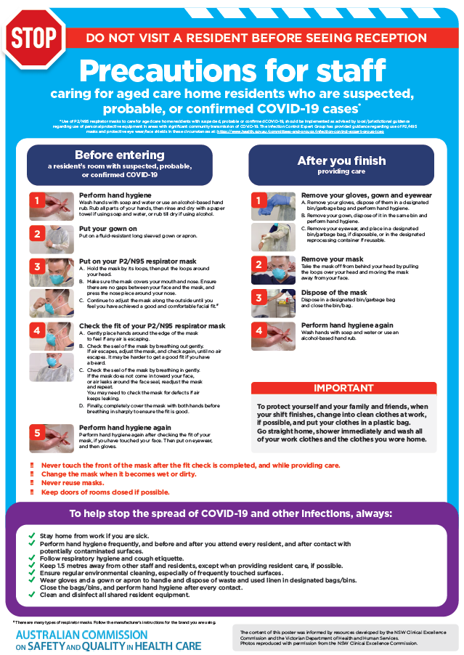](https://www.safetyandquality.gov.au/publications-and-resources/resource-library/poster-ppe-use-aged-care-staff-caring-residents-covid-19)

* ***Poster – Combined contact and droplet precautions*** <https://www.safetyandquality.gov.au/publications-and-resources/resource-library/poster-combined-contact-and-droplet-precautions>  
  [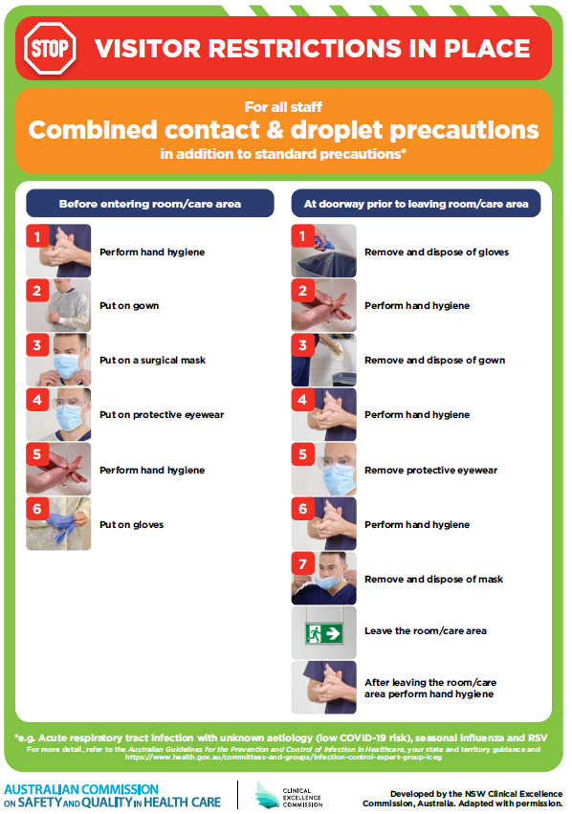](https://www.safetyandquality.gov.au/publications-and-resources/resource-library/poster-combined-contact-and-droplet-precautions)
* ***Poster – Combined airborne and contact precautions*** <https://www.safetyandquality.gov.au/publications-and-resources/resource-library/poster-combined-airborne-and-contact-precautions>   
  [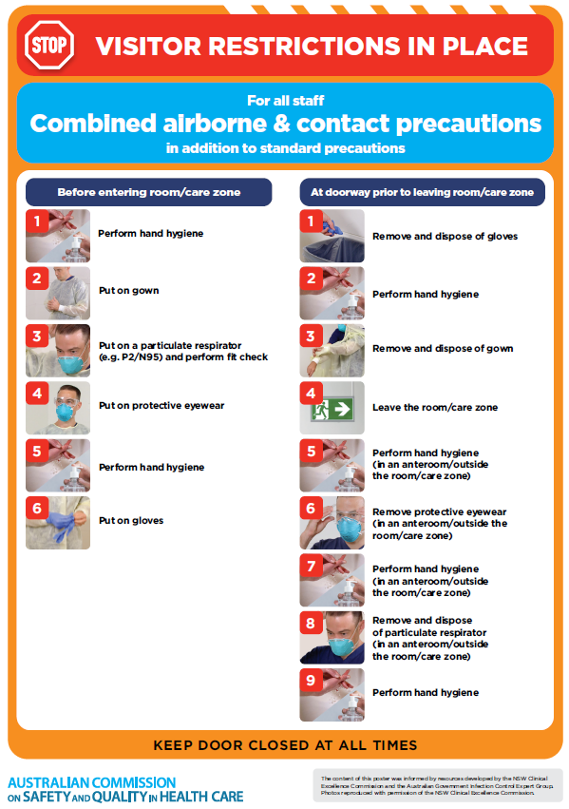](https://www.safetyandquality.gov.au/publications-and-resources/resource-library/poster-combined-airborne-and-contact-precautions)
* ***Environmental Cleaning and Infection Prevention and Control*** [www.safetyandquality.gov.au/environmental-cleaning](http://www.safetyandquality.gov.au/environmental-cleaning)
* ***COVID-19 infection prevention and control risk management – Guidance*** <https://www.safetyandquality.gov.au/publications-and-resources/resource-library/covid-19-infection-prevention-and-control-risk-management-guidance>
* ***Safe care for people with cognitive impairment during COVID-19***<https://www.safetyandquality.gov.au/our-work/cognitive-impairment/cognitive-impairment-and-covid-19>
* ***Stop COVID-19: Break the chain of infection*** posterhttps://www.safetyandquality.gov.au/publications-and-resources/resource-library/break-chain-infection-poster-a3  
  **[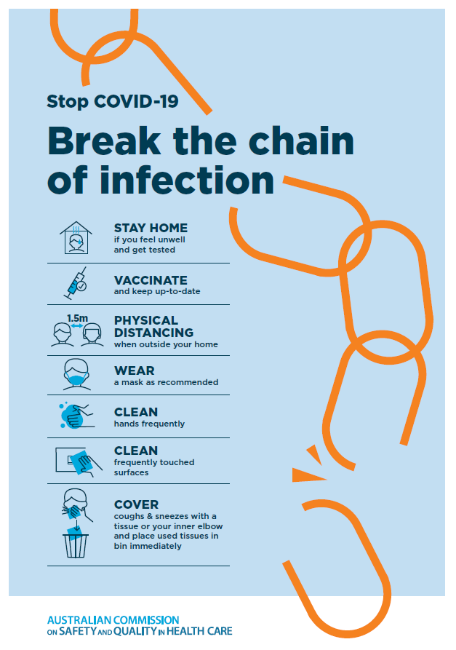](https://www.safetyandquality.gov.au/publications-and-resources/resource-library/break-chain-poster-a3https:/www.safetyandquality.gov.au/publications-and-resources/resource-library/break-chain-poster-a3)**
* ***FAQs for clinicians on elective surgery*** <https://www.safetyandquality.gov.au/node/5724>
* ***FAQs for consumers on elective surgery*** <https://www.safetyandquality.gov.au/node/5725>
* ***COVID-19 and face masks – Information for consumers*** <https://www.safetyandquality.gov.au/publications-and-resources/resource-library/covid-19-and-face-masks-information-consumers>

[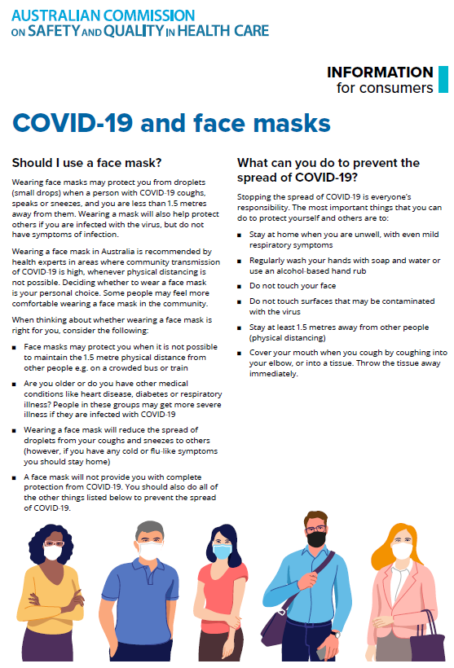](https://www.safetyandquality.gov.au/sites/default/files/2020-07/covid-19_and_face_masks_-_information_for_consumers.pdf)

*National COVID-19 Clinical Evidence Taskforce*

<https://covid19evidence.net.au/>

The National COVID-19 Clinical Evidence Taskforce is a collaboration of peak health professional bodies across Australia whose members are providing clinical care to people with COVID-19. The taskforce is undertaking continuous evidence surveillance to identify and rapidly synthesise emerging research in order to provide national, **evidence-based guidelines and clinical flowcharts for the clinical care of people with COVID-19**. The guidelines address questions that are specific to managing COVID-19 and cover the full disease course across mild, moderate, severe and critical illness. These are ‘living’ guidelines, updated with new research in near real-time in order to give reliable, up-to-the minute advice to clinicians providing frontline care in this unprecedented global health crisis.

*COVID-19 Critical Intelligence Unit*

<https://www.aci.health.nsw.gov.au/covid-19/critical-intelligence-unit>

The Agency for Clinical Innovation (ACI) in New South Wales has developed this page summarising rapid, evidence-based advice during the COVID-19 pandemic. Its operations focus on systems intelligence, clinical intelligence and evidence integration. The content includes a daily evidence digest, a COVID status monitor, a risk monitoring dashboard and evidence checks on a discrete topic or question relating to the current COVID-19 pandemic. There is also a ‘Living evidence’ section summarising key studies and emerging evidence on **COVID-19 vaccines** and **SARS-CoV-2 variants**. The most recent updates include:

* ***COVID-19 vaccines in Australia*** – What is the evidence on COVID-19 vaccines in Australia?

**Disclaimer**

On the Radar is an information resource of the Australian Commission on Safety and Quality in Health Care. The Commission is not responsible for the content of, nor does it endorse, any articles or sites listed. The Commission accepts no liability for the information or advice provided by these external links. Links are provided on the basis that users make their own decisions about the accuracy, currency and reliability of the information contained therein. Any opinions expressed are not necessarily those of the Australian Commission on Safety and Quality in Health Care.