# Australian Commission on Safety and Quality in Health Care logo with Radar imageOn the Radar

Issue 544

31 January 2022

*On the Radar* is a summary of some of the recent publications in the areas of safety and quality in health care. Inclusion in this document is not an endorsement or recommendation of any publication or provider. Access to particular documents may depend on whether they are Open Access or not, and/or your individual or institutional access to subscription sites/services. Material that may require subscription is included as it is considered relevant.

*On the Radar* is available online, via email or as a PDF or Word document from <https://www.safetyandquality.gov.au/publications-and-resources/newsletters/radar>

If you would like to receive *On the Radar* via email, you can subscribe on our website <https://www.safetyandquality.gov.au/publications-and-resources/newsletters>  
or by emailing us at H[Umail@safetyandquality.gov.auU](mailto:mail@safetyandquality.gov.au).   
You can also send feedback and comments to H[Umail@safetyandquality.gov.auU](mailto:mail@safetyandquality.gov.au).

For information about the Commission and its programs and publications, please visit <https://www.safetyandquality.gov.au>

You can also follow us on Twitter @ACSQHC.

**On the Radar**

Editor: Dr Niall Johnson [niall.johnson@safetyandquality.gov.au](mailto:niall.johnson@safetyandquality.gov.au)

Contributors: Niall Johnson, Kim Stewart, Kozue Yamada

**Antimicrobial resistance update**

<https://www.safetyandquality.gov.au/publications-and-resources/resource-library/agar-sepsis-outcome-programs-2020-report>

The *AGAR Sepsis Outcomes Programs 2020 Report* , is now available. The report is the sixth in a series of annual reports produced by the Australian Group on Antimicrobial Resistance (AGAR) in collaboration with the Australian Commission on Safety and Quality in Health Care. These reports bring together the key findings of three AGAR sepsis outcome programs, as a means of increasing access to antimicrobial resistance surveillance data to inform response strategies and improve the safety of care provided to patients.

Data for the analyses were reported by 30 laboratories, servicing 49 public and private institutions across Australia in 2020, which demonstrates the significant commitment of these laboratories, and states and territories and the private sector to antimicrobial resistance surveillance, prevention and control.

Some key findings from analysis of AGAR 2020 are:

* Overwhelmingly the onset of episodes of bacteraemia in Australia was in the community, rather than hospitals
* A long term trend of increasing resistance to important antimicrobial agents, such as ceftriaxone and ciprofloxacin, in *Eschericia coli* (a major cause of urinary tract infections)
* • A concerning steady rise in resistance to fluoroquinolones in hospital-onset bacteraemia.

For all of the AGAR data and trends, visit the <https://www.safetyandquality.gov.au/publications-and-resources/resource-library/agar-sepsis-outcome-programs-2020-report>

**Open Disclosure**

<https://www.safetyandquality.gov.au/our-work/clinical-governance/open-disclosure>

The Australian Commission on Safety and Quality in Health Care has released two consumer fact sheets on open disclosure:

* *Open disclosure – what to expect if you experience harm during health care?* is a short fact sheet about open disclosure and healthcare rights.
* *Preparing and participating in open disclosure discussions* is a fact sheet with specific information for a person and/or their support people when starting the open disclosure process. This includes what to expect during the process, how to access support and how to prepare for open disclosure discussions.

The fact sheets are available in easy English versions and 25 language translations.

The fact sheets are available on the Commission’s website and can be accessed at <https://www.safetyandquality.gov.au/our-work/clinical-governance/open-disclosure>

**Journal articles**

*BMJ Quality & Safety* online first articles

|  |  |
| --- | --- |
| URL | <https://qualitysafety.bmj.com/content/early/recent> |
| Notes | *BMJ Quality &Safety* has published a number of ‘online first’ articles, including:   * Barriers and enablers to **monitoring and deprescribing opioid analgesics for chronic non-cancer pain**: a systematic review with qualitative evidence synthesis using the Theoretical Domains Framework (Amanda J Cross, Rachelle Buchbinder, Stephanie Mathieson, Allison Bourne, Christopher G Maher, Chung-Wei Christine Lin, Denise A O'Connor) * **Influence of drug safety advisories on drug utilisation**: an international interrupted time series and meta-analysis (Richard L Morrow, Barbara Mintzes, Patrick C Souverein, Marie L De Bruin, Elizabeth Ellen Roughead, Joel Lexchin, Anna Kemp-Casey, Lorri Puil, Ingrid Sketris, Dee Mangin, Christine E Hallgreen, Sallie-Anne Pearson, Ruth Lopert, Lisa Bero, Richard Ofori-Asenso, Danijela Gnjidic, Ameet Sarpatwari, Lucy T Perry, Colin R Dormuth) * **Improving responses to safety incidents**: we need to talk about justice (Alan Cribb, Jane K. O'Hara, Justin Waring) * Implications of resource constraints and high workload on **speaking up about threats to patient safety**: a qualitative study of surgical teams in Ghana (Emmanuel Kwasi Mawuena, Russell Mannion) * We’re all in this together: how COVID-19 revealed the **co-construction of mindful organising and organisational reliability** (Timothy J Vogus, Amy D Wilson, Kelly Randall, Mary C Sitterding) * **Impact of unacceptable behaviour between healthcare workers on clinical performance and patient outcomes**: a systematic review (Linda Guo, Benjamin Ryan, Isabel Anne Leditschke, Kimberley J Haines, Katrina Cook, Lars Eriksson, Olusegun Olusanya, Tanya Selak, Kiran Shekar, Mahesh Ramanan) * Editorial: **Inequalities exacerbated**: an all-too-familiar story (Jonathan Stokes) * Medication-related interventions to improve **medication safety and patient outcomes on transition from adult intensive care settings**: a systematic review and meta-analysis (Richard S Bourne, Jennifer K Jennings, Maria Panagioti, Alexander Hodkinson, Anthea Sutton, Darren M Ashcroft) * **Impact of the COVID-19 pandemic on the incidence and mortality of hospital-onset bloodstream infection**: a cohort study (John Karlsson Valik, Pontus Hedberg, Fredrik Holmberg, Suzanne Desirée van der Werff, Pontus Nauclér) |

*International Journal for Quality in Health Care* online first articles

|  |  |
| --- | --- |
| URL | <https://academic.oup.com/intqhc/advance-articles> |
| Notes | *International Journal for Quality in Health Care* has published a number of ‘online first’ articles, including:   * Combining Failure Modes and Effects Analysis and Cause–Effect Analysis: A Novel Method of Risk Analysis to Reduce **Anaphylaxis Due to Contrast Media** (Daisuke Koike, Junichi Yamakami, Terumi Miyashita, Yumi Kataoka, Hiroshi Nishida, Hidekazu Hattori, Ayuko Yasuda) |

**Online resources**

*[UK] NICE Guidelines and Quality Standards*

<https://www.nice.org.uk/guidance>

The UK’s National Institute for Health and Care Excellence (NICE) has published new (or updated) guidelines and quality standards. The latest reviews or updates are:

* NICE Guideline NG211 *Rehabilitation after* ***traumatic injury*** <https://www.nice.org.uk/guidance/ng211>
* NICE Guideline NG81 ***Glaucoma****: diagnosis and management* <https://www.nice.org.uk/guidance/ng81>
* NICE Guideline NG191 *COVID-19 rapid guideline:* ***managing COVID-19*** <https://www.nice.org.uk/guidance/ng191>

**COVID-19 resources**

https://www.safetyandquality.gov.au/covid-19

The Australian Commission on Safety and Quality in Health Care has developed a number of resources to assist healthcare organisations, facilities and clinicians. These and other material on COVID-19 are available at <https://www.safetyandquality.gov.au/covid-19>

These resource include:

* ***COVID-19 infection prevention and control risk management*** <https://www.safetyandquality.gov.au/publications-and-resources/resource-library/covid-19-infection-prevention-and-control-risk-management-guidance>
* ***Poster - PPE use for aged care staff caring for residents with COVID-19*** <https://www.safetyandquality.gov.au/publications-and-resources/resource-library/poster-ppe-use-aged-care-staff-caring-residents-covid-19>

[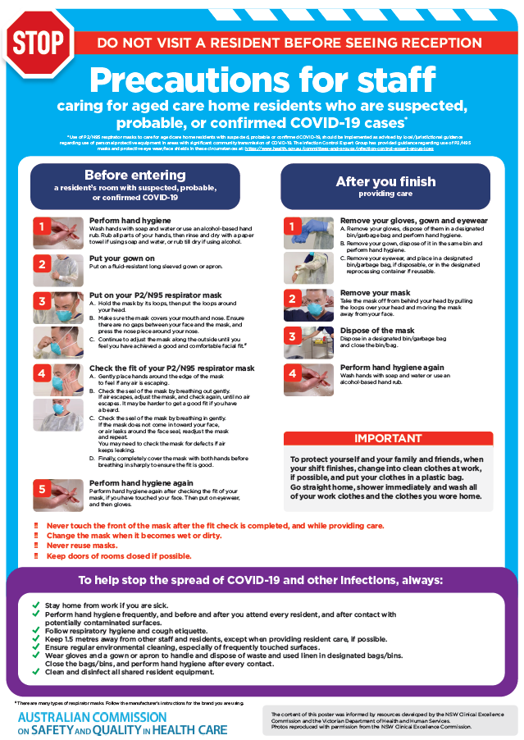](https://www.safetyandquality.gov.au/publications-and-resources/resource-library/poster-ppe-use-aged-care-staff-caring-residents-covid-19)

* ***Poster – Combined contact and droplet precautions*** <https://www.safetyandquality.gov.au/publications-and-resources/resource-library/poster-combined-contact-and-droplet-precautions>  
  [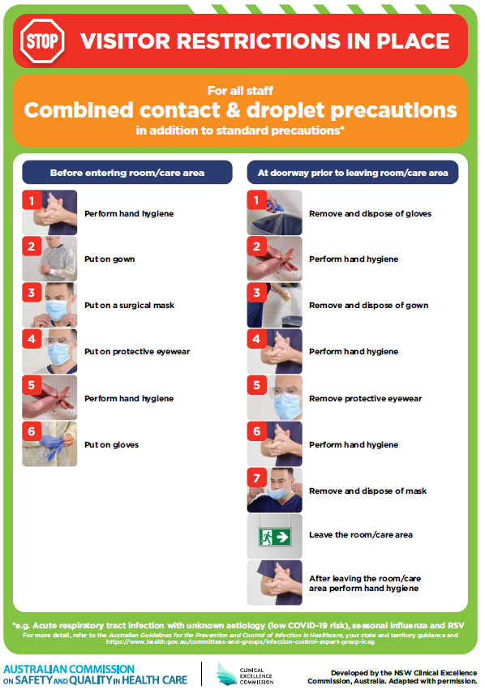](https://www.safetyandquality.gov.au/publications-and-resources/resource-library/poster-combined-contact-and-droplet-precautions)
* ***Poster – Combined airborne and contact precautions*** <https://www.safetyandquality.gov.au/publications-and-resources/resource-library/poster-combined-airborne-and-contact-precautions>   
  [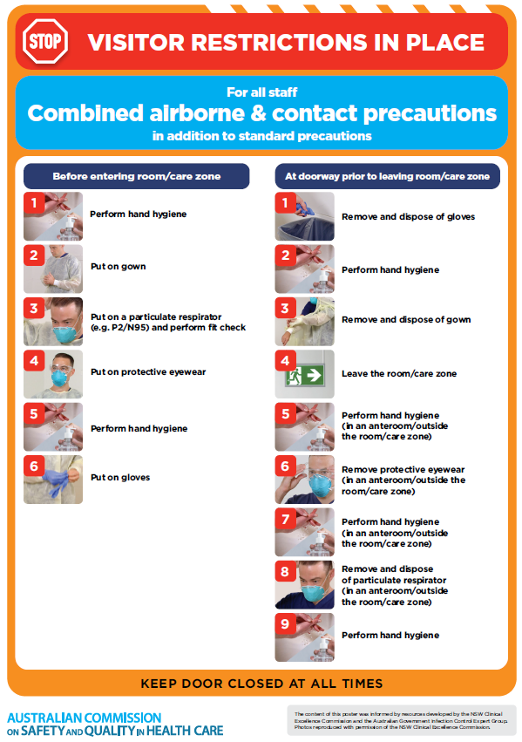](https://www.safetyandquality.gov.au/publications-and-resources/resource-library/poster-combined-airborne-and-contact-precautions)
* ***Environmental Cleaning and Infection Prevention and Control*** [www.safetyandquality.gov.au/environmental-cleaning](http://www.safetyandquality.gov.au/environmental-cleaning)
* ***COVID-19 infection prevention and control risk management – Guidance*** <https://www.safetyandquality.gov.au/publications-and-resources/resource-library/covid-19-infection-prevention-and-control-risk-management-guidance>
* ***Safe care for people with cognitive impairment during COVID-19***<https://www.safetyandquality.gov.au/our-work/cognitive-impairment/cognitive-impairment-and-covid-19>
* ***Stop COVID-19: Break the chain of infection*** posterhttps://www.safetyandquality.gov.au/publications-and-resources/resource-library/break-chain-infection-poster-a3  
  **[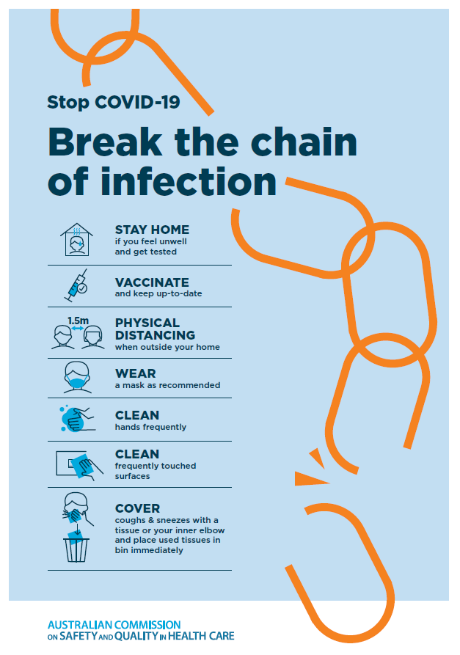](https://www.safetyandquality.gov.au/publications-and-resources/resource-library/break-chain-poster-a3https:/www.safetyandquality.gov.au/publications-and-resources/resource-library/break-chain-poster-a3)**
* ***FAQs for clinicians on elective surgery*** <https://www.safetyandquality.gov.au/node/5724>
* ***FAQs for consumers on elective surgery*** <https://www.safetyandquality.gov.au/node/5725>
* ***COVID-19 and face masks – Information for consumers*** <https://www.safetyandquality.gov.au/publications-and-resources/resource-library/covid-19-and-face-masks-information-consumers>

[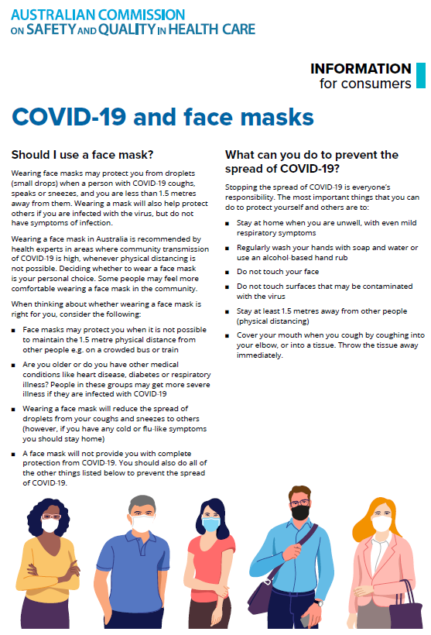](https://www.safetyandquality.gov.au/sites/default/files/2020-07/covid-19_and_face_masks_-_information_for_consumers.pdf)

*National COVID-19 Clinical Evidence Taskforce*

<https://covid19evidence.net.au/>

The National COVID-19 Clinical Evidence Taskforce is a collaboration of peak health professional bodies across Australia whose members are providing clinical care to people with COVID-19. The taskforce is undertaking continuous evidence surveillance to identify and rapidly synthesise emerging research in order to provide national, **evidence-based guidelines and clinical flowcharts for the clinical care of people with COVID-19**. The guidelines address questions that are specific to managing COVID-19 and cover the full disease course across mild, moderate, severe and critical illness. These are ‘living’ guidelines, updated with new research in near real-time in order to give reliable, up-to-the minute advice to clinicians providing frontline care in this unprecedented global health crisis.

*COVID-19 Critical Intelligence Unit*

<https://www.aci.health.nsw.gov.au/covid-19/critical-intelligence-unit>

The Agency for Clinical Innovation (ACI) in New South Wales has developed this page summarising rapid, evidence-based advice during the COVID-19 pandemic. Its operations focus on systems intelligence, clinical intelligence and evidence integration. The content includes a daily evidence digest, a COVID status monitor, a risk monitoring dashboard and evidence checks on a discrete topic or question relating to the current COVID-19 pandemic. There is also a ‘Living evidence’ section summarising key studies and emerging evidence on **COVID-19 vaccines** and **SARS-CoV-2 variants**. The most recent updates include:

* ***Surgical masks, eye protection and PPE guidance*** –What is the evidence for surgical masks in the endemic phase in hospitals and for eyewear to protect against COVID-19?
* ***Paediatrics and COVID-19 reporting rates and differences*** – How are paediatric patients with COVID-19 reported, and what are the differences in rates and severity with Omicron?
* ***Incidental COVID-19*** – How are incidental COVID-19 cases being reported internationally, and what is the proportional of incidental COVID-19 cases?
* ***Sotrovimab*** –What is the evidence for sotrovimab as a treatment for COVID-19?
* ***Omicron - symptoms and hospitalised patients*** – What are the symptoms associated with Omicron and what is the risk of hospitalisation for Omicron
* ***COVID-19 vaccines in Australia*** – What is the evidence on COVID-19 vaccines in Australia?

**Disclaimer**

On the Radar is an information resource of the Australian Commission on Safety and Quality in Health Care. The Commission is not responsible for the content of, nor does it endorse, any articles or sites listed. The Commission accepts no liability for the information or advice provided by these external links. Links are provided on the basis that users make their own decisions about the accuracy, currency and reliability of the information contained therein. Any opinions expressed are not necessarily those of the Australian Commission on Safety and Quality in Health Care.