# Australian Commission on Safety and Quality logotypeOn the Radar

Issue 547

21 February 2022

*On the Radar* is a summary of some of the recent publications in the areas of safety and quality in health care. Inclusion in this document is not an endorsement or recommendation of any publication or provider. Access to particular documents may depend on whether they are Open Access or not, and/or your individual or institutional access to subscription sites/services. Material that may require subscription is included as it is considered relevant.

*On the Radar* is available online, via email or as a PDF or Word document from <https://www.safetyandquality.gov.au/publications-and-resources/newsletters/radar>

If you would like to receive *On the Radar* via email, you can subscribe on our website <https://www.safetyandquality.gov.au/publications-and-resources/newsletters>  
or by emailing us at H[Umail@safetyandquality.gov.auU](mailto:mail@safetyandquality.gov.au).   
You can also send feedback and comments to H[Umail@safetyandquality.gov.auU](mailto:mail@safetyandquality.gov.au).

For information about the Commission and its programs and publications, please visit <https://www.safetyandquality.gov.au>

You can also follow us on Twitter @ACSQHC.

**On the Radar**

Editor: Dr Niall Johnson [niall.johnson@safetyandquality.gov.au](mailto:niall.johnson@safetyandquality.gov.au)

Contributors: Niall Johnson

**Reports**

*Weight-based medication errors in children*

Independent report by the Healthcare Safety Investigation Branch I2020/026

Healthcare Safety Investigation Branch

Farnborough: HSIB; 2022. p. 109.

|  |  |
| --- | --- |
| URL | <https://www.hsib.org.uk/investigations-and-reports/weight-based-medication-errors-in-children/> |
| Notes | The UK’s Healthcare Safety Investigation Branch (HSIB) has released this report examining the issue of medication errors, particularly for weight-based prescribing for children.  The reference event that triggered the investigation was a four-year-old girl who received 10 times the intended dose of an anticoagulant on five separate occasions over three days. This led to a bleed on the brain and a further three months in hospital followed by discharge home with an ongoing care plan.  The investigation examined the risks involved when prescribing, dispensing and administering medicine to children. Prescribing for children is usually personalised: individual calculations are needed for each child, taking weight, age, gestation and body surface area into account.  In the UK (and elsewhere), electronic prescribing and medicines administration (ePMA) systems are now commonly used. They are considered a more effective way to reduce medication errors however, they may cause new technology-related errors.  Errors in prescribing for children can lead to unsafe doses of medicines, causing significant harm or death if administered.  The report includes a number of recommendations at peak bodies and health organisations. |

For information on the Commission’s work on medication safety, see <https://www.safetyandquality.gov.au/our-work/medication-safety>

**Journal articles**

*Including the Reason for Use on Prescriptions Sent to Pharmacists: Scoping Review*

Mercer K, Carter C, Burns C, Tennant R, Guirguis L, Grindrod K

JMIR Hum Factors. 2021 2021/11/25;8(4):e22325.

|  |  |
| --- | --- |
| DOI | <https://doi.org/10.2196/22325> |
| Notes | Health is an information business. But determining what information to share and when is not always straightforward. Often, concerns about privacy and confidentiality need to be considered. This paper reports on a scoping review that examined the literature on how including the reason for use on a prescription impacts pharmacists. Focussing on 19 studies, the study found ‘there is a consensus that the addition of this information to prescriptions benefits patient safety and enables pharmacists to be more effective.’ What literature there is suggests that that including the indication can help identify errors, support communication, and improve patient safety, but there are also queries about impact on workflow and patient privacy. |

*Medication-related interventions to improve medication safety and patient outcomes on transition from adult intensive care settings: a systematic review and meta-analysis*

Bourne RS, Jennings JK, Panagioti M, Hodkinson A, Sutton A, Ashcroft DM

BMJ Quality Safety. 2022.

|  |  |
| --- | --- |
| DOI | <https://doi.org/10.1136/bmjqs-2021-013760> |
| Notes | Transitions of care are times of risk. This paper reports on a systematic review and meta-analysis of the literature on medication issues at transition from intensive care units (ICU). Based on 17 studies, the authors report that invention components in the literature included staff education, medication review, guidelines, transfer/handover tools or aids and medication reconciliation. They observe that ‘Multicomponent interventions based on education of staff and guidelines were effective at achieving almost four times more de-prescribing of inappropriate medication by the time of patient hospital discharge.’ They also noted ‘. More complex interventions such as medication review and medicines reconciliation, targeted at reducing MEs [medication errors] and medication-related problems on ICU discharge, were very effective and reduced potential ADEs [adverse drug events].’ |

For information on the Commission’s work on medication safety, see <https://www.safetyandquality.gov.au/our-work/medication-safety>

*Non-conveyance of older adult patients and association with subsequent clinical and adverse events after initial assessment by ambulance clinicians: a cohort analysis*

Lederman J, Lindström V, Elmqvist C, Löfvenmark C, Ljunggren G, Djärv T

BMC Emergency Medicine. 2021 2021/12/11;21(1):154.

|  |  |
| --- | --- |
| DOI | <https://doi.org/10.1186/s12873-021-00548-7> |
| Notes | The decisions that healthcare workers make can have significant implications for patients. This Swedish study looked at the decision by emergency medical services to not transport patients to hospital. This was a retrospective cohort study that covered all adult non-conveyed patients ‘who availed the ambulance service of Region Stockholm, Sweden in 2015’. Older adult patients comprised 48% of the 17,809 non-conveyed patients. The authors report that:   * Dispatch priority levels were generally lower among older non-conveyed patients than among younger patients * Non-conveyance among older patients occurred more often during daytime * Approximately one in five older adults was hospitalised within 7 days following non-conveyance * Patients presenting with infectious symptoms had the highest mortality risk following non-conveyance. * Oxygen saturation level < 95% or systolic blood pressure > 160 mmHg had significantly higher associations with hospitalisation within 7 days following non-conveyance in older adult patients.   The study found that for older adult patients there was an increased risk of adverse events, including infection, hospitalisation, death, within 7 days of the non-conveyance decision. |

*Australian Journal of Primary Health*

Volume 28 Number 1, February 2022

|  |  |
| --- | --- |
| URL | <https://www.publish.csiro.au/py/issue/10790> |
| Notes | A new issue of the *Australian Journal of Primary Health* has been published. Articles in this issue of the *Australian Journal of Primary Health* include:   * Implementation of evidence-based **nutritional management in primary health care settings**: a systematic scoping review (Nara Letícia Zandonadi de Oliveira, Marina Peduzzi, Heloise L F Agreli and K dos Santos Matsumoto) * **Oral health surveillance** in Australia: the need for ongoing data to inform public health decision-making (Amit Chattopadhyay, Bradley Christian, Mark Gussy, Mohd Masood, Shalika Hegde, Anil Raichur, R Martin and A Kenny) * Model of **nutritional care in older adults**: improving the identification and management of malnutrition using the Mini Nutritional Assessment–Short Form (MNA®-SF) in general practice (Karen Charlton, Karen Walton, Kate Brumerskyj, Elizabeth Halcomb, A Hull, T Comerford and V A do Rosario) * First call, home: perception and practice around **health among South Asian migrants** in Melbourne, Australia (Rajan Subedi, Sabitra Kaphle, Manju Adhikari, Yamuna Dhakal, M Khadka, S Duwadi, S Tamang and S Shakya) * Willingness to use **community health centres for initial diagnosis**: the role of policy incentives among Chinese patients (Jingrong Zhu, Xiaofei Li, Hongrui Chu and Jinlin Li) * Establishing consensus on key elements and implementation enablers of **community-based pain programs to support primary health network decision making**: an eDelphi study (Pippy Walker, Simone De Morgan, Andrew Wilson and Fiona M Blyth) * Australian primary health care nurses’ knowledge, practice and attitudes relating to **preconception care**: learnings for service implementation (E Dorney, J Millard, K Hammarberg, K Griffin, A Gordon, K McGeechan and K I Black) * **Advance care planning in dementia**: a qualitative study of Australian general practitioners (Adnan Alam, Christopher Barton, Pallavi Prathivadi and Danielle Mazza) * **Internationalisation of general practice journals**: a bibliometric analysis of the Science Citation Index database (Hsin Ma, Bo-Ren Cheng, An-Hui Chang, Hsiao-Ting Chang, Ming-Hwai Lin, Tzeng-Ji Chen and Shinn-Jang Hwang) |

*Pediatric Quality & Safety*

Volume 7, Issue 1, January/February 2022

|  |  |
| --- | --- |
| URL | <https://journals.lww.com/pqs/toc/2022/01000> |
|  | A new issue of *Pediatric Quality & Safety* has been published. Articles in this issue of *Pediatric Quality & Safety* include:   * Simulation-Based System Analysis: Testing Preparedness for **Extracorporeal Membrane Oxygenation Cannulation in Pediatric COVID-19 Patients** (Alyssa C Stoner, Robert D Schremmer, Mikaela A Miller, Kari L Davidson, Rachael L Pedigo, Jamie S Parson, C S Kennedy, E K Pallotto, J O Miller) * A Standardized Peer Review Program Improves Assessment and Documentation of **Child Sexual Abuse** (Suzanne P Starling, Kimberly A Martinez, Lori D Frasier) * Behavioral and Psychological Aspects of the Physician Experience with **Deimplementation** (Corrie E McDaniel, Samantha A House, S L Ralston) * Improving Quality and Efficiency in Pediatric **Emergency Department Behavioral Health Care** (Beth L Emerson, Erika Setzer, E Blake, L Siew) * Sustained Reduction in Time to Data Entry in the **Cystic Fibrosis Foundation Registry** (Laura Nay, Jame’ Vajda, Sharon McNamara, T Ong) * Improving the Diagnosis of **Menstrual Dysfunction** through Quality Improvement (Kayla Daniel, Anastasia Fischer, Michael Welty, A E Valasek) * Reducing PICU-to-Floor Time-to-Transfer Decision in Critically Ill **Bronchiolitis Patients** using Quality Improvement Methodology (Cristin Q Fritz, Blake Martin, Megan Riccolo, Michelle Fennell, Elise Rolison, Todd Carpenter, Lalit Bajaj, Amy Tyler, Mark Brittan) * Right on Schedule: Improving the **Rate of Clinic Appointments Scheduled Prior to Hospital Discharge** (Mahvish Q Rahim, Jordyn Griffin, Kerry Hege, Emily L Mueller, Kristine Kauffman, Stacey Corman, Kari Anderson, Stayce Woodburn, Meghan Drayton Jackson) * Improving Adherence to **Safe Sleep Guidelines for Hospitalized Infants** at a Children’s Hospital (Adolfo L Molina, Meghan Harrison, Candice Dye, Christine Stoops, Erinn O Schmit) * Quality Improvement Methodology Facilitates Adherence to **Echocardiogram Protocol Measurements** (Saira Siddiqui, Eunice Hahn, Garick D Hill, James Brown, Katherine Lehmkuhl, Christopher Statile) * Improving Efficiency of **Multidisciplinary Bedside Rounds in the NICU**: A Single Centre QI Project (Sandesh Shivananda, Horacio Osiovich, Julie de Salaberry, Valoria Hait, Kanekal S Gautham) * Implementing an **EMR-based Health-related Social Needs Screen** in a Pediatric Hospital System (Millie Dolce, Hannah Keedy, Laura Chavez, Samantha Boch, Hannah Zaim, Brennan Dias, Deena Chisolm) * A Quality Improvement Initiative to Increase **Central Line Maintenance Bundle Compliance** through Nursing-led Rounds (Maria C Hugo, Rheannon R Rzucidlo, Lauren M Weisert, Isaac Parakati, Sangeeta K Schroeder) * Improving Care for **Children with Bloody Diarrhea at Risk for Hemolytic Uremic Syndrome** (Carson S Burns, Jason Rubin, Tara Sardesai, Eileen J Klein, Surabhi B Vora, Ryan Kearney, Lori Rutman) * A Quality Improvement Initiative to Improve **Patient Safety Event Reporting by Residents** (Daniel Herchline, Christina Rojas, Amit A Shah, Victoria Fairchild, Sanjiv Mehta, Jessica Hart) * Shifting the Paradigm: A Quality Improvement Approach to **Proactive Cardiac Arrest Reduction in the Pediatric Cardiac Intensive Care Unit** (Christine M Riley, J Wesley Diddle, Ashleigh Harlow, Kara Klem, Jason Patregnani, Evan Hochberg, Jenhao Jacob Cheng, Sopnil Bhattarai, Lisa Hom, Justine M Fortkiewicz, Darren Klugman) * Reducing Avoidable **Transfer Delays in the Pediatric Intensive Care Unit** for Status Asthmaticus Patients (Takaharu Karube, Theresa Goins, Todd J Karsies, Samantha W Gee) * A Quality Improvement Approach to **Improving Discharge Documentation** (Sumeet L Banker, Divya Lakhaney, Benjamin S Hooe, Teresa A McCann, Connie Kostacos, Mariellen Lane) |

*International Journal for Quality in Health Care*

Volume 33, Issue Supplement 2, November

|  |  |
| --- | --- |
| URL | <https://academic.oup.com/intqhc/issue/33/Supplement_2> |
|  | A supplement issue of the *International Journal for Quality in Health Care* has been published with a theme of **Coproduction of health**. Articles in this issue of the *International Journal for Quality in Health Care* include:   * Policy, accreditation and leadership: creating the **conditions for effective coproduction of health, healthcare and science** (Peter Lachman, Eugene C Nelson) * Editorial: **Science-informed practice**: an essential epistemologic contributor to health-care coproduction (Paul Batalden, Anais Ovalle, Tina Foster, Glyn Elwyn) * Editorial: New ways of working: **health professional development for effective coproduction** (Tina Foster, Paul Batalden) * Editorial: **Making health and healthcare really matter in less resourced countries** (Peter Lachman, Ezequiel García-Elorrio) * **From assurance to coproduction**: a century of improving the quality of health-care service (Paul Batalden, Tina Foster) * Quality as strategy, the **evolution of co-production** in the Region Jönköping health system, Sweden: a descriptive qualitative study )Sofia Persson, Ann-Christine Andersson, Annmargreth Kvarnefors, J Thor, B Andersson Gäre) * **Person-centered care** (PCC): the people’s perspective (Gro Rosvold Berntsen, Sara Yaron, Morgan Chetty, Carolyn Canfield, Louis Ako-Egbe, Phuk Phan, Caitriona Curran, Isabela Castro) * The role of **co-production in Learning Health Systems** (Andreas Gremyr, Boel Andersson Gäre, Johan Thor, Glyn Elwyn, Paul Batalden, Ann-Christine Andersson) * **Coproduction in the management of individuals with cleft lip and palate** in South Africa: the Ekhaya Lethu model (Phumzile Hlongwa, Laetitia C Rispel) * **Point-of-care dashboards promote coproduction** of healthcare services for patients with inflammatory bowel disease (Aricca D Van Citters, Megan M Holthoff, Alice M Kennedy, Gil Y Melmed, Ridhima Oberai, Corey A Siegel, Alandra Weaver, Eugene C Nelson) * Initial development of a **self-assessment approach for coproduction value creation** by an international community of practice (Brant J Oliver, Rachel C Forcino, Paul B Batalden * A starter’s guide to **learning and teaching how to coproduce healthcare services** (Julie K Johnson, Paul Batalden, Tina Foster, Charlotte Arvidsson, Maren Batalden, Rachel Forcino, Boel Andersson Gäre) * **Coproducing value during the COVID-19** pandemic (Rachel C Forcino, Christian Von Plessen) * **Coproduction in medical education during the COVID-19** pandemic: critical components of successful curricular reform (Bruce Gregoire, Lena Trager, Jessamina Blum) * International, national and local trends in the spread of COVID-19: a geographic view of **COVID-19 spread and the role to be played by coproduction** (Peter Schmidt, Eugene C Nelson, Gregory Kearney, Sally Kraft, Brant J Oliver) * A ‘**COVID Compass**’ for navigating the pandemic (Brant J Oliver, Peter Schmidt, Stephanie Tomlin, Sally A Kraft, Elliott Fisher, Eugene C Nelson) |

*BMJ Quality & Safety* online first articles

|  |  |
| --- | --- |
| URL | <https://qualitysafety.bmj.com/content/early/recent> |
| Notes | *BMJ Quality &Safety* has published a number of ‘online first’ articles, including:   * Editorial: Pay-for-performance incentives for **health worker vaccination**: looking under the hood (Alison M Buttenheim, Harsha Thirumurthy) |

*International Journal for Quality in Health Care* online first articles

|  |  |
| --- | --- |
| URL | <https://academic.oup.com/intqhc/advance-articles> |
| Notes | *International Journal for Quality in Health Care* has published a number of ‘online first’ articles, including:   * Embracing **Multiple Aims in Healthcare Improvement and Innovation** (Rene Amalberti, Anthony Staines, Charles Vincent) * Perceived Reliability of **Medical Device Alarms** – A Major Determinant of Medical Errors Driven by Frozen Medical Thinking (Hilel Frankenthal, Izhar Ben Shlomo, Yael Kurzweil Segev, Alon K, Dina Orkin) |

**Online resources**

*[UK] NICE Guidelines and Quality Standards*

<https://www.nice.org.uk/guidance>

The UK’s National Institute for Health and Care Excellence (NICE) has published new (or updated) guidelines and quality standards. The latest reviews or updates are:

* NICE Guideline NG28 ***Type 2 diabetes*** *in adults: management* <https://www.nice.org.uk/guidance/ng28>

**COVID-19 resources**

https://www.safetyandquality.gov.au/covid-19

The Australian Commission on Safety and Quality in Health Care has developed a number of resources to assist healthcare organisations, facilities and clinicians. These and other material on COVID-19 are available at <https://www.safetyandquality.gov.au/covid-19>

These resources include:

* ***COVID-19 infection prevention and control risk management*** <https://www.safetyandquality.gov.au/publications-and-resources/resource-library/covid-19-infection-prevention-and-control-risk-management-guidance>
* ***Poster – Combined contact and droplet precautions*** <https://www.safetyandquality.gov.au/publications-and-resources/resource-library/poster-combined-contact-and-droplet-precautions>  
  [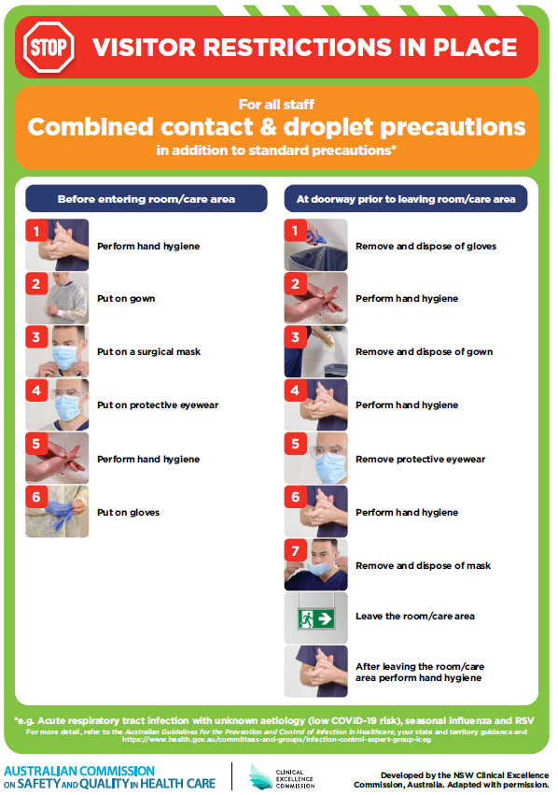](https://www.safetyandquality.gov.au/publications-and-resources/resource-library/poster-combined-contact-and-droplet-precautions)
* ***Poster – Combined airborne and contact precautions*** <https://www.safetyandquality.gov.au/publications-and-resources/resource-library/poster-combined-airborne-and-contact-precautions>   
  [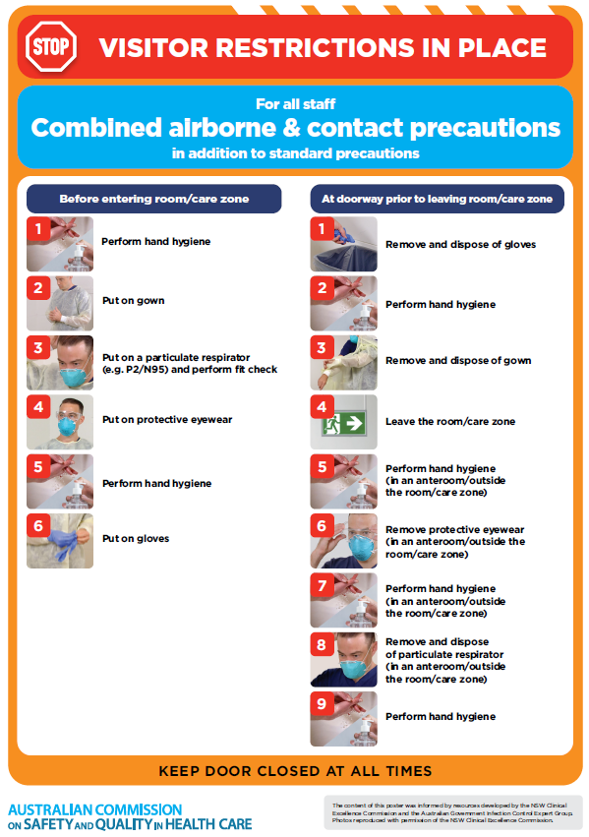](https://www.safetyandquality.gov.au/publications-and-resources/resource-library/poster-combined-airborne-and-contact-precautions)
* ***Environmental Cleaning and Infection Prevention and Control*** [www.safetyandquality.gov.au/environmental-cleaning](http://www.safetyandquality.gov.au/environmental-cleaning)
* ***COVID-19 infection prevention and control risk management – Guidance*** <https://www.safetyandquality.gov.au/publications-and-resources/resource-library/covid-19-infection-prevention-and-control-risk-management-guidance>
* ***Safe care for people with cognitive impairment during COVID-19***<https://www.safetyandquality.gov.au/our-work/cognitive-impairment/cognitive-impairment-and-covid-19>
* ***Stop COVID-19: Break the chain of infection*** posterhttps://www.safetyandquality.gov.au/publications-and-resources/resource-library/break-chain-infection-poster-a3  
  **[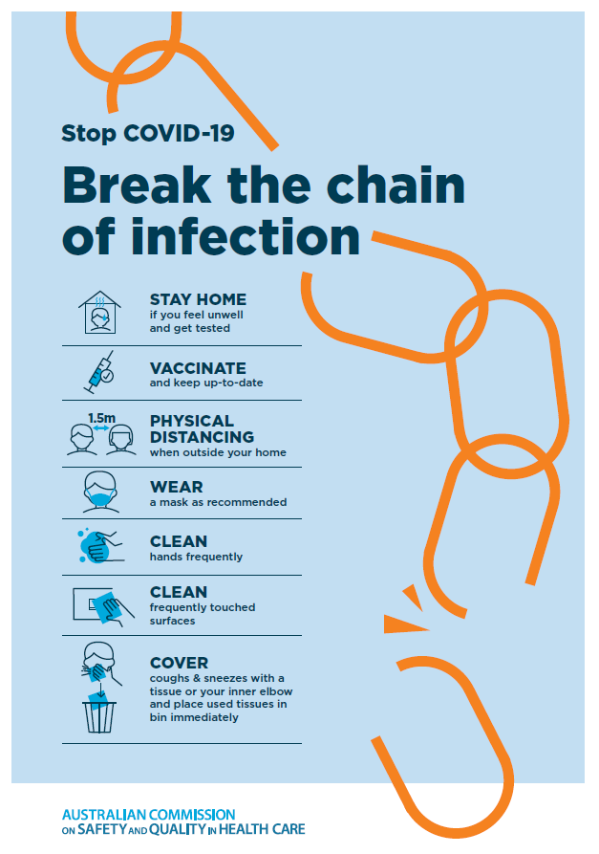](https://www.safetyandquality.gov.au/publications-and-resources/resource-library/break-chain-poster-a3https:/www.safetyandquality.gov.au/publications-and-resources/resource-library/break-chain-poster-a3)**
* ***FAQs for clinicians on elective surgery*** <https://www.safetyandquality.gov.au/node/5724>
* ***FAQs for consumers on elective surgery*** <https://www.safetyandquality.gov.au/node/5725>
* ***COVID-19 and face masks – Information for consumers*** <https://www.safetyandquality.gov.au/publications-and-resources/resource-library/covid-19-and-face-masks-information-consumers>

[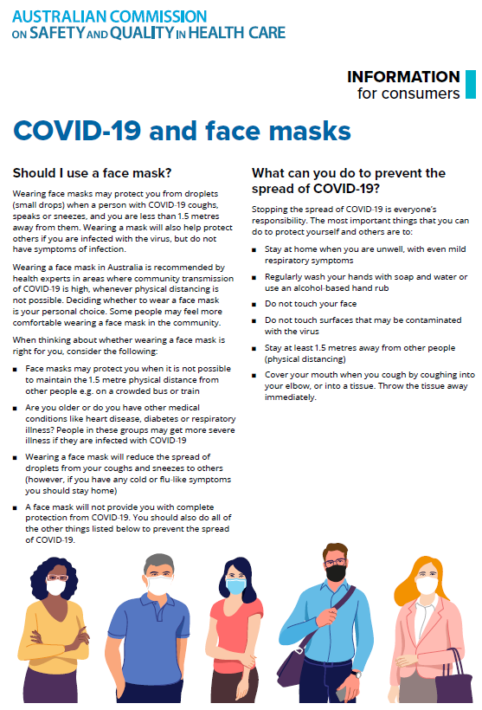](https://www.safetyandquality.gov.au/sites/default/files/2020-07/covid-19_and_face_masks_-_information_for_consumers.pdf)

*National COVID-19 Clinical Evidence Taskforce*

<https://covid19evidence.net.au/>

The National COVID-19 Clinical Evidence Taskforce is a collaboration of peak health professional bodies across Australia whose members are providing clinical care to people with COVID-19. The taskforce is undertaking continuous evidence surveillance to identify and rapidly synthesise emerging research in order to provide national, **evidence-based guidelines and clinical flowcharts for the clinical care of people with COVID-19**. The guidelines address questions that are specific to managing COVID-19 and cover the full disease course across mild, moderate, severe and critical illness. These are ‘living’ guidelines, updated with new research in near real-time in order to give reliable, up-to-the minute advice to clinicians providing frontline care in this unprecedented global health crisis.

*COVID-19 Critical Intelligence Unit*

<https://www.aci.health.nsw.gov.au/covid-19/critical-intelligence-unit>

The Agency for Clinical Innovation (ACI) in New South Wales has developed this page summarising rapid, evidence-based advice during the COVID-19 pandemic. Its operations focus on systems intelligence, clinical intelligence and evidence integration. The content includes a daily evidence digest, a COVID status monitor, a risk monitoring dashboard and evidence checks on a discrete topic or question relating to the current COVID-19 pandemic. There is also a ‘Living evidence’ section summarising key studies and emerging evidence on **COVID-19 vaccines** and **SARS-CoV-2 variants**. The most recent updates include:

* ***Surgery post COVID-19*** – What is the evidence for the timing of surgery, and outcomes following surgery, for people who have recovered from COVID-19?
* Show summary | Download full Evidence Check (PDF 189 KB)
* ***Disease modifying treatments for COVID-19 in children*** – What is the evidence for disease modifying treatments for COVID-19 in children?
* ***Omicron (BA.2 sub-lineage)*** – What is the available evidence for the BA.2 sub-lineage of the Omicron variant of concern?
* ***Mask type for COVID-19 positive wearer*** – What is the evidence for different mask types for COVID-19 positive wearers?
* ***Post acute and subacute COVID-19 care*** – What published advice and models of care are available regarding post-acute and subacute care for COVID-19 patients?
* ***COVID-19 vaccines in Australia*** – What is the evidence on COVID-19 vaccines in Australia?
* ***Hospital visitor policies*** – What is the evidence for hospital visitor policies during and outside of the COVID-19 pandemic?
* ***Surgical masks, eye protection and PPE guidance*** –What is the evidence for surgical masks in the endemic phase in hospitals and for eyewear to protect against COVID-19?

**Disclaimer**

On the Radar is an information resource of the Australian Commission on Safety and Quality in Health Care. The Commission is not responsible for the content of, nor does it endorse, any articles or sites listed. The Commission accepts no liability for the information or advice provided by these external links. Links are provided on the basis that users make their own decisions about the accuracy, currency and reliability of the information contained therein. Any opinions expressed are not necessarily those of the Australian Commission on Safety and Quality in Health Care.