# Australian Commission on Safety and Quality logotypeOn the Radar

Issue 556

2 May 2022

*On the Radar* is a summary of some of the recent publications in the areas of safety and quality in health care. Inclusion in this document is not an endorsement or recommendation of any publication or provider. Access to particular documents may depend on whether they are Open Access or not, and/or your individual or institutional access to subscription sites/services. Material that may require subscription is included as it is considered relevant.

*On the Radar* is available online, via email or as a PDF or Word document from <https://www.safetyandquality.gov.au/publications-and-resources/newsletters/radar>

If you would like to receive *On the Radar* via email, you can subscribe on our website <https://www.safetyandquality.gov.au/publications-and-resources/newsletters>  
or by emailing us at H[Umail@safetyandquality.gov.auU](mailto:mail@safetyandquality.gov.au).   
You can also send feedback and comments to H[Umail@safetyandquality.gov.auU](mailto:mail@safetyandquality.gov.au).

For information about the Commission and its programs and publications, please visit <https://www.safetyandquality.gov.au>

You can also follow us on Twitter @ACSQHC.

**On the Radar**

Editor: Dr Niall Johnson [niall.johnson@safetyandquality.gov.au](mailto:niall.johnson@safetyandquality.gov.au)

Contributors: Niall Johnson

[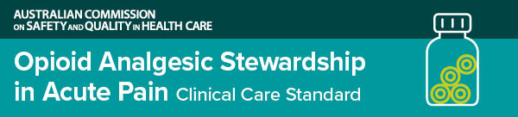](https://www.safetyandquality.gov.au/standards/clinical-care-standards/opioid-analgesic-stewardship-acute-pain-clinical-care-standard)

**Opioid Analgesic Stewardship in Acute Pain Clinical Care Standard**

Australian Commission on Safety and Quality in Health Care

Sydney: ACSQHC; 2022. p. 58.

<https://www.safetyandquality.gov.au/standards/clinical-care-standards/opioid-analgesic-stewardship-acute-pain-clinical-care-standard>

Australia has introduced a national clinical care standard to reduce risks of long-term reliance on opioid analgesics following short-term use for acute pain in hospital.

Developed by the Australian Commission on Safety and Quality in Health Care, the new standard has been welcomed by consumers and clinicians working across healthcare settings, including emergency, surgery, pain management, nursing, allied health and clinical pharmacy services.

The *Opioid Analgesic Stewardship in Acute Pain Clinical Care Standard* encourages prescribers to consider alternate analgesics and, where opioids are required, promotes appropriate use accompanied by planning for their cessation.

The aim is to ensure adequate pain relief in the emergency department and after surgery, while minimising the risk of over-reliance on opioids, particularly after discharge from hospital.

Every year, more than 2.5 million people undergo surgery in public and private hospitals, some of whom become persistent users of opioid analgesics after being treated for acute pain.

The standard highlights the importance of shared decision making with patients and assessment of pain, as well as appropriate prescribing in terms of dose and duration. It also focuses on review of therapy and ensuring clear transfer of care after discharge.

**Journal articles**

*Strength of Improvement Recommendations From Injurious Fall Investigations: A Retrospective Multi-Incident Analysis*

Paulik O, Hallen J, Lapkin S, Green H, Fernandez R

Journal of Patient Safety. 2022;18(3):e613-e619.

|  |  |
| --- | --- |
| DOI | <https://doi.org/10.1097/pts.0000000000000897> |
| Notes | Paper reporting on an examination of the strength of improvement recommendations proposed after investigation of fall incidents in a number of New South Wales health care facilities that result in major injuries. The study retrospectively reviewed 98 inpatient falls resulting in injury in 4 tertiary teaching hospitals, 1 subacute rehabilitation facility, and a residential aged care facility in a metropolitan health district over a two year period (2015–2016). The authors report that ‘The majority of the incidents (34.7%; n = 34) occurred between 1300 and 1859 hours, 65.3% (n = 64) occurred in the patient’s room, and 79.4% (n = 81) of the injuries were fractures.’  The authors categorised 8.5% of recommendations as ‘strong’ (i.e., environmental modifications, equipment/process redesign), 35.7% as ‘medium’ (i.e., changing documentation process and/or skill mix, providing education) and 55.8% as ‘weak’ (i.e., alerts or warnings). |

For information on the Commission’s work on preventing falls and harm from falls, see <https://www.safetyandquality.gov.au/standards/nsqhs-standards/comprehensive-care-standard>

*Extending the role of nursing assistants in mental health inpatient settings: A multi-method study*

Roche MA, Glover S, Luo X, Joyce M, Rossiter C

International Journal of Mental Health Nursing. 2021;30(5):1070-1079.

*Enhancing person-centred care in inpatient mental health settings through supported person-side handover: a multi method study*

Paul D, Glover S, Roche MA, Klarnett K, Chen X, Wall J, et al

Contemporary Nurse. 2021;57(3-4):290-301.

|  |  |
| --- | --- |
| DOI | Roche et al <https://doi.org/10.1111/inm.12859>  Paul et al <https://doi.org/10.1080/10376178.2021.1999837> |
| Notes | A pair of papers looking at nursing in the inpatient mental health setting based on the experiences in an Australian metropolitan health district.  Roche et al examined the role of nursing assistants in inpatient mental health, particularly expanding the role and the activities that nursing assistants undertook. The perceptions of nursing assistants and others can vary and affect how the changed roles are received. The authors suggest this paper aligns with Standard 1 of the National Safety and Quality Health Service Standards  Paul et al argue that the patient or person-centredness of inpatient mental health can be enhanced through changes to beside handovers. The intervention included a structured education and support package to assist mental health nursing staff to conduct bedside handover (‘where the person in care participates in the transfer of clinical information, with benefits for person, carers, and clinicians’). Based on a survey and audit before and after implementation of the package, the authors report that ‘Significant improvements were observed in nurses’ reports of confidence, the ability to maintain privacy, identified benefits for the person and in information transfer.’ The authors see alignment with Standards 2 and 6 of the National Safety and Quality Health Service Standards. |

For information on the National Safety and Quality Health Service Standards, see <https://www.safetyandquality.gov.au/standards/nsqhs-standards>

*Pharmacist transition-of-care services improve patient satisfaction and decrease hospital readmissions*

March KL, Peters MJ, Finch CK, Roberts LA, McLean KM, Covert AM, et al

Journal of Pharmacy Practice. 2022;35(1):86-93.

|  |  |
| --- | --- |
| DOI | <https://doi.org/10.1177/0897190020958264> |
| Notes | Having pharmacists involved at transitions of care, including discharge from hospital, has been seen to improve the safety and quality of care at these times. This US study saw patients in the intervention arm receive pharmacist medication reconciliation and education prior to discharge and post-discharge telephone follow-up. These patients reported higher patient satisfaction and had lower readmission rates when compared with the control arm patients. The authors concluded that ‘Pharmacy-based TOC models can improve patient satisfaction, prevent hospital readmissions, and generate revenue.’ |

For information on the Commission’s work on medication safety, see <https://www.safetyandquality.gov.au/our-work/medication-safety>

*Antibiotic prescribing errors in patients discharged from the pediatric emergency department*

LaScala EC, Monroe AK, Hall GA, Weant KA

Pediatric Emergency Care. 2022;38(1):e387-e392.

|  |  |
| --- | --- |
| DOI | <https://doi.org/10.1097/pec.0000000000002296> |
| Notes | The authors of this piece start with the assertion that ‘The pediatric emergency department (PED) is an especially high-risk setting for medication errors.’ Factors they identify as contributing to this risk include ‘the need to provide care to complex patients who are unknown to staff, the frequent use of verbal orders, and the necessity of weight-based dosing’.  The study was a retrospective study of paediatric patients seen at a large teaching hospital PED in the USA. All prescriptions written for an antibiotic for patients 18 years or younger that were discharged from the PED from 2015 to 2018 were evaluated for errors in directions, indication, dose, quantity, and refills with a total of 11,815 prescriptions reviewed. The review identified 1986 (16.8%) errors in the antibiotic prescriptions. Errors included incomplete prescription errors, dosing errors with underdosing more common than overdosing. |

*Collaborative case review: a systems-based approach to patient safety event investigation and analysis*

Lacson R, Khorasani R, Fiumara K, Kapoor N, Curley P, Boland GW, et al  
Journal of Patient Safety. 2022;18(2):e522-e527.

|  |  |
| --- | --- |
| DOI | <https://doi.org/10.1097/pts.0000000000000857> |
| Notes | When a patient safety event occurs, it is common for there to be an investigation of that event. This piece discusses a specific approach to event investigation and analysis, that of collaborative case reviews (CCRs). The authors focus on the experience of the implementation of a CCR process in a US hospital. The CCR process was ‘co-led by radiology and an institutional patient safety program’. In 2018, 73 CCR processes ‘generated 260 action items from 10 specialties’. The study sought to identify contributing factors and explore the strength of recommended actions. The authors report that these processes led to stronger action items, and a higher action item completion rate in radiology than in other hospital departments. |

*Patient Experience Journal*

Volume 9, Issue 1, 2022

|  |  |
| --- | --- |
| URL | https://pxjournal.org/journal/vol9/iss1/ |
| Notes | A new issue of *Patient Experience Journal* has been published. Articles in this issue of *Patient Experience Journal* include:   * Editorial: **Community: The true driver of excellence** in human experience (Jason A Wolf) * **Measuring what matters**: A proposal for reframing how we evaluate and improve experience in healthcare (Alpa Vyas, Lisa Allen, Anne Brown, Jennifer Carron, Cassandra Crowe-Jackson, R Evans, K Gwin, and J A Wolf) * Current **PROM and PREM use in health system performance measurement**: Still a way to go (Claudia Bull and Emily J Callander) * Before it is over: A family’s experience with **end-of-life care during COVID**-related restrictive visitation policies (Andjela H Kaur) * **Family’s sufferings from asymptomatic COVID**: Clinicians’ perspective (Neha Joshi, Jitender Nagpal, and Anand Sinha) * Assessment of the **COVID-19 pandemic and its impact on a children's hospital**: The point of view of patients and families (Maria D Navarro-Rubio, Ana Bosque, Arian Tarbal, Paula Cañal, David Nadal, and Mercedes Jabalera) * Understanding both sides of the **blood draw: The experience of the pediatric patient and the phlebotomist** (Julie R Piazza, Sandra Merkel, Brooke Rothberg, Joan Gargaro, and Kristin Kullgren) * The impact of **patient-centered care on health outcomes in adolescents living with diabetes** (Rashida Farhad Vasanwala, Amos Lim, Lim Soo Ting, Lim Pei Kwee, Hui Yuen Ching, and Tan Xiang Feng) * **Patient and family engagement**: Bridging together interprofessional practice and patient- and family-centred care (Yuchen Gao, Sylvia Abonyi, Pamela Downe, Krista Baerg, and Heather A Ward) * Adapting and responding to a pandemic: **Patient and family advisory councils in children's hospitals during COVID-19** (Pam Dardess, Deborah L Dokken, Ndidi I Unaka, Jesse Hsu, M Hoang, A F Beck, and B H Johnson) * **Consumer experience of mental health services during the COVID-19 pandemic**: Evidence from an Australian mental health system (Sarah Kelshaw, Jason Boyd, Irene Gallagher, and Grant Sara) * An exploration of **psychological trauma and positive adaptation** in adults with congenital heart disease during the COVID-19 pandemic (Liza Morton Dr, Calum Calderwood, Nicola Cogan, Claire Murphy, E Nix, and J Kolacz) * Understanding **patient experiences before and during the COVID-19 pandemic**: A quasi-experimental comparison of in-person and virtual cancer care (Linda Watson, Claire Link, Siwei Qi, Eclair Photitai, Lindsi Chmielewski, Diane Fode, and Andrea DeIure) * **Resource utilization among informal caregiver of lung cancer patients** undergoing treatment (Charlotte T Lee, Clarelle L Gonsalves, Jenny Gao-Kang, Wyatt G Pickrell, and Ruth F Barker) * **Patient reported experience in a radiation oncology department** (Demetra Yannitsos, Petra Grendarova, Abdulla Al-Rashdan, Linda Watson, Wendy Smith, Fiona Lochray, Jackson Wu, and Lisa Barbera) * The quantitative assessment of **patient satisfaction in the COVID-19 epidemic** compared to the epidemic-free period (Vesna Zupančič and Ajda Rogelj) * What are the sources of **patient experience feedback in the UK prison setting**, and what do patients and healthcare staff think about giving and receiving feedback in prison? A qualitative study (Frances Hankins, George Charlesworth, Philippa Hearty, Nat Wright, and Laura Sheard) * Development of an **experienced quality measure for clients, informal and formal caregivers in home care** in the Netherlands: A participatory action research (Roy Haex; Theresa Thoma-Lürken; Anna J H M Beurskens; and Sandra M G Zwakhalen) * Beyond HCAHPS: **Analysis of patients’ comments** provides an expanded view of their hospital experiences (Andrew S Gallan, Rakesh Niraj, and Awanindra Singh) * Patient involvement in the **development of PROMs within the MS Field**: A systematic review (Signe Baattrup Reitzel, Melinda Magyari, Lasse Skovgaard, and Maria Kristiansen) * The use of **patient experience data for quality improvement in hospitals**: A scoping review (Lauren Cadel, Michelle Marcinow, H Singh, and K Kuluski) * When **healthcare leadership and philanthropy lead to an improved patient experience**: The Paul Lepsoe Music Initiative (Sara Olivier; Corianne Bell; Cheryl Jones; and Jerry M. Maniate) * Positively waiting: Technology as the **preferred distractor in a pediatric outpatient setting** (Timothy Ernest, Victoria Maddex, Arnaldo Mejias, Lindy Davidson, and Donna Ettel-Gambino) * From liability to asset: A large health system’s approach to **transforming hospital food** (Sven Gierlinger, Bruno Tison, and Nicole Giammarinaro) * **Virtual cardiac rehabilitation**: A rapid shift in care delivery in response to the COVID-19 Pandemic (Clare Koning, Brigitte Friesen, Justin Daigle, and Anita Ytsma) * Showcasing **patient and public involvement**: Using consultation, collaboration and co-design to shape a respiratory programme (Kate Strong, Elizabeth Williams, and Jude Hancock) * **Engaging patients and families in developing, implementing, and evaluating hospital at home**: A Canadian case study (Sean P Spina; Taylor Hainstock; Rounak Haddadi; Beth Bourke; Lisa Thompson; Elizabeth Borycki; Jennifer Cartwright; David Forbes; Curtis K Harder; Andre Kushniruk; Tasha Mckelvey; Tara McMillan; Stephanie Menz; Katy Mukai; Michelle Riddle; Shauna Tierney; and Melinda Zeron Mullins) |

*BMJ Quality & Safety* online first articles

|  |  |
| --- | --- |
| URL | <https://qualitysafety.bmj.com/content/early/recent> |
| Notes | *BMJ Quality &Safety* has published a number of ‘online first’ articles, including:   * Development and pilot testing of survey items to assess the **culture of value and efficiency in hospitals and medical offices** (Joann Sorra, Katarzyna Zebrak, Naomi Yount, Theresa Famolaro, Laura Gray, Martha Franklin, Scott Allan Smith, Suzanne Streagle) * **Patient-centred outcomes of imaging tests**: recommendations for patients, clinicians and researchers (Matthew J Thompson, Monica Zigman Suchsland, Victoria Hardy, Danielle C Lavallee, Sally Lord, Emily Beth Devine, Jeffrey G Jarvik, Steven Findlay, Thomas A Trikalinos, Fiona M Walter, Roger Chou, Beverly B Green, Karen J Wernli, Annette L Fitzpatrick, Patrick M Bossuyt) |

*International Journal for Quality in Health Care* online first articles

|  |  |
| --- | --- |
| URL | <https://academic.oup.com/intqhc/advance-articles> |
| Notes | *International Journal for Quality in Health Care* has published a number of ‘online first’ articles, including:   * Prioritization Score on the **Inter-Hospital Transfer Time Management and Severe COVID-19 Patients** (Rujittika Mungmunpuntipantip, Viroj Wiwanitkit) * Modelling the **Effect of COVID-19 Mass Vaccination on Acute Hospital Admissions** (Ross D Booton, Anna L Powell, Katy M E Turner, Richard M Wood) |

**Online resources**

*[UK] NICE Guidelines and Quality Standards*

<https://www.nice.org.uk/guidance>

The UK’s National Institute for Health and Care Excellence (NICE) has published new (or updated) guidelines and quality standards. The latest reviews or updates are:

* NICE Guideline NG217 ***Epilepsies*** *in children, young people and adults* <https://www.nice.org.uk/guidance/ng217>

***[USA] Patient Safety Primers***

<https://psnet.ahrq.gov/primers/>

The Patient Safety Primers from the (US) Agency for Healthcare Research and Quality (AHRQ) discuss key concepts in patient safety. Each primer defines a topic, offers background information on its epidemiology and context, and provides links to relevant materials.

* *Post-Acute Transitional Services:* ***Safety in Home-Based Care*** *Programs* <https://psnet.ahrq.gov/primer/post-acute-transitional-services-safety-home-based-care-programs>

***[UK] NIHR Evidence alerts***

<https://evidence.nihr.ac.uk/>alerts/

The UK’s National Institute for Health Research (NIHR) has posted new evidence alerts on its site. Evidence alerts are short, accessible summaries of health and care research which is funded or supported by NIHR. This is research which could influence practice and each Alert has a message for people commissioning, providing or receiving care. The latest alerts include:

* Frail older people and those living in deprived areas remain at **risk from COVID-19**, even after vaccination
* **Palliative and end of life care** should not wait for a prediction of death
* People of all ages benefit from drugs to **lower blood pressure**
* Mesh surgery for **prolapse**: complications are uncommon
* **Emergency care** in hospitals is as good at the weekend as on weekdays
* **Hot weather health warnings** are not getting through to people at risk
* **Advanced glaucoma**: surgery lowers pressure in the eye more effectively than eye drops
* Almost half of those on **long-term antidepressants** can stop without relapsing
* Genetic risk scores for **breast cancer** are not accurate in some ethnic groups.

**COVID-19 resources**

https://www.safetyandquality.gov.au/covid-19

The Australian Commission on Safety and Quality in Health Care has developed a number of resources to assist healthcare organisations, facilities and clinicians. These and other material on COVID-19 are available at <https://www.safetyandquality.gov.au/covid-19>

These resources include:

* ***OVID-19 infection prevention and control risk management*** This primer provides an overview of three widely used tools for investigating and responding to patient safety events and near misses. Tools covered in this primer include incident reporting systems, Root Cause Analysis (RCA), and Failure Modes and Effects Analysis (FMEA).   
  <https://www.safetyandquality.gov.au/publications-and-resources/resource-library/covid-19-infection-prevention-and-control-risk-management-guidance>
* ***Poster – Combined contact and droplet precautions*** <https://www.safetyandquality.gov.au/publications-and-resources/resource-library/poster-combined-contact-and-droplet-precautions>  
  [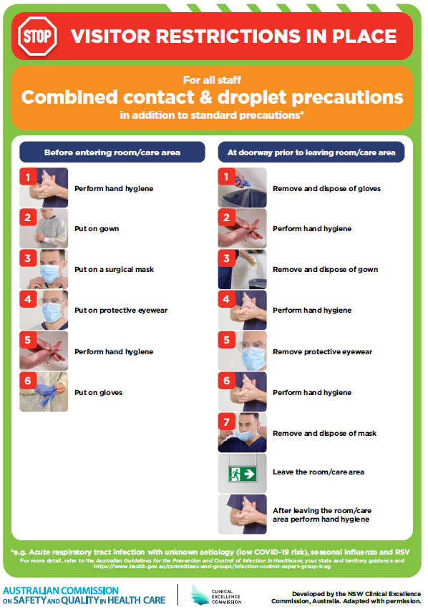](https://www.safetyandquality.gov.au/publications-and-resources/resource-library/poster-combined-contact-and-droplet-precautions)
* ***Poster – Combined airborne and contact precautions*** <https://www.safetyandquality.gov.au/publications-and-resources/resource-library/poster-combined-airborne-and-contact-precautions>   
  [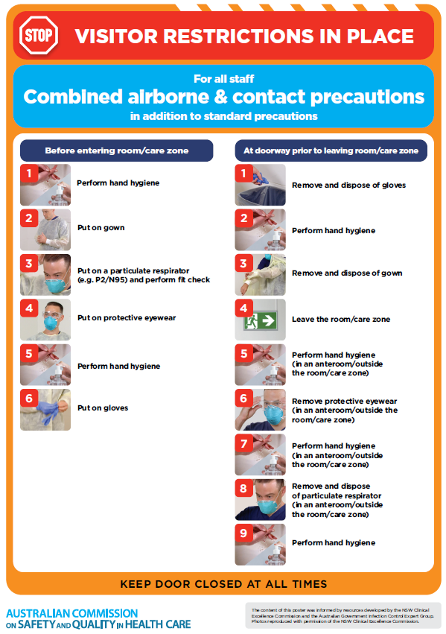](https://www.safetyandquality.gov.au/publications-and-resources/resource-library/poster-combined-airborne-and-contact-precautions)
* ***Environmental Cleaning and Infection Prevention and Control*** [www.safetyandquality.gov.au/environmental-cleaning](http://www.safetyandquality.gov.au/environmental-cleaning)
* ***COVID-19 infection prevention and control risk management – Guidance*** <https://www.safetyandquality.gov.au/publications-and-resources/resource-library/covid-19-infection-prevention-and-control-risk-management-guidance>
* ***Safe care for people with cognitive impairment during COVID-19***<https://www.safetyandquality.gov.au/our-work/cognitive-impairment/cognitive-impairment-and-covid-19>
* ***Stop COVID-19: Break the chain of infection*** posterhttps://www.safetyandquality.gov.au/publications-and-resources/resource-library/break-chain-infection-poster-a3  
  **[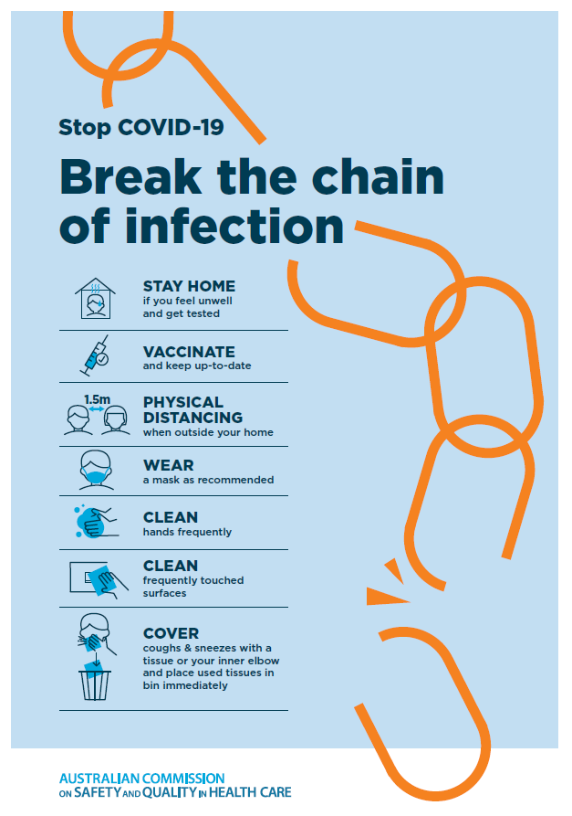](https://www.safetyandquality.gov.au/publications-and-resources/resource-library/break-chain-poster-a3https:/www.safetyandquality.gov.au/publications-and-resources/resource-library/break-chain-poster-a3)**
* ***FAQs for clinicians on elective surgery*** <https://www.safetyandquality.gov.au/node/5724>
* ***FAQs for consumers on elective surgery*** <https://www.safetyandquality.gov.au/node/5725>
* ***COVID-19 and face masks – Information for consumers*** <https://www.safetyandquality.gov.au/publications-and-resources/resource-library/covid-19-and-face-masks-information-consumers>

[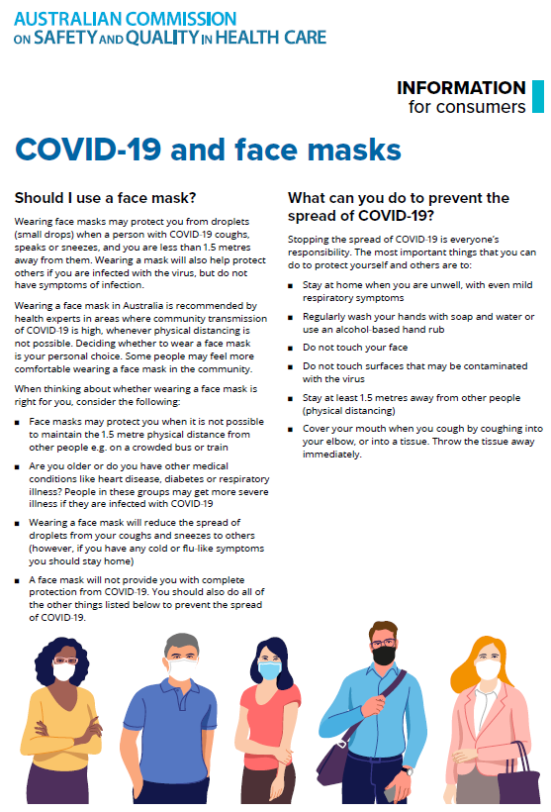](https://www.safetyandquality.gov.au/sites/default/files/2020-07/covid-19_and_face_masks_-_information_for_consumers.pdf)

*National COVID-19 Clinical Evidence Taskforce*

<https://covid19evidence.net.au/>

The National COVID-19 Clinical Evidence Taskforce is a collaboration of peak health professional bodies across Australia whose members are providing clinical care to people with COVID-19. The taskforce is undertaking continuous evidence surveillance to identify and rapidly synthesise emerging research in order to provide national, **evidence-based guidelines and clinical flowcharts for the clinical care of people with COVID-19**. The guidelines address questions that are specific to managing COVID-19 and cover the full disease course across mild, moderate, severe and critical illness. These are ‘living’ guidelines, updated with new research in near real-time in order to give reliable, up-to-the minute advice to clinicians providing frontline care in this unprecedented global health crisis.

*COVID-19 Critical Intelligence Unit*

<https://www.aci.health.nsw.gov.au/covid-19/critical-intelligence-unit>

The Agency for Clinical Innovation (ACI) in New South Wales has developed this page summarising rapid, evidence-based advice during the COVID-19 pandemic. Its operations focus on systems intelligence, clinical intelligence and evidence integration. The content includes a daily evidence digest, a COVID status monitor, a risk monitoring dashboard and evidence checks on a discrete topic or question relating to the current COVID-19 pandemic. There is also a ‘Living evidence’ section summarising key studies and emerging evidence on **COVID-19 vaccines** and **SARS-CoV-2 variants**. The most recent updates include:

* ***COVID-19 pandemic and influenza*** – What is the evidence for COVID-19 pandemic and influenza?
* ***Post-acute sequelae of COVID-19*** – What is the evidence on the post-acute sequelae of COVID-19?
* ***Budesonide and aspirin for pregnant women with COVID-19 –*** What is the evidence for the use of Budesonide for pregnant women with COVID-19? What is the evidence for aspirin prophylaxis for pre-eclampsia in pregnant women with a COVID-19 infection?
* ***Omicron (BA.2 sub-lineage)*** – What is the available evidence for the BA.2 sub-lineage of the Omicron variant of concern?
* ***COVID-19 vaccines in Australia*** – What is the evidence on COVID-19 vaccines in Australia?
* ***COVID-19 pandemic and wellbeing of critical care and other healthcare workers*** – Evidence in brief on the impact of the COVID-19 pandemic on the wellbeing of critical care and other healthcare workers.
* ***Surgery post COVID-19*** – What is the evidence for the timing of surgery, and outcomes following surgery, for people who have recovered from COVID-19?
* ***Disease modifying treatments for COVID-19 in children*** – What is the evidence for disease modifying treatments for COVID-19 in children?
* ***Mask type for COVID-19 positive wearer*** – What is the evidence for different mask types for COVID-19 positive wearers?
* ***Post acute and subacute COVID-19 care*** – What published advice and models of care are available regarding post-acute and subacute care for COVID-19 patients?
* ***Hospital visitor policies*** – What is the evidence for hospital visitor policies during and outside of the COVID-19 pandemic?
* ***Surgical masks, eye protection and PPE guidance*** –What is the evidence for surgical masks in the endemic phase in hospitals and for eyewear to protect against COVID-19?

**Disclaimer**

On the Radar is an information resource of the Australian Commission on Safety and Quality in Health Care. The Commission is not responsible for the content of, nor does it endorse, any articles or sites listed. The Commission accepts no liability for the information or advice provided by these external links. Links are provided on the basis that users make their own decisions about the accuracy, currency and reliability of the information contained therein. Any opinions expressed are not necessarily those of the Australian Commission on Safety and Quality in Health Care.