# Australian Commission on Safety and Quality logotypeOn the Radar

Issue 559

23 May 2022

*On the Radar* is a summary of some of the recent publications in the areas of safety and quality in health care. Inclusion in this document is not an endorsement or recommendation of any publication or provider. Access to particular documents may depend on whether they are Open Access or not, and/or your individual or institutional access to subscription sites/services. Material that may require subscription is included as it is considered relevant.

*On the Radar* is available online, via email or as a PDF or Word document from <https://www.safetyandquality.gov.au/publications-and-resources/newsletters/radar>

If you would like to receive *On the Radar* via email, you can subscribe on our website <https://www.safetyandquality.gov.au/publications-and-resources/newsletters>  
or by emailing us at H[Umail@safetyandquality.gov.auU](mailto:mail@safetyandquality.gov.au).   
You can also send feedback and comments to H[Umail@safetyandquality.gov.auU](mailto:mail@safetyandquality.gov.au).

For information about the Commission and its programs and publications, please visit <https://www.safetyandquality.gov.au>

You can also follow us on Twitter @ACSQHC.

**On the Radar**

Editor: Dr Niall Johnson [niall.johnson@safetyandquality.gov.au](mailto:niall.johnson@safetyandquality.gov.au)

Contributors: Niall Johnson

**Reports**

*Avoiding hospital readmissions: the models and the role of primary care*

Deeble Institute for Health Policy Research Evidence Brief No. 24

Chua D, Johnson T

Canberra: Australian Healthcare & Hospitals Association; 2022. p. 23.

|  |  |
| --- | --- |
| URL | <https://ahha.asn.au/publication/health-policy-evidence-briefs/evidence-brief-no-24-avoiding-hospital-readmissions-models> |
| Notes | This Evidence Brief from the Australian Healthcare and Hospitals Association’s Deeble Institute examines approaches to and the role of primary care in reducing or avoiding hospital readmissions. The authors of this brief observe ‘Unplanned hospital readmissions indicate suboptimal patient outcomes, care coordination, and quality of care and contribute to significant avoidable healthcare costs’. The authors outline some of the models of care which have been used to prevent unplanned hospital readmissions, including those models that improve transitional care, as well as virtual wards and telehealth. They also examine the role of primary care, specifically general practice, in helping to reduce hospital readmissions. |

For information on the Commission’s work on avoidable hospital readmissions, including the 2019 *Avoidable Hospital Readmissions: Report on Australian and International indicators, their use and the efficacy of interventions to reduce readmissions*, see <https://www.safetyandquality.gov.au/our-work/indicators/avoidable-hospital-readmissions>

**Journal articles**

*It is time to reinvest in quality improvement collaboratives to support Australian general practice*

Knight AW, Fraser J, Pond CD

Medical Journal of Australia. 2022;216(9):438-440.

|  |  |
| --- | --- |
| DOI | <https://doi.org/10.5694/mja2.51502> |
| Notes | This Perspectives piece in the *Medical Journal of Australia* observes that while ‘Australian general practice is among the highest quality in the world’ there are ‘significant stresses, and ‘professional isolation and fragmentation of care persist’. The authors argue that quality improvement collaboratives, including regional and national-level collaboratives, could play a role in supporting and improving general practice in Australia. |

*Management of type 2 diabetes in young adults aged 18–30 years: ADS/ADEA/APEG consensus statement*

Wong J, Ross GP, Zoungas S, Craig ME, Davis EA, Donaghue KC, et al

Medical Journal of Australia. 2022;216(8):422-429.

|  |  |
| --- | --- |
| DOI | <https://doi.org/10.5694/mja2.51482> |
| Notes | Announcement via the Medical Journal of Australia of the first Australian consensus statement on the management of type 2 diabetes in young adults. This consensus statement ‘considers areas where existing type 2 diabetes guidance, directed mainly towards older adults, may not be appropriate or relevant for the young adult population.’ The full statement is available at from the Australian Diabetes Society <https://www.diabetessociety.com.au>, the Australian Diabetes Educators Association <https://www.adea.com.au> and the Australian Paediatric Endocrine Group <https://www.apeg.org.au> |

*Last days of life: Paediatric and Neonatal Toolkit*

Coombs S

Australian Nursing & Midwifery Journal. 2022 17 May 2022.

|  |  |
| --- | --- |
| URL | <https://anmj.org.au/last-days-of-life-paediatric-and-neonatal-toolkit/> |
| Notes | Piece describing the development and production of the *Last Days of Life: Paediatric & Neonatal (LDOL: P&N) Toolkit*. The toolkit ‘was developed to support clinicians when caring for a paediatric or neonatal patient in an acute care setting during the last days of life.’ The toolkit can be viewed on the New South Wales Paediatric Palliative Care Programme website <https://www.nswppcprogramme.com.au/> |

*BMJ Quality & Safety* online first articles

|  |  |
| --- | --- |
| URL | <https://qualitysafety.bmj.com/content/early/recent> |
| Notes | *BMJ Quality &Safety* has published a number of ‘online first’ articles, including:   * Mortality before and after **reconfiguration of the Danish hospital-based emergency healthcare system**: a nationwide interrupted time series analysis (Marianne Flojstrup, Søren Bie Bie Bogh, Mickael Bech, Daniel Pilsgaard Henriksen, Søren Paaske Johnsen, Mikkel Brabrand) |

*International Journal for Quality in Health Care* online first articles

|  |  |
| --- | --- |
| URL | <https://academic.oup.com/intqhc/advance-articles> |
| Notes | *International Journal for Quality in Health Care* has published a number of ‘online first’ articles, including:   * Epidemiology of **Falls in 25 Australian Residential Aged Care Facilities**: A Retrospective Longitudinal Cohort Study Using Routinely Collected Data (Nasir Wabe, Karla L Seaman, Amy Nguyen, Joyce Siette, Magdalena Z Raban, Peter Hibbert, Jacqueline Close, Stephen R Lord, Johanna I Westbrook) |

**Online resources**

*[UK] NICE Guidelines and Quality Standards*

<https://www.nice.org.uk/guidance>

The UK’s National Institute for Health and Care Excellence (NICE) has published new (or updated) guidelines and quality standards. The latest reviews or updates are:

* NICE Guideline NG218 ***Vaccine uptake*** *in the general population* <https://www.nice.org.uk/guidance/ng218>
* Quality Standard QS145 ***Vaccine uptake*** *in under 19s* <https://www.nice.org.uk/guidance/qs145>
* NICE Guideline NG191 *COVID-19 rapid guideline:* ***managing COVID-19*** <https://www.nice.org.uk/guidance/ng191>

***[USA] AHRQ Perspectives on Safety***

<https://psnet.ahrq.gov/psnet-collection/perspectives>

The US Agency for Healthcare Research and Quality (AHRQ) publishes Perspectives on Safety essays. Recent essays include:

* ***Identifying Safety Events in the Prehospital Setting*** –focuses on the measuring and monitoring of patient safety in the prehospital setting, which brings a unique set of challenges and opportunities. Emergency medical services (EMS) personnel provide care outside of a healthcare facility in complex environments. The unpredictability of the scene, environmental issues like lighting (or lack thereof), and the need to make decisions for time-sensitive conditions with often incomplete information are just a few of the factors that contribute to the challenge of providing care in the prehospital setting.<https://psnet.ahrq.gov/perspective/identifying-safety-events-prehospital-setting>

**COVID-19 resources**

https://www.safetyandquality.gov.au/covid-19

The Australian Commission on Safety and Quality in Health Care has developed a number of resources to assist healthcare organisations, facilities and clinicians. These and other material on COVID-19 are available at <https://www.safetyandquality.gov.au/covid-19>

These resources include:

* ***OVID-19 infection prevention and control risk management*** This primer provides an overview of three widely used tools for investigating and responding to patient safety events and near misses. Tools covered in this primer include incident reporting systems, Root Cause Analysis (RCA), and Failure Modes and Effects Analysis (FMEA).   
  <https://www.safetyandquality.gov.au/publications-and-resources/resource-library/covid-19-infection-prevention-and-control-risk-management-guidance>
* ***Poster – Combined contact and droplet precautions*** <https://www.safetyandquality.gov.au/publications-and-resources/resource-library/poster-combined-contact-and-droplet-precautions>  
  [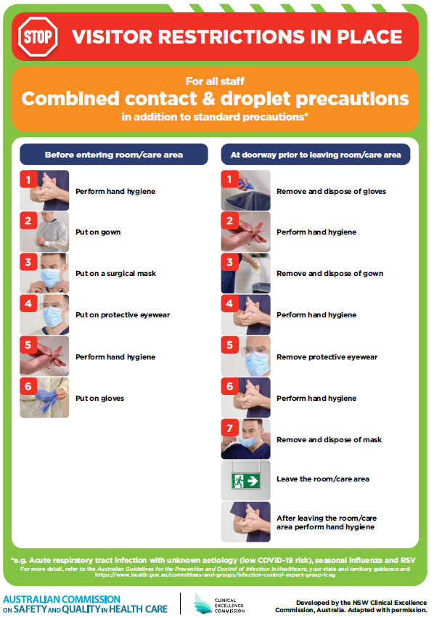](https://www.safetyandquality.gov.au/publications-and-resources/resource-library/poster-combined-contact-and-droplet-precautions)
* ***Poster – Combined airborne and contact precautions*** <https://www.safetyandquality.gov.au/publications-and-resources/resource-library/poster-combined-airborne-and-contact-precautions>   
  [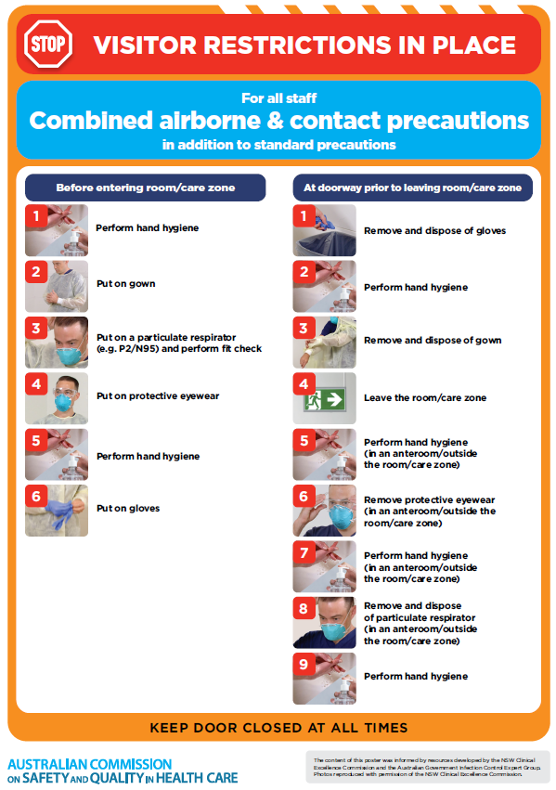](https://www.safetyandquality.gov.au/publications-and-resources/resource-library/poster-combined-airborne-and-contact-precautions)
* ***Environmental Cleaning and Infection Prevention and Control*** [www.safetyandquality.gov.au/environmental-cleaning](http://www.safetyandquality.gov.au/environmental-cleaning)
* ***COVID-19 infection prevention and control risk management – Guidance*** <https://www.safetyandquality.gov.au/publications-and-resources/resource-library/covid-19-infection-prevention-and-control-risk-management-guidance>
* ***Safe care for people with cognitive impairment during COVID-19***<https://www.safetyandquality.gov.au/our-work/cognitive-impairment/cognitive-impairment-and-covid-19>
* ***Stop COVID-19: Break the chain of infection*** posterhttps://www.safetyandquality.gov.au/publications-and-resources/resource-library/break-chain-infection-poster-a3  
  **[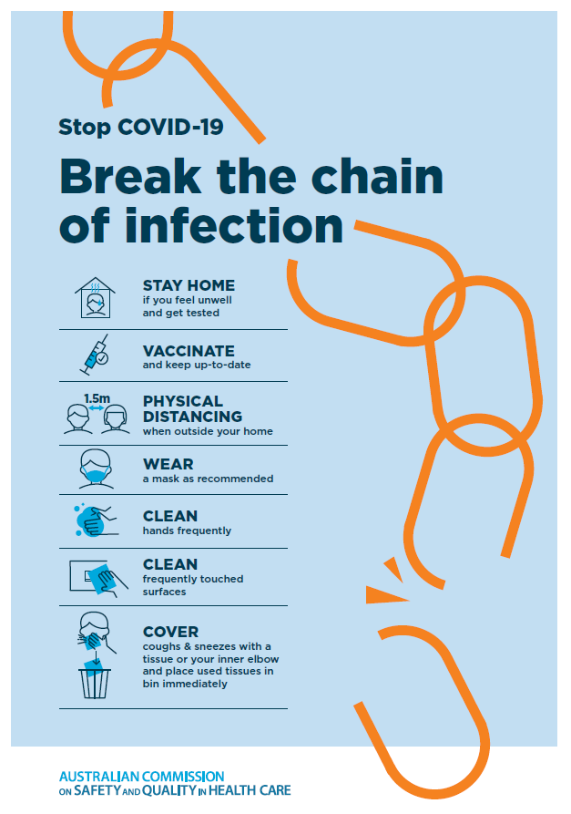](https://www.safetyandquality.gov.au/publications-and-resources/resource-library/break-chain-poster-a3https:/www.safetyandquality.gov.au/publications-and-resources/resource-library/break-chain-poster-a3)**
* ***FAQs for clinicians on elective surgery*** <https://www.safetyandquality.gov.au/node/5724>
* ***FAQs for consumers on elective surgery*** <https://www.safetyandquality.gov.au/node/5725>
* ***COVID-19 and face masks – Information for consumers*** <https://www.safetyandquality.gov.au/publications-and-resources/resource-library/covid-19-and-face-masks-information-consumers>

[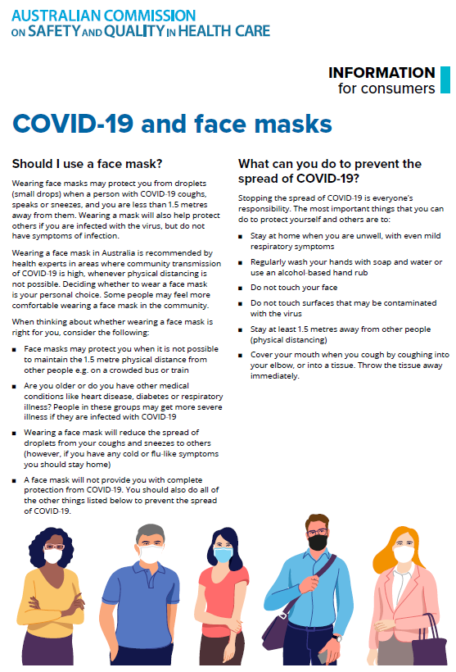](https://www.safetyandquality.gov.au/sites/default/files/2020-07/covid-19_and_face_masks_-_information_for_consumers.pdf)

*National COVID-19 Clinical Evidence Taskforce*

<https://covid19evidence.net.au/>

The National COVID-19 Clinical Evidence Taskforce is a collaboration of peak health professional bodies across Australia whose members are providing clinical care to people with COVID-19. The taskforce is undertaking continuous evidence surveillance to identify and rapidly synthesise emerging research in order to provide national, **evidence-based guidelines and clinical flowcharts for the clinical care of people with COVID-19**. The guidelines address questions that are specific to managing COVID-19 and cover the full disease course across mild, moderate, severe and critical illness. These are ‘living’ guidelines, updated with new research in near real-time in order to give reliable, up-to-the minute advice to clinicians providing frontline care in this unprecedented global health crisis.

*COVID-19 Critical Intelligence Unit*

<https://www.aci.health.nsw.gov.au/covid-19/critical-intelligence-unit>

The Agency for Clinical Innovation (ACI) in New South Wales has developed this page summarising rapid, evidence-based advice during the COVID-19 pandemic. Its operations focus on systems intelligence, clinical intelligence and evidence integration. The content includes a daily evidence digest, a COVID status monitor, a risk monitoring dashboard and evidence checks on a discrete topic or question relating to the current COVID-19 pandemic. There is also a ‘Living evidence’ section summarising key studies and emerging evidence on **COVID-19 vaccines** and **SARS-CoV-2 variants**. The most recent updates include:

* ***Emerging variants*** – What is the available evidence for emerging variants?
* ***Chest pain or dyspnoea following COVID-19 vaccination*** – What is evidence for chest pain or dyspnoea following COVID-19 vaccination?
* ***Cardiac investigations and elective surgery post-COVID-19*** – What is evidence for cardiac investigations and elective surgery post-COVID-19?
* ***Breathlessness post COVID-19*** – How to determine those patients who present with ongoing breathlessness in need of urgent review or intervention due to suspected pulmonary embolus?
* ***COVID-19 pandemic and influenza*** – What is the evidence for COVID-19 pandemic and influenza?
* ***Post-acute sequelae of COVID-19*** – What is the evidence on the post-acute sequelae of COVID-19?
* ***Budesonide and aspirin for pregnant women with COVID-19 –*** What is the evidence for the use of Budesonide for pregnant women with COVID-19? What is the evidence for aspirin prophylaxis for pre-eclampsia in pregnant women with a COVID-19 infection?
* ***COVID-19 vaccines in Australia*** – What is the evidence on COVID-19 vaccines in Australia?
* ***COVID-19 pandemic and wellbeing of critical care and other healthcare workers*** – Evidence in brief on the impact of the COVID-19 pandemic on the wellbeing of critical care and other healthcare workers.
* ***Surgery post COVID-19*** – What is the evidence for the timing of surgery, and outcomes following surgery, for people who have recovered from COVID-19?
* ***Disease modifying treatments for COVID-19 in children*** – What is the evidence for disease modifying treatments for COVID-19 in children?
* ***Mask type for COVID-19 positive wearer*** – What is the evidence for different mask types for COVID-19 positive wearers?
* ***Post acute and subacute COVID-19 care*** – What published advice and models of care are available regarding post-acute and subacute care for COVID-19 patients?
* ***Hospital visitor policies*** – What is the evidence for hospital visitor policies during and outside of the COVID-19 pandemic?
* ***Surgical masks, eye protection and PPE guidance*** –What is the evidence for surgical masks in the endemic phase in hospitals and for eyewear to protect against COVID-19?

**Disclaimer**

On the Radar is an information resource of the Australian Commission on Safety and Quality in Health Care. The Commission is not responsible for the content of, nor does it endorse, any articles or sites listed. The Commission accepts no liability for the information or advice provided by these external links. Links are provided on the basis that users make their own decisions about the accuracy, currency and reliability of the information contained therein. Any opinions expressed are not necessarily those of the Australian Commission on Safety and Quality in Health Care.