# Australian Commission on Safety and Quality logotypeOn the Radar

Issue 571

22 August 2022

*On the Radar* is a summary of some of the recent publications in the areas of safety and quality in health care. Inclusion in this document is not an endorsement or recommendation of any publication or provider. Access to particular documents may depend on whether they are Open Access or not, and/or your individual or institutional access to subscription sites/services. Material that may require subscription is included as it is considered relevant.

*On the Radar* is available online, via email or as a PDF or Word document from <https://www.safetyandquality.gov.au/publications-and-resources/newsletters/radar>

If you would like to receive *On the Radar* via email, you can subscribe on our website <https://www.safetyandquality.gov.au/publications-and-resources/newsletters>  
or by emailing us at H[Umail@safetyandquality.gov.auU](mailto:mail@safetyandquality.gov.au).   
You can also send feedback and comments to H[Umail@safetyandquality.gov.auU](mailto:mail@safetyandquality.gov.au).

For information about the Commission and its programs and publications, please visit <https://www.safetyandquality.gov.au>

You can also follow us on Twitter @ACSQHC.

**On the Radar**

Editor: Dr Niall Johnson [niall.johnson@safetyandquality.gov.au](mailto:niall.johnson@safetyandquality.gov.au)

Contributors: Niall Johnson, Amy Forsyth

**Launch of the first clinical care standard on low back pain**

<https://www.safetyandquality.gov.au/standards/clinical-care-standards/low-back-pain-clinical-care-standard>

You are invited to the virtual launch of the first national *Low Back Pain Clinical Care Standard*, hosted by the Australian Commission on Safety and Quality in Health Care.

Low back pain is a leading cause of disability worldwide. This burden is increasing despite a burgeoning number of treatment options. Back problems and back pain are the second most common reason Australians seek care from their general practitioner, and one of the top five presentations to emergency departments.

Early appropriate management of people experiencing an acute episode is important to reduce the chance of developing chronic low back pain.

Join the webcast to hear the experts discuss the challenges presented by this common condition, and how the standard will improve patient-centred care, while reducing investigations and treatments that may be ineffective or unnecessary.

The event will be hosted by journalist and broadcaster Geraldine Doogue AO.

The *Low Back Pain Clinical Care Standard* will be launched via webcast on **Thursday, 1 September 2022 at 12pm AEST**.

Register at <https://safetyandquality.tv>

Expert panellists:

* Associate Professor Liz Marles – Clinical Director, Australian Commission on Safety and Quality in Health Care and General Practitioner, Hornsby-Brooklyn GP Unit
* Professor Peter O’Sullivan – Professor of Musculoskeletal Physiotherapy, Curtin University
* Professor Michael Nicholas – Director and Professor, Pain Education Unit, The Kolling Institute, University of Sydney and Director, Pain Management Programs, Pain Management and Research Centre, Royal North Shore Hospital
* Dr James Edwards – Director, Emergency Department, Royal Prince Alfred Hospital and Medical Lead, NSW Health Vaccination Centre.

This event is relevant to all healthcare professionals involved in the early management of people with low back pain, especially general practitioners, physiotherapists and other allied health professionals, emergency physicians, nurses and nurse practitioners.

For more information, email ccs@safetyandquality.gov.au or visit our web page <https://www.safetyandquality.gov.au/standards/clinical-care-standards/low-back-pain-clinical-care-standard>

[The Low Back Pain Clinical Care Standard will be launched via webcast on Thursday, 1 September 2022 at 12pm AEST.
Register at https://safetyandquality.tv](https://safetyandquality.tv)

**Reports**

*Patient Safety Incident Response Framework*

NHS England

London: NHS England; 2022. p. 13.

*Engaging and involving patients, families and staff following a patient safety incident*

NHS England

London: NHS England; 2022. p. 49.

|  |  |
| --- | --- |
| URL | <https://www.england.nhs.uk/patient-safety/incident-response-framework/> |
| Notes | NHS England has published the *Patient Safety Incident Response Framework* (PSIRF) as new guidance on how NHS organisations respond to patient safety incidents. The framework supports the key principles of a patient safety culture. It is centred on:   * compassion and involving those affected * system based approaches to learning and improvement * considered and proportionate responses * supportive oversight.   The PSIRF aims to ensure that there is a focus on understanding how incidents happen, rather than apportioning blame on individuals. This will allow for more effective learning and improvement.  Published alongside the framework, the *Guide to engaging and involving patients, families and staff following a patient safety incident*, also sets out expectations for how those affected by an incident, for example, patients, families and staff, should be treated with compassion and involved in any investigation process. |

*Hospital-treated self-harm: Improving care through improved data*

Deeble Institute for Health Policy Research Issues Brief No. 47

McGill K, Haddock R

Canberra: Australian Healthcare and Hospitals Association; 2022. p. 39.

|  |  |
| --- | --- |
| URL | <https://ahha.asn.au/publication/health-policy-issue-briefs/deeble-issues-brief-no-47-hospital-treated-self-harm-0> |
| Notes | This Issues Brief from the Australian Healthcare and Hospitals Association’s Deeble Institute looks at the issue of self-harm in Australia. Apparently, ‘Self-harm accounts for more than 30,000 hospital admissions each year in Australia.’ While self-harm is prevalent, the authors assert that care is variable and can be substandard, noting that ‘care is not always in line with best practice and many people report that contact with hospitals after self-harm does not meet their needs. Consistent best practice care is required to improve outcomes for people who have presented to hospitals after self-harm.’ The authors argue that there is a need for better data to drive improvements in care, with the creation of a clinical quality registry for hospital-treated self-harm as a key component. |

*The use of an appropriate flush fluid with arterial lines*

Independent report by the Healthcare Safety Investigation Branch NI-000832

Healthcare Safety Investigation Branch

Farnborough: HSIB; 2022. p. 104.

|  |  |
| --- | --- |
| URL | <https://www.hsib.org.uk/investigations-and-reports/the-use-of-an-appropriate-flush-fluid-with-arterial-lines/> |
| Notes | This is the latest report from the UK’s Healthcare Safety Investigation Branch (HSIB) reports on an investigation that sought to understand the risks for patients associated with blood sampling from arterial line systems used in adult critical care. Following a “reference event” where the use of incorrect flush in a patient’s arterial line led to the contamination of the blood samples taken from the site of the arterial line, which consequently misled clinicians to give unnecessary and potentially harmful treatment. The findings, safety recommendations and safety observations seek to ‘demonstrate the risk associated with the set-up of the arterial monitoring line and use of the correct flush fluid’. |

**Journal articles**

*Impact of unacceptable behaviour between healthcare workers on clinical performance and patient outcomes: a systematic review*

Guo L, Ryan B, Leditschke IA, Haines KJ, Cook K, Eriksson L, et al

BMJ Quality & Safety. 2022;31(9):679-687.

|  |  |
| --- | --- |
| DOI | <https://dx.doi.org/10.1136/bmjqs-2021-013955> |
| Notes | Systematic review based on 36 studies that sought to ‘summarise the current evidence of the impact of unacceptable behaviour occurring between HCWs [health care workers] on clinical performance and patient outcomes.’ The review found that the literature was of variable quality and ‘some inconsistencies in the strengths of associations reported’. However, ‘the overall weight of evidence shows that unacceptable behaviour negatively affects the clinical performance of HCWs, quality of care, workplace productivity and patient outcomes.’ |

*Clinical incidents in the emergency department: is there an association with emergency nursing shift patterns? A retrospective observational study*

Roberts K, Thom O, Hocking J, Bernard A, Doyle T

BMJ Open Quality. 2022;11(3):e001785.

|  |  |
| --- | --- |
| URL / DOI | <https://bmjopenquality.bmj.com/content/11/3/e001785>  <https://doi.org/10.1136/bmjoq-2021-001785> |
| Notes | Paper reporting on a Queensland study that examined the association between clinical incidents (CI) and nursing shift patterns in the emergency department (ED). This was a retrospective observational study that examined 244 clinical incidents that occurred in a single ED over a 1-year period. Analysis of the nursing shifts covered 1095 nursing shifts and examined early, late and night shifts, including days not worked by the ED nurse was conducted over a 48-hour and 96-hour period around each incident.  The results reported included ‘There was no significant relationship identified between the CI and nursing shift patterns. ED length of stay (LOS) was significantly higher for a patient presentation when a CI occurred.’ |

*Developing Methods to Support Collaborative Learning and Co-creation of Resilient Healthcare—Tips for Success and Lessons Learned From a Norwegian Hospital Cancer Care Study*

Bergerød IJ, Clay-Williams R, Wiig S

Journal of Patient Safety. 2022;18(5):396-403.

|  |  |
| --- | --- |
| DOI | <https://doi.org/10.1097/PTS.0000000000000958> |
| Notes | Paper on a Norwegian exploration (involving Australian academics) of how collaborative learning and co-creation can foster resilient healthcare services.  Figure 5 from Developing Methods to Support Collaborative Learning and Co-creation of Resilient Healthcare—Tips for Success and Lessons Learned From a Norwegian Hospital Cancer Care Study.  Modeling methods for second-order learning processes in resilience. |

*Machine Learning–Based Mortality Prediction of Patients at Risk During Hospital Admission*

Trentino KM, Schwarzbauer K, Mitterecker A, Hofmann A, Lloyd A, Leahy MF, et al.

Journal of Patient Safety. 2022;18(5):494-498.

|  |  |
| --- | --- |
| DOI | <https://doi.org/10.1097/PTS.0000000000000957> |
| Notes | The potential for artificial intelligence (AI) and machine learning (ML) have been touted for some time and in some areas there appears to be demonstrable progress and utility, for example diagnostic imaging, dermatology, etc. This paper describes how machine learning was applied in 3 Western Australian hospitals ‘to predict in-hospital mortality from standardized data sets available at hospital admission.’ The paper reports on a retrospective, observational study that ran between January 2008 and June 2017 and saw four predictive models examined for their predictive value. While the results suggest the model(s) are satisfactory, this remains a work in progress. The authors conclude ‘This study demonstrates that using only a limited, standardized data set in-hospital mortality can be predicted satisfactorily at the time point of hospital admission. More parameters describing patient’s health are likely needed to improve our model.’ |

*BMJ Quality & Safety*

September 2022 Volume 31 Issue 9

|  |  |
| --- | --- |
| URL | <https://qualitysafety.bmj.com/content/31/9> |
| Notes | A new issue of *BMJ Quality & Safety* has been published. Many of the papers in this issue have been referred to in previous editions of *On the Radar* (when they were released online). Articles in this issue of *BMJ Quality & Safety* include:   * Editorial: **Pay-for-performance incentives for** **health worker vaccination**: looking under the hood (Alison M Buttenheim, Harsha Thirumurthy) * Editorial: **Replicating and publishing research in different countries and different settings**: advice for authors (Bryony Dean Franklin, Eric J Thomas) * Editorial: **Speaking up in resource-constrained settings**: how to secure safe surgical care in the moment and in the future? (Graham P Martin, Natalie Armstrong) * Editorial: **Improving health equity** through clinical innovation (Myrtede Alfred, Kristin P Tully) * Editorial: **Unacceptable behaviours between healthcare workers**: just the tip of the patient safety iceberg (Ellen Bamberger, Peter Bamberger) * Examining organisational responses to **performance-based financial incentive systems**: a case study using NHS staff influenza vaccination rates from 2012/2013 to 2019/2020 (Adiba Liaqat, Suzy Gallier, Katharine Reeves, Hannah Crothers, Felicity Evison, Kelly Schmidtke, Paul Bird, Samuel I Watson, Kamlesh Khunti, Richard Lilford) * Patterns, appropriateness and outcomes of **peripherally inserted central catheter** **use** in Brazil: a multicentre study of 12 725 catheters (Eneida Rejane Rabelo-Silva, Solange Antonia Lourenço, Rubia Natasha Maestri, Claudia Candido da Luz, Vanderlei Carlos Pupin, Raquel Bauer Cechinel, Eduarda Bordini Ferro, Marco Aurélio Lumertz Saffi, Telma Christina do Campo Silva, Larissa Martins de Andrade, Larissa Fernanda Sales Gomes, Lorena Alves da Gama, Mariana Marques de Araújo, Fábio Rodrigues Ferreira do Espírito Santo, Leticia López Pedraza, Vânia Naomi Hirakata, Vilma Santana Soares, Widlani Sousa Montenegro, Gustavo Rocha Costa de Freitas, Thaís Souza de Jesus, Vineet Chopra) * Implications of resource constraints and high workload on **speaking up about threats to patient safety**: a qualitative study of surgical teams in Ghana (Emmanuel Kwasi Mawuena, Russell Mannion) * Examining the effect of quality improvement initiatives on decreasing **racial disparities in maternal morbidity** (Christina Davidson, Stacie Denning, Kristin Thorp, Lynda Tyer-Viola, Michael Belfort, Haleh Sangi-Haghpeykar, Manisha Gandhi) * **Impact of** **unacceptable behaviour between healthcare workers on clinical performance and patient outcomes**: a systematic review (Linda Guo, Benjamin Ryan, Isabel Anne Leditschke, Kimberley J Haines, Katrina Cook, Lars Eriksson, Olusegun Olusanya, Tanya Selak, Kiran Shekar, Mahesh Ramanan) |

*Australian Journal of Primary Health*

Volume 28, Number 4, August 2022

|  |  |
| --- | --- |
| URL | <https://www.publish.csiro.au/py/issue/10796> |
|  | A new issue of the *Australian Journal of Primary Health* has been published. Articles in this issue of the *Australian Journal of Primary Health* include:   * **Rapid deployment of support for a mental health crisis**: 10 priorities framing Australia’s COVID-19 pandemic response (Jane Desborough, Grant Blashki, Sally Hall Dykgraaf, Ruth Vine, Mark Roddam, Ashvini Munindradasa and Michael Kidd) * ‘We’re also healers’: **Elders leading the way in Aboriginal community healing** (Terrance Cox, Jonathon Mond and Ha Hoang) * **Community-driven health research** in the Torres Strait (Hylda Wapau, Ella Kris, Luisa Roeder and Malcolm McDonald) * ‘Look, wait, I’ll translate’: **refugee women’s experiences with interpreters in healthcare** in Aotearoa New Zealand (Shemana Cassim, Jacquie Kidd, Madiha Ali, Nur Abdul Hamid, Dina Jamil, Rawiri Keenan, Fariya Begum and Ross Lawrenson) * **Community-based pain programs** commissioned by primary health networks: key findings from an online survey and consultation with program managers (Simone De Morgan, Pippy Walker, Fiona M. Blyth, Michael Nicholas and Andrew Wilson) * Process evaluation of **chest camps for increased tuberculosis case finding** in Punjab, Pakistan (Muhammad Amir Khan, Fouzia Perveen, Muhammad Ahmar Khan, Muhammad Jameel, Nida Khan, Zarfishan Tahir, Hussain Hadi and Haroon Jehangir Khan) * ‘What is this about? Let’s play this out’: the experience of **integrating primary health care registered nurses with school learning and support teams** (Catherine Sanford, Emily Saurman, Sarah Dennis and David Lyle) * Evaluation of a **General Practitioner with Special Interest model**: lessons learned from staff experiences (L Purtell, E Whiting, K Muller, C McSherry, K Gillespie, K Havas and A Bonner) * Steps towards equitable care: creating web pages to highlight **diversity for Australia’s aged care and end of life care workforce** (Georgia Rowley, Jennifer Tieman and Kelly Jones) * Understanding of **advance care planning in primary care**: a gap analysis (Josephine Chow, Ann Harley, Danielle Ni Chroinin, Friedbert Kohler, Janeane Harlum, Kim Jobburn, Pamela Keech, Rachael Williams, Susan Fraser and Ken Hillman) * A trial of the **AASPIRE healthcare toolkit** with Australian adults on the autism spectrum (Lisa R J Kang, Tim Barlott, Merrill Turpin and Anna Urbanowicz) * **Experiences of adults with adult-onset type 1 diabetes**: a cross-sectional study (Danielle Berkovic, Rebecca Fransquet, Sze-Ee Soh and Darshini Ayton) |

*BMJ Quality & Safety* online first articles

|  |  |
| --- | --- |
| URL | <https://qualitysafety.bmj.com/content/early/recent> |
| Notes | *BMJ Quality &Safety* has published a number of ‘online first’ articles, including:   * Effectiveness of a multifaceted quality improvement intervention to improve **patient outcomes after total hip and knee arthroplasty**: a registry nested cluster randomised controlled trial (Peter van Schie, Leti van Bodegom-Vos, Tristan M Zijdeman, Rob G H H Nelissen, Perla J Marang-van de Mheen IQ Joint study group) |

**Online resources**

***[UK] NICE Guidelines and Quality Standards***

<https://www.nice.org.uk/guidance>

The UK’s National Institute for Health and Care Excellence (NICE) has published new (or updated) guidelines and quality standards. The latest reviews or updates are:

* NICE Guideline NG17 ***Type 1 diabetes*** *in adults: diagnosis and management* <https://www.nice.org.uk/guidance/ng17>

**COVID-19 resources**

https://www.safetyandquality.gov.au/covid-19

The Australian Commission on Safety and Quality in Health Care has developed a number of resources to assist healthcare organisations, facilities and clinicians. These and other material on COVID-19 are available at <https://www.safetyandquality.gov.au/covid-19>

These resources include:

* ***OVID-19 infection prevention and control risk management*** This primer provides an overview of three widely used tools for investigating and responding to patient safety events and near misses. Tools covered in this primer include incident reporting systems, Root Cause Analysis (RCA), and Failure Modes and Effects Analysis (FMEA).   
  <https://www.safetyandquality.gov.au/publications-and-resources/resource-library/covid-19-infection-prevention-and-control-risk-management-guidance>
* ***Poster – Combined contact and droplet precautions*** <https://www.safetyandquality.gov.au/publications-and-resources/resource-library/infection-prevention-and-control-poster-combined-contact-and-droplet-precautions>  
  [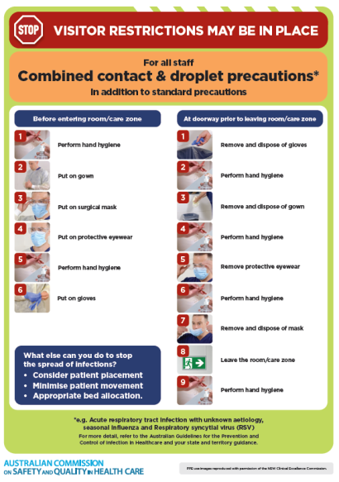](https://www.safetyandquality.gov.au/publications-and-resources/resource-library/infection-prevention-and-control-poster-combined-contact-and-droplet-precautions)
* ***Poster – Combined airborne and contact precautions*** <https://www.safetyandquality.gov.au/publications-and-resources/resource-library/poster-combined-airborne-and-contact-precautions>   
  [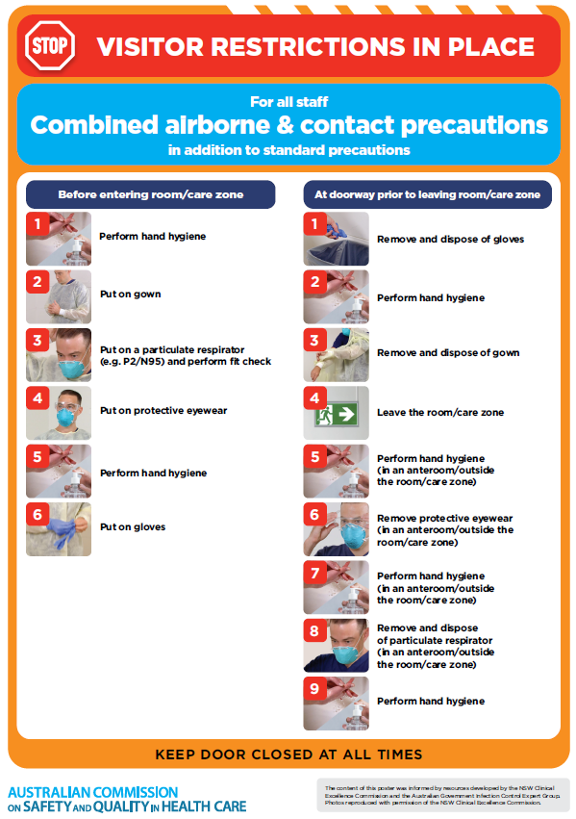](https://www.safetyandquality.gov.au/publications-and-resources/resource-library/poster-combined-airborne-and-contact-precautions)
* ***Environmental Cleaning and Infection Prevention and Control*** [www.safetyandquality.gov.au/environmental-cleaning](http://www.safetyandquality.gov.au/environmental-cleaning)
* ***COVID-19 infection prevention and control risk management – Guidance*** <https://www.safetyandquality.gov.au/publications-and-resources/resource-library/covid-19-infection-prevention-and-control-risk-management-guidance>
* ***Safe care for people with cognitive impairment during COVID-19***<https://www.safetyandquality.gov.au/our-work/cognitive-impairment/cognitive-impairment-and-covid-19>
* ***Stop COVID-19: Break the chain of infection*** posterhttps://www.safetyandquality.gov.au/publications-and-resources/resource-library/break-chain-infection-poster-a3  
  **[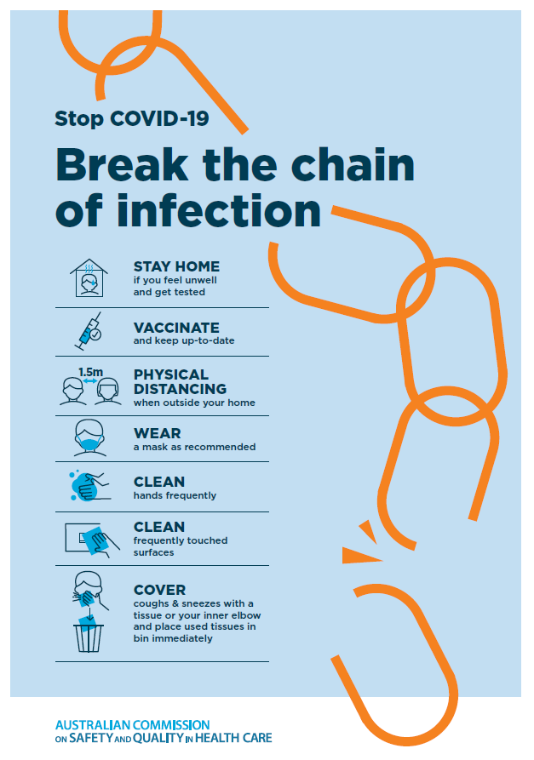](https://www.safetyandquality.gov.au/publications-and-resources/resource-library/break-chain-poster-a3https:/www.safetyandquality.gov.au/publications-and-resources/resource-library/break-chain-poster-a3)**
* ***FAQs for clinicians on elective surgery*** <https://www.safetyandquality.gov.au/node/5724>
* ***FAQs for consumers on elective surgery*** <https://www.safetyandquality.gov.au/node/5725>
* ***COVID-19 and face masks – Information for consumers*** <https://www.safetyandquality.gov.au/publications-and-resources/resource-library/covid-19-and-face-masks-information-consumers>

[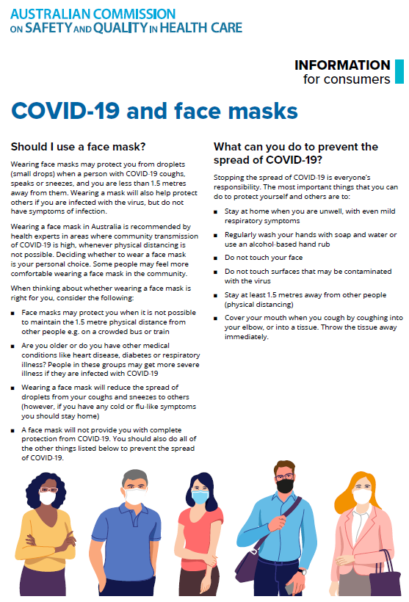](https://www.safetyandquality.gov.au/sites/default/files/2020-07/covid-19_and_face_masks_-_information_for_consumers.pdf)

*National COVID-19 Clinical Evidence Taskforce*

<https://covid19evidence.net.au/>

The National COVID-19 Clinical Evidence Taskforce is a collaboration of peak health professional bodies across Australia whose members are providing clinical care to people with COVID-19. The taskforce is undertaking continuous evidence surveillance to identify and rapidly synthesise emerging research in order to provide national, **evidence-based guidelines and clinical flowcharts for the clinical care of people with COVID-19**. The guidelines address questions that are specific to managing COVID-19 and cover the full disease course across mild, moderate, severe and critical illness. These are ‘living’ guidelines, updated with new research in near real-time in order to give reliable, up-to-the minute advice to clinicians providing frontline care in this unprecedented global health crisis.

*COVID-19 Critical Intelligence Unit*

<https://www.aci.health.nsw.gov.au/covid-19/critical-intelligence-unit>

The Agency for Clinical Innovation (ACI) in New South Wales has developed this page summarising rapid, evidence-based advice during the COVID-19 pandemic. Its operations focus on systems intelligence, clinical intelligence and evidence integration. The content includes a daily evidence digest, a COVID status monitor, a risk monitoring dashboard and evidence checks on a discrete topic or question relating to the current COVID-19 pandemic. There is also a ‘Living evidence’ section summarising key studies and emerging evidence on **COVID-19 vaccines** and **SARS-CoV-2 variants**. The most recent updates include:

* ***Long COVID –*** What is the evidence on the prevalence, presentation and management of long-COVID?
* ***Oseltamivir (Tamiflu) use in healthcare settings*** – What is the evidence that use of oseltamivir in healthcare workers with a symptomatic influenza diagnosis result in an earlier return to work and reduced absenteeism? What is the evidence that use of oseltamivir in adults and children with symptomatic influenza reduces influenza transmission in health care settings?
* ***Alternative models of care for acute medical conditions*** – What is the evidence on alternative models of care for managing patients with acute medical conditions outside of emergency or inpatient hospital settings?
* ***Exercise and long COVID*** – Is exercise helpful in individuals with long COVID? Is post-exertional symptom exacerbation a risk in long COVID?
* ***Influenza and seasonal prophylaxis with oseltamivir*** – What is the place or evidence for seasonal influenza prophylaxis (such as taking oseltamivir for 10 to 12 weeks continuously) in healthcare and aged care settings?
* ***Rapid access models of care for respiratory illnesses*** – What is the evidence for rapid access models of care for respiratory illnesses, especially during winter seasons, in emergency departments?
* ***Current and emerging patient safety issues during COVID-19*** – What is the evidence on the current and emerging patient safety issues arising from the COVID-19 pandemic?
* ***Post-acute sequelae of COVID-19*** – What is the evidence on the post-acute sequelae of COVID-19?
* ***Emerging variants*** – What is the available evidence for emerging variants?
* ***Chest pain or dyspnoea following COVID-19 vaccination*** – What is evidence for chest pain or dyspnoea following COVID-19 vaccination?
* ***Cardiac investigations and elective surgery post-COVID-19*** – What is evidence for cardiac investigations and elective surgery post-COVID-19?
* ***Breathlessness post COVID-19*** – How to determine those patients who present with ongoing breathlessness in need of urgent review or intervention due to suspected pulmonary embolus?
* ***COVID-19 pandemic and influenza*** – What is the evidence for COVID-19 pandemic and influenza?
* ***Budesonide and aspirin for pregnant women with COVID-19 –*** What is the evidence for the use of Budesonide for pregnant women with COVID-19? What is the evidence for aspirin prophylaxis for pre-eclampsia in pregnant women with a COVID-19 infection?
* ***COVID-19 vaccines in Australia*** – What is the evidence on COVID-19 vaccines in Australia?
* ***COVID-19 pandemic and wellbeing of critical care and other healthcare workers*** – Evidence in brief on the impact of the COVID-19 pandemic on the wellbeing of critical care and other healthcare workers.
* ***Surgery post COVID-19*** – What is the evidence for the timing of surgery, and outcomes following surgery, for people who have recovered from COVID-19?
* ***Disease modifying treatments for COVID-19 in children*** – What is the evidence for disease modifying treatments for COVID-19 in children?
* ***Mask type for COVID-19 positive wearer*** – What is the evidence for different mask types for COVID-19 positive wearers?
* ***Post acute and subacute COVID-19 care*** – What published advice and models of care are available regarding post-acute and subacute care for COVID-19 patients?
* ***Hospital visitor policies*** – What is the evidence for hospital visitor policies during and outside of the COVID-19 pandemic?
* ***Surgical masks, eye protection and PPE guidance*** –What is the evidence for surgical masks in the endemic phase in hospitals and for eyewear to protect against COVID-19?

**Disclaimer**

On the Radar is an information resource of the Australian Commission on Safety and Quality in Health Care. The Commission is not responsible for the content of, nor does it endorse, any articles or sites listed. The Commission accepts no liability for the information or advice provided by these external links. Links are provided on the basis that users make their own decisions about the accuracy, currency and reliability of the information contained therein. Any opinions expressed are not necessarily those of the Australian Commission on Safety and Quality in Health Care.