# Australian Commission on Safety and Quality logotypeOn the Radar

Issue 572

29 August 2022

*On the Radar* is a summary of some of the recent publications in the areas of safety and quality in health care. Inclusion in this document is not an endorsement or recommendation of any publication or provider. Access to particular documents may depend on whether they are Open Access or not, and/or your individual or institutional access to subscription sites/services. Material that may require subscription is included as it is considered relevant.

*On the Radar* is available online, via email or as a PDF or Word document from <https://www.safetyandquality.gov.au/publications-and-resources/newsletters/radar>

If you would like to receive *On the Radar* via email, you can subscribe on our website <https://www.safetyandquality.gov.au/publications-and-resources/newsletters>  
or by emailing us at H[Umail@safetyandquality.gov.auU](mailto:mail@safetyandquality.gov.au).   
You can also send feedback and comments to H[Umail@safetyandquality.gov.auU](mailto:mail@safetyandquality.gov.au).

For information about the Commission and its programs and publications, please visit <https://www.safetyandquality.gov.au>

You can also follow us on Twitter @ACSQHC.

**On the Radar**

Editor: Dr Niall Johnson [niall.johnson@safetyandquality.gov.au](mailto:niall.johnson@safetyandquality.gov.au)

Contributors: Niall Johnson, Amy Forsyth, Paul Miles, Jennifer Caldwell

**Launch of the first clinical care standard on low back pain**

<https://www.safetyandquality.gov.au/standards/clinical-care-standards/low-back-pain-clinical-care-standard>

You are invited to the virtual launch of the first national *Low Back Pain Clinical Care Standard*, hosted by the Australian Commission on Safety and Quality in Health Care.

Low back pain is a leading cause of disability worldwide. This burden is increasing despite a burgeoning number of treatment options. Back problems and back pain are the second most common reason Australians seek care from their general practitioner, and one of the top five presentations to emergency departments.

Early appropriate management of people experiencing an acute episode is important to reduce the chance of developing chronic low back pain.

Join the webcast to hear the experts discuss the challenges presented by this common condition, and how the standard will improve patient-centred care, while reducing investigations and treatments that may be ineffective or unnecessary.

The event will be hosted by journalist and broadcaster Geraldine Doogue AO.

The *Low Back Pain Clinical Care Standard* will be launched via webcast on **Thursday, 1 September 2022 at 12pm AEST**.

Register at <https://safetyandquality.tv>

Expert panellists:

* Associate Professor Liz Marles – Clinical Director, Australian Commission on Safety and Quality in Health Care and General Practitioner, Hornsby-Brooklyn GP Unit
* Professor Peter O’Sullivan – Professor of Musculoskeletal Physiotherapy, Curtin University
* Professor Michael Nicholas – Director and Professor, Pain Education Unit, The Kolling Institute, University of Sydney and Director, Pain Management Programs, Pain Management and Research Centre, Royal North Shore Hospital
* Dr James Edwards – Director, Emergency Department, Royal Prince Alfred Hospital and Medical Lead, NSW Health Vaccination Centre.

This event is relevant to all healthcare professionals involved in the early management of people with low back pain, especially general practitioners, physiotherapists and other allied health professionals, emergency physicians, nurses and nurse practitioners.

For more information, email ccs@safetyandquality.gov.au or visit our web page <https://www.safetyandquality.gov.au/standards/clinical-care-standards/low-back-pain-clinical-care-standard>

[The Low Back Pain Clinical Care Standard will be launched via webcast on Thursday, 1 September 2022 at 12pm AEST.
Register at https://safetyandquality.tv](https://safetyandquality.tv)

***Updated Introduction to reprocessing reusable medical devices eLearning module***

<https://nhhi.southrock.com>

The Australian Commission on Safety and Quality in Health Care continues to develop and support online learning for infection prevention and control (IPC) and hand hygiene for healthcare workers through its centralised online Learning Management System (LMS).

The Commission is working to ensure that the content of the modules is current and to improve the learner experience. The *Introduction to reusable medical devices* eLearning module has now been updated to ensure consistency with the National Safety and Quality Health Service Standards, specifically the [*Preventing and Controlling Infections Standard*](https://www.safetyandquality.gov.au/standards/nsqhs-standards/preventing-and-controlling-infections-standard), and the [*Australian Guidelines for the Prevention and Control of Infection in Healthcare*.](https://www.safetyandquality.gov.au/our-work/infection-prevention-and-control/australian-infection-prevention-and-control-guidelines/australian-guidelines-prevention-and-control-infection-healthcare-2019)

The module is available in the National Hand Hygiene Initiative (NHHI) LMS at <https://nhhi.southrock.com>. Access to the NHHI LMS is free for all users and modules can be accessed after a learner has registered a profile on the system.

[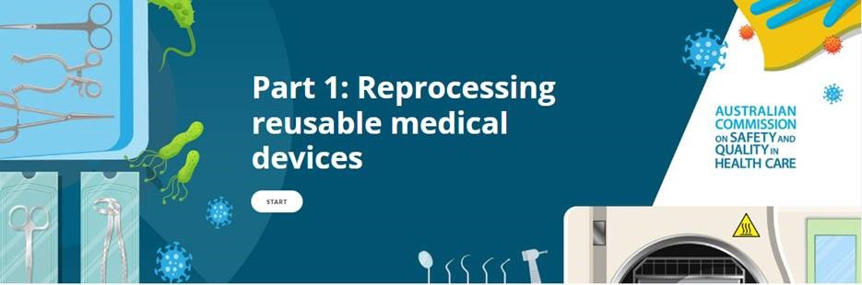](https://nhhi.southrock.com)

**Reports**

*Bringing hospital care home: Virtual Wards and Hospital at Home for older people*

British Geriatrics Society

London: British Geriatrics Society; 2022. p. 10.

|  |  |
| --- | --- |
| URL | <https://www.bgs.org.uk/ImplementingVirtualWards> |
| Notes | During the COVID-19 pandemic there has been an increase in the use of hospital in the home programs in many locations. This brief report from the British Geriatrics Society explores the potential benefits, limitations, and current evidence that may be considered when providing a safe, effective, and person-centred alternative to hospital inpatient care for older adults. This report focuses on the UK context but may have application in other settings, and possibly for other vulnerable populations. |

*My Health Record in emergency departments: final report and adoption model*

Australian Commission on Safety and Quality in Health Care

Sydney: ACSQHC; 2021.

|  |  |
| --- | --- |
| URL | <https://www.digitalhealth.gov.au/newsroom/blogs/my-health-record-in-emergency-departments> |
| Notes | The Australian Digital Health Agency engaged the Australian Commission on Safety and Quality in Health Care to investigate what ED clinicians need to support their use of the My Health Record system and how content can be applied to clinical decision-making. The final report from this work is now available at the Agency’s website.  The project was led by a senior emergency physician and covered almost 130,000 patients across 4 hospitals and states and involved more than 1,000 ED staff. The authors report that the project ‘found that the My Health Record system is a vital tool that can improve the quality of decision-making by ED clinicians and support safer patient care. Of those that accessed the system, more than a third of ED clinicians stated that their clinical decision-making had been influenced by My Health Record content.’ Other project findings include:   * Patients with the most complex healthcare needs often had the most populated My Health Records. * ED clinicians considered medication-related documents and diagnostics tests as high-value content. * ED clinicians want to see electrocardiograms, advance care plans and specialist (or outpatient) letters in My Health Record. * Improved and intuitive My Health Record viewing platforms, which enhance usability and on-screen presentation of content, would improve ED clinicians’ user experience.   The report also provided 30 findings and recommendations, along with a national My Health Record adoption model and checklist. |

*Measure Dx: A Resource To Identify, Analyze, and Learn From Diagnostic Safety Events*

Agency for Healthcare Research and Quality

Rockville MD: Agency for Healthcare Research and Quality,; 2022. p. 57.

|  |  |
| --- | --- |
| URL | <https://www.ahrq.gov/patient-safety/settings/measure-dx.html> |
| Notes | The US Agency for Healthcare Research and Quality has developed this guide to help healthcare organizations identify diagnostic safety events and gain insights for improvement. |

*Journal of Patient Safety*

Volume 18, Number 6, September 2022

|  |  |
| --- | --- |
| URL | <https://journals.lww.com/journalpatientsafety/toc/2022/09000> |
|  | A new issue of the *Journal of Patient Safety* has been published. Articles in this issue of the *Journal of Patient Safety* include:   * The Psychological Safety Scale of the **Safety, Communication, Operational, Reliability, and Engagement (SCORE) Survey**: A Brief, Diagnostic, and Actionable Metric for the **Ability to Speak Up in Healthcare Settings** (Kathryn C. Adair, Annemarie Heath, Maureen A. Frye, Allan Frankel, Joshua Proulx, Kyle J. Rehder, Erin Eckert, Caitlin Penny, Franz Belz, J. B Sexton) * Development and Usability Testing of the Agency for Healthcare Research and Quality **Common Formats to Capture Diagnostic Safety Events** (Andrea Bradford, Umber Shahid, Gordon D Schiff, Mark L Graber, Abigail Marinez, Paula DiStabile, Andrea Timashenka, H Jalal, P J Brady, H Singh) * Development of the Leapfrog Group’s **Bar Code Medication Administration Standard** to Address Hospital Inpatient Medication Safety (J Matthew Austin, Anne Bane, Valerie Gooder, Connie Saltsman, Marisa Wilson, Kathryn Burggraf Stewart, Jordan Derk, M Danforth, C Michalek) * Multispecialty Physician Online Survey Reveals That **Burnout Related to Adverse Event Involvement** May Be Mitigated by Peer Support (Kiran Gupta, Natalie A Rivadeneira, Sarah Lisker, K Chahal, N Gross, U Sarkar) * Development and Validation of the **Veterans Health Administration Patient Safety Culture Survey** (David C Mohr, Charity Chen, Jennifer Sullivan, William Gunnar, Laura Damschroder) * Comparison of the Outcomes of Patients Starting **Mechanical Ventilation** in the General Ward Versus the Intensive Care Unit (Song-I Lee, Younsuck Koh, Chae-Man Lim, Sang-Bum Hong, Jin Won Huh) * **Intravenous Smart Pumps** at the Point of Care: A Descriptive, Observational Study (Karen K Giuliano, Jeannine W C Blake, Nancy Phoenix Bittner, Vicki Gamez, Robert Butterfield) * Development of an Inventory of **Dental Harms**: Methods and Rationale (Elsbeth Kalenderian, Joo Hyun Lee, Enihomo M. Obadan-Udoh, Alfa Yansane, Joel M White, Muhammad F. Walji) * Usability and Accessibility of Publicly Available **Patient Safety Databases** (Julia G Sheehan, Jessica L Howe, Allan Fong, Seth A Krevat, Raj M Ratwani) * A Novel Approach for Engagement in **Team Training in High-Technology Surgery**: The Robotic-Assisted Surgery Olympics (Tara N Cohen, Jennifer T Anger, Falisha F Kanji, Jennifer Zamudio, Elise DeForest, C Lusk, R Avenido, C Yoshizawa, S Bartkowicz, L S Nemeth, K Catchpole) * Early Prediction of **All-Cause Clinical Deterioration in General Wards Patients**: Development and Validation of a Biomarker-Based Machine Learning Model Derived From Rapid Response Team Activations (Antoine Saab, Cynthia Abi Khalil, Mouin Jammal, Melody Saikali, Jean-Baptiste Lamy) * Toward **Constructive Change After Making a Medical Error**: Recovery From Situations of Error Theory as a Psychosocial Model for Clinician Recovery (Reema Harrison, Judith Johnson, Ryan D McMullan, Maha Pervaz-Iqbal, Upma Chitkara, Steve Mears, Jo Shapiro, Rebecca Lawton) * Use of Hospital Capacity Command Centers to Improve **Patient Flow and Safety**: A Scoping Review (Brian J Franklin, Stephanie K Mueller, David W Bates, Tejal K Gandhi, Charles A Morris, Eric Goralnick) * Clinical and Cost-Saving Effects of the **Drug Utilization Review Modernization Project** in Inpatient and Outpatient Settings in Korea (Dongwon Yoon, Inmyung Song, Ha-Lim Jeon, Sungho Bea, Ahhyung Choi, Hyesung Lee, Ju-Young Shin) * Comparison of a Voluntary Safety Reporting System to a Global Trigger Tool for **Identifying Adverse Events in an Oncology Population** (Lipika Samal, Srijesa Khasnabish, Cathy Foskett, Katherine Zigmont, Arild Faxvaag, Frank Chang, Marsha Clements, Sarah Collins Rossetti, Anuj K Dalal, Kathleen Leone, Stuart Lipsitz, Anthony Massaro, Ronen Rozenblum, Kumiko O Schnock, Catherine Yoon, David W Bates, Patricia C Dykes) * Analyzing and Discussing Human Factors Affecting **Surgical Patient Safety** Using Innovative Technology: Creating a Safer Operating Culture (Anne Sophie Helena Maria van Dalen, James J Jung, Els J M Nieveen van Dijkum, Christianne J Buskens, Teodor P Grantcharov, W A Bemelman, M P Schijven) * Room of Hazards: A Comparison of Differences in **Safety Hazard Recognition** Among Various Hospital-Based Healthcare Professionals and Trainees in a Simulated Patient Room (Melinda Wang, Barbara Banda, Benjamin A Rodwin, Naseema B Merchant) * National Surgical Quality Improvement Program Adverse Events Combined With Clavien-Dindo Scores Can Direct **Quality Improvement Processes in Surgical Patients** (Alexander D Ghannam, Marie L Crandall, Grant Woodruff, Jin Ra, Andrew J Kerwin, Ziad T Awad, Joseph Tepas) * Exploring **Care Left Undone in Pediatric Nursing** (Annamaria Bagnasco, Silvia Rossi, Nicoletta Dasso, Gianluca Catania, Milko Zanini, Giuseppe Aleo, Silvia Scelsi, Paolo Petralia, Roger Watson, Loredana Sasso) * The Relationship Between Duration of **General Anesthesia and Postoperative Fall Risk** During Hospital Stay in Orthopedic Patients (Takeo Hata, Hiroaki Shima, Masahiko Nitta, Eiichiro Ueda, Masami Nishihara, Kazuhisa Uchiyama, Takahiro Katsumata, Masashi Neo) * Disparities in **Adverse Event Reporting for Hospitalized Children** (Elizabeth Eby Halvorson, D P Thurtle, A Easter, J Lovato, D Stockwell) * The Impact of Electronic Communication of **Medication Discontinuation (CancelRx) on Medication Safety**: A Pilot Study (Samantha I Pitts, Yushi Yang, T Woodroof, N L Mollenkopf, N-Y Wang, B A Thomas, A R Chen) * **Impact of Extended Duty Hours** on Perceptions of Care and Objective Patient Outcomes (Sanjay M Salgado, Joel T Katz, Stephen R Pelletier, Melanie Goodberlet, Julie Kelly, Megan Duperreault, Nadaa B Ali, Helen M Shields) * The Stoplight Mobility Alert System for Safety and **Prevention of Falls in Children With Physical and Cognitive Impairments** (Joellan B Mullen, Steven Z Wirt, Alana Moser, Christian Niedzwecki) * The Spanish and Italian Healthcare Professionals’ Contribution to the **Safety Attitudes Questionnaire Short Form in the Operating Room**: Construct Validity and Reliability (Vicente Bernalte-Martí) * Exploring Uniformity of Clinical Judgment: A Vignette Approach to Understanding Healthcare Professionals’ **Suicide Risk Assessment Practices** (Lydia Sequeira, Gillian Strudwick, V De Luca, J Strauss, D Wiljer) * Differential **Impact of** **Work Overload on Physicians’ Attention**: A Comparison Between Residential Fields (Talya Dolev, Salman Zubedat, Iris Manor, Boaz Bloch, Orna Blondheim, Avi Avital) * **Attitudes Toward Safety and Teamwork: Benchmarking Australian Surgeons and Nurses** (Christine Boag-Hodgson, Annie Duong, L Bagley) * Characteristics of **Cumulative Annual Radiation Exposure** in Young Intensive Care Unit Survivors (Guramrinder Singh Thind, Ahmed Hussein, Vedant Mishra, Vidhya Ramachandran, Mehul Lohia, Sravanthi Ennala, N Guduguntla, S Dugar, C Martin, III, A Moghekar, D S Sadana, S Krishnan) * Assessing Impact: Implementing an **Opioid Prescription Protocol** in Otolaryngology (Arielle G Thal, Sadia Ahmed, Stanley Kim, Christina J Yang, Qi Gao, Mona Gangar, Vikas Mehta) * **Patient Safety Issues From Information Overload in Electronic Medical Records** (Sohn Nijor, Gavin Rallis, Nimit Lad, Eric Gokcen) * Effects of an Intranet-Based **Call-for-Help System** on Teamwork, Work Efficiency, Job Satisfaction, and Job Stress in Nurses (Jui-Fen Tai, Tsung-Lung Yang, Wang-Chuan Juang, Li-Ying Lin) * Clinician Satisfaction With Advanced Clinical Decision Support to Reduce the Risk of **Torsades de Pointes** (Tyler Gallo, Craig William Heise, Raymond L Woosley, James E Tisdale, Corneliu C Antonescu, S M Gephart, D C Malone) * Exploring **Changes in Patient Safety Incidents During the COVID-19 Pandemic** in a Canadian Regional Hospital System: A Retrospective Time Series Analysis (Julia Lombardi, Stephenson Strobel, Virginia Pullar, Pooja Senthil, Suneel Upadhye, Ekta Khemani) * Standardization of **Pediatric Noncardiac Operating Room to Intensive Care Unit Handoffs** Improves Communication and Patient Care (Nutan B Hebballi, Vikas S Gupta, Kyle Sheppard, Ann Kubanda, Danielle Salley, Tiffany Ostovar-Kermani, Christina Bryndzia, Amir M Khan, Nitin Wadhwa, KuoJen Tsao, Ranu Jain, Akemi L Kawaguchi) * Are Operating Rooms With Laminar Airflow a Risk for Inadvertent **Perioperative Hypothermia** During Ureterorenoscopic Lithotripsy Under Spinal Anesthesia? A Prospective Randomized Clinical Trial (Recai Dagli, Muhammet Şahin Bağbancı, Mümtaz Dadalı, Erol Erşekerci) * **Allergic Adverse Drug Events After Alert Overrides** in Hospitalized Patients (Marta Luri, Gabriel Gastaminza, Antonio Idoate, Ana Ortega) * Incorporating **Patient Safety and Quality Into the Medical School Curriculum**: An Assessment of Student Gains (Fasih Ali Ahmed, Fozia Asif, Ayesha Mubashir, Hanan J. Aboumatar, Malika Hameed, Adil Haider, A Latif) * **Efficiency and Safety of Electronic Health Records** in Switzerland—A Comparative Analysis of 2 Commercial Systems in Hospitals (Simone Fischer, David L B Schwappach) |

*Healthcare Quarterly*

Volume 25, Number 2, 2022

|  |  |
| --- | --- |
| URL | <https://www.longwoods.com/publications/healthcare-quarterly/26883/1/vol.-25-no.-2-2022> |
|  | A new issue of *Healthcare Quarterly* has been published. Articles in this issue of *Healthcare Quarterly* include:   * Responding to Ontario’s **Overdose Crisis in the Context of the COVID-19 Pandemic** (Tara Gomes, Sophie Kitchen, Tonya Campbell, Regan Murray, P Leece and G Kolla on Behalf of the Ontario Opioid Drug Observatory) * The Impact of the **COVID-19 Pandemic on Patient Experience in Acute Care** Hospitals (Naomi Diestelkamp, Lyubov Kushtova, Guillaume Gazil, Tracy Fernandez, Doreen MacNeil and Mélanie Josée Davidson) * Developing Relationships on a Shared Path to Reconciliation: The Core of **Health Transformation and Safe Care for Indigenous People** (Marion Maar, Ed Connors, Carol Fancott, William (Bill) Mussell and D Papadopoulos) * **Can the Healthcare System Improve Food Security?** A Need for Collaborative Community Partnerships (Kathryn Wiens, Meghan O’Neill, Robert J. Redelmeier, Sahr Wali, Anjum Chagpar, Sané Dube, Lori Diemert, Camilla Michalski, B Ziebell, S Elliott, L Campbell, L Rosella and A Boozary) * **Enhancing Hospital Accreditation Practices**: Building and Implementing a Continuous Readiness Model (Nicole A Thomson, Kimberly Hunter, Rani H Srivastava, Masooma Hassan, Leila Anderson and Lydia Sequeira) * **Is Your Organization “Accreditation Ready” Every Day?** (L J Thompson) * The Emerging Features of **Healthcare Supply Chain Resilience**: Learning from a Pandemic (Anne Snowdon, Michael Saunders and Alexandra Wright) * **Strategic Clinical Network Teams** Improve Effectiveness, Team and Leadership Processes and Inputs: Theory-Based Longitudinal Survey (Deborah E White, Jill M Norris, D A Southern, T Wasylak and W A Ghali) * **Virtual Reality in Today’s Healthcare Settings**: An Analysis Using the Alberta Quality Matrix for Health (Anne Arvidson, Justin Burkett, Jackie Hartley, Cherry Tse and Paul Wright) * Considerations for **Virtual Care Following the Pandemic** (Melanie Powis and Monika K. Krzyzanowska) * Reducing Hospital Harm: Establishing a **Command Centre to Foster Situational Awareness** (Barbara E Collins) * Empowering Patients and Families to Create, Inform and Endorse a New **Patient and Family Declaration of Values** (Julie Finnigan, Susan Gibson, Phillip Valvasori, Lindsay Pietrangelo and Sonia Pagura) |

*BMJ Quality & Safety* online first articles

|  |  |
| --- | --- |
| URL | <https://qualitysafety.bmj.com/content/early/recent> |
| Notes | *BMJ Quality &Safety* has published a number of ‘online first’ articles, including:   * A better way: **training for direct observations in healthcare** (Myrtede Alfred, John Del Gaizo, Falisha Kanji, Samuel Lawton, Ashley Caron, Lynne S Nemeth, A V Alekseyenko, Daniel Shouhed, Stephen Savage, Jennifer T Anger, Ken Catchpole, Tara Cohen) |

*International Journal for Quality in Health Care* online first articles

|  |  |
| --- | --- |
| URL | <https://academic.oup.com/intqhc/advance-articles> |
| Notes | *International Journal for Quality in Health Care* has published a number of ‘online first’ articles, including:   * Psychometric Properties of the **Person-Centred Coordinated Care Experience Questionnaire (P3CEQ)** in a Norwegian Radiotherapy Setting (May Ingvild Volungholen Sollid, Marit Slaaen, Signe Danielsen, Øyvind Kirkevold) |

**Online resources**

***caring@home for Aboriginal and Torres Strait Islander Families***

<https://healthinfonet.ecu.edu.au/learn/health-system/palliative-care/caring-at-home-for-aboriginal-and-torres-strait-islander-families/>

The caring@home for Aboriginal and Torres Strait Islander Families project aims to support the provision of palliative care at home for Aboriginal and Torres Strait Islander people.

The project works to help connect family, culture, community, Country and the spiritual wellbeing of Aboriginal and Torres Strait Islander people when care at home is preferred.

The Palliative Care Clinic Box

a Palliative Care Clinic Box has been developed which contains a suite of tailored resources to support the provision of at-home palliative care symptom management for Aboriginal and Torres Strait Islander people. The Clinic Box includes:

* a suite of hard copy resources that will be applicable for use Australia-wide by clinical services, health professionals and families
* a USB with short training videos
* practice demonstration kits to teach carers how to give subcutaneous (applied under the skin) medicines.

Appropriate resources can be selected from the Clinic Box to meet the individual needs of the family.

***Just Culture toolkit for health services***

<https://www.safercare.vic.gov.au/news-and-media/new-just-culture-toolkit-for-health-services>

Safer Care Victoria has released their Just Culture toolkit to improve safety culture at participating services and therefore improve patient experiences and outcomes. Just Culture is part of safety culture with the major features being:

* a systems-thinking mindset to adverse event review
* provision of a psychologically safe workplace where employees feel safe to report adverse events and near misses
* managing the innate cognitive biases we all have as part of being human
* the concept of shared accountability between the organisation and an individual when adverse events occur.

For information on the Commission’s work on patient safety culture, see <https://www.safetyandquality.gov.au/our-work/indicators-measurement-and-reporting/patient-safety-culture>

***Healthcare Safety and Quality Capabilities***

<https://www.cec.health.nsw.gov.au/CEC-Academy/healthcare-safety-and-quality-capability>

In 2021, the Clinical Excellence Commission in New South Wales developed a set of e Healthcare Safety and Quality Capabilities. The capabilities ‘provide a common language for healthcare workers across the NSW public health system to describe the key healthcare safety and quality knowledge, skills, abilities and behaviours needed to prevent patient harm, ensure reliable care and improve the quality of health outcomes.’ The capabilities include:

* Contribute to High Reliability
* Manage Clinical Incidents and Risk
* Manage Individual Factors that Influence Performance at Work
* Uphold a Safety Culture
* Utilise Improvement Methodologies
* Utilise System Thinking.

***[NZ] Code of expectations for health entities’ engagement with consumers and whānau***

<https://www.hqsc.govt.nz/consumer-hub/engaging-consumers-and-whanau/code-of-expectations-for-health-entities-engagement-with-consumers-and-whanau/>

The Health Quality and Safety Commission New Zealand has published their *Code of expectations for health entities’ engagement with consumers and whānau*. This code sets the expectations for how health entities must work with consumers, whānau (extended family or family group) and communities in the planning, design, delivery and evaluation of health services.

For information on the Commission’s work on partnering with consumers, see <https://www.safetyandquality.gov.au/our-work/partnering-consumers>

**COVID-19 resources**

https://www.safetyandquality.gov.au/covid-19

The Australian Commission on Safety and Quality in Health Care has developed a number of resources to assist healthcare organisations, facilities and clinicians. These and other material on COVID-19 are available at <https://www.safetyandquality.gov.au/covid-19>

These resources include:

* ***OVID-19 infection prevention and control risk management*** This primer provides an overview of three widely used tools for investigating and responding to patient safety events and near misses. Tools covered in this primer include incident reporting systems, Root Cause Analysis (RCA), and Failure Modes and Effects Analysis (FMEA).   
  <https://www.safetyandquality.gov.au/publications-and-resources/resource-library/covid-19-infection-prevention-and-control-risk-management-guidance>
* ***Poster – Combined contact and droplet precautions*** <https://www.safetyandquality.gov.au/publications-and-resources/resource-library/infection-prevention-and-control-poster-combined-contact-and-droplet-precautions>  
  [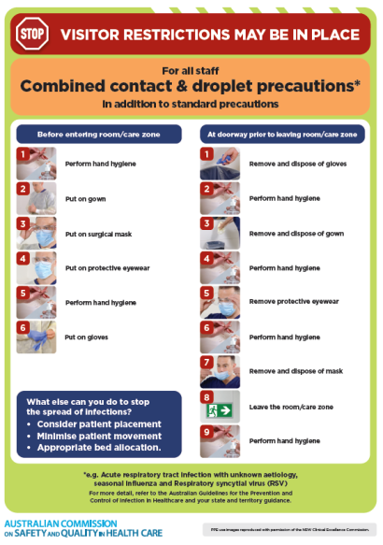](https://www.safetyandquality.gov.au/publications-and-resources/resource-library/infection-prevention-and-control-poster-combined-contact-and-droplet-precautions)
* ***Poster – Combined airborne and contact precautions*** <https://www.safetyandquality.gov.au/publications-and-resources/resource-library/poster-combined-airborne-and-contact-precautions>   
  [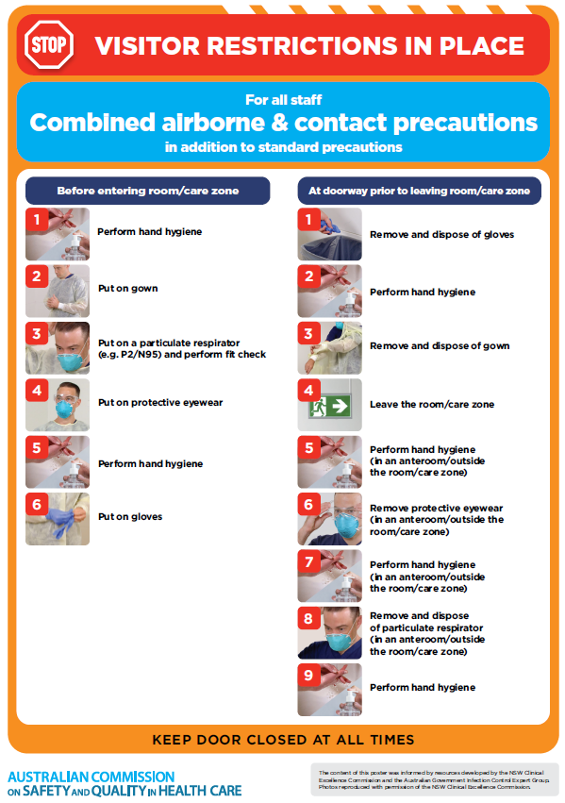](https://www.safetyandquality.gov.au/publications-and-resources/resource-library/poster-combined-airborne-and-contact-precautions)
* ***Environmental Cleaning and Infection Prevention and Control*** [www.safetyandquality.gov.au/environmental-cleaning](http://www.safetyandquality.gov.au/environmental-cleaning)
* ***COVID-19 infection prevention and control risk management – Guidance*** <https://www.safetyandquality.gov.au/publications-and-resources/resource-library/covid-19-infection-prevention-and-control-risk-management-guidance>
* ***Safe care for people with cognitive impairment during COVID-19***<https://www.safetyandquality.gov.au/our-work/cognitive-impairment/cognitive-impairment-and-covid-19>
* ***Stop COVID-19: Break the chain of infection*** posterhttps://www.safetyandquality.gov.au/publications-and-resources/resource-library/break-chain-infection-poster-a3  
  **[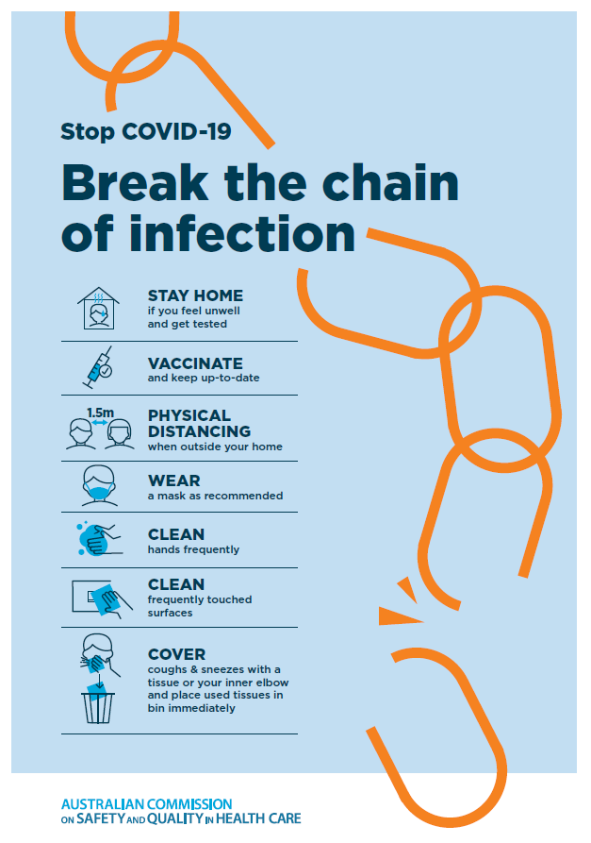](https://www.safetyandquality.gov.au/publications-and-resources/resource-library/break-chain-poster-a3https:/www.safetyandquality.gov.au/publications-and-resources/resource-library/break-chain-poster-a3)**
* ***FAQs for clinicians on elective surgery*** <https://www.safetyandquality.gov.au/node/5724>
* ***FAQs for consumers on elective surgery*** <https://www.safetyandquality.gov.au/node/5725>
* ***COVID-19 and face masks – Information for consumers*** <https://www.safetyandquality.gov.au/publications-and-resources/resource-library/covid-19-and-face-masks-information-consumers>

[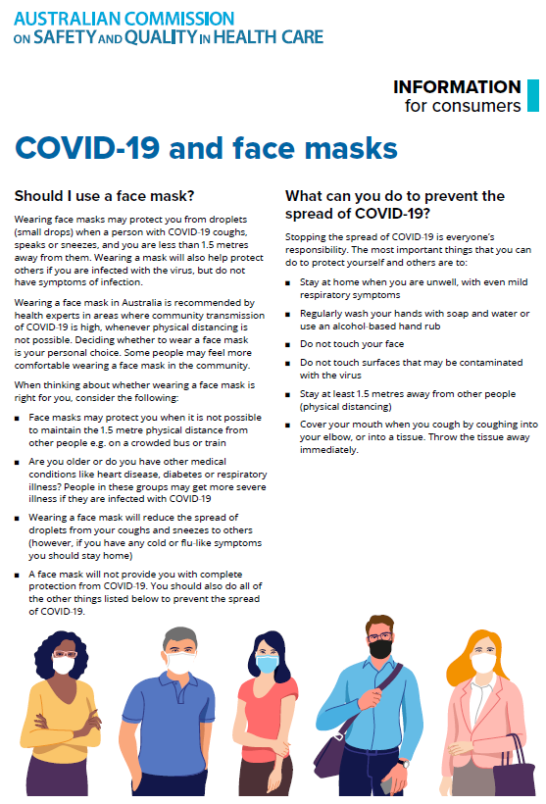](https://www.safetyandquality.gov.au/sites/default/files/2020-07/covid-19_and_face_masks_-_information_for_consumers.pdf)

*National COVID-19 Clinical Evidence Taskforce*

<https://covid19evidence.net.au/>

The National COVID-19 Clinical Evidence Taskforce is a collaboration of peak health professional bodies across Australia whose members are providing clinical care to people with COVID-19. The taskforce is undertaking continuous evidence surveillance to identify and rapidly synthesise emerging research in order to provide national, **evidence-based guidelines and clinical flowcharts for the clinical care of people with COVID-19**. The guidelines address questions that are specific to managing COVID-19 and cover the full disease course across mild, moderate, severe and critical illness. These are ‘living’ guidelines, updated with new research in near real-time in order to give reliable, up-to-the minute advice to clinicians providing frontline care in this unprecedented global health crisis.

*COVID-19 Critical Intelligence Unit*

<https://www.aci.health.nsw.gov.au/covid-19/critical-intelligence-unit>

The Agency for Clinical Innovation (ACI) in New South Wales has developed this page summarising rapid, evidence-based advice during the COVID-19 pandemic. Its operations focus on systems intelligence, clinical intelligence and evidence integration. The content includes a daily evidence digest, a COVID status monitor, a risk monitoring dashboard and evidence checks on a discrete topic or question relating to the current COVID-19 pandemic. There is also a ‘Living evidence’ section summarising key studies and emerging evidence on **COVID-19 vaccines** and **SARS-CoV-2 variants**. The most recent updates include:

* ***Eating disorders and COVID-19*** – What is the impact of the COVID-19 pandemic on the prevalence of eating disorders?
* ***Long COVID –*** What is the evidence on the prevalence, presentation and management of long-COVID?
* ***Oseltamivir (Tamiflu) use in healthcare settings*** – What is the evidence that use of oseltamivir in healthcare workers with a symptomatic influenza diagnosis result in an earlier return to work and reduced absenteeism? What is the evidence that use of oseltamivir in adults and children with symptomatic influenza reduces influenza transmission in health care settings?
* ***Alternative models of care for acute medical conditions*** – What is the evidence on alternative models of care for managing patients with acute medical conditions outside of emergency or inpatient hospital settings?
* ***Exercise and long COVID*** – Is exercise helpful in individuals with long COVID? Is post-exertional symptom exacerbation a risk in long COVID?
* ***Influenza and seasonal prophylaxis with oseltamivir*** – What is the place or evidence for seasonal influenza prophylaxis (such as taking oseltamivir for 10 to 12 weeks continuously) in healthcare and aged care settings?
* ***Rapid access models of care for respiratory illnesses*** – What is the evidence for rapid access models of care for respiratory illnesses, especially during winter seasons, in emergency departments?
* ***Current and emerging patient safety issues during COVID-19*** – What is the evidence on the current and emerging patient safety issues arising from the COVID-19 pandemic?
* ***Post-acute sequelae of COVID-19*** – What is the evidence on the post-acute sequelae of COVID-19?
* ***Emerging variants*** – What is the available evidence for emerging variants?
* ***Chest pain or dyspnoea following COVID-19 vaccination*** – What is evidence for chest pain or dyspnoea following COVID-19 vaccination?
* ***Cardiac investigations and elective surgery post-COVID-19*** – What is evidence for cardiac investigations and elective surgery post-COVID-19?
* ***Breathlessness post COVID-19*** – How to determine those patients who present with ongoing breathlessness in need of urgent review or intervention due to suspected pulmonary embolus?
* ***COVID-19 pandemic and influenza*** – What is the evidence for COVID-19 pandemic and influenza?
* ***Budesonide and aspirin for pregnant women with COVID-19 –*** What is the evidence for the use of Budesonide for pregnant women with COVID-19? What is the evidence for aspirin prophylaxis for pre-eclampsia in pregnant women with a COVID-19 infection?
* ***COVID-19 vaccines in Australia*** – What is the evidence on COVID-19 vaccines in Australia?
* ***COVID-19 pandemic and wellbeing of critical care and other healthcare workers*** – Evidence in brief on the impact of the COVID-19 pandemic on the wellbeing of critical care and other healthcare workers.
* ***Surgery post COVID-19*** – What is the evidence for the timing of surgery, and outcomes following surgery, for people who have recovered from COVID-19?
* ***Disease modifying treatments for COVID-19 in children*** – What is the evidence for disease modifying treatments for COVID-19 in children?
* ***Mask type for COVID-19 positive wearer*** – What is the evidence for different mask types for COVID-19 positive wearers?
* ***Post acute and subacute COVID-19 care*** – What published advice and models of care are available regarding post-acute and subacute care for COVID-19 patients?
* ***Hospital visitor policies*** – What is the evidence for hospital visitor policies during and outside of the COVID-19 pandemic?
* ***Surgical masks, eye protection and PPE guidance*** –What is the evidence for surgical masks in the endemic phase in hospitals and for eyewear to protect against COVID-19?

**Disclaimer**

On the Radar is an information resource of the Australian Commission on Safety and Quality in Health Care. The Commission is not responsible for the content of, nor does it endorse, any articles or sites listed. The Commission accepts no liability for the information or advice provided by these external links. Links are provided on the basis that users make their own decisions about the accuracy, currency and reliability of the information contained therein. Any opinions expressed are not necessarily those of the Australian Commission on Safety and Quality in Health Care.