# Australian Commission on Safety and Quality logotypeOn the Radar

Issue 573

5 September 2022

*On the Radar* is a summary of some of the recent publications in the areas of safety and quality in health care. Inclusion in this document is not an endorsement or recommendation of any publication or provider. Access to particular documents may depend on whether they are Open Access or not, and/or your individual or institutional access to subscription sites/services. Material that may require subscription is included as it is considered relevant.

*On the Radar* is available online, via email or as a PDF or Word document from <https://www.safetyandquality.gov.au/publications-and-resources/newsletters/radar>

If you would like to receive *On the Radar* via email, you can subscribe on our website <https://www.safetyandquality.gov.au/publications-and-resources/newsletters>  
or by emailing us at H[Umail@safetyandquality.gov.auU](mailto:mail@safetyandquality.gov.au).   
You can also send feedback and comments to H[Umail@safetyandquality.gov.auU](mailto:mail@safetyandquality.gov.au).

For information about the Commission and its programs and publications, please visit <https://www.safetyandquality.gov.au>

You can also follow us on Twitter @ACSQHC.

**On the Radar**

Editor: Dr Niall Johnson [niall.johnson@safetyandquality.gov.au](mailto:niall.johnson@safetyandquality.gov.au)

Contributors: Niall Johnson, Kristin Xenos, Amy Forsyth

***Low Back Pain Clinical Care Standard***

Australian Commission on Safety and Quality in Health Care

Sydney: ACSQHC; 2022. p. 66.

<https://www.safetyandquality.gov.au/standards/clinical-care-standards/low-back-pain-clinical-care-standard>

The first national [*Low Back Pain Clinical Care Standard*](https://www.safetyandquality.gov.au/standards/clinical-care-standards/low-back-pain-clinical-care-standard) was launched by the Australian Commission on Safety and Quality in Health Care on Thursday 1 September via a live-streamed event. The panel discussion was hosted by broadcaster and commentator Geraldine Doogue AO and included the Commission’s Clinical Director, Associate Professor Liz Marles, Professor Michael Nicholas from Royal North Shore Hospital, Professor Peter O’Sullivan from Curtin University and Dr James Edwards from Royal Prince Alfred Hospital.

The new standard of care for low back pain will improve early management of patients with this common condition.

Did you know that one in six Australians are affected by back problems and it is a leading cause of disability worldwide?

The clinical care standard outlines optimal care for patients with an acute episode, recurrence or exacerbation of chronic low back pain, and advocates a shift towards active approaches to support people with low back pain.

Recommendations in the standard include self-management and physical activity, addressing psychological barriers to recovery such as thoughts and emotions about pain, and tackling social obstacles, including work and home stress.

Learn more about Australia’s first national standard for low back pain, access the standard, [implementation resources](https://www.safetyandquality.gov.au/standards/clinical-care-standards/low-back-pain-clinical-care-standard/implementation-resources) and access resources for consumers, clinicians and health services at: <https://www.safetyandquality.gov.au/standards/clinical-care-standards/low-back-pain-clinical-care-standard>

The *Low Back Pain Clinical Care Standard* contains eight quality statements and eleven indicators to improve the early assessment, management, and review and referral of patients with low back pain.

**Reports**

*Decarbonising clinical care in Australia*

Deeble Institute for Health Policy Research Issues Brief No. 48

Pickles K, Haddock R

Canberra: Australian Healthcare and Hospitals Association; 2022. p. 40.

|  |  |
| --- | --- |
| URL | <https://ahha.asn.au/publication/health-policy-issue-briefs/deeble-issues-brief-no-48-decarbonising-clinical-care> |
| Notes | This Issues Brief from the Australian Healthcare and Hospitals Association’s Deeble Institute for Health Policy Research looks at the challenge of decarbonising Australia’s healthcare system. According to this brief, ‘The Australian healthcare sector produces 7% of national carbon emissions’. However, while this is a significant contribution there are many gaps in knowledge and understanding of the issues.  It’s argued that it is the ‘Delivery of care, that is medical devices, consumables, and pharmaceuticals, is estimated to account for the majority of the sector’s total emissions, rather than energy consumption or capital costs.’ It then follows that such activity should be aimed at providing high value care and ‘The identification and elimination of sources of low value care is an opportunity to reduce avoidable emissions from the health sector in a direct and immediate way.’  The brief touches on many issues, including the various environmental impacts, need for monitoring and reporting, along with incentives to encourage change, and the importance of governance and leadership. The brief makes a number of recommendations, including:   * Reduce low value care and switch to low carbon options * Establish nationally coordinated data collection, monitoring, and reporting * Add carbon footprint indicators to health technology assessment processes * Decarbonise healthcare supply chains * Establish a national healthcare sustainability unit or task force. |

*Management of preterm labour and birth of twins*

Independent report by the Healthcare Safety Investigation Branch NI-003479

Healthcare Safety Investigation Branch

Farnborough: HSIB; 2022. p. 61.U

|  |  |
| --- | --- |
| URL | <https://www.hsib.org.uk/investigations-and-reports/management-of-preterm-labour-and-birth/> |
| Notes | This is the latest report from the UK’s Healthcare Safety Investigation Branch (HSIB) and looks at the management and care of preterm labour and birth of twins. Preterm is defined as babies born alive before 37 weeks of pregnancy. The investigation reviewed a ‘reference event’ examining the care and the evidence relating to the management of preterm labour of a twin pregnancy and a later diagnosis of brain injury. The investigation identified several findings to explain the experience of the mother in the reference event, including the lack of scientific evidence or specific guidelines and the uncertainty associated with the clinical decision making relevant to preterm labour and birth of twins. This highlighted the need for further research into preterm labour as a recognised risk factor for twin pregnancies. |

**Journal articles**

*Pharmacist beliefs about antimicrobial resistance and impacts on antibiotic supply: a multinational survey*

Chan AHY, Beyene K, Tuck C, Rutter V, Ashiru-Oredope D

JAC-Antimicrobial Resistance. 2022;4(4).

|  |  |
| --- | --- |
| DOI | <https://doi.org/10.1093/jacamr/dlac062> |
| Notes | This study considered how pharmacist’s knowledge and beliefs regarding antimicrobial resistance (AMR) influenced their practice across different countries. The majority of study participants came from Africa and Asia. Pharmacists were assessed on their antimicrobial knowledge based on the WHO Antibiotic resistance: multi-country public awareness survey and their beliefs about whether they considered AMR an important public health concern. Pharmacists who agreed that AMR was a significant problem where less likely to supply antibiotics without a prescription. The odds of supplying antibiotics without a prescription were 7.4 times higher amongst respondents from lower income countries. The study suggested that interventions targeted to the pharmacists work setting (i.e., hospital vs community pharmacy) may be beneficial. |

For information on the Commission’s work on antimicrobial resistance, see <https://www.safetyandquality.gov.au/our-work/antimicrobial-resistance>

*Pediatric Surgical Revisits by Specialty and Procedure Across US Children’s Hospitals, 2016-2020*

De Boer C, Ghomrawi H, Zeineddin S, Linton S, Tian Y, Kwon S, et al

JAMA. 2022;328(8):774-776.

|  |  |
| --- | --- |
| DOI | <https://doi.org/10.1001/jama.2022.11806> |
| Notes | Paper reporting on a study that examined paediatric ‘surgical revisits’ (readmissions and emergency department visits) in 52 tertiary children’s hospitals in the USA, Using data on patients 18 years and younger who underwent 1 of 26 inpatient or ambulatory procedures across 9 surgical subspecialties from 1 January 2016 to 1 January 2020 the study identified a total of 1,189,140 ‘index procedures’. Of these, there were 88,796 **revisits** (**7.46%**) with 38,742 to the emergency department. The authors reported that:   * Tonsillectomy/adenoidectomy had the highest number of revisits (n = 18 279) * CVC/port insertion had the highest revisit rate (41.45%; 95% CI, 40.93%-41.97%). * Tonsillectomy/adenoidectomy (n = 10 419) and appendectomy (n = 3637) contributed the most ED-only visits * Otolaryngology and general paediatric surgery accounted for 77.58% of the revisit prevalence and 74.32% of the ED-only visit prevalence * 6 procedures (tonsillectomy/adenoidectomy, appendectomy, CVC/port insertion, gastrostomy, myringotomy/tympanostomy, and circumcision) accounted for 67.77% of all revisits and 63.08% of ED-only visits. |

*Journal of Patient Safety and Risk Management*

Volume 27, Number 4, August 2022

|  |  |
| --- | --- |
| URL | <https://journals.sagepub.com/toc/cric/27/4> |
|  | A new issue of the *Journal of Patient Safety and Risk Management* has been published. Articles in this issue of the *Journal of Patient Safety and Risk Management* include:   * Editorial: Third Time’s the Charm: Strengthening **Global Efforts to Reduce Medication-Related Harm** (Albert Wu, Alpana Mair, Irina Papieva, Ayda Taha, Neelam Dhingra) * Opportunities to **mine EHRs for malpractice risk management and patient safety** (Julia Adler-Milstein, Urmimala Sarkar, Robert M Wachter) * **Patient Safety is Alive but Consumers Pose Challenges**: Response to “Who Killed Patient Safety?” (Doug Wojcieszak) * Value-based analysis of a Singaporean **post-ED discharge support program for older adults** (Colin Eng Choon Ong, Phillip Phan, Christine Xia Wu, Zhaoqi Chen, Lit Sin Quek) * **Improving patient safety and quality in India's largest hospital network** through a dashboard driven approach - The Apollo Quality Program (Pritindira Kaur, Raju Vaishya, Anupam Sibal, Gaurav Loria, K. Hari Prasad, Sangita Reddy, Shobana Kamineni, Suneeta Reddy, Preetha Reddy) * Identifying **boundary spanning reporter roles in patient safety events** (Vanessa Beth Hurley, Christian Boxley, Elizabeth Ann Sloss, Allan Fong) * Knowledge, attitudes and practices of clinical pharmacists to **medication error reporting** in ministry of health and population hospitals in Egypt (Shymaa Mahmoud Youssef Elshoura, Rasha Ali Mosallam) |

*Journal for Healthcare Quality*

Volume 44, Issue 5, September/October 2022

|  |  |
| --- | --- |
| URL | <https://journals.lww.com/jhqonline/toc/2022/10000> |
|  | A new issue of the *Journal for Healthcare Quality* has been published. Articles in this issue of the *Journal for Healthcare Quality* include:   * Editorial: Moving Beyond Describing Disparities: The Urgent Need to **Understand Multilevel Determinants and Evaluate Programs Promoting Health Equity** (Allyson G Hall, Michael J Mugavero) * **Team-Based Care for Cancer Survivors With Comorbidities**: A Systematic Review (Michelle Doose, Dana Verhoeven, Janeth I Sanchez, Alicia A Livinski, Michelle Mollica, Veronica Chollette, Sallie J Weaver) * Do Hospitals Achieving “Leader in **LGBTQ Healthcare Equality**” Maintain Higher Patient Scores Compared To Nonleaders? (Rita DiLeo, Seongwon Choi, Tari Hanneman, Ali Riza Demirbas, K. Ria Hearld, Paul Datti, Nancy Borkowski) * Lessons on **Increasing Racial and Health Equity** From Accountable Health Communities (Brandon G Wilson, Emily Jones) * No Quick Fixes: Integrating **Population Health Education and Quality Improvement** in a Large Residency Program (John Paul Shoup, Azalea Kim, Jonathan Wilson, Jane Pendergast, Benjamin L Ranard, Joel C Boggan) * Interprofessional Collaborative Practice Improves Access to Care and Healthcare Quality to Advance **Health Equity** (Connie White-Williams, Vera Bittner, Reid Eagleson, Morgan Feltman, Maria Shirey) * Implementing a Process for **Screening Hospitalized Adults for Food Insecurity** at a Tertiary Care Center (Emily Gore, Joseph DiTursi, Richard Rambuss, Elizabeth Pope-Collins, Meghan K Train) |

*Pharmacy Practice and Research*

Volume 52, Issue 4, August 2022

|  |  |
| --- | --- |
| URL | <https://onlinelibrary.wiley.com/toc/20552335/2022/52/4> |
|  | A new issue of *Pharmacy Practice and Research* has been published. Articles in this issue of *Pharmacy Practice and Research* include:   * Editorial: **Embedding pharmacists in residential aged care**: Why it's important to integrate resident- and system-level services (Amanda J Cross, Adam La Caze, Michelle Steeper, J Simon Bell) * Challenges and opportunities relating to **medication safety: learning from coroners' cases** (Joseph E Ibrahim) * **Building a pharmacy workforce** from the ground up to support the COVID-19 vaccine rollout: lessons learned and recommendations (Asad E Patanwala, Rosemary Burke, Alexander McNamara, Parisa Aslani, Andrew J McLachlan) * A benchmarking scoping review of **research output from hospital pharmacy departments** in Australia (Jonathan Penm, Sujita Narayan, Jan-Willem Alffenaar, Jacinta L Johnson, Sanja Mirkov, Amy T Page, Lisa G Pont, Asad E Patanwala) * **Swallowing safety of oral liquid medications**: assessment using the International Dysphagia Diet Standardisation Initiative framework (Kathryn J Steadman, Min-Tz Weng Marwa A Malouh, Keli Symons, Julie A Y Cichero) * **Knowledge and perceptions of outpatients regarding upper respiratory tract infections** and awareness of an Antibiotics Smart Use campaign in Thailand (Pacharaporn Phueanpinit, Nongchanok Siriwattanasakul, Penpit Tichakorn, Siranan Klanbut) * Efficacy and safety of **tolvaptan in chronic heart failure** (Tomonori Oya, Junya Sato, Kayoko Maezawa, Nobuyuki Shiba, Morihiko Takeda, Yasuyuki Momose) * **Type 2 Diabetes mellitus treatment intensification and deintensification in primary care**: a retrospective cohort study (Jay An Wong, Isabel Young, Ruth Sim, Kok Pim Kua, Shaun Wen Huey Lee) * Impact of COVID-19 pandemic on **pharmacist-led allergy assessments and penicillin skin testing** (Justin Spivey, Connor R Deri, Rebekah H Wrenn, Nicholas A Turner) * Infusion reaction incidence after switching all patients to an **infliximab biosimilar** in an Australian hospital (Sarah Whatmough, Centaine Snoswell, Gavin Callaghan, Grace Lucas, Michael Barras, Christopher Morris) * **Australian hospital outpatient pharmacies: service adaptations** during the 2020 national coronavirus disease 2019 lockdown (Sarah Wise, Matthew J Coleshill, Natalie Taylor, Michelle Le, Deborah Debono, Richard O Day, Terry Melocco, Melissa T Baysari, Tracey-Lea Laba, Jane E Carland) |

*BMJ Quality & Safety* online first articles

|  |  |
| --- | --- |
| URL | <https://qualitysafety.bmj.com/content/early/recent> |
| Notes | *BMJ Quality &Safety* has published a number of ‘online first’ articles, including:   * **Communication about sexual orientation and gender** between clinicians, LGBT+ people facing serious illness and their significant others: a qualitative interview study of experiences, preferences and recommendations (Debbie Braybrook, Katherine Bristowe, Liadh Timmins, Anna Roach, Elizabeth Day, Paul Clift, Ruth Rose, Steve Marshall, Katherine Johnson, Katherine E Sleeman, Richard Harding) |

*International Journal for Quality in Health Care* online first articles

|  |  |
| --- | --- |
| URL | <https://academic.oup.com/intqhc/advance-articles> |
| Notes | *International Journal for Quality in Health Care* has published a number of ‘online first’ articles, including:   * **Environmental Sustainability and Quality Care**: Not One without the Other (Nina Putnis, Matthew Neilson) * The Attitude of Hospital Directors Towards Normalising **Accreditation Standards**: A Qualitative Descriptive Study for Saudi Arabia (Mohammed Hussein, Milena Pavlova, Wim Groot) * Measure Dx: Implementing Pathways to Discover and Learn from **Diagnostic Errors** (Andrea Bradford, Marjorie Shofer, Hardeep Singh) |

**Online resources**

***Future Leaders Communiqué***

Volume 7 Issue 3 July 2022

<https://www.thecommuniques.com/post/future-leaders-communiqu%C3%A9-volume-7-issue-3-july-2022>

This issue of *Future Leaders Communiqué* focuses on the safe **transfer of care** when dealing with **critically ill patients** and includesdiscussion of **clinical deterioration**.

For information on the Commission’s work on communication in health care, including clinical handover, see <https://www.safetyandquality.gov.au/our-work/communicating-safety>

For information on the Commission’s work on recognising and responding to deterioration, see <https://www.safetyandquality.gov.au/our-work/recognising-and-responding-deterioration>

***My Health Record Rule 42 security and access policy template and guidance***

<https://www.oaic.gov.au/privacy/guidance-and-advice/my-health-record/security-and-access-policies-rule-42-guidance>

The Office of the Australian Information Commissioner (OAIC) has published a security and access policy template to help healthcare providers comply with their obligations under Rule 42 of the My Health Records Rule 2016.

Rule 42 requires healthcare provider organisations to have, communicate and enforce a written security and access policy to register, and remain registered, to use the My Health Record system.

The template is available for download as a customisable Word document. The Australian Digital Health Agency has developed a new eLearning course to support users of the template. The Agency’s online learning portal is at <https://training.digitalhealth.gov.au/login/index.php>

***[UK] NICE Guidelines and Quality Standards***

<https://www.nice.org.uk/guidance>

The UK’s National Institute for Health and Care Excellence (NICE) has published new (or updated) guidelines and quality standards. The latest reviews or updates include:

* Medical technologies guidance MTG71 *Faecal microbiota transplant for recurrent* **Clostridioides difficile *infection*** <https://www.nice.org.uk/guidance/mtg71>

***[UK] NIHR Evidence alerts***

<https://evidence.nihr.ac.uk/>alerts/

The UK’s National Institute for Health Research (NIHR) has posted new evidence alerts on its site. Evidence alerts are short, accessible summaries of health and care research which is funded or supported by NIHR. This is research which could influence practice and each Alert has a message for people commissioning, providing or receiving care. The latest alerts include:

* Video feedback helped parents manage **behaviour problems in their toddlers**
* Advertising ban was linked to lower purchases of **unhealthy food and drink**
* Why don’t people have **kidney dialysis** at home?
* Unemployment and insecure housing are linked to less successful treatment for **depression**
* How to improve care for **people with severe mental illness and a lung condition**
* How should **vascular services** be organised?
* **Falls prevention** programme is effective in care homes
* People discharged from **inpatient mental healthcare** are at increased risk of dying.

**COVID-19 resources**

https://www.safetyandquality.gov.au/covid-19

The Australian Commission on Safety and Quality in Health Care has developed a number of resources to assist healthcare organisations, facilities and clinicians. These and other material on COVID-19 are available at <https://www.safetyandquality.gov.au/covid-19>

These resources include:

* ***OVID-19 infection prevention and control risk management*** This primer provides an overview of three widely used tools for investigating and responding to patient safety events and near misses. Tools covered in this primer include incident reporting systems, Root Cause Analysis (RCA), and Failure Modes and Effects Analysis (FMEA).   
  <https://www.safetyandquality.gov.au/publications-and-resources/resource-library/covid-19-infection-prevention-and-control-risk-management-guidance>
* ***Poster – Combined contact and droplet precautions*** <https://www.safetyandquality.gov.au/publications-and-resources/resource-library/infection-prevention-and-control-poster-combined-contact-and-droplet-precautions>  
  [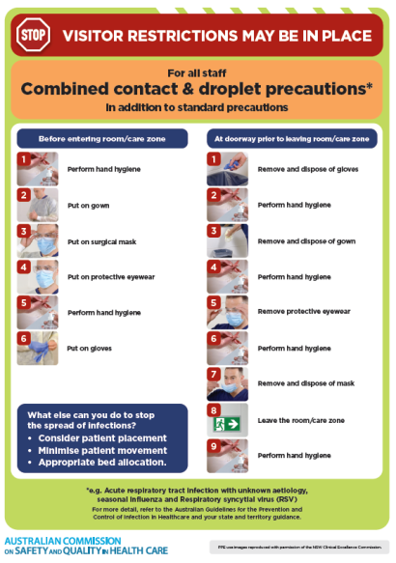](https://www.safetyandquality.gov.au/publications-and-resources/resource-library/infection-prevention-and-control-poster-combined-contact-and-droplet-precautions)
* ***Poster – Combined airborne and contact precautions*** <https://www.safetyandquality.gov.au/publications-and-resources/resource-library/poster-combined-airborne-and-contact-precautions>   
  [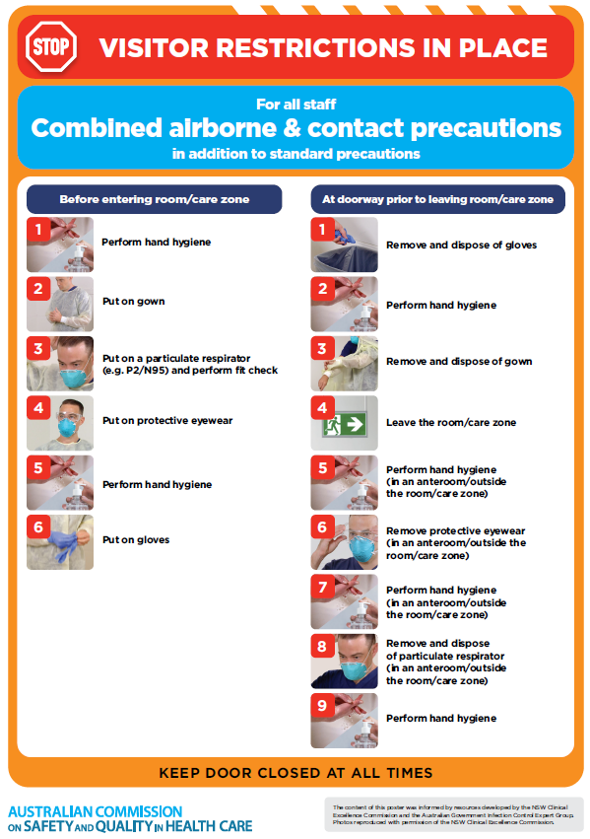](https://www.safetyandquality.gov.au/publications-and-resources/resource-library/poster-combined-airborne-and-contact-precautions)
* ***Environmental Cleaning and Infection Prevention and Control*** [www.safetyandquality.gov.au/environmental-cleaning](http://www.safetyandquality.gov.au/environmental-cleaning)
* ***COVID-19 infection prevention and control risk management – Guidance*** <https://www.safetyandquality.gov.au/publications-and-resources/resource-library/covid-19-infection-prevention-and-control-risk-management-guidance>
* ***Safe care for people with cognitive impairment during COVID-19***<https://www.safetyandquality.gov.au/our-work/cognitive-impairment/cognitive-impairment-and-covid-19>
* ***Stop COVID-19: Break the chain of infection*** posterhttps://www.safetyandquality.gov.au/publications-and-resources/resource-library/break-chain-infection-poster-a3  
  **[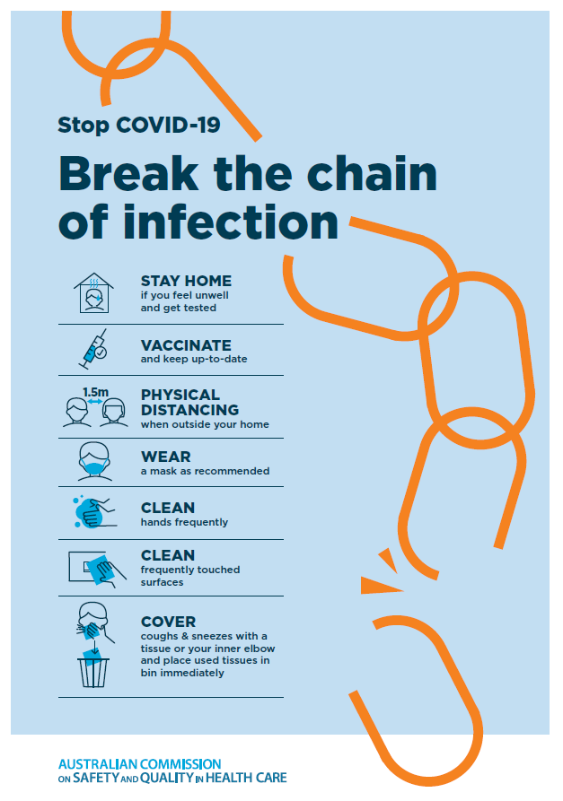](https://www.safetyandquality.gov.au/publications-and-resources/resource-library/break-chain-poster-a3https:/www.safetyandquality.gov.au/publications-and-resources/resource-library/break-chain-poster-a3)**
* ***FAQs for clinicians on elective surgery*** <https://www.safetyandquality.gov.au/node/5724>
* ***FAQs for consumers on elective surgery*** <https://www.safetyandquality.gov.au/node/5725>
* ***COVID-19 and face masks – Information for consumers*** <https://www.safetyandquality.gov.au/publications-and-resources/resource-library/covid-19-and-face-masks-information-consumers>

[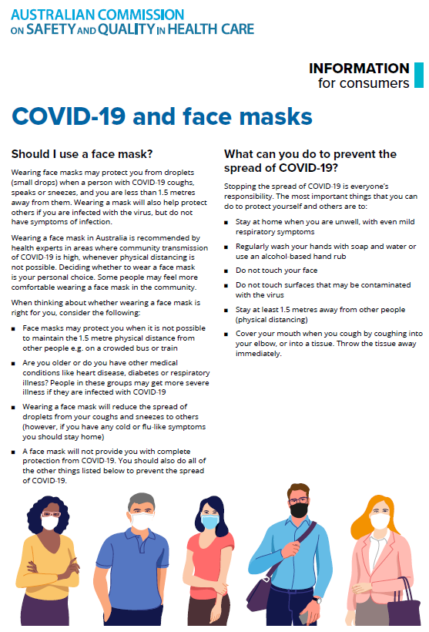](https://www.safetyandquality.gov.au/sites/default/files/2020-07/covid-19_and_face_masks_-_information_for_consumers.pdf)

*National COVID-19 Clinical Evidence Taskforce*

<https://covid19evidence.net.au/>

The National COVID-19 Clinical Evidence Taskforce is a collaboration of peak health professional bodies across Australia whose members are providing clinical care to people with COVID-19. The taskforce is undertaking continuous evidence surveillance to identify and rapidly synthesise emerging research in order to provide national, **evidence-based guidelines and clinical flowcharts for the clinical care of people with COVID-19**. The guidelines address questions that are specific to managing COVID-19 and cover the full disease course across mild, moderate, severe and critical illness. These are ‘living’ guidelines, updated with new research in near real-time in order to give reliable, up-to-the minute advice to clinicians providing frontline care in this unprecedented global health crisis.

*COVID-19 Critical Intelligence Unit*

<https://www.aci.health.nsw.gov.au/covid-19/critical-intelligence-unit>

The Agency for Clinical Innovation (ACI) in New South Wales has developed this page summarising rapid, evidence-based advice during the COVID-19 pandemic. Its operations focus on systems intelligence, clinical intelligence and evidence integration. The content includes a daily evidence digest, a COVID status monitor, a risk monitoring dashboard and evidence checks on a discrete topic or question relating to the current COVID-19 pandemic. There is also a ‘Living evidence’ section summarising key studies and emerging evidence on **COVID-19 vaccines** and **SARS-CoV-2 variants**. The most recent updates include:

* ***Eating disorders and COVID-19*** – What is the impact of the COVID-19 pandemic on the prevalence of eating disorders?
* ***Long COVID –*** What is the evidence on the prevalence, presentation and management of long-COVID?
* ***Oseltamivir (Tamiflu) use in healthcare settings*** – What is the evidence that use of oseltamivir in healthcare workers with a symptomatic influenza diagnosis result in an earlier return to work and reduced absenteeism? What is the evidence that use of oseltamivir in adults and children with symptomatic influenza reduces influenza transmission in health care settings?
* ***Alternative models of care for acute medical conditions*** – What is the evidence on alternative models of care for managing patients with acute medical conditions outside of emergency or inpatient hospital settings?
* ***Exercise and long COVID*** – Is exercise helpful in individuals with long COVID? Is post-exertional symptom exacerbation a risk in long COVID?
* ***Influenza and seasonal prophylaxis with oseltamivir*** – What is the place or evidence for seasonal influenza prophylaxis (such as taking oseltamivir for 10 to 12 weeks continuously) in healthcare and aged care settings?
* ***Rapid access models of care for respiratory illnesses*** – What is the evidence for rapid access models of care for respiratory illnesses, especially during winter seasons, in emergency departments?
* ***Current and emerging patient safety issues during COVID-19*** – What is the evidence on the current and emerging patient safety issues arising from the COVID-19 pandemic?
* ***Post-acute sequelae of COVID-19*** – What is the evidence on the post-acute sequelae of COVID-19?
* ***Emerging variants*** – What is the available evidence for emerging variants?
* ***Chest pain or dyspnoea following COVID-19 vaccination*** – What is evidence for chest pain or dyspnoea following COVID-19 vaccination?
* ***Cardiac investigations and elective surgery post-COVID-19*** – What is evidence for cardiac investigations and elective surgery post-COVID-19?
* ***Breathlessness post COVID-19*** – How to determine those patients who present with ongoing breathlessness in need of urgent review or intervention due to suspected pulmonary embolus?
* ***COVID-19 pandemic and influenza*** – What is the evidence for COVID-19 pandemic and influenza?
* ***Budesonide and aspirin for pregnant women with COVID-19 –*** What is the evidence for the use of Budesonide for pregnant women with COVID-19? What is the evidence for aspirin prophylaxis for pre-eclampsia in pregnant women with a COVID-19 infection?
* ***COVID-19 vaccines in Australia*** – What is the evidence on COVID-19 vaccines in Australia?
* ***COVID-19 pandemic and wellbeing of critical care and other healthcare workers*** – Evidence in brief on the impact of the COVID-19 pandemic on the wellbeing of critical care and other healthcare workers.
* ***Surgery post COVID-19*** – What is the evidence for the timing of surgery, and outcomes following surgery, for people who have recovered from COVID-19?
* ***Disease modifying treatments for COVID-19 in children*** – What is the evidence for disease modifying treatments for COVID-19 in children?
* ***Mask type for COVID-19 positive wearer*** – What is the evidence for different mask types for COVID-19 positive wearers?
* ***Post acute and subacute COVID-19 care*** – What published advice and models of care are available regarding post-acute and subacute care for COVID-19 patients?
* ***Hospital visitor policies*** – What is the evidence for hospital visitor policies during and outside of the COVID-19 pandemic?
* ***Surgical masks, eye protection and PPE guidance*** –What is the evidence for surgical masks in the endemic phase in hospitals and for eyewear to protect against COVID-19?

**Disclaimer**

On the Radar is an information resource of the Australian Commission on Safety and Quality in Health Care. The Commission is not responsible for the content of, nor does it endorse, any articles or sites listed. The Commission accepts no liability for the information or advice provided by these external links. Links are provided on the basis that users make their own decisions about the accuracy, currency and reliability of the information contained therein. Any opinions expressed are not necessarily those of the Australian Commission on Safety and Quality in Health Care.