# Australian Commission on Safety and Quality logotypeOn the Radar

Issue 577

Tuesday 4 October 2022

*On the Radar* is a summary of some of the recent publications in the areas of safety and quality in health care. Inclusion in this document is not an endorsement or recommendation of any publication or provider. Access to particular documents may depend on whether they are Open Access or not, and/or your individual or institutional access to subscription sites/services. Material that may require subscription is included as it is considered relevant.

*On the Radar* is available online, via email or as a PDF or Word document from <https://www.safetyandquality.gov.au/publications-and-resources/newsletters/radar>

If you would like to receive *On the Radar* via email, you can subscribe on our website <https://www.safetyandquality.gov.au/publications-and-resources/newsletters>  
or by emailing us at H[Umail@safetyandquality.gov.auU](mailto:mail@safetyandquality.gov.au).   
You can also send feedback and comments to H[Umail@safetyandquality.gov.auU](mailto:mail@safetyandquality.gov.au).

For information about the Commission and its programs and publications, please visit <https://www.safetyandquality.gov.au>

You can also follow us on Twitter @ACSQHC.

**On the Radar**

Editor: Dr Niall Johnson [niall.johnson@safetyandquality.gov.au](mailto:niall.johnson@safetyandquality.gov.au)

Contributors: Niall Johnson, Helen Dowling

***Consultation – Review of the Aged Care Quality Standards***

The Royal Commission into Aged Care Quality and Safety recommended the urgent review of the current Aged Care Quality Standards (Quality Standards).

Review of the Quality Standards is being led by the Department of Health and Aged Care (the Department). The purpose of this review is to strengthen the current Quality Standards, to protect older people from harm and improve the quality of Commonwealth-subsidised aged care services.

The Australian Commission on Safety and Quality in Health Care has been given responsibility for developing ***Standard 5 - Clinical Care*** that will form part of the revised set of Quality Standards. This has been drafted in consultation with clinical experts, peak bodies and consumers.

Public consultation on the revised Quality Standards is being led by the Department from **17 October to 25 November 2022**. Consultation activities will include webinars, focus groups and surveys.

The Commission encourages your participation in the consultation. Register your interest at the Department’s Ageing and Aged Care Engagement Hub at <https://www.agedcareengagement.health.gov.au/qualitystandards/>

**Journal articles**

*Polypharmacy and deprescribing: challenging the old and embracing the new*

O’Donnell LK, Ibrahim K

BMC Geriatrics. 2022;22(1):734.

|  |  |
| --- | --- |
| DOI | <https://doi.org/10.1186/s12877-022-03408-6> |
| Notes | Editorial introducing a collection in *BMC Geriatrics* on polypharmacy and deprescribing. The editorial highlights key priorities in the field of polypharmacy and deprescribing research aimed at improving quality use of medicines and outcomes in older adults, globally.  Other papers in the collection (<https://www.biomedcentral.com/collections/PolypharmacyandDeprescribing>) include:   * Prevalence and factors associated with polypharmacy: a systematic review and meta-analysis * Association of personality traits with polypharmacy among community-dwelling older adults in Japan: a cross-sectional analysis of data from the SONIC study * Association between statin use and physical performance in home-dwelling older patients receiving polypharmacy: cross-sectional study * A bitter pill to swallow - Polypharmacy and psychotropic treatment in people with advanced dementia * Persistent polypharmacy and fall injury risk: the Health, Aging and Body Composition Study * Expert-based medication reviews to reduce polypharmacy in older patients in primary care: a northern-Italian cluster-randomised controlled trial. |

For information on the Commission’s work on medication safety, see <https://www.safetyandquality.gov.au/our-work/medication-safety>

*Nurse staffing and inpatient mortality in the English National Health Service: a retrospective longitudinal study*

Zaranko B, Sanford NJ, Kelly E, Rafferty AM, Bird J, Mercuri L, et al

BMJ Quality & Safety. 2022 [epub].

|  |  |
| --- | --- |
| DOI | <https://dx.doi.org/10.1136/bmjqs-2022-015291> |
| Notes | Paper reporting on a UK study that sought to ‘examine the impact of nursing team size and composition on inpatient hospital mortality.’ This was a retrospective longitudinal study using linked nursing staff rostering and patient data that took place in 3 NHS hospitals in England and included ‘19 287 ward-day observations with information on 4498 nurses and 66 923 hospital admissions in 53 inpatient hospital wards for acutely ill adult patients for calendar year 2017.’ The authors report finding a ‘statistically significant association between the fill-rate for registered nurses (RNs) and inpatient mortality (OR 0.9883, 95% CI 0.9773 to 0.9996, p=0.0416) was found only for RNs hospital employees. There was no association for healthcare support workers (HCSWs) or agency workers.’ They also note that association with patient mortality applied to seniority as well as staffing level. |

*Journal of Patient Safety*

Volume 18, Number 7, October 2022

|  |  |
| --- | --- |
| URL | <https://journals.lww.com/journalpatientsafety/toc/2022/10000> |
|  | A new issue of the *Journal of Patient Safety* has been published. Articles in this issue of the *Journal of Patient Safety* include:   * Discrepancies Between Clinical and Autopsy Diagnoses in **Rapid Response Team–Assisted Patients**: What Are We Missing? (Fernando Rabioglio Giugni, Fernanda Aburesi Salvadori, Luciana Andrea Avena Smeili, Izabel Marcílio, Beatriz Perondi, Thais Mauad, Edison Ferreira de Paiva, Amaro Nunes Duarte-Neto) * A Pragmatic Method for **Measuring Inpatient Complications and Complication-Specific Mortality** (George T Blike, Irina M Perreard, Krystal M McGovern, Susan P McGrath) * Report of a Multimodal Strategy for Improvement of **Hand Hygiene Compliance** in a Latin American Hospital. How Far From Excellence? (Ricardo González-González, Martha Asunción Huertas-Jiménez, Eric Ochoa-Hein, Arturo Galindo-Fraga, A E Macías-Hernández, A De la Torre-Rosas) * Assessment of Culture and Laboratory Practices Related to **Patient Safety in Brazilian Laboratories** (Wilson Shcolnik, Alberto Jose da Silva Duarte) * Toward Zero Harm: Mackenzie Health’s Journey Toward **Becoming a High Reliability Organization and Eliminating Avoidable Harm** (Mary-Agnes Wilson, Maya Sinno, Matthew Hacker Teper, Karoline Courtney, Deema Nuseir, Aidan Schonewille, David Rauchwerger, Ahmed Taher) * The Impact of a 22-Month Multistep Implementation Program on **Speaking-Up Behavior** in an Academic Anesthesia Department (Fabio Walther, Carl Schick, David Schwappach, E Kornilov, S Orbach-Zinger, D Katz, M Heesen) * Awareness of **Peripheral Intravenous Catheters** Among Nurses, Physicians, and Students (Nicole Marsh, Gillian Ray-Barruel, Tessa Adzemovic, Emily N. Larsen, Claire M. Rickard, Anita Pelecanos, Stephanie Hadikusumo, V Chopra) * Preventing **Medication Errors in Pediatric Anesthesia**: A Systematic Scoping Review (Ramzi Shawahna, Mohammad Jaber, Eman Jumaa, B Antari) * **Delays in Diagnosis, Treatment, and Surgery**: Root Causes, Actions Taken, and Recommendations for Healthcare Improvement (Ruth E Politi, Peter D Mills, Lisa Zubkoff, Julia Neily) * **Identification of Prescribing Errors in an Electronic Health Record** Using a Retract-and-Reorder Tool: A Pilot Study (Joan Devin, Shane Cullinan, Claudia Looi, Brian J Cleary) * **Pressure Injury Prediction Model** Using Advanced Analytics for At-Risk Hospitalized Patients (Quan Do, Kirill Lipatov, Kannan Ramar, Jenna Rasmusson, Brian W. Pickering, Vitaly Herasevich * **Hospital-Acquired Conditions Reduction Program**, Racial and Ethnic Diversity, and Magnet Designation in the United States (Sheila A Boamah, Hanadi Y Hamadi, Aaron C Spaulding) * A Longitudinal Evaluation of **Computed Tomography Radiation Incidents** Within a Multisite NHS Trust (Helen Katie Adamson, Beverley Foster, Ruth Clarke, Andrew Scally, Beverly Snaith) * Scientific View of the Global Literature on **Medical Error Reporting and Reporting Systems** From 1977 to 2021: A Bibliometric Analysis (Aysun Ünal, Şeyda Seren Intepeler) * Cost-effectiveness Analysis of **Peripherally Inserted Central Catheters Versus Central Venous Catheters** for in-Hospital Parenteral Nutrition (Mercè Comas, Laia Domingo, Anna Jansana, Elisabeth Lafuente, Anna Civit, Lídia García-Pérez, Carmen Lasso de la Vega, F Cots, M Sala, X Castells) * **Patient Safety and Legal Regulations**: A Total-Scale Analysis of the Scientific Literature (Andy Wai Kan Yeung, Maria Kletecka-Pulker, Elisabeth Klager, Fabian Eibensteiner, Klara Doppler, Amer El-Kerdi, Harald Willschke, Sabine Völkl-Kernstock, Atanas G Atanasov) * **Why Is Patient Safety a Challenge?** Insights From the Professionalism Opinions of Medical Students’ Research (Paul M McGurgan, Katrina L Calvert, Elizabeth A Nathan, Kiran Narula, Antonio Celenza, Christine Jorm) * Veterans Health Administration **Response to the COVID-19 Crisis**: Surveillance to Action (Maureen A Charles, Edward E Yackel, Peter D Mills, Deborah E Welsh) * Validation and Psychometric Properties of the Spanish Version of the **Second Victim Experience and Support Tool Questionnaire** (Irene Santana-Domínguez, Héctor González-de la Torre, José Verdú-Soriano, Andreu Nolasco, Alicia Martín-Martínez) * Effects of **Generic Exchange of Levodopa Medication** in Patients With Parkinson Disease (Johanna Weitzel, Klaus Langer, Olaf Rose) * **Communication During Interhospital Transfers of Emergency General Surgery Patients**: A Qualitative Study of Challenges and Opportunities (Esra Alagoz, Megan Saucke, Natalia Arroyo, Sara Fernandez Taylor, A Ingraham) * A Comparative Study Measuring the Difference of **Healthcare Workers Reactions Among Those Involved in a Patent Safety Incident and Healthcare Professionals While Working During COVID-19** (Deborah Seys, Evelien De Decker, Hadi Waelkens, Stephan Claes, Massimiliano Panella, Marina Danckaerts, Kris Vanhaecht) * We Are Not There Yet: A Qualitative System Probing Study of a **Hospital Rapid Response System** (Siri Lerstøl Olsen, Eldar Søreide, Britt S Hansen) * The Barriers and Enhancers to **Trust in a Just Culture in Hospital Settings**: A Systematic Review (Sjoerd van Marum, Daan Verhoeven, Diederik de Rooy) |

*BMJ Leader*

Volume 6, Number 3, September 2022

|  |  |
| --- | --- |
| URL | <https://bmjleader.bmj.com/content/6/3> |
| Notes | A new issue of *BMJ Leader* has been published. Articles in this issue of *BMJ Leader* include:   * **Leading by virtual interaction**: an application of cultural-historical activity theory (Ana Sjaus, Krista Corinne Ritchie) * A long and winding road: **non-traditional routes into medical leadership** (Steve Gulati, Christiane Shrimpton) * **Diversity matters**: the other doctor within the Dutch academic healthcare system (TTT Tweed, CV Maduro, NH Güneș, M Poeze, J O Busari) * **Impact of the COVID-19 pandemic** on a respiratory physiology department and the patient’s perception of rapid service change (Ian Cliff, Naveed Mustfa, Imran Hussain, Emma Munro, Hayley Bishop, Helen Stone) * Relational aspects of **regulating clinical work**: examining electronic and in-person compliance mechanisms (Kartikeya Bajpai, Jillian Chown, Gopi Astik, Kristine Green) * Enactment of **compassionate leadership** by nursing and midwifery managers: results from an international online survey (Irena Papadopoulos, Steve Wright, Runa Lazzarino, Christina Koulouglioti, Magdeline Aagard, Özlem Akman, Lise-Merete Alpers, Paraskevi Apostolara, Julieta Araneda, Sylvia Biglete-Pangilinan, Orit Eldar-Regev, Maria Teresa González-Gil, Christiana Kouta, Radka Krepinska, Małgorzata Lesińska-Sawicka, Miroslava Liskova, Lucero Lopez-Diaz, Maria Malliarou, Ángel Martín-García, Mara Muñoz-Salinas, Małgorzata Nagórska, Roinah Nkhensani Ngunyulu, Sara Nissim, Line Nortvedt, Florinda Oconer-Rubiano, Cristina Oter-Quintana, Candan Öztürk, Katalin Papp, Blanca Piratoba-Hernandez, Elena Rousou, Maria Ymelda Tolentino-Diaz, Valerie Tothova, Akile Zorba) * **Organisational values of National Health Service trusts in England**: semantic analysis and relation to performance indicators (Amina Waheed, Edward Presswood, Gregory Scott) * Evaluating the impact of a **national strategic leader development programme** for UK doctors: myth-busting, mind-changing, mood-enhancing (Judy McKimm, Peter Lees, Kirsten Armit, Chloe Mills) * To dictate or collaborate? A phenomenological exploration of **physiotherapists’ leadership styles** (Victoria Smith, Claire Maxwell, Lisa Robinson) * Enhanced model for **leadership development for trainees and early career health professionals**: insights from a national survey of UK clinical scientists (Sharon Buckley, Megan Smith, Jaimini Patel, Sandie Gay, Ian Davison) * Clinical leaders, the first step for **emotionally intelligent leadership** (Oriol Yuguero, Marco Inzitari, Gustavo Tolchinsky) * **Setting up an emergency medical task force to manage the demands of COVID-19**: experiences of a London teaching hospital (Pramit Khetrapal, Sophie Skarbek, Louis Tapper, Claire Mason, Sarah Davis, Daisy Henderson, Ben Riley, Liam Price, Charlotte Cumby, Caroline Kennedy, Hannah Woodcock, Neel Jain, Shier Ziser, Timothy Yates, Jay Mehta, Alex Amphlett, Deirdre Dinneen, Umaira Aziz, Vanisha Parekh, Bimbi Fernando, Paul Dilworth, Amir Jehangir, John Connolly, Rupert Negus, Nick Murch, Aoife Molloy, Christopher Hui, Aine Burns) * Leveraging technological change to **address racial injustice and worker shortages in frontline care delivery** (Adam Seth Litwin) * **Medical students’ and junior doctors’ leadership and teamwork skills** improved after involvement with Simulation via Instant Messaging-Birmingham Advance (SIMBA) (Cai Ying Ng, Isabel Allison, Emma Ooi, Meri Davitadze, Eka Melson, Punith Kempegowda) * Moral injury and well-being in essential workers during the COVID-19 pandemic: local survey findings (12 January, 2022) FREE * Catherine Guy, Edward Kunonga, Angela Kennedy, Paras Patel * Appetite for more exchange, connection and collaboration among senior health professionals (20 January, 2022) * Sara Sharp, Anjana Prasad, Anita Sugavanam * Relational Gestalt approach to building a COVID-19 community of practice in a hospital setting (31 January, 2022) * Justin T Denholm, Douglas Johnson, Gina C Denholm, Eva Deligiannis |

*BMJ Quality & Safety* online first articles

|  |  |
| --- | --- |
| URL | <https://qualitysafety.bmj.com/content/early/recent> |
| Notes | *BMJ Quality &Safety* has published a number of ‘online first’ articles, including:   * **Nurse staffing and inpatient mortality** in the English National Health Service: a retrospective longitudinal study (Ben Zaranko, Natalie Jean Sanford, Elaine Kelly, Anne Marie Rafferty, James Bird, Luca Mercuri, Janice Sigsworth, Mary Wells, Carol Propper) * Editorial: ‘Show me the data!’ Using **time series to display performance data** for hospital boards (Christine Soong, Chaim M. Bell, Paula Blackstien-Hirsch) |

*International Journal for Quality in Health Care* online first articles

|  |  |
| --- | --- |
| URL | <https://academic.oup.com/intqhc/advance-articles> |
| Notes | *International Journal for Quality in Health Care* has published a number of ‘online first’ articles, including:   * Measuring **Shared Decision Making** in Younger and Older Adults with Depression (Suzanne Brodney, K D Valentine, Ha Vo, Carol Cosenza, Michael J Barry, Karen R Sepucha) * **Cost of postoperative complications** after general surgery at a Major Canadian Academic Center (Eileen Roach, Luis de la Maza, Scott Rieder, Laavanyah Vigneswaran, Azusa Maeda, Allan Okrainec, Timothy Jackson) |

**Online resources**

***[UK] NICE Guidelines and Quality Standards***

<https://www.nice.org.uk/guidance>

The UK’s National Institute for Health and Care Excellence (NICE) has published new (or updated) guidelines and quality standards. The latest reviews or updates include:

* Quality Standard QS37 ***Postnatal care*** <https://www.nice.org.uk/guidance/qs37>

***[USA] Patient Safety Primers***

<https://psnet.ahrq.gov/primers/>

The Patient Safety Primers from the (US) Agency for Healthcare Research and Quality (AHRQ) discuss key concepts in patient safety. Each primer defines a topic, offers background information on its epidemiology and context, and provides links to relevant materials.

* ***Burnout*** – Burnout is an occupational phenomenon that is highly prevalent among health care professionals. Current work focuses on understanding burnout and clinician well-being as primarily system-level concerns that can adversely influence safety, quality, and organizational performance. This updated primer summarizes recent research and systems-level interventions addressing burnout, as well as the impact of COVID-19 on burnout among healthcare workers. <https://psnet.ahrq.gov/primer/burnout>

***[USA] AHRQ Perspectives on Safety***

<https://psnet.ahrq.gov/psnet-collection/perspectives>

The US Agency for Healthcare Research and Quality (AHRQ) publishes occasional Perspectives on Safety essays. Recent essays include:

* ***Primary Care and Patient Safety****: Opportunities at the Interface* explores the convergence of primary care and patient safety  
  <https://psnet.ahrq.gov/perspective/primary-care-and-patient-safety-opportunities-interface>

***[UK] NIHR Evidence alerts***

<https://evidence.nihr.ac.uk/>

The UK’s National Institute for Health Research (NIHR) has posted new evidence alerts on its site. Evidence alerts are short, accessible summaries of health and care research which is funded or supported by NIHR. This is research which could influence practice and each Alert has a message for people commissioning, providing or receiving care. The latest alerts include:

* **Hospital at home** is a good option for many older people
* **Personalised follow-up after a knee replacement** may reduce long-term pain
* **Assisted conception** is linked to cardiovascular disease and birth complications
* Obesity alone should not rule out **knee replacement surgery**
* Who is most at risk of **long-COVID** after a hospital admission for COVID-19?
* **Patient Advice and Liaison Service**: Are we making the most of PALS?
* No benefit from the switch to citrate anticoagulation in intensive care for the treatment of **kidney injury.**

**COVID-19 resources**

https://www.safetyandquality.gov.au/covid-19

The Australian Commission on Safety and Quality in Health Care has developed a number of resources to assist healthcare organisations, facilities and clinicians. These and other material on COVID-19 are available at <https://www.safetyandquality.gov.au/covid-19>

These resources include:

* ***OVID-19 infection prevention and control risk management*** This primer provides an overview of three widely used tools for investigating and responding to patient safety events and near misses. Tools covered in this primer include incident reporting systems, Root Cause Analysis (RCA), and Failure Modes and Effects Analysis (FMEA).   
  <https://www.safetyandquality.gov.au/publications-and-resources/resource-library/covid-19-infection-prevention-and-control-risk-management-guidance>
* ***Poster – Combined contact and droplet precautions*** <https://www.safetyandquality.gov.au/publications-and-resources/resource-library/infection-prevention-and-control-poster-combined-contact-and-droplet-precautions>  
  [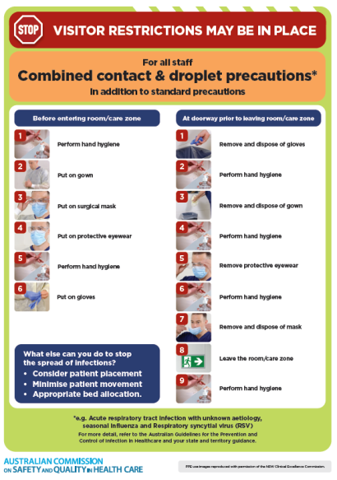](https://www.safetyandquality.gov.au/publications-and-resources/resource-library/infection-prevention-and-control-poster-combined-contact-and-droplet-precautions)
* ***Poster – Combined airborne and contact precautions*** <https://www.safetyandquality.gov.au/publications-and-resources/resource-library/poster-combined-airborne-and-contact-precautions>   
  [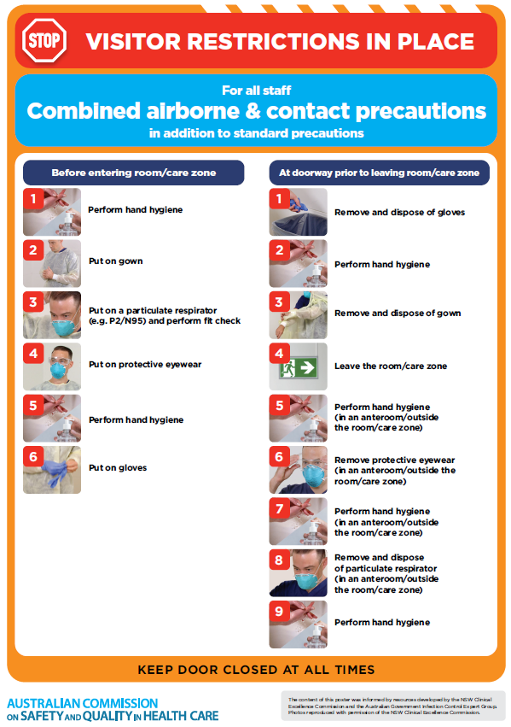](https://www.safetyandquality.gov.au/publications-and-resources/resource-library/poster-combined-airborne-and-contact-precautions)
* ***Environmental Cleaning and Infection Prevention and Control*** [www.safetyandquality.gov.au/environmental-cleaning](http://www.safetyandquality.gov.au/environmental-cleaning)
* ***COVID-19 infection prevention and control risk management – Guidance*** <https://www.safetyandquality.gov.au/publications-and-resources/resource-library/covid-19-infection-prevention-and-control-risk-management-guidance>
* ***Safe care for people with cognitive impairment during COVID-19***<https://www.safetyandquality.gov.au/our-work/cognitive-impairment/cognitive-impairment-and-covid-19>
* ***Stop COVID-19: Break the chain of infection*** posterhttps://www.safetyandquality.gov.au/publications-and-resources/resource-library/break-chain-infection-poster-a3  
  **[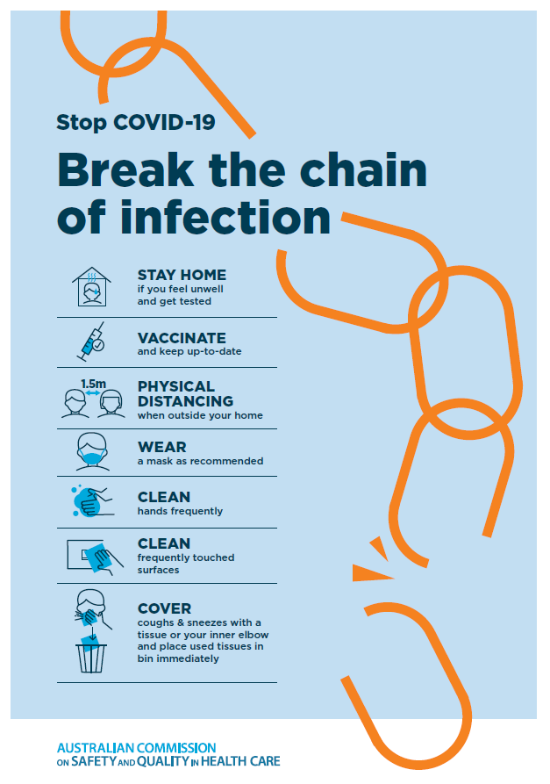](https://www.safetyandquality.gov.au/publications-and-resources/resource-library/break-chain-poster-a3https:/www.safetyandquality.gov.au/publications-and-resources/resource-library/break-chain-poster-a3)**
* ***FAQs for clinicians on elective surgery*** <https://www.safetyandquality.gov.au/node/5724>
* ***FAQs for consumers on elective surgery*** <https://www.safetyandquality.gov.au/node/5725>
* ***COVID-19 and face masks – Information for consumers*** <https://www.safetyandquality.gov.au/publications-and-resources/resource-library/covid-19-and-face-masks-information-consumers>

[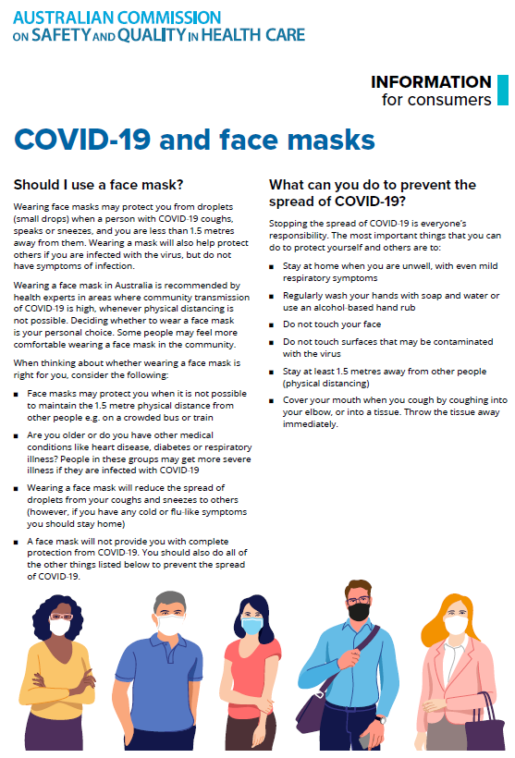](https://www.safetyandquality.gov.au/sites/default/files/2020-07/covid-19_and_face_masks_-_information_for_consumers.pdf)

*National COVID-19 Clinical Evidence Taskforce*

<https://covid19evidence.net.au/>

The National COVID-19 Clinical Evidence Taskforce is a collaboration of peak health professional bodies across Australia whose members are providing clinical care to people with COVID-19. The taskforce is undertaking continuous evidence surveillance to identify and rapidly synthesise emerging research in order to provide national, **evidence-based guidelines and clinical flowcharts for the clinical care of people with COVID-19**. The guidelines address questions that are specific to managing COVID-19 and cover the full disease course across mild, moderate, severe and critical illness. These are ‘living’ guidelines, updated with new research in near real-time in order to give reliable, up-to-the minute advice to clinicians providing frontline care in this unprecedented global health crisis.

*COVID-19 Critical Intelligence Unit*

<https://www.aci.health.nsw.gov.au/covid-19/critical-intelligence-unit>

The Agency for Clinical Innovation (ACI) in New South Wales has developed this page summarising rapid, evidence-based advice during the COVID-19 pandemic. Its operations focus on systems intelligence, clinical intelligence and evidence integration. The content includes a daily evidence digest, a COVID status monitor, a risk monitoring dashboard and evidence checks on a discrete topic or question relating to the current COVID-19 pandemic. There is also a ‘Living evidence’ section summarising key studies and emerging evidence on **COVID-19 vaccines** and **SARS-CoV-2 variants**. The most recent updates include:

* ***Paxlovid*** – What is the evidence for Paxlovid for treatment of COVID-19?
* ***Molnupiravir*** –What is the evidence for and regulatory context of molnupiravir for treatment of COVID-19?
* ***Eating disorders and COVID-19*** – What is the impact of the COVID-19 pandemic on the prevalence of eating disorders?
* ***Long COVID –*** What is the evidence on the prevalence, presentation and management of long-COVID?
* ***Oseltamivir (Tamiflu) use in healthcare settings*** – What is the evidence that use of oseltamivir in healthcare workers with a symptomatic influenza diagnosis result in an earlier return to work and reduced absenteeism? What is the evidence that use of oseltamivir in adults and children with symptomatic influenza reduces influenza transmission in health care settings?
* ***Alternative models of care for acute medical conditions*** – What is the evidence on alternative models of care for managing patients with acute medical conditions outside of emergency or inpatient hospital settings?
* ***Exercise and long COVID*** – Is exercise helpful in individuals with long COVID? Is post-exertional symptom exacerbation a risk in long COVID?
* ***Influenza and seasonal prophylaxis with oseltamivir*** – What is the place or evidence for seasonal influenza prophylaxis (such as taking oseltamivir for 10 to 12 weeks continuously) in healthcare and aged care settings?
* ***Rapid access models of care for respiratory illnesses*** – What is the evidence for rapid access models of care for respiratory illnesses, especially during winter seasons, in emergency departments?
* ***Current and emerging patient safety issues during COVID-19*** – What is the evidence on the current and emerging patient safety issues arising from the COVID-19 pandemic?
* ***Post-acute sequelae of COVID-19*** – What is the evidence on the post-acute sequelae of COVID-19?
* ***Emerging variants*** – What is the available evidence for emerging variants?
* ***Chest pain or dyspnoea following COVID-19 vaccination*** – What is evidence for chest pain or dyspnoea following COVID-19 vaccination?
* ***Cardiac investigations and elective surgery post-COVID-19*** – What is evidence for cardiac investigations and elective surgery post-COVID-19?
* ***Breathlessness post COVID-19*** – How to determine those patients who present with ongoing breathlessness in need of urgent review or intervention due to suspected pulmonary embolus?
* ***COVID-19 pandemic and influenza*** – What is the evidence for COVID-19 pandemic and influenza?
* ***Budesonide and aspirin for pregnant women with COVID-19 –*** What is the evidence for the use of Budesonide for pregnant women with COVID-19? What is the evidence for aspirin prophylaxis for pre-eclampsia in pregnant women with a COVID-19 infection?
* ***COVID-19 vaccines in Australia*** – What is the evidence on COVID-19 vaccines in Australia?
* ***COVID-19 pandemic and wellbeing of critical care and other healthcare workers*** – Evidence in brief on the impact of the COVID-19 pandemic on the wellbeing of critical care and other healthcare workers.
* ***Surgery post COVID-19*** – What is the evidence for the timing of surgery, and outcomes following surgery, for people who have recovered from COVID-19?
* ***Disease modifying treatments for COVID-19 in children*** – What is the evidence for disease modifying treatments for COVID-19 in children?
* ***Mask type for COVID-19 positive wearer*** – What is the evidence for different mask types for COVID-19 positive wearers?
* ***Post acute and subacute COVID-19 care*** – What published advice and models of care are available regarding post-acute and subacute care for COVID-19 patients?
* ***Hospital visitor policies*** – What is the evidence for hospital visitor policies during and outside of the COVID-19 pandemic?
* ***Surgical masks, eye protection and PPE guidance*** –What is the evidence for surgical masks in the endemic phase in hospitals and for eyewear to protect against COVID-19?

**Disclaimer**

On the Radar is an information resource of the Australian Commission on Safety and Quality in Health Care. The Commission is not responsible for the content of, nor does it endorse, any articles or sites listed. The Commission accepts no liability for the information or advice provided by these external links. Links are provided on the basis that users make their own decisions about the accuracy, currency and reliability of the information contained therein. Any opinions expressed are not necessarily those of the Australian Commission on Safety and Quality in Health Care.