Australian Commission on Safety and Quality in Health Care logo 


TRIM: D18-34185

**National Standard Medication Chart (NSMC) Audit System:** Reporting user guide for coordinators

**Hospital version 1.1**

October 2022

Published by the Australian Commission on Safety and Quality in Health Care  
Level 5, 255 Elizabeth Street, Sydney NSW 2000

Phone: (02) 9126 3600  
Email: [mail@safetyandquality.gov.au](mailto:mail@safetyandquality.gov.au)   
Website: [www.safetyandquality.gov.au](http://www.safetyandquality.gov.au/)

© Australian Commission on Safety and Quality in Health Care 2022

All material and work produced by the Australian Commission on Safety and Quality in Health Care is protected by copyright. The Commission reserves the right to set out the terms and conditions for the use of such material.

As far as practicable, material for which the copyright is owned by a third party will be clearly labelled. The Australian Commission on Safety and Quality in Health Care has made all reasonable efforts to ensure that this material has been reproduced in this publication with the full consent of the copyright owners.

With the exception of any material protected by a trademark, any content provided by third parties, and where otherwise noted, all material presented in this publication is licensed under a [Creative Commons Attribution-NonCommercial-NoDerivatives 4.0 International Licence](http://creativecommons.org/licenses/by-nc-nd/4.0/).

Creative Commons Licence

Enquiries regarding the licence and any use of this publication are welcome and can be sent to [communications@safetyandquality.gov.au](mailto:communications@safetyandquality.gov.au).

The Commission’s preference is that you attribute this publication (and any material sourced from it) using the following citation:

Australian Commission on Safety and Quality in Health Care. NSMC (National Standard Medication Chart) Audit System User Guide. Sydney: ACSQHC; 2022

**Disclaimer**

The content of this document is published in good faith by the Australian Commission on Safety and Quality in Health Care for information purposes. The document is not intended to provide guidance on particular healthcare choices. You should contact your healthcare provider on particular healthcare choices.

This document includes the views or recommendations of its authors and third parties. Publication of this document by the Commission does not necessarily reflect the views of the Commission, or indicate a commitment to a particular course of action. The Commission does not accept any legal liability for any injury, loss or damage incurred by the use of, or reliance on, this document.

Contents

Introduction 4

Access control 4

Audit Statistics Report 5

Patient Audit Report 6

Summary Report 7

**Introduction**

The Australian Commission on Safety and Quality in Health Care (the Commission) developed the [National Standard Medication Chart (NSMC) Audit System](https://nsmc.safetyandquality.gov.au/Login/?ReturnUrl=%2fUI%2f), as a secure web-based audit data collection tool

Further information and resources for the NSMC audit can be found on the [National Standard Medication Chart auditing](https://www.safetyandquality.gov.au/our-work/medication-safety/nsmc-audit/) web page.

The minimum supported browsers are:

* Chrome 57–59 (2017)
* Microsoft Edge 12 (Windows 10)
* Internet Explorer 11 (Windows 7+)
* Mac Safari 9 (2015).

Other browsers that should work, but have not been tested, are:

* Opera 43+ (2017)
* Firefox 45–50 (2016)
* iOS 9 Safari.

**Access to NSMC audit system reporting**

There are three types of reports generated through the NSMC audit system:

* Audit Statistics Report
* Patient Audit Report
* Summary Report

The reporting feature is only available to audit coordinators and can only viewed for their associated hospital(s).

**Where to access the reports**

1. Login to the [NSMC audit system](https://nsmc.safetyandquality.gov.au/Login/?ReturnUrl=%2fUI%2f) with the registered email id and password
2. Click the ‘Reports’ tab in the NSMC Audit menu
3. Click on the report you would like to run.

The next three sections provide further detail on each reports.

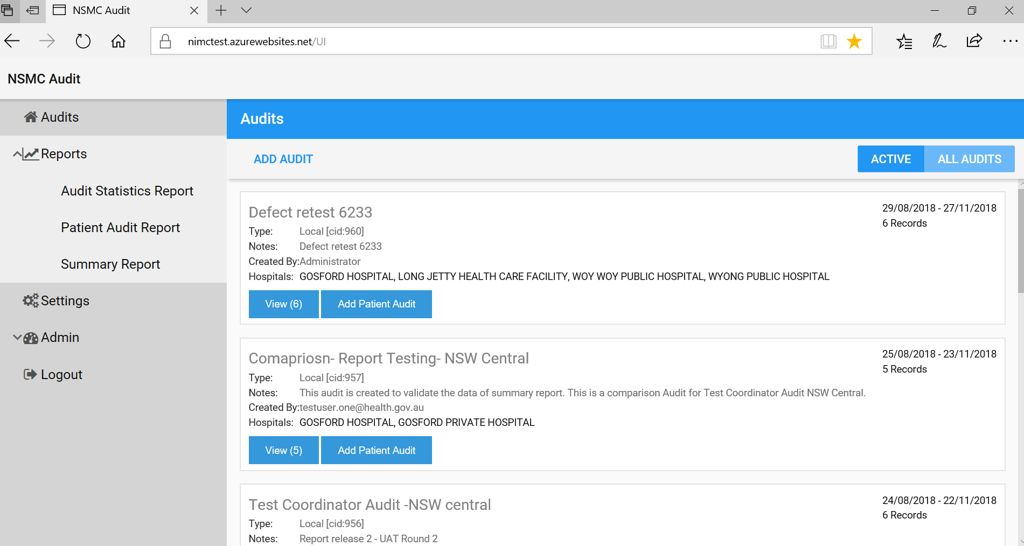

**Audit Statistics Report**

Provides information for the selected audit, including total number of:

* participating hospitals
* public and private patient audits
* public and private patient audits by state
* patient audits by chart type and by patient type (adult and paediatric)
* patient audits by hospital peer-group
* hospitals within peer-group

**Generating the report:**

1. Click on ‘Audit Statistics Report’

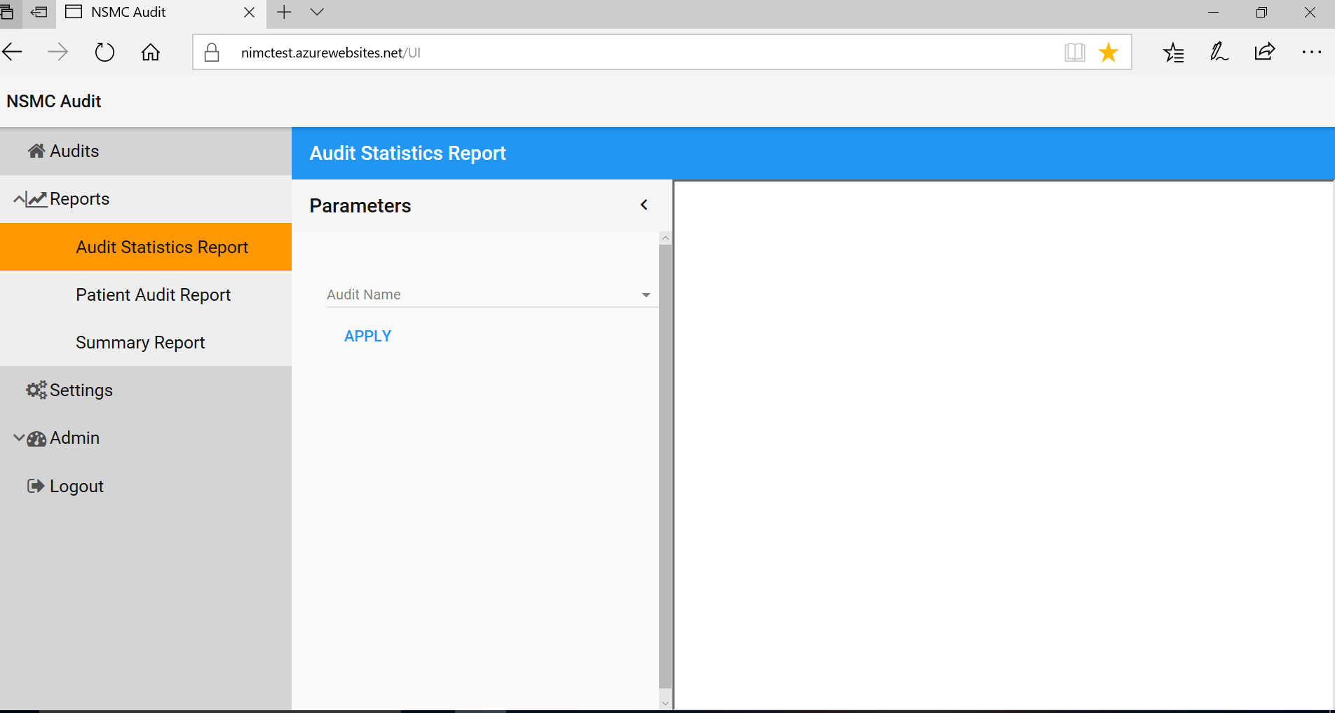

1. Select the audit name from the drop-down list and click ‘APPLY’

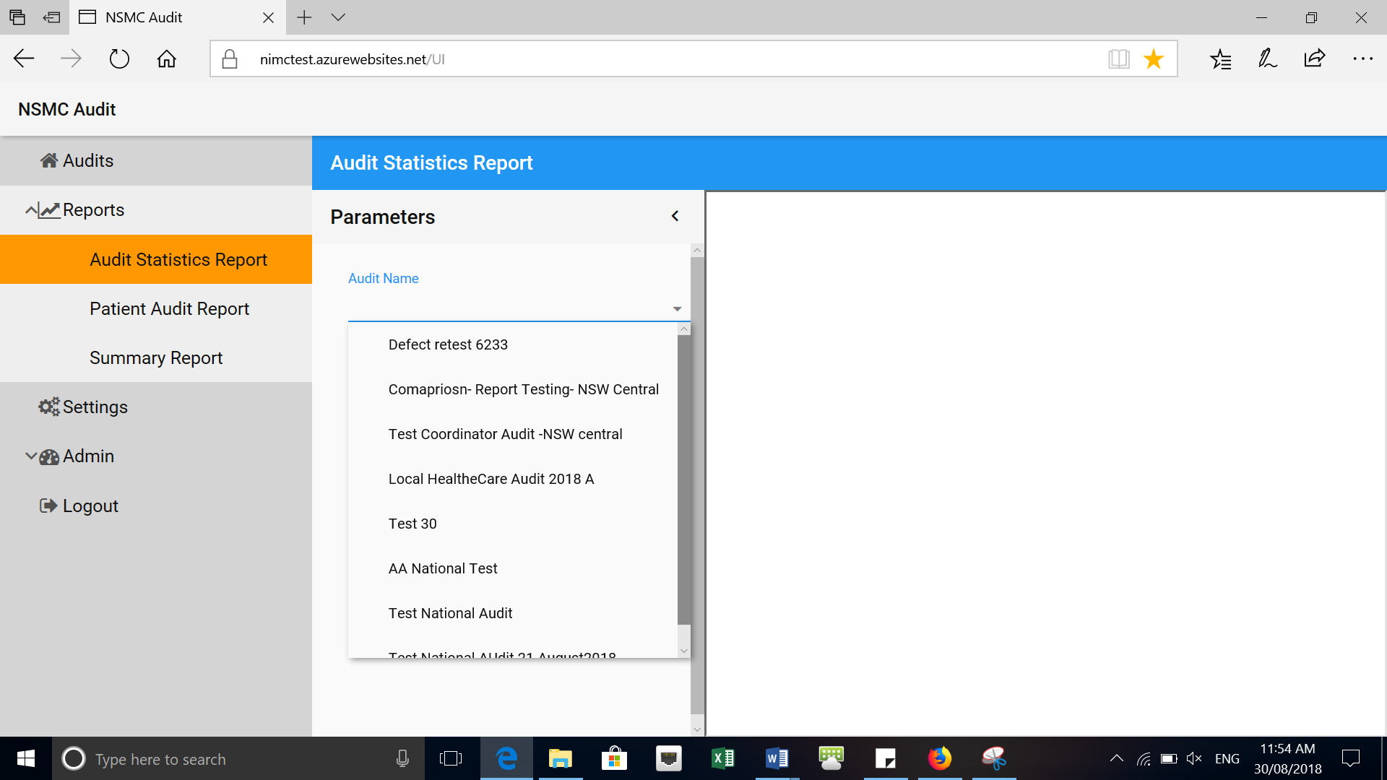

1. Click the save icon to download the report in Excel or Word format.

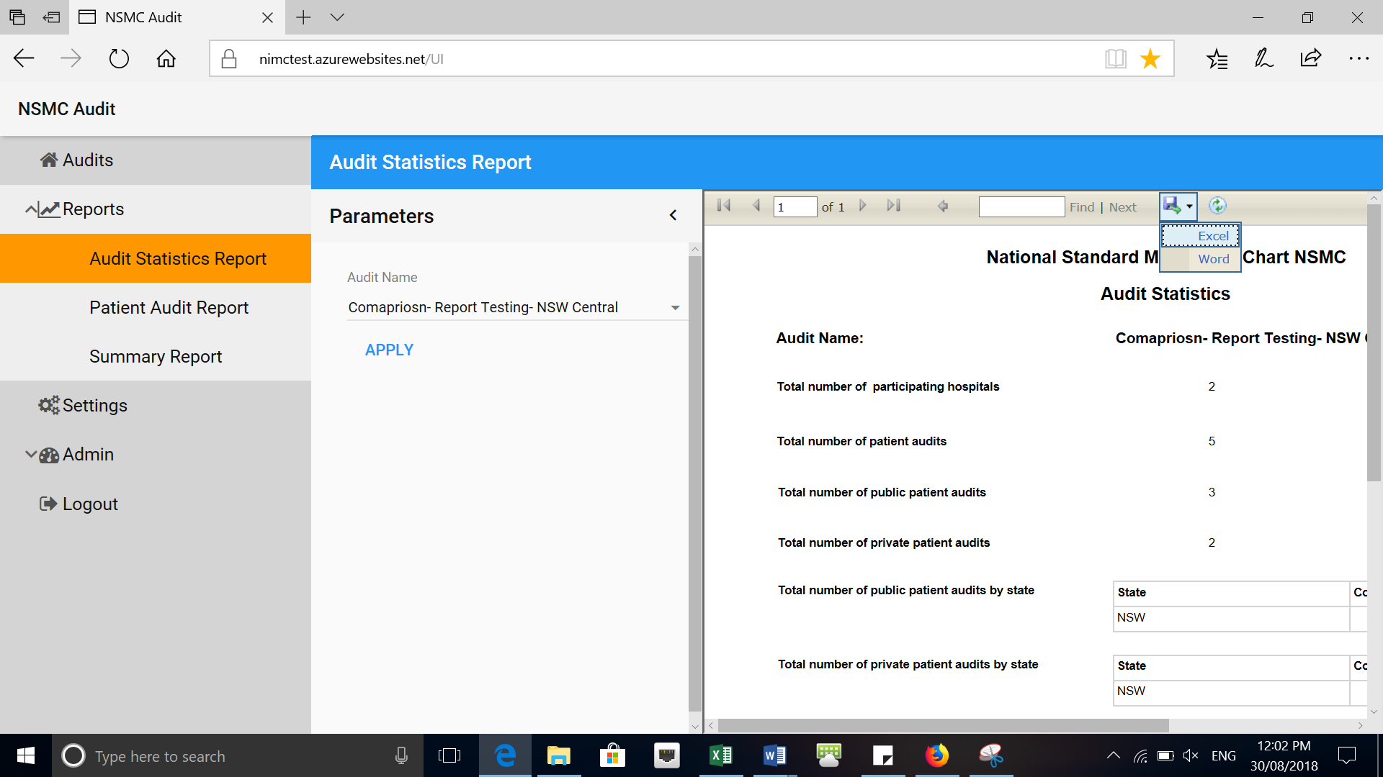

**Patient Audit Report**

Provides the raw data collected from the selected audit

**Generating the report**

1. Click on Patient Audit Report

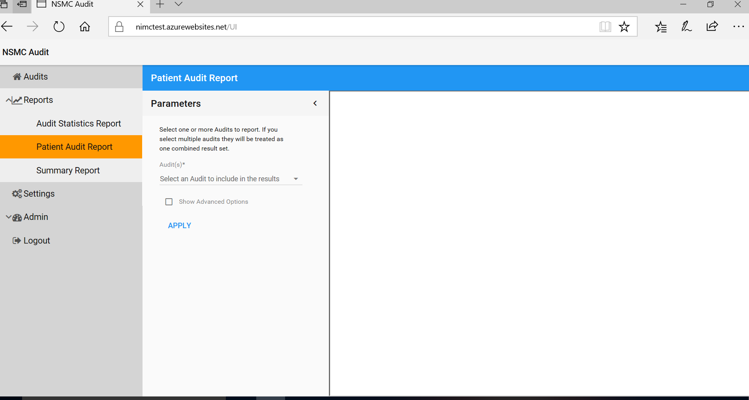

1. Select the audit(s) from the drop-down list and click ‘APPLY’.

Additional filters can be applied by selecting ‘Show Advanced Options’:

* Hospital name
* Group
* Peer-group
* State
* Hospital type
* Chart type
* Specific patient cohort ‘Only show Age 12 and under’

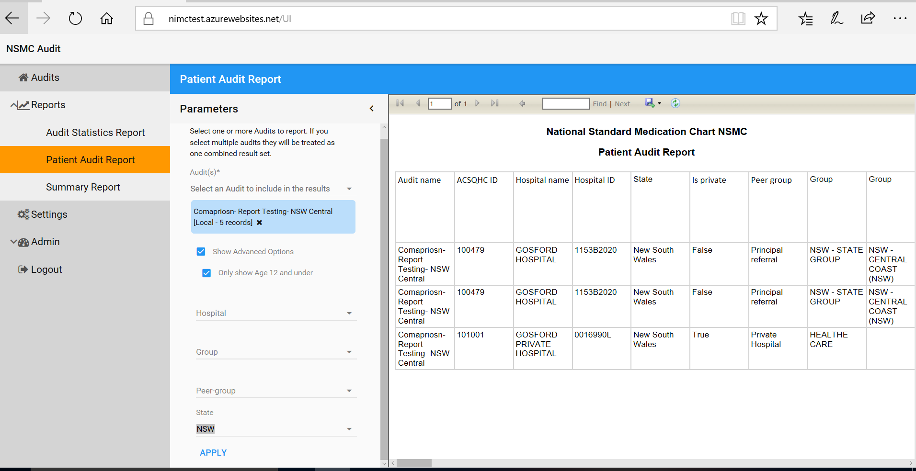

1. Click the save icon to download the report to Excel or Word format

**Summary Report**

Provides a summary of results for the selected audit. Multiple audits can be selected to generate aggregated results.

A Summary report can also be created with a comparison of two audits, including the national audit. For example, hospitals may compare their hospital audit or local audit results with the national audit results.

**Generating the report**

1. Click on Summary Report

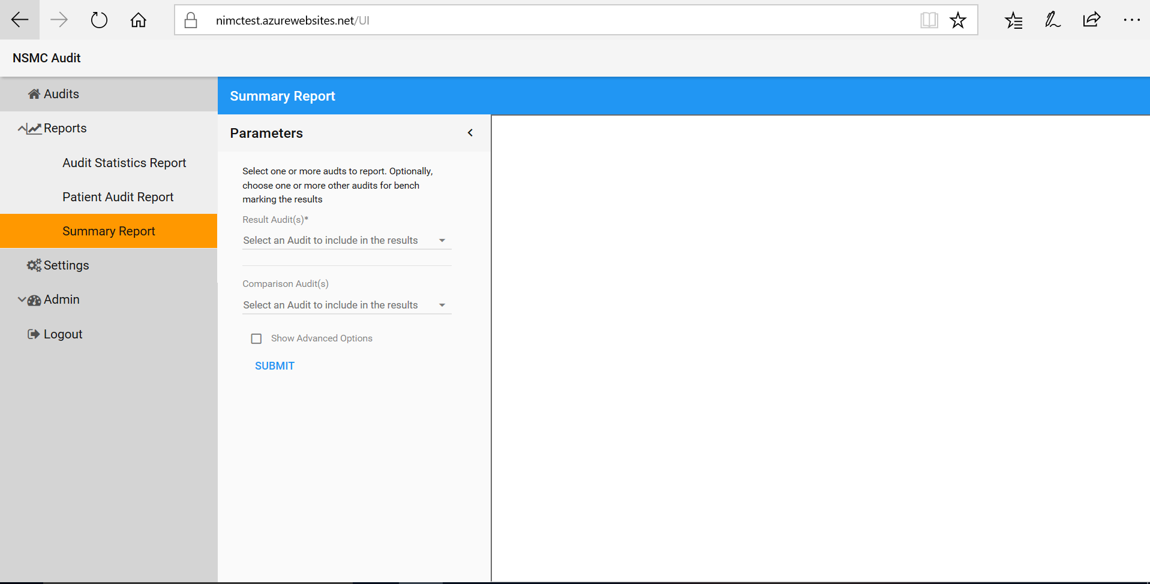

1. Select the audit(s) you would like to include in your report under the heading ‘Result Audit(s)*’ and click ‘SUBMIT’

If you select multiple audits they will be aggregated

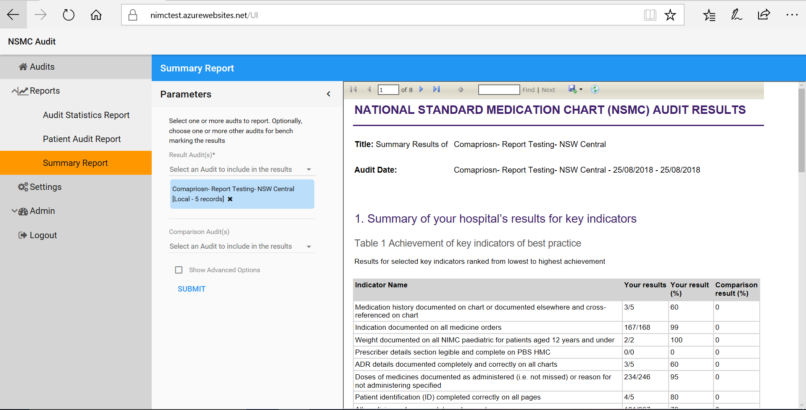

1. Click on the save icon to download the report in Excel or Word.

**Generating the comparison Audit(s) report**

1. Select the audit(s) for the comparison under the heading ‘Comparison Audit(s)’ and click ‘SUBMIT’

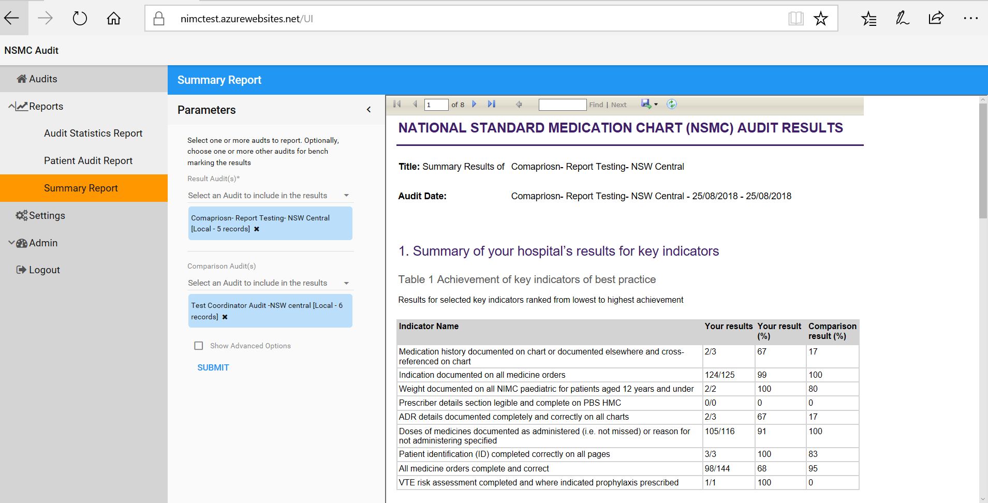

1. Additional filters can be applied by selecting ‘Show Advanced Options’

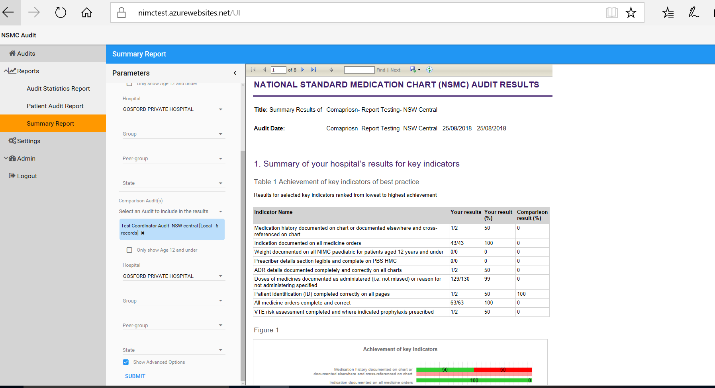

1. Click on the save icon to download the report in Excel or Word.