# Australian Commission on Safety and Quality logotypeOn the Radar

Issue 580

24 October 2022

*On the Radar* is a summary of some of the recent publications in the areas of safety and quality in health care. Inclusion in this document is not an endorsement or recommendation of any publication or provider. Access to particular documents may depend on whether they are Open Access or not, and/or your individual or institutional access to subscription sites/services. Material that may require subscription is included as it is considered relevant.

*On the Radar* is available online, via email or as a PDF or Word document from <https://www.safetyandquality.gov.au/publications-and-resources/newsletters/radar>

If you would like to receive *On the Radar* via email, you can subscribe on our website <https://www.safetyandquality.gov.au/publications-and-resources/newsletters>  
or by emailing us at H[Umail@safetyandquality.gov.auU](mailto:mail@safetyandquality.gov.au).   
You can also send feedback and comments to H[Umail@safetyandquality.gov.auU](mailto:mail@safetyandquality.gov.au).

For information about the Commission and its programs and publications, please visit <https://www.safetyandquality.gov.au>

You can also follow us on Twitter @ACSQHC.

**On the Radar**

Editor: Dr Niall Johnson [niall.johnson@safetyandquality.gov.au](mailto:niall.johnson@safetyandquality.gov.au)

Contributors: Niall Johnson, Amy Forsyth, Paul Miles

***Join the launch of the first care standard on stillbirth***

<https://safetyandquality.tv/>

You are invited to join the online launch of the first national [*Stillbirth Clinical Care Standard*](https://www.safetyandquality.gov.au/standards/clinical-care-standards/stillbirth-clinical-care-standard), developed by the Australian Commission on Safety and Quality in Health Care. The event will be streamed live from the [Annual National Stillbirth Forum](https://stillbirthcre.org.au/news/annual-national-stillbirth-forum-2022/).

Stillbirth is a tragic and profound experience that affects more than 2,000 families in Australia every year. Despite being the most common form of perinatal death in Australia, the experience of stillbirth can be hidden due to stigma, taboo and a culture of silence.

Hear leading experts discuss best practice in preventing stillbirth, investigations after stillbirth and the importance of bereavement care after perinatal loss.

**When**: **Friday** **4 November**, 12:30 – 1:30 PM AEDT

**Expert panellists**

ABC journalist and broadcaster Tegan Taylor will host an expert panel including:

* Associate Professor Liz Marles – Clinical Director, Australian Commission on Safety and Quality in Health Care and General Practitioner, Hornsby-Brooklyn GP Unit
* Professor Adrienne Gordon – Neonatologist at Royal Prince Alfred Hospital, Clinical Professor at University of Sydney, and Chief Investigator at the Stillbirth CRE
* Professor Caroline Homer AO – Co-Program Director Maternal, Child and Adolescent Health at the Burnet Institute and President of the Perinatal Society of Australia and New Zealand
* Professor David Ellwood – Professor of Obstetrics & Gynaecology at Griffith University, Director of Maternal-Fetal Medicine at Gold Coast University Hospital, and Co-Director of the Stillbirth CRE
* Ms Deanna Stuart-Butler – Senior Advisor, Indigenous Research and Chair of the National Stillbirth Indigenous Advisory Group at the Stillbirth CRE.

Click [here](https://safetyandquality.tv/home/) to register.

For more information email [ccs@safetyandquality.gov.au](mailto:ccs@safetyandquality.gov.au) or visit our web page <https://www.safetyandquality.gov.au/standards/clinical-care-standards/stillbirth-clinical-care-standard>



**Journal articles**

*Polypharmacy and continuity of care: medicines optimisation in the era of multidisciplinary teams*

Tarrant C, Lewis R, Armstrong N

BMJ Quality & Safety. 2022.

|  |  |
| --- | --- |
| DOI | <https://dx.doi.org/10.1136/bmjqs-2022-015082> |
| Notes | Editorial in *BMJ Quality & Safety* reflecting on polypharmacy, particularly in light of an ethnographic study of how primary care clinicians manage polypharmacy. The authors of this editorial suggest that it is the coordinating of medication management within and across teams that warrants focus, so as ‘to enable sharing of responsibility for iterative, ongoing medicines management *between clinicians* involved in a patient’s care over time’. They go on to suggest five areas for attention:   1. ‘an explicit understanding of medication management as an ongoing, iterative process, where the decision to prescribe medication is seen as the start of a journey rather than a destination. … Clear articulation, forward planning and recording of the goals of treatment at the point of prescribing would help support other clinicians, in subsequent consultations, to have conversations with patients about their medications and make informed decisions about medicines management.’ 2. ‘understanding of what person-centred care means in the context of medicines optimisation and medication reviews. Prescribers should recognise the patient as an expert in their own experiences of medication, and in what they want to achieve from their medication.’ 3. ‘clearer guidance about what information should be recorded in medication reviews. This should include documenting detail that extends beyond the outcome of the review, for example, patient goals and preferences, and important elements of the decision-making process’ 4. ‘improving information and management continuity across healthcare professionals within primary care, and the transition between primary and secondary care, will support healthcare professionals to have more informed discussions with patients’ 5. ‘understanding of the purpose and potential contribution of clinical pharmacists following their integration into primary care’. |

For information on the Commission’s work on medication safety, see <https://www.safetyandquality.gov.au/our-work/medication-safety>

*World guidelines for falls prevention and management for older adults: a global initiative*

Montero-Odasso M, van der Velde N, Martin FC, Petrovic M, Tan MP, Ryg J, et al

Age and Ageing. 2022;51(9):afac205.

|  |  |
| --- | --- |
| DOI | <https://doi.org/10.1093/ageing/afac205> |
| Notes | Paper reporting on the creation of ‘a set of evidence- and expert consensus-based falls prevention and management recommendations applicable to older adults for use by healthcare and other professionals that consider:   1. a person-centred approach that includes the perspectives of older adults with lived experience, caregivers and other stakeholders; 2. gaps in previous guidelines; 3. recent developments in e-health and 4. implementation across locations with limited access to resources such as low- and middle-income countries.   The various recommendations relate to various populations and contexts. |

*The Lancet Commission on ending stigma and discrimination in mental health*

Thornicroft G, Sunkel C, Alikhon Aliev A, Baker S, Brohan E, el Chammay R, et al.

The Lancet 2022 epub.

|  |  |
| --- | --- |
| DOI | <https://doi.org/10.1016/S0140-6736(22)01470-2> |
| Notes | The impact of stigma on mental health and treatment is widely recognised but possibly the scale and range of impacts is not appreciated. As is noted in this report, ‘many people describe stigma as being worse than the condition itself’. This Lancet Commission seeks to bring together evidence and experience of the impact of stigma and discrimination and successful interventions for stigma reduction. |

For information on the Commission’s work on mental health, see <https://www.safetyandquality.gov.au/our-work/mental-health>

*Weight stigma in Australia: a public health call to action*

Lawrence B, de la Piedad Garcia X, Kite J, Hill B, Cooper K, Flint S, et al

Public Health Research & Practice. 2022; 32(3):e3232224.

|  |  |
| --- | --- |
| DOI | <https://doi.org/10.17061/phrp3232224> |
| Notes | Another piece examining the role of stigma is this article on weight stigma in Australia. The authors observe that ‘Weight stigma is perpetuated by the media, healthcare practitioners and researchers, and even in public health campaigns and policies designed to help people living with obesity.’ There are calls for health research, practice and delivery to reverse stigma and adopt more welcoming and inclusive approaches. |

*BMJ Quality & Safety*

November 2022 Volume 31 Issue 11

|  |  |
| --- | --- |
| URL | <https://qualitysafety.bmj.com/content/31/11> |
| Notes | A new issue of *BMJ Quality & Safety* has been published. Many of the papers in this issue have been referred to in previous editions of *On the Radar* (when they were released online). Articles in this issue of *BMJ Quality & Safety* include:   * Editorial: **Antibiotic documentation**: death by a thousand clicks (Claire Ciarkowski, Valerie M Vaughn) * Why identifying **adverse events in paediatric emergency care** matters (Kenneth A Michelson, Richard T Griffey) * Reporting on **implementation trials with null findings**: the need for concurrent process evaluation reporting (Anne Sales) * Addressing **long-term and repeat antibiotic prescriptions in primary care**: considerations for a behavioural approach (Eva M Krockow, Eleanor J Harvey, Diane Ashiru-Oredope) * **Documenting the indication for antimicrobial prescribing**: a scoping review (Sharon Saini, Valerie Leung, Elizabeth Si, Certina Ho, Anne Cheung, Dan Dalton, Nick Daneman, Kelly Grindrod, Rita Ha, Warren McIsaac, Anjali Oberai, Kevin Schwartz, Anastasia Shiamptanis, Bradley J Langford) * Framework to **optimise learning network activities** for long-term success (Katherine E Bates, Nicolas L Madsen, Anne Lyren, Paige Krack, Jeffrey B Anderson, Carole M Lannon, Sharyl Wooton) * **How safe are paediatric emergency departments?** A national prospective cohort study (Amy C Plint, Amanda S Newton, Antonia Stang, Zach Cantor, Lamia Hayawi, Nick Barrowman, Kathy Boutis, Serge Gouin, Quynh Doan, Andrew Dixon, Robert Porter, Gary Joubert, Scott Sawyer, Tyrus Crawford, Jocelyn Gravel, Maala Bhatt, Patrick Weldon, Kelly Millar, Sandy Tse, Gina Neto, Simran Grewal, Melissa Chan, Kevin Chan, Grant Yung, Jennifer Kilgar, Tim Lynch, Mary Aglipay, Dale Dalgleish, Ken Farion, Terry P Klassen, David W Johnson, Lisa A Calder) * **Prioritising Responses Of Nurses To deteriorating patient Observations (PRONTO):** a pragmatic cluster randomised controlled trial evaluating the effectiveness of a facilitation intervention on recognition and response to clinical deterioration (Tracey K Bucknall, Julie Considine, Gillian Harvey, Ian D Graham, Jo Rycroft-Malone, Imogen Mitchell, Bridey Saultry, Jennifer J Watts, Mohammadreza Mohebbi, Shalika Bohingamu Mudiyanselage, Mojtaba Lotfaliany, Alison Hutchinson) * **Comparing antibiotic prescribing between clinicians** in UK primary care: an analysis in a cohort study of eight different measures of antibiotic prescribing (Tjeerd Van Staa, Yan Li, Natalie Gold, Tim Chadborn, William Welfare, Victoria Palin, Darren M Ashcroft, Joanna Bircher) |

*BMJ Quality & Safety* online first articles

|  |  |
| --- | --- |
| URL | <https://qualitysafety.bmj.com/content/early/recent> |
| Notes | *BMJ Quality &Safety* has published a number of ‘online first’ articles, including:   * Editorial: COP27 **climate change** conference: urgent action needed for Africa and the world |

**Online resources**

***[UK] NICE Guidelines and Quality Standards***

<https://www.nice.org.uk/guidance>

The UK’s National Institute for Health and Care Excellence (NICE) has published new (or updated) guidelines and quality standards. The latest reviews or updates include:

* NICE Guideline NG226 ***Osteoarthritis*** *in over 16s: diagnosis and management* <https://www.nice.org.uk/guidance/ng226>
* Quality Standard QS87 ***Osteoarthritis*** *in over 16s* <https://www.nice.org.uk/guidance/qs87>

***[Canada] Code Grey – where security practices meet patient care***

<https://codegrey.digitalhealthcanada.com/>

Digital Health Canada has produced this resource. According to their website, ‘cyber attacks can have ramifications beyond financial loss and breach of privacy; a cyber attack can bring the delivery of patient care to a halt. To support the continuity of patient care during and after a cyber incident, this CHIEF Executive Forum resource provides high-level strategic suggestions and trustworthy sources for further information and available tools. Healthcare delivery organizations can use this to guide them through three key stages of a cyber incident: Prepare. Respond. Recover.’

**COVID-19 resources**

https://www.safetyandquality.gov.au/covid-19

The Australian Commission on Safety and Quality in Health Care has developed a number of resources to assist healthcare organisations, facilities and clinicians. These and other material on COVID-19 are available at <https://www.safetyandquality.gov.au/covid-19>

These resources include:

* ***OVID-19 infection prevention and control risk management*** This primer provides an overview of three widely used tools for investigating and responding to patient safety events and near misses. Tools covered in this primer include incident reporting systems, Root Cause Analysis (RCA), and Failure Modes and Effects Analysis (FMEA).   
  <https://www.safetyandquality.gov.au/publications-and-resources/resource-library/covid-19-infection-prevention-and-control-risk-management-guidance>
* ***Poster – Combined contact and droplet precautions*** <https://www.safetyandquality.gov.au/publications-and-resources/resource-library/infection-prevention-and-control-poster-combined-contact-and-droplet-precautions>  
  [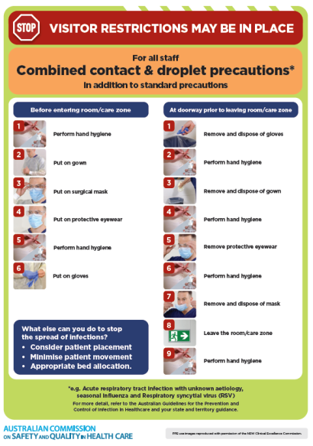](https://www.safetyandquality.gov.au/publications-and-resources/resource-library/infection-prevention-and-control-poster-combined-contact-and-droplet-precautions)
* ***Poster – Combined airborne and contact precautions*** <https://www.safetyandquality.gov.au/publications-and-resources/resource-library/poster-combined-airborne-and-contact-precautions>   
  [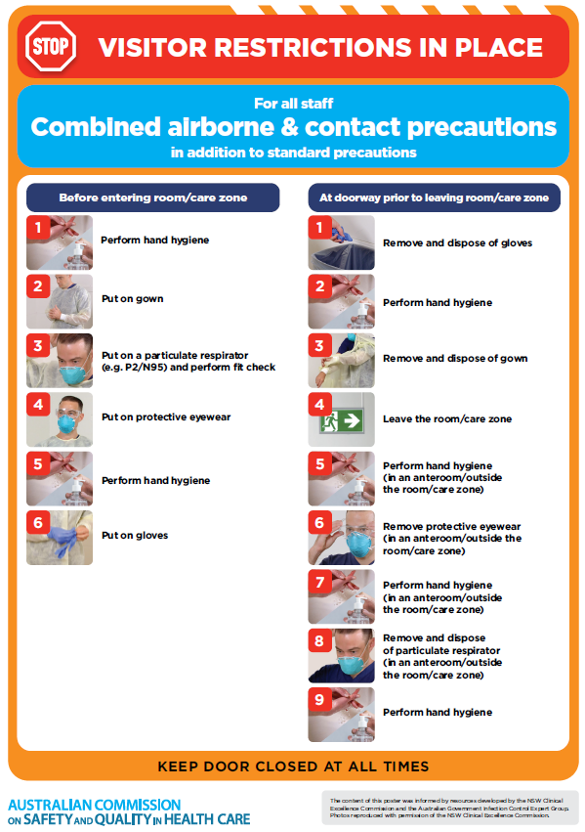](https://www.safetyandquality.gov.au/publications-and-resources/resource-library/poster-combined-airborne-and-contact-precautions)
* ***Environmental Cleaning and Infection Prevention and Control*** [www.safetyandquality.gov.au/environmental-cleaning](http://www.safetyandquality.gov.au/environmental-cleaning)
* ***COVID-19 infection prevention and control risk management – Guidance*** <https://www.safetyandquality.gov.au/publications-and-resources/resource-library/covid-19-infection-prevention-and-control-risk-management-guidance>
* ***Safe care for people with cognitive impairment during COVID-19***<https://www.safetyandquality.gov.au/our-work/cognitive-impairment/cognitive-impairment-and-covid-19>
* ***Stop COVID-19: Break the chain of infection*** posterhttps://www.safetyandquality.gov.au/publications-and-resources/resource-library/break-chain-infection-poster-a3  
  **[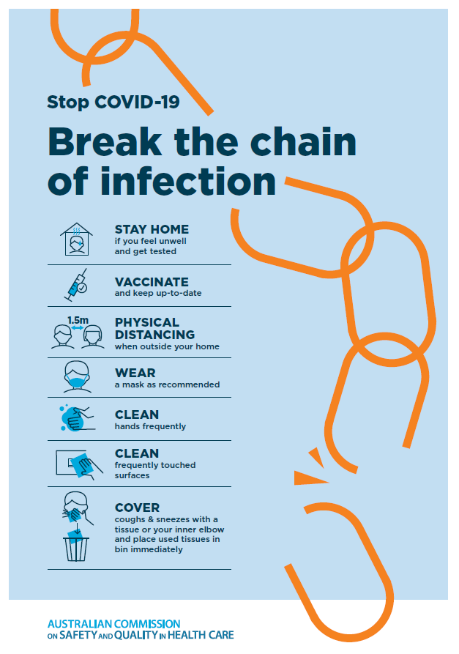](https://www.safetyandquality.gov.au/publications-and-resources/resource-library/break-chain-poster-a3https:/www.safetyandquality.gov.au/publications-and-resources/resource-library/break-chain-poster-a3)**
* ***FAQs for clinicians on elective surgery*** <https://www.safetyandquality.gov.au/node/5724>
* ***FAQs for consumers on elective surgery*** <https://www.safetyandquality.gov.au/node/5725>
* ***COVID-19 and face masks – Information for consumers*** <https://www.safetyandquality.gov.au/publications-and-resources/resource-library/covid-19-and-face-masks-information-consumers>

[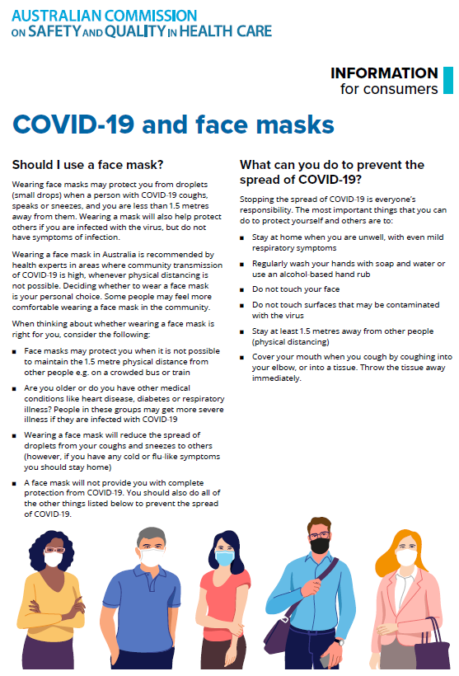](https://www.safetyandquality.gov.au/sites/default/files/2020-07/covid-19_and_face_masks_-_information_for_consumers.pdf)

*National COVID-19 Clinical Evidence Taskforce*

<https://covid19evidence.net.au/>

The National COVID-19 Clinical Evidence Taskforce is a collaboration of peak health professional bodies across Australia whose members are providing clinical care to people with COVID-19. The taskforce is undertaking continuous evidence surveillance to identify and rapidly synthesise emerging research in order to provide national, **evidence-based guidelines and clinical flowcharts for the clinical care of people with COVID-19**. The guidelines address questions that are specific to managing COVID-19 and cover the full disease course across mild, moderate, severe and critical illness. These are ‘living’ guidelines, updated with new research in near real-time in order to give reliable, up-to-the minute advice to clinicians providing frontline care in this unprecedented global health crisis.

*COVID-19 Critical Intelligence Unit*

<https://www.aci.health.nsw.gov.au/covid-19/critical-intelligence-unit>

The Agency for Clinical Innovation (ACI) in New South Wales has developed this page summarising rapid, evidence-based advice during the COVID-19 pandemic. Its operations focus on systems intelligence, clinical intelligence and evidence integration. The content includes a daily evidence digest, a COVID status monitor, a risk monitoring dashboard and evidence checks on a discrete topic or question relating to the current COVID-19 pandemic. There is also a ‘Living evidence’ section summarising key studies and emerging evidence on **COVID-19 vaccines** and **SARS-CoV-2 variants**. The most recent updates include:

* ***Paxlovid*** – What is the evidence for Paxlovid for treatment of COVID-19?
* ***Molnupiravir*** –What is the evidence for and regulatory context of molnupiravir for treatment of COVID-19?
* ***Eating disorders and COVID-19*** – What is the impact of the COVID-19 pandemic on the prevalence of eating disorders?
* ***Long COVID –*** What is the evidence on the prevalence, presentation and management of long-COVID?
* ***Oseltamivir (Tamiflu) use in healthcare settings*** – What is the evidence that use of oseltamivir in healthcare workers with a symptomatic influenza diagnosis result in an earlier return to work and reduced absenteeism? What is the evidence that use of oseltamivir in adults and children with symptomatic influenza reduces influenza transmission in health care settings?
* ***Alternative models of care for acute medical conditions*** – What is the evidence on alternative models of care for managing patients with acute medical conditions outside of emergency or inpatient hospital settings?
* ***Exercise and long COVID*** – Is exercise helpful in individuals with long COVID? Is post-exertional symptom exacerbation a risk in long COVID?
* ***Influenza and seasonal prophylaxis with oseltamivir*** – What is the place or evidence for seasonal influenza prophylaxis (such as taking oseltamivir for 10 to 12 weeks continuously) in healthcare and aged care settings?
* ***Rapid access models of care for respiratory illnesses*** – What is the evidence for rapid access models of care for respiratory illnesses, especially during winter seasons, in emergency departments?
* ***Current and emerging patient safety issues during COVID-19*** – What is the evidence on the current and emerging patient safety issues arising from the COVID-19 pandemic?
* ***Post-acute sequelae of COVID-19*** – What is the evidence on the post-acute sequelae of COVID-19?
* ***Emerging variants*** – What is the available evidence for emerging variants?
* ***Chest pain or dyspnoea following COVID-19 vaccination*** – What is evidence for chest pain or dyspnoea following COVID-19 vaccination?
* ***Cardiac investigations and elective surgery post-COVID-19*** – What is evidence for cardiac investigations and elective surgery post-COVID-19?
* ***Breathlessness post COVID-19*** – How to determine those patients who present with ongoing breathlessness in need of urgent review or intervention due to suspected pulmonary embolus?
* ***COVID-19 pandemic and influenza*** – What is the evidence for COVID-19 pandemic and influenza?
* ***Budesonide and aspirin for pregnant women with COVID-19 –*** What is the evidence for the use of Budesonide for pregnant women with COVID-19? What is the evidence for aspirin prophylaxis for pre-eclampsia in pregnant women with a COVID-19 infection?
* ***COVID-19 vaccines in Australia*** – What is the evidence on COVID-19 vaccines in Australia?
* ***COVID-19 pandemic and wellbeing of critical care and other healthcare workers*** – Evidence in brief on the impact of the COVID-19 pandemic on the wellbeing of critical care and other healthcare workers.
* ***Surgery post COVID-19*** – What is the evidence for the timing of surgery, and outcomes following surgery, for people who have recovered from COVID-19?
* ***Disease modifying treatments for COVID-19 in children*** – What is the evidence for disease modifying treatments for COVID-19 in children?
* ***Mask type for COVID-19 positive wearer*** – What is the evidence for different mask types for COVID-19 positive wearers?
* ***Post acute and subacute COVID-19 care*** – What published advice and models of care are available regarding post-acute and subacute care for COVID-19 patients?
* ***Hospital visitor policies*** – What is the evidence for hospital visitor policies during and outside of the COVID-19 pandemic?
* ***Surgical masks, eye protection and PPE guidance*** –What is the evidence for surgical masks in the endemic phase in hospitals and for eyewear to protect against COVID-19?

**Disclaimer**

On the Radar is an information resource of the Australian Commission on Safety and Quality in Health Care. The Commission is not responsible for the content of, nor does it endorse, any articles or sites listed. The Commission accepts no liability for the information or advice provided by these external links. Links are provided on the basis that users make their own decisions about the accuracy, currency and reliability of the information contained therein. Any opinions expressed are not necessarily those of the Australian Commission on Safety and Quality in Health Care.