# Australian Commission on Safety and Quality logotypeOn the Radar

Issue 585

28 November 2022

*On the Radar* is a summary of some of the recent publications in the areas of safety and quality in health care. Inclusion in this document is not an endorsement or recommendation of any publication or provider. Access to particular documents may depend on whether they are Open Access or not, and/or your individual or institutional access to subscription sites/services. Material that may require subscription is included as it is considered relevant.

*On the Radar* is available online, via email or as a PDF or Word document from <https://www.safetyandquality.gov.au/publications-and-resources/newsletters/radar>

If you would like to receive *On the Radar* via email, you can subscribe on our website <https://www.safetyandquality.gov.au/publications-and-resources/newsletters>  
or by emailing us at H[Umail@safetyandquality.gov.auU](mailto:mail@safetyandquality.gov.au).   
You can also send feedback and comments to H[Umail@safetyandquality.gov.auU](mailto:mail@safetyandquality.gov.au).

For information about the Commission and its programs and publications, please visit <https://www.safetyandquality.gov.au>

You can also follow us on Twitter @ACSQHC.

**On the Radar**

Editor: Dr Niall Johnson [niall.johnson@safetyandquality.gov.au](mailto:niall.johnson@safetyandquality.gov.au)

Contributors: Niall Johnson

**National Safety and Quality Mental Health Standards for Community Managed Organisations**

Australian Commission on Safety and Quality in Health Care

Sydney: ACSQHC; 2022. p. 51.

<https://www.safetyandquality.gov.au/publications-and-resources/resource-library/national-safety-and-quality-mental-health-standards-community-managed-organisations-2022>

The National Safety and Quality Mental Health (NSQMH) Standards for Community Managed Organisations (CMOs) will help provide safety and quality assurance for community mental health services users, and best practice guidance for service providers and developers.

The NSQMH Standards for CMOs were released by the Commission on 23 November 2022.

**Reports**

*Stressed Out and Burned Out: The Global Primary Care Crisis — Findings from the 2022 International Health Policy Survey of Primary Care Physicians*

Gunja MZ, Gumas ED, Williams II RD, Doty MM, Shah A, Fields K

New York: Commonwealth Fund; 2022.

|  |  |
| --- | --- |
| DOI | <https://doi.org/10.26099/j2ag-mx88> |
| Notes | The Commonwealth Fun in the USA conducts regular surveys of aspects pf the health care systems in a group of nations. This issue brief reports on their 2022 International Health Policy Survey of Primary Care Physicians that surveyed more than 9,500 primary care doctors. The majority of primary care doctors surveyed across 10 nations, including Australia, reported that they are burned out and stressed, and many feel the pandemic has negatively impacted the quality of care they provide. According to the brief, nearly half of older physicians in most of the countries intend to leave the workforce soon.  [Graph showing Percentage of primary care physicians who said their workload “increased somewhat” or “increased a lot” compared to before COVID-19 in 10 nations.](https://doi.org/10.26099/j2ag-mx88) |

**Journal articles**

*Twelve-month mortality outcomes for Indigenous and non-Indigenous people admitted to intensive care units in Australia: a registry-based data linkage study*

Secombe PJ, Brown A, Bailey MJ, Huckson S, Chavan S, Litton E, et al

Medical Journal of Australia. 2022 [epub]

|  |  |
| --- | --- |
| DOI | <https://doi.org/10.5694/mja2.51763> |
| Notes | This “early view” paper has been published on the *MJA* website. The authors sought to ‘compare longer term (12-month) mortality outcomes for Indigenous and non-Indigenous people admitted to intensive care units (ICUs) in Australia’. This was a retrospective registry-based data linkage cohort study that analysed all admissions of adults (16 years or older) to Australian ICUs in the period 1 January 2017 – 31 December 2019 as recorded in the Australian and New Zealand Intensive Care Society (ANZICS) Adult Patient Database (APD). This dataset ‘recorded 330 712 eligible ICU admissions during 2017–2019 (65% of all ICU admissions registered), of which 11 322 were of Indigenous people (3.4%)’. The authors observe:   * **Median age at admission was lower for Indigenous patients** (51.2 [IQR, 36.7–63.6] years) than for non-Indigenous patients (66.5 [IQR, 52.7–76.1] years). * Unadjusted **mortality risk** was similar for Indigenous and non-Indigenous patients, but was **higher for Indigenous patients after adjusting** for age, admission diagnosis, illness severity, hospital type, jurisdiction, remoteness and socio-economic status (adjusted hazard ratio, 1.20; 95% CI, 1.14–1.27). * **Twelve-month mortality was higher for Indigenous** than non-Indigenous patients (adjusted odds ratio, 1.24; 95% CI, 1.16–1.33). |

*Medication-related Medical Emergency Team activations: a case review study of frequency and preventability*

Levkovich BJ, Orosz J, Bingham G, Cooper DJ, Dooley M, Kirkpatrick C, et al

BMJ Quality & Safety. 2022 [epub].

*Adverse drug events leading to medical emergency team activation in hospitals: what can we learn?*

Härkänen M, Syyrilä T, Schepel L

BMJ Quality & Safety. 2022 [epub].

|  |  |
| --- | --- |
| DOI | Levkovich et al <https://dx.doi.org/10.1136/bmjqs-2021-014185>  Härkänen et al <https://dx.doi.org/10.1136/bmjqs-2022-015275> |
| Notes | Paper and related editorial in *BMJ Quality & Safety* examining adverse drug events that led to medical emergency team (MAT) activations. The study (Levkovich et al) was a case review study of consecutive MET activations at two acute, academic teaching hospitals in Melbourne, Australia over a 3-week period covering 9439 admissions and 628 MET activations. The authors report that 23.2% of MET activations were medication related: an incidence of 15.5 medication-related MET activation per 1000 admissions. Medication-related MET activations occurred a median of 46.6 hours earlier in an admission than non-medication-related activations. The authors also report that ‘One in seven MET activations were due to potentially preventable adverse medication events. The most common of these were omission of beta-blockers and clinically inappropriate antihypertensive use.’  The related editorial (Härkänen et al) observes that the hospitals in the study ‘met national medication safety standards and used bar code scanning, smart pump technology and drug libraries for infusion administration. In addition, 24/7 RRT/MET alerting system was in use throughout the hospitals, but no automated monitoring or early warning systems were in place.’ They also note the ‘high number of omission errors of cardiovascular drugs …leading to serious ADEs’ [Adverse Drug Events. The editorial concludes that ‘Hospitals, MET leaders and pharmacists can use this information to review their own MET activations and consider interventions to prevent the most common ADEs while simultaneously preventing patient deterioration. |

For information on the Commission’s work on medication safety, see <https://www.safetyandquality.gov.au/our-work/medication-safety>

*BMJ Quality & Safety* online first articles

|  |  |
| --- | --- |
| URL | <https://qualitysafety.bmj.com/content/early/recent> |
| Notes | *BMJ Quality &Safety* has published a number of ‘online first’ articles, including:   * Editorial: **Adverse drug events leading to medical emergency team activation in hospitals**: what can we learn? (Marja Härkänen, Tiina Syyrilä, Lotta Schepel) |

*International Journal for Quality in Health Care* online first articles

|  |  |
| --- | --- |
| URL | <https://academic.oup.com/intqhc/advance-articles> |
| Notes | International Journal for Quality in Health Care has published a number of ‘online first’ articles, including:   * Predicting **non-response in patient-reported outcome measures**—Results from the Swiss quality assurance program in cardiac inpatient rehabilitation (Stefanie KÖhn, Anna Schlumbohm, Manuela Marquardt, Anke Scheel-sailer, Stephan Tobler, Jan Vontobel, Luise Menzi) * Impact of **physical therapy managed spinal orthoses program** on cost of care in the hospital setting: a retrospective interrupted time-series study (Sue Willey, James Lenk, Linda Waters, Charles J French Iii, Jonathan M Cayce) * The **cost of dispensing errors in Iranian health system**: A retrospective evaluation (Nazila Yousefi, Farideh Asadi, Zahra Sharif, Akram Khani, Dana Baymaninezhad, Jamshid Salamzade, Farzad Peiravian) |

**Online resources**

***[UK] NICE Guidelines and Quality Standards***

<https://www.nice.org.uk/guidance>

The UK’s National Institute for Health and Care Excellence (NICE) has published new (or updated) guidelines and quality standards. The latest reviews or updates include:

* NICE guideline NG37 ***Fractures*** *(complex): assessment and management* <https://www.nice.org.uk/guidance/ng37>
* NICE guideline NG228 ***Subarachnoid haemorrhage*** *caused by a ruptured aneurysm: diagnosis and management*   
  <https://www.nice.org.uk/guidance/ng228>

**COVID-19 resources**

https://www.safetyandquality.gov.au/covid-19

The Australian Commission on Safety and Quality in Health Care has developed a number of resources to assist healthcare organisations, facilities and clinicians. These and other material on COVID-19 are available at <https://www.safetyandquality.gov.au/covid-19>

These resources include:

* ***OVID-19 infection prevention and control risk management*** This primer provides an overview of three widely used tools for investigating and responding to patient safety events and near misses. Tools covered in this primer include incident reporting systems, Root Cause Analysis (RCA), and Failure Modes and Effects Analysis (FMEA).   
  <https://www.safetyandquality.gov.au/publications-and-resources/resource-library/covid-19-infection-prevention-and-control-risk-management-guidance>
* ***Poster – Combined contact and droplet precautions*** <https://www.safetyandquality.gov.au/publications-and-resources/resource-library/infection-prevention-and-control-poster-combined-contact-and-droplet-precautions>  
  [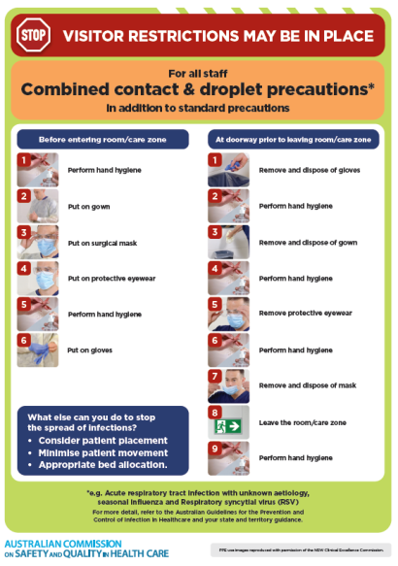](https://www.safetyandquality.gov.au/publications-and-resources/resource-library/infection-prevention-and-control-poster-combined-contact-and-droplet-precautions)
* ***Poster – Combined airborne and contact precautions*** <https://www.safetyandquality.gov.au/publications-and-resources/resource-library/poster-combined-airborne-and-contact-precautions>   
  [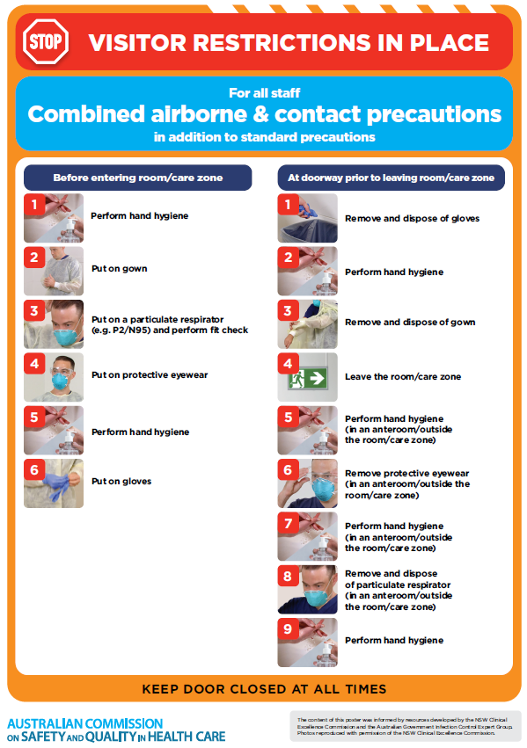](https://www.safetyandquality.gov.au/publications-and-resources/resource-library/poster-combined-airborne-and-contact-precautions)
* ***Environmental Cleaning and Infection Prevention and Control*** [www.safetyandquality.gov.au/environmental-cleaning](http://www.safetyandquality.gov.au/environmental-cleaning)
* ***COVID-19 infection prevention and control risk management – Guidance*** <https://www.safetyandquality.gov.au/publications-and-resources/resource-library/covid-19-infection-prevention-and-control-risk-management-guidance>
* ***Safe care for people with cognitive impairment during COVID-19***<https://www.safetyandquality.gov.au/our-work/cognitive-impairment/cognitive-impairment-and-covid-19>
* ***Stop COVID-19: Break the chain of infection*** posterhttps://www.safetyandquality.gov.au/publications-and-resources/resource-library/break-chain-infection-poster-a3  
  **[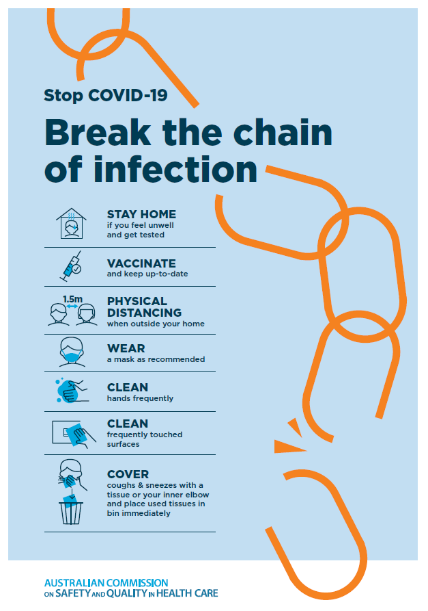](https://www.safetyandquality.gov.au/publications-and-resources/resource-library/break-chain-poster-a3https:/www.safetyandquality.gov.au/publications-and-resources/resource-library/break-chain-poster-a3)**
* ***FAQs for clinicians on elective surgery*** <https://www.safetyandquality.gov.au/node/5724>
* ***FAQs for consumers on elective surgery*** <https://www.safetyandquality.gov.au/node/5725>
* ***COVID-19 and face masks – Information for consumers*** <https://www.safetyandquality.gov.au/publications-and-resources/resource-library/covid-19-and-face-masks-information-consumers>

[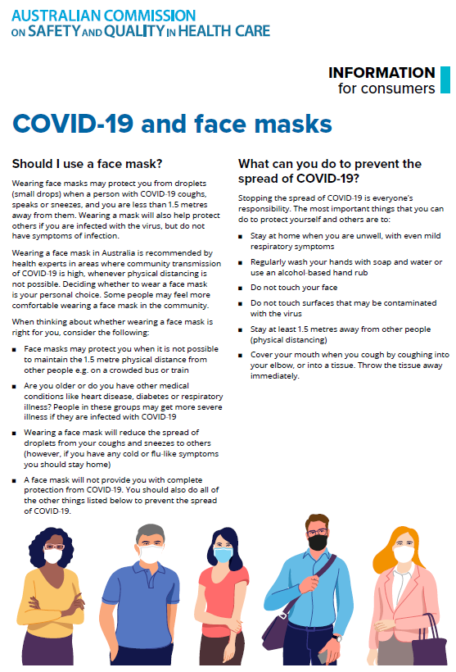](https://www.safetyandquality.gov.au/sites/default/files/2020-07/covid-19_and_face_masks_-_information_for_consumers.pdf)

*National COVID-19 Clinical Evidence Taskforce*

<https://covid19evidence.net.au/>

The National COVID-19 Clinical Evidence Taskforce is a collaboration of peak health professional bodies across Australia whose members are providing clinical care to people with COVID-19. The taskforce is undertaking continuous evidence surveillance to identify and rapidly synthesise emerging research in order to provide national, **evidence-based guidelines and clinical flowcharts for the clinical care of people with COVID-19**. The guidelines address questions that are specific to managing COVID-19 and cover the full disease course across mild, moderate, severe and critical illness. These are ‘living’ guidelines, updated with new research in near real-time in order to give reliable, up-to-the minute advice to clinicians providing frontline care in this unprecedented global health crisis.

*COVID-19 Critical Intelligence Unit*

<https://www.aci.health.nsw.gov.au/covid-19/critical-intelligence-unit>

The Agency for Clinical Innovation (ACI) in New South Wales has developed this page summarising rapid, evidence-based advice during the COVID-19 pandemic. Its operations focus on systems intelligence, clinical intelligence and evidence integration. The content includes a daily evidence digest, a COVID status monitor, a risk monitoring dashboard and evidence checks on a discrete topic or question relating to the current COVID-19 pandemic. There is also a ‘Living evidence’ section summarising key studies and emerging evidence on **COVID-19 vaccines** and **SARS-CoV-2 variants**. The most recent updates include:

* ***Bivalent COVID-19 vaccines*** – What is the available regulatory and research evidence for bivalent COVID-19 vaccines?
* ***Surgery post COVID-19*** – What is the evidence for the timing of surgery, and outcomes following surgery, for people who have recovered from COVID-19?
* ***Paxlovid*** – What is the evidence for Paxlovid for treatment of COVID-19?
* ***Molnupiravir*** –What is the evidence for and regulatory context of molnupiravir for treatment of COVID-19?
* ***Eating disorders and COVID-19*** – What is the impact of the COVID-19 pandemic on the prevalence of eating disorders?
* ***Long COVID –*** What is the evidence on the prevalence, presentation and management of long-COVID?
* ***Oseltamivir (Tamiflu) use in healthcare settings*** – What is the evidence that use of oseltamivir in healthcare workers with a symptomatic influenza diagnosis result in an earlier return to work and reduced absenteeism? What is the evidence that use of oseltamivir in adults and children with symptomatic influenza reduces influenza transmission in health care settings?
* ***Alternative models of care for acute medical conditions*** – What is the evidence on alternative models of care for managing patients with acute medical conditions outside of emergency or inpatient hospital settings?
* ***Exercise and long COVID*** – Is exercise helpful in individuals with long COVID? Is post-exertional symptom exacerbation a risk in long COVID?
* ***Influenza and seasonal prophylaxis with oseltamivir*** – What is the place or evidence for seasonal influenza prophylaxis (such as taking oseltamivir for 10 to 12 weeks continuously) in healthcare and aged care settings?
* ***Rapid access models of care for respiratory illnesses*** – What is the evidence for rapid access models of care for respiratory illnesses, especially during winter seasons, in emergency departments?
* ***Current and emerging patient safety issues during COVID-19*** – What is the evidence on the current and emerging patient safety issues arising from the COVID-19 pandemic?
* ***Post-acute sequelae of COVID-19*** – What is the evidence on the post-acute sequelae of COVID-19?
* ***Emerging variants*** – What is the available evidence for emerging variants?
* ***Chest pain or dyspnoea following COVID-19 vaccination*** – What is evidence for chest pain or dyspnoea following COVID-19 vaccination?
* ***Cardiac investigations and elective surgery post-COVID-19*** – What is evidence for cardiac investigations and elective surgery post-COVID-19?
* ***Breathlessness post COVID-19*** – How to determine those patients who present with ongoing breathlessness in need of urgent review or intervention due to suspected pulmonary embolus?
* ***COVID-19 pandemic and influenza*** – What is the evidence for COVID-19 pandemic and influenza?
* ***Budesonide and aspirin for pregnant women with COVID-19 –*** What is the evidence for the use of Budesonide for pregnant women with COVID-19? What is the evidence for aspirin prophylaxis for pre-eclampsia in pregnant women with a COVID-19 infection?
* ***COVID-19 vaccines in Australia*** – What is the evidence on COVID-19 vaccines in Australia?
* ***COVID-19 pandemic and wellbeing of critical care and other healthcare workers*** – Evidence in brief on the impact of the COVID-19 pandemic on the wellbeing of critical care and other healthcare workers.
* ***Disease modifying treatments for COVID-19 in children*** – What is the evidence for disease modifying treatments for COVID-19 in children?
* ***Mask type for COVID-19 positive wearer*** – What is the evidence for different mask types for COVID-19 positive wearers?
* ***Post acute and subacute COVID-19 care*** – What published advice and models of care are available regarding post-acute and subacute care for COVID-19 patients?
* ***Hospital visitor policies*** – What is the evidence for hospital visitor policies during and outside of the COVID-19 pandemic?
* ***Surgical masks, eye protection and PPE guidance*** –What is the evidence for surgical masks in the endemic phase in hospitals and for eyewear to protect against COVID-19?

**Disclaimer**

On the Radar is an information resource of the Australian Commission on Safety and Quality in Health Care. The Commission is not responsible for the content of, nor does it endorse, any articles or sites listed. The Commission accepts no liability for the information or advice provided by these external links. Links are provided on the basis that users make their own decisions about the accuracy, currency and reliability of the information contained therein. Any opinions expressed are not necessarily those of the Australian Commission on Safety and Quality in Health Care.