# Australian Commission on Safety and Quality logotypeOn the Radar

Issue 587

23 January 2023

*On the Radar* is a summary of some of the recent publications in the areas of safety and quality in health care. Inclusion in this document is not an endorsement or recommendation of any publication or provider. Access to particular documents may depend on whether they are Open Access or not, and/or your individual or institutional access to subscription sites/services. Material that may require subscription is included as it is considered relevant.

*On the Radar* is available online, via email or as a PDF or Word document from <https://www.safetyandquality.gov.au/publications-and-resources/newsletters/radar>

If you would like to receive *On the Radar* via email, you can subscribe on our website <https://www.safetyandquality.gov.au/publications-and-resources/newsletters>  
or by emailing us at H[Umail@safetyandquality.gov.auU](mailto:mail@safetyandquality.gov.au).   
You can also send feedback and comments to H[Umail@safetyandquality.gov.auU](mailto:mail@safetyandquality.gov.au).

For information about the Commission and its programs and publications, please visit <https://www.safetyandquality.gov.au>

You can also follow us on Twitter @ACSQHC.

**On the Radar**

Editor: Dr Niall Johnson [niall.johnson@safetyandquality.gov.au](mailto:niall.johnson@safetyandquality.gov.au)

Contributors: Niall Johnson, Casey Silman, Alice Bhasale, Bernadette Aliprandi-Costa, Anne Kubiak

***Optimising ventilation for infection prevention and control in healthcare settings***

<https://www.safetyandquality.gov.au/publications-and-resources/resource-library/optimising-ventilation-infection-prevention-and-control-healthcare-settings>

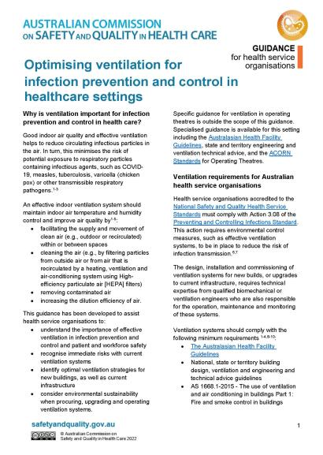This guidance has been developed for health service organisations to explain the importance of effective ventilation systems for preventing and controlling infections and how ventilation risks can be mitigated to improve patient and workforce safety.

***New quality improvement tools for sepsis***

<https://www.safetyandquality.gov.au/standards/clinical-care-standards/sepsis-clinical-care-standard/implementation-resources>

The Australian Commission on Safety and Quality in Health Care has released two new quality improvement tools to help healthcare services implement the *Sepsis Clinical Care Standard* that was launched last year.

* The ***Sepsis Clinical Care Standard Self-Assessment Tool*** allows services to assess their progress in implementing key elements of the standard. This tool also enables services to develop and monitor quality improvement plans.
* The ***Sepsis Clinical Care Standard Indicator Monitoring Tool*** is a data repository, analysis and reporting tool for the standard indicators. Services can use the tool to collect and audit individual patient data, examine results, and identify improvement targets. It is accompanied by a quick reference guide.

These tools and a range of other implementation resources for clinicians and healthcare services are available on the Commission’s website at <https://www.safetyandquality.gov.au/standards/clinical-care-standards/sepsis-clinical-care-standard/implementation-resources>

The *Sepsis Clinical Care Standard* aims to ensure that sepsis is recognised early and that all patients receive coordinated high-quality care. The clinical care standard is available at <https://www.safetyandquality.gov.au/standards/clinical-care-standards/sepsis-clinical-care-standard>

For more information, email the Clinical Care Standards team at [ccs@safetyandquality.gov.au](mailto:ccs@safetyandquality.gov.au)



***Consultation on Framework for Australian clinical quality registries Second Edition***

<https://www.safetyandquality.gov.au/our-work/health-and-human-research/national-arrangements-clinical-quality-registries>

Clinical quality registries support the delivery of better value care and improve patient outcomes. Recognising the need for strengthened guidance on registry operations, the Commission has developed a second edition of the *Framework for Australian clinical quality registries*.

The updated Framework provides national best practice principles and detailed guidance for establishing and operating Australian national clinical quality registries. These include guidance on governance, infrastructure, security and privacy compliance, technical standards, reporting and more.

Greater clarity around local governance arrangements will help clinical registries increase efficiency, strengthen partnerships and collaboration, deliver better patient outcomes, and reduce healthcare variation.

Visit the website <https://www.safetyandquality.gov.au/our-work/health-and-human-research/national-arrangements-clinical-quality-registries> to review the draft Framework Second Edition and tell us what you think by:

* Responding to a short online survey
* Providing a written submission.

***Closing soon: Public Consultation on Sustainable Healthcare Module***

<https://www.safetyandquality.gov.au/standards/nsqhs-standards/sustainable-healthcare-module>

The Sustainable Healthcare Module (the Module) has been developed for public consultation by the Australian Commission on Safety and Quality in Health Care in collaboration with health service organisations, professional bodies, Primary Health Networks, consumers and other sector representatives. The Module acknowledges the importance of delivering environmentally sustainable, adaptable, and resilient healthcare services. It aims to protect the public from harm and improve the quality of care delivered to consumers.

Public consultation on the Draft Sustainable Healthcare Module is now open and is **closing soon. Please share your insights on the Module before 31 January and help shape the future of Sustainability in Healthcare.**

You can access the Module for consultation on our website at <https://www.safetyandquality.gov.au/standards/nsqhs-standards/sustainable-healthcare-module> and provide feedback by:

* Responding to a short online survey
* Providing a written submission via email to [NSQHSStandards@safetyandquality.gov.au](mailto:NSQHSStandards@safetyandquality.gov.au)

Consultation will close on **31 January 2023**.

To stay updated on the progress of the Sustainable Healthcare Module, subscribe here <https://www.safetyandquality.gov.au/about-us/latest-news/newsletters>.

**Journal articles**

*BMJ Quality & Safety*

January 2023 Volume 32 Issue 1

|  |  |
| --- | --- |
| URL | <https://qualitysafety.bmj.com/content/32/1> |
| Notes | A new issue of *BMJ Quality & Safety* has been published. Many of the papers in this issue have been referred to in previous editions of *On the Radar* (when they were released online). Articles in this issue of *BMJ Quality & Safety* include:   * Editorial: **Peer review of quality of care**: methods and metrics (Julian Bion, Joseph Edward Alderman) * Editorial: Beyond mixed case lettering: **reducing the risk of wrong drug errors requires a multimodal response** (Bruce L Lambert, Scott Ryan Schroeder, Michael R Cohen, Susan Paparella) * Editorial: ‘You can’t do quality between surgical cases and tea time’: barriers to **surgeon engagement in quality improvement** (Jesse Isaac Wolfstadt, Anna Cohen-Rosenblum) * Editorial: *Grand Rounds in Methodology*: a new series to contribute to **continuous improvement of methodology and scientific rigour in quality and safety** (Perla J Marang-van de Mheen, John P Browne, Eric J Thomas, Bryony Dean Franklin) * Effect of clinical peer review on **mortality in patients ventilated for more than 24 hours**: a cluster randomised controlled trial (Jochen Schmitt, Martin Roessler, Peter Scriba, Felix Walther, Xina Grählert, Maria Eberlein-Gonska, Ralf Kuhlen, Olaf Schoffer) * Effects of tall man lettering on the visual behaviour of critical care nurses while **identifying syringe drug labels**: a randomised in situ simulation (Quentin Lohmeyer, Cornel Schiess, Pedro David Wendel Garcia, Heidi Petry, Eric Strauch, Andreas Dietsche, Reto A. Schuepbach, Philipp K. Buehler, Daniel A. Hofmaenner) * Effectiveness of a multifaceted quality improvement intervention to improve **patient outcomes after total hip and knee arthroplasty**: a registry nested cluster randomised controlled trial (Peter van Schie, Leti van Bodegom-Vos, Tristan M Zijdeman, Rob G H H Nelissen, Perla J Marang-van de Mheen) * Grand rounds in methodology: four critical decision points in **statistical process control evaluations of quality improvement initiatives** (Perla J Marang-van de Mheen, Thomas Woodcock) |

*Journal for Healthcare Quality*

Volume 45, Number 1, January/February 2023

|  |  |
| --- | --- |
| URL | <https://journals.lww.com/jhqonline/toc/2023/02000> |
| Notes | A new issue of the *Journal for Healthcare Quality* has been published. Articles in this issue of the *Journal for Healthcare Quality* include:   * Implementation of a **Nurse-Driven Medication Ordering Protocol** to Improve Clinician and Nursing Experiences (Claire C Ford, James B Clements, Jacob T Luty, Jackie K Sharpe, Brittney N Caldera, Alan J Hunter) * A **Structured Rounding Proforma** in the Hyper Acute Stroke Unit (HASU): A Quality Improvement Project (Alistair Ludley, Anna Bahk, A Al-Shihabi) * Increasing **Language Interpreter Services Use and Documentation**: A Quality Improvement Project (Mohga Behairy, Amala Alenchery, Claudia Cuesta-Ferrino, Hemangini Bhakta, Arnaldo Zayas-Santiago) * **Group Medical Visits Versus Usual Care for Illness Perception and Hypertension**: A Randomized Pilot Study (Orhan Acehan, Nafiz Bozdemir, Sevgi Özcan, Olgun Duran, Hatice Kurdak) * **Pay-for-Performance in the Massachusetts Medicaid Delivery System** Transformation Initiative (Laura Sefton, Laxmi Tierney) * Efficacy of the **Crisis Risk Triage Scale in Inpatient Units** Within the United States (Kathie S Zimbro, Ralitsa S Maduro, Patricia Ver Schneider, Donna S Hahn, James F Paulson, Merri K Morgan) |

*International Journal for Quality in Health Care*

Volume 34, Issue 4, 2022

|  |  |
| --- | --- |
| URL | <https://academic.oup.com/intqhc/issue/34/4> |
| Notes | A new issue of the *International Journal for Quality in Health Care* has been published. Articles in this issue of the *International Journal for Quality in Health Care* include:   * A quality assurance initiative on improving **cefazolin perioperative redose compliance** (Faiza Qureshi; J L Romeiser; P F Murphy; R A Go; R Abola) * **COVID-19 lockdown impact on quality of treatment and outcomes of STEMI and stroke patients** in a large tertiary medical center: an observational study (Alex Galper; Racheli Magnezi; Anat Ekka Zohar; Bernice Oberman ; Eyal Zimlichman) * Measuring **shared decision-making** in younger and older adults with depression (Suzanne Brodney; K D Valentine; H A Vo ; Carol Cosenza; Michael J Barry, Karen R Sepucha) * **Cost of postoperative complications after general surgery** at a major Canadian academic centre (Eileen Roach; Luis de la Maza; Scott Rieder; Laavanyah Vigneswaran; Azusa Maeda, Allan Okrainec, Timothy D Jackson) * A regional approach to reduce **postoperative opioid prescribing** in Ontario, Canada (Timothy D Jackson; Azusa Maeda; Tricia Beath; Nancy Ahmad; Pierrette Price-arsenault, Hui Jia, Jonathan Lam, David Schramm) * A Delphi consensus study to identify priorities for improving and measuring **medication safety for intensive care patients on transfer** to a hospital ward (Richard S Bourne ; Jennifer K Jennings; Darren M Ashcroft) * **Abdominal surgical trajectories associated with failure to rescue**. A nationwide analysis (Katrine Skyrud ; Jon Helgeland; Anne Karin Lindahl; Knut Magne Augestad) * Outcomes among patients admitted for **non-ST-segment myocardial infarction in the pre-pandemic and pandemic COVID-19 era**: Israel Nationwide study (Elad Asher; Alexander Fardman; Hezzy Shmueli; Katia Orvin ; Daniel Oren , Natalia Kofman, Jameel Mohsen, Gassan Moady, Louay Taha, Ronen Rubinshtein, Osherov Azriel, Roi Efraim, D Saleem, P Taieb, E Ben-assa, T Cohen, R Klempfner, A Orlev, R Beigel, A Segev, S Matetzky) * Development and validation of questionnaire assessing the **perception of hospital patient safety practices** in public health facilities of India (Yuvaraj Krishnamoorthy; G Samuel; V Elangovan; K Kanth; M Krishnan, I Sinha) * Dedicated teams to optimize **quality and safety of surgery**: A systematic review (C M Lentz ; R A F De Lind Van Wijngaarden; F Willeboordse; L Hooft; M J van der Laan) * Effects of an educational intervention for **rational cardiac enzyme requisitions in critically ill patients**: a pre–post intervention study (Natália sarracceni Tedesco; F A Gurgel Pinheiro ; J m Vieira Júnior; L U Taniguchi) * Accelerating improvement: **The Pediatric Acute Care Cardiology Collaborative data timeliness project** (Margaret Graupe; Ashlin Tignor ; Kelly Veneziale; Megan Jensen; Lara Khadr, Heather Beckstrom, Martin Gister, Karen Hendricks, N L Madsen, F Roberts, S Youngberg, S Schachtner on behalf of the Pediatric Acute Care Cardiology Collaborative (PAC3)) * A qualitative study exploring challenges and solutions to negotiating **goals of care at the end of life in hospital** settings (Kim Devery; Megan Winsall; Deb Rawlings) * The **cost of dispensing errors** in Iranian health system: a retrospective evaluation (Nazila Yousefi; Farideh Asadi; Zahra Sharif; Akram Khani; Dana Baymaninezhad, Jamshid Salamzade, Farzad Peiravian) * Application of **DRGs in hospital medical record management** and its impact on service quality (Qin Zhang; Xiaodong Li) * The impact of **outsourcing bed-based aged care services** on quality of care: A multisite observational study (Anne Horne-Thompson; Hanan Khalil; Katherine Harding; Richard Kane ; Nicholas F Taylor) * Predicting **non-response in patient-reported outcome measures**: results from the Swiss quality assurance programme in cardiac inpatient rehabilitation (Stefanie KÖhn; Anna Schlumbohm; Manuela Marquardt; Anke Scheel-Sailer; Stephan Tobler, Jan Vontobel, Luise Menzi) * Impact of the **physical therapy–managed spinal orthoses program** on cost of care in the hospital setting: a retrospective interrupted time-series study (Sue Willey; James Lenk; Linda Waters ; Charles Joseph French III; Jonathan Mathew Cayce) * Uncomfortable yet necessary: The **impact of PPE on communication in emergency medicine** (Jennifer Aengst; Grace Walker-Stevenson ; Tabria Harrod; Jonathan Ivankovic; Jacob Neilson, Jeanne-Marie Guise) * **Triage nurse–initiated X-ray radiography** in minor trauma (Julie Gautier ; Matthieu Verdan; Emmanuelle Rochette; Céline Lambert; N Caron, E Merlin) * Editorial: The future of **AI in health-care quality**: defining the challenges and opportunities moving forward (Phillip H Phan; Cybele Lara Abad) * Editorial: An invitation for contributions to a themed issue on **artificial intelligence and safety and quality in health care** (Phillip Phan ; C lAbad) * Editorial: **Impact of COVID-19 lockdowns on health disparities**: Lessons from Israel on preventive health utilization (Richard G Greenhill; P Gupta) * I got your back! Social support against workplace violence for health professionals (Dalmacito A Cordero Jr) * **Artificial intelligence (AI) and human virtues**: Towards a moral and quality health care system (Dalmacito A Cordero Jr.) |

*Pediatric Quality & Safety*

Volume 7, Number 6, November/December 2022

|  |
| --- |
| <https://journals.lww.com/pqs/toc/2022/11000> |
| A new issue of *Pediatric Quality & Safety* has been published. Articles in this issue of *Pediatric Quality & Safety* include:   * Improving research personnel’s **hand hygiene adherence in the pediatric acute care setting** during the COVID-19 pandemic: a quality improvement initiative (Ashini Dissanayake, Abigale MacLellan, Quynh Doan, Vikram Sabhaney, Punit Virk) * Reduction of **Central-line–Associated Bloodstream Infections** in a Tertiary Neonatal Intensive Care Unit through Simulation Education (Hannah B Hightower, John Andrew Young, Jennifer Thomas, Jill Jones Smith, D Hobby-Noland, G Palombo, M McCaskey, B Benton, C Hutto, C Coghill, B McCullough, L Hayes, C Martin, J H Chewning) * Boston Febrile Infant Algorithm 2.0: Improving Care of the **Febrile Infant 1–2 Months of Age** (Kate Dorney, Mark I Neuman, Marvin B Harper, Richard G Bachur) * Optimizing **Resident Education during Family-centered Rounds**: An Educational Improvement Initiative (Sarah J Calardo, Lesya Tomlinson, D Bhatia, A Weis, C Port) * Quality Improvement Targeting Non-pharmacologic Care and As-needed Morphine Improves Outcomes in **Neonatal Abstinence Syndrome** (Thomas J McMorrow, Kristen Byrnes, Megan Gates, Tai Hairston, Aysha Jawed, Megan Keydash, Sonya Ulrike Steele, Dörte Thorndike, Liselotte van Londen, Benjamin E Bodnar) * Improving **Documentation of Postdischarge Issue Mitigation** during Postdischarge Phone Calls (Sarah Vepraskas, Snezana Nena Osorio, Sarah C Bauer, A Stephany, S Gage) * **Endotracheal Tube Cuff Pressures** in the Operating Room of a Pediatric Hospital: A Quality Improvement Initiative (Kelly M Moon, Sherry Donaworth, Molly S Hagele, Stephani S Kim, Brittany L Willer, Joseph D Tobias) * **Feeding Pathway for Children on High Flow Nasal Cannula** Decreases Time to Enteral Nutrition (Sara H Soshnick, Gabriella S Mark, Jacqueline Weingarten-Arams, Ying Chuu, Swati Chandhoke, Shivanand S Medar, Kaitlyn Philips, Gina N. Cassel-Choudhury) * HeartWatch: Implementing a Pediatric Heart Center Program to Prevent **Cardiac Arrests Outside the ICU** (Alexandra Birely, Sravani Avula, Ryan J Butts, Joshua S Wolovits, Matthew S Lemler, Olivia L Hoffman) * A Quality Improvement Initiative to Improve **After-visit Summary Distribution** in Orthopedic Outpatient Clinics (Jayme Williamson, Jessica Holstine, Julie Balch Samora) * Variability in **Serious Safety Event Classification among Children’s Hospitals**: A Measure for Comparison? (Amy Poppy, Sonja I Ziniel, Daniel Hyman) |

*Health Affairs*

Volume 41, Number 12, December 2022

|  |  |
| --- | --- |
| URL | <https://www.healthaffairs.org/toc/hlthaff/41/12> |
| Notes | A new issue of *Health Affairs* has been published with the theme “**Equitable Social Supports & More**”. Articles in this issue of *Health Affairs* include:   * Networks Of Support **Help Patients Navigate Complex Systems** (Harris Meyer) * Economic Well-Being And Health: The Role Of **Income Support Programs In Promoting Health** And Advancing Health Equity (Daniel M Finkelstein, Jessica F Harding, Diane Paulsell, B English, G R Hijjawi, and J Ng’andu) * How **Low-Paid Parents Navigate The Complex Financial Landscape** Of Benefits Cliffs And Disincentive Deserts (Kess Ballentine, Sara Goodkind, and Jeffrey Shook) * Understanding **Take-Up Of The Earned Income Tax Credit** Among Californians With Low Income (Rita Hamad, Wendi Gosliner, Erika M Brown, Mekhala Hoskote, Kaitlyn Jackson, E M Esparza, and L C H Fernald) * **Earned Income Tax Credit Receipt** By Hispanic Families With Children: State Outreach And Demographic Factors (Dana Thomson, Yiyu Chen, Lisa A Gennetian, and Luis E Basurto) * Temporary **Assistance For Needy Families**: Sanctioning And Child Support Compliance Among Black Families In Illinois (Kathryn Kaplan, Suniya Farooqui, Jamela Clark, Emily Dobson, Rita Jefferson, Niya Kelly, Katherine Buitrago, Kimberly Drew, Aces Lira, Maxica Williams, T Neuman, and Y Kim) * Associations Between **State TANF Policies, Child Protective Services Involvement, And Foster Care** Placement (Donna K Ginther and Michelle Johnson-Motoyama) * **Expanded Contraceptive Access** Linked To Increase In College Completion Among Women In Colorado (Sara Yeatman, James M Flynn, Amanda Stevenson, Katie Genadek, Stefanie Mollborn, and Jane Menken) * Building Community Power To Dismantle Policy-Based **Structural Inequity In Population Health** (Anthony Iton, Robert K Ross, and Pritpal S Tamber) * Trends In **Treat-And-Release Emergency Care Visits With High-Intensity Billing** In The US, 2006–19 (Alexander T Janke, Cameron Gettel, Ryan Koski-Vacirca, Michelle P Lin, Keith E Kocher, and Arjun K Venkatesh) * Variation And Changes In The Targeting Of **Medicaid Disproportionate Share Hospital Payments** (Paula Chatterjee, Soham Sinha, Olivia Reszczynski, Anita Amin, and William L Schpero) * Characteristics Of **Medical Device Shortages In The US**, 2006–20 (Trinidad Beleche, Maria Kuecken, Aliya Sassi, K Toran, E Galloway, and T Henry) * The Longitudinal Impact Of A Multistate **Commercial Accountable Care Program** On Cost, Use, And Quality (Charmaine Girdish, Alina Rossini, Bryce S Sutton, Alexis K Parente, and Benjamin L Howell) * Use Of **Area-Based Socioeconomic Deprivation Indices**: A Scoping Review And Qualitative Analysis (Stephen Trinidad, Cole Brokamp, Andres Mor Huertas, A F Beck, C L Riley, E Rasnick, R Falcone, and M Kotagal) * The Health Plan Environment In California Contributed To Differential Use Of **Telehealth During The COVID-19 Pandemic** (Christopher M Whaley, Yuki Ito, Jonathan T Kolstad, David W Cowling, and Benjamin Handel) * Germany’s Use Of **Reference Pricing For Biologics**: Lessons For The US (James C Robinson) * Understanding **Pandemic Experiences Among America’s Elders** (Louise Aronson and Ashwin Kotwal) |

*Health Affairs*

Volume 42, Number 1, January 2023

|  |  |
| --- | --- |
| URL | <https://www.healthaffairs.org/toc/hlthaff/42/1> |
| Notes | A new issue of *Health Affairs* has been published with the themes “**Medicaid Expansion, Behavioral Health & More**”. Articles in this issue of *Health Affairs* include:   * **National Health Care Spending In 2021**: Decline In Federal Spending Outweighs Greater Use Of Health Care (Anne B Martin, Micah Hartman, J Benson, A Catlin, and The National Health Expenditure Accounts Team) * Medicaid Expansion Led To Reductions In **Postpartum Hospitalizations** (Maria W Steenland and Laura R Wherry) * **Racial And Ethnic Disparities In Preventable Hospitalizations And ED Visits** Five Years After ACA Medicaid Expansions (Asako S Moriya and Sujoy Chakravarty_) * Assessing **Hospital Quality Scores** By Proportion Of Patients Dually Eligible For Medicare And Medicaid (Steven B Spivack, Li Qin, Jeph Herrin, Demetri B Goutos, Michelle Schreiber, L A Fleisher, A B Venkatesh, and S Bernheim) * **Food Insecurity** Was Associated With Greater Family Health Care Expenditures In The US, 2016–17 (Deepak Palakshappa, Arvin Garg, Alon Peltz, Charlene A Wong, Rushina Cholera, and Seth A Berkowitz) * Parental Immigration Status, Medicaid Expansion, And **Supplemental Nutrition Assistance Program Participation** (Kevin H Nguyen, Nicole C Giron, and Amal N Trivedi) * Differences In **Debt Among Postgraduate Medical Residents** By Self-Designated Race And Ethnicity, 2014–19 (Louisa W Holaday, Jasmine M Weiss, Sire D Sow, Hector R Perez, Joseph S Ross, and Inginia Genao) * Effects Of The 2021 **Expanded Child Tax Credit On Adults’ Mental Health**: A Quasi-Experimental Study (A Batra, K Jackson, and R Hamad) * Coverage Parity And Racial And Ethnic **Disparities In Mental Health And Substance Use Care** Among Medicare Beneficiaries (Vicki Fung, Mary Price, Alex McDowell, Andrew A Nierenberg, J Hsu, J P Newhouse, and B Lê Cook) * **Financing And Funding Gap For 16 Vaccines** Across 94 Low- And Middle-Income Countries, 2011–30 (Salin Sriudomporn, So Yoon Sim, Joshua Mak, Logan Brenzel, and Bryan N Patenaude) * Risk Adjustment And Promoting Health Equity In **Population-Based Payment: Concepts** And Evidence (J Michael McWilliams, Gabe Weinreb, Lin Ding, Chima D Ndumele, and Jacob Wallace) * **Excess Deaths** Of Medicaid Home And Community-Based Services Recipients **During COVID-19** (H Stephen Kaye and Joseph Caldwell) * **Workforce Composition** In Private Equity–Acquired Versus Non–Private Equity–Acquired **Physician Practices** (Joseph Dov Bruch, Canyon Foot, Yashaswini Singh, Zirui Song, Daniel Polsky, and Jane M Zhu) * A Randomized Trial Of Letters To Encourage **Prescription Monitoring Program Use And Safe Opioid Prescribing** (Adam Sacarny, Tatyana Avilova, David Powell, Ian Williamson, Weston Merrick, and M Jacobson) |

*BMJ Quality & Safety* online first articles

|  |  |
| --- | --- |
| URL | <https://qualitysafety.bmj.com/content/early/recent> |
| Notes | *BMJ Quality &Safety* has published a number of ‘online first’ articles, including:   * Reducing **unnecessary diagnostic phlebotomy in intensive care**: a prospective quality improvement intervention (Thomas Bodley, Olga Levi, Maverick Chan, Jan O Friedrich, Lisa K Hicks) * Illness severity characteristics and outcomes of **patients remaining on an acute ward following medical emergency team review**: a latent profile analysis (Anthony Batterbury, Clint Douglas, Lee Jones, Fiona Coyer) |

**Online resources**

***[UK] NICE Guidelines and Quality Standards***

<https://www.nice.org.uk/guidance>

The UK’s National Institute for Health and Care Excellence (NICE) has published new (or updated) guidelines and quality standards. The latest reviews or updates include:

* NICE Guideline NG213 ***Disabled children and young people up to 25 with severe complex needs****: integrated service delivery and organisation across health, social care and education* <https://www.nice.org.uk/guidance/ng213>
* NICE Guideline NG209 ***Tobacco****: preventing uptake, promoting quitting and treating dependence* <https://www.nice.org.uk/guidance/ng209>
* NICE Guideline NG19 ***Diabetic foot problems****: prevention and management* <https://www.nice.org.uk/guidance/ng19>
* Clinical Guideline CG103 ***Delirium****: prevention, diagnosis and management in hospital and long-term care* <https://www.nice.org.uk/guidance/cg103>

**COVID-19 resources**

https://www.safetyandquality.gov.au/covid-19

The Australian Commission on Safety and Quality in Health Care has developed a number of resources to assist healthcare organisations, facilities and clinicians. These and other material on COVID-19 are available at <https://www.safetyandquality.gov.au/covid-19>

These resources include:

* ***OVID-19 infection prevention and control risk management*** This primer provides an overview of three widely used tools for investigating and responding to patient safety events and near misses. Tools covered in this primer include incident reporting systems, Root Cause Analysis (RCA), and Failure Modes and Effects Analysis (FMEA).   
  <https://www.safetyandquality.gov.au/publications-and-resources/resource-library/covid-19-infection-prevention-and-control-risk-management-guidance>
* ***Poster – Combined contact and droplet precautions*** <https://www.safetyandquality.gov.au/publications-and-resources/resource-library/infection-prevention-and-control-poster-combined-contact-and-droplet-precautions>  
  [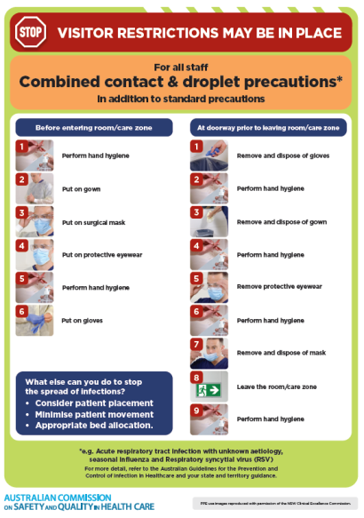](https://www.safetyandquality.gov.au/publications-and-resources/resource-library/infection-prevention-and-control-poster-combined-contact-and-droplet-precautions)
* ***Poster – Combined airborne and contact precautions*** <https://www.safetyandquality.gov.au/publications-and-resources/resource-library/poster-combined-airborne-and-contact-precautions>   
  [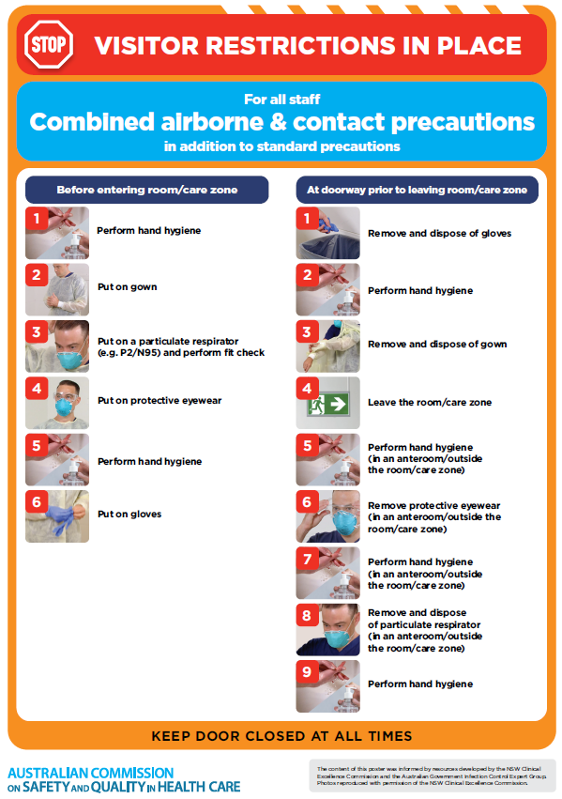](https://www.safetyandquality.gov.au/publications-and-resources/resource-library/poster-combined-airborne-and-contact-precautions)
* ***Environmental Cleaning and Infection Prevention and Control*** [www.safetyandquality.gov.au/environmental-cleaning](http://www.safetyandquality.gov.au/environmental-cleaning)
* ***COVID-19 infection prevention and control risk management – Guidance*** <https://www.safetyandquality.gov.au/publications-and-resources/resource-library/covid-19-infection-prevention-and-control-risk-management-guidance>
* ***Safe care for people with cognitive impairment during COVID-19***<https://www.safetyandquality.gov.au/our-work/cognitive-impairment/cognitive-impairment-and-covid-19>
* ***Stop COVID-19: Break the chain of infection*** posterhttps://www.safetyandquality.gov.au/publications-and-resources/resource-library/break-chain-infection-poster-a3  
  **[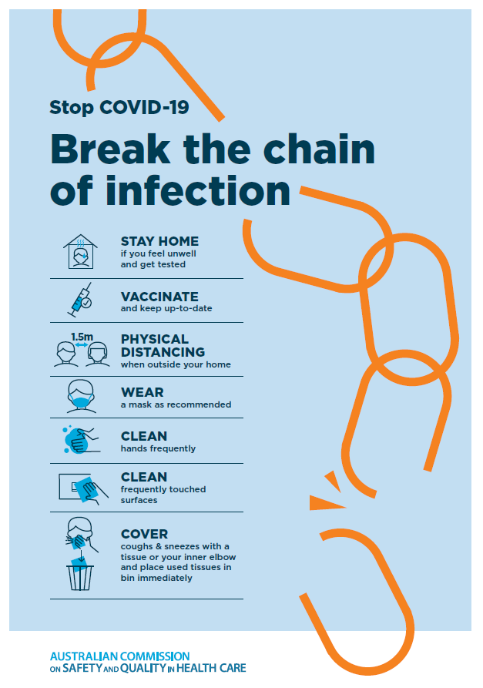](https://www.safetyandquality.gov.au/publications-and-resources/resource-library/break-chain-poster-a3https:/www.safetyandquality.gov.au/publications-and-resources/resource-library/break-chain-poster-a3)**
* ***COVID-19 and face masks – Information for consumers*** <https://www.safetyandquality.gov.au/publications-and-resources/resource-library/covid-19-and-face-masks-information-consumers>

[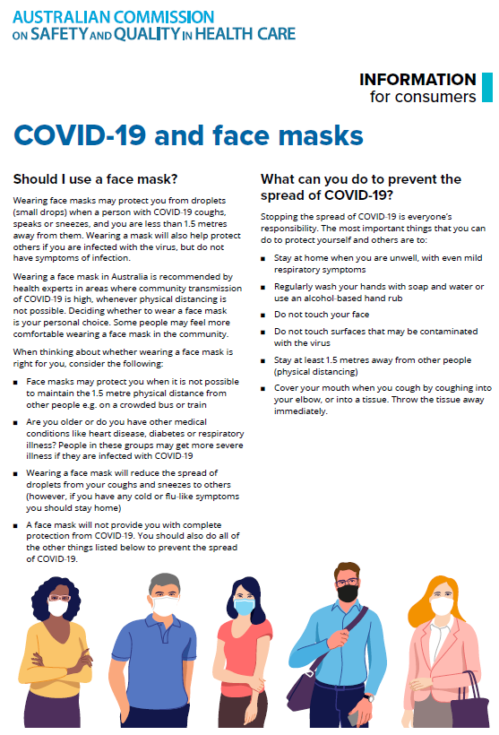](https://www.safetyandquality.gov.au/sites/default/files/2020-07/covid-19_and_face_masks_-_information_for_consumers.pdf)

*National COVID-19 Clinical Evidence Taskforce*

<https://covid19evidence.net.au/>

The National COVID-19 Clinical Evidence Taskforce is a collaboration of peak health professional bodies across Australia whose members are providing clinical care to people with COVID-19. The taskforce is undertaking continuous evidence surveillance to identify and rapidly synthesise emerging research in order to provide national, **evidence-based guidelines and clinical flowcharts for the clinical care of people with COVID-19**. The guidelines address questions that are specific to managing COVID-19 and cover the full disease course across mild, moderate, severe and critical illness. These are ‘living’ guidelines, updated with new research in near real-time in order to give reliable, up-to-the minute advice to clinicians providing frontline care in this unprecedented global health crisis.

*COVID-19 Critical Intelligence Unit*

<https://www.aci.health.nsw.gov.au/covid-19/critical-intelligence-unit>

The Agency for Clinical Innovation (ACI) in New South Wales has developed this page summarising rapid, evidence-based advice during the COVID-19 pandemic. Its operations focus on systems intelligence, clinical intelligence and evidence integration. The content includes a daily evidence digest, a COVID status monitor, a risk monitoring dashboard and evidence checks on a discrete topic or question relating to the current COVID-19 pandemic. There is also a ‘Living evidence’ section summarising key studies and emerging evidence on **COVID-19 vaccines** and **SARS-CoV-2 variants**. The most recent updates include:

* ***Current and emerging patient safety issues during COVID-19*** – What is the evidence on the current and emerging patient safety issues arising from the COVID-19 pandemic?
* ***Bivalent COVID-19 vaccines*** – What is the available regulatory and research evidence for bivalent COVID-19 vaccines?
* ***Surgery post COVID-19*** – What is the evidence for the timing of surgery, and outcomes following surgery, for people who have recovered from COVID-19?
* ***Paxlovid*** – What is the evidence for Paxlovid for treatment of COVID-19?
* ***Molnupiravir*** –What is the evidence for and regulatory context of molnupiravir for treatment of COVID-19?
* ***Eating disorders and COVID-19*** – What is the impact of the COVID-19 pandemic on the prevalence of eating disorders?
* ***Long COVID –*** What is the evidence on the prevalence, presentation and management of long-COVID?
* ***Oseltamivir (Tamiflu) use in healthcare settings*** – What is the evidence that use of oseltamivir in healthcare workers with a symptomatic influenza diagnosis result in an earlier return to work and reduced absenteeism? What is the evidence that use of oseltamivir in adults and children with symptomatic influenza reduces influenza transmission in health care settings?
* ***Alternative models of care for acute medical conditions*** – What is the evidence on alternative models of care for managing patients with acute medical conditions outside of emergency or inpatient hospital settings?
* ***Exercise and long COVID*** – Is exercise helpful in individuals with long COVID? Is post-exertional symptom exacerbation a risk in long COVID?
* ***Influenza and seasonal prophylaxis with oseltamivir*** – What is the place or evidence for seasonal influenza prophylaxis (such as taking oseltamivir for 10 to 12 weeks continuously) in healthcare and aged care settings?
* ***Rapid access models of care for respiratory illnesses*** – What is the evidence for rapid access models of care for respiratory illnesses, especially during winter seasons, in emergency departments?
* ***Post-acute sequelae of COVID-19*** – What is the evidence on the post-acute sequelae of COVID-19?
* ***Emerging variants*** – What is the available evidence for emerging variants?
* ***Chest pain or dyspnoea following COVID-19 vaccination*** – What is evidence for chest pain or dyspnoea following COVID-19 vaccination?
* ***Cardiac investigations and elective surgery post-COVID-19*** – What is evidence for cardiac investigations and elective surgery post-COVID-19?
* ***Breathlessness post COVID-19*** – How to determine those patients who present with ongoing breathlessness in need of urgent review or intervention due to suspected pulmonary embolus?
* ***COVID-19 pandemic and influenza*** – What is the evidence for COVID-19 pandemic and influenza?
* ***Budesonide and aspirin for pregnant women with COVID-19 –*** What is the evidence for the use of Budesonide for pregnant women with COVID-19? What is the evidence for aspirin prophylaxis for pre-eclampsia in pregnant women with a COVID-19 infection?
* ***COVID-19 vaccines in Australia*** – What is the evidence on COVID-19 vaccines in Australia?
* ***COVID-19 pandemic and wellbeing of critical care and other healthcare workers*** – Evidence in brief on the impact of the COVID-19 pandemic on the wellbeing of critical care and other healthcare workers.
* ***Disease modifying treatments for COVID-19 in children*** – What is the evidence for disease modifying treatments for COVID-19 in children?
* ***Mask type for COVID-19 positive wearer*** – What is the evidence for different mask types for COVID-19 positive wearers?
* ***Post acute and subacute COVID-19 care*** – What published advice and models of care are available regarding post-acute and subacute care for COVID-19 patients?
* ***Hospital visitor policies*** – What is the evidence for hospital visitor policies during and outside of the COVID-19 pandemic?
* ***Surgical masks, eye protection and PPE guidance*** –What is the evidence for surgical masks in the endemic phase in hospitals and for eyewear to protect against COVID-19?

**Disclaimer**

On the Radar is an information resource of the Australian Commission on Safety and Quality in Health Care. The Commission is not responsible for the content of, nor does it endorse, any articles or sites listed. The Commission accepts no liability for the information or advice provided by these external links. Links are provided on the basis that users make their own decisions about the accuracy, currency and reliability of the information contained therein. Any opinions expressed are not necessarily those of the Australian Commission on Safety and Quality in Health Care.