# Australian Commission on Safety and Quality logotypeOn the Radar

Issue 588

30 January 2023

*On the Radar* is a summary of some of the recent publications in the areas of safety and quality in health care. Inclusion in this document is not an endorsement or recommendation of any publication or provider. Access to particular documents may depend on whether they are Open Access or not, and/or your individual or institutional access to subscription sites/services. Material that may require subscription is included as it is considered relevant.

*On the Radar* is available online, via email or as a PDF or Word document from <https://www.safetyandquality.gov.au/publications-and-resources/newsletters/radar>

If you would like to receive *On the Radar* via email, you can subscribe on our website <https://www.safetyandquality.gov.au/publications-and-resources/newsletters>  
or by emailing us at H[Umail@safetyandquality.gov.auU](mailto:mail@safetyandquality.gov.au).   
You can also send feedback and comments to H[Umail@safetyandquality.gov.auU](mailto:mail@safetyandquality.gov.au).

For information about the Commission and its programs and publications, please visit <https://www.safetyandquality.gov.au>

You can also follow us on Twitter @ACSQHC.

**On the Radar**

Editor: Dr Niall Johnson [niall.johnson@safetyandquality.gov.au](mailto:niall.johnson@safetyandquality.gov.au)

Contributors: Niall Johnson

***Guiding principles for medication management***

Three national quality use of medicines (QUM) publications have been updated to improve the quality and safety of medication management for all Australians.

The Australian Government Department of Health and Aged Care, in collaboration with the Australian Commission on Safety and Quality in Health Care, has released the national guiding principles and resources to shape future medication management practices.

The updated guiding principles align with the *National Medicines Policy* (<https://www.health.gov.au/resources/publications/national-medicines-policy?language=en>) and are focused on person-centred care in aged care facilities, the community and at transitions of care. They provide guidance to healthcare professionals and the individual, their carer and/or family in the quality use of medicines.

The updated publications include:

* *Guiding principles for medication management in residential aged care facilities* <https://www.health.gov.au/resources/collections/guiding-principles-for-medication-management-in-residential-aged-care-facilities-collection>
* *Guiding principles for medication management in the community* <https://www.health.gov.au/resources/collections/guiding-principles-for-medication-management-in-the-community-collection>
* *Guiding principles to achieve continuity in medication management* <https://www.health.gov.au/resources/collections/guiding-principles-to-achieve-continuity-in-medication-management-collection>

The Australian Commission on Safety and Quality in Health Care led the review and public consultation of the guiding principles, with the Aged Care Quality and Safety Commission. There was broad input from peak organisations and experts involved in medication management, individuals receiving care, and healthcare professionals, including registered nurses, doctors and pharmacists.

For more information, email [medsafety@safetyandquality.gov.au](mailto:medsafety@safetyandquality.gov.au) or visit our web page <https://www.safetyandquality.gov.au/our-work/medication-safety/quality-use-medicines>

**Reports**

*Diversity, dignity, equity and best practice: a framework for supported decision-making*

Bigby C, Carney T, Then S-N, Wiesel I, Sinclair C, Douglas J, et al

Royal Commission into Violence, Abuse, Neglect and Exploitation of People with Disability; 2023. p. 434.

|  |  |
| --- | --- |
| URL | <https://disability.royalcommission.gov.au/publications/diversity-dignity-equity-and-best-practice-framework-supported-decision-making> |
| Notes | The Royal Commission into Violence, Abuse, Neglect and Exploitation of People with Disability has released this research report commissioned by the Royal Commission. The work sought to ‘understand the significance of supported decision-making to the lives of people with cognitive disabilities, identify its essential elements common to anyone with cognitive disabilities in any context, and locate key implementation issues.’ The report proposes ‘a ‘Diversity, Dignity, Equity and Best Practice Framework for Supported Decision-Making’ (Framework) to guide all supported decision-making legislation, policy, programs and practice across all jurisdictions, service systems, people with cognitive disabilities, types of decisions and contexts in Australia.’ The report sets out the nine universal principles that inform the Framework and eight essential elements of the Framework. The authors also observe that ‘Reforms to embed supported decision-making must be centred around co-leadership and co-design with people with cognitive disability and their decision supporters, and engage all levels of government, non-government agencies, and civil society.’ |

For information on the Commission’s work on shared decision making, see <https://www.safetyandquality.gov.au/our-work/partnering-consumers/shared-decision-making>

**Journal articles**

*BMJ Quality & Safety*

February 2023 Volume 32 Issue 2

|  |  |
| --- | --- |
| URL | <https://qualitysafety.bmj.com/content/32/2> |
| Notes | A new issue of *BMJ Quality & Safety* has been published. Many of the papers in this issue have been referred to in previous editions of *On the Radar* (when they were released online). Articles in this issue of *BMJ Quality & Safety* include:   * Editorial: **Impact of medical education on patient safety**: finding the signal through the noise (Jasmine Hwang, Rachel Kelz) * Editorial: **Top-down and bottom-up approaches to low-value care** (Andrea M Patey, Christine Soong) * Editorial: ‘Show me the data!’ Using time series to display **performance data for hospital boards** (Christine Soong, Chaim M. Bell, P Blackstien-Hirsch) * Editorial: **Monitoring patients’ sexual orientation and gender identity**: Can we ask? Should we ask? How do we ask? (Kathryn Almack) * You can lead clinicians to water, but you can’t make them drink: the role of tailoring in **clinical performance feedback to improve care quality** (Laura Desveaux, Zahava R S Rosenberg-Yunger, Noah Ivers) * National improvements in **resident physician-reported patient safety after limiting first-year resident physicians’ extended duration work shifts**: a pooled analysis of prospective cohort studies (Matthew D Weaver, Christopher P Landrigan, Jason P Sullivan, Conor S O'Brien, Salim Qadri, Natalie Viyaran, Charles A Czeisler, Laura K Barger) * Evaluation of the **NHS England evidence-based interventions programme**: a difference-in-difference analysis (Michael Anderson, Aoife Molloy, Laia Maynou, Ilias Kyriopoulos, Alistair McGuire, Elias Mossialos) * Retrospective evaluation of an intervention based on training sessions to increase the **use of control charts in hospitals** (Laura Kudrna, Paul Bird, Karla Hemming, Laura Quinn, Kelly Schmidtke, Richard Lilford) * **Communication about sexual orientation and gender between clinicians**, LGBT+ people facing serious illness and their significant others: a qualitative interview study of experiences, preferences and recommendations (Debbie Braybrook, Katherine Bristowe, Liadh Timmins, Anna Roach, Elizabeth Day, Paul Clift, Ruth Rose, Steve Marshall, Katherine Johnson, Katherine E Sleeman, Richard Harding) |

*Public Health Research & Practice*

Volume 32, Issue 4, December 2022

|  |  |
| --- | --- |
| URL | <https://www.phrp.com.au/issues/december-2022-volume-32-issue-4/> |
|  | A new issue of *Public Health Research & Practice* has been published. Articles in this issue of *Public Health Research & Practice* include:   * Editorial: Reflecting on **the ‘45 and Up Study’ after 15 years**: learnings, impact and future opportunities from a large-scale cohort study (Martin McNamara, Karen Canfell) * **Physical activity research** in the first 15 years of the “45 and Up” cohort study: a narrative review and citation analysis (Adrian Bauman, Karen Lee, Ding Ding, Philayrath Phongsavan) * Unlocking the **power of population health cohort studies with biobanking** in Australia (Ashleigh A Armanasco, A Lee, B Liu, L McIndoe, M McNamara) * Lessons learnt from **pandemic research with refugee communities** (Sunita Joann Rebecca Healey, Nafiseh Ghafournia) * The 45 and Up Study: an investment in **healthy ageing** (Julie Byles) * 45 and Up COVID Insights: a dynamic and collaborative approach to **evidence-making during the COVID-19 pandemic** (Greer Dawson, Kerrin Bleicher, Sarah Baynes, Catherine D'Este, Julia Steinberg, Marianne F Weber, Jill Newby, Ding Ding, Bette Liu, Barry Edwards, A Milat, M McNamara) * The **Australian moratorium on genetics and life insurance**: evaluating policy compared to Parliamentary recommendations regarding genetic discrimination (Jane Tiller, Paul Lacaze, Margaret Otlowski) * Reasons that clinicians in Australia offer **cervical screening outside guidelines** for frequency, age and co-testing (Rachael H Dodd, Helena M Obermair, Kirsten J McCaffery) * Identifying modifiable features of **home bowel cancer screening** kits to facilitate use: consumer perspectives (Belinda C Goodwin, Bianca Viljoen, Larry Myers, Michael J Ireland, J Dunn, S K Chambers, N Ralph, J F Aitken) * Capacity of the 45 and Up Study to mobilise **evidence-based improvements in cancer control**: lung cancer case study (Marianne F Weber, Preston J Ngo, Emily Banks, Julia Steinberg, David E Goldsbury, Paul Grogan, K Canfell) * The 45 and Up Study: reflecting on **contributions to global evidence using case studies** on cardiovascular disease and smoking (Ellie Paige, Jennifer Welsh, Grace Joshy, Marianne F Weber, Emily Banks) * Lessons from **billed telepsychiatry in Australia during the COVID-19 pandemic**: rapid adaptation to increase specialist psychiatric care (Jeffrey CL Looi, Tarun Bastiampillai, William Pring, R E Reay, S R Kisely, S Allison) * Knowledge, attitudes and practices regarding **influenza vaccination** among parents of infants hospitalised for acute respiratory infection in Australia (Samantha J Carlson, Jocelynne McRae, Kerrie Wiley, J Leask, K Macartney) |

*Healthcare Quarterly*

Volume 25, Special Issue, December 2022

|  |  |
| --- | --- |
| URL | <https://www.longwoods.com/publications/healthcare-quarterly/26976/1/vol.-25-special-issue-strengthening-pandemic-preparedness-in-long-term-care> |
| Notes | A new issue of *Healthcare Quarterly* has been published. This is a special issue with the theme ‘Strengthening Pandemic Preparedness in Long-Term Care’. Articles in this issue of *Healthcare Quarterly* include:   * Editorial: **Lessons from the COVID-19 Pandemic for Long-Term Care**: Where Do We Go Next? (Neil Stuart) * Introduction: Strengthening **Pandemic Preparedness in Long-Term Care** (Strengthening Pandemic Preparedness in Long-Term Care Program Delivery Team (including* Richard H Glazier, Joanne Goldberg, Jessica Hodge, Justin Lui, Kirstin Loates, Meghan McMahon, Jessica Nadigel, Ayah Nayfeh, Susan Rogers, Jane Rylett, Erin Thompson, Patricia Versteegh, Lindsay Yarrow and Jennifer Zelmer) * Pandemic Preparedness and Beyond: **Person-Centred Care for Older Adults Living in Long- Term Care** during the COVID-19 Pandemic (Amy T Hsu, Geetha Mukerji, Anne-Marie Levy and Andrea Iaboni) * The Canadian Long-Term Care Sector Collapse from COVID-19: **Innovations to Support People in the Workforce** (Britney J Glowinski,*, Shirin Vellani,*, Mona Aboumrad, Idrissa Beogo, Thea Frank, Farinaz Havaei, Sharon Kaasalainen, Bonnie Lashewicz, Anne-Marie Levy, Katherine S McGilton, Josephine McMurray and Joanie Sims-Gould) * **Lessons from Long-Term Care Home Partners during the COVID-19** Pandemic (Sheena Campbell, Mary Boutette and Jennifer Plant) * **Improving Family Presence in Long-Term Care** during the COVID-19 Pandemic (Natasha L. Gallant, Marie-Soleil Hardy, Idrissa Beogo, James Conklin, Denise Connelly, Sharon Kaasalainen, Janice Keefe, Annie Robitaille, Marie-Lee Yous, Chaimaa Fanaki and Courtney Cameron) * **Experiences of Essential Care Partners during the COVID-19** Pandemic (Pauline Johnston, Margaret Keatings and Allan Monk) * Reflecting on the Journey to Develop **New National Long-Term Care Standards** (Samir K Sinha) * Conclusion: What We Have Heard: Next Steps for **Long-Term Care Pandemic Preparedness** in Canada (Erin Thompson, Meghan McMahon, Kirstin Loates, Lindsay Yarrow, Jane Rylett, Richard H Glazier and Jennifer Zelmer on behalf of the Strengthening Pandemic Preparedness in Long-Term Care Program Delivery Team) |

*BMJ Quality & Safety* online first articles

|  |  |
| --- | --- |
| URL | <https://qualitysafety.bmj.com/content/early/recent> |
| Notes | *BMJ Quality &Safety* has published a number of ‘online first’ articles, including:   * Predictors and population health outcomes of **persistent high GP turnover in English general practices**: a retrospective observational study (Rosa Parisi, Yiu-Shing Lau, Peter Bower, Katherine Checkland, Jill Rubery, Matt Sutton, Sally J Giles, Aneez Esmail, Sharon Spooner, E Kontopantelis) * Effect of contextual factors on the **prevalence of diagnostic errors** among patients managed by physicians of the same specialty: a single-centre retrospective observational study (Yukinori Harada, Yumi Otaka, Shinichi Katsukura, Taro Shimizu) |

*International Journal for Quality in Health Care* online first articles

|  |  |
| --- | --- |
| URL | <https://academic.oup.com/intqhc/advance-articles> |
| Notes | International Journal for Quality in Health Care has published a number of ‘online first’ articles, including:   * Benefit of **linking hospital resource information and patient-level Stroke Registry data** (Tara Purvis, Dominique A Cadilhac, Kelvin Hill, Adele K Gibbs, Jot Ghuliani, Sandy Middleton, Monique F Kilkenny) * Documentation quality of **patient-directed discharge and early warning interactions** in an adult inpatient service (Maniraj Jeyaraju, Cristiana Grace Salvatori, Nivya George, Sarah Ann Schmalzle) * The double use of **PROMs to improve patient-provider communication and to compare providers**: A potential conflict? (Werner Vach, Marcel Jakob, George Luta) |

**Online resources**

***Caring@home palliative care clinic box***

<https://www.caringathomeproject.com.au/>

The caring@home for Aboriginal and Torres Strait Islander Families project aims to help connect family, culture, community, Country and the spiritual wellbeing of Aboriginal and Torres Strait Islander people when care at home is preferred. The project has seen the development of resources for carers and families and for health professionals.

The *caring@home Palliative Care Clinic Box* resources aim to support Aboriginal and Torres Strait Islander families by helping them manage breakthrough symptoms through the safe use of subcutaneous (applied under the skin) medicines for a person when care at home is preferred.

The collection of culturally appropriate, tailored resources includes a wide range of tip sheets, step-by-step guides and training videos to help carers support the provision of palliative care at home for Aboriginal and Torres Strait Islander people.

The *caring@home Palliative Care Clinic Box* health practice resources aim to assist health professionals support families giving subcutaneous (applied under the skin) medicines to Aboriginal and Torres Strait Islander people. The Clinic Box includes:

* *Assembly guide: disposable practice demonstration kit for carers* – a guide for health professionals to help them assemble the kit used to practise giving medicines through a subcutaneous cannula.
* *Managing palliative care symptoms: a guide for health professionals* – a guide for health professionals to support families who are caring for a person who chooses to die at home.
* *Training checklist and carer/family post-training competency assessment* – a checklist for health professionals to guide one-on-one training sessions with the carer/family, and to check competency after the training session.

***Recognizing Deteriorating Patient Condition in Infants, Children and Adolescents***

<https://www.healthcareexcellence.ca/en/resources/recognizing-deteriorating-patient-condition/public-deteriorating-patient-condition/public-recognizing-deteriorating-patient-condition-in-infants-children-and-adolescents/>

Healthcare Excellence Canada has produced resources (a webpage and a printable resource) to help in the recognition of clinical deterioration in infants, children and adolescents. Designed primarily for parents, families and carers it provides written and visual information to help identify and articulate the manifestations of severe illness in children.

[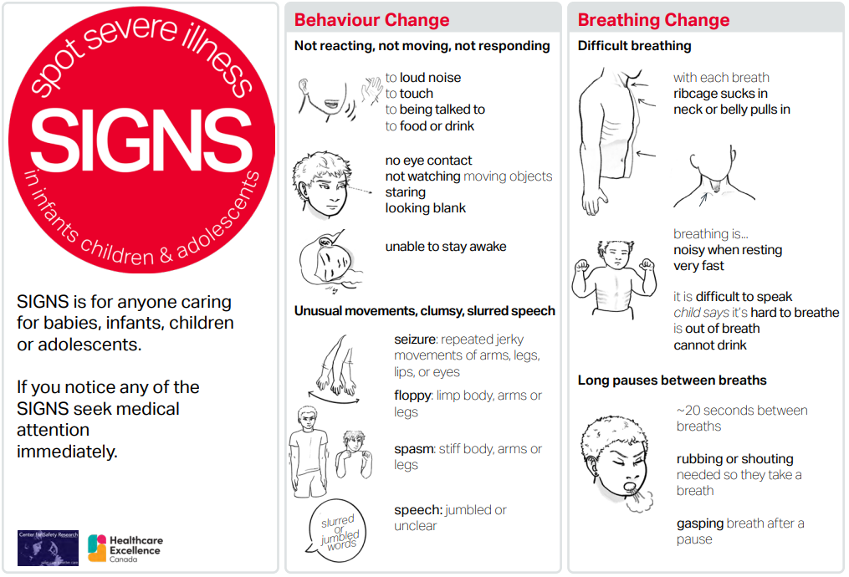](https://www.healthcareexcellence.ca/en/resources/recognizing-deteriorating-patient-condition/public-deteriorating-patient-condition/public-recognizing-deteriorating-patient-condition-in-infants-children-and-adolescents/)

**COVID-19 resources**

https://www.safetyandquality.gov.au/covid-19

The Australian Commission on Safety and Quality in Health Care has developed a number of resources to assist healthcare organisations, facilities and clinicians. These and other material on COVID-19 are available at <https://www.safetyandquality.gov.au/covid-19>

These resources include:

* ***OVID-19 infection prevention and control risk management*** This primer provides an overview of three widely used tools for investigating and responding to patient safety events and near misses. Tools covered in this primer include incident reporting systems, Root Cause Analysis (RCA), and Failure Modes and Effects Analysis (FMEA).   
  <https://www.safetyandquality.gov.au/publications-and-resources/resource-library/covid-19-infection-prevention-and-control-risk-management-guidance>
* ***Poster – Combined contact and droplet precautions*** <https://www.safetyandquality.gov.au/publications-and-resources/resource-library/infection-prevention-and-control-poster-combined-contact-and-droplet-precautions>  
  [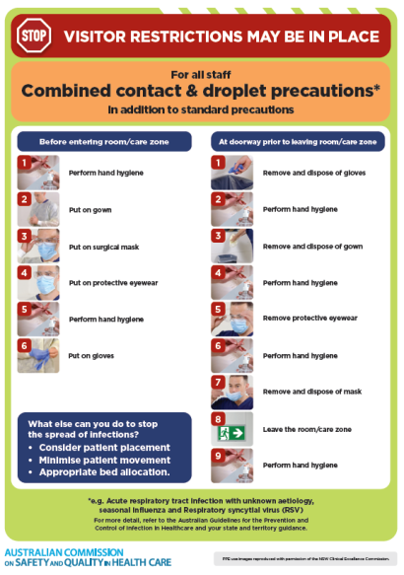](https://www.safetyandquality.gov.au/publications-and-resources/resource-library/infection-prevention-and-control-poster-combined-contact-and-droplet-precautions)
* ***Poster – Combined airborne and contact precautions*** <https://www.safetyandquality.gov.au/publications-and-resources/resource-library/poster-combined-airborne-and-contact-precautions>   
  [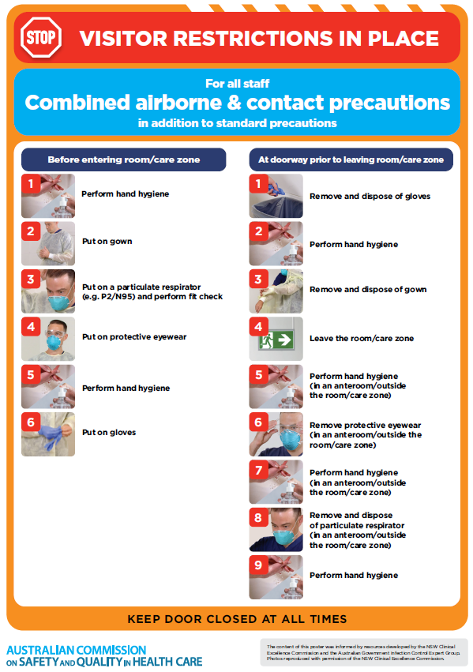](https://www.safetyandquality.gov.au/publications-and-resources/resource-library/poster-combined-airborne-and-contact-precautions)
* ***Environmental Cleaning and Infection Prevention and Control*** [www.safetyandquality.gov.au/environmental-cleaning](http://www.safetyandquality.gov.au/environmental-cleaning)
* ***COVID-19 infection prevention and control risk management – Guidance*** <https://www.safetyandquality.gov.au/publications-and-resources/resource-library/covid-19-infection-prevention-and-control-risk-management-guidance>
* ***Safe care for people with cognitive impairment during COVID-19***<https://www.safetyandquality.gov.au/our-work/cognitive-impairment/cognitive-impairment-and-covid-19>
* ***Stop COVID-19: Break the chain of infection*** posterhttps://www.safetyandquality.gov.au/publications-and-resources/resource-library/break-chain-infection-poster-a3  
  **[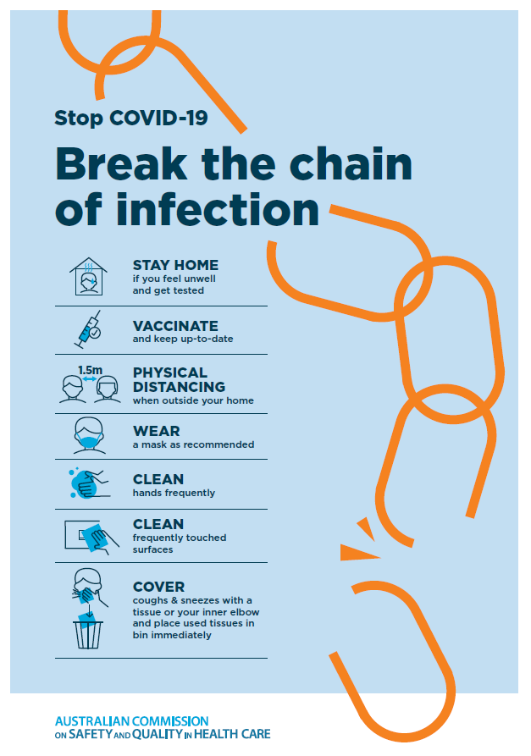](https://www.safetyandquality.gov.au/publications-and-resources/resource-library/break-chain-poster-a3https:/www.safetyandquality.gov.au/publications-and-resources/resource-library/break-chain-poster-a3)**
* ***COVID-19 and face masks – Information for consumers*** <https://www.safetyandquality.gov.au/publications-and-resources/resource-library/covid-19-and-face-masks-information-consumers>

[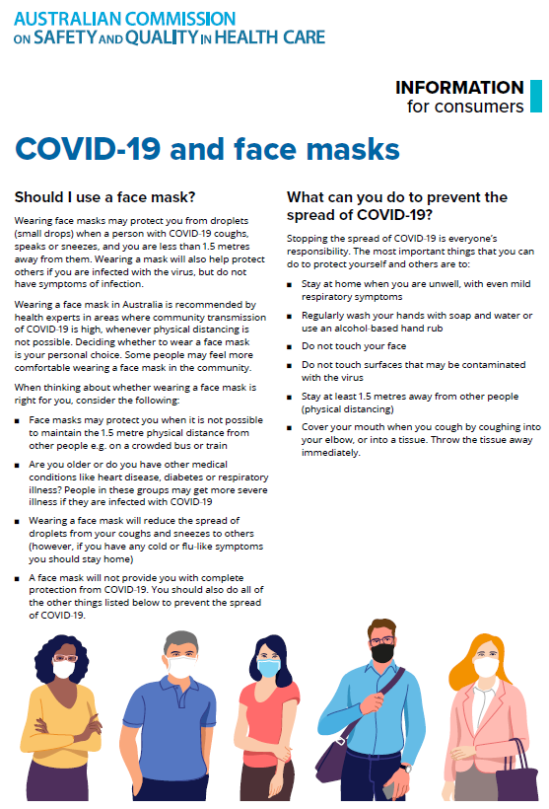](https://www.safetyandquality.gov.au/sites/default/files/2020-07/covid-19_and_face_masks_-_information_for_consumers.pdf)

*National COVID-19 Clinical Evidence Taskforce*

<https://covid19evidence.net.au/>

The National COVID-19 Clinical Evidence Taskforce is a collaboration of peak health professional bodies across Australia whose members are providing clinical care to people with COVID-19. The taskforce is undertaking continuous evidence surveillance to identify and rapidly synthesise emerging research in order to provide national, **evidence-based guidelines and clinical flowcharts for the clinical care of people with COVID-19**. The guidelines address questions that are specific to managing COVID-19 and cover the full disease course across mild, moderate, severe and critical illness. These are ‘living’ guidelines, updated with new research in near real-time in order to give reliable, up-to-the minute advice to clinicians providing frontline care in this unprecedented global health crisis.

*COVID-19 Critical Intelligence Unit*

<https://www.aci.health.nsw.gov.au/covid-19/critical-intelligence-unit>

The Agency for Clinical Innovation (ACI) in New South Wales has developed this page summarising rapid, evidence-based advice during the COVID-19 pandemic. Its operations focus on systems intelligence, clinical intelligence and evidence integration. The content includes a daily evidence digest, a COVID status monitor, a risk monitoring dashboard and evidence checks on a discrete topic or question relating to the current COVID-19 pandemic. There is also a ‘Living evidence’ section summarising key studies and emerging evidence on **COVID-19 vaccines** and **SARS-CoV-2 variants**. The most recent updates include:

* ***Current and emerging patient safety issues during COVID-19*** – What is the evidence on the current and emerging patient safety issues arising from the COVID-19 pandemic?
* ***Bivalent COVID-19 vaccines*** – What is the available regulatory and research evidence for bivalent COVID-19 vaccines?
* ***Surgery post COVID-19*** – What is the evidence for the timing of surgery, and outcomes following surgery, for people who have recovered from COVID-19?
* ***Paxlovid*** – What is the evidence for Paxlovid for treatment of COVID-19?
* ***Molnupiravir*** –What is the evidence for and regulatory context of molnupiravir for treatment of COVID-19?
* ***Eating disorders and COVID-19*** – What is the impact of the COVID-19 pandemic on the prevalence of eating disorders?
* ***Long COVID –*** What is the evidence on the prevalence, presentation and management of long-COVID?
* ***Oseltamivir (Tamiflu) use in healthcare settings*** – What is the evidence that use of oseltamivir in healthcare workers with a symptomatic influenza diagnosis result in an earlier return to work and reduced absenteeism? What is the evidence that use of oseltamivir in adults and children with symptomatic influenza reduces influenza transmission in health care settings?
* ***Alternative models of care for acute medical conditions*** – What is the evidence on alternative models of care for managing patients with acute medical conditions outside of emergency or inpatient hospital settings?
* ***Exercise and long COVID*** – Is exercise helpful in individuals with long COVID? Is post-exertional symptom exacerbation a risk in long COVID?
* ***Influenza and seasonal prophylaxis with oseltamivir*** – What is the place or evidence for seasonal influenza prophylaxis (such as taking oseltamivir for 10 to 12 weeks continuously) in healthcare and aged care settings?
* ***Rapid access models of care for respiratory illnesses*** – What is the evidence for rapid access models of care for respiratory illnesses, especially during winter seasons, in emergency departments?
* ***Post-acute sequelae of COVID-19*** – What is the evidence on the post-acute sequelae of COVID-19?
* ***Emerging variants*** – What is the available evidence for emerging variants?
* ***Chest pain or dyspnoea following COVID-19 vaccination*** – What is evidence for chest pain or dyspnoea following COVID-19 vaccination?
* ***Cardiac investigations and elective surgery post-COVID-19*** – What is evidence for cardiac investigations and elective surgery post-COVID-19?
* ***Breathlessness post COVID-19*** – How to determine those patients who present with ongoing breathlessness in need of urgent review or intervention due to suspected pulmonary embolus?
* ***COVID-19 pandemic and influenza*** – What is the evidence for COVID-19 pandemic and influenza?
* ***Budesonide and aspirin for pregnant women with COVID-19 –*** What is the evidence for the use of Budesonide for pregnant women with COVID-19? What is the evidence for aspirin prophylaxis for pre-eclampsia in pregnant women with a COVID-19 infection?
* ***COVID-19 vaccines in Australia*** – What is the evidence on COVID-19 vaccines in Australia?
* ***COVID-19 pandemic and wellbeing of critical care and other healthcare workers*** – Evidence in brief on the impact of the COVID-19 pandemic on the wellbeing of critical care and other healthcare workers.
* ***Disease modifying treatments for COVID-19 in children*** – What is the evidence for disease modifying treatments for COVID-19 in children?
* ***Mask type for COVID-19 positive wearer*** – What is the evidence for different mask types for COVID-19 positive wearers?
* ***Post acute and subacute COVID-19 care*** – What published advice and models of care are available regarding post-acute and subacute care for COVID-19 patients?
* ***Hospital visitor policies*** – What is the evidence for hospital visitor policies during and outside of the COVID-19 pandemic?
* ***Surgical masks, eye protection and PPE guidance*** –What is the evidence for surgical masks in the endemic phase in hospitals and for eyewear to protect against COVID-19?

**Disclaimer**

On the Radar is an information resource of the Australian Commission on Safety and Quality in Health Care. The Commission is not responsible for the content of, nor does it endorse, any articles or sites listed. The Commission accepts no liability for the information or advice provided by these external links. Links are provided on the basis that users make their own decisions about the accuracy, currency and reliability of the information contained therein. Any opinions expressed are not necessarily those of the Australian Commission on Safety and Quality in Health Care.