# Australian Commission on Safety and Quality logotypeOn the Radar

Issue 590

13 February 2023

*On the Radar* is a summary of some of the recent publications in the areas of safety and quality in health care. Inclusion in this document is not an endorsement or recommendation of any publication or provider. Access to particular documents may depend on whether they are Open Access or not, and/or your individual or institutional access to subscription sites/services. Material that may require subscription is included as it is considered relevant.

*On the Radar* is available online, via email or as a PDF or Word document from <https://www.safetyandquality.gov.au/publications-and-resources/newsletters/radar>

If you would like to receive *On the Radar* via email, you can subscribe on our website <https://www.safetyandquality.gov.au/publications-and-resources/newsletters>  
or by emailing us at H[Umail@safetyandquality.gov.auU](mailto:mail@safetyandquality.gov.au).  
You can also send feedback and comments to H[Umail@safetyandquality.gov.auU](mailto:mail@safetyandquality.gov.au).

For information about the Commission and its programs and publications, please visit <https://www.safetyandquality.gov.au>

You can also follow us on Twitter @ACSQHC.

**On the Radar**

Editor: Dr Niall Johnson [niall.johnson@safetyandquality.gov.au](mailto:niall.johnson@safetyandquality.gov.au)

Contributors: Niall Johnson, Marge Overs

***New case study on reviewing clinical variation***

Reducing unplanned readmissions after paediatric tonsillectomy in Victoria

ACSQHC 2023

<https://www.safetyandquality.gov.au/our-work/healthcare-variation/user-guide-reviewing-clinical-variation/case-studies/reducing-unplanned-readmissions-after-paediatric-tonsillectomy-victoria>

The Commission has published a new case study on reducing unplanned readmission after paediatric tonsillectomy as part of the *User Guide for Reviewing Clinical Variation* (<https://www.safetyandquality.gov.au/our-work/healthcare-variation/user-guide-reviewing-clinical-variation>)

The Paediatric Clinical Network at Safer Care Victoria (SCV) partnered with five health services in Victoria to substantially reduce readmissions after paediatric tonsillectomy. The case study features the SCV team’s insights about why the project worked and what they learnt along the way. The project resources are available for other health services to use.

The case study joins others that showcase best practice and innovation in the review of clinical variation, across healthcare settings. Topics include hip fracture surgery, stroke, colonoscopy, reducing preterm and planned early term births and improving end-of-life care. The case studies are available at <https://www.safetyandquality.gov.au/our-work/healthcare-variation/user-guide-reviewing-clinical-variation/case-studies>

**Reports**

*U.S. Health Care from a Global Perspective, 2022: Accelerating Spending, Worsening Outcomes*

Gunja MZ, Gumas ED, Williams II RD

New York: The Commonwealth Ffund; 2023.

|  |  |
| --- | --- |
| DOI | <https://doi.org/10.26099/8ejy-yc74> |
| Notes | This issues brief from the Commonwealth Fund in the USA notes that Health care spending, both per person and as a share of GDP, continues to be far higher in the United States than in other high-income countries. Yet the U.S. is the only country that doesn’t have universal health coverage and on many health measures it compares poorly with other high income nations. This issues brief presents the cross-national comparison of health care systems to assess U.S. health spending, outcomes, status, and service use relative to Australia, Canada, France, Germany, Japan, the Netherlands, New Zealand, Norway, South Korea, Sweden, Switzerland, and the United Kingdom. It also assesses many aspects against OECD nations and the average across the OCED. The USA consistently emerges as an outlier with higher spending but poorer outcomes.  While Australia fares well across many of these measures there are others where Australia does not compare so favourably. |

**Journal articles**

*Changes in unprofessional behaviour, teamwork and co-operation among hospital staff during the COVID-19 pandemic*

Westbrook JI, McMullan R, Urwin R, Churruca K, Metri J, Loh E, et al

Internal Medicine Journal. 2022;52(10):1821-1825.

|  |  |
| --- | --- |
| DOI | <https://doi.org/10.1111/imj.15913> |
| Notes | This Australian study surveyed staff at five hospitals on changes in unprofessional behaviour, teamwork and co-operation during the COVID-19 pandemic. Based on 1583 responses, **76.1% reported no change or a decrease in unprofessional behaviours**. The authors also report that ‘Across all professional groups, **43.6%** (n = 579, 95% CI: 41.0–46.3%) **reported improvements in teamwork and co-operation**.’ The authors ‘suggest that intensifying work demands, such as those resulting from the pandemic, are not a major trigger for unprofessional behaviour, and root causes lie elsewhere.’ |

*Healthy indoor air is our fundamental need: the time to act is now*

Morawska L, Marks GB, Monty J

Medical Journal of Australia. 2022;217(11):578-581.

|  |  |
| --- | --- |
| DOI | <https://doi.org/10.5694/mja2.51768> |
| Notes | During the COVID-19 pandemic the significance of indoor air quality has been much-debated. However, the issue is no one purely of airborne disease, indoor air quality in much of the world is poor and this can be due to a number of factors. The authors of this piece call for the development and implementation of indoor air quality standards.  The Commission recently released guidance on *Optimising ventilation for infection prevention and control in healthcare settings*. The guidance is available at <https://www.safetyandquality.gov.au/publications-and-resources/resource-library/optimising-ventilation-infection-prevention-and-control-healthcare-settings> |

*The science of clinical quality registries*

Parker KJ, Hickman LD, Ferguson C

European Journal of Cardiovascular Nursing. 2023:zvad008.

|  |  |
| --- | --- |
| DOI | <https://doi.org/10.1093/eurjcn/zvad008> |
| Notes | Clinical Quality Registries (CQRs) have been described as ‘unique safety and quality clinical data collections that report on retrospective, current and prospectively collected health data. The purpose of CQRs is to systematically monitor the quality of health care within specific clinical domains so that the information generated can be used to improve care.’ The authors of this piece also consider that they ‘can be a transformational tool to improve healthcare delivery’. They seek to ‘highlights the skills and capabilities required to build and maintain a robust clinical quality registry. This includes key measures to ensure data security, quality control, ongoing operational components, and benchmarking of care outcomes.’  In a number of respects this piece rehearses and extends the rationale and contents of the 2010 *Operating principles and technical standards for clinical quality registries* and the later *Framework for Australian clinical quality registrie*s developed by the Australian Commission on Safety and Quality in Health Care.  [Graphical abstract of The science of clinical quality registries.  Using a figure from Australia New Zealand Trauma Registry, previously produced by the Australian Commission on Quality and Safety.](https://doi.org/10.1093/eurjcn/zvad008) |

For information on the Commission’s work on clinical quality registries, see <https://www.safetyandquality.gov.au/our-work/health-and-human-research/national-arrangements-clinical-quality-registries>

*Health care in the metaverse*

Curtis C, Brolan CE

Medical Journal of Australia. 2023;218(1):46-46.

*Precision medicine in Australia: now is the time to get it right*

O'Shea R, Ma AS, Jamieson RV, Rankin NM

Medical Journal of Australia. 2022;217(11):559-563.

|  |  |
| --- | --- |
| DOI | Curtis and Brolan <https://doi.org/10.5694/mja2.51793>  O’Shea et al <https://doi.org/10.5694/mja2.51777> |
| Notes | These recent pieces are united by visions of the future of healthcare, and by the need for the sector to prepare for these possibilities, including implementation challenges, changes to funding, regulation and oversight. |

*Health Affairs*

Volume 42, Number 2, February 2023

|  |  |
| --- | --- |
| URL | <https://www.healthaffairs.org/toc/hlthaff/42/2> |
| Notes | A new issue of *Health Affairs* has been published with the themes “**Behavioral Health, Nursing Home Workforce & More**”. Articles in this issue of *Health Affairs* include:   * **Psychosocial Rehab** Meets Patients’ Behavioral Health Needs (Brian Rinker) * Adult **Primary Care** Physician Visits Increasingly Address **Mental Health** Concerns (Lisa S Rotenstein, Samuel T Edwards, and Bruce E Landon) * Geographical Variations In **Emergency Department Visits For Mental Health** Conditions For Medicaid Beneficiaries (K John McConnell, Kelsey Watson, Esther Choo, and Jane M Zhu) * Many Clinicians Implement Digital Equity Strategies To Treat **Opioid Use Disorder** (Lori Uscher-Pines, Lauren E Riedel, Ateev Mehrotra, Sherri Rose, Alisa B Busch, and Haiden A Huskamp) * A Widening Divide: **Cigarette Smoking Trends** Among People With Substance Use Disorder And Criminal Legal Involvement (Brendan Saloner, Wenshu Li, Michael Flores, Ana M. Progovac, and Benjamin Lê Cook) * Understanding **Nursing Home Spending And Staff Levels** In The Context Of Recent Nursing Staff Recommendations (John R Bowblis, Christopher S Brunt, Huiwen Xu, and David C Grabowski) * The Role Of Real Estate Investment Trusts In **Staffing US Nursing Homes** (Robert Tyler Braun, Dunc Williams, David G Stevenson, Lawrence P Casalino, Hye-young Jung, Rahul Fernandez, and Mark A Unruh) * Differences In **Nursing Home Staff COVID-19** Testing Rates And Odds Of Vaccination Across Work Shifts (Elizabeth M White, Jasmine L Travers, Natalia Gouskova, Gahee Oh, Maggie Syme, Xiaofei Yang, Ana Montoya, Richard A Feifer, David C Grabowski, Vincent Mor, and Sarah D Berry) * Ground **Ambulance Billing** And Prices Differ By Ownership Structure (Loren Adler, Bich Ly, Erin Duffy, Kathleen Hannick, M Hall, and E Trish) * **Ambulance Transport Destinations** In The US Differ By Patient Race And Ethnicity (Christine E Pack, Andrew T Partain, R P Crowe, and L H Brown) * Substantial Growth In **Medicare Advantage** And Implications For Reform (Erin Trish, Samuel Valdez, Paul B Ginsburg, S Randall, and S M Lieberman) * Narrow **Dialysis Networks** In Medicare Advantage: Exposure By Race, Ethnicity, And Dual Eligibility (Eunhae Grace Oh, David J Meyers, Kevin H Nguyen, and Amal N Trivedi) * **Rates Of Preterm Birth And Low Birthweight**: An Analysis Of Racial And Ethnic Populations (Clare C Brown, Jennifer E Moore, and J Mick Tilford) * **Community Health, Health Care Access, And COVID-19 Booster Uptake** In Massachusetts (Adam Gaffney, Steffie Woolhandler, Jacob Bor, Danny McCormick, and David U Himmelstein) * **Trends In Medical And Pharmacy Spending** In The Affordable Care Act Markets, 2015–19 (Nathaniel G Jacobson, Dane Hansen, and G Dieguez) * **Dental Services Use**: Medicare Beneficiaries Experience Immediate And Long-Term Reductions After Enrollment (L Simon, Z Song, and M L Barnett) * **Abortion Care** Is Essential Medical Care (Rachel Jensen) |

*BMJ Quality & Safety* online first articles

|  |  |
| --- | --- |
| URL | <https://qualitysafety.bmj.com/content/early/recent> |
| Notes | *BMJ Quality &Safety* has published a number of ‘online first’ articles, including:   * Editorial: Making it happen: engaging the power of many in **translating research into practice** (Lillian S Kao, Clifford Y Ko) * Roles and effectiveness of knowledge brokers for **translating clinical practice guidelines in health-related settings**: a systematic review (Amanda J Cross, Terry P Haines, Choon Ean Ooi, Adam La Caze, Sara Karavesovska, Eu Jin Lee, Samuel Siu, Sagar Sareen, Carlos Jones, Michelle Steeper, John Simon Bell) |

*International Journal for Quality in Health Care* online first articles

|  |  |
| --- | --- |
| URL | <https://academic.oup.com/intqhc/advance-articles> |
| Notes | International Journal for Quality in Health Care has published a number of ‘online first’ articles, including:   * **Hospital accreditation**: an umbrella review (Katherine Lewis, Reece Hinchcliff) |

**Online resources**

***End of Life Essentials***

<https://www.endoflifeessentials.com.au/>

A new set of free Training Resources are now available from End-of-Life Essentials (EOLE) <https://www.endoflifeessentials.com.au/tabid/7633/Default.aspx>. Tailored for short and focused in-service training sessions, EOLE offers a variety of assets including seminar presentations, templates, videos, and quizzes to support health professionals in the following topics:

* Death as a normal part of life
* Recognising Dying
* Imminent Death
* Communication
* Team Work
* After a Death.

These can be used in small learning groups, presentations, discussions, and more. EOLE provide the tools and flexibility needed to enhance and personalise professional learning in end-of-life care.

The education modules and supporting resources have been developed to help doctors, nurses and allied health professionals develop their skills and confidence in end-of-life care. Although, initially targeted at acute care, the education is applicable to a wide range of health settings. All components of the e-learning package draw upon the Australian Commission on Safety and Quality in Health Care’s [*National Consensus Statement: Essential elements for safe and high-quality end-of-life care*](https://www.safetyandquality.gov.au/our-work/comprehensive-care/end-life-care/national-consensus-statement).  
End-of-Life Essentials is funded by the Australian Government Department of Health and Aged Care.

***[UK] NICE Guidelines and Quality Standards***

<https://www.nice.org.uk/guidance>

The UK’s National Institute for Health and Care Excellence (NICE) has published new (or updated) guidelines and quality standards. The latest reviews or updates include:

* NICE Guideline NG231 ***Barrett's oesophagus*** *and stage 1* ***oesophageal adenocarcinoma****: monitoring and management*   
  <https://www.nice.org.uk/guidance/ng231>

***[USA] Effective Health Care Program reports***

<https://effectivehealthcare.ahrq.gov/>

The US Agency for Healthcare Research and Quality (AHRQ) has an Effective Health Care (EHC) Program. The EHC has released the following final reports and updates:

* ***Partial Breast Irradiation for Breast Cancer****. Comparative Effectiveness Review No. 259*<https://effectivehealthcare.ahrq.gov/products/partial-breast-irradiation/research>

**COVID-19 resources**

https://www.safetyandquality.gov.au/covid-19

The Australian Commission on Safety and Quality in Health Care has developed a number of resources to assist healthcare organisations, facilities and clinicians. These and other material on COVID-19 are available at <https://www.safetyandquality.gov.au/covid-19>

These resources include:

* ***OVID-19 infection prevention and control risk management*** This primer provides an overview of three widely used tools for investigating and responding to patient safety events and near misses. Tools covered in this primer include incident reporting systems, Root Cause Analysis (RCA), and Failure Modes and Effects Analysis (FMEA).   
  <https://www.safetyandquality.gov.au/publications-and-resources/resource-library/covid-19-infection-prevention-and-control-risk-management-guidance>
* ***Poster – Combined contact and droplet precautions*** <https://www.safetyandquality.gov.au/publications-and-resources/resource-library/infection-prevention-and-control-poster-combined-contact-and-droplet-precautions>  
  [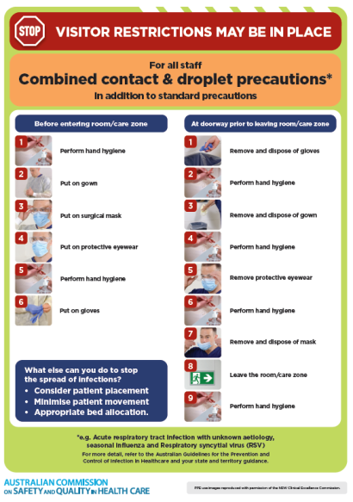](https://www.safetyandquality.gov.au/publications-and-resources/resource-library/infection-prevention-and-control-poster-combined-contact-and-droplet-precautions)
* ***Poster – Combined airborne and contact precautions*** <https://www.safetyandquality.gov.au/publications-and-resources/resource-library/poster-combined-airborne-and-contact-precautions>   
  [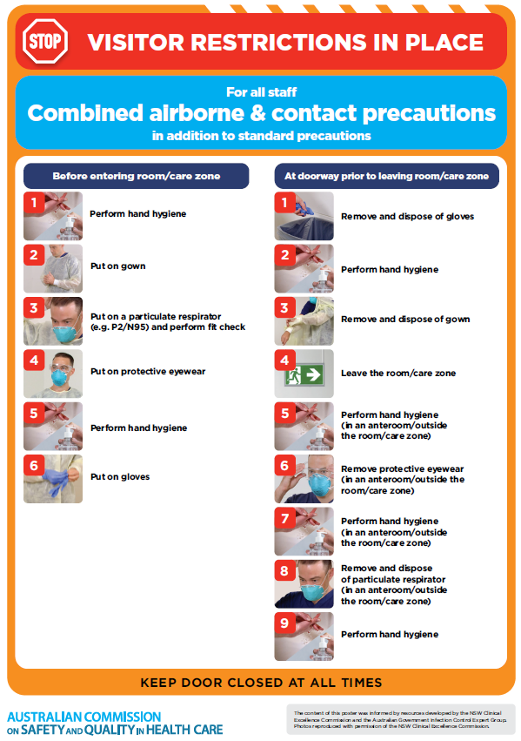](https://www.safetyandquality.gov.au/publications-and-resources/resource-library/poster-combined-airborne-and-contact-precautions)
* ***Environmental Cleaning and Infection Prevention and Control*** [www.safetyandquality.gov.au/environmental-cleaning](http://www.safetyandquality.gov.au/environmental-cleaning)
* ***COVID-19 infection prevention and control risk management – Guidance*** <https://www.safetyandquality.gov.au/publications-and-resources/resource-library/covid-19-infection-prevention-and-control-risk-management-guidance>
* ***Safe care for people with cognitive impairment during COVID-19***<https://www.safetyandquality.gov.au/our-work/cognitive-impairment/cognitive-impairment-and-covid-19>
* ***Stop COVID-19: Break the chain of infection*** posterhttps://www.safetyandquality.gov.au/publications-and-resources/resource-library/break-chain-infection-poster-a3  
  **[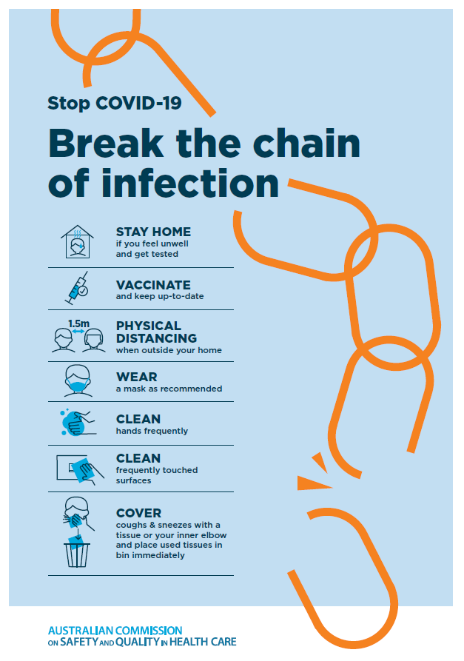](https://www.safetyandquality.gov.au/publications-and-resources/resource-library/break-chain-poster-a3https:/www.safetyandquality.gov.au/publications-and-resources/resource-library/break-chain-poster-a3)**
* ***COVID-19 and face masks – Information for consumers*** <https://www.safetyandquality.gov.au/publications-and-resources/resource-library/covid-19-and-face-masks-information-consumers>

[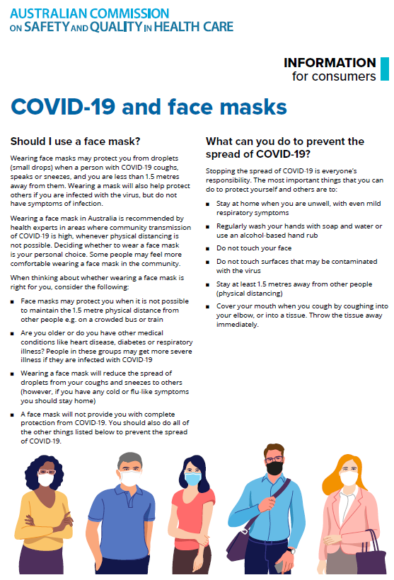](https://www.safetyandquality.gov.au/sites/default/files/2020-07/covid-19_and_face_masks_-_information_for_consumers.pdf)

*National COVID-19 Clinical Evidence Taskforce*

<https://covid19evidence.net.au/>

The National COVID-19 Clinical Evidence Taskforce is a collaboration of peak health professional bodies across Australia whose members are providing clinical care to people with COVID-19. The taskforce is undertaking continuous evidence surveillance to identify and rapidly synthesise emerging research in order to provide national, **evidence-based guidelines and clinical flowcharts for the clinical care of people with COVID-19**. The guidelines address questions that are specific to managing COVID-19 and cover the full disease course across mild, moderate, severe and critical illness. These are ‘living’ guidelines, updated with new research in near real-time in order to give reliable, up-to-the minute advice to clinicians providing frontline care in this unprecedented global health crisis.

*COVID-19 Critical Intelligence Unit*

<https://www.aci.health.nsw.gov.au/covid-19/critical-intelligence-unit>

The Agency for Clinical Innovation (ACI) in New South Wales has developed this page summarising rapid, evidence-based advice during the COVID-19 pandemic. Its operations focus on systems intelligence, clinical intelligence and evidence integration. The content includes a daily evidence digest, a COVID status monitor, a risk monitoring dashboard and evidence checks on a discrete topic or question relating to the current COVID-19 pandemic. There is also a ‘Living evidence’ section summarising key studies and emerging evidence on **COVID-19 vaccines** and **SARS-CoV-2 variants**. The most recent updates include:

* ***Current and emerging patient safety issues during COVID-19*** – What is the evidence on the current and emerging patient safety issues arising from the COVID-19 pandemic?
* ***Bivalent COVID-19 vaccines*** – What is the available regulatory and research evidence for bivalent COVID-19 vaccines?
* ***Surgery post COVID-19*** – What is the evidence for the timing of surgery, and outcomes following surgery, for people who have recovered from COVID-19?
* ***Paxlovid*** – What is the evidence for Paxlovid for treatment of COVID-19?
* ***Molnupiravir*** –What is the evidence for and regulatory context of molnupiravir for treatment of COVID-19?
* ***Eating disorders and COVID-19*** – What is the impact of the COVID-19 pandemic on the prevalence of eating disorders?
* ***Long COVID –*** What is the evidence on the prevalence, presentation and management of long-COVID?
* ***Oseltamivir (Tamiflu) use in healthcare settings*** – What is the evidence that use of oseltamivir in healthcare workers with a symptomatic influenza diagnosis result in an earlier return to work and reduced absenteeism? What is the evidence that use of oseltamivir in adults and children with symptomatic influenza reduces influenza transmission in health care settings?
* ***Alternative models of care for acute medical conditions*** – What is the evidence on alternative models of care for managing patients with acute medical conditions outside of emergency or inpatient hospital settings?
* ***Exercise and long COVID*** – Is exercise helpful in individuals with long COVID? Is post-exertional symptom exacerbation a risk in long COVID?
* ***Influenza and seasonal prophylaxis with oseltamivir*** – What is the place or evidence for seasonal influenza prophylaxis (such as taking oseltamivir for 10 to 12 weeks continuously) in healthcare and aged care settings?
* ***Rapid access models of care for respiratory illnesses*** – What is the evidence for rapid access models of care for respiratory illnesses, especially during winter seasons, in emergency departments?
* ***Post-acute sequelae of COVID-19*** – What is the evidence on the post-acute sequelae of COVID-19?
* ***Emerging variants*** – What is the available evidence for emerging variants?
* ***Chest pain or dyspnoea following COVID-19 vaccination*** – What is evidence for chest pain or dyspnoea following COVID-19 vaccination?
* ***Cardiac investigations and elective surgery post-COVID-19*** – What is evidence for cardiac investigations and elective surgery post-COVID-19?
* ***Breathlessness post COVID-19*** – How to determine those patients who present with ongoing breathlessness in need of urgent review or intervention due to suspected pulmonary embolus?
* ***COVID-19 pandemic and influenza*** – What is the evidence for COVID-19 pandemic and influenza?
* ***Budesonide and aspirin for pregnant women with COVID-19 –*** What is the evidence for the use of Budesonide for pregnant women with COVID-19? What is the evidence for aspirin prophylaxis for pre-eclampsia in pregnant women with a COVID-19 infection?
* ***COVID-19 vaccines in Australia*** – What is the evidence on COVID-19 vaccines in Australia?
* ***COVID-19 pandemic and wellbeing of critical care and other healthcare workers*** – Evidence in brief on the impact of the COVID-19 pandemic on the wellbeing of critical care and other healthcare workers.
* ***Disease modifying treatments for COVID-19 in children*** – What is the evidence for disease modifying treatments for COVID-19 in children?
* ***Mask type for COVID-19 positive wearer*** – What is the evidence for different mask types for COVID-19 positive wearers?
* ***Post acute and subacute COVID-19 care*** – What published advice and models of care are available regarding post-acute and subacute care for COVID-19 patients?
* ***Hospital visitor policies*** – What is the evidence for hospital visitor policies during and outside of the COVID-19 pandemic?
* ***Surgical masks, eye protection and PPE guidance*** –What is the evidence for surgical masks in the endemic phase in hospitals and for eyewear to protect against COVID-19?

**Disclaimer**

On the Radar is an information resource of the Australian Commission on Safety and Quality in Health Care. The Commission is not responsible for the content of, nor does it endorse, any articles or sites listed. The Commission accepts no liability for the information or advice provided by these external links. Links are provided on the basis that users make their own decisions about the accuracy, currency and reliability of the information contained therein. Any opinions expressed are not necessarily those of the Australian Commission on Safety and Quality in Health Care.