Australian Commission on Safety and Quality in Health Care logo 
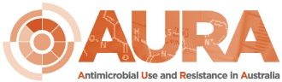

November 2022

Antimicrobial use and appropriateness in the  
community: 2020–2021

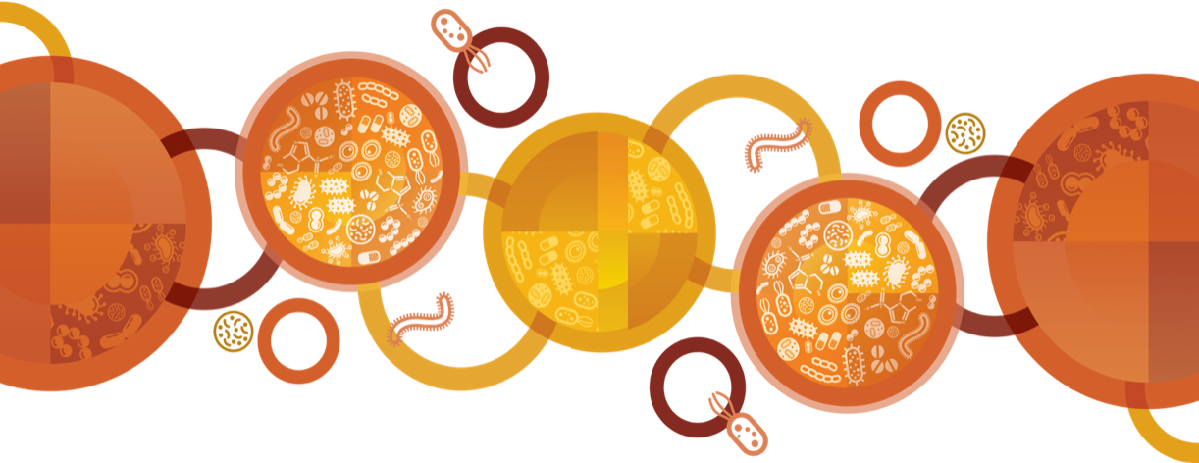

Published by the Australian Commission on Safety and Quality in Health Care  
Level 5, 255 Elizabeth Street, Sydney NSW 2000

Phone: (02) 9126 3600

Email: AURA@safetyandquality.gov.au   
Website: www.safetyandquality.gov.au

ISBN: 978-1-922563-78-1

© Australian Commission on Safety and Quality in Health Care 2022

All material and work produced by the Australian Commission on Safety and Quality in Health Care (the Commission) is protected by copyright. The Commission reserves the right to set out the terms and conditions for the use of such material.

As far as practicable, material for which the copyright is owned by a third party will be clearly labelled. The Commission has made all reasonable efforts to ensure that this material has been reproduced in this publication with the full consent of the copyright owners.

With the exception of any material protected by a trademark, any content provided by third parties and where otherwise noted, all material presented in this publication is licensed under a [Creative Commons Attribution–NonCommercial–No Derivatives 4.0 International licence](http://creativecommons.org/licenses/by-nc-nd/4.0/).



Enquiries about the licence and any use of this publication are welcome and can be sent to [communications@safetyandquality.gov.au](mailto:communications@safetyandquality.gov.au).

The Commission’s preference is that you attribute this publication (and any material sourced from it) using the following citation:

Australian Commission on Safety and Quality in Health Care. Antimicrobial use and appropriateness in the community: 2020–2021. Sydney: ACSQHC; 2022

**Disclaimer**

The content of this document is published in good faith by the Commission for information purposes. The document is not intended to provide guidance on particular healthcare choices. You should contact your health care provider for information or advice on particular healthcare choices.

The Commission does not accept any legal liability for any injury, loss or damage incurred by the use of, or reliance on, this document.

Contents

List of Tables 4

List of Figures 4

Executive summary 6

Key findings 6

Introduction 8

About this report 8

Understanding how the data are presented in this report 8

Why is surveillance of community antimicrobial use important? 8

[Factors affecting community antimicrobial use in 2020 and 2021:   
COVID-19 pandemic and repeat prescriptions 9](#_Toc121826724)

Methodology 10

[Pharmaceutical Benefits Scheme and   
Repatriation Pharmaceutical Benefits Scheme 10](#_Toc121826726)

NPS MedicineWise MedicineInsight program 12

Considerations for interpreting data 16

Results and descriptive analyses 19

[Pharmaceutical Benefits Scheme and   
Repatriation Pharmaceutical Benefits Scheme 19](#_Toc121826730)

[Antimicrobial prescribing in general practice:   
NPS MedicineWise MedicineInsight program 27](#_Toc121826731)

Impact of COVID-19 on antimicrobial use 41

Discussion 54

Overall antimicrobial use and appropriateness in the community 54

Impact of the COVID-19 pandemic on antimicrobial use in the community 55

International comparisons of community antimicrobial use 56

What will be done to improve appropriateness of antimicrobial prescribing and patient safety in the community? 57

References 58

Appendix 60

Appendix 1: Data source description 60

[A1.1 About the Pharmaceutical Benefits Scheme and   
Repatriation Pharmaceutical Benefits Scheme 60](#_Toc121826741)

A1.2 About NPS MedicineWise MedicineInsight program 60

Appendix 2: Terminology 62

A2.1 Abbreviations and acronyms 62

A2.2 Common terms 63

A2.3 Antimicrobial, antibacterial or antibiotic? 65

Appendix 3: Supplementary Data 66

### List of Tables

Table 1: PBS/RPBS community antimicrobial use data source 10

Table 2: Antimicrobials included in the analyses of PBS/RPBS data, 2015–2021 11

Table 3: NPS MedicineWise community antimicrobial use data source 13

Table 4: NPS Medicinewise MedicineInsight data definitions 16

Table 5: Number of PBS/RPBS antimicrobial prescriptions dispensed, 2015–2021 20

Table 6: Highest and lowest PBS/RPBS antimicrobial dispensing rates per 1,000 people, age standardised, by SA3, 2019–2021 23

Table 7: Number and percent of PBS/RPBS repeat antimicrobial prescriptions dispensed within 10 days of the original prescription being dispensed, 2019 and 2021 27

Table 8: Region of residence and socioeconomic status (represented by SEIFA decile) for patients prescribed antimicrobials, MedicineInsight practices, 2019–2021 30

Table 9:Patterns of GP prescribing for high use antimicrobials, MedicineInsight practices, 2021 36

Table 10: Number and percentage of patients prescribed antimicrobials by GPs for selected conditions, MedicineInsight practices, 2020–2021 39

Table 11: Number of PBS/RPBS antimicrobial prescriptions, 2019–2021 (year-to-year comparison) 44

Table 12: Volume of PBS/RPBS antimicrobial prescriptions use (DDD/1,000 people/day), 2019–2021 (year-to-year comparison) 45

### List of Figures

Figure 1: Number of PBS/RPBS antimicrobial prescriptions dispensed per 1,000 people, crude and age-standardised rates, 2015–2021 20

Figure 2: Quantity of PBS/RPBS antimicrobial prescriptions dispensed (DDD/1,000 people/day), 2015–2021 21

Figure 3: Age-standardised rate of the number of PBS/RPBS antimicrobial prescriptions dispensed per 1,000 people, by state and territory, 2015–2021 22

Figure 4: Ten most commonly dispensed PBS/RPBS antimicrobial prescriptions, by percentage of all antimicrobial prescriptions, 2019–2021 24

Figure 5: Number of PBS/RPBS prescriptions dispensed (DDD/1,000 people/day), by antimicrobial class, 2015–2021 25

Figure 6: Number of PBS/RPBS antimicrobial prescriptions dispensed per 1,000 people, by patient age group, 2019–2021 26

Figure 7: Percentage of patients prescribed one or more antimicrobials, MedicineInsight practices, 2015–2021 28

Figure 8: Number of patients prescribed one or more antimicrobials, per 100 patients, by age group, MedicineInsight practices, 2019–2021 29

Figure 9: Rate of high use antimicrobials prescribed (total prescriptions including originals and repeats) per 100 GP visits, MedicineInsight practices, 2015–2021 31

Figure 10: Rate of original high use antimicrobial prescriptions issued per 100 GP visits, MedicineInsight practices, 2015–2021 32

Figure 11 : Rate of repeat high use antimicrobial prescriptions issued per 100 GP visits, MedicineInsight practices, 2015–2021 32

Figure 12: Percentage of total antimicrobial prescriptions recorded on the same day as presentations for respiratory tract infections, MedicineInsight practices, 2015–2021 33

Figure 13: Number of non-PBS/RPBS antimicrobial prescriptions per 100 GP Visits, MedicineInsight practices, 2015–2021 34

Figure 14: Percentage of non-PBS/RPBS antimicrobial prescriptions (originals plus repeats) of total antimicrobial prescriptions (originals plus repeats), MedicineInsight practices, 2015–2021 34

Figure 15: Number of PBS/RPBS prescriptions for azithromycin and ciprofloxacin per 100 GP visits, MedicineInsight practices, 2015–2021 37

Figure 16: Number of patients per 100 patients prescribed one or more high use antimicrobials, by age group, MedicineInsight practices, 2020–2021 38

Figure 17: Trends in antimicrobial prescribing rates for specific conditions, MedicineInsight practices, 2015–2021 40

Figure 18: Rate of antimicrobial prescribing per 100 telehealth visits per 100 face-to-face visits or per 100 GP visits of any type (all visits), MedicineInsight practices, 2020–2021 41

Figure 19: Number of PBS/RPBS antimicrobial prescriptions dispensed, 2019–2021 42

Figure 20: Quantity of PBS/RPBS antimicrobial prescriptions dispensed (DDD/1,000 people/day), 2019–2021 43

Figure 21: Monthly total antimicrobial prescriptions per 100 GP visits, MedicineInsight practices, 2015–2021 43

Figure 22: Number of PBS/RPBS antimicrobial prescriptions dispensed for URTIs, 2019–2021 46

Figure 23: Number of PBS/RPBS antimicrobial prescriptions dispensed for various indications, 2019–2021 47

Figure 24: Number of PBS/RPBS prescriptions with PBS/RPBS restriction changes dispensed for URTIs, by type of antimicrobial, 2019–2021 48

Figure 25: Number of PBS/RPBS prescriptions without PBS/RPBS restriction changes, dispensed for URTIs, by type of antimicrobial, 2019–2021 48

Figure 26: Number of PBS/RPBS antimicrobial prescriptions per 1,000 people for URTIs, by state and territory, 2019–2021 49

Figure 27: Number of PBS/RPBS antimicrobial prescriptions dispensed for URTIs per 1,000 people, by age groups, 2019–2021 50

Figure 28: Number of PBS/RPBS antimicrobial prescriptions for URTIs per 1,000 people, 2019–2021 51

Figure 29: Number of PBS/RPBS antimicrobial prescriptions for URTIs per 1,000 people, 2019–2021 52

Figure 30: Number of PBS/RPBS antimicrobial prescriptions for URTIs per 1,000 people, 2019–2021 53

Figure 31: Community antimicrobial use in Australia (2020), European countries (2020) and Canada (2019), by DDD/1,000 people/day 56

# Executive summary

Antimicrobials are an integral component of healthcare delivery and need to be readily available and effective. Antimicrobial resistance (AMR) is a critical risk to patient safety by reducing the number of antimicrobials available to treat infections. AMR increases morbidity and mortality associated with infections caused by multidrug-resistant organisms.

The emergence of AMR and consequent reduction in the efficacy of antimicrobials has resulted in significant impacts on individuals receiving treatment for infections, and on the community more broadly. As antimicrobials become ineffective, important treatments such as organ transplantation, a range of major surgical procedures, and chemotherapy for cancer may become limited, or no longer viable.

Increased and inappropriate antimicrobial use are important drivers of AMR. Since 2015, there has been a positive downward trend in overall antimicrobial use in the Australian community sector. There was a gradual decline in the number of antimicrobial prescriptions dispensed under the Pharmaceutical Benefits Scheme (PBS) and the Repatriation Pharmaceutical Benefits Scheme (RPBS) between 2015 and 2019. This was followed by a substantial decrease in PBS/RPBS dispensing in 2020. This decrease, which was sustained in 2021, coincided with the response to the COVID-19 pandemic in Australia. Similar trends were apparent in prescribing data from general practices participating in the NPS MedicineWise MedicineInsight program.

### Key findings

#### What do the findings show about antimicrobial use in the community?

##### Overall findings (2015–2021)

* Antimicrobial use in the community declined from 2015 to 2021, across all states and territories and most age groups, with the exception of children (0–9 year age group), where the number of antimicrobial prescriptions increased in 2021
* Cefalexin, amoxicillin and amoxicillin–clavulanic acid were the most frequently prescribed (MedicineInsight) and dispensed (PBS/RPBS) antimicrobials
* There were high rates of azithromycin prescribing compared to guideline recommendations
* Non-PBS/RPBS (private) prescriptions for antimicrobials more than doubled from 2.5% (2015) to 5.3% (2021)
* Prescribing rates for respiratory-related illnesses were not consistent with national guidelines but showed improvement in appropriateness. This is compared to urinary tract infections and acute otitis media, for which appropriateness was not improved, and prescribing rates for these conditions remained high.

##### Potential impact of the COVID-19 pandemic (2019 compared to 2020–2021)

* A 40.3% reduction in antimicrobial use was observed between March and April 2020 coinciding with the implementation of COVID-19 restrictions in Australia
* Antimicrobial use decreased dramatically between 2019 and 2021 (25.3%), compared to 2015 and 2019 (8.9%)
* The average number of antimicrobial prescriptions declined from 16 per 100 GP visits in 2019 to 7 per 100 GP visits in 2020 and 2021
* Antimicrobials were prescribed at a lower rate in telehealth consultations, compared to face-to-face consultations.

#### What do the findings mean and why are they important?

* The results from this report suggest that lower levels of antimicrobial use in Australia are achievable long-term
* Enhanced infection prevention and control strategies at national, state and territory, and local levels, including promotion of hand hygiene, staying at home when unwell, and physical isolation, resulted in reduced respiratory infections, general practice attendances, and antimicrobial prescribing and dispensing
* The changes in antimicrobial use, coinciding with the COVID-19 pandemic, indicate that combined strategies of strong antimicrobial stewardship (AMS) and infection prevention and control are most effective in reducing community antimicrobial use to prevent and control AMR
* Promoting these results to inform AMS in the community; raised community awareness of the value of appropriate antimicrobial use; and sustained infection prevention and control measures to maintain these lower levels are essential.

#### What can be done to improve antimicrobial use and appropriateness and patient safety in the community?

To promote ongoing reductions in antimicrobial use and increased appropriateness of antimicrobial use in the community, the Australian Commission on Safety and Quality in Health Care (the Commission) will:

* Continue to report the results of antimicrobial prescribing and use the data to inform quality improvement strategies
* Work with the Department of Health and Aged Care (the Department) to increase capacity to monitor the volume of antimicrobials dispensed through non-PBS/RPBS prescriptions and the indications for which they are prescribed
* Support implementation of the National Safety and Quality Primary and Community Healthcare Standards (Primary and Community Healthcare Standards), to deliver safe, high-quality health care through appropriate antimicrobial prescribing and use
* Continue to work with clinicians, the Royal Australian College of General Practitioners, Primary Health Networks and other primary care organisations, and the Department and state and territory governments to develop targeted strategies to improve appropriateness of antimicrobial prescribing
* Promote maintenance of public health actions such as wearing a mask and staying home when experiencing symptoms of respiratory illness and encouraging hand hygiene and physical distancing to reduce the risk of transmission of infection in the community
* Develop strategies that impact antimicrobial use generally, and specifically target conditions for which antimicrobials are not generally recommended and are not effective
* Review resources for consumers to improve their understanding of the importance of antimicrobial use.

# Introduction

### About this report

This report presents analyses of antimicrobial use in the Australian community in 2020 and 2021. It builds on analyses presented in a series of national reports on antimicrobial use and resistance in human health developed by the Australian Commission on Safety and Quality in Health Care (the Commission) from 2016 to 2021 using data captured by the Antimicrobial Use and Resistance in Australia (AURA) Surveillance System.1-4 Funding for the AURA Surveillance System is provided by the Australian Government Department of Health and Aged Care (the Department), with further contributions from the states and territories by the collection and submission of their data.

Data on antimicrobial use and appropriateness of prescribing presented in this report are sourced from: the Pharmaceutical Benefits Scheme (PBS) and Repatriation Pharmaceutical Benefits Scheme (RPBS)5, and the NPS MedicineWise MedicineInsight program.6

The PBS/RPBS are Australian Government schemes that provide all Australians with subsidised access to many medicines and provide information on antimicrobials dispensed or supplied from pharmacies to the Australian population. MedicineInsight captures information on prescriptions supplied by doctors from participating practices. Information on each of these data sources is included in Appendix 1.

### Understanding how the data are presented in this report

This report includes analyses of antimicrobial use in the Australian community between 2015 and 2021. Over this seven-year period overall antimicrobial use in the community declined by 31.9%. There was a gradual decline of 8.9% from 2015 to 2019, followed by a more dramatic decline of 24.6% between 2019 and 2020; and this dramatic decline was sustained in 2021. For this reason, the findings presented in this report about community antimicrobial use in 2020 and 2021 are frequently compared to 2019.

### Why is surveillance of community antimicrobial use important?

Community prescribing in general practice, community health services, aged care homes and other non-hospital settings accounts for most antimicrobial use in Australia. Monitoring the overall volume of use of antimicrobials and the extent of inappropriate use is an important part of the approach to understand and address the risks associated with antimicrobial resistance (AMR).

AMR poses a risk to patient safety because it reduces the number of antimicrobials available to treat infections. In the community setting, this could mean that there are no oral antimicrobial options available, resulting in increased hospitalisations for parenteral therapy. AMR increases morbidity and mortality associated with infections caused by multidrug-resistant organisms. It may also limit future capacity for important treatments such as major surgeries, organ transplantation, cancer chemotherapy and diabetes management among others, due to a lack of effective antimicrobials.7

Surveillance of the volume of antimicrobial use and appropriateness of prescribing are essential to promote antimicrobial stewardship (AMS) and inform AMR prevention and containment strategies, including providing feedback about prescribing to clinicians and information to consumers about safe and appropriate use of antimicrobials.

### Factors affecting community antimicrobial use in 2020 and 2021: COVID-19 pandemic and repeat prescriptions

Australia’s first case of COVID-19 was reported on 25 January 2020.8 The World Health Organization (WHO) declared COVID-19, a viral infection caused by Severe Acute Respiratory Syndrome Coronavirus 2 (SARS-CoV-2), a global pandemic on 11 March 2020.9 Early reports of the COVID-19 pandemic suggested that it could result in increased morbidity and mortality, along with an increased demand on health services. In response, all Australian governments initiated a series of structural and policy decisions, along with clinical practice changes, to minimise the impact of the pandemic.

From 13 March 2020, the Australian Government expanded access to the Medicare Benefits Schedule (MBS) for telehealth consultations, and video and telehealth MBS items were made available to people at risk of healthcare harms from COVID-19 and those in quarantine.10 Telehealth services were extended to enable vulnerable medical and other health practitioners to provide telehealth to their patients from 23 March 2020, and further expanded to all practitioners and all patients from 29 March 2020.11 The aims of these changes were to improve access to healthcare services and reduce opportunities for infection transmission.

Lockdowns, involving restriction of movement within local communities and between states and territories were used at various times nationally, in additional to international border restrictions, as part of efforts to prevent and control COVID-19.

There was increased emphasis on hand hygiene, working from home and physical distancing measures have the potential to reduce transmission of infectious conditions.12 This was reflected in the data collected during the 2020 influenza season, with laboratory-confirmed cases of influenza in Australia approximately eight times lower in 2020 than the average for the previous five years.12 During the COVID-19 pandemic, people experiencing sore throats or cold and influenza-like symptoms were encouraged to perform a COVID-19 test and to self-isolate until the results became available, which may have limited their attendance at general practices for upper respiratory tract infection (URTIs). Sentinel surveillance reports revealed that general practice presentations for influenza-like symptoms were four times lower in 2020 than the average in the previous five years.12 In April 2020, in association with changes in access to healthcare, there was a decrease in the use of antimicrobials in Australia.1,13

From 1 April 2020, PBS/RPBS policy changes came into effect to encourage prescribers to issue repeat prescriptions for antimicrobials only when indicated. The maximum prescribed quantity and access to repeats were restricted for the five most commonly dispensed antimicrobials, amoxicillin, amoxicillin–clavulanic acid, cefalexin, doxycycline and roxithromycin14, as follows:

* Maximum quantities and numbers of repeats (typically from one to zero) were changed to reduce inadvertent and unnecessary repeat prescribing when initiating antimicrobial treatment
* New PBS/RPBS listings were added for amoxicillin, amoxicillin–clavulanic acid and cefalexin under authority listings for people who required longer courses of treatment.

However, prescribers were able to request PBS/RPBS authority to prescribe repeats for antimicrobials which otherwise had restricted repeats, and no changes to the maximum quantities for unrestricted antimicrobials were made.14

# Methodology

### Pharmaceutical Benefits Scheme and Repatriation Pharmaceutical Benefits Scheme

#### Data source and criteria

This report analyses data on antimicrobials dispensed under the PBS/RPBS, from 1 January 2015 to 31 December 2021 (Table 1), and complements analyses previously reported for the period 2015 to 2019.1 This included all prescriptions priced under the patient co-payment which are prescriptions that do not attract a reimbursement.

These data were obtained from Services Australia following approval for disclosure from the Department and the Department of Veterans’ Affairs. The Department collects data on antimicrobial dispensing in the community through the PBS/RPBS from the Medicare pharmacy claims database. The data does not contain details on any prescriptions supplied privately.

Table : PBS/RPBS community antimicrobial use data source

|  |  |
| --- | --- |
| Subject and type of surveillance | Passive surveillance of antimicrobial use in the community |
| Data source | Pharmaceutical Benefits Scheme (PBS) and Repatriation Pharmaceutical Benefits Scheme (RPBS) |
| Type of data | Dispensed volume, trends |
| Setting | Australian general practices and community health services*† § |
| Coverage | National  2015: 29,264,932 prescriptions for all antimicrobials  2016: 27,324,648 prescriptions for all antimicrobials  2017: 26,553,451 prescriptions for all antimicrobials  2018: 26,229,366 prescriptions for all antimicrobials  2019: 26,669,561 prescriptions for all antimicrobials  2020: 20,095,926 prescriptions for all antimicrobials  2021: 19,931,271 prescriptions for all antimicrobials |

* Data include all antimicrobials dispensed through the PBS/RPBS; therefore, antimicrobials dispensed from some inpatient and outpatient services, and some community health services, and Aboriginal and Torres Strait Islander health services may not be captured

† Non-PBS/RPBS prescriptions are not included in this dataset

§ The data do not indicate the diagnosis or condition of the patient or the indication for prescription

Source: Gadzhanova, Roughead5

#### Data development and analysis

The antimicrobials included in the analyses presented in this report are shown in Table 2 and are referred to as ‘all antimicrobials’ (see Appendix 2).

The codes in addition to J01 antimicrobials ensure that data on important agents, such as topical fluoroquinolones, were captured to better reflect antimicrobial exposure in the community and resistance selection pressure.

Table : Antimicrobials included in the analyses of PBS/RPBS data, 2015–2021

|  |  |
| --- | --- |
| **ATC codes** | **Description** |
| J01 | Antibacterials for systemic use |
| A02BD | Combinations for eradication of *Helicobacter pylori* |
| A07AA09 | Vancomycin (intestinal anti-infectives) |
| A07AA11 | Rifaximin (intestinal anti-infectives) |
| D06AX09 | Mupirocin (cream/ointment, RPBS) |
| D06BA01 | Sulfadiazine silver (cream) |
| S01AA01, S01AA11, S01AA12 | Ophthalmological antibiotics: gentamicin, chloramphenicol, tobramycin |
| S01AE01, S01AE03 | Ophthalmological fluoroquinolones: ofloxacin, ciprofloxacin |
| S02AA01, S02AA15 | Otological anti-infectives: chloramphenicol, ciprofloxacin |
| S03AA | Framycetin (S01AA07 on WHO, but S03AA on www.pbs.gov.au) |

The data included the following fields:

* Patient Identifier (Encrypted, system generated unique identifier)
* Patient Date of Birth (MMYYYY)
* Postcode in which the patient resided at the date of supply
* Postcode in which the prescriber’s address was located at the date of supply
* PBS/RPBS Item Code
* Anatomical Therapeutic Chemical (ATC) code (Level 2)
* Drug Name
* Product form and strength
* Quantity of PBS/RPBS item supplied
* Date of supply
* Type of prescription: original, repeat, or authority
* Number of repeats ordered
* Number of previous supplies
* Regulation 49 indicator (previously Regulation 24, which indicates whether all repeats for a PBS/RPBS prescription were supplied at the same time as the original prescription)
* Specialty group of prescriber.

As part of the development of this report, the Commission engaged the University of South Australia to perform the following analyses:

1. Overall trends for all antimicrobials supplied from 2015 to 2021, defined as:
   1. Number of prescriptions/1,000 people at national, state/ territory, and statistical area level 3 (SA3) (derived from postcode)
   2. Number of prescriptions/1,000 people by class of antibacterial for systemic use (J01)
   3. Defined daily dose (DDD)/1,000 people/day at national and state levels
   4. DDD/1,000 people/day by class of antibacterial for systemic use (J01).
2. Antimicrobial use by age in 2020 and 2021:
   1. Number of all antimicrobials dispensed per 1,000 people by patient age, by patient SA3 (derived from postcode) and state/ territory.
3. Top 10 antimicrobials supplied in 2020 and 2021:
   1. Most commonly supplied antimicrobials
   2. Original and repeat dispensing of the top 10 most commonly supplied antimicrobials.
4. Rate per 1,000 people of all antimicrobials supplied in the winter season (June, July, August) of 2020 and 2021 by prescriber SA3, and by state and territory. The results are mapped to the Australian map to enable comparisons to analysis and reporting in the Australian Atlas of Healthcare Variation.15
5. Impact of COVID-19 on antimicrobial use:
   1. Monthly number of dispensing of antibacterials for systemic use (J01) are reported from January 2019 to December 2021. Changes in antimicrobial use in each month of 2021 compared to the same month in 2019 and 2020 are reported as percentage change in dispensing numbers and percentage change in volume of antimicrobial as measured by DDD/1,000 people/day
   2. Monthly number of dispensing of antibacterials for systemic use (J01) are reported from January 2019 to December 2021. Changes in antimicrobial use in each month of 2021 compared to the same months in 2019 and 2020 are reported as percentage change in dispensing numbers and percentage change in volume of antimicrobial as measured by DDD/1,000 people/day.

Analysis was stratified by oral antimicrobials predominantly used for URTIs, urinary tract infections (UTIs) and for skin conditions. For antimicrobials used for URTIs, the results are stratified by type of antimicrobial, by state/ territory, and by patient age.

For reporting of age-standardised rates, the reference population was the Australian population at mid-2013 for consistency with previous AURA reports.1-4 Where population data were used, the mid-year (30 June) estimates for each calendar year as provided by the Australian Bureau of Statistics (ABS) were used.

### NPS MedicineWise MedicineInsight program

#### Data source and criteria

This report analyses MedicineInsight data for 2015 to 2021, and complements analyses previously reported for the period 2010 to 2019.1,3,4

Table 3 outlines data source, type of data analysed, setting, time-period, and population.

Table : MedicineInsight community antimicrobial use data source

|  |  |
| --- | --- |
| Subject and type of surveillance | Targeted surveillance of antimicrobial use in the community |
| Data source | NPS MedicineWise MedicineInsight program |
| Type of data | Appropriateness of prescribing, prescribing patterns |
| Setting | Australian general practices*† |
| Coverage | National  2015: 480 general practices, 2,291,604 patients  2016: 493 general practices, 2,413,269 patients  2017: 498 general practices, 2,560,823 patients  2018: 502 general practices, 2,657,445 patients  2019: 502 general practices, 2,726,115 patients  2020: 503 general practices, 2,581,255 patients  2021: 504 general practices, 2,778,848 patients |

* Prescribing data can differ from dispensing data, because not all prescriptions are dispensed, and this dataset includes only J01 antimicrobials unlike PBS/RPBS data; therefore, these data may not correlate completely with PBS/RPBS data

† Data are sourced from medical records and rely on an appropriate level of completeness and accuracy of those records. Specialist prescriptions and samples are not included

Source: NPS MedicineWise6

Data were analysed for antimicrobials included in the standard collection of WHO ATC class J01 (antibacterials for systemic use). Additional analyses are included for the seven most frequently prescribed antimicrobials (referred to as ’high use antimicrobials’ in this report): amoxicillin, amoxicillin–clavulanic acid, azithromycin, cefalexin, ciprofloxacin, doxycycline, roxithromycin (see Appendix 2).

MedicineInsight prescribing data differs from PBS/RPBS dispensing data as not all prescriptions issued by general practitioners (GPs) are dispensed. Therefore, MedicineInsight data and PBS/RPBS data may not always correlate. Additionally, MedicineInsight data includes only antimicrobials that are classed ATC J01 (antibacterials for systemic use). PBS/RPBS data also includes ATC code A02, A07, D06, S01, S02 and S03 antimicrobials (Table 2).

Both GP visits and number of patients prescribed an antimicrobial are used as denominators in the MedicineInsight data. Absolute numbers are used within this report to describe patterns in prescribing and do not take into consideration differences in the number of GP visits in that period. This should be taken into consideration when interpreting results based on absolute numbers. Comparison of prescribing between years is presented as rates where applicable, not absolute numbers, to account for these differences.

MedicineInsight data are sourced from GP medical records derived from monthly longitudinal, de-identified, whole-of-practice data extracted from the clinical information systems of consenting general practices across Australia and rely on the level of completeness and accuracy of those records.

Patients are included from the first recording of their clinical data in the participating practices’ clinical systems.

Information about the clinical indication for an antimicrobial prescription can be collected from general practice clinical information software in several ways. The most straightforward approach is through the ‘Reason for Prescription’ field associated with the record for a clinical encounter. However, it is not mandatory for GPs to complete this field and it is often left blank. Where a reason for prescription was not recorded, the analysis used information recorded on the same day as the antimicrobial prescription from other fields – Reason for Encounter and Diagnosis – to identify the clinical indication(s). For the purposes of this report, appropriateness is assessed by drug choice and indication whereby an appropriate antimicrobial is compliant with recommendations in *Therapeutic Guidelines: Antibiotic*.16

From March 2020, the Australian Government introduced telehealth items on the MBS.17 Data on antimicrobial prescribing during telehealth consultations were extracted from patient records of participating MedicineInsight practices.

#### Data development and analysis

As part of the development of this report, in collaboration with NPS MedicineWise, the Commission performed the following analyses:

1. Monthly rate of GP PBS/RPBS prescriptions for J01 systemic antimicrobials (originals and repeats) per 100 GP visits:
   1. PBS/RPBS
   2. Non-PBS/RPBS.
2. Patterns of antimicrobial prescribing among GPs for high use antimicrobials:
   1. Proportions of non-PBS/RPBS to total prescriptions, originals, and repeat
   2. Proportion of patients issued a prescription
   3. Indications (taken from Reason for Prescription, Reason for Encounter and Diagnosis) for therapy recorded
   4. Repeats prescribed
   5. PBS/RPBS and non-PBS/RPBS prescriptions
   6. Patient demographics (5-year age group, state/territory, Socio-Economic Indexes for Areas [SEIFA], remoteness)
   7. Patients issued a prescription (PBS/RPBS or non-PBS/RPBS) (%)
   8. Most common indication (%)
   9. Patient age group with highest rate of prescribing (years)
   10. Prescriptions (PBS/RPBS or non-PBS/RPBS) ordered with repeats (%)
   11. Prescriptions ordered as non-subsidised (%).
3. Number and percentage of patients prescribed systemic antimicrobials by GPs stratified by:
4. State/territory
5. Remoteness
6. SEIFA
7. Age group (5-year age group):
   * 1. Confidence intervals (CI) and acceptable range:
        1. Number of patients
        2. %
        3. 95% CI.
8. Number and percentage of patients prescribed systemic antimicrobials by GPs for selected conditions:
9. Selected conditions include acute URTI, acute bronchitis or bronchiolitis, acute tonsillitis sinusitis (chronic or acute), acute otitis media/myringitis, community acquired pneumonia, cystitis, or other UTI, influenza-like illness, chronic obstructive pulmonary disease (COPD)
10. CI and acceptable range:
    1. Number of patients
    2. %
    3. 95% CI.
11. Number and percentage of GPs recording ‘indication’ for antimicrobial prescription for systemic antimicrobials:
    1. Calendar years
    2. Age group by 5-year group.
12. Telehealth services:
    1. Rate of antimicrobial prescribing (original prescription only) per 100 telehealth visits versus rate of antimicrobial prescribing per 100 non-telehealth GP visits or per 100 GP visits of any type.

Billing data were used to classify patient-date interactions into one of the following categories using the relevant MBS item numbers (that correspond to a regular face-to-face MBS encounter)17:

* Face-to-face
* Telehealth
* Unknown (Billing item found but not included in the list of relevant codes)
* Missing (Billing item not found).

Prescribing rates were provided in two ways for telehealth analyses17:

* Direct Date Match: prescription/encounter and face-to-face or telehealth MBS billing item identified on the same day (direct date match)
* Sensitivity Analysis (+/- 1 Day Match): if no MBS billing item was identified on the same day as the prescription/encounter, rates were calculated by identifying prescriptions/encounters with a face-to-face or telehealth MBS billing item on the same day, or on the day before or after the prescription/encounter.

##### Data definitions

The definitions in Table 4 are used for MedicineInsight in relation to the analyses conducted for this report.

Table : NPS Medicinewise MedicineInsight data definitions

|  |  |
| --- | --- |
| Term | Definition |
| Clinical encounter | An encounter provided by a doctor, when the visit type is not administrative (that is, not ‘non-visit’, ‘practice admin’ or ‘email’). |
| Condition | Conditions are described using fields in the clinical information system (CIS) that capture the patient’s medical history, reason for encounter and reason for prescription. The CIS uses coding systems, such as DOCLE in Medical Director or PYEFINCH in Best Practice, for data entered into the system. Medical, pharmaceutical, and other experts in the MedicineInsight team develop algorithms to identify specific conditions and measures of interest (such as remoteness and SEIFA decile) in the MedicineInsight database, based on commonly accepted definitions. |
| General practice sites | One or more practices that share the same CIS. For example, a site may be one organisation that consists of a number of geographically diverse general practices that share the same CIS, or a site may be a single GP practice. |
| Indication | Indications for prescribing are described using the ‘reason for prescription’ field in the first instance. |
| Patients | Patients who had at least one clinical encounter with a GP in the year of analysis, and were marked as active by the practices, and not recorded as deceased. |
| Systemic antimicrobial | Antimicrobials with an ATC code of J01. This excludes antimicrobials that act systemically but are part of a different ATC (such as A02BD – ‘combinations for eradication of *Helicobacter pylori’*). |
| Telehealth | The remote diagnosis and treatment of patients by means of telecommunications technology. |

### Considerations for interpreting data

#### All data sources

Prescribing data presented in this report are an indication of the volume and appropriateness of prescribing. Prescribing data can differ from dispensing data because not all prescriptions are dispensed, sometimes under the instruction of the treating doctor not to have the prescription filled unless the condition worsens. Similarly, dispensing data may differ from consumption data because not all prescriptions dispensed are consumed, as patients may not use any or all of the antimicrobials provided.

In this report, prescribing data are captured by the MedicineInsight program and dispensing data are captured by PBS/RPBS. PBS/RPBS data includes a broader range of antimicrobials (ATC codes J01, A02BD, A07AA09, A07AA11, D06AX09, D06BA01, S01AA01, S01AA11, S01AA12, S01AE01, S01AE03, S02AA01, S02AA15, and S03AA) than that included by MedicineInsight, which captures data only on antibacterials for systemic use (ATC code J01).

Percentages and other data relating to 2015 to 2021 may have changed compared to previous reports as more data have become available.

Volumes of prescriptions are represented as original with repeats, or original only, noting that repeat prescriptions may not have been supplied.

Appropriateness has been assessed by drug choice and indication whereby an appropriate antimicrobial is compliant with *Therapeutic Guidelines: Antibiotic*16 recommendations. Further information on dose, frequency, duration and other prescribing parameters are not considered as they are not captured in these data.

#### Pharmaceutical Benefits Scheme (PBS) and Repatriation Pharmaceutical Benefits Scheme (RPBS)

Issues that need to be considered when interpreting PBS/RPBS data include the following:

* The principal source of dispensing data in the community in Australia is the PBS/RPBS. Data on all antimicrobial prescriptions dispensed under the PBS/RPBS are recorded in a national database. Based on non-PBS/RPBS prescribing in MedicineInsight data, PBS/RPBS data are estimated to capture more than 90% of all antimicrobial prescriptions dispensed in the community1
* PBS/RPBS listings for some antimicrobials changed to restrict the maximum quantity and number of repeats from April 202014
* Antimicrobials dispensed from most inpatient and some outpatient services, some community health services, and some Aboriginal and Torres Strait Islander health services may not be captured in the dataset. This may impact findings between states and territories as approximately 30% of the Northern Territory population identify as Aboriginal or Torres Strait Islander, compared to approximately 5% or less in other states and territories18
* PBS/RPBS data do not indicate the diagnosis or condition of the patient
* Antimicrobials prescribed by health practitioners other than medical practitioners, dental practitioners, nurse practitioners and optometrists may not be subsidised under the PBS/RPBS and are not captured in this dataset.

Other prescriptions may be dispensed privately or are non-PBS/RPBS, meaning that the PBS/RPBS does not subsidise the cost of the medicine. The reasons for antimicrobials being dispensed privately may include that the prescriber wishes to prescribe:

* An antimicrobial for a non-subsidised indication or for travel
* A quantity that exceeds the PBS/RPBS limit.

Further information on the PBS/RPBS can be found on the PBS website.19 A more accurate estimate of the proportion of dispensing through the PBS/RPBS will provide a more complete picture of dispensing in Australia. In the interim, an indication of the proportion of these non-PBS/RPBS prescriptions is provided in the MedicineInsight section.

For analysis of the effect of the COVID-19 pandemic on PBS/RPBS data, it was not possible to test the statistical effect of lockdowns from July 2021 (in New South Wales) and August 2021 (in Victoria and the Australian Capital Territory). This was because the time post an event needs to include at least 12 data points – months in this case – for statistical testing using segmented regression, which was not available at the time of analysis.

#### NPS MedicineWise MedicineInsight program

The MedicineInsight program relies on voluntary participation and submission of data from general practices. Due to the voluntary nature of the program, the proportion of participating practices in each state and territory varies from month-to-month, resulting in non-random sampling, connection, practice involvement and other issues. Therefore, comparisons between different states and territories should be interpreted carefully.

General practices that participate in the MedicineInsight program may be more likely to focus on quality use of medicines in their practice.

NPS MedicineWise made several changes to MedicineInsight after 201920, including to some of the rules and algorithms used for data analysis. These included:

* An ability to select antimicrobials by ATC code, rather than active ingredient alone to allow systemic antimicrobials to be identified as a group (J01) and as specific antimicrobials of interest
* Restricting the patient count to those who attended the GP practice in the year of analysis, rather than also including the previous year
* Restricting reporting on prescribing rates for conditions of interest to prescriptions issued on the same day as the condition being recorded.

NPS MedicineWise regarded the methodology described above as providing a more accurate picture of appropriateness of prescribing in participating practices.

Clinical encounters were classified as being face-to-face or telehealth using MBS item numbers recorded in the billing section of the CIS.

Not all MedicineInsight practices have billing software that is compatible with their CIS. Therefore, analyses that require billing data do not include all practices. For the analysis included in this report, 484 practices had compatible billing software out of a potential 503 practices in 2020 and 504 practices in 2021.

To support comparison of antimicrobial prescribing rates for face-to-face encounters, the search for MBS items in the MedicineInsight database was restricted to telehealth MBS item numbers that directly correlate to face-to-face MBS items as per the MBS changes online fact sheet, *Continuing MBS Telehealth Services*.17

It is important to note that:

* Telehealth MBS items changed during the COVID-19 pandemic, so that both current and obsolete MBS telehealth items were included
* Items were excluded for health assessments for Aboriginal and Torres Strait Islander patients (small numbers), pregnancy support counselling, autism and eating disorders. All other telehealth MBS items were included (including the blood-borne virus, sexual and reproductive health items added in July 2021)
* There are many more MBS items for consultations than listed in the fact sheet. Some of these are likely to be face-to-face MBS items. As there is no identifiable direct correlation between the above MBS and the telehealth items, the above MBS items were not included in the data extract.

# Results and descriptive analyses

### Pharmaceutical Benefits Scheme and Repatriation Pharmaceutical Benefits Scheme

#### Prescription volume

In 2020, there were 20,095,926 antimicrobial prescriptions supplied under the PBS/RPBS (Table 5). This was a 24.6% decrease compared to the number of PBS/RPBS antimicrobial prescriptions supplied in 2019 (*n*= 26,669,561).

In 2021, there were 19,931,271 antimicrobial prescriptions supplied under the PBS/RPBS, which was a 0.8% decrease compared to 2020, and a 25.3% decrease compared to 2019.

The decrease in antimicrobial use observed in 2020 and 2021 compared to 2019 was seen across all Australian states and territories.

In 2020, 32.1% (*n* = 8,234,276) of the Australian population had at least one antimicrobial supplied under the PBS/RPBS, compared to 40.3% (*n* = 10,227,693) in 2019 (19.5% decrease).

In 2021, 32.9% (*n* = 8,468,093) of the Australian population had at least one antimicrobial supplied under the PBS/RPBS, which was a slight increase of 2.8% compared to 2020.

There was also a small decrease in the number of prescriptions supplied per person among people who received antimicrobials during this time: there were 2.61 antimicrobial prescriptions per person in 2019 compared to 2.44 in 2020 and 2.35 in 2021 (data not shown).

There was a slight increase in the number of Australians who had an antimicrobial dispensed under the PBS/RPBS between 2020 and 2021, however the number of antimicrobial prescriptions supplied per person decreased in the same period. These changes were small compared to the differences observed between 2019 and 2020.

In 2015, non-J01 antimicrobials comprised 8.4% of all prescriptions dispensed (Table 5). However, in 2016, chloramphenicol eye drops were rescheduled to become available over the counter without a prescription, resulting in a substantial drop in the total volume of non-J01 prescriptions.

The proportion of prescriptions dispensed for non-J01 antimicrobials has increased steadily since 2016, and these antimicrobials accounted for 3.3% of prescriptions in 2020 and 3.6% of prescriptions in 2021. There are no data available for topical antimicrobials that are provided over the counter.

Table : Number of PBS/RPBS antimicrobial prescriptions dispensed, 2015–2021

|  |  |  |  |  |
| --- | --- | --- | --- | --- |
| Year | All antimicrobials (*n*) | J01 antimicrobials (*n*) | Non-J01 antimicrobials (*n*) | Non-J01 antimicrobials (%) |
| 2015 | 29,264,932 | 26,813,587 | 2,451,345 | 8.4% |
| 2016 | 27,324,648 | 26,926,933 | 397,715 | 1.5% |
| 2017 | 26,553,451 | 25,924,324 | 629,127 | 2.4% |
| 2018 | 26,229,366 | 25,427,786 | 801,580 | 3.1% |
| 2019 | 26,669,561 | 25,871,075 | 798,486 | 3.0% |
| 2020 | 20,095,926 | 19,425,518 | 670,408 | 3.3% |
| 2021 | 19,931,271 | 19,208,986 | 722,285 | 3.6% |

J01 = antibacterials for systemic use; PBS = Pharmaceutical Benefits Scheme; RPBS = Repatriation Pharmaceutical Benefits Scheme  
Source: Gadzhanova, Roughead5

The crude and age-standardised rates of PBS/RPBS antimicrobial prescriptions supplied per 1,000 people in Australia declined since 2015 and was relatively stable between 2017 and 2019. These rates declined further in 2020 and declined slightly into 2021 (Figure 1).

Figure : Number of PBS/RPBS antimicrobial* prescriptions dispensed per 1,000 people, crude and age-standardised rates, 2015–2021

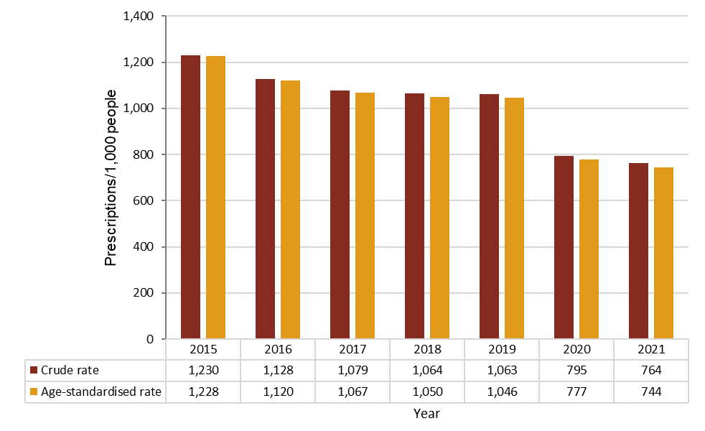

PBS = Pharmaceutical Benefits Scheme; RPBS = Repatriation Pharmaceutical Benefits Scheme  
* Antibacterials for systemic use (ATC code J01) and combinations for eradication of *Helicobacter pylori* (A02BD)  
Source: Gadzhanova, Roughead5

Antimicrobial use in the community decreased slightly between 2020 (17.6 DDD/1,000 people/day) and 2021 (17.5 DDD/1,000 people/day). The volume in 2020 and 2021 showed a 23.4% decrease compared to 2019 (22.9 DDD/1,000 people/day) (Figure 2).

Figure : Quantity of PBS/RPBS antimicrobial* prescriptions dispensed (DDD/1,000 people/day), 2015–2021

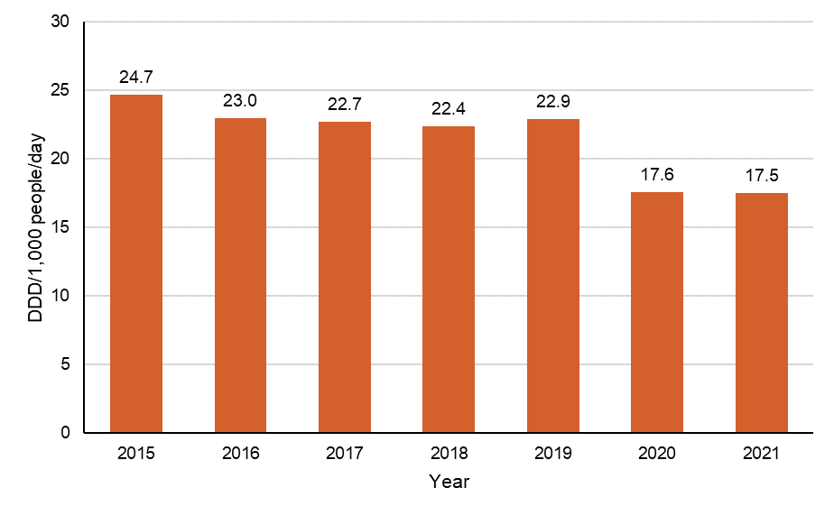

DDD = defined daily dose; PBS = Pharmaceutical Benefits Scheme; RPBS = Repatriation Pharmaceutical Benefits Scheme  
* Antibacterials for systemic use (ATC code J01)  
Source: Gadzhanova, Roughead5

Lower rates of antimicrobial use observed nationally (Figures 1 and 2), were also observed across all states and territories (Figure 3). While a similar pattern of decline was observed from 2015 to 2021 (Figures 1 to 3), rates of supply of antimicrobials varied between states and territories (Figure 3).

In 2019, age-standardised antimicrobial use was highest in Queensland (1,104 prescriptions/1,000 people), New South Wales (1,102 prescriptions/1,000 people), and Victoria (1,023 prescriptions/1,000 people), and lowest in the Northern Territory (717 prescriptions/1,000 people) (Figure 3).

In 2020, age-standardised antimicrobial use was highest in Queensland (852 prescriptions/1,000 people), New South Wales (812 prescriptions/1,000 people), and South Australia (762 prescriptions/1,000 people), and lowest in the Northern Territory (615 prescriptions/1,000 people) (Figure 3).

In 2021, age-standardised antimicrobial use was highest in Queensland (838 prescriptions/1,000 people), Western Australia (748 prescriptions/1,000 people), and South Australia (731 prescriptions/1,000 people), and lowest in the Northern Territory (542 prescriptions/1,000 people) (Figure 3).

Figure : Age-standardised rate of the number of PBS/RPBS antimicrobial* prescriptions dispensed per 1,000 people, by state and territory, 2015–2021

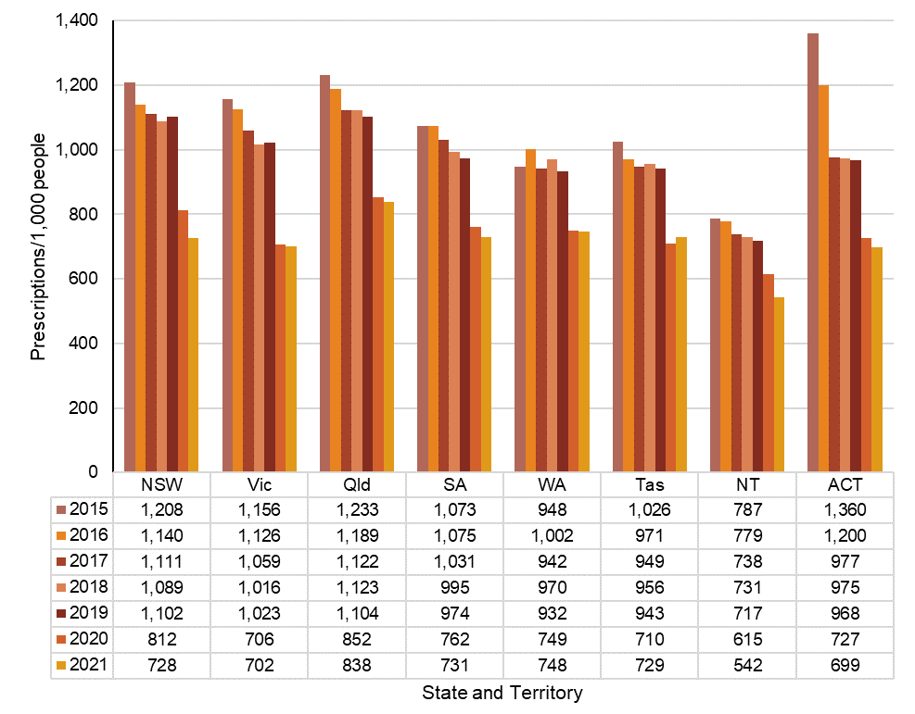

PBS = Pharmaceutical Benefits Scheme; RPBS = Repatriation Pharmaceutical Benefits Scheme  
* All antimicrobials  
Source: Gadzhanova, Roughead5

Figure 3 and Table 6 show comparatively lower rates of antimicrobial dispensing in the Northern Territory than the other states and the Australian Capital Territory. This likely reflects access to antimicrobial supply through sources other than the PBS/RPBS.

Table 6 shows that dispensing rates vary by region (as defined by local SA3). The highest and lowest antimicrobial dispensing rates remained consistent from 2019 to 2021 for all states and territories, except for the SA3 region with the highest rate of antimicrobial dispensing in Victoria in 2019 and the Northern Territory in 2021.

It is noticeable that the area with the lowest dispensing rate is often near to, or contiguous with the area with the highest dispensing rate. This may suggest that local physician preference is a major influence on antimicrobial use.

Table : Highest and lowest PBS/RPBS antimicrobial* dispensing rates per 1,000 people, age standardised, by SA3, 2019–2021

|  |  |  |  |  |  |  |  |  |  |  |  |  |
| --- | --- | --- | --- | --- | --- | --- | --- | --- | --- | --- | --- | --- |
| State or territory | 2019 | | | | 2020 | | | | 2021 | | | |
| Lowest SA3 region | Rate | Highest SA3 region | Rate | Lowest SA3 region | Rate | Highest SA3 region | Rate | Lowest SA3 region | Rate | Highest SA3 region | Rate |
| NSW | Hawkesbury | 514 | Richmond - Windsor | 2030 | Hawkesbury | 407 | Richmond - Windsor | 1503 | Hawkesbury | 342 | Richmond - Windsor | 1328 |
| Vic | Melbourne City | 552 | Melton - Bacchus Marsh | 1374 | Melbourne City | 378 | Casey - South | 951 | Melbourne City | 375 | Casey - South | 983 |
| Qld | Jimboomba | 380 | Beenleigh | 1727 | Jimboomba | 299 | Beenleigh | 1404 | Jimboomba | 295 | Beenleigh | 1414 |
| SA | Adelaide City | 666 | Playford | 1200 | Adelaide City | 514 | Playford | 958 | Adelaide City | 497 | Playford | 934 |
| WA | Augusta - Margaret River - Busselton | 273 | Canning | 1302 | Augusta - Margaret River - Busselton | 229 | Canning | 1038 | Augusta - Margaret River - Busselton | 239 | Canning | 1042 |
| Tas | Central Highlands | 450 | Brighton | 1562 | Central Highlands | 308 | Brighton | 1200 | Central Highlands | 377 | Brighton | 1141 |
| NT | East Arnhem | 40 | Darwin Suburbs | 801 | East Arnhem | 45 | Darwin Suburbs | 681 | East Arnhem | 31 | Palmerston | 647 |
| ACT | North Canberra | 720 | Weston Creek | 1133 | North Canberra | 547 | Weston Creek | 880 | North Canberra | 521 | Weston Creek | 918 |

PBS = Pharmaceutical Benefits Scheme; RPBS = Repatriation Pharmaceutical Benefits Scheme; SA3 = Statistical Area Level 3  
* All antimicrobials  
Note: Rate may be influenced by the availability of other sources of supply of antimicrobials, such as Aboriginal and Torres Strait Islander health services.  
Source: Gadzhanova, Roughead5

As in previous years1-4, the three most commonly dispensed antimicrobials in 2020 and 2021 were cefalexin, amoxicillin and amoxicillin–clavulanic acid (Figure 4), which were most likely used predominately for URTIs. These agents accounted for at least 55% of all antimicrobial prescriptions supplied under the PBS/RPBS in the given year (*n* = 15,328,276/26,669,561 in 2019; *n* = 11,094,028/20,095,926 in 2020; *n* = 11,180,139/19,931,271 in 2021).

The 10 most commonly dispensed antimicrobials accounted for 84.7%, 83.0% and 83.7% of all antimicrobials supplied under the PBS/RPBS in 2019 (*n* = 22,641,543/26,669,561), 2020 (*n*= 16,676,735/20,095,926) and 2021 (*n* = 16,706,709/19,931,271), respectively.

The 10 most commonly dispensed antimicrobials were generally consistent from 2019 to 2021. Some exceptions included trimethoprim–sulfamethoxazole, which was twelfth most commonly dispensed in 2019; phenoxymethylpenicillin, which was eleventh most commonly dispensed in 2020; and clarithromycin, which was the twelfth most commonly dispensed antimicrobial in 2021.

Figure : Ten most commonly dispensed PBS/RPBS antimicrobial prescriptions, by percentage of all antimicrobial prescriptions, 2019–2021

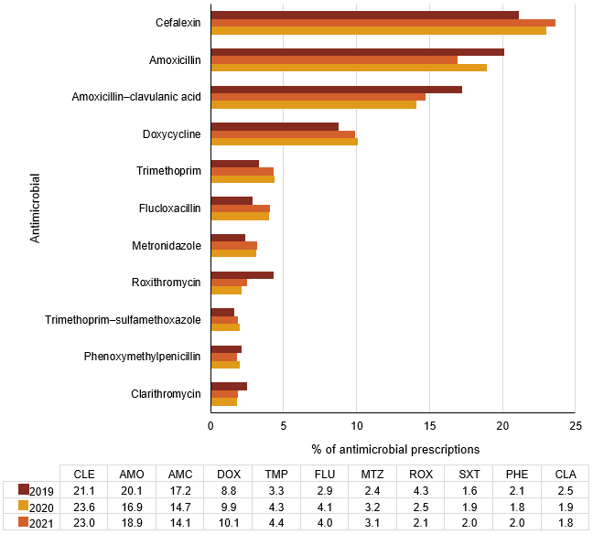

AMC = amoxicillin–clavulanic acid; AMO = amoxicillin; CLA = clarithromycin; CLE = cefalexin; DOX = doxycycline; FLU = flucloxacillin; MTZ = metronidazole; PBS = Pharmaceutical Benefits Scheme; PHE = phenoxymethylpenicillin; ROX = roxithromycin; RPBS = Repatriation Pharmaceutical Benefits Scheme; SXT = Trimethoprim–sulfamethoxazole; TMP = trimethoprim

Note: Outside the ten most commonly dispensed antimicrobials under the PBS/RPBS: Trimethoprim–sulfamethoxazole, 12th in 2019; Phenoxymethylpenicillin, 11th in 2020; Clarithromycin, 12th in 2021.   
Source: Gadzhanova, Roughead5

The most commonly dispensed antimicrobial classes (based on DDD per 1,000 people per day and antimicrobial class; Figure 5) were:

1. Penicillins with extended spectrum (3.4 DDD/1,000 people/day in 2020; 3.6 DDD/1,000 people/day in 2021; mainly amoxicillin)
2. Tetracyclines (3.6 DDD/1,000 people/day in 2020 and 2021; mainly doxycycline)
3. β-lactamase inhibitor combinations (2.8 DDD/1,000 people/day in 2020 and 2021; amoxicillin–clavulanic acid)
4. First-generation cephalosporins (2.5 DDD/1,000 people/day in 2020; 2.4 DDD/1,000 people/day in 2021; cefalexin).

Figure : Number of PBS/RPBS prescriptions dispensed (DDD/1,000 people/day), by antimicrobial class, 2015–2021

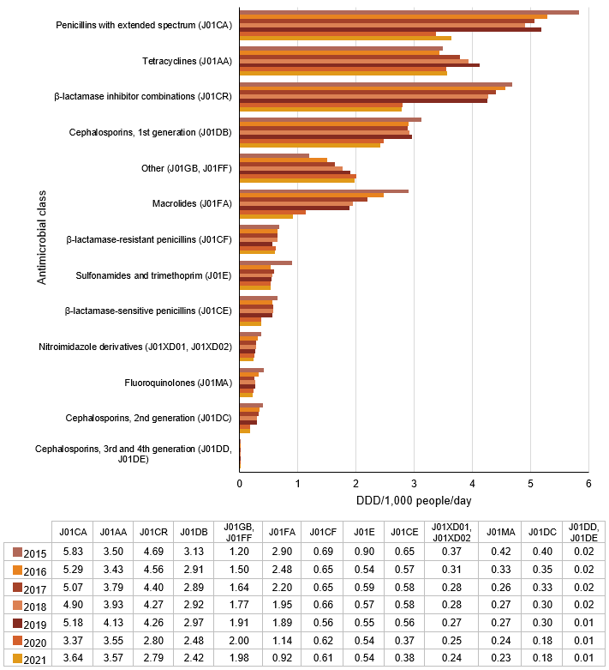DDD = defined daily dose; PBS = Pharmaceutical Benefits Scheme; RPBS = Repatriation Pharmaceutical Benefits Scheme

Source: Gadzhanova, Roughead5

The age-standardised rate of antimicrobials supplied in the winter of 2020 and 2021 was lower across all states and territories when compared to 2019 (data not shown).

The dispensing rate decreased in all age groups each year from 2019 to 2021, except for those aged 0–9 years where the rates increased from 2020 to 2021, most substantially for the 2–4-year age group. However, dispensing rates did not increase to the levels observed in 2019 (Figure 6).

There was noticeable variation in PBS/RPBS antimicrobial dispensing rates for different age groups (Figure 6). In 2020, the rates were highest for those aged 45 years and over, which was consistent across all states and territories. The lowest rate in 2020 was observed for the 5–9-year age group.

In 2021, PBS/RPBS dispensing rates were highest for those aged 65 years and over, which was consistent across all states and territories. The lowest rate in 2021 was observed for the 5–9-year age group. The 2019 patterns of prescribing by patient age group, were similar to those observed in 2021. However, the lowest rate of prescribing was for those aged 10–19 years in 2019.

Figure : Number of PBS/RPBS antimicrobial* prescriptions dispensed per 1,000 people, by patient age group, 2019–2021

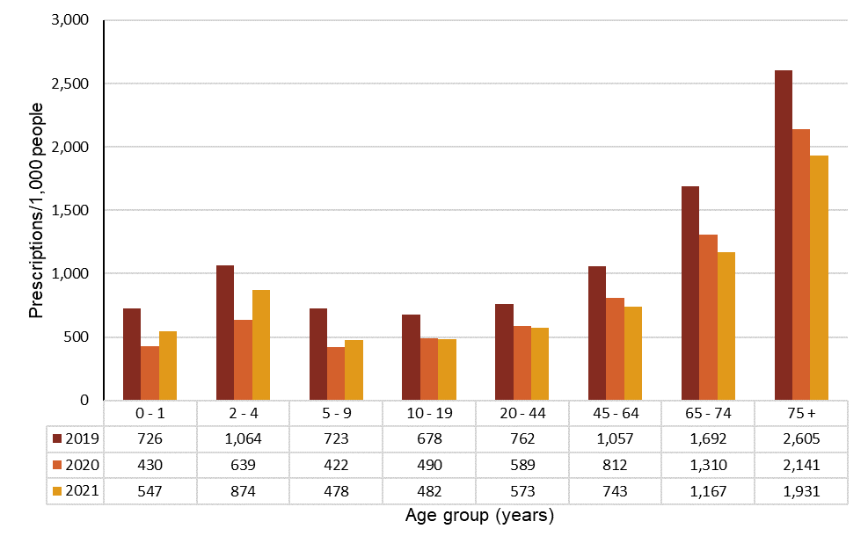PBS = Pharmaceutical Benefits Scheme; RPBS = Repatriation Pharmaceutical Benefits Scheme  
* All antimicrobials  
Source: Gadzhanova, Roughead5

Original prescriptions accounted for 79% of all antimicrobial prescriptions supplied in 2020 and for 83% of all antimicrobial prescriptions supplied in 2021. This compares to 77% in 2019.

Since PBS/RPBS policy changes were implemented from April 2020, the vast majority of original prescriptions for amoxicillin, amoxicillin–clavulanic acid, cefalexin, doxycycline and roxithromycin were ordered without repeats. There was a substantial reduction in the number of repeats that were dispensed for these agents in 2020 and 2021, compared to 2019 (Table 7; 2020 data not shown).

In 2019, approximately 50% of all antimicrobial prescriptions were ordered with repeats – of these, approximately 50% were filled within 10 days of the original prescription.1 Repeat prescriptions filled within 10 days usually indicate a continuation of the original course of treatment. Repeat prescriptions dispensed after 10 days may indicate an interruption of the original duration and increased potential for inappropriate use.

Analysis of the proportion of commonly dispensed antimicrobial prescriptions where the first repeat was dispensed within 10 days of the original, however, showed marginal or little difference between 2019 and 2021 – remaining around one quarter to one half. This is except for roxithromycin, for which there was a considerable reduction in the proportion of repeats dispensed within 10 days of the original after PBS/RPBS restrictions were introduced – from 69.9% in 2019 to 6.4% in 2021 (Table 7). These changes meant that repeats were not allowed for amoxicillin, amoxicillin–clavulanic acid, cefalexin, doxycycline, roxithromycin and flucloxacillin capsules.

Table : Number and percent of PBS/RPBS repeat antimicrobial* prescriptions dispensed within 10 days of the original prescription being dispensed, 2019 and 2021

|  |  |  |  |  |
| --- | --- | --- | --- | --- |
| Antimicrobial | 2019 (*n*) | 2019 (%) | 2021 (*n*) | 2021 (%) |
| Cefalexin | 398,222 | 51.3% | 33,495 | 36.5% |
| Amoxicillin | 193,492 | 50.3% | 39,902 | 50.4% |
| Amoxicillin–clavulanic acid | 510,847 | 61.1% | 25,934 | 60.0% |
| Doxycycline | 102,562 | 32.8% | 66,969 | 24.1% |
| Roxithromycin | 142,145 | 69.9% | 144 | 6.4% |
| Trimethoprim | 35,494 | 40.8% | 30,485 | 39.3% |
| Flucloxacillin | 7,466 | 56.1% | 5,370 | 47.9% |
| Clarithromycin | 54,748 | 55.8% | 28,456 | 49.5% |
| Metronidazole | 14,613 | 44.8% | 12,381 | 40.3% |
| Phenoxymethylpenicillin | 2,582 | 32.5% | 1,709 | 27.3% |
| Trimethoprim–sulfamethoxazole | 28,948 | 34.0% | 20,228 | 26.3% |

PBS = Pharmaceutical Benefits Scheme; RPBS = Repatriation Pharmaceutical Benefits Scheme  
* Most commonly dispensed antimicrobials  
Notes:

1. From 1 April 2020, repeats were not allowed for amoxicillin, amoxicillin–clavulanic acid, cefalexin, doxycycline and roxithromycin (shaded) so 2020 data have been excluded from Table 7 to enable full year-to-year comparison.
2. Repeats were not allowed for flucloxacillin capsules, but repeats were allowed for flucloxacillin powder for oral liquid.
3. Less than 10 days was chosen for analysis as most pack sizes provide treatment for 5 to 10 days.

Source: Gadzhanova, Roughead 5

**Antimicrobial prescribing in general practice: NPS MedicineWise** **MedicineInsight program**

In 2020, 24.8% (639,306/2,581,255) of MedicineInsight patients who attended a practice in that year were prescribed antimicrobials at least once during the year – a reduction of 6.6% compared to 2019. Although this decline is lower than that observed by PBS/RPBS, it may reflect a number of differences in the data between MedicineInsight and PBS/RPBS and the services they capture.

In 2021, 23.5% (654,385/2,778,848) of patients who attended a MedicineInsight practice were prescribed antimicrobials at least once. This is a decrease of 1.3 percentage points compared to 2020, and a reduction of 12 percentage points compared to 2015, when 36.7% (616,019/1,679,592) of patients were prescribed antimicrobials (Figure 7).

Figure : Percentage of patients prescribed one or more antimicrobials*, MedicineInsight practices, 2015–2021

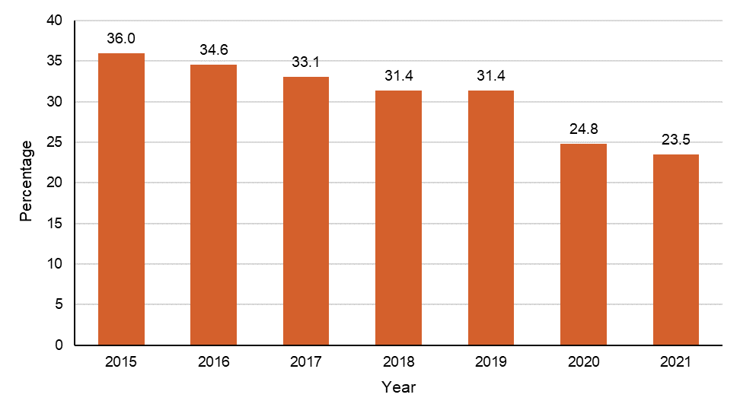

* Antibacterials for systemic use (ATC code J01)  
Note: Number of practices was 480 in 2015, 493 in 2016, 498 in 2017, 502 in 2018, 502 in 2019, 503 in 2020 and 504 in 2021. The number of denominator patients will also change each year (see Methodology).   
Source: NPS MedicineWise6

Among MedicineInsight practices, people aged 90–94 years were more frequently prescribed amoxicillin, amoxicillin–clavulanic acid, azithromycin, cefalexin, ciprofloxacin, doxycycline and roxithromycin than any other age group in both 2020 (39 prescriptions per 100 patients) and 2021 (35 prescriptions per 100 patients).

In 2020 and 2021, in patients aged less than 69 years, the highest rates of prescribing were for people aged 15–19 years (26.5 and 24.3 prescriptions per 100 patients respectively), and children aged 0–4 years (22.9 and 27.1 prescriptions per 100 patients respectively).

Rates of prescribing for all age groups continued to decline from 2020 to 2021, except in children aged 0–9 years in which antimicrobial prescribing rates increased (Figure 8). However, prescribing rates for children aged 0–9 years remained lower than pre-COVID-19 pandemic rates (32 prescriptions per 100 patients in 2019 compared to 27 prescriptions per 100 patients in 2021). In 2020, the prescribing rate for females was higher than for males (29.2 and 27.6 prescriptions per 100 patients, respectively) and also in 2021 (24.1 and 22.6 prescriptions per 100 patients, respectively). For further detail on antimicrobial prescribing trends, including for age groups 15–69 years, see Appendix Figure A3.

Figure : Number of patients prescribed one or more antimicrobials*, per 100 patients, by age group, MedicineInsight practices, 2019–2021

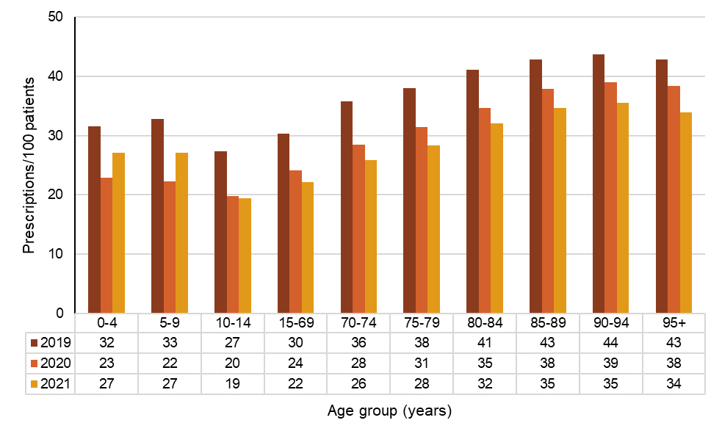

* Antibacterials for systemic use (ACT code J01)  
Note: Number of practices was 502 in 2019, 503 in 2020, and 504 in 2021.  
Source: NPS MedicineWise6

Table 8 summarises the demographics of patients prescribed antimicrobials in MedicineInsight practices between 2019 and 2021. Socioeconomic differences are measured using the SEIFA deciles. In 2020 and 2021, the rate of prescribing per 100 patients was 25.9% and 24.6%, respectively among people living within the most disadvantaged SEIFA decile, and 23.3% and 21.3%, respectively per 100 patients among people living within the least disadvantaged SEIFA decile. There was consistency across states and territories in relation to SEIFA score and the rate of antimicrobial prescriptions.

Differences were observed in antimicrobial prescribing between people living in major cities and those living in more remote areas – there were 25.0 and 23.5 prescriptions in 2020 and 2021, respectively per 100 patients for those living in major cities, compared to 26.9 and 28.1 prescriptions per 100 patients for people living in very remote areas. People living in very remote areas were the only non-metropolitan group for which prescribing rates increased between 2020 and 2021. There were decreases in prescribing rates for all other groups from inner regional to remote areas between 2020 and 2021, consistent with average prescribing rates for this period.

Although overall there was minimal variation in antimicrobial prescribing rates between states and territories, the highest rates were observed in the Northern Territory in 2020 (28.8 prescriptions per 100 patients) and in the Australian Capital Territory in 2021 (26 prescriptions per 100 patients). The lowest rates were observed in Tasmania (23.9 prescriptions per 100 patients) in 2020 and in New South Wales (22.3 prescriptions per 100 patients) in 2021. Tasmania was the only state where prescribing rates increased slightly from 2020 to 2021.

**Table 8**: Region of residence and socioeconomic status (represented by SEIFA decile) for patients prescribed antimicrobials*, MedicineInsight practices, 2019–2021

|  |  |  |  |  |
| --- | --- | --- | --- | --- |
| Measure | Category | Percentage of patients prescribed one or more antimicrobial | | |
| **2019** | **2020** | **2021** |
| State or territory | NSW | 31.7 | 24.4 | 22.3 |
| Vic | 31.8 | 24.0 | 22.9 |
| Qld | 31.6 | 25.5 | 24.5 |
| SA | 31.4 | 26.4 | 24.8 |
| WA | 29.4 | 25.3 | 25.2 |
| Tas | 30.2 | 23.9 | 24.8 |
| NT | 33.5 | 28.8 | 25.2 |
| ACT | 34.3 | 27.2 | 26.0 |
| Remoteness | Major Cities | 32.1 | 25.0 | 23.5 |
| Inner Regional | 30.0 | 24.1 | 23.5 |
| Outer Regional | 31.1 | 25.0 | 24.2 |
| Remote | 24.6 | 20.8 | 19.3 |
| Very Remote | 28.3 | 26.9 | 28.1 |
| Unknown/other | 22.7 | 22.8 | 16.8 |
| SEIFA decile | 1 (most disadvantaged) | 31.6 | 25.9 | 24.6 |
| 2 | 30.8 | 25.1 | 24.1 |
| 3 | 30.8 | 24.7 | 24.7 |
| 4 | 30.7 | 24.9 | 23.8 |
| 5 | 31.5 | 25.0 | 23.6 |
| 6 | 31.9 | 25.2 | 24.2 |
| 7 | 32.0 | 25.2 | 23.8 |
| 8 | 31.8 | 25.2 | 24.0 |
| 9 | 31.1 | 23.8 | 22.6 |
| 10 (least disadvantaged) | 31.6 | 23.3 | 21.3 |
| Unknown/other | 22.7 | 22.8 | 16.8 |

SEIFA = Socio-Economic Indexes for Areas

* Antibacterials for systemic use (ATC code J01)

Notes:

* + - 1. The number of MedicineInsight practices was 498 in 2017, 502 in 2018, 502 in 2019, 503 in 2020 and 504 in 2021.
      2. The number of patients in the denominator may change each year.
      3. Differences across states and territories should be interpreted with caution because of non-random sampling and varying levels of participation in the MedicineInsight program.

Source: NPS MedicineWise6

**Antimicrobial prescribing: trends from 2015 to 2021**

Figures 9 to 11 show data on the high use antimicrobials recorded in the MedicineInsight program. Between January 2015 and December 2021, the number of antimicrobial prescriptions (originals and repeats) per 100 GP consultations in participating MedicineInsight practices steadily declined, from a peak of 22.9 (229,672/1,001,891) in August 2015 to a trough of 11.1 (142,069/1,281,039) in June 2021. Monthly and seasonal variations were observed throughout this period. However, the variation observed across 2020 and 2021 was much smaller compared to previous years (Figures 9 and 10). During the COVID-19 pandemic antimicrobial prescribing decreased from an average of 16 prescriptions per 100 GP visits in 2019 to an average of 7 prescriptions per 100 GP visits in both 2020 and 2021.

Seasonal prescribing variation, with peaks in winter months, was observed for all antimicrobials, except cefalexin. This is possibly because cefalexin is less commonly prescribed when an antimicrobial is indicated for a respiratory tract infection.

There were more prescriptions for cefalexin during the summer period, and it was also the most frequently prescribed antimicrobial in 2020 and 2021. However, cefalexin prescribing rates declined by 36.4% from 3.3 to 2.1 prescriptions per 100 GP visits from March 2020 to May 2020, respectively. The rate of amoxicillin prescribing also decreased dramatically at this time after an overall ongoing decline since 2016.

Figures 10 and 11 show the rate of prescribing for originals and repeats respectively, and both demonstrate a decreasing pattern for amoxicillin, consistent with the trends observed for original and repeats combined in Figure 9. Smaller decreases in prescribing rates were observed for other antimicrobials commonly used for respiratory tract infections (amoxicillin–clavulanic acid, doxycycline, azithromycin and roxithromycin) but not for cefalexin, which is more frequently used for the treatment of skin and soft tissue infections and UTIs. Of note, there was only a marginal decrease in the rate of doxycycline repeat prescriptions following the introduction of PBS/RPBS restrictions, compared to other high use antimicrobials (Figure 11). This is possibly because doxycycline has a broader range of indications.

Figure : Rate of high use antimicrobials prescribed (total prescriptions including originals and repeats) per 100 GP visits, MedicineInsight practices, 2015–2021

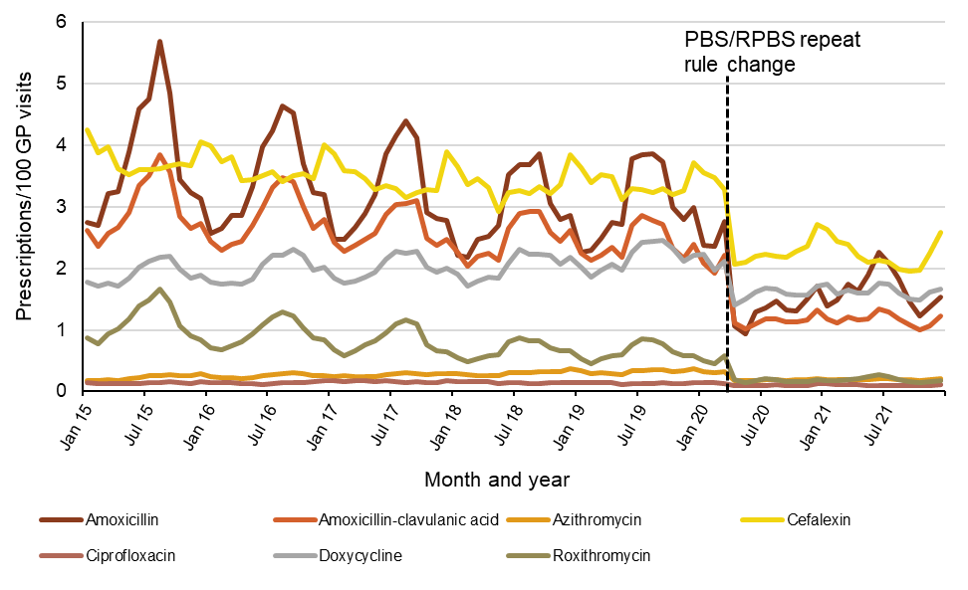

GP =  general practitioner; PBS = Pharmaceutical Benefits Scheme; RPBS = Repatriation Pharmaceutical Benefits Scheme  
Note: Monthly variations were observed and were consistent with seasonal variations – the number of prescriptions per 100 GP visits increased during the winter months.  
Source: NPS MedicineWise6

Figure : Rate of original high use antimicrobial prescriptions issued per 100 GP visits, MedicineInsight practices, 2015–2021

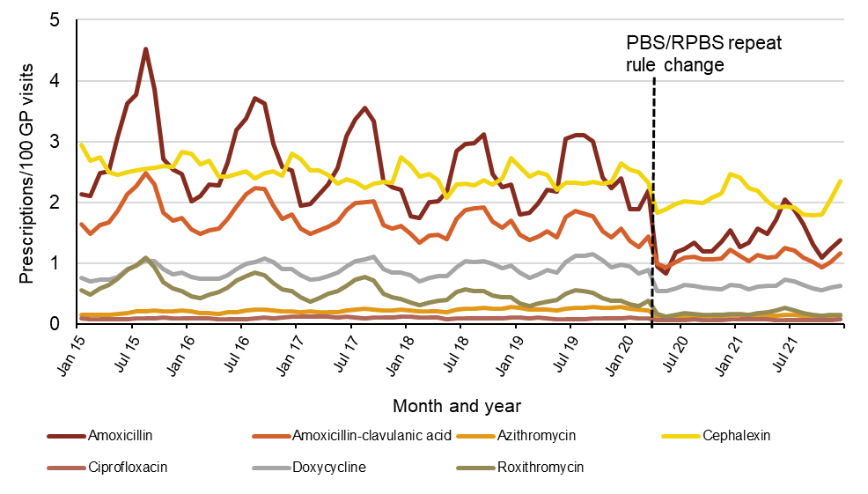 GP = general practitioner; PBS = Pharmaceutical Benefits Scheme; RPBS = Repatriation Pharmaceutical Benefits Scheme  
Source: NPS MedicineWise6

Figure  : Rate of repeat high use antimicrobial prescriptions issued per 100 GP visits, MedicineInsight practices, 2015–2021

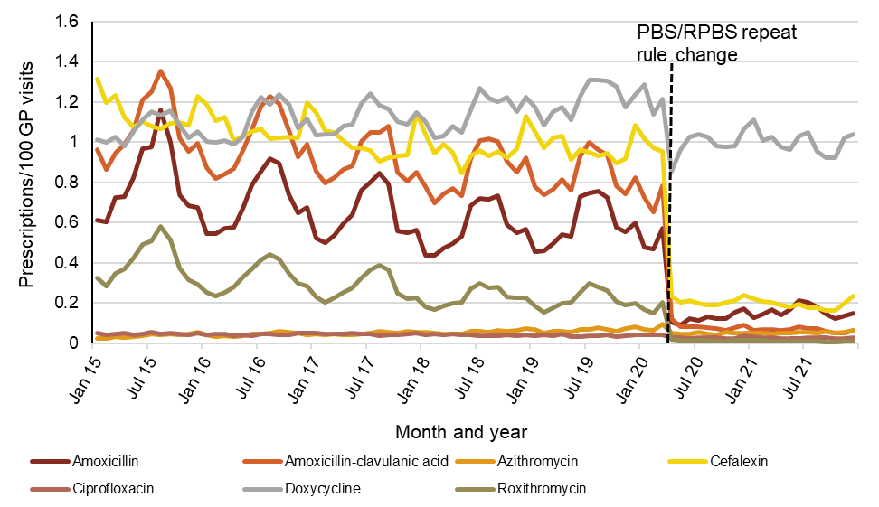

GP = general practitioner; PBS = Pharmaceutical Benefits Scheme; RPBS = Repatriation Pharmaceutical Benefits Scheme  
Source: NPS MedicineWise6

Figure 12 shows the percentage of all antimicrobial prescriptions that were likely indicated for respiratory tract infections. From 2015 to 2019, approximately one quarter of antimicrobial prescriptions were issued for respiratory tract infections. This decreased in 2020 to 16.0% but rose slightly to 17.3% in 2021.

Figure : Percentage of total antimicrobial* prescriptions recorded on the same day as presentations for respiratory tract infections, MedicineInsight practices, 2015–2021

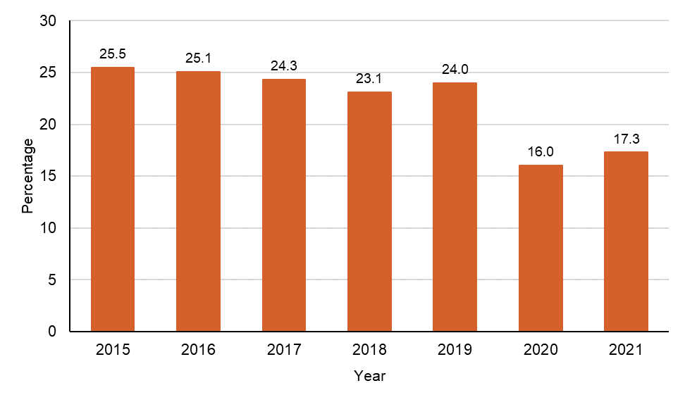

* Antibacterials for systemic use (ATC code J01)

Notes:

1. Respiratory tract infections include acute bronchitis, acute upper respiratory tract infection, influenza/influenza-like illness, pneumonia, and sinusitis.
2. Percent of total antimicrobial prescription including indications not recorded.

Source: NPS MedicineWise6

The number of non-PBS/RPBS subsidised antimicrobials, like those subsidised by the PBS/RPBS, rose steadily from 2015 to 2020 then decreased dramatically from March 2020 to April 2020. This reduction was maintained, although it increased steadily from May 2020 (Figure 13).

While a decrease occurred in April 2020, the proportion of high use antimicrobial non-PBS/RPBS prescriptions continued to increase such that it more than doubled from 2.5% (54,152/2,144,394) in 2015 to 5.3% (79,207/1,502,438) in 2021 (Figure 14). This is notwithstanding this volume is relatively small compared to PBS/RPBS prescriptions.

With the exception of these data from the MedicineInsight program, there are no reporting mechanisms available for non-PBS/RPBS prescriptions. This represents an important gap in the surveillance of antimicrobial use in Australia.

Figure : Number of non-PBS/RPBS antimicrobial* prescriptions per 100 GP Visits, MedicineInsight practices, 2015–2021

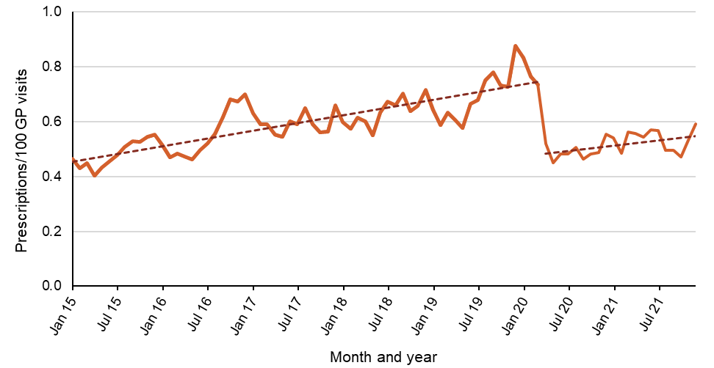

GP = general practitioner; PBS = Pharmaceutical Benefits Scheme; RPBS = Repatriation Pharmaceutical Benefits Scheme  
* Antibacterials for systemic use (ATC code J01)

Source: NPS MedicineWise6

Figure : Percentage of non-PBS/RPBS antimicrobial* prescriptions (originals plus repeats) of total antimicrobial* prescriptions (originals plus repeats), MedicineInsight practices, 2015–2021

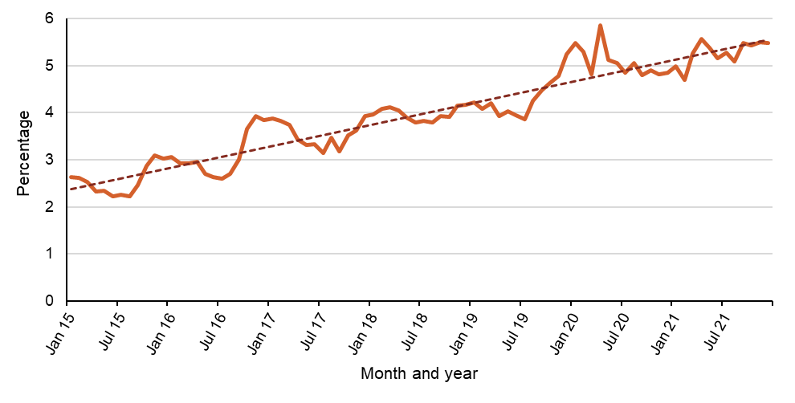

PBS = Pharmaceutical Benefits Scheme; RPBS = Repatriation Pharmaceutical Benefits Scheme  
* Antibacterials for systemic use (ATC code J01)

Notes:

* + - 1. Figure 14 represents the proportion of prescriptions that are written with repeats, compared to prescriptions that are written as originals (repeat not stated). It is noted that changes in number of GP visits, practices and patients occur over time.
      2. Number of practices was 480 in 2015, 493 in 2016, 498 in 2017, 502 in 2018, 502 in 2019, 503 in 2020, and 504 in 2021.

Source: NPS MedicineWise6

It is notable that there has been a high and increasing proportion of non-PBS/RPBS azithromycin prescriptions between 2015 and 2021. This was at 51.4% (22,299/43,391) in 2019, which was sustained into 2020 (14,432/30,239, 47.7%) and 2021 (14,050/28,743, 48.9%). It is possible that azithromycin is being prescribed in favour of roxithromycin – also a macrolide antibiotic – in general practice.

There was also a steady rise in the proportion of non-PBS/RPBS prescriptions for ciprofloxacin, reaching 36.0% (6,405/17,771) by 2019. This may be partly attributed to the ciprofloxacin PBS/RPBS restriction category. Understanding the total use of ciprofloxacin as a broad-spectrum antimicrobial, is important as Australia has historically had low rates of ciprofloxacin use compared to other countries, and limiting its use is a key aspect of AMS programs.

Non-PBS/RPBS prescribing of ciprofloxacin increased from an average of 334 prescriptions per month in 2015 (0.04 prescriptions per 100 GP visits) to an average of 534 prescriptions per month in 2019 (0.05 prescriptions per 100 GP visits). There was a small decline in 2020 and 2021, with an average of 416 prescriptions per month (0.035 prescriptions per 100 GP visits). However, a small uptick occurred in the second half of 2021 with 441 non-PBS/RPBS prescriptions for ciprofloxacin (0.041 prescriptions per 100 GP visits) in December 2021.

While amoxicillin, roxithromycin and doxycycline are available for all common indications on the PBS/RPBS, approximately 10% of all doxycycline prescriptions were non-PBS/RPBS between 2015 and 2019. This declined slightly to approximately 8% during 2020 to 2021. There was also an upward trend in non-PBS/RPBS prescribing of doxycycline in December 2021. These findings for doxycycline and ciprofloxacin may be related to prescribing for travel-related purposes, which is not subsidised by the PBS/RPBS.

There have been increasing restrictions placed on amoxicillin–clavulanic acid within the PBS/RPBS. However, non-PBS/RPBS prescriptions for amoxicillin–clavulanic acid accounted for less than 2% (37,760/2,011,825) of total prescriptions between 2015 and 2021. In 2019, amoxicillin–clavulanic acid accounted for 2.4% (7,905/323,131) of total prescriptions. During 2020 and 2021 this increased to 3.6% (13,091/364,055) of non-PBS/RPBS prescriptions, with 4.1% (534/13,117) of amoxicillin–clavulanic acid prescriptions prescribed privately in December 2021. Amoxicillin–clavulanic acid is a broader spectrum antibiotic that should be restricted to guideline-indicated infections. Use outside of PBS/RPBS restrictions should be discouraged unless clinically appropriate.

**Patterns of prescribing**

Table 9 shows patterns of GP prescribing in 2021 for high use antimicrobials in the MedicineInsight program. In 2021, cefalexin was the most frequently prescribed antimicrobial followed by amoxicillin, amoxicillin–clavulanic acid, doxycycline, roxithromycin, azithromycin and ciprofloxacin. This order has remained the same since 2015. However, the proportion of cefalexin prescribed relative to the other high use antimicrobials increased during 2020 and 2021.

The most commonly recorded indications for cefalexin prescribing in 2020 and 2021 were skin infections (22.3% and 20.7% of prescriptions, respectively) and UTIs (17.2% and 16.7% of prescriptions, respectively). Of these prescriptions, on average, 4.9% were recorded as indicated for respiratory-related conditions (acute bronchitis, acute tonsillitis, acute URTI, influenza/influenza-like illness, pneumonia and sinusitis). This may be why there was less impact on the number of original prescriptions for cefalexin compared to other high use antimicrobials during the COVID-19 pandemic.

The ‘Reason for Prescription’ field was completed for approximately 37% of prescriptions issued by MedicineInsight practices between 2015 and 2021. If there was no data in the ‘Reason for Prescription’ field that matched one of the identifiable conditions, then the analysis included the ‘Reason for Encounter and Diagnosis’ recorded on the same day as the prescription to identify the indication. As a result, NPS MedicineWise was able to establish the likely indication for the prescription in more than 65% of cases.

Table : Patterns of GP prescribing for high use antimicrobials, MedicineInsight practices, 2021

|  |  |  |  |  |  |
| --- | --- | --- | --- | --- | --- |
| Antimicrobial | Patients issued a prescription (PBS/RPBS or private) (%) * | Most common indication (%) † | Patient age group with highest rate§ of prescribing (years) | Prescrip­tions (PBS/RPBS or non-PBS) ordered with repeats (%) | Prescriptions ordered as non-PBS/RPBS ordered with repeats (%) |
| Cefalexin | 7.7 | * Skin/wound infection (20.7) * UTI (16.7) * Other infection (8.4) * Respiratory-related infection (5.2) | 90–94 | 7.2 | 0.9 |
| Amoxicillin | 6.5 | * URTI (acute) (16.3) * Pneumonia (10.6) * Otitis media (10.3) * Sinusitis (acute/chronic) (8.5) | 0–4 | 9.1 | 0.9 |
| Amoxicillin–clavulanic acid | 4.1 | * Other infection (13.2) * Sinusitis (acute/chronic) (8.1) * Skin/wound infection (6.2) * Pneumonia (5.8) | 80–84 | 5.4 | 2.9 |
| Doxycycline | 3.9 | * Acne (16.4) * Pneumonia (10.2) * Skin/wound infection (6.2) * Sinusitis (6.0) | 15–19 | 60.9 | 6.8 |
| Roxithromycin | 1.7 | * URTI (acute) (17.2) * Pneumonia (12.1) * Sinusitis (acute/chronic) (7.6) * Other infection (6.8) * Bronchitis (acute) (5.4) | 80–84 | 2.7 | 1.6 |
| Azithromycin | 0.6 | * *Chlamydia* infection (12.2) * Unclassified reason for prescription# (9.6) * Pneumonia (6.8) * Other infection (6.6) | 20–24 | 16.8 | 44.6 |
| Ciprofloxacin | 0.3 | * Other infection (31.6) * Unclassified reason for prescription# (10.8) * UTI (9.7) * Skin/wound infection (8.3) | 95+ | 24.5 | 37.4 |

GP = general practitioner; PBS = Pharmaceutical Benefits Scheme; RPBS = Repatriation Pharmaceutical Benefits Scheme; URTI = upper respiratory tract infection; UTI = urinary tract infection   
* Percentage of patients who visited a MedicineInsight practice general practitioner at least once between 1 January and 31 December 2021 and had one or more prescriptions for the specified antimicrobial issued on the day of the visit   
† 34.7% of prescriptions in 2019 included an explicit reason for prescription recorded. If an explicit recorded reason for the prescription was incomplete, an association was assumed between the antimicrobial prescribed and a reason for the encounter and/or a diagnosis that was recorded on the same day as the prescription

§ Number of MedicineInsight patients prescribed one or more antimicrobial prescriptions, per 100 patients

# Prescriptions with a recorded entry in the reason for prescription, or a reason for encounter or diagnosis on the same day that did not match an antimicrobial-related indication

Note: The denominator reflects number of patients and therefore ranking and values will be different to denominator using GP visits. Source: NPS MedicineWise6

In 2019, one fifth (20.2%) of ciprofloxacin prescriptions did not have a clear indication, with ‘other infection’ being the most common indication. This pattern continued into 2020 and 2021, as ‘other infection’ (23.5% and 31.6% respectively) and ‘unclassified reason for prescription’ (12.2% and 10.8% respectively) were the most commonly recorded reasons for prescribing ciprofloxacin. This was followed by UTIs (10.6% in 2020; 9.7% in 2021). As ciprofloxacin has a broad-spectrum of activity, recording its indication is important in order to understand appropriateness of prescribing, identify focus areas for AMS interventions, and limit the impact on AMR.

PBS/RPBS benefits are restricted for both azithromycin and ciprofloxacin. Prescribing of azithromycin has steadily increased in contrast to the declining prescribing of ciprofloxacin (Figure15). It is important to note that the use of azithromycin for the treatment of conditions such as chlamydia and gonorrhoea in the sexual health clinic setting may not be captured in these data.

Figure : Number of PBS/RPBS prescriptions for azithromycin and ciprofloxacin per 100 GP visits, MedicineInsight practices, 2015–2021

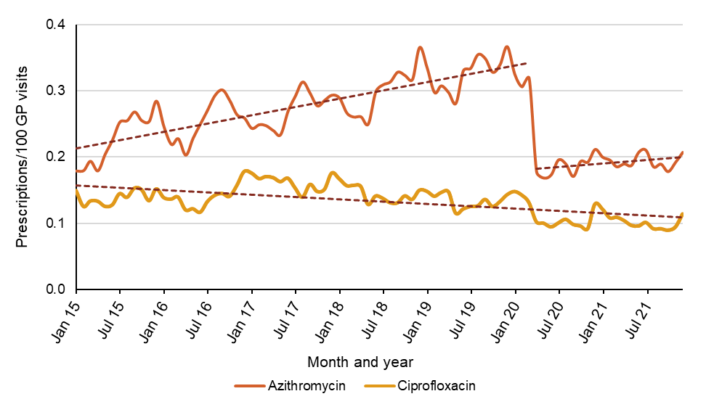

GP = general practitioner; PBS = Pharmaceutical Benefits Scheme; RPBS = Repatriation Pharmaceutical Benefits Scheme  
Source: NPS MedicineWise6

As in previous reports1, similar prescribing patterns were identified across patient age groups for amoxicillin, cefalexin, doxycycline, azithromycin, and ciprofloxacin, but less so for amoxicillin–clavulanic acid and roxithromycin. Amoxicillin was commonly prescribed for children aged 0–4 years (15.0 per 100 patients), while cefalexin and ciprofloxacin were commonly prescribed for adults aged 85 years or over (19.2–21 per 100 patients; 1.4-1.8 per 100 patients). Doxycycline was commonly prescribed for the 15–19 year age group (4.7 per 100 patients) and azithromycin for the 20–24 year age group (1.9 per 100 patients) (Figure 16). This pattern of prescribing likely reflects the common infection types most seen in these age groups (Table 9).

Figure : Number of patients per 100 patients prescribed one or more high use antimicrobials, by age group, MedicineInsight practices, 2020–2021

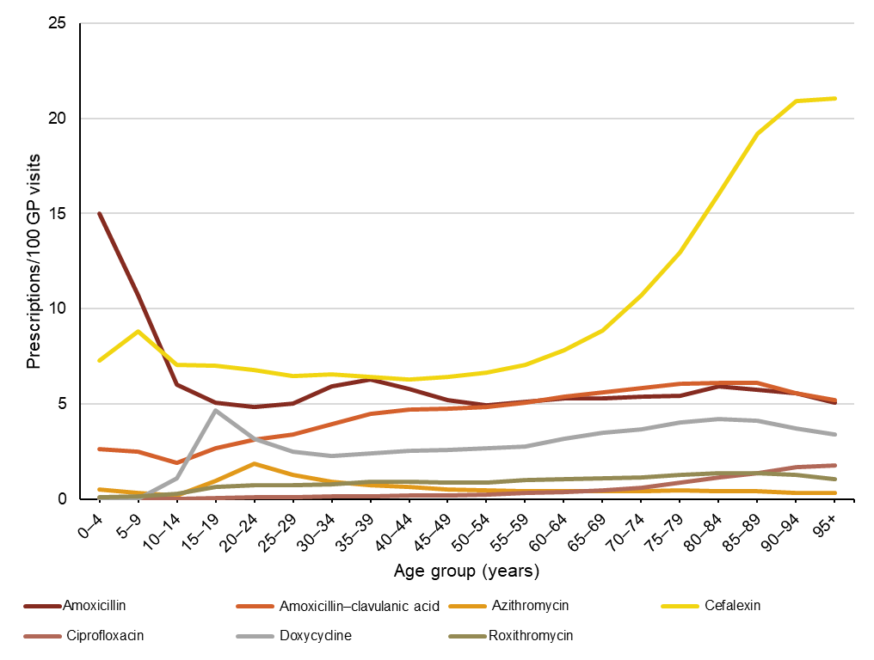

Note: The number of practices in 2020 was 503, and 504 in 2021.   
Source: NPS MedicineWise6

#### Appropriateness of prescribing

For conditions such as acute bronchitis for which antimicrobials are not recommended, antimicrobials were prescribed in almost 80% of presenting patients aged 18–75 years. Approximately 19–40% of patients presenting with acute tonsillitis are expected to require antimicrobial treatment. However, 84.5% of patients with tonsillitis who were older than 1 year were treated with an antimicrobial in 2020, and 86.1% in 2021. Similarly, 83.3% and 85.8% of patients in 2020 and 2021, respectively, were provided an antimicrobial prescription for acute otitis media despite estimates that antimicrobials may be required in only 20–31% of cases.21 Although direct comparisons should be made with caution, these percentages suggest that antimicrobials are overprescribed for these conditions compared to recommendations in the *Therapeutic Guidelines: Antibiotic*16 and relevant clinical pathways (Table 10); a trend that has continued from previous reports.1-4

These data also highlight that, for some conditions, antimicrobial prescribing was not consistent with first-line recommendations in *Therapeutic Guidelines: Antibiotic*.16 For example, only 30.2% and 34.3% of MedicineInsight patients with sinusitis and who were prescribed an antimicrobial received guideline-recommended amoxicillin in 2020 and 2021, respectively.

Table : Number and percentage of patients prescribed antimicrobials* by GPs for selected conditions, MedicineInsight practices, 2020–2021

|  |  |  |  |  |  |  |  |  |
| --- | --- | --- | --- | --- | --- | --- | --- | --- |
| Condition§ | Patients | 2020 | | | 2021 | | | Expected  new cases to be  managed with  antimicrobials† |
| **No.** | **%** | **95% CI** | **No.** | **%** | **95% CI** | **Range (%)** |
| Acute bronchitis | Aged 18–75 years prescribed antimicrobials | 11,007 | 78.5 | 76.0–81.1 | 12,403 | 80.9 | 78.9-82.9 | 0 |
| COPD | Aged 18–75 years prescribed antimicrobials | 7,326 | 31.0 | 29.9–32.2 | 6,981 | 32.0 | 30.7-33.3 | nd |
| Influenza-like illness | Older than 1-year prescribed antimicrobials | 650 | 8.6 | 7.4– 9.5 | 287 | 6.3 | 3.8- 8.7 | 0 |
| Acute otitis media | Older than 2 years prescribed antimicrobials | 20,809 | 83.3 | 81.6–85.0 | 26,137 | 85.8 | 84.5-87.0 | 20–31 |
| And prescribed TG-recommended amoxicillin | 13,818 | 55.3 | 53.5–57.1 | 18,284 | 60.0 | 58.1-61.9 | 20–31 |
| Pneumonia | Aged 18–65 years prescribed antimicrobials | 26,978 | 78.4 | 76.4–80.5 | 30,804 | 83.8 | 82.6-85.1 | nd |
| And prescribed TG-recommended antimicrobial (for mild CAP – amoxicillin or doxycycline) | 15,814 | 46.0 | 44.1–47.8 | 19,236 | 52.3 | 50.2-54.5 | 100 |
| Sinusitis (acute/chronic) | Older than 18 years prescribed antimicrobials | 35,947 | 75.2 | 73.5–76.8 | 38,028 | 78.2 | 76.9-79.6 | 0.5-8 |
| And prescribed TG-recommended amoxicillin | 14,463 | 30.2 | 28.8–31.7 | 16,667 | 34.3 | 32.4-36.2 | 0.5–8 (acute) |
| Acute tonsillitis | Older than 1-year prescribed antimicrobials | 26,158 | 84.5 | 81.0–87.9 | 26,384 | 86.1 | 83.8-88.3 | 19-40 |
| And prescribed TG-recommended penicillin V | 14,835 | 48.0 | 44.5–51.3 | 15,561 | 50.8 | 47.9-53.6 | 19-40 |
| Acute URTI | Older than 1-year prescribed antimicrobials | 64,676 | 27.4 | 25.3–29.5 | 70,165 | 35.1 | 33.1-37.0 | nd |
| UTI | Females older than 18 years prescribed antimicrobials | 65,943 | 89.5 | 88.5–90.5 | 63,436 | 90.6 | 89.9-91.3 | nd |
| And prescribed TG-recommended trimethoprim | 30,646 | 41.6 | 40.3–42.8 | 29,516 | 42.2 | 40.9-43.4 | nd |

CAP = community-acquired pneumonia; CI = confidence interval; COPD = chronic obstructive pulmonary disease; GP = general practitioner; nd = not determined; TG = *Therapeutic Guidelines: Antibiotic*; URTI = upper respiratory tract infection; UTI = urinary tract infection

* Antibacterials for systemic use (ATC code J01)  
† Mean percentage of new cases to be managed with antimicrobials, based on guideline recommendations, where available

§ NPS MedicineWise developed algorithms to identify specific conditions and measures of interest in the MedicineInsight database, based on commonly accepted definitions. These definitions may differ slightly from McCullough et al.21

Note: Number of practices in 2020 was 503, and 504 in 2021.

Source: NPS MedicineWise6, McCullough et al.21

Prescribing rates for acute bronchitis, acute sinusitis, acute URTI and influenza-like illnesses were not consistent with national guidelines21, but showed improvement in appropriateness from 2015 to 2021.6,21 This is compared to other conditions including UTIs and acute otitis media, for which appropriateness has not improved21 and prescribing rates for these conditions remain high (Figure 17).

For conditions where antimicrobials are generally recommended, rates of antimicrobial use varied. For example, antimicrobial use in patients presenting with UTIs increased. Antimicrobial prescribing for pneumonia, sinusitis, and acute URTIs decreased at the start of the COVID-19 pandemic, and returned to pre-pandemic rates in 2021.

Figure : Trends in antimicrobial* prescribing rates for specific conditions, MedicineInsight practices, 2015–2021

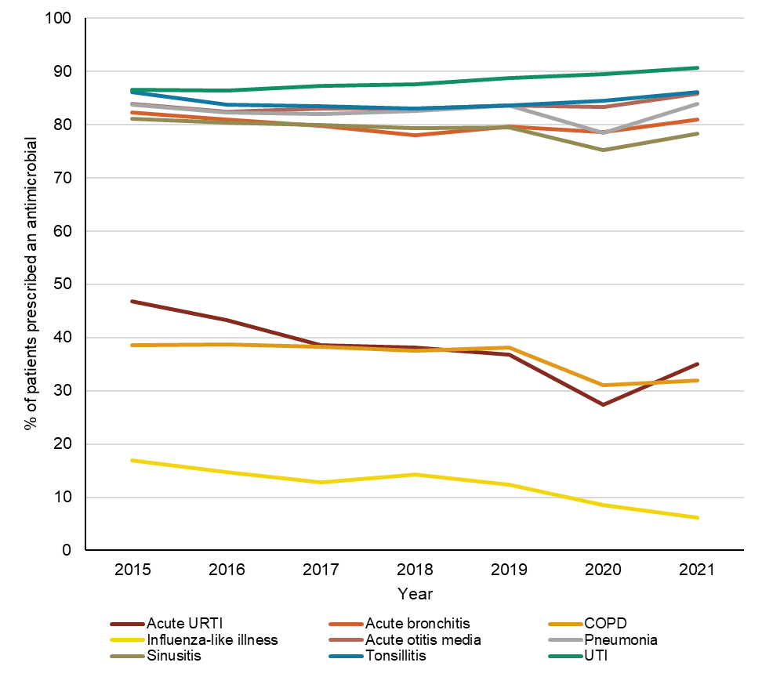

COPD = chronic obstructive pulmonary disorder; URTI = upper respiratory tract infection; UTI = urinary tract infection  
* Antibacterials for systemic use (ATC code J01)  
Source: NPS MedicineWise6

#### Telehealth service

Although telehealth services existed prior to the COVID-19 pandemic, they were not commonly available or subsidised. Changes to the MBS to facilitate improved access to telehealth services, were introduced in April 2020. From March 2020 to December 2020, it was estimated that 3 in 10 of all consultations were provided as a telehealth service (mostly telephone consultations), with particularly high usage in Victoria during the second wave of the COVID-19 pandemic.22

The rates of GP prescribing of antimicrobials for patients during a telehealth compared to face-to-face consultations are shown in Figure 18. Antimicrobial prescribing rates per 100 GP visits were lower on average for telehealth services compared to face-to-face services.

Figure : Rate of antimicrobial* prescribing per 100 telehealth visits per 100 face-to-face visits or per 100 GP visits of any type (all visits), MedicineInsight practices, 2020–2021

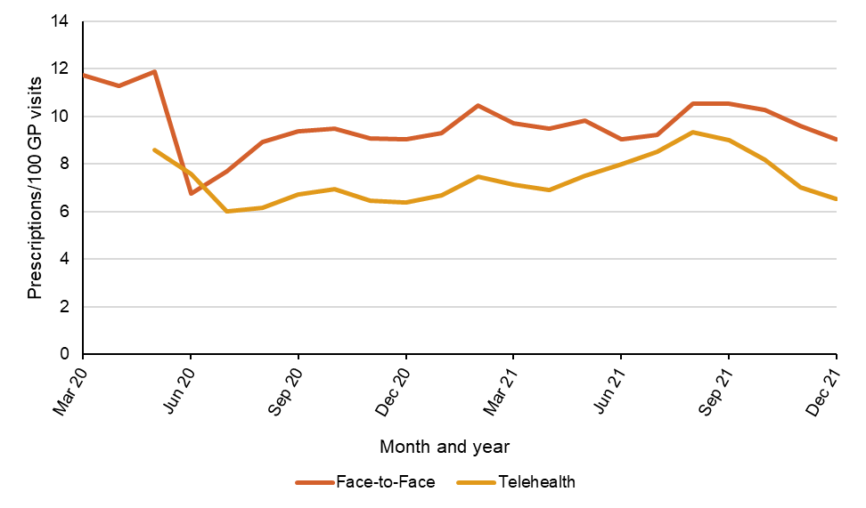

* Antibacterials for systemic use (ATC code J01)

Notes:

1. Data presented for antimicrobial prescription rates (original prescription only) from practices with 2020–2021 Billing by GP Interaction type (based on +/- 1 Day Match).
2. Includes only acute encounters. MBS telehealth items for chronic disease management, health assessments, mental health, pregnancy support counselling, autism or eating disorders have not been included.
3. There were 484 practices that had compatible billing software for this analysis, out of a potential 503 practices in 2020 and 504 practices in 2021.

Source: NPS MedicineWise6

**Impact of COVID-19 on antimicrobial use**

#### Monthly number of prescriptions for antimicrobials for systemic use

Figure 19 shows the number of PBS/RPBS prescriptions dispensed for antimicrobials from 2019 to 2021, and Figure 20 shows the rate of community antimicrobial use as DDD/1,000 people/day.

A peak in the number of prescriptions for antimicrobials was observed in March 2020. This is consistent with reported stockpiling of medicines before COVID-19 pandemic restrictions were implemented23 – which also affected availability of antihypertensives, cholesterol-lowering medicines, and other goods. Use of PBS/RPBS antimicrobials markedly reduced in April 2020. The number of PBS/RPBS prescriptions supplied decreased from 2.3 million in March 2020 to 1.4 million in April 2020 – a 40.3% drop. Antimicrobial use in 2021 increased in winter but overall remained lower compared to 2019.

MedicineInsight data complements these findings showing antimicrobial prescriptions issued per 100 GP visits markedly decreased from April 2020 (Figure 21).

Figure : Number of PBS/RPBS antimicrobial* prescriptions dispensed, 2019–2021

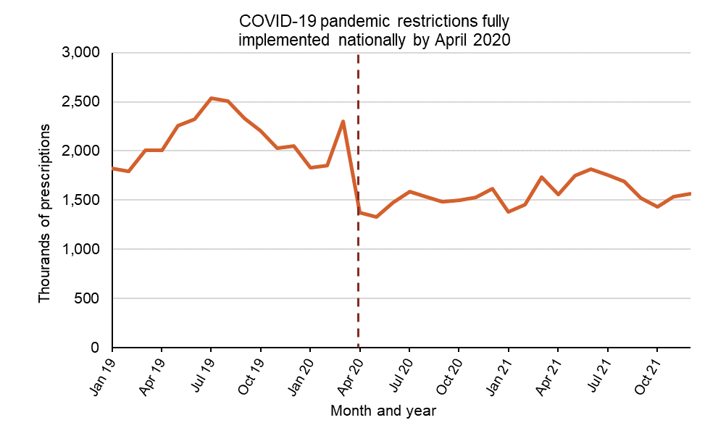

PBS = Pharmaceutical Benefits Scheme; RPBS = Repatriation Pharmaceutical Benefits Scheme  
* Antibacterials for systemic use (ATC code J01)   
Source: Gadzhanova, Roughead5

Figure : Quantity of PBS/RPBS antimicrobial* prescriptions dispensed (DDD/1,000 people/day), 2019–2021

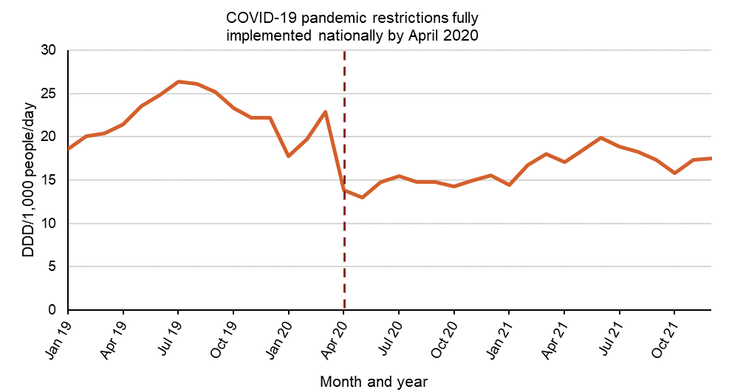

DDD = Defined daily dose; PBS = Pharmaceutical Benefits Scheme; RPBS = Repatriation Pharmaceutical Benefits Scheme  
* Antibacterials for systemic use (ATC code J01)  
Source: Gadzhanova, Roughead5

Figure : Monthly total antimicrobial* prescriptions per 100 GP visits, MedicineInsight practices, 2015–2021

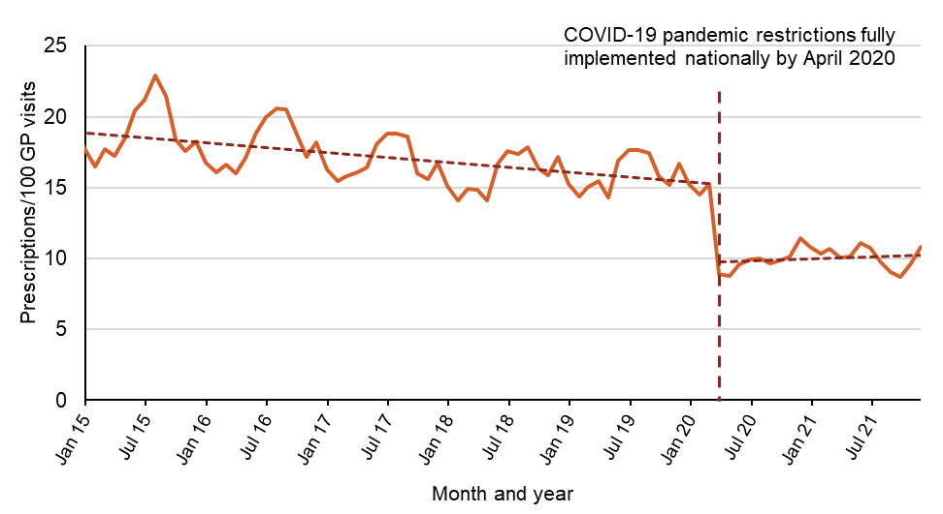

GP = general practitioner  
* Antibacterials for systemic use (ATC code J01)   
Source: NPS MedicineWise6

Tables 11 and 12 report changes in antimicrobial use for each month of 2020 and 2021, compared to the same month in the previous year.

There was an average decrease of 34% in the number of prescriptions issued between April and December 2020 compared to the same period in 2019. The average decrease in the volume supplied between April and December 2020 compared to the same period in 2019 was 39%.

While lower than 2019, the number of prescriptions supplied and volume of antimicrobials dispensed remained lower in 2021 until April, compared to 2020.

For amoxicillin, amoxicillin–clavulanic acid, clarithromycin, phenoxymethylpenicillin, roxithromycin and trimethoprim, 6 of the 10 most commonly PBS/RPBS-dispensed antimicrobials between 2017 and 2021, use increased across winter in 2021 but did not increase to levels as high as prior to the pandemic (data not shown).

Table : Number of PBS/RPBS antimicrobial* prescriptions, 2019–2021 (year-to-year comparison)

|  |  |  |  |  |  |
| --- | --- | --- | --- | --- | --- |
| Month | Prescription numbers, 2019 | Prescription numbers, 2020 | Prescription numbers, 2021 | Percent change in prescription numbers, 2019 to 2020 | Percent change in prescription numbers, 2020 to 2021 |
| January | 1,820,483 | 1,828,814 | 1,383,944 | 0.5% | -24.3% |
| February | 1,791,389 | 1,851,621 | 1,455,118 | 3.4% | -21.4% |
| March | 2,007,020 | 2,301,800 | 1,731,488 | 14.7% | -24.8% |
| April | 2,007,517 | 1,373,470 | 1,561,206 | -31.6% | 13.7% |
| May | 2,259,025 | 1,332,901 | 1,751,783 | -41.0% | 31.4% |
| June | 2,322,758 | 1,480,499 | 1,818,959 | -36.3% | 22.9% |
| July | 2,538,929 | 1,588,499 | 1,759,258 | -37.4% | 10.7% |
| August | 2,508,220 | 1,535,752 | 1,689,161 | -38.8% | 10.0% |
| September | 2,332,355 | 1,487,862 | 1,520,661 | -36.2% | 2.2% |
| October | 2,207,047 | 1,499,769 | 1,434,354 | -32.0% | -4.4% |
| November | 2,026,532 | 1,530,543 | 1,535,654 | -24.5% | 0.3% |
| December | 2,049,800 | 1,613,988 | 1,567,400 | -21.3% | -2.9% |

PBS = Pharmaceutical Benefits Scheme; RPBS = Repatriation Pharmaceutical Benefits Scheme  
* Antibacterials for systemic use (ATC code J01)  
Source: Gadzhanova, Roughead5

Table : Volume of PBS/RPBS antimicrobial* prescriptions use (DDD/1,000 people/day), 2019–2021 (year-to-year comparison)

|  |  |  |  |  |  |
| --- | --- | --- | --- | --- | --- |
| Month | Volume (DDD/1,000/day), 2019 | Volume (DDD/1,000/day), 2020 | Volume (DDD/1,000/day), 2021 | Change in volume (DDD/1,000/day), 2019 to 2020 | Change in volume (DDD/1,000/day), 2020 to 2021 |
| January | 18.61 | 17.73 | 14.47 | -4.7 | -18.4 |
| February | 20.1 | 19.7 | 16.72 | -2 | -15.1 |
| March | 20.45 | 22.88 | 18.06 | 11.9 | -21.1 |
| April | 21.39 | 13.88 | 17.09 | -35.1 | 23.2 |
| May | 23.54 | 12.96 | 18.47 | -44.9 | 42.5 |
| June | 24.81 | 14.75 | 19.92 | -40.5 | 35.1 |
| July | 26.39 | 15.43 | 18.85 | -41.5 | 22.2 |
| August | 23.15 | 14.82 | 18.27 | -43.3 | 23.3 |
| September | 25.17 | 14.77 | 17.31 | -41.3 | 17.2 |
| October | 23.33 | 14.31 | 15.81 | -38.7 | 10.5 |
| November | 22.18 | 14.95 | 17.36 | -32.6 | 16.1 |
| December | 22.21 | 15.55 | 17.55 | -30 | 12.9 |

DDD = defined daily dose; PBS = Pharmaceutical Benefits Scheme; RPBS = Repatriation Pharmaceutical Benefits Scheme  
* Antibacterials for systemic use (ATC code J01)  
Source: Gadzhanova, Roughead5

#### Number of prescriptions for antimicrobials by indication for use

To further determine the impact of the COVID-19 pandemic on type of antimicrobials, this section of the report groups oral antibacterials for systemic use (ATC code J01) by indication for use as follows:

* Oral systemic antimicrobials for URTIs – amoxicillin, amoxicillin–clavulanic acid, azithromycin, cefaclor, cefalexin, ciprofloxacin, clarithromycin, doxycycline, erythromycin, phenoxymethylpenicillin, roxithromycin
* Oral systemic antimicrobials for UTIs – methenamine hippurate, nitrofurantoin, norfloxacin, trimethoprim
* Oral systemic antimicrobials for skin conditions – flucloxacillin, minocycline
* Oral systemic antimicrobials for other conditions – the remaining J01 antibacterials.

Figure 22 shows antimicrobials were most commonly prescribed for URTIs in 2019, 2020 and 2021 compared to other indications (Figure 23). It is noted that some antimicrobials are commonly indicated for multiple conditions. Based on MedicineInsight data, cefalexin was often prescribed for UTIs and skin conditions. However, given that the sharp decline in cefalexin use between March and April 2020 (*n* = 513,447 in March 2020; *n* = 341,373) correlates with the decline in dispensing for URTIs (*n* = 1,903,783 in March 2020; *n* = 1,054,355) (Figure 22), but not for UTIs (*n* = 130,228 in March 2020; *n* = 108,559 or skin conditions (*n* = 102,263 in March 2020; *n* = 82,580) (Figure 23), it may be inferred that cefalexin was commonly prescribed for respiratory infections. It is also important to note that MedicineInsight captures information on a much smaller dataset than the PBS/RPBS. Therefore, cefalexin has been grouped as an antimicrobial indicated for URTIs in this section.

There was an increase in supply of antimicrobials for URTIs in March 2020, which aligned with increased GP presentations for respiratory illnesses.6,12 The largest decrease in supply of antimicrobials following the introduction of the COVID-19 pandemic restrictions was for antimicrobials commonly indicated for URTIs (Figure 22). This is compared to prescription rates for antimicrobials predominantly used for UTIs and skin conditions and those prescribed for other indications, which have been relatively consistent between 2019 and 2021 (Figure 23).There was also an increase in the use of antimicrobials commonly used for respiratory illnesses during the winter months in 2021, although use remained lower than in 2019 (Figure 22).

Figure : Number of PBS/RPBS antimicrobial prescriptions dispensed for URTIs*, 2019–2021

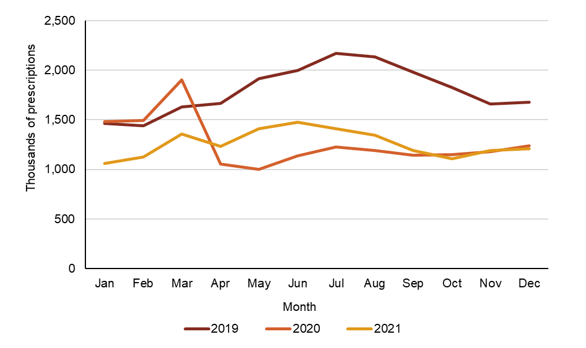

PBS = Pharmaceutical Benefits Scheme; RPBS = Repatriation Pharmaceutical Benefits Scheme; URTI = upper respiratory tract infection

* Amoxicillin, amoxicillin–clavulanic acid, azithromycin, cefaclor, cefalexin, ciprofloxacin, clarithromycin, doxycycline, erythromycin, phenoxymethylpenicillin and roxithromycin

Source: Gadzhanova, Roughead5

**Figure 23:** Number of PBS/RPBS antimicrobial prescriptions dispensed for various indications*, 2019–2021

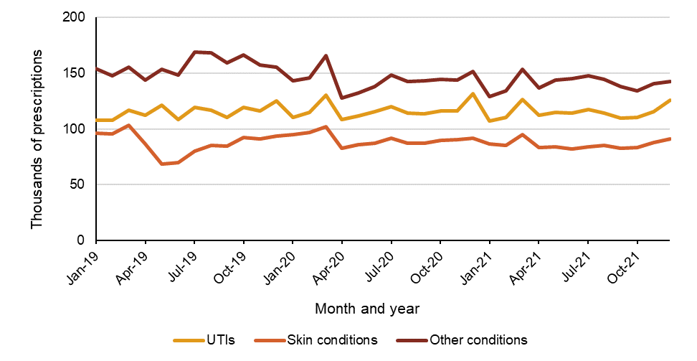

PBS = Pharmaceutical Benefits Scheme; RPBS = Repatriation Pharmaceutical Benefits Scheme; UTI = urinary tract infection

* Urinary tract infections (methenamine hippurate, nitrofurantoin, norfloxacin, trimethoprim); Skin conditions (flucloxacillin, minocycline); Other conditions (antibacterials for systemic use excluding amoxicillin, amoxicillin–clavulanic acid, azithromycin, cefaclor, cefalexin, ciprofloxacin, clarithromycin, doxycycline, erythromycin, flucloxacillin, methenamine hippurate, minocycline, nitrofurantoin, norfloxacin, phenoxymethylpenicillin, roxithromycin and trimethoprim)

Source: Gadzhanova, Roughead5

#### Changes in use of antimicrobials for upper respiratory tract infections due to the COVID-19 pandemic

Figures 24 and 25 show the number of prescriptions for antimicrobials used for URTIs by type of antimicrobial. The largest reductions in use were observed for amoxicillin, amoxicillin–clavulanic acid and cefalexin between March and April 2020. These antimicrobials were also subject to PBS/RPBS restriction changes relating to maximum quantities and the number of allowed repeats in April 2020.14 However, these restrictions do not fully account for the observed reductions in use, as use of other antimicrobials frequently indicated for URTIs also declined.

There was increasing use of antimicrobials in the winter months of 2021 (Figures 24 and 25). When assessed by age, use of amoxicillin particularly increased in the 0–9 year age group (data not shown). The increase in antimicrobial use for URTIs in 2021 did not reach the same peaks observed prior to the pandemic in 2019.

Figure : Number of PBS/RPBS prescriptions with PBS/RPBS restriction changes dispensed for URTIs, by type of antimicrobial, 2019–2021

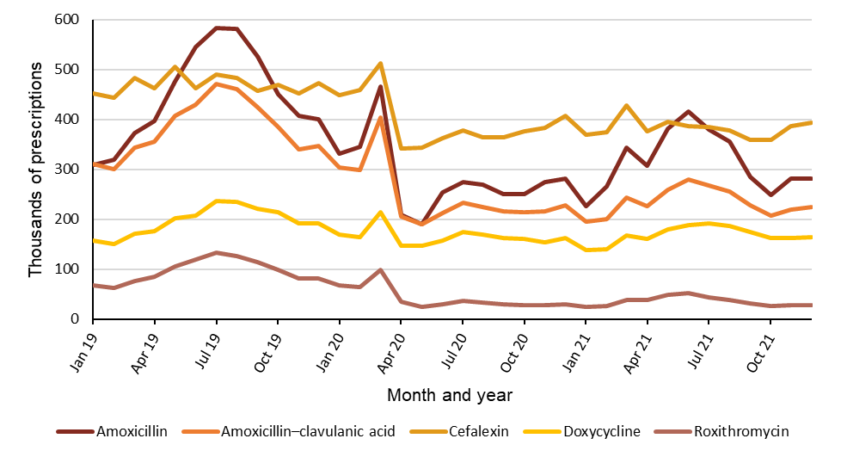

PBS = Pharmaceutical Benefits Scheme; RPBS = Repatriation Pharmaceutical Benefits Scheme; URTI = upper respiratory tract infection  
Source: Gadzhanova, Roughead5

Figure : Number of PBS/RPBS prescriptions without PBS/RPBS restriction changes, dispensed for URTIs, by type of antimicrobial, 2019–2021

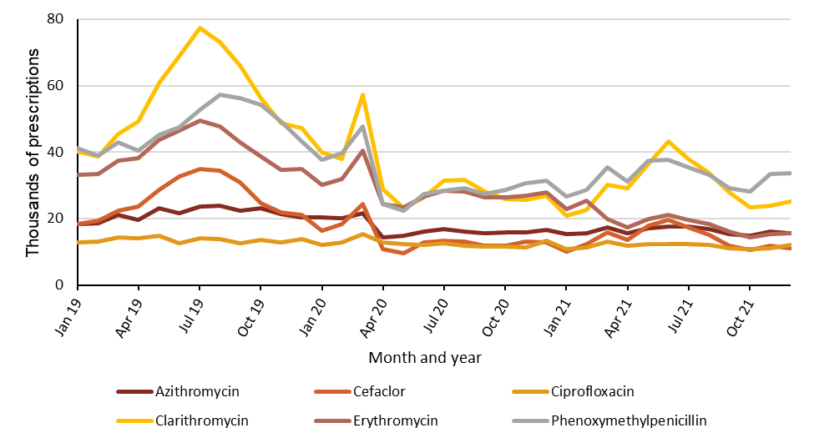

PBS = Pharmaceutical Benefits Scheme; RPBS = Repatriation Pharmaceutical Benefits Scheme; URTI = upper respiratory tract infection  
Source: Gadzhanova, Roughead5

Figure 26 stratifies the number of prescriptions for URTIs per 1,000 people at state and territory level, comparing 2019, 2020 and 2021. Despite differences in state and territory lockdown restrictions, there was a decrease in the number of antimicrobials prescribed across all states and territories in 2020 compared to 2019, which was sustained in 2021.

From 2019 to 2020, the largest decrease was in Victoria (*n* = 831 in 2019; *n* = 537 in 2020; down 35.4%) and the smallest was in the Northern Territory (*n* = 481 in 2019; *n* = 382 in 2020; down 20.6%).

When comparing 2021 to 2020, the largest decrease was in New South Wales (*n* = 648 in 2020; *n* = 598 in 2021; down 7.7%), whilst the largest increase was in Tasmania (*n* = 554 in 2020; *n* = 589 in 2021; up 6.3%). A 1.2% decrease was observed in South Australia (*n* = 596 in 2020; *n* = 589 in 2021), which did not experience prolonged lockdowns but did close inter-state borders. In contrast however, in Western Australia, which also experienced closed borders without prolonged lockdowns, there was an increase of 4.5% in dispensing for URTIs in 2021 (*n* = 572) compared to 2020 (*n* = 546).

While there was variation in restrictions across local government areas, Victoria had the longest enforced lockdown period of all Australian states and territories. Further analysis for Victoria, showed that dispensing of antimicrobial prescriptions per 1,000 people was lower in Greater Melbourne compared to the rest of Victoria in both 2020 (*n*=530 and *n*= 576 respectively) and 2021 (*n*=532 and *n*= 588 respectively).

Figure : Number of PBS/RPBS antimicrobial* prescriptions per 1,000 people for URTIs, by state and territory, 2019–2021

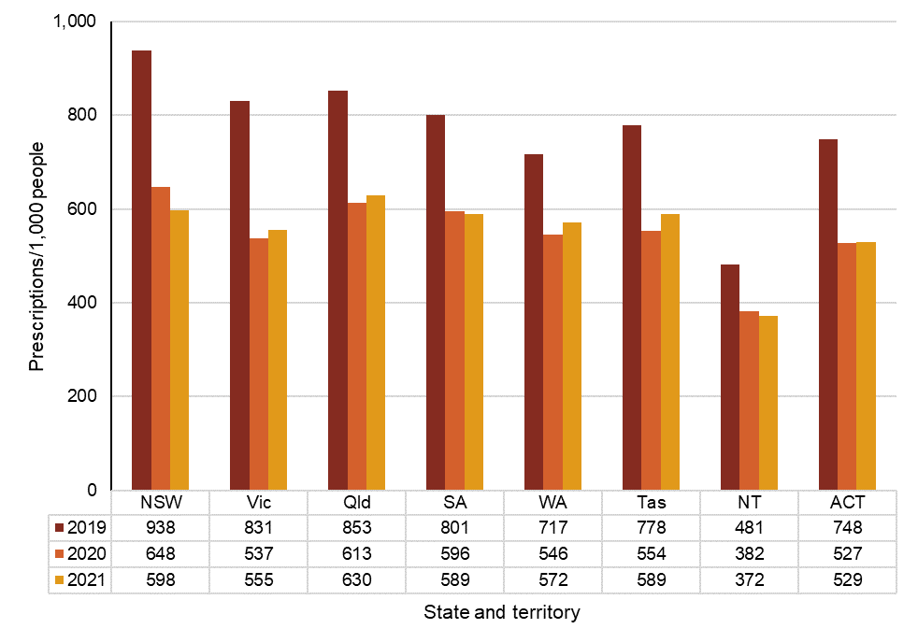

PBS = Pharmaceutical Benefits Scheme; RPBS = Repatriation Pharmaceutical Benefits Scheme; URTI = upper respiratory tract infection  
* Antibacterials for systemic use (ATC code J01)  
Source: Gadzhanova, Roughead5

When comparing 2020 with 2019, there was a decrease in all age groups for the number of prescriptions of antimicrobials frequently used for URTIs per 1,000 people (Figure 27). The largest decrease was in children aged 0–4 years (*n* = 851 in 2019; *n* = 500 in 2020; down 41.2%) and 5–14 years (*n* = 577 in 2019; *n* = 334 in 2020; down 42.1%). While largest by number, the decrease in use was the smallest by percentage in adults aged 75 years and over (*n* = 1,918 in 2019; *n* = 1,438 in 2020; down 25.0%).

When comparing 2021 to 2020, the use of antimicrobials for URTIs further decreased in the elderly; by approximately 9% in both people aged 65–74 years (*n* = 915 in 2020; *n* = 832 in 2021) and aged 75 years and over (*n* = 1,438 in 2020; *n* = 1,308 in 2021). Use remained the same for the 20–44-year age group (*n* = 446 in 2020 and 2021), and the highest increase in use was observed in children aged 0–4 years (*n* = 500 in 2020; *n* = 673 in 2021; up 34.6%) (Figure 27).

The findings in children are consistent with the reduction in standard GP consultations for these age groups around the beginning of the COVID-19 pandemic in Australia in March 2020. This is also consistent with MedicineInsight data, which revealed that prescribing rates decreased for all age groups from 2019 to 2020 and increased for children aged 0–4 years from 2020 to 2021.

Figure : Number of PBS/RPBS antimicrobial prescriptions dispensed for URTIs* per 1,000 people, by age groups, 2019–2021

633B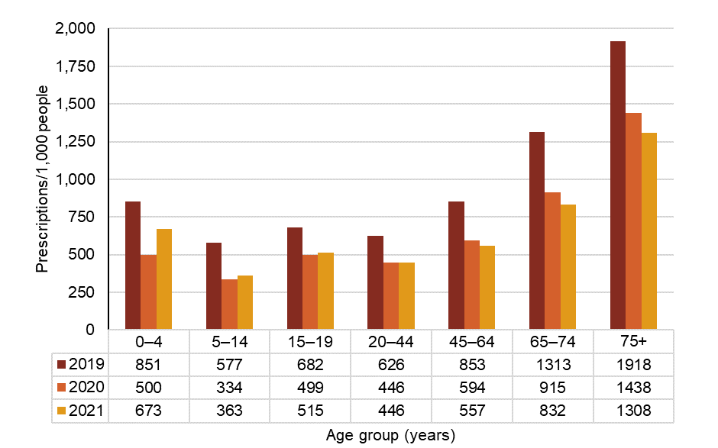

634BPBS = Pharmaceutical Benefits Scheme; RPBS = Repatriation Pharmaceutical Benefits Scheme; URTI = upper respiratory tract infection

635B* Amoxicillin, amoxicillin–clavulanic acid, azithromycin, cefaclor, cefalexin, ciprofloxacin, clarithromycin, doxycycline, erythromycin, phenoxymethylpenicillin and roxithromycin

636BSource: Gadzhanova, Roughead5

#### Effect of COVID-19 lockdowns on use of antimicrobials for upper respiratory tract infections

637BAs shown in Figure 26, all states and territories experienced a reduction in the use of antimicrobials for URTIs from April 2020 compared to 2019. Monthly utilisation of antimicrobials for URTIs between 2019 and 2021 are shown in Figures 28,29and30 for Victoria, New South Wales, and the Australian Capital Territory, respectively. These are the jurisdictions that experienced at least one lockdown for greater than 2 weeks, in addition to the Australia-wide lockdown that commenced in late March 2020 and was fully implemented in April 2020 (marked on Figures 28 to 30). There were variations in the extent of the lockdowns across local government areas in Victoria and New South Wales.

638BVictoria’s second major lockdown commenced in July 2020 and lasted for 111 days to October 2020, and the third major lockdown occurred in August 2021 and was for 82 days to October 2021 (Figure28).

41BFigure : Number of PBS/RPBS antimicrobial prescriptions for URTIs* per 1,000 people, 2019–2021

639B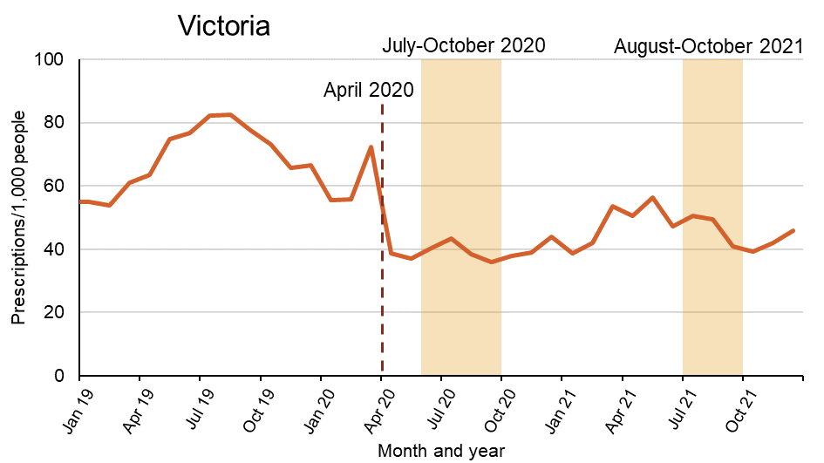

640BPBS = Pharmaceutical Benefits Scheme; RPBS = Repatriation Pharmaceutical Benefits Scheme; URTI = upper respiratory tract infection

641B* Amoxicillin, amoxicillin–clavulanic acid, azithromycin, cefaclor, cefalexin, ciprofloxacin, clarithromycin, doxycycline, erythromycin, phenoxymethylpenicillin and roxithromycin

642BSource: Gadzhanova, Roughead5

643BNew South Wales’ second major lockdown commenced in July 2021 and lasted for 107 days to October 2021 (Figure 29).

42BFigure : Number of PBS/RPBS antimicrobial prescriptions for URTIs* per 1,000 people, 2019–2021

644B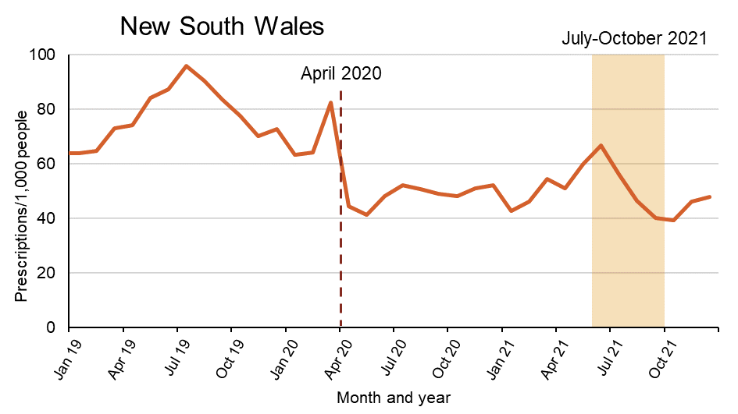

645BPBS = Pharmaceutical Benefits Scheme; RPBS = Repatriation Pharmaceutical Benefits Scheme; URTI = upper respiratory tract infection

646B* Amoxicillin, amoxicillin–clavulanic acid, azithromycin, cefaclor, cefalexin, ciprofloxacin, clarithromycin, doxycycline, erythromycin, phenoxymethylpenicillin and roxithromycin

647BSource: Gadzhanova, Roughead5

648BThe Australian Capital Territory’s second major lockdown commenced in August 2021 and lasted for 63 days to October 2021 (Figure 30).

43BFigure : Number of PBS/RPBS antimicrobial prescriptions for URTIs* per 1,000 people, 2019–2021

649B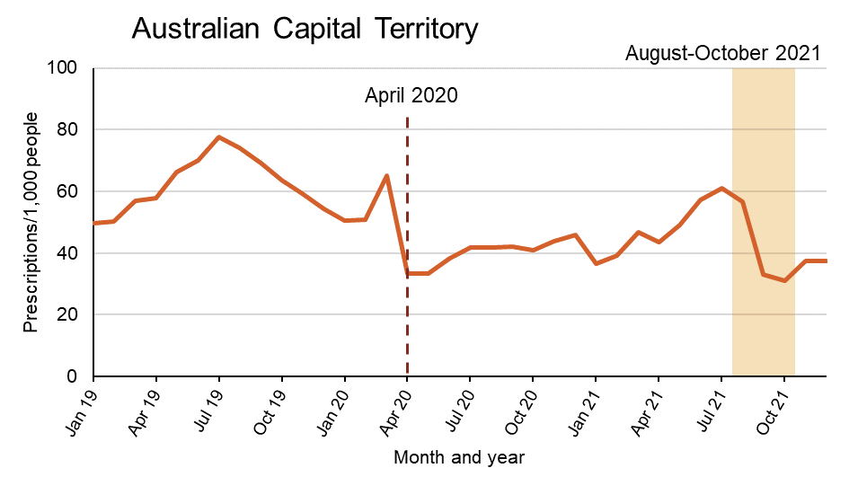

650BPBS = Pharmaceutical Benefits Scheme; RPBS = Repatriation Pharmaceutical Benefits Scheme; URTI = upper respiratory tract infection

651B* Amoxicillin, amoxicillin–clavulanic acid, azithromycin, cefaclor, cefalexin, ciprofloxacin, clarithromycin, doxycycline, erythromycin, phenoxymethylpenicillin and roxithromycin

652BSource: Gadzhanova, Roughead5

**Discussion**

### Overall antimicrobial use and appropriateness in the community

654BAntimicrobial use in the community declined from 2015 to 2021. Decreased antimicrobial use was observed in PBS/RPBS dispensing data and NPS MedicineWise MedicineInsight prescribing data. The decline was observed across all states and territories and most age groups, with a relatively minor variation between states and territories and patient demographics.

655BA steady downward trend was observed until 20191, then data from both MedicineInsight and the PBS/RPBS demonstrated a dramatic reduction in the volume of antimicrobials prescribed and dispensed in 2020 and 2021 – coinciding with the COVID-19 pandemic. This demonstrates the impact of strong, system-wide public health messaging and actions in encouraging effective infection prevention and control, reducing infection rates, and supporting appropriate antimicrobial prescribing. These public health actions included messaging for working and learning from home, wearing a mask and staying home when experiencing symptoms of respiratory illness and encouraging hand hygiene and physical distancing.

656BHowever, increases were observed towards the end of 2021, highlighting the need for continued intervention to sustain ongoing reductions in antimicrobial use.

657BCefalexin, amoxicillin and amoxicillin–clavulanic acid remain the most commonly prescribed antimicrobials in MedicineInsight practices and the most commonly dispensed antimicrobials under the PBS/RPBS. Cefalexin is often prescribed for skin and soft tissue infections, and UTIs, whereas amoxicillin is commonly indicated for respiratory tract infections.

658BThe decline in antimicrobial use was observed across all age-groups from 2015 to 2020. The number of antimicrobial prescriptions in the adult population continued to decline but increased in children into 2021. Antimicrobial use was highest by number of prescriptions dispensed per 1,000 people in the elderly.

659BChanges in the restrictions for PBS/RPBS-subsidised repeat prescriptions for five of Australia’s most commonly dispensed antimicrobials (amoxicillin, amoxicillin–clavulanic acid, cefalexin, doxycycline and roxithromycin) are likely to account for some of the reductions in antimicrobial use observed from April 2020.

660BThe findings highlight a number of key areas that warrant further attention and action, including the overall increase in antimicrobial prescribing among children compared to adults (particularly in the 0–9 year age group) and the increasing rates of private, or non-PBS/RPBS, antimicrobial prescriptions. Although the number of private prescriptions is relatively small compared to those supplied under the PBS/RPBS, it is difficult to quantify non-PBS/RPBS prescribing rates and to monitor trends over time. Given that the most common privately prescribed antimicrobials (azithromycin and ciprofloxacin) are broad-spectrum agents reserved for critical infections, sustained efforts to support appropriate prescribing are required. The lack of mechanisms to record and monitor rates of non-PBS/RPBS antimicrobial prescribing at the time of dispensing is a noteworthy gap in current surveillance efforts that requires attention.

### Impact of the COVID-19 pandemic on antimicrobial use in the community

661BThe COVID-19 pandemic had a profound impact on antimicrobial use in Australia, and there has been a notable global impact on antimicrobial use and appropriateness during the pandemic.24 Several potential factors are likely to have influenced the decrease in antimicrobial prescribing in Australia, including:

* 200BThe prevalence of infections requiring antimicrobials
* 201BChanges in the availability of PBS/RPBS-subsidised repeat prescriptions for five of the most commonly dispensed antimicrobials – amoxicillin, amoxicillin–clavulanic acid, cefalexin, doxycycline and roxithromycin
* 202BImproved infection prevention and control in the community
* 203BPeriods of lockdown
* 204BGP factors, such as individual prescriber preferences, access, mode of consultation (face-to-face or telehealth)
* 205BPotential improved community awareness of the role of antimicrobials in treating infections.

662BIt is notable that the use of antimicrobials not subject to PBS/RPBS policy changes for repeats also declined. This suggests factors relating to circulating respiratory illnesses and changes in health service-seeking behaviour may have contributed to reduced antimicrobial use.

663BIn addition to national campaigns for hand hygiene and physical distancing during the COVID-19 pandemic, Australian workplaces, schools and childcare centres issued ‘stay home if sick’ orders, and most workplaces and educational institutions enabled ‘work or learn from home’ practices on a scale that had not previously been experienced. These actions meant that parents and carers could work from home with greater flexibility when they or their children were unwell or required to isolate to reduce transmission of disease. It is likely that these measures reduced the demand for antimicrobials – antimicrobials may have previously been issued in response to perceptions that use of an antimicrobial may enable continued attendance at work, school, or childcare. This information suggests that a systematic approach to support workplaces, schools and childcare is necessary for ongoing improvements to AMS in the community.

664BPBS/RPBS data have shown that reduced antimicrobial dispensing was sustained over 2020 and 2021. Overall, the community data presented in this report have affirmed that policy measures, restrictive practices, and effective infection prevention and control efforts can help improve overall antimicrobial use and appropriateness. Continued monitoring of antimicrobial prescribing rates and appropriateness is required to determine if these increases are sustained.

665BAccess to telehealth services was expanded during the COVID-19 pandemic. Analyses for this report show a lower rate of antimicrobial prescribing for telehealth services compared to face-to-face services in MedicineInsight practices, commencing at the start of the pandemic, and being sustained throughout 2020 and 2021. Ongoing use of these services also poses challenges for ongoing patient care and AMS given limited physical examination.25

666BAnalyses of PBS/RPBS and MedicineInsight data for 2020 and 2021 indicate that lower levels of antimicrobial use in Australia are achievable long term and that promotion of these results to inform AMS in the community; raise community awareness of the benefits of appropriate antimicrobial use; and sustain infection prevention and control actions to maintain these lower levels of antimicrobial use, is required.

### International comparisons of community antimicrobial use

667BFor more than a decade Australia has had consistently high antimicrobial prescribing rates relative to most other countries in the Organisation for Economic Co-operation and Development (OECD).26,27 This is despite significant national efforts for more than 20 years to reduce antimicrobial use, including national campaigns, antimicrobial guidelines, the National Safety and Quality Health Service (NSQHS) Standards, and audit and feedback mechanisms for prescribers.1 Many of these interventions have focused on improving prescribing practices.

668BFigure 31 shows community use of antimicrobials in Australia remained high in 2020 compared to most European countries.

669BMany countries, including Australia, Canada, the United States, New Zealand and European countries reported decreases in use of antimicrobials during the COVID-19 pandemic.1,22,28-31 Although the United Kingdom did not submit full data to the *Annual Epidemiological Report on Communicable Diseases in Europe*, a population-based cohort study reported that overall rates of antimicrobial prescribing in the UK were lower between April and August 2020, compared to rates prior to the pandemic.32,33 The rate of decline in community antimicrobial use observed in Australia since 2015 and into 2020 is similar to rates internationally.

44BFigure : Community antimicrobial use in Australia (2020), European countries (2020) and Canada (2019), by DDD/1,000 people/day

670B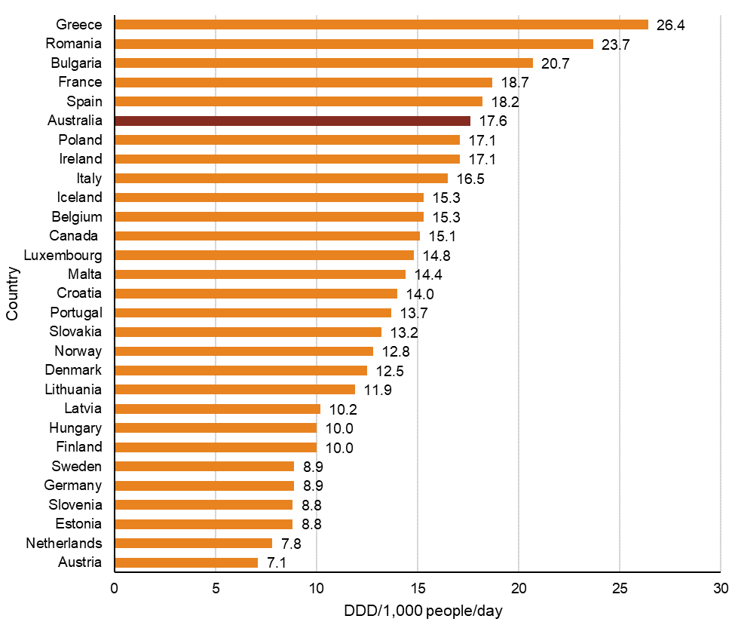

671BDDD = defined daily dose  
Note: 2020 data for Canada were not available at the time of reporting, therefore 2019 data have been included.  
Source: Gadzhanova, Roughead5, European Centre for Disease Prevention and Control32, Public Health Agency Canada34

### What will be done to improve appropriateness of antimicrobial prescribing and patient safety in the community?

672BThere are opportunities to build on the encouraging decrease in the volume of antimicrobial prescribing in primary care by focusing on strategies to improve the appropriateness of prescribing and enhance antimicrobial prescribing and dispensing data collection and surveillance efforts.

673BThe Commission’s National Safety and Quality Primary and Community Healthcare Standards (Primary and Community Healthcare Standards)35 describe the processes and structures that are needed to deliver safe and high-quality health care in relation to antimicrobial use and prescribing. These Standards require healthcare services that prescribe, supply, and administer antimicrobials to:

* 206BProvide healthcare providers with access to, and promote the use of, current evidence-based Australian therapeutic guidelines and resources on antimicrobial prescribing
* 207BIncorporate core elements, recommendations, and principles from the current AMS Clinical Care Standard36 into service delivery
* 208BSupport healthcare providers who prescribe antimicrobials to review compliance of antimicrobial prescribing against current local or Australian therapeutic guidelines
* 209BSupport healthcare providers to identify the areas of improvement and take action to increase the appropriateness of antimicrobial usage
* 210BHave mechanisms to educate consumers about the risks, benefits, and alternatives to antimicrobials for their condition.

674BTo promote ongoing reductions in antimicrobial use and increased appropriateness of antimicrobial use in the community, the Commission will:

* 706BContinue to report the results of antimicrobial prescribing and use the data to inform quality improvement strategies
* 707BIn liaison with the Department, explore opportunities to increase capacity to monitor non-PBS/RPBS antimicrobial use, repeat prescriptions for antimicrobials, and the indications for which antimicrobials are prescribed
* 708BContinue to work with clinicians, the Royal Australian College of General Practitioners, Primary Health Networks and other primary care organisations, the Department and states and territories to develop targeted strategies to improve appropriateness of antimicrobial prescribing
* 709BSupport implementation of the Primary and Community Healthcare Standards
* 710BWork with states and territories to develop and promote strategies to reduce inappropriate antimicrobial prescribing to improve the care of patients, particularly in the treatment of conditions associated with high inappropriate use
* 711BPromote maintenance of public health actions, and infection prevention and control strategies such as wearing a mask and staying home when experiencing symptoms of respiratory illness and encouraging hand hygiene and physical distancing to reduce the risk of transmission of infection in the community, and their potential impact on reducing antimicrobial use
* 712BReview resources for consumers to improve their understanding of the importance of antimicrobial use.

# References

45B1. Australian Commission on Safety and Quality in Health Care. AURA 2021: fourth Australian report on antimicrobial use and resistance in human health. Sydney: ACSQHC, 2021.

46B2. Australian Commission on Safety and Quality in Health Care. AURA 2016: first Australian report on antimicrobial use and resistance in human health. Sydney: ACSQHC, 2016.

47B3. Australian Commission on Safety and Quality in Health Care. AURA 2017: second Australian report on antimicrobial use and resistance in human health. Sydney: ACSQHC, 2017.

48B4. Australian Commission on Safety and Quality in Health Care. AURA 2019: third Australian report on antimicrobial use and resistance in human health. Sydney: ACSQHC, 2019.

49B5. Gadzhanova S, Roughead E. Analysis of 2015–2021 PBS data for the National Report on Antimicrobial Use and Resistance (unpublished).

50B6. NPS MedicineWise. MedicineInsight data analyses for AURA Community report, May 2022 (unpublished).

51B7. World Health Organization. Antimicrobial resistance. [Internet] 2021. Available from: <https://www.who.int/news-room/fact-sheets/detail/antimicrobial-resistance>

52B8. G Hunt (Minister for Health), B Murphy (Chief Medical Officer). First confirmed case of novel coronavirus in Australia. 2020.

53B9. World Health Organization. WHO Director-General's opening remarks at the media briefing on COVID-19 - 11 March 2020. [Internet] 2020. Available from: <https://www.who.int/director-general/speeches/detail/who-director-general-s-opening-remarks-at-the-media-briefing-on-covid-19---11-march-2020>

54B10. Prime Minister, Minister for Health, Minister for Aged Care and Senior Australians, Minister for Youth and Sport. $2.4 Billion health plan to fight COVID-19. 2020.

55B11. Australian Government Department of Health. $1.1 billion to support more mental health, Medicare and domestic violence services [Internet] 2020. Available from: <https://www.health.gov.au/news/11-billion-to-support-more-mental-health-medicare-and-domestic-violence-services>

56B12. Australian Government Department of Health. National 2020 Influenza Season Summary 2020.

57B13. Australian Institute of Health and Welfare. Impacts of COVID-19 on Medicare Benefits Scheme and Pharmaceutical Benefits Scheme service use. Canberra: AIHW, 2020.

58B14. Australian Government Department of Health. Revised PBS listings for Antibiotic use [Internet] 2020. Available from: <https://www.pbs.gov.au/news/2020/03/files/Antibiotics-factsheet-2020.pdf>

59B15. Australian Commission on Safety and Quality in Health Care and Australian Institute of Health and Welfare. The Fourth Australian Atlas of Healthcare Variation. Sydney: ACSQHC, 2021.

60B16. Antibiotic Expert Groups. Therapeutic guidelines: antibiotic. Melbourne: Therapeutic Guidelines Limited; 2019.

61B17. Australian Government Department of Health. MBS changes factsheet. [Internet] 2022. Available from: <http://www.mbsonline.gov.au/internet/mbsonline/publishing.nsf/Content/2211355D5611CA3DCA2587A70006FF09/$File/Factsheet-telehealth-GPs-OMP.v.13.04.22.pdf>

62B18. Australian Bureau of Statistics. Estimates of Aboriginal and Torres Strait Islander Australians. [Internet] Canberra: ABS; 2020. Available from: <https://www.abs.gov.au/statistics/people/aboriginal-and-torres-strait-islander-peoples/estimates-aboriginal-and-torres-strait-islander-australians/latest-release>

63B19. Australian Government Department of Health. Pharmaceutical Benefits Scheme (PBS). [Internet] 2022. Available from: <https://www.pbs.gov.au/pbs/home>

64B20. NPS MedicineWise. MedicineInsight. [Internet] Sydney: NPS MedicineWise; 2018. Available from: <https://www.nps.org.au/medicine-insight>

65B21. McCullough AR, Pollack AJ, Plejdrup Hansen M, Glasziou PP, Looke DF, Britt HC, et al. Antibiotics for acute respiratory infections in general practice: comparison of prescribing rates with guideline recommendations. Med J Aust 2017;207:65–9.

66B22. NPS MedicineWise. General Practice Insights Report July 2019–June 2020 including analyses related to the impact of COVID-19. Sydney: NPS MedicineWise, 2021.

67B23. Therapeutic Goods Administration. TGA cautions against over-buying medicines. 2020.

68B24. Khouja T, Mitsantisuk K, Tadrous M, Suda KJ. Global consumption of antimicrobials: impact of the WHO Global Action Plan on Antimicrobial Resistance and 2019 coronavirus pandemic (COVID-19). J Antimicrob Chemother 2022;77:1491-9.

69B25. Sine K, Appaneal H, Dosa D, LaPlante KL. Antimicrobial Prescribing in the Telehealth Setting: Framework for stewardship during a period of rapid acceleration within primary care. Clin Infect Dis 2022.

70B26. Organisation for Economic Co-operation and Development. OECD Health Statistics 2020 [Internet]. OECD: Paris; 2021.

71B27. Organisation for Economic Co-operation and Decelopment. Antimicrobial Resistance in the EU/EEA: A One Health Response. [Internet]. OECD: Paris; 2022.

72B28. Buehrle DJ, Nguyen MH, Wagener MM, Clancy CJ. Impact of the Coronavirus Disease 2019 Pandemic on Outpatient Antibiotic Prescriptions in the United States. Open Forum Infect Dis; 2020.

73B29. Buehrle DJ, Wagener MM, Nguyen MH, Clancy CJ. Trends in Outpatient Antibiotic Prescriptions in the United States During the COVID-19 Pandemic in 2020. JAMA Network Open; 2021.

74B30. Duffy E, Thomas M, Hills T, Ritchie S. The impacts of New Zealand's COVID-19 epidemic response on community antibiotic use and hospitalisation for pneumonia, peritonsillar abscess and rheumatic fever. Lancet Reg Health West Pac 2021;12:100162.

75B31. Högberg LD, Vlahović-Palčevski V, Pereira C, Weist K, Monnet DL. Decrease in community antibiotic consumption during the COVID-19 pandemic, EU/EEA, 2020. Euro Surveill; 2021.

76B32. European Centre for Disease Prevention and Control. Antimicrobial consumption in the EU/EEA (ESAC-Net) - Annual Epidemiological Report 2020. Stockholm: ECDC, 2021.

77B33. Rezel-Potts E, L’Esperance V, Gulliford MC. Antimicrobial stewardship in the UK during the COVID-19 pandemic: a population-based cohort study and interrupted time-series analysis. British Journal of General Practice; 2021.

78B34. Public Health Agency of Canada. Canadian Antimicrobial Resistance Surveillance System Report 2021. Ottawa: PHAC, 2020.

79B35. Australian Commission on Safety and Quality in Health Care. National Safety and Quality Primary and Community Healthcare Standards. Sydney: ACSQHC; 2021.

80B36. Australian Commission on Safety and Quality in Health Care. Antimicrobial Stewardship Clinical Care Standard. Sydney: ACSQHC; 2020.

81B37. Australian Government Department of Health. About the PBS. [Internet] 2022. Available from: <https://www.pbs.gov.au/info/about-the-pbs>

82B38. Australian Government Department of Veterans' Affairs. Concessional medicines under RPBS. [Internet] 2022. Available from: <https://www.dva.gov.au/health-and-treatment/help-cover-healthcare-costs/manage-medicine-and-keep-costs-down/concessional>

# Appendix

### Appendix 1: Data source description

#### A1.1 About the Pharmaceutical Benefits Scheme and Repatriation Pharmaceutical Benefits Scheme

675BThe Pharmaceutical Benefits Scheme (PBS) provides timely, reliable and affordable access to necessary medicines for Australians. The PBS is part of the Australian Government’s broader National Medicines Policy. The aim of the National Medicines Policy is to meet medication and related service needs, so that both optimal health outcomes and economic objectives are achieved. Under the PBS, the government subsidises the cost of medicine for most medical conditions. Most of the listed medicines are dispensed by pharmacists, and used by patients at home.37

676BThe Repatriation Pharmaceutical Benefits Scheme (RPBS) provides eligible people with access to a wide range of medicines and wound care items at a concession rate. People who are eligible for the RPBS are those who have a Veteran Gold Card, Veteran White Card and the script is for a condition covered by your Veteran White Card, and a Veteran Orange Card.38

677BThe proportion of prescriptions written in the community that are captured by the PBS/RPBS is estimated to be more than 90%1,4, although the exact percentage is not known. The PBS/RPBS also capture public hospital outpatient and discharge prescriptions in all states and territories except New South Wales. The PBS/RPBS do not capture data on non-PBS/RPBS prescriptions, or from many Aboriginal and Torres Strait Islander health services.

678BThe Australian Government Department of Health and Aged Care (the Department) analyses PBS/RPBS data to inform economic analyses and policy development. Comprehensive medicine usage data are required for a number of purposes, including pharmacosurveillance and targeting, and evaluation of initiatives for quality use of medicines. The data are also needed by regulatory and financing authorities, and the pharmaceutical industry.

#### A1.2 About NPS MedicineWise MedicineInsight program

679BNPS MedicineWise MedicineInsight is a national program that collects longitudinal, de-identified clinical data from participating general practices across Australia (Table A1). Responsibility for operation of the MedicineInsight program will transfer from NPS MedicineWise to the Australian Commission on Safety and Quality in Health Care (the Commission) from 1 January 2023 as part of the 2022–23 Budget initiative, which included the redesign of the Quality Use of Diagnostics, Therapeutics and Pathology Program.

680BThe MedicineInsight program, which was established in 2011, aims to support quality improvement by providing local data to general practices. The data can be benchmarked at local, regional and national levels. Participating practices are offered customised quality improvement activities that support alignment with best practice and identify key areas for improvement.

681BMedicineInsight data include patient demographic and clinical data entered directly into the system by voluntarily participating general practitioners (GPs) and practice staff, or collected from external sources (for example, pathology test results), and system-generated data such as antimicrobial start time and date of a patient encounter. The data can be used to analyse use of medicines, switching of medicines, indications for prescribing, adherence to guidelines, and pharmacovigilance to support post-market surveillance of medicine use in primary care.

682BIt is estimated that there were 8,147 general practices in Australia in 2021. MedicineInsight data is therefore estimated to represent approximately 6% of Australian general practices.

683BMedicineInsight data provides unique capacity to monitor community antimicrobial prescribing patterns and assess the appropriateness of antimicrobial use in the community in Australia.

684B**Table A1:** Number of general practices contributing to MedicineInsight, by state and territory, 2020–2021

|  |  |  |
| --- | --- | --- |
| State or Territory | 2020 | 2021 |
| NSW | 176 | 176 |
| Vic | 95 | 95 |
| Qld | 107 | 108 |
| SA | 13 | 13 |
| WA | 59 | 59 |
| Tas | 36 | 36 |
| NT | 8 | 8 |
| ACT | 9 | 9 |
| TOTAL | 503 | 504 |

685BSource: NPS MedicineWise6

### Appendix 2: Terminology

#### A2.1 Abbreviations and acronyms

|  |  |
| --- | --- |
| Term | Definition |
| ABS | Australian Bureau of Statistics |
| ACT | Australian Capital Territory |
| AIHW | Australian Institute of Health and Welfare |
| AMR | antimicrobial resistance |
| AMS | antimicrobial stewardship |
| ATC | Anatomical Therapeutic Chemical |
| AU | antimicrobial use |
| AURA | Antimicrobial Use and Resistance in Australia |
| β-lactamase inhibitors | beta-lactamase inhibitors |
| CAP | community-acquired pneumonia |
| CI | confidence interval |
| CIS | clinical information system |
| Commission | Australian Commission on Safety and Quality in Health Care |
| COPD | chronic obstructive pulmonary disease |
| COVID-19 | coronavirus disease 2019 |
| DDD | defined daily dose |
| GP | general practitioner |
| LRTI | lower respiratory tract infection |
| MBS | Medicare Benefits Schedule |
| NSQHS | National Safety and Quality Health Service |
| NSW | New South Wales |
| NT | Northern Territory |
| OECD | Organisation for Economic Co-operation and Development |
| PBS | Pharmaceutical Benefits Scheme |
| Qld | Queensland |
| RPBS | Repatriation Pharmaceutical Benefits Scheme |
| SA | South Australia |
| SA3 | Statistical Area Level 3 |
| SARS-CoV-2 | Severe Acute Respiratory Syndrome Coronavirus 2 |
| SEIFA | Socio-Economic Indexes for Areas |
| Tas | Tasmania |
| URTI | upper respiratory tract infection |
| UTI | urinary tract infection |
| Vic | Victoria |
| WA | Western Australia |
| WHO | World Health Organization |

#### A2.2 Common terms

| Term | Definition |
| --- | --- |
| Anatomical Therapeutic Chemical (ATC) classification | An internationally accepted classification system for medicines that is maintained by the World Health Organization. Active substances are divided into different groups according to the organ or system on which they act, and their therapeutic, pharmacological, and chemical properties. |
| antimicrobial | Chemical substances that inhibit the growth of, or destroy, bacteria, fungi, viruses, or parasites. They can be administered therapeutically to humans or animals. |
| antimicrobial resistance (AMR) | Failure of an antimicrobial to inhibit a microorganism at the antimicrobial concentrations usually achieved over time with standard dosing regimens. |
| antimicrobial stewardship (AMS) | An ongoing effort by a health service organisation to reduce the risks associated with increasing antimicrobial resistance and to extend the effectiveness of antimicrobial treatments. It may incorporate a broad range of strategies, including monitoring, reviewing, and promoting appropriate antimicrobial use. |
| broad-spectrum antimicrobials | A single antimicrobial, or class of antimicrobials, which affects many organisms. |
| defined daily dose (DDD) | The assumed average maintenance dose per day to treat the main indication for an average adult patient, as defined by the World Health Organization. The DDD is a technical unit of measurement that is widely accepted in international surveillance programs because it enables comparison of antimicrobial use within and between countries. DDDs are only assigned for medicines given an Anatomical Therapeutic Chemical (ATC) code. |
| DDDs per 1,000 people per day | Sales or prescription data about medicine use in the community can be expressed as DDDs per 1,000 people per day to give a population estimate for use of a medicine (or group of medicines). For example, 10 DDDs per 1,000 people per day means that, on a given day, 1% of the population received a medicine (or group of medicines). This estimate is most useful for medicines that treat chronic illnesses for which the DDD and the average prescribed daily dose are similar. |
| J01 | A code within the Anatomical Therapeutic Chemical (ATC) classification system that is applied to the group labelled ‘Antibacterials for systemic use’. |
| narrow-spectrum antimicrobials | A single antimicrobial or class of antimicrobials that affects few organisms and contributes less to antimicrobial resistance than broad-spectrum antimicrobials. |
| National Safety and Quality Health Service (NSQHS) Standards | Standards developed by the Australian Commission on Safety and Quality in Health Care to drive the implementation of safety and quality systems and improve the quality of health care in Australia. The NSQHS Standards provide a nationally consistent statement about the standard of care that consumers can expect from their health service organisations. |
| Pharmaceutical Benefits Scheme (PBS) | An Australian Government program that subsidises medicines |

| Term | Definition |
| --- | --- |
| National Safety and Quality Primary and Community Healthcare Standards | Standards developed by the Australian Commission on Safety and Quality in Health Care to drive the implementation of safety and quality systems and improve the quality of primary and community health care in Australia. These Standards provide a nationally consistent statement about the standard of care that consumers can expect from their community and primary health service organisations. |
| Repatriation Pharmaceutical Benefits Scheme (RPBS) | An Australian Government program that subsidises medicines for veterans. |
| Statistical Area Level 3 (SA3) | Geographical areas designed for the output of regional data, including 2016 Census data. SA3s create a standard framework for analysing Australian Bureau of Statistics data at the regional level by clustering groups of Statistical Areas Level 2 (SA2) that have similar regional characteristics. |
| therapeutic group or class | A category of medicines that have similar chemical structure. |
| topical (medication) | A medication that is applied to body surfaces such as the skin or mucous membranes; includes creams, foams, gels, lotions, and ointments. |

#### A2.3 Antimicrobial, antibacterial or antibiotic?

686BAntimicrobial is the term which includes all antibiotics, antifungals, antivirals and antiparasitic agents. The terms antibacterial and antibiotic have the same meaning, and they are used to treat infections caused by bacteria.

687BThe term ‘antibacterial’ is used in this report in reference to antimicrobials classified as Anatomical Therapeutic Chemical (ATC) code J01, ‘antibacterials for systemic use’.

688BThe term ‘all antimicrobials’ is used in this report in reference to all antimicrobials classified under ATC codes J01 (antibacterials for systemic use), A07 (antidiarrheals, intestine anti-inflammatory/anti-infective agents), D06 (antibiotics and chemotherapeutics for dermatological use), S01 (ophthalmologicals), S02 (otologicals) and S03 (ophthalmological and ontological preparations).

689BThe term ‘high use antimicrobials’ refers to seven most commonly prescribed antimicrobials: amoxicillin, amoxicillin–clavulanic acid, azithromycin, cefalexin, ciprofloxacin, doxycycline and roxithromycin.

690BGraphic depicting terminology that comprises 'antimicrobials'.
Antibiotics have activity against bacteria (e.g., medicines for urine infections).
Antivirals have activity against viruses (e.g., medicines for herpes or HIV).
Antifungals have activity against fungi (e.g., medicines for thrush).
Antiparasitics have activity against parasites (e.g., medicines for malaria). 

## 

### Appendix 3: Supplementary Data

691BFigure A3 complements Figure 8 of this report and provides greater detail on the age profile of patients prescribed one or more antimicrobials (ATC code J01) in MedicineInsight practices from 2015 to 2021.

692B**Figure A3:** Number of patients prescribed one or more antimicrobials* per 100 patients, by age group, MedicineInsight practices, 2015–2021

693B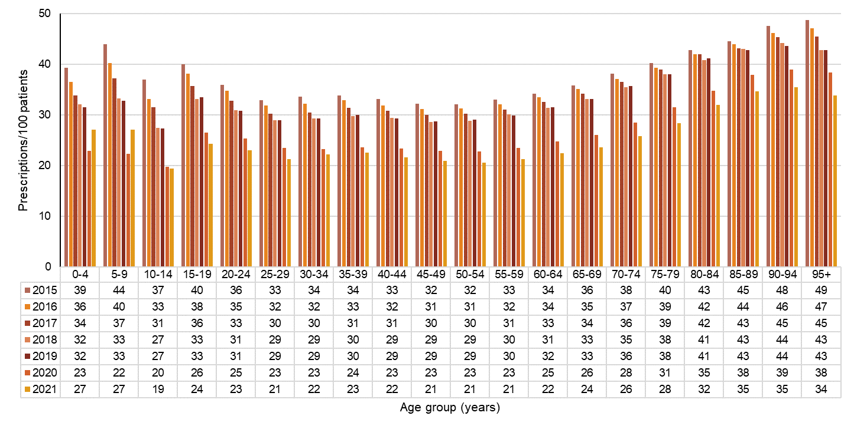

694B* Antibacterials for systemic use (ATC code J01)  
Source: NPS MedicineWise6



Australian Commission on Safety and Quality in Health Care logo 


695B696BLevel 5, 255 Elizabeth Street, Sydney NSW 2000

697BGPO Box 5480, Sydney NSW 2001

698B**PHONE:** (02) 9126 3600

0BTwitter logo @ACSQHC