# Australian Commission on Safety and Quality logotypeOn the Radar

Issue 593

6 March 2023

*On the Radar* is a summary of some of the recent publications in the areas of safety and quality in health care. Inclusion in this document is not an endorsement or recommendation of any publication or provider. Access to particular documents may depend on whether they are Open Access or not, and/or your individual or institutional access to subscription sites/services. Material that may require subscription is included as it is considered relevant.

*On the Radar* is available online, via email or as a PDF or Word document from <https://www.safetyandquality.gov.au/publications-and-resources/newsletters/radar>

If you would like to receive *On the Radar* via email, you can subscribe on our website <https://www.safetyandquality.gov.au/publications-and-resources/newsletters>  
or by emailing us at H[Umail@safetyandquality.gov.auU](mailto:mail@safetyandquality.gov.au).   
You can also send feedback and comments to H[Umail@safetyandquality.gov.auU](mailto:mail@safetyandquality.gov.au).

For information about the Commission and its programs and publications, please visit <https://www.safetyandquality.gov.au>

You can also follow us on Twitter @ACSQHC.

**On the Radar**

Editor: Dr Niall Johnson [niall.johnson@safetyandquality.gov.au](mailto:niall.johnson@safetyandquality.gov.au)

Contributors: Niall Johnson

**Reports**

*Time for Better Care at the End of Life*

OECD. Paris: OECD Publishing; 2023. p.243.

*Dying well at home: Commissioning quality end-of-life care*

Baylis A, Chikwira L, Robertson R, Tiratelli L.

London: The King's Fund; 2023. p. 66.

|  |  |
| --- | --- |
| DOI / URL | OECD <https://doi.org/10.1787/722b927a-en>  Baylis et al <https://www.kingsfund.org.uk/publications/dying-well-home-commissioning-quality-end-life-care> |
| Notes | A pair of reports examining the quality of health care for patients at the end of life.  The OECD’s report ‘reviews end-of-life care policies across OECD countries, along the following policy dimensions: accessibility, people-centredness, quality, financing, and governance.’ The report’s key findings on end-of-life care across the OECD, include:   * ‘Too many people receive sub-par care in their last days or months of life. Access to services is often insufficient and unequal, especially at home. * Professionals often fail to discuss choices that provide people a dignified end of life, and their care preferences are rarely recorded. * Care provided at the end of life often fails to alleviate people suffering and limit unnecessary treatments. * Costs at the end of life are high for both the public purse and families, while not necessarily delivering quality of life, and there are questions about, which different care models could improve outcomes for patients while reducing costs. * Putting end-of-life care higher in the policy agenda and implementing a more comprehensive set of policies would make the end of life a more meaningful and humane experience for people and their relatives, and improve the outcomes achieved for the resources invested.’   In the UK, The King’s Fund (Baylis et al) has looked at the issue of how to commission and ensure high quality end of life care for the patient in their own home. While this report focuses on the UK context and some aspects, such as the role of local government and the creation of integrated care systems, may be quite different to other locations, some of the issues are clearly applicable elsewhere. |

For information on the Commission’s work on end-of-life care, including a range of tools and resources to support health services to improve the safety and quality of end-of-life care, the *National Consensus Statement: Essential elements for safe and high-quality end-of-life care* and the *National Consensus Statement: Essential elements for safe and high quality paediatric end-of-life care*, see <https://www.safetyandquality.gov.au/our-work/end-life-care>

*Ready for the Next Crisis? Investing in Health System Resilience*

OECD

Paris: OECD Publishing; 2023. p. 475.

|  |  |
| --- | --- |
| DOI | <https://doi.org/https://doi.org/10.1787/1e53cf80-en> |
| Notes | The COVID-19 pandemic tested the capabilities and strengths of health systems around the world. This OECE report reviews the vulnerabilities exposed by the pandemic and ‘Using a resilience lens, this report calls for major investment in the health workforce, alongside increased spending on prevention and digital infrastructure.’ The report makes six recommendations to improve health systems resilience and to reduce the impact of future shocks:   * Promote population health: vulnerable populations make for vulnerable health systems * Promote workforce retention and recruitment: people are the key to making systems resilient * Promote data collection and use: without the right data, decision makers are flying blind * Promote international co-operation: responses are better together than alone * Promote supply chain resilience: getting products and services when and where they are needed * Promote governance and trust: without trust, whole-of-society responses are less effective. |

*Digital maturity models for primary health care*

Deeble Institute Perspectives Brief No. 26

Reddy S, Nguyen L, Cooper P, Huggins K, Ugalde A, Peeters A, et al

Canberra: Australian Healthcare and Hospitals Association; 2023. p. 20.

|  |  |
| --- | --- |
| URL | <https://ahha.asn.au/sites/default/files/docs/policy-issue/perspectives_brief_no_26_digital_maturity_models.pdf> |
| Notes | This perspectives brief from the Australian Healthcare and Hospitals Association’s Deeble Institute looks at ways of assessing the digital maturity of primary health care providers. The authors examine a couple of existing digital maturity assessment tools and also ‘a new model, the Digital Maturity Assessment of Primary Care Providers (DMAPP)’. |

*BMJ Quality & Safety*

February 2023 Volume 32 Issue 3

|  |  |
| --- | --- |
| URL | <https://qualitysafety.bmj.com/content/32/3> |
| Notes | A new issue of *BMJ Quality & Safety* has been published. Many of the papers in this issue have been referred to in previous editions of *On the Radar* (when they were released online). Articles in this issue of *BMJ Quality & Safety* include:   * Editorial: **Polypharmacy and continuity of care**: medicines optimisation in the era of multidisciplinary teams (Carolyn Tarrant, Rachel Lewis, Natalie Armstrong) * Editorial: **The debrief imperative:** building teaming competencies and team effectiveness (Scott I Tannenbaum, Philip E Greilich) * Beyond the equity project: grounding **equity in all quality improvement efforts** (Wiljeana Glover, Tim Vogus) * Incidence and characteristics of **adverse events in paediatric inpatient care**: a systematic review and meta-analysis (Pernilla Dillner, Luisa C Eggenschwiler, Anne W S Rutjes, Lena Berg, Sarah N Musy, Michael Simon, Giusi Moffa, Ulrika Förberg, Maria Unbeck) * **Negotiating the polypharmacy paradox**: a video-reflexive ethnography study of polypharmacy and its practices in primary care (Deborah Swinglehurst, Lucie Hogger, Nina Fudge) * Helping **healthcare teams to debrief effectively**: associations of debriefers’ actions and participants’ reflections during team debriefings (Michaela Kolbe, Bastian Grande, Nale Lehmann-Willenbrock, Julia Carolin Seelandt) * Grand rounds in methodology: when are **realist reviews** useful, and what does a ‘good’ realist review look like? (Claire Duddy, Geoff Wong) |

*Journal of Patient Safety and Risk Management*

Volume: 28, Number 1, February 2023

|  |  |
| --- | --- |
| URL | <https://journals.sagepub.com/toc/cric/28/1> |
| Notes | A new issue of the *Journal of Patient Safety and Risk Management* has been published. Articles in this issue of the *Journal of Patient Safety and Risk Management* include:   * Editorial: Getting better: **Staying ahead of the curve on patient safety** (Albert W Wu) * **Comparing caesarean birth rates**: An institutionalized habit that is hard to break (Pauline McDonagh Hull) * Root cause analysis to identify major **barriers to the promotion of patient safety** in Japan (Masaru Kurihara, Takashi Watari, Shintaro Kosaka, Kiichi Enomoto, Toru Kimura, Kaori Taniguchi) * Strengths and weaknesses of the **incident reporting system**: An Italian experience (Marcello Benevento, Simona Nicolì, Gabriele Mandarelli, Davide Ferorelli, Giancarlo Cicolini) * Development of **risk inventory for hospitals in India** (Joseph S Fidelis) * **Perioperative safety determinants** in ethnic patient groups (Gerrit Bloo, Hiske Calsbeek, Gert Westert, Wim Dekkers, George Akkersdijk) * **Glaucoma-related malpractice litigation** in the United States: A review of the WestLaw database (Jae-Chiang Wong, Nikki A Mehran, Mark Andriola, Daniel Lee, Jonathan S Myers, Natasha Nayak Kolomeyer) |

*BMJ Quality & Safety* online first articles

|  |  |
| --- | --- |
| URL | <https://qualitysafety.bmj.com/content/early/recent> |
| Notes | *BMJ Quality &Safety* has published a number of ‘online first’ articles, including:   * Editorial: Improving risk stratification and decision support for **deteriorating hospital patients** (Judit Orosz, Daryl A Jones) |

*International Journal for Quality in Health Care* online first articles

|  |  |
| --- | --- |
| URL | <https://academic.oup.com/intqhc/advance-articles> |
| Notes | *International Journal for Quality in Health Care* has published a number of ‘online first’ articles, including:   * Reducing **last-minute cancellations of elective urological surgery** - effectiveness of specialist nurse pre-operative assessment (Martina Spazzapan, Pinky Javier, Yasmin Abu-Ghanem, David Dryhurst, Nicholas Faure Walker, Rahul Lunawat, Nkwam Nkwam, Ali Tasleem) * **Community Pantries**: A Health Service of Great Quality for the Most Affected Ones (Dalmacito A Cordero Jr) * The accuracy of the **Global Trigger Tool** is higher for the identification of adverse events of greater harm: a diagnostic test study (Sara Monteiro Moraes, Teresa Cristina Abreu Ferrari, Alline Beleigoli) |

**Online resources**

***Health Innovation Series - e-Medication Safety***

<https://www.mq.edu.au/research/research-centres-groups-and-facilities/healthy-people/centres/australian-institute-of-health-innovation/our-projects/Health-Innovation-Series/health-innovation-series-e-medication-safety>

The Health Innovation Series from the Australian Institute of Health Innovation at Macquarie University has had a number of recent issues, including:

* Pre-operative medication frequencies matter
* Accidental prescribing of extended-release opioids
* Dose calculator missing in action
* Can’t find a medication in the electronic medication system? How to prevent errors and user frustration
* Is the rounding rule in your dose calculator causing dose errors in children?

***[UK] NICE Guidelines and Quality Standards***

<https://www.nice.org.uk/guidance>

The UK’s National Institute for Health and Care Excellence (NICE) has published new (or updated) guidelines and quality standards. The latest reviews or updates include:

* Quality Standard QS208 ***Type 1 diabetes*** *in adults* <https://www.nice.org.uk/guidance/qs208>
* Quality Standard QS209 ***Type 2 diabetes*** *in adults* <https://www.nice.org.uk/guidance/qs209>

***[UK] NIHR Evidence alerts***

<https://evidence.nihr.ac.uk/>

The UK’s National Institute for Health Research (NIHR) has posted new evidence alerts on its site. Evidence alerts are short, accessible summaries of health and care research which is funded or supported by NIHR. This is research which could influence practice and each Alert has a message for people commissioning, providing or receiving care. The latest alerts include:

* Online CBT for **post-traumatic stress disorder** is as effective as face-to-face therapy
* Research provides reassurance about the safety of **testosterone treatment**
* Decision aid helps **pregnant women with high blood pressure**
* What information do people need about their **blood tests**?

**COVID-19 resources**

https://www.safetyandquality.gov.au/covid-19

The Australian Commission on Safety and Quality in Health Care has developed a number of resources to assist healthcare organisations, facilities and clinicians. These and other material on COVID-19 are available at <https://www.safetyandquality.gov.au/covid-19>

These resources include:

* ***OVID-19 infection prevention and control risk management*** This primer provides an overview of three widely used tools for investigating and responding to patient safety events and near misses. Tools covered in this primer include incident reporting systems, Root Cause Analysis (RCA), and Failure Modes and Effects Analysis (FMEA).   
  <https://www.safetyandquality.gov.au/publications-and-resources/resource-library/covid-19-infection-prevention-and-control-risk-management-guidance>
* ***Poster – Combined contact and droplet precautions*** <https://www.safetyandquality.gov.au/publications-and-resources/resource-library/infection-prevention-and-control-poster-combined-contact-and-droplet-precautions>  
  [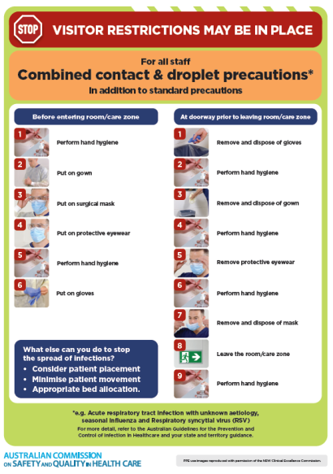](https://www.safetyandquality.gov.au/publications-and-resources/resource-library/infection-prevention-and-control-poster-combined-contact-and-droplet-precautions)
* ***Poster – Combined airborne and contact precautions*** <https://www.safetyandquality.gov.au/publications-and-resources/resource-library/poster-combined-airborne-and-contact-precautions>   
  [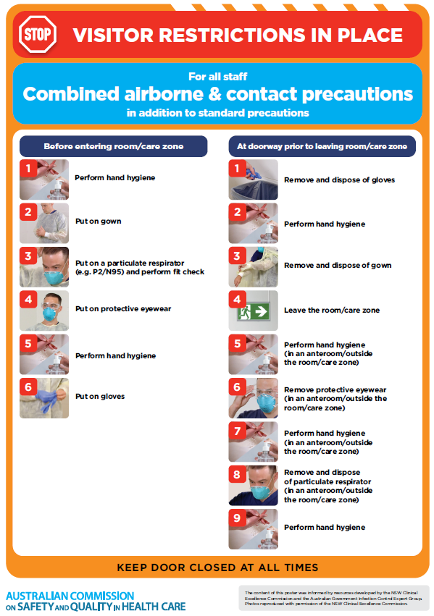](https://www.safetyandquality.gov.au/publications-and-resources/resource-library/poster-combined-airborne-and-contact-precautions)
* ***Environmental Cleaning and Infection Prevention and Control*** [www.safetyandquality.gov.au/environmental-cleaning](http://www.safetyandquality.gov.au/environmental-cleaning)
* ***COVID-19 infection prevention and control risk management – Guidance*** <https://www.safetyandquality.gov.au/publications-and-resources/resource-library/covid-19-infection-prevention-and-control-risk-management-guidance>
* ***Safe care for people with cognitive impairment during COVID-19***<https://www.safetyandquality.gov.au/our-work/cognitive-impairment/cognitive-impairment-and-covid-19>
* ***Stop COVID-19: Break the chain of infection*** posterhttps://www.safetyandquality.gov.au/publications-and-resources/resource-library/break-chain-infection-poster-a3  
  **[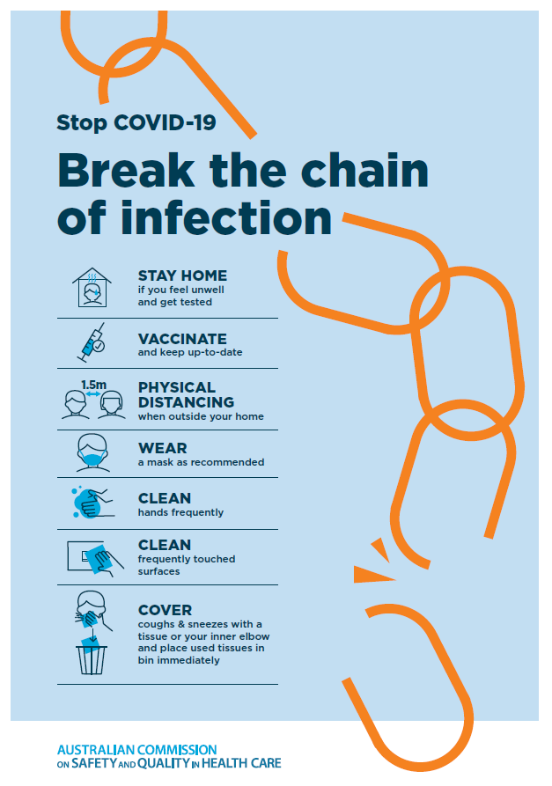](https://www.safetyandquality.gov.au/publications-and-resources/resource-library/break-chain-poster-a3https:/www.safetyandquality.gov.au/publications-and-resources/resource-library/break-chain-poster-a3)**
* ***COVID-19 and face masks – Information for consumers*** <https://www.safetyandquality.gov.au/publications-and-resources/resource-library/covid-19-and-face-masks-information-consumers>

[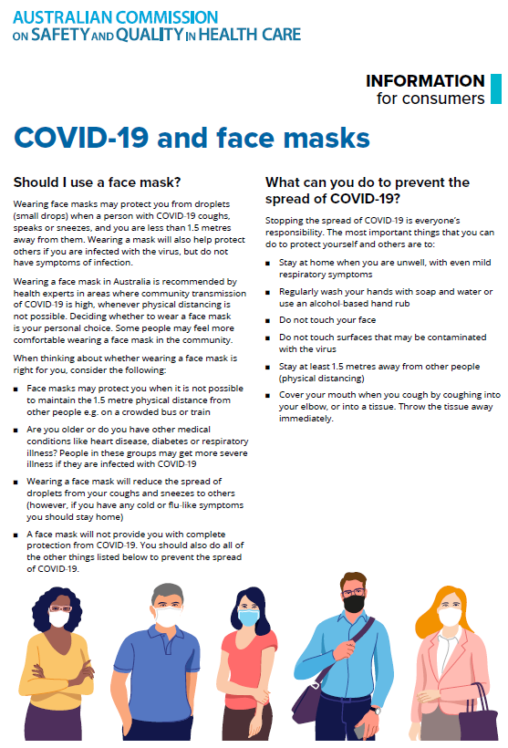](https://www.safetyandquality.gov.au/sites/default/files/2020-07/covid-19_and_face_masks_-_information_for_consumers.pdf)

*National COVID-19 Clinical Evidence Taskforce*

<https://covid19evidence.net.au/>

The National COVID-19 Clinical Evidence Taskforce is a collaboration of peak health professional bodies across Australia whose members are providing clinical care to people with COVID-19. The taskforce is undertaking continuous evidence surveillance to identify and rapidly synthesise emerging research in order to provide national, **evidence-based guidelines and clinical flowcharts for the clinical care of people with COVID-19**. The guidelines address questions that are specific to managing COVID-19 and cover the full disease course across mild, moderate, severe and critical illness. These are ‘living’ guidelines, updated with new research in near real-time in order to give reliable, up-to-the minute advice to clinicians providing frontline care in this unprecedented global health crisis.

*COVID-19 Critical Intelligence Unit*

<https://www.aci.health.nsw.gov.au/covid-19/critical-intelligence-unit>

The Agency for Clinical Innovation (ACI) in New South Wales has developed this page summarising rapid, evidence-based advice during the COVID-19 pandemic. Its operations focus on systems intelligence, clinical intelligence and evidence integration. The content includes a daily evidence digest, a COVID status monitor, a risk monitoring dashboard and evidence checks on a discrete topic or question relating to the current COVID-19 pandemic. There is also a ‘Living evidence’ section summarising key studies and emerging evidence on **COVID-19 vaccines** and **SARS-CoV-2 variants**. The most recent updates include:

* ***Current and emerging patient safety issues during COVID-19*** – What is the evidence on the current and emerging patient safety issues arising from the COVID-19 pandemic?
* ***Bivalent COVID-19 vaccines*** – What is the available regulatory and research evidence for bivalent COVID-19 vaccines?
* ***Surgery post COVID-19*** – What is the evidence for the timing of surgery, and outcomes following surgery, for people who have recovered from COVID-19?
* ***Paxlovid*** – What is the evidence for Paxlovid for treatment of COVID-19?
* ***Molnupiravir*** –What is the evidence for and regulatory context of molnupiravir for treatment of COVID-19?
* ***Eating disorders and COVID-19*** – What is the impact of the COVID-19 pandemic on the prevalence of eating disorders?
* ***Long COVID –*** What is the evidence on the prevalence, presentation and management of long-COVID?
* ***Oseltamivir (Tamiflu) use in healthcare settings*** – What is the evidence that use of oseltamivir in healthcare workers with a symptomatic influenza diagnosis result in an earlier return to work and reduced absenteeism? What is the evidence that use of oseltamivir in adults and children with symptomatic influenza reduces influenza transmission in health care settings?
* ***Alternative models of care for acute medical conditions*** – What is the evidence on alternative models of care for managing patients with acute medical conditions outside of emergency or inpatient hospital settings?
* ***Exercise and long COVID*** – Is exercise helpful in individuals with long COVID? Is post-exertional symptom exacerbation a risk in long COVID?
* ***Influenza and seasonal prophylaxis with oseltamivir*** – What is the place or evidence for seasonal influenza prophylaxis (such as taking oseltamivir for 10 to 12 weeks continuously) in healthcare and aged care settings?
* ***Rapid access models of care for respiratory illnesses*** – What is the evidence for rapid access models of care for respiratory illnesses, especially during winter seasons, in emergency departments?
* ***Post-acute sequelae of COVID-19*** – What is the evidence on the post-acute sequelae of COVID-19?
* ***Emerging variants*** – What is the available evidence for emerging variants?
* ***Chest pain or dyspnoea following COVID-19 vaccination*** – What is evidence for chest pain or dyspnoea following COVID-19 vaccination?
* ***Cardiac investigations and elective surgery post-COVID-19*** – What is evidence for cardiac investigations and elective surgery post-COVID-19?
* ***Breathlessness post COVID-19*** – How to determine those patients who present with ongoing breathlessness in need of urgent review or intervention due to suspected pulmonary embolus?
* ***COVID-19 pandemic and influenza*** – What is the evidence for COVID-19 pandemic and influenza?
* ***Budesonide and aspirin for pregnant women with COVID-19 –*** What is the evidence for the use of Budesonide for pregnant women with COVID-19? What is the evidence for aspirin prophylaxis for pre-eclampsia in pregnant women with a COVID-19 infection?
* ***COVID-19 vaccines in Australia*** – What is the evidence on COVID-19 vaccines in Australia?
* ***COVID-19 pandemic and wellbeing of critical care and other healthcare workers*** – Evidence in brief on the impact of the COVID-19 pandemic on the wellbeing of critical care and other healthcare workers.
* ***Disease modifying treatments for COVID-19 in children*** – What is the evidence for disease modifying treatments for COVID-19 in children?
* ***Mask type for COVID-19 positive wearer*** – What is the evidence for different mask types for COVID-19 positive wearers?
* ***Post acute and subacute COVID-19 care*** – What published advice and models of care are available regarding post-acute and subacute care for COVID-19 patients?
* ***Hospital visitor policies*** – What is the evidence for hospital visitor policies during and outside of the COVID-19 pandemic?
* ***Surgical masks, eye protection and PPE guidance*** –What is the evidence for surgical masks in the endemic phase in hospitals and for eyewear to protect against COVID-19?

**Disclaimer**

On the Radar is an information resource of the Australian Commission on Safety and Quality in Health Care. The Commission is not responsible for the content of, nor does it endorse, any articles or sites listed. The Commission accepts no liability for the information or advice provided by these external links. Links are provided on the basis that users make their own decisions about the accuracy, currency and reliability of the information contained therein. Any opinions expressed are not necessarily those of the Australian Commission on Safety and Quality in Health Care.