# Australian Commission on Safety and Quality logotypeOn the Radar

Issue 594

13 March 2023

*On the Radar* is a summary of some of the recent publications in the areas of safety and quality in health care. Inclusion in this document is not an endorsement or recommendation of any publication or provider. Access to particular documents may depend on whether they are Open Access or not, and/or your individual or institutional access to subscription sites/services. Material that may require subscription is included as it is considered relevant.

*On the Radar* is available online, via email or as a PDF or Word document from <https://www.safetyandquality.gov.au/publications-and-resources/newsletters/radar>

If you would like to receive *On the Radar* via email, you can subscribe on our website <https://www.safetyandquality.gov.au/publications-and-resources/newsletters>  
or by emailing us at H[Umail@safetyandquality.gov.auU](mailto:mail@safetyandquality.gov.au).   
You can also send feedback and comments to H[Umail@safetyandquality.gov.auU](mailto:mail@safetyandquality.gov.au).

For information about the Commission and its programs and publications, please visit <https://www.safetyandquality.gov.au>

You can also follow us on Twitter @ACSQHC.

**On the Radar**

Editor: Dr Niall Johnson [niall.johnson@safetyandquality.gov.au](mailto:niall.johnson@safetyandquality.gov.au)

Contributors: Niall Johnson, Suraj Rasakulasingam, Jing Song

***HACs FAQs and Resources update***

<https://www.safetyandquality.gov.au/our-work/indicators-measurement-and-reporting/complications/hacs-faqs-and-resources>

Following feedback and discussions with clinical experts and health services from across Australia, the Australian Commission on Safety and Quality in Health Care is pleased to announce new resources to support the understanding, prevention and reduction of Hospital-Acquired Complications (HACs). HACs monitoring and review builds on, and aligns with the NSQHS Standards ([Action 1.28 - Variation in clinical practice and health outcomes](https://safetyandquality.govcms.gov.au/standards/nsqhs-standards/clinical-governance-standard/clinical-performance-and-effectiveness/action-128)) and is further supported by the Commission’s recently published [*User Guide for Reviewing Clinical Variation*](https://safetyandquality.govcms.gov.au/our-work/healthcare-variation/user-guide-reviewing-clinical-variation) and [Clinical Care Standards](https://www.safetyandquality.gov.au/standards/clinical-care-standards/stillbirth-clinical-care-standard/implementation-resources).

In addition to the previously available HACs factsheets, these updates include:

* how to use and interpret HACs data
* a user guide for reviewing clinical variation
* recommended national goal rates for reducing HACs
* a searchable list of complication specific clinical care standards, guidelines and literature
* a feedback survey at <https://www.safetyandquality.gov.au/our-work/indicators-measurement-and-reporting/complications/hacs-faqs-and-resources#submit-your-feedback>

**Journal articles**

*Bending the patient safety curve: how much can AI help?*

Classen DC, Longhurst C, Thomas EJ

npj Digital Medicine 2023;6:2.

|  |  |
| --- | --- |
| DOI | <https://doi.org/10.1038/s41746-022-00731-5> |
| Notes | Artificial intelligence (AI) and machine learning (ML) have been touted as the next big thing for many industries, including healthcare. The recent flurry of interest in “generative AI”, such as ChatGPT, has renewed this interest. This commentary piece offers a review of ‘current state of patient safety and the application of artificial intelligence (AI) techniques to patient safety’. The authors review some of the current and emerging uses of AI in patient safety, along with some of the limitations and risks. The authors consider that ‘AI has significant potential to improve patient safety’ but suggest that there needs to be ‘a critical evaluation of AI and patient safety’. Drawing on a recent ‘multistakeholder conference’ the piece includes lists of areas of focus and use cases for specific clinical problems.  ***Areas of focus for AI and patient safety***   1. Develop AI/advanced analytics implementation models, implementation approaches, and methods for integration into clinical workflows 2. Create a patient safety framework to guide measurement of AI impact: How to use AI to improve each dimension of safety from retrospective analysis to real-time monitoring to future use of prediction 3. Build an AI patient safety financial business case 4. Reduce cognitive and total work burden with AI which should be interpretable and usable for frontline users. 5. AI patient and consumer focused issues: study how patients and consumers will view and use these tools and how their use will impact patient-doctor and patient-healthcare team relationships 6. Create ways to engage all the relevant stakeholders in AI use and design 7. Develop effective governance/oversight and accountability for AI in clinical care 8. Develop methods to learn and loop back to adjust AI algorithms to ensure equity—refine or change for different or changing populations 9. Create AI to enhance adverse event/near miss monitoring and real time safety surveillance 10. Create Use Cases for the application of AI to specific problems in patient safety.   ***Top use cases for the application of AI to specific clinical problems in patient safety***   1. Actionable real time patient safety electronic clinical quality measures 2. Surgical complication prediction 3. Pressure ulcer prediction 4. Hypoglycemia prediction 5. Sepsis prediction 6. Suicide prediction 7. Diabetic eye AI screening 8. Breast imaging cancer screening 9. Chest x-ray imaging AI diagnosis 10. Skin melanoma AI diagnosis 11. Chest x-ray imaging AI cancer screening 12. Patient self-managed electronic safety dashboards. |

*Cognitive biases in surgery: systematic review*

Armstrong BA, Dutescu IA, Tung A, Carter DN, Trbovich PL, Wong S, et al

British Journal of Surgery 2023:znad004.

|  |  |
| --- | --- |
| DOI | <https://doi.org/10.1093/bjs/znad004> |
| Notes | One of the major concerns around AI and ML is that of bias, particularly algorithmic bias. This piece looks at bias in humans, specifically cognitive bias in surgery. This systematic review examined the issue of cognitive biases and their impact on surgical performance and patient outcomes. Based on 39 studies that cover 6514 surgeons and more than 200,000 patients, the analysis identified 31 types of cognitive bias, ‘with overconfidence, anchoring, and confirmation bias the most common’. The authors observe that ‘Cognitive biases differentially influenced six themes of surgical performance. For example, overconfidence bias associated with inaccurate perceptions of ability, whereas anchoring bias associated with inaccurate risk–benefit estimations and not considering alternative options. Anchoring and confirmation biases associated with actual patient harm, such as never events.’ |

*There is a worrying amount of fraud in medical research*

The Economist

London 2023

|  |  |
| --- | --- |
| URL | <https://www.economist.com/science-and-technology/2023/02/22/there-is-a-worrying-amount-of-fraud-in-medical-research>. |
| Notes | This piece, available online and also published in the 25 February 2023 edition of *The Economist* under the headline 'Doctored data" and as a related podcast (<https://www.economist.com/fraud-pod>) looks at scientific and medical research publishing, particularly issues of fabrication and fraud. The concerning aspects of this include that these tainted papers can form part of the evidence base that clinician's decisions and the clinical practice guidelines they use to make those decisions are founded upon. Fraud can range from cosy publishing and reviewing agreements between colleagues through corruption to outright fabrication. In the podcast, the editor of one medical journal reveals that he suspects that as much as 30% of the papers that journal receives contain data that is not factual. |

*Health Affairs*

Volume 42, Number 3, March 2023

|  |  |
| --- | --- |
| URL | <https://www.healthaffairs.org/toc/hlthaff/42/3> |
| Notes | A new issue of *Health Affairs* has been published with the themes ‘**Public Health During COVID-19 & More’**. Articles in this issue of *Health Affairs* include:   * Integrating The US Public Health And Medical Care Systems To Improve **Health Crisis Response** (Margaret Bourdeaux, Annmarie Sasdi, Shefali Oza, and Vanessa B Kerry) * Public Health Law Modernization 2.0: Rebalancing **Public Health Powers And Individual Liberty** In The Age Of COVID-19 (Michelle M Mello and Lawrence O Gostin) * **Trust In** US Federal, State, And Local **Public Health Agencies During COVID-19**: Responses And Policy Implications (Gillian K SteelFisher, Mary G Findling, Hannah L Caporello, Keri M Lubell, Kathleen G Vidoloff Melville, Lindsay Lane, Alyssa A Boyea, T J Schafer, and E N Ben-Porath) * The **Exodus Of State And Local Public Health Employees**: Separations Started Before And Continued Throughout COVID-19 (Jonathon P Leider, Brian C Castrucci, Moriah Robins, Rachel Hare Bork, Michael R Fraser, Elena Savoia, Rachael Piltch-Loeb, and Howard K Koh) * **Community-Based Outbreak Investigation And Response**: Enhancing Preparedness, Public Health Capacity, And Equity (Shefali Oza, Flavia Chen, Victoria Selser, Marguerite M Clougherty, Kristi Dews Dale, Jenna Iberg Johnson, Taylor Brock-Fisher, K J Seung, and Margaret Bourdeaux) * Increases In COVID-19 Vaccination Among NYC Municipal Employees After **Implementation Of Vaccination Requirements** (Beth L Rubenstein, Pierre J Amiel, Alexandra Ternier, Hannah Helmy, Sungwoo Lim, Dave A Chokshi, and Jane R Zucker) * **Planning For The Next Pandemic**: Lab Systems Need Policy Shift To Speed Emerging Infectious Disease Warning And Tracking (Jay K Varma, Jill Taylor, and Joshua M Sharfstein) * COVID-19 Revealed **Shortcomings Of The US Public Health System** And The Need To Strengthen Funding And Accountability (Jason M Orr, Jonathon P Leider, Paul Kuehnert, and Betty Bekemeier) * Proposing An Innovative Bond To Increase **Investments In Social Drivers Of Health Interventions** In Medicaid Managed Care (Pinar Karaca-Mandic, Sayeh Nikpay, Susanna Gibbons, David Haynes, R Koranne, and R Thakor) * Can Capitalism Drive Health Equity? Considering The Benefits And Risks Of Social Drivers Of **Health Bonds** (Nathan Chomilo) * Proposed Social Drivers Of **Health Bonds** Offer Promising Improvements But Face Many Challenges To Implementation (Jo E McNamara and E Chen) * Patent Challenges And Litigation On **Inhalers For Asthma And COPD** (Sanjay Reddy, Reed F Beall, S Sean Tu, A S Kesselheim, and W B Feldman) * Competition And Vulnerabilities In The Global Supply Chain For US **Generic Active Pharmaceutical Ingredients** (Mariana P Socal, Kiefer Ahn, Jeremy A Greene, and Gerard F Anderson) * **Surviving The Surge**: Nonurgent Elective Procedures, Intensive Care, And Mississippi’s COVID-19 Waves (Thomas Dobbs, M Staneva, and P Byers) * **Drug Repurposing** During The COVID-19 Pandemic: Lessons For Expediting Drug Development And Access (Wesley Greenblatt, Charu Gupta, and Jennifer Kao) * Demographic And Clinical Factors Associated With **Long COVID** (Zirui Song and Mia Giuriato) * Keeping Quiet About **Genetic Risk** (Susanna J Smith) |

**COVID-19 resources**

https://www.safetyandquality.gov.au/covid-19

The Australian Commission on Safety and Quality in Health Care has developed a number of resources to assist healthcare organisations, facilities and clinicians. These and other material on COVID-19 are available at <https://www.safetyandquality.gov.au/covid-19>

These resources include:

* ***OVID-19 infection prevention and control risk management*** This primer provides an overview of three widely used tools for investigating and responding to patient safety events and near misses. Tools covered in this primer include incident reporting systems, Root Cause Analysis (RCA), and Failure Modes and Effects Analysis (FMEA).   
  <https://www.safetyandquality.gov.au/publications-and-resources/resource-library/covid-19-infection-prevention-and-control-risk-management-guidance>
* ***Poster – Combined contact and droplet precautions*** <https://www.safetyandquality.gov.au/publications-and-resources/resource-library/infection-prevention-and-control-poster-combined-contact-and-droplet-precautions>  
  [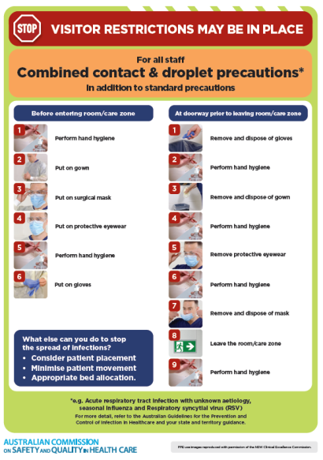](https://www.safetyandquality.gov.au/publications-and-resources/resource-library/infection-prevention-and-control-poster-combined-contact-and-droplet-precautions)
* ***Poster – Combined airborne and contact precautions*** <https://www.safetyandquality.gov.au/publications-and-resources/resource-library/poster-combined-airborne-and-contact-precautions>   
  [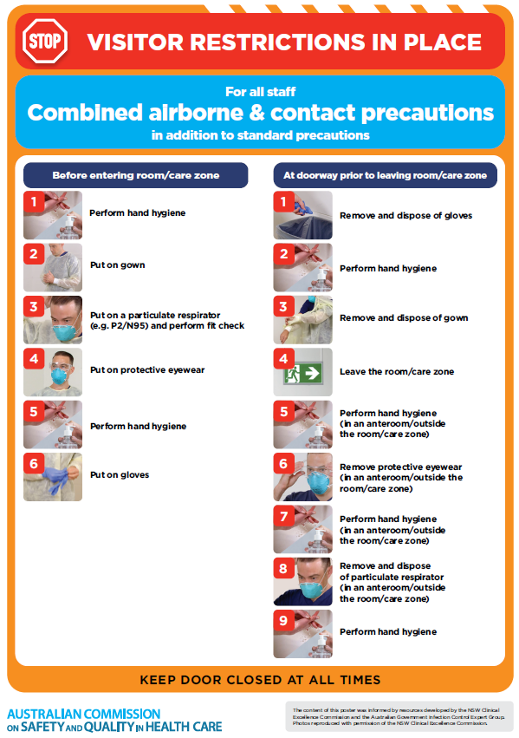](https://www.safetyandquality.gov.au/publications-and-resources/resource-library/poster-combined-airborne-and-contact-precautions)
* ***Environmental Cleaning and Infection Prevention and Control*** [www.safetyandquality.gov.au/environmental-cleaning](http://www.safetyandquality.gov.au/environmental-cleaning)
* ***COVID-19 infection prevention and control risk management – Guidance*** <https://www.safetyandquality.gov.au/publications-and-resources/resource-library/covid-19-infection-prevention-and-control-risk-management-guidance>
* ***Safe care for people with cognitive impairment during COVID-19***<https://www.safetyandquality.gov.au/our-work/cognitive-impairment/cognitive-impairment-and-covid-19>
* ***Stop COVID-19: Break the chain of infection*** posterhttps://www.safetyandquality.gov.au/publications-and-resources/resource-library/break-chain-infection-poster-a3  
  **[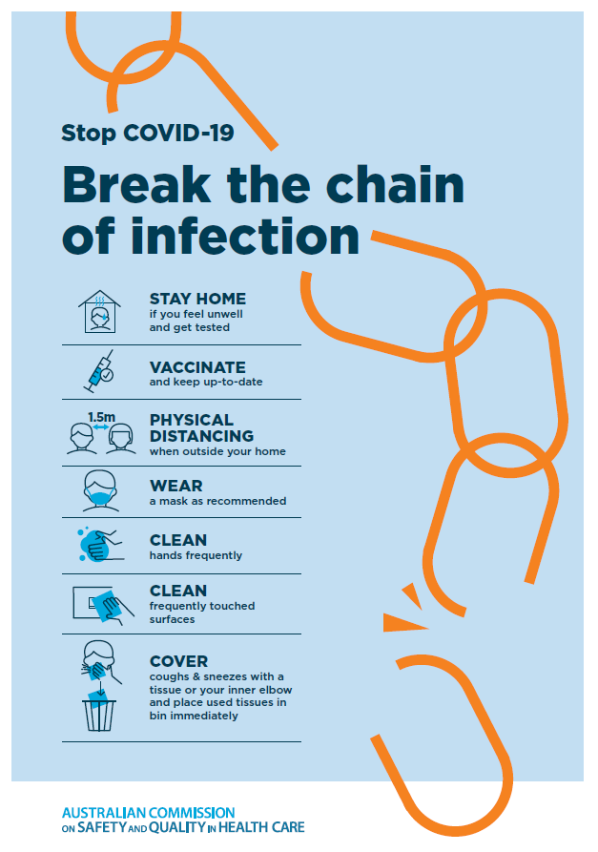](https://www.safetyandquality.gov.au/publications-and-resources/resource-library/break-chain-poster-a3https:/www.safetyandquality.gov.au/publications-and-resources/resource-library/break-chain-poster-a3)**
* ***COVID-19 and face masks – Information for consumers*** <https://www.safetyandquality.gov.au/publications-and-resources/resource-library/covid-19-and-face-masks-information-consumers>

[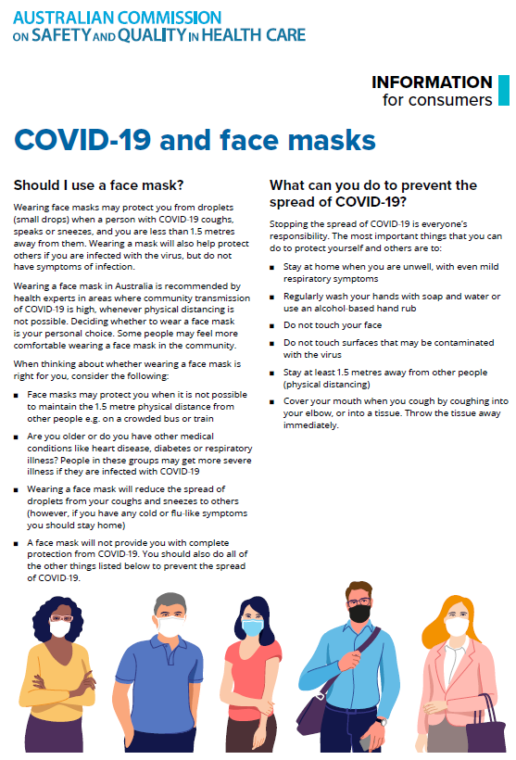](https://www.safetyandquality.gov.au/sites/default/files/2020-07/covid-19_and_face_masks_-_information_for_consumers.pdf)

*National COVID-19 Clinical Evidence Taskforce*

<https://covid19evidence.net.au/>

The National COVID-19 Clinical Evidence Taskforce is a collaboration of peak health professional bodies across Australia whose members are providing clinical care to people with COVID-19. The taskforce is undertaking continuous evidence surveillance to identify and rapidly synthesise emerging research in order to provide national, **evidence-based guidelines and clinical flowcharts for the clinical care of people with COVID-19**. The guidelines address questions that are specific to managing COVID-19 and cover the full disease course across mild, moderate, severe and critical illness. These are ‘living’ guidelines, updated with new research in near real-time in order to give reliable, up-to-the minute advice to clinicians providing frontline care in this unprecedented global health crisis.

*COVID-19 Critical Intelligence Unit*

<https://www.aci.health.nsw.gov.au/covid-19/critical-intelligence-unit>

The Agency for Clinical Innovation (ACI) in New South Wales has developed this page summarising rapid, evidence-based advice during the COVID-19 pandemic. Its operations focus on systems intelligence, clinical intelligence and evidence integration. The content includes a daily evidence digest, a COVID status monitor, a risk monitoring dashboard and evidence checks on a discrete topic or question relating to the current COVID-19 pandemic. There is also a ‘Living evidence’ section summarising key studies and emerging evidence on **COVID-19 vaccines** and **SARS-CoV-2 variants**. The most recent updates include:

* ***Current and emerging patient safety issues during COVID-19*** – What is the evidence on the current and emerging patient safety issues arising from the COVID-19 pandemic?
* ***Bivalent COVID-19 vaccines*** – What is the available regulatory and research evidence for bivalent COVID-19 vaccines?
* ***Surgery post COVID-19*** – What is the evidence for the timing of surgery, and outcomes following surgery, for people who have recovered from COVID-19?
* ***Paxlovid*** – What is the evidence for Paxlovid for treatment of COVID-19?
* ***Molnupiravir*** –What is the evidence for and regulatory context of molnupiravir for treatment of COVID-19?
* ***Eating disorders and COVID-19*** – What is the impact of the COVID-19 pandemic on the prevalence of eating disorders?
* ***Long COVID –*** What is the evidence on the prevalence, presentation and management of long-COVID?
* ***Oseltamivir (Tamiflu) use in healthcare settings*** – What is the evidence that use of oseltamivir in healthcare workers with a symptomatic influenza diagnosis result in an earlier return to work and reduced absenteeism? What is the evidence that use of oseltamivir in adults and children with symptomatic influenza reduces influenza transmission in health care settings?
* ***Alternative models of care for acute medical conditions*** – What is the evidence on alternative models of care for managing patients with acute medical conditions outside of emergency or inpatient hospital settings?
* ***Exercise and long COVID*** – Is exercise helpful in individuals with long COVID? Is post-exertional symptom exacerbation a risk in long COVID?
* ***Influenza and seasonal prophylaxis with oseltamivir*** – What is the place or evidence for seasonal influenza prophylaxis (such as taking oseltamivir for 10 to 12 weeks continuously) in healthcare and aged care settings?
* ***Rapid access models of care for respiratory illnesses*** – What is the evidence for rapid access models of care for respiratory illnesses, especially during winter seasons, in emergency departments?
* ***Post-acute sequelae of COVID-19*** – What is the evidence on the post-acute sequelae of COVID-19?
* ***Emerging variants*** – What is the available evidence for emerging variants?
* ***Chest pain or dyspnoea following COVID-19 vaccination*** – What is evidence for chest pain or dyspnoea following COVID-19 vaccination?
* ***Cardiac investigations and elective surgery post-COVID-19*** – What is evidence for cardiac investigations and elective surgery post-COVID-19?
* ***Breathlessness post COVID-19*** – How to determine those patients who present with ongoing breathlessness in need of urgent review or intervention due to suspected pulmonary embolus?
* ***COVID-19 pandemic and influenza*** – What is the evidence for COVID-19 pandemic and influenza?
* ***Budesonide and aspirin for pregnant women with COVID-19 –*** What is the evidence for the use of Budesonide for pregnant women with COVID-19? What is the evidence for aspirin prophylaxis for pre-eclampsia in pregnant women with a COVID-19 infection?
* ***COVID-19 vaccines in Australia*** – What is the evidence on COVID-19 vaccines in Australia?
* ***COVID-19 pandemic and wellbeing of critical care and other healthcare workers*** – Evidence in brief on the impact of the COVID-19 pandemic on the wellbeing of critical care and other healthcare workers.
* ***Disease modifying treatments for COVID-19 in children*** – What is the evidence for disease modifying treatments for COVID-19 in children?
* ***Mask type for COVID-19 positive wearer*** – What is the evidence for different mask types for COVID-19 positive wearers?
* ***Post acute and subacute COVID-19 care*** – What published advice and models of care are available regarding post-acute and subacute care for COVID-19 patients?
* ***Hospital visitor policies*** – What is the evidence for hospital visitor policies during and outside of the COVID-19 pandemic?
* ***Surgical masks, eye protection and PPE guidance*** –What is the evidence for surgical masks in the endemic phase in hospitals and for eyewear to protect against COVID-19?

**Disclaimer**

On the Radar is an information resource of the Australian Commission on Safety and Quality in Health Care. The Commission is not responsible for the content of, nor does it endorse, any articles or sites listed. The Commission accepts no liability for the information or advice provided by these external links. Links are provided on the basis that users make their own decisions about the accuracy, currency and reliability of the information contained therein. Any opinions expressed are not necessarily those of the Australian Commission on Safety and Quality in Health Care.