# Australian Commission on Safety and Quality logotypeOn the Radar

Issue 595

20 March 2023

*On the Radar* is a summary of some of the recent publications in the areas of safety and quality in health care. Inclusion in this document is not an endorsement or recommendation of any publication or provider. Access to particular documents may depend on whether they are Open Access or not, and/or your individual or institutional access to subscription sites/services. Material that may require subscription is included as it is considered relevant.

*On the Radar* is available online, via email or as a PDF or Word document from <https://www.safetyandquality.gov.au/publications-and-resources/newsletters/radar>

If you would like to receive *On the Radar* via email, you can subscribe on our website <https://www.safetyandquality.gov.au/publications-and-resources/newsletters>  
or by emailing us at H[Umail@safetyandquality.gov.auU](mailto:mail@safetyandquality.gov.au).   
You can also send feedback and comments to H[Umail@safetyandquality.gov.auU](mailto:mail@safetyandquality.gov.au).

For information about the Commission and its programs and publications, please visit <https://www.safetyandquality.gov.au>

You can also follow us on Twitter @ACSQHC.

**On the Radar**

Editor: Dr Niall Johnson [niall.johnson@safetyandquality.gov.au](mailto:niall.johnson@safetyandquality.gov.au)

Contributors: Niall Johnson, Angie Dalli, Naomi Poole

**March 20-26 is National Advance Care Planning week**

*Underlying goals of advance care planning (ACP): a qualitative analysis of the literature*

Fleuren N, Depla MFIA, Janssen DJA, Huisman M, Hertogh CMPMBMC Palliative Care. 2020 2020/03/06;19(1):27.

<https://doi.org/10.1186/s12904-020-0535-1>

Advance care planning (ACP) is a process of discussing, determining, and documenting a person’s preferences for their future care should they be unable to make and communicate decisions about their care. Advance care planning is commonly associated with end-of-life care; however, it is also useful for people with physical or cognitive impairment or mental illness which could affect their capacity for decision making.

Advance care plans contribute to improved ongoing care and enhanced patient experience and family satisfaction through the delivery of comprehensive care that is consistent with the patient’s beliefs, values, needs and preferences. Advance care planning can lead to improvements in patient autonomy, confidence and agency, healthcare team morale, communication, and reduction of costs through unnecessary interventions and transfers.

Fleuren et al discuss research that identifies five different underlying goals of ACP - respecting individual patient autonomy, improving quality of care, strengthening relationships, preparing for end-of-life, and reducing overtreatment.

Advance Care Planning Australia offer webinars aimed at individuals and their families, and resources for health professionals. You can see the full list of webinars at <https://www.advancecareplanning.org.au/training-and-education/webinars>

Find more resources or information about how to get involved in National Advance Care Planning Week at <https://www.advancecareplanning.org.au/nacpweek/get-involved>

**Reports**

*Moving from exclusion to inclusion in digital health and care*

Mistry P, Jabbal J

London: The King's Fund; 2023

|  |  |
| --- | --- |
| URL | <https://www.kingsfund.org.uk/publications/exclusion-inclusion-digital-health-care> |
| Notes | This long read from The King’s Fund in the UK examines some of the issues around the emergence of digital technologies in health care delivery, particularly around the potential for improving accessibility, flexibility and improving patient-centredness and the experience of care. However, there are also concerns of digital exclusion and the need to ensure that ‘digitally enabled services are inclusive and meet the expectations of staff and the public.’. |

**Journal articles**

*Consumers’ and health providers’ views and perceptions of partnering to improve health services design, delivery and evaluation: a co‐produced qualitative evidence synthesis*

Merner B, Schonfeld L, Virgona A, Lowe D, Walsh L, Wardrope C, et al

Cochrane Database of Systematic Reviews. 2023 (3).

|  |  |
| --- | --- |
| DOI | <https://doi.org/10.1002/14651858.CD013274.pub2> |
| Notes | This qualitative evidence synthesis examined the partnering with consumers, particularly on ‘formal group partnerships where health providers and consumers share decision‐making about planning, delivering and/or evaluating health services’. The work sought to:   1. ‘To synthesise the views and experiences of consumers and health providers of formal partnership approaches that aimed to improve planning, delivery or evaluation of health services. 2. To identify best practice principles for formal partnership approaches in health services by understanding consumers' and health providers' views and experiences.’   Focussing on 33 studies, the analysis identified 19 findings that were then grouped into 5 categories:   * Contextual factors influencing partnerships * Consumer recruitment * Partnership dynamics and processes * Perceived impacts on partnership participants * Perceived impacts on health service planning, delivery and evaluation.   The authors emphasise the importance of power imbalances and the need to be aware of these and to address them. The key messages in the plain language summary stress these in noting:   * ‘Power imbalances between health providers and consumers can limit consumer participation in health service planning, delivery and evaluation. * Power imbalances in the partnership may happen because of the ways consumers are recruited, how meetings are run, and how decisions are made. * To have successful partnerships with consumers, health providers need to address these power imbalances. * Some consumers and health providers believed that partnerships improved the culture and environment of the health service, as well as how health services were planned and developed.’ |

For information on the Commission’s work on e-partnering with consumers, see <https://www.safetyandquality.gov.au/our-work/partnering-consumers>

*Association of Primary Care Visit Length With Potentially Inappropriate Prescribing*

Neprash HT, Mulcahy JF, Cross DA, Gaugler JE, Golberstein E, Ganguli I.

JAMA Health Forum. 2023;4(3):e230052-e230052.

|  |  |
| --- | --- |
| DOI | <https://doi.org/10.1001/jamahealthforum.2023.0052> |
| Notes | This piece at *JAMA Health Forum* reports on a US study that examined the relationship between the length of a consultation and prescribing patterns. The study used data covering 8 119 161 primary care visits by 4 360 445 patients (56.6% women) with 8091 primary care physicians in the USA. The authors report that ‘shorter visit length was associated with a higher likelihood of inappropriate antibiotic prescribing for patients with upper respiratory tract infections and coprescribing of opioids and benzodiazepines for patients with painful conditions. These findings suggest opportunities for additional research and operational improvements to visit scheduling and quality of prescribing decisions in primary care.’ |

*Public Health Research & Practice*

Volume 33, Issue 1, March 2023

|  |  |
| --- | --- |
| URL | https://www.phrp.com.au/issues/march-2023-volume-33-issue-1/ |
|  | A new issue of *Public Health Research & Practice* has been published. Articles in this issue of *Public Health Research & Practice* include:   * Editorial: **Improving health literacy**: how to succeed (Don Nutbeam) * **Lung cancer screening**: the hidden public health emergency (Emily Stone, Rachael H Dodd, Henry Marshall, Billie Bonevski, Nicole M Rankin) * Is the evidence-based medicine movement counter-productive: are randomised controlled trials the best approach to establish **evidence in complex healthcare situations**? (Susan P Jacups, Clare Bradley) * **Reigniting tobacco control**: returning Australia to the front of the pack (Becky Freeman) * Improving colonoscopy prioritisation and promoting the National Bowel Cancer Screening Program: keys to reducing **bowel cancer burden** (Paul Grogan, Emily He, Peter Pockney) * The increasing use of **cosmetic non-ionising radiation applications** – types of procedures, potential risks to consumers and regulation in Australia (Ken K Karipidis, David Urban, Rick A Tinker, Trevor Wheatley) * Considering potential benefits, as well as harms, from the **COVID-19 disruption to cancer screening and other healthcare services** (Katy JL Bell, Fiona F Stanaway, Kirsten McCaffery, Michael Shirley, Stacy M Carter) * The availability and promotion of **low alcohol beverages in licensed venues**: an environmental audit on the Gold Coast, Australia (Blake Palmer, Christopher Irwin, Christina Mailer, Ben Desbrow) * **Colonoscopies in Australia** – how much does the National Bowel Cancer Screening Program contribute to colonoscopy use? (Joachim Worthington, Emily He, Jie-Bin Lew, James St John, Christopher Horn, Paul Grogan, Karen Canfell, Eleonora Feletto) * An analysis of the **legal framework influencing walking** in Australia (Tracy Nau, Adrian Bauman, William Bellew, Billie Giles-Corti, Ben J Smith) * Priorities for **building Australian workforce capacity** to leverage population-based, routinely collected data: views from pharmacoepidemiology (Derrick Lopez, Cecily Strange, Frank Sanfilippo, Benjamin Daniels, Sallie Pearson, David Preen) * **Filling the gap between evidence, policy and practice**: are 45 and Up Study researchers planning for impact? (Tam C Ha, Martin McNamara, Luciano Melo, Emma K Frost, Gabriel M Moore) * Development of the **Consumer Involvement & Engagement Toolkit**: a digital resource to build capacity for undertaking patient-centred clinical trials in Australia (Tanya Symons, Janelle Bowden, Anne McKenzie, Julia M Fallon-Ferguson, Leanne Y Weekes, James Ansell, Rinki Murphy, Shilpa Jesudason, Manoj Saxena, Alistair Nichol, Nicola Straiton) * **Efficacy of submissions as an advocacy strategy**: piloting the Public Health Association of Australia’s submission evaluation tool (Jaini Ghatalia, Cherie Russell, Megan Ferguson, Katherine Cullerton) |

*Healthcare Policy*

Volume 18, Number 3, 2023

|  |  |
| --- | --- |
| URL | <https://www.longwoods.com/publications/healthcare-policy/27032/1/vol.-18-no.-3-2023> |
| Notes | A new issue of *Healthcare Policy* has been published. Articles in this issue of *Healthcare Policy* include:   * Editorial: Provinces and Territories Are Overdue for an Update in **Healthcare Funding Policies** (Jason M Sutherland) * Multinational **Pharmaceutical** Companies Shortchange Canada in **Research and Development Investments**: Is It Time to Pursue Other Options? (Shoo K Lee, Sukhy K Mahl, Jessica J Green and Joel Lexchin * Commentary: Reconsidering **Pharmaceutical Research and Development Investments** (Marc-André Gagnon) * Nursing Home Residents’ Use of Radiography in New Brunswick: A Case for **Mobile Radiography**? (Eric Plant, Rose McCloskey, Isdore Chola Shamputa, Kavish Chandra, Paul Atkinson, Jacqueline Fraser, Tushar Pishe and Patrick Price) * How Engaged in **Legal Planning for Incapacity and Death** Are Canadians? A Mixed-Methods Survey (Ariane Plaisance, Jessie Stilson, Aurore Benadiba and Daren K Heyland) * **Pharmacist Disciplinary Action**: What Do Pharmacists Get in Trouble for? (Ai-Leng Foong-Reichert, Kelly A Grindrod, David J Edwards, Zubin Austin and Sherilyn K D Houle) * **Dentist Disciplinary Action**: What Do Dentists Get in Trouble for? (Ai-Leng Foong-Reichert, Sherilyn K D Houle, Zubin Austin, David J Edwards and Kelly A Grindrod) |

*BMJ Quality & Safety* online first articles

|  |  |
| --- | --- |
| URL | <https://qualitysafety.bmj.com/content/early/recent> |
| Notes | *BMJ Quality &Safety* has published a number of ‘online first’ articles, including:   * **Error disclosure in neonatal intensive care**: a multicentre, prospective, observational study (Loïc Passini, Stephane Le Bouedec, Gilles Dassieu, Audrey Reynaud, Camille Jung, Marie-Laurence Keller, Aline Lefebvre, Therese Katty, Jean-Marc Baleyte, Richard Layese, Etienne Audureau, Laurence Caeymaex SEPREVEN Study Group) * Editorial: How can **routine colorectal cancer screening** in the USA be considered low value in other countries? (Kelsey Chalmers, Shannon Brownlee, Vikas Saini) |

*International Journal for Quality in Health Care* online first articles

|  |  |
| --- | --- |
| URL | <https://academic.oup.com/intqhc/advance-articles> |
| Notes | *International Journal for Quality in Health Care* has published a number of ‘online first’ articles, including:   * Scaling Up **Quality in an Anesthesia Practice** (Richard P Dutton, Thomas H Swygert, Matthew Maloney, Mo Azam, D Kurt Jones, Aesha S Shukla, Paul Taheri, Olivia Lounsbury) |

**Online resources**

***[UK] NICE Guidelines and Quality Standards***

<https://www.nice.org.uk/guidance>

The UK’s National Institute for Health and Care Excellence (NICE) has published new (or updated) guidelines and quality standards. The latest reviews or updates include:

* NICE Guideline NG122 ***Lung cancer****: diagnosis and management* <https://www.nice.org.uk/guidance/ng122>

***[USA] AHRQ Perspectives on Safety***

<https://psnet.ahrq.gov/psnet-collection/perspectives>

The US Agency for Healthcare Research and Quality (AHRQ) publishes occasional Perspectives on Safety essays. Recent essays include:

* ***Remote Patient Monitoring*** <https://psnet.ahrq.gov/perspective/remote-patient-monitoring>

**COVID-19 resources**

https://www.safetyandquality.gov.au/covid-19

The Australian Commission on Safety and Quality in Health Care has developed a number of resources to assist healthcare organisations, facilities and clinicians. These and other material on COVID-19 are available at <https://www.safetyandquality.gov.au/covid-19>

These resources include:

* ***OVID-19 infection prevention and control risk management*** This primer provides an overview of three widely used tools for investigating and responding to patient safety events and near misses. Tools covered in this primer include incident reporting systems, Root Cause Analysis (RCA), and Failure Modes and Effects Analysis (FMEA).   
  <https://www.safetyandquality.gov.au/publications-and-resources/resource-library/covid-19-infection-prevention-and-control-risk-management-guidance>
* ***Poster – Combined contact and droplet precautions*** <https://www.safetyandquality.gov.au/publications-and-resources/resource-library/infection-prevention-and-control-poster-combined-contact-and-droplet-precautions>  
  [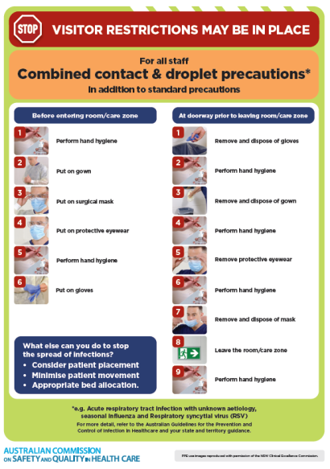](https://www.safetyandquality.gov.au/publications-and-resources/resource-library/infection-prevention-and-control-poster-combined-contact-and-droplet-precautions)
* ***Poster – Combined airborne and contact precautions*** <https://www.safetyandquality.gov.au/publications-and-resources/resource-library/poster-combined-airborne-and-contact-precautions>   
  [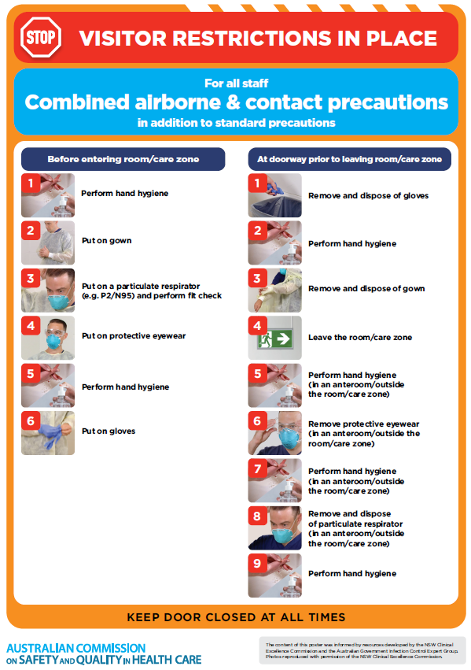](https://www.safetyandquality.gov.au/publications-and-resources/resource-library/poster-combined-airborne-and-contact-precautions)
* ***Environmental Cleaning and Infection Prevention and Control*** [www.safetyandquality.gov.au/environmental-cleaning](http://www.safetyandquality.gov.au/environmental-cleaning)
* ***COVID-19 infection prevention and control risk management – Guidance*** <https://www.safetyandquality.gov.au/publications-and-resources/resource-library/covid-19-infection-prevention-and-control-risk-management-guidance>
* ***Safe care for people with cognitive impairment during COVID-19***<https://www.safetyandquality.gov.au/our-work/cognitive-impairment/cognitive-impairment-and-covid-19>
* ***Stop COVID-19: Break the chain of infection*** posterhttps://www.safetyandquality.gov.au/publications-and-resources/resource-library/break-chain-infection-poster-a3  
  **[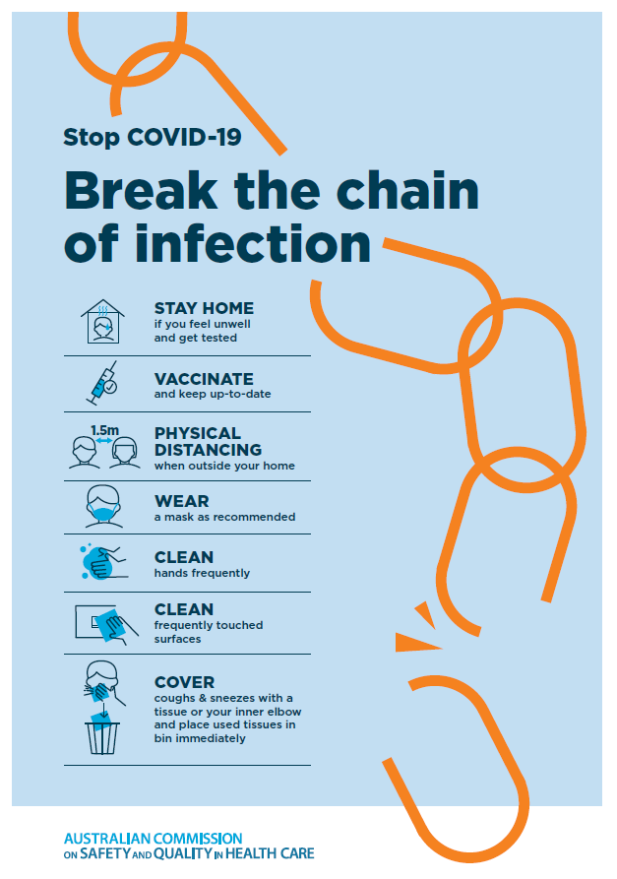](https://www.safetyandquality.gov.au/publications-and-resources/resource-library/break-chain-poster-a3https:/www.safetyandquality.gov.au/publications-and-resources/resource-library/break-chain-poster-a3)**
* ***COVID-19 and face masks – Information for consumers*** <https://www.safetyandquality.gov.au/publications-and-resources/resource-library/covid-19-and-face-masks-information-consumers>

[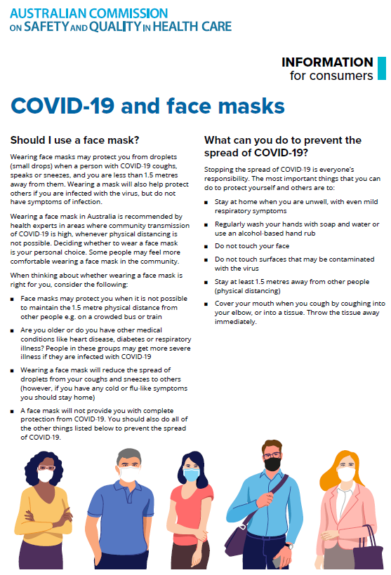](https://www.safetyandquality.gov.au/sites/default/files/2020-07/covid-19_and_face_masks_-_information_for_consumers.pdf)

*National COVID-19 Clinical Evidence Taskforce*

<https://covid19evidence.net.au/>

The National COVID-19 Clinical Evidence Taskforce is a collaboration of peak health professional bodies across Australia whose members are providing clinical care to people with COVID-19. The taskforce is undertaking continuous evidence surveillance to identify and rapidly synthesise emerging research in order to provide national, **evidence-based guidelines and clinical flowcharts for the clinical care of people with COVID-19**. The guidelines address questions that are specific to managing COVID-19 and cover the full disease course across mild, moderate, severe and critical illness. These are ‘living’ guidelines, updated with new research in near real-time in order to give reliable, up-to-the minute advice to clinicians providing frontline care in this unprecedented global health crisis.

*COVID-19 Critical Intelligence Unit*

<https://www.aci.health.nsw.gov.au/covid-19/critical-intelligence-unit>

The Agency for Clinical Innovation (ACI) in New South Wales has developed this page summarising rapid, evidence-based advice during the COVID-19 pandemic. Its operations focus on systems intelligence, clinical intelligence and evidence integration. The content includes a daily evidence digest, a COVID status monitor, a risk monitoring dashboard and evidence checks on a discrete topic or question relating to the current COVID-19 pandemic. There is also a ‘Living evidence’ section summarising key studies and emerging evidence on **COVID-19 vaccines** and **SARS-CoV-2 variants**. The most recent updates include:

* ***Current and emerging patient safety issues during COVID-19*** – What is the evidence on the current and emerging patient safety issues arising from the COVID-19 pandemic?
* ***Bivalent COVID-19 vaccines*** – What is the available regulatory and research evidence for bivalent COVID-19 vaccines?
* ***Surgery post COVID-19*** – What is the evidence for the timing of surgery, and outcomes following surgery, for people who have recovered from COVID-19?
* ***Paxlovid*** – What is the evidence for Paxlovid for treatment of COVID-19?
* ***Molnupiravir*** –What is the evidence for and regulatory context of molnupiravir for treatment of COVID-19?
* ***Eating disorders and COVID-19*** – What is the impact of the COVID-19 pandemic on the prevalence of eating disorders?
* ***Long COVID –*** What is the evidence on the prevalence, presentation and management of long-COVID?
* ***Oseltamivir (Tamiflu) use in healthcare settings*** – What is the evidence that use of oseltamivir in healthcare workers with a symptomatic influenza diagnosis result in an earlier return to work and reduced absenteeism? What is the evidence that use of oseltamivir in adults and children with symptomatic influenza reduces influenza transmission in health care settings?
* ***Alternative models of care for acute medical conditions*** – What is the evidence on alternative models of care for managing patients with acute medical conditions outside of emergency or inpatient hospital settings?
* ***Exercise and long COVID*** – Is exercise helpful in individuals with long COVID? Is post-exertional symptom exacerbation a risk in long COVID?
* ***Influenza and seasonal prophylaxis with oseltamivir*** – What is the place or evidence for seasonal influenza prophylaxis (such as taking oseltamivir for 10 to 12 weeks continuously) in healthcare and aged care settings?
* ***Rapid access models of care for respiratory illnesses*** – What is the evidence for rapid access models of care for respiratory illnesses, especially during winter seasons, in emergency departments?
* ***Post-acute sequelae of COVID-19*** – What is the evidence on the post-acute sequelae of COVID-19?
* ***Emerging variants*** – What is the available evidence for emerging variants?
* ***Chest pain or dyspnoea following COVID-19 vaccination*** – What is evidence for chest pain or dyspnoea following COVID-19 vaccination?
* ***Cardiac investigations and elective surgery post-COVID-19*** – What is evidence for cardiac investigations and elective surgery post-COVID-19?
* ***Breathlessness post COVID-19*** – How to determine those patients who present with ongoing breathlessness in need of urgent review or intervention due to suspected pulmonary embolus?
* ***COVID-19 pandemic and influenza*** – What is the evidence for COVID-19 pandemic and influenza?
* ***Budesonide and aspirin for pregnant women with COVID-19 –*** What is the evidence for the use of Budesonide for pregnant women with COVID-19? What is the evidence for aspirin prophylaxis for pre-eclampsia in pregnant women with a COVID-19 infection?
* ***COVID-19 vaccines in Australia*** – What is the evidence on COVID-19 vaccines in Australia?
* ***COVID-19 pandemic and wellbeing of critical care and other healthcare workers*** – Evidence in brief on the impact of the COVID-19 pandemic on the wellbeing of critical care and other healthcare workers.
* ***Disease modifying treatments for COVID-19 in children*** – What is the evidence for disease modifying treatments for COVID-19 in children?
* ***Mask type for COVID-19 positive wearer*** – What is the evidence for different mask types for COVID-19 positive wearers?
* ***Post acute and subacute COVID-19 care*** – What published advice and models of care are available regarding post-acute and subacute care for COVID-19 patients?
* ***Hospital visitor policies*** – What is the evidence for hospital visitor policies during and outside of the COVID-19 pandemic?
* ***Surgical masks, eye protection and PPE guidance*** –What is the evidence for surgical masks in the endemic phase in hospitals and for eyewear to protect against COVID-19?

**Disclaimer**

On the Radar is an information resource of the Australian Commission on Safety and Quality in Health Care. The Commission is not responsible for the content of, nor does it endorse, any articles or sites listed. The Commission accepts no liability for the information or advice provided by these external links. Links are provided on the basis that users make their own decisions about the accuracy, currency and reliability of the information contained therein. Any opinions expressed are not necessarily those of the Australian Commission on Safety and Quality in Health Care.