# Australian Commission on Safety and Quality logotypeOn the Radar

Issue 596

27 March 2023

*On the Radar* is a summary of some of the recent publications in the areas of safety and quality in health care. Inclusion in this document is not an endorsement or recommendation of any publication or provider. Access to particular documents may depend on whether they are Open Access or not, and/or your individual or institutional access to subscription sites/services. Material that may require subscription is included as it is considered relevant.

*On the Radar* is available online, via email or as a PDF or Word document from <https://www.safetyandquality.gov.au/publications-and-resources/newsletters/radar>

If you would like to receive *On the Radar* via email, you can subscribe on our website <https://www.safetyandquality.gov.au/publications-and-resources/newsletters>  
or by emailing us at H[Umail@safetyandquality.gov.auU](mailto:mail@safetyandquality.gov.au)  
You can also send feedback and comments to H[Umail@safetyandquality.gov.au](mailto:mail@safetyandquality.gov.au)

For information about the Commission and its programs and publications, please visit <https://www.safetyandquality.gov.au>

You can also follow us on Twitter @ACSQHC.

**On the Radar**

Editor: Dr Niall Johnson [niall.johnson@safetyandquality.gov.au](mailto:niall.johnson@safetyandquality.gov.au)

Contributors: Niall Johnson, Kristin Xenos, Bernadette Aliprandi-Costa, Alice Bhasale

***Antimicrobial Shortages Guidance***

The Commission has published two general guidance resources for clinicians and consumers about antimicrobial shortages in both primary and acute care settings.

The consumer resource (<https://www.safetyandquality.gov.au/publications-and-resources/resource-library/antimicrobial-shortages-consumer-guidance>) covers:

* What to do if your medicine is out of stock and how prescribers and pharmacists can work with consumers
* Particular advice for shortages of liquid antibiotics and tips for taking different forms of antibiotics
* Information about imported medications from other countries.

The clinician resource (<https://www.safetyandquality.gov.au/publications-and-resources/resource-library/antimicrobial-shortages-clinician-guidance>) covers:

* How clinicians are informed about shortages
* What actions pharmacists and prescribers can take to manage a shortage
* General advice on encouraging administration of oral tablets or capsules if a liquid antibiotic is out of stock
* TGA instruments that can assist with stock management including Serious Scarcity Substitution Instruments (SSSIs); Section 19A stock; Special Access Scheme (SAS)
* Links to other useful resources.

**Journal articles**

*Embracing carers: when will adult hospitals fully adopt the same practices as children’s hospitals?*

Williams MV, Li J

BMJ Quality & Safety. 2023 [epub].

|  |  |
| --- | --- |
| DOI | <http://dx.doi.org/10.1136/bmjqs-2022-015425> |
| Notes | This editorial in BMJ Quality & Safety reflects on how some of the aspects of care that hospitalised children and their families receive in hospital and why they are not also routine in adult hospitals. This includes medical teams meeting with patients and their families or ‘’family centred rounds (FCRs)’, family centred communications, etc. The transitions of care, including intrahospital transfers and discharge, are key times for the sharing of information.  The editorial notes a US study (Project ACHIEVE) that examined factors affecting discharge readiness and utilisation of FCRs. The participants in that study ‘clearly communicated what they want when leaving the hospital and how healthcare providers can help achieve their goals’:  **Achieving healthcare that delivers what matters most to patients in care transitions**  What matters most to patients and carers (family caregivers) when transitioning from hospital to home   1. To feel prepared and capable; they want:  * Hospital providers to tell them what to expect when they leave the hospital. * To be shown what to do and be given tools to care for themselves. * To be prepared for potential issues and know what to do if they occur.  1. Clear accountability; they want:  * Clear understanding of who is responsible for different aspects of their care when they leave the hospital. * To know who I can contact if there are any problems.  1. To feel cared for and cared about; they want:  * To be confident that their healthcare providers are taking care of them and care about them as individuals.   Five behaviours healthcare providers can perform   1. Include patients and carers in discharge planning and provide actionable information that is tailored and understandable with confirmed comprehension (ie, ‘teach back’). 2. Provide timely information about the patient’s diagnosis and treatment. 3. Show they care with language and gestures that communicate compassion and empathy. 4. Anticipate patients’ needs to support self-care at home. 5. Provide uninterrupted care with minimal handoffs between providers. |

*Analysis of the nature and contributory factors of medication safety incidents following hospital discharge using National Reporting and Learning System (NRLS) data from England and Wales: a multi-method study*

Alqenae FA, Steinke D, Carson-Stevens A, Keers RN

Therapeutic Advances in Drug Safety. 2023;14.

|  |  |
| --- | --- |
| DOI | <https://doi.org/10.1177/20420986231154365> |
| Notes | Safety and quality of care at transitions of care is a known issue. Also well-recognised is that medication-related incidents are among the most common of safety and quality issues. This study used a retrospective analysis of medication incidents reported to the National Reporting and Learning System (NRLS) in England and Wales between 2015 and 2019 to examine the nature and contributory factors of medication-related incidents during transition of care from secondary to primary care. From the 1121 medication-related incident reports studied, the authors report that ‘Most incidents involved patients over 65 years old (55%, n = 626/1121). More than one in 10 (12.6%, n = 142/1121) incidents were associated with patient harm. The drug monitoring (17%) and administration stages (15%) were associated with a higher proportion of harmful incidents than any other drug use stages. Common medication classes associated with incidents were the cardiovascular (n = 734) and central nervous (n = 273) systems. The authors suggest that targets for interventions may include ‘commonly observed medication classes, older adults, increase patient engagement, and improve shared care agreement for medication monitoring post hospital discharge.’ |

For information on the Commission’s work on medication safety, see <https://www.safetyandquality.gov.au/our-work/medication-safety>

*What works in medication reconciliation: an on-treatment and site analysis of the MARQUIS2 study*

Schnipper JL, Reyes Nieva H, Yoon C, Mallouk M, Mixon AS, Rennke S, et al

BMJ Quality & Safety. 2023 [epub]

|  |  |
| --- | --- |
| DOI | <http://dx.doi.org/10.1136/bmjqs-2022-014806> |
| Notes | Medication reconciliation, particularly at transitions of care, has been considered an important mechanism in preventing and reducing medication issues. This paper stems from the second Multicenter Medication Reconciliation Quality Improvement Study that had demonstrated a marked reduction in medication discrepancies per patient. The focus here is ‘the association of patient exposure to each system-level intervention and receipt of each patient-level intervention on these results’. The authors report that: ‘Patient-level interventions most associated with reductions in discrepancies were receipt of a BPMH [best practice medical history] of admitted patients in the ED [emergency department] and admission and discharge medication reconciliation by a trained clinician.  System-level interventions were associated with modest reduction in discrepancies for the average patient but are likely important to support patient-level interventions and may reach more patients.  These findings can be used to help hospitals and health systems prioritise interventions to improve medication safety during care transitions.’ |

For information on the Commission’s work on medication safety, including medication reconciliation, see <https://www.safetyandquality.gov.au/our-work/medication-safety>

*Building health service management workforce capacity in the era of health informatics and digital health - A scoping review*

Brommeyer M, Whittaker M, Mackay M, Ng F, Liang ZInternational Journal of Medical Informatics. 2023;169:104909.

*A Systematic Approach in Developing Management Workforce Readiness for Digital Health Transformation in Healthcare*

Brommeyer M, Liang Z

International Journal of Environmental Research and Public Health. 2022; 19(21).

|  |  |
| --- | --- |
| DOI | <https://doi.org/10.1016/j.ijmedinf.2022.104909>  <https://doi.org/10.3390%2Fijerph192113843> |
| Notes | A pair of papers stemming from a research project looking at digital health and health service management. With the increasing uptake and implementation of digital health and health informatics there is need for workforce development and readiness, including among the health service management workforce.  The scoping review sought to identify the competencies required for health service managers leading the implementation and transformation of informatics and digital technology and the factors that are critical to building that management workforce capacity. The competencies identified include information and data management, leadership, operational and resource management; personal, interpersonal and professional qualities and understanding the industry and environment. The enabling factors identified fell into three categories, policy/system, organizational structure and processes and people factors.  The second paper proposes an approach or framework for ‘overall health management workforce development in the digital health era’. This framework ‘suggests that national collaboration is necessary to articulate a more coordinated, consistent, and coherent set of policy guidelines and the system, policy, educational, and professional organizational enablers that drive a digital health focused approach across all the healthcare sectors, in a coordinated and contextual manner.’ |

*Outcome differences between surgeons performing first and subsequent coronary artery bypass grafting procedures in a day: a retrospective comparative cohort study*

Zhang D, Gu D, Rao C, Zhang H, Su X, Chen S, et al.

BMJ Quality & Safety. 2023;32(4):192-201.

|  |  |
| --- | --- |
| DOI | <http://dx.doi.org/10.1136/bmjqs-2021-014244> |
| Notes | There is a belief that its preferable to be earlier on a surgical list. This study was a retrospective cohort study of 21,866 patients undergoing isolated coronary artery bypass grafting (CABG) in China from January 2013 to December 2018 with the aim of examining whether prior procedures performed by the surgeon impact the outcomes. The study ‘compared the outcomes between CABGs performed first versus those performed after prior procedures, separately for on-pump and off-pump CABGs as they differed in technical complexity.’ The authors report that ‘In the on-pump cohort, there was no significant association between procedure order and the outcome’. However, they also found that ‘In the off-pump cohort, non-first procedures were associated with an increased number of AEC [Adverse Events Composite] (adjusted rate ratio 1.29, 95% CI 1.13 to 1.47, p<0.001), myocardial infarction (adjusted OR (ORadj) 1.43, 95% CI 1.13 to 1.81, p=0.003) and stroke (ORadj 1.73, 95% CI 1.18 to 2.53, p=0.005) compared with first procedures. These increases were only found to be statistically significant when the procedure was performed by surgeons with <20 years’ practice or surgeons with a preindex volume <700 cases.’ |

*Defining avoidable healthcare-associated harm in prisons: A mixed-method development study*

Keers RN, Wainwright V, McFadzean J, Davies K, Campbell SM, Stevenson C, et al

PLOS ONE. 2023;18(3):e0282021.

|  |  |
| --- | --- |
| DOI | <https://doi.org/10.1371/journal.pone.0282021> |
| Notes | Some populations and some particular settings present particular safety and quality challenges. One such is people incarcerated in correctional facilities. This paper reports on an effort to understand the burden and aetiology of avoidable harm in prisons using prison patient safety incident report data derived from the UK’s National Reporting and Learning System (NRLS). The work focussed on the development of ‘a working definition of avoidable harm in prison health care that enables consideration of caveats associated with prison environments and systems. Our definition enables future studies of the safety of prison healthcare to standardise outcome measurement.’ |

*BMJ Quality & Safety*

Volume 32 Issue 4 April 2023

|  |  |
| --- | --- |
| URL | <https://qualitysafety.bmj.com/content/32/4> |
| Notes | A new issue of *BMJ Quality & Safety* has been published. Many of the papers in this issue have been referred to in previous editions of *On the Radar* (when they were released online). Articles in this issue of *BMJ Quality & Safety* include:   * Editorial: **Surgeons and systems working together to drive safety and quality** (Robert B Hawkins, Brahmajee K Nallamothu) * Editorial: **Reconfiguring emergency and acute services**: time to pause and reflect (Louella Vaughan, John Browne) * Editorial: **Adverse drug events leading to medical emergency team activation** in hospitals: what can we learn? (Marja Härkänen, Tiina Syyrilä, Lotta Schepel) * **Outcome differences between surgeons performing first and subsequent coronary artery bypass grafting procedures in a day**: a retrospective comparative cohort studyEditor's Choice (Danwei Zhang, Dachuan Gu, Chenfei Rao, Heng Zhang, Xiaoting Su, Sipeng Chen, Hanping Ma, Yan Zhao, Wei Feng, Hansong Sun, Zhe Zheng) * Mortality before and after **reconfiguration of the Danish hospital-based emergency healthcare system**: a nationwide interrupted time series analysis (Marianne Flojstrup, Søren Bie Bie Bogh, Mickael Bech, Daniel Pilsgaard Henriksen, Søren Paaske Johnsen, Mikkel Brabrand) * **Medication-related Medical Emergency Team activations**: a case review study of frequency and preventability (Bianca J Levkovich, Judit Orosz, Gordon Bingham, D James Cooper, Michael Dooley, Carl Kirkpatrick, Daryl A Jones) * Complex interplay between moral distress and other risk factors of **burnout in ICU professionals**: findings from a cross-sectional survey study (Niek Kok, Jelle Van Gurp, Johannes G van der Hoeven, Malaika Fuchs, Cornelia Hoedemaekers, Marieke Zegers) |

*BMJ Quality & Safety* online first articles

|  |  |
| --- | --- |
| URL | <https://qualitysafety.bmj.com/content/early/recent> |
| Notes | *BMJ Quality &Safety* has published a number of ‘online first’ articles, including:   * Editorial: Embracing **carers**: when will **adult hospitals** fully adopt the same practices as children’s hospitals? (Mark V Williams, Jing Li) * Editorial: **Translating evidence into policy and practice**: what do we know already, and what would further research look like? (Paul Cairney, Annette Boaz, Kathryn Oliver) * Editorial: **Prescribing medications with indications**: time to flip the script (Gordon D Schiff, Bruce L Lambert, Adam Wright) * What works in **medication reconciliation**: an on-treatment and site analysis of the MARQUIS2 study (Jeffrey L Schnipper, Harry Reyes Nieva, Catherine Yoon, Meghan Mallouk, Amanda S Mixon, Stephanie Rennke, Eugene S Chu, Stephanie K Mueller, G Randy Smith, Mark V Williams, Tosha B Wetterneck, Jason Stein, Anuj K Dalal, Stephanie Labonville, Anirudh Sridharan, Deonni P Stolldorf, Endel John Orav, Marcus Gresham, Jenna Goldstein, Sara Platt, Christopher Tugbéh Nyenpan, Eric Howell, Sunil Kripalani MARQUIS2 Site Leaders for the MARQUIS2 Study Group) |

**Online resources**

**GRADE for Guidelines webinar**

<https://connect.g-i-n.net/events/640b0233915ac90008511fb9/description?ticket=640b0233915ac90008511fba>

The ANZ GIN (Australia-New Zealand Guidelines International Network) are holding a free webinar on 26 April 2023. The webinar will focus on the GRADE (Grading of Recommendations, Assessment, Development, and Evaluation) approach to assessing evidence. This presentation will provide an introduction to the GRADE approach and methods in systematic reviews and guidelines.

***[UK] NICE Guidelines and Quality Standards***

<https://www.nice.org.uk/guidance>

The UK’s National Institute for Health and Care Excellence (NICE) has published new (or updated) guidelines and quality standards. The latest reviews or updates include:

* Quality Standard QS76 Acute kidney injury <https://www.nice.org.uk/guidance/qs76>

**COVID-19 resources**

https://www.safetyandquality.gov.au/covid-19

The Australian Commission on Safety and Quality in Health Care has developed a number of resources to assist healthcare organisations, facilities and clinicians. These and other material on COVID-19 are available at <https://www.safetyandquality.gov.au/covid-19>

These resources include:

* ***OVID-19 infection prevention and control risk management*** This primer provides an overview of three widely used tools for investigating and responding to patient safety events and near misses. Tools covered in this primer include incident reporting systems, Root Cause Analysis (RCA), and Failure Modes and Effects Analysis (FMEA).   
  <https://www.safetyandquality.gov.au/publications-and-resources/resource-library/covid-19-infection-prevention-and-control-risk-management-guidance>
* ***Poster – Combined contact and droplet precautions*** <https://www.safetyandquality.gov.au/publications-and-resources/resource-library/infection-prevention-and-control-poster-combined-contact-and-droplet-precautions>  
  [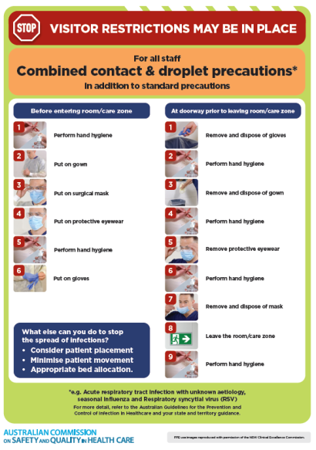](https://www.safetyandquality.gov.au/publications-and-resources/resource-library/infection-prevention-and-control-poster-combined-contact-and-droplet-precautions)
* ***Poster – Combined airborne and contact precautions*** <https://www.safetyandquality.gov.au/publications-and-resources/resource-library/poster-combined-airborne-and-contact-precautions>   
  [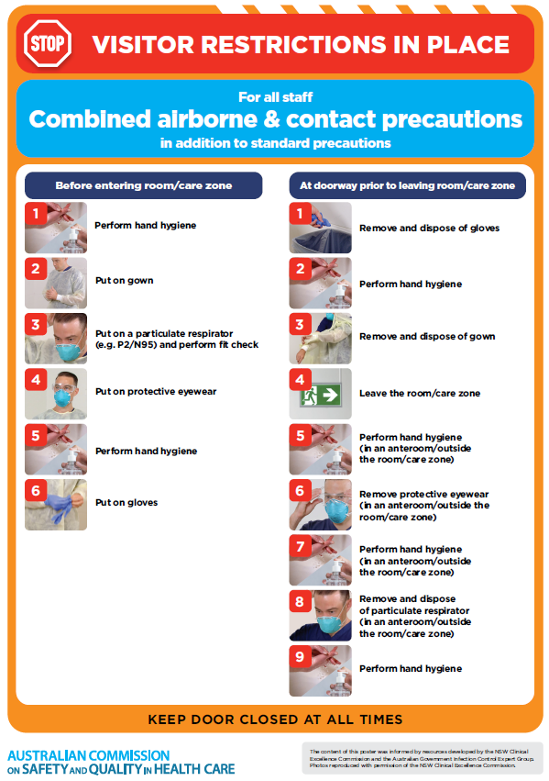](https://www.safetyandquality.gov.au/publications-and-resources/resource-library/poster-combined-airborne-and-contact-precautions)
* ***Environmental Cleaning and Infection Prevention and Control*** [www.safetyandquality.gov.au/environmental-cleaning](http://www.safetyandquality.gov.au/environmental-cleaning)
* ***COVID-19 infection prevention and control risk management – Guidance*** <https://www.safetyandquality.gov.au/publications-and-resources/resource-library/covid-19-infection-prevention-and-control-risk-management-guidance>
* ***Safe care for people with cognitive impairment during COVID-19***<https://www.safetyandquality.gov.au/our-work/cognitive-impairment/cognitive-impairment-and-covid-19>
* ***Stop COVID-19: Break the chain of infection*** posterhttps://www.safetyandquality.gov.au/publications-and-resources/resource-library/break-chain-infection-poster-a3  
  **[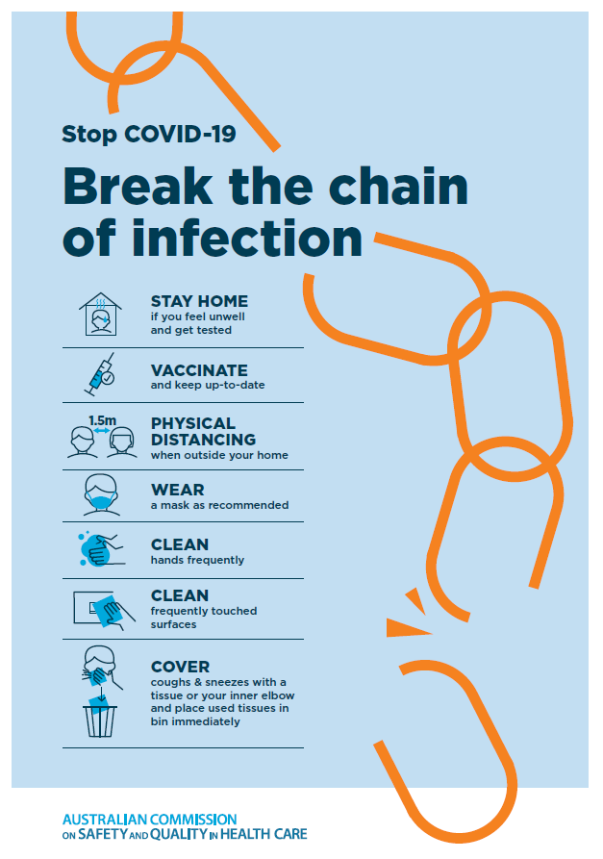](https://www.safetyandquality.gov.au/publications-and-resources/resource-library/break-chain-poster-a3https:/www.safetyandquality.gov.au/publications-and-resources/resource-library/break-chain-poster-a3)**
* ***COVID-19 and face masks – Information for consumers*** <https://www.safetyandquality.gov.au/publications-and-resources/resource-library/covid-19-and-face-masks-information-consumers>

[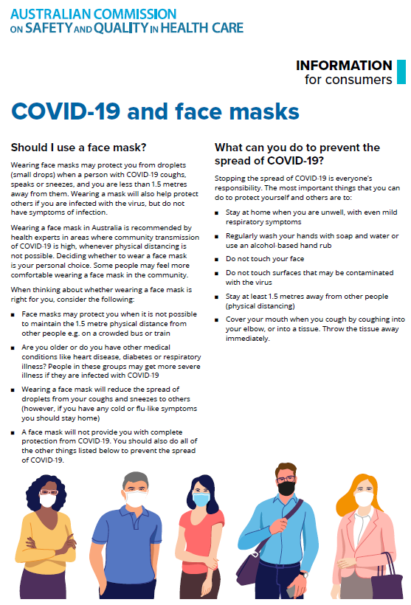](https://www.safetyandquality.gov.au/sites/default/files/2020-07/covid-19_and_face_masks_-_information_for_consumers.pdf)

*National COVID-19 Clinical Evidence Taskforce*

<https://covid19evidence.net.au/>

The National COVID-19 Clinical Evidence Taskforce is a collaboration of peak health professional bodies across Australia whose members are providing clinical care to people with COVID-19. The taskforce is undertaking continuous evidence surveillance to identify and rapidly synthesise emerging research in order to provide national, **evidence-based guidelines and clinical flowcharts for the clinical care of people with COVID-19**. The guidelines address questions that are specific to managing COVID-19 and cover the full disease course across mild, moderate, severe and critical illness. These are ‘living’ guidelines, updated with new research in near real-time in order to give reliable, up-to-the minute advice to clinicians providing frontline care in this unprecedented global health crisis.

*COVID-19 Critical Intelligence Unit*

<https://www.aci.health.nsw.gov.au/covid-19/critical-intelligence-unit>

The Agency for Clinical Innovation (ACI) in New South Wales has developed this page summarising rapid, evidence-based advice during the COVID-19 pandemic. Its operations focus on systems intelligence, clinical intelligence and evidence integration. The content includes a daily evidence digest, a COVID status monitor, a risk monitoring dashboard and evidence checks on a discrete topic or question relating to the current COVID-19 pandemic. There is also a ‘Living evidence’ section summarising key studies and emerging evidence on **COVID-19 vaccines** and **SARS-CoV-2 variants**. The most recent updates include:

* ***Current and emerging patient safety issues during COVID-19*** – What is the evidence on the current and emerging patient safety issues arising from the COVID-19 pandemic?
* ***Bivalent COVID-19 vaccines*** – What is the available regulatory and research evidence for bivalent COVID-19 vaccines?
* ***Surgery post COVID-19*** – What is the evidence for the timing of surgery, and outcomes following surgery, for people who have recovered from COVID-19?
* ***Paxlovid*** – What is the evidence for Paxlovid for treatment of COVID-19?
* ***Molnupiravir*** –What is the evidence for and regulatory context of molnupiravir for treatment of COVID-19?
* ***Eating disorders and COVID-19*** – What is the impact of the COVID-19 pandemic on the prevalence of eating disorders?
* ***Long COVID –*** What is the evidence on the prevalence, presentation and management of long-COVID?
* ***Oseltamivir (Tamiflu) use in healthcare settings*** – What is the evidence that use of oseltamivir in healthcare workers with a symptomatic influenza diagnosis result in an earlier return to work and reduced absenteeism? What is the evidence that use of oseltamivir in adults and children with symptomatic influenza reduces influenza transmission in health care settings?
* ***Alternative models of care for acute medical conditions*** – What is the evidence on alternative models of care for managing patients with acute medical conditions outside of emergency or inpatient hospital settings?
* ***Exercise and long COVID*** – Is exercise helpful in individuals with long COVID? Is post-exertional symptom exacerbation a risk in long COVID?
* ***Influenza and seasonal prophylaxis with oseltamivir*** – What is the place or evidence for seasonal influenza prophylaxis (such as taking oseltamivir for 10 to 12 weeks continuously) in healthcare and aged care settings?
* ***Rapid access models of care for respiratory illnesses*** – What is the evidence for rapid access models of care for respiratory illnesses, especially during winter seasons, in emergency departments?
* ***Post-acute sequelae of COVID-19*** – What is the evidence on the post-acute sequelae of COVID-19?
* ***Emerging variants*** – What is the available evidence for emerging variants?
* ***Chest pain or dyspnoea following COVID-19 vaccination*** – What is evidence for chest pain or dyspnoea following COVID-19 vaccination?
* ***Cardiac investigations and elective surgery post-COVID-19*** – What is evidence for cardiac investigations and elective surgery post-COVID-19?
* ***Breathlessness post COVID-19*** – How to determine those patients who present with ongoing breathlessness in need of urgent review or intervention due to suspected pulmonary embolus?
* ***COVID-19 pandemic and influenza*** – What is the evidence for COVID-19 pandemic and influenza?
* ***Budesonide and aspirin for pregnant women with COVID-19 –*** What is the evidence for the use of Budesonide for pregnant women with COVID-19? What is the evidence for aspirin prophylaxis for pre-eclampsia in pregnant women with a COVID-19 infection?
* ***COVID-19 vaccines in Australia*** – What is the evidence on COVID-19 vaccines in Australia?
* ***COVID-19 pandemic and wellbeing of critical care and other healthcare workers*** – Evidence in brief on the impact of the COVID-19 pandemic on the wellbeing of critical care and other healthcare workers.
* ***Disease modifying treatments for COVID-19 in children*** – What is the evidence for disease modifying treatments for COVID-19 in children?
* ***Mask type for COVID-19 positive wearer*** – What is the evidence for different mask types for COVID-19 positive wearers?
* ***Post acute and subacute COVID-19 care*** – What published advice and models of care are available regarding post-acute and subacute care for COVID-19 patients?
* ***Hospital visitor policies*** – What is the evidence for hospital visitor policies during and outside of the COVID-19 pandemic?
* ***Surgical masks, eye protection and PPE guidance*** –What is the evidence for surgical masks in the endemic phase in hospitals and for eyewear to protect against COVID-19?

**Disclaimer**

On the Radar is an information resource of the Australian Commission on Safety and Quality in Health Care. The Commission is not responsible for the content of, nor does it endorse, any articles or sites listed. The Commission accepts no liability for the information or advice provided by these external links. Links are provided on the basis that users make their own decisions about the accuracy, currency and reliability of the information contained therein. Any opinions expressed are not necessarily those of the Australian Commission on Safety and Quality in Health Care.