# Australian Commission on Safety and Quality logotypeOn the Radar

Issue 597

3 April 2023

*On the Radar* is a summary of some of the recent publications in the areas of safety and quality in health care. Inclusion in this document is not an endorsement or recommendation of any publication or provider. Access to particular documents may depend on whether they are Open Access or not, and/or your individual or institutional access to subscription sites/services. Material that may require subscription is included as it is considered relevant.

*On the Radar* is available online, via email or as a PDF or Word document from <https://www.safetyandquality.gov.au/publications-and-resources/newsletters/radar>

If you would like to receive *On the Radar* via email, you can subscribe on our website <https://www.safetyandquality.gov.au/publications-and-resources/newsletters>  
or by emailing us at H[Umail@safetyandquality.gov.auU](mailto:mail@safetyandquality.gov.au).   
You can also send feedback and comments to H[Umail@safetyandquality.gov.auU](mailto:mail@safetyandquality.gov.au).

For information about the Commission and its programs and publications, please visit <https://www.safetyandquality.gov.au>

You can also follow us on Twitter @ACSQHC.

**On the Radar**

Editor: Dr Niall Johnson [niall.johnson@safetyandquality.gov.au](mailto:niall.johnson@safetyandquality.gov.au)

Contributors: Niall Johnson

**Reports**

*Healthcare system transformation and the journey towards inclusive care. Healthcare Horizons*

KPMG Australia

KMPG Australia; 2023. p. 41.

|  |  |
| --- | --- |
| URL | <https://kpmg.com/au/en/home/insights/2023/03/transforming-australian-healthcare-system.html> |
| Notes | KPMG Australia have published this report under their Healthcare Horizons banner arguing that Australia’s healthcare system faces transformation. It could be argued that perhaps healthcare systems are continually facing change and that transformations are brought about from many factors, ranging from patient expectation, technological changes, funding models, political and the experience of massive events, such as a global pandemic. |

**Journal articles**

*Associations between Clinical Pathway Concordance, Cost and Survival Outcomes for Stage II Colon Cancer: A Population-based Study*

Milroy S, Wong J, Eberg M, Ieraci L, Forster K, Holloway CMB, et al

International Journal for Quality in Health Care 2023:mzad012.i

|  |  |
| --- | --- |
| DOI | <https://doi.org/10.1093/intqhc/mzad012> |
| Notes | Paper reporting on a Canadian study that examined ‘patient’s concordance between clinical reference pathways with survival or cost among a population-based cohort of colon cancer patients’. The authors report that ‘When patients’ care followed the clinical pathway, survival outcomes were better and total health system costs were lower in this cohort.’ |

*Patient Safety Informatics: Criteria Development for Assessing the Maturity of Digital Patient Safety in Hospitals*

Kutza JO, Hübner U, Holmgren AJ, Esdar M

Studies in health technology and informatics. 2022 May 25;294:885-889.

|  |  |
| --- | --- |
| DOI | <https://doi.org/10.3233/SHTI220618> |
| Notes | Paper discussing the development of a framework that health systems can use to assess their digital maturity and guide plans for further development and implementation. The project identified 64 criteria across 11 categories. |

*Interventions to reduce repetitive ordering of low-value inpatient laboratory tests: a systematic review*

Yeshoua B, Bowman C, Dullea J, Ditkowsky J, Shyu M, Lam H, et al

BMJ Open Quality. 2023;12(1):e002128.

|  |  |
| --- | --- |
| DOI | <https://dx.doi.org/10.1136/bmjoq-2022-002128> |
| Notes | Paper reporting on a systematic review that examined the literature on how to reduce the ordering of “low value” tests. The review examined ‘interventions focused on reducing daily complete blood count, complete metabolic panel and basic metabolic panel labs’. Based on 41 studies, the authors report that the interventions could be grouped into 5 categories: audit and feedback, cost display, education, electronic medical record (EMR) change, and policy change. Further they report, ‘All categories were effective in most studies, with EMR change being most frequently highly effective.’ |

*Near-Miss Events Detected Using the Emergency Department Trigger Tool*

Griffey RT, Schneider RM, Todorov AA

Journal of Patient Safety. 2023;19(2):59-66.

*Mapping Processes in the Emergency Department Using the Functional Resonance Analysis Method*

Anderson N, Krishnan RG, Kumar M, Ayres T, Slater D, Neelakantapuram AV, et al

Annals of Emergency Medicine. 2023 [epub].

|  |  |
| --- | --- |
| DOI | Griffey et al <https://doi.org/10.1097/PTS.0000000000001092>  Anderson et al <https://doi.org/10.1016/j.annemergmed.2022.12.029> |
| Notes | Paper reporting on a study examining and emergency department (ED) trigger tool (EDTT) in an US teaching hospital. The tool was used to review 5582 records and found that almost 23% of ED visits during the 13-month study period included a near-miss incident. The authors report that ‘Most events were patient care related (77%) involving delays due to crowding and ED boarding followed by medication administration errors. The EDTT is a high-yield approach for detecting important near misses and latent system deficiencies that impact patient safety.’  Also situated in the ED is the study reported by Anderson et al. The authors observe that ‘Emergency departments (EDs) are dynamic, complex, and demanding environments. Introducing changes that lead to improvements in EDs can be challenging owing to the high staff turnover and mix, high patient volume with different needs, and being the front door to the hospital for the sickest patients.’ These can all make change and quality improvement challenging. This paper is more methodological in illustrating how ‘the functional resonance analysis method can be used to capture the experiences and perceptions of frontline staff to identify the key functions in the system…, to understand the interactions and dependencies between them to make up the ED ecosystem … and to support quality improvement planning, identifying priorities and patient safety risks.’ |

*Journal of Patient Safety*

Volume 19, Issue 3, April 2023

|  |  |
| --- | --- |
| URL | <https://journals.lww.com/journalpatientsafety/toc/2023/04000> |
| Notes | A new issue of the *Journal of Patient Safety* has been published. Articles in this issue of the *Journal of Patient Safety* include:   * **Reducing Medication Errors in Children’s Hospitals** (Kai-Wen Liu, Ya-Fen Shih, Yi-Jung Chiang, Lih-Ju Chen, Cheng-Han Lee, Hsiao-Neng Chen, Jia-Yuh Chen, Chien-Chou Hsiao) * Using the Generic Analysis Method to **Analyze Sentinel Event Reports** Across Hospitals: A Retrospective Cross-Sectional Study (Mees C Baartmans, Steffie M Van Schoten, Bert J Smit, Cordula Wagner) * **Linking Patient Safety Climate With Missed Nursing Care in Labor and Delivery Units**: Findings From the LaborRNs Survey (Jie Zhong, Kathleen Rice Simpson, Joanne Spetz, C L Gay, J Fletcher, G L Landstrom, A Lyndon) * A Quality Improvement Initiative to Decrease **Central Line–Associated Bloodstream Infections** During the COVID-19 Pandemic: A “Zero Harm” Approach (Carol S Redstone, Maryam Zadeh, Mary-Agnes Wilson, Samantha McLachlan, Danny Chen, Maya Sinno, Safiyya Khamis, Kassia Malis, Flavia Lui, Steven Forani, Christina Scerbo, Yuka Hutton, Latha Jacob, A Taher) * Using a Learning System Approach to Improve **Safety for Prone-Position Ventilation Patients** (Anna L Thomas, Kelly Graham, S Davila, P Giuffrida) * Development of a **Periprocedure Trigger for Outpatient Interventional Radiology Procedures** in the Veterans Health Administration (Nina Bart, Hillary J Mull, Mikhail Higgins, Daniel Sturgeon, Kierstin Hederstedt, Rebecca Lamkin, Brian Sullivan, Westyn Branch-Elliman, Marva Foster) * The Careful Return of **Sports Medicine Procedures in the United States During COVID-19**: Comparison of Utilization, Patient Demographics, and Complications (Adam M Gordon, Bhavya K Sheth, Andrew R Horn, Matthew L Magruder, Charles A Conway, Orry Erez) * Use of Obstetric and Gynecologic Hospitalists Is Associated With Decreased **Severe Maternal Morbidity** in the United States (Vanessa E Torbenson, Vasiliki Tatsis, Sarah L Bradley, Jennifer Butler, L Kjerulff, G B McLaughlin, C S Stika, D Tappin, A VanBlaricom, R Mehta, M Branda, B McCue) * Factors Associated With **Diagnostic Error**: An Analysis of Closed Medical Malpractice Claims (Véronique Grenon, Jackie Szymonifka, Julia Adler-Milstein, Jacqueline Ross, Urmimala Sarkar) * Outcomes for **Hospitalized Aggressive and Violent Patients** When Physical Restraints Are Introduced (Ché Matthew Harris, Ishaan Gupta, Hind Beydoun, Scott Mitchell Wright) |

*Journal of Health Services Research & Policy*

Volume 28, Issue 2, April 2023

|  |  |
| --- | --- |
| URL | <https://journals.sagepub.com/toc/hsrb/28/2> |
| Notes | A new issue of the *Journal of Health Services Research & Policy* has been published. Articles in this issue of the *Journal of Health Services Research & Policy* include:   * Editorial: **Impact of the COVID-19 pandemic on people with disabilities** and implications for health services research (Divya Goyal, Xanthe Hunt, Hannah Kuper, Tom Shakespeare, and Lena Morgon Banks) * Locked down or locked out? Trends in **psychiatric emergency services utilization during the COVID-19 pandemic** (Alison Duncan, Carolina-Nicole Herrera, Margaret Okobi, Shurobhi Nandi, and Rachel Oblath) * **A new children’s hospital** with a larger floor space, single rooms, and V-shaped ward design: A pre–post evaluation of nurse time providing patient care and nurse, patient, and family experiences (Fenella J Gill, Helen Nelson, Natasha Bear, Mary Tallon, Catherine Pienaar, Jade Ferullo, and Sue Baker) * Creating **healthy hospital retail food environments**: Multiple pathways to successful at scale policy implementation in Australia (Leonie Cranney, Margaret Thomas, Tarli O’Connell, Renee Moreton, Lucy Corbett, Adrian Bauman, and Philayrath Phongsavan) * State-level heterogeneity in associations between **structural stigma and individual health care access**: A multilevel analysis of transgender adults in the United States (Nguyen K Tran, Kellan E Baker, Elle Lett, and A I Scheim) * **Impact of COVID-19 in mental health trusts** (Russell Mannion, Frederick H Konteh, and Rowena Jacobs) * **Scale and spread of innovation in health and social care**: Insights from the evaluation of the New Care Model/Vanguard programme in England (Julie MacInnes, Jenny Billings, Anna Coleman, Rasa Mikelyte, Sarah Croke, Pauline Allen, and Kath Checkland) * **Mental health emergencies attended by ambulances** in the United Kingdom and the implications for health service delivery: A cross-sectional study (Harriet Elizabeth Moore, Aloysius Niroshan Siriwardena, Mark Gussy, and Robert Spaight) |

*BMJ Leader*

Volume 7, Issue 1, March 2023

|  |  |
| --- | --- |
| URL | <https://bmjleader.bmj.com/content/7/1> |
| Notes | A new issue of *BMJ Leader* has been published. Articles in this issue of *BMJ Leader* include:   * Editorial: Looking back, leading forward: **BMJ Leader 5 years on** (Jan C Frich, Dominique Allwood, Jamiu O Busari, Ming-Ka Chan, Amelia Compagni, Rachel Gemine, Indra Joshi, Robert Klaber, Benjamin Laker, Erwin Loh, Oscar Lyons, Aoife Molloy, James Mountford, Amit Nigam, Rachael Moses, Julie-Lyn Noël, Iain Smith, Janice St. John-Matthews, Catherine Stoddart, Charlotte Emily Williams) * Ten-year tenure as a **physician CEO at a Nordic university hospital: five lessons learnt** (Tor Ingebrigtsen) * Reflection of **leadership skills by a clinical educator** (Bibi Sumera Keenoo) * **Developing future clinical leaders in patient safety**: the Irish experience (Kieran Murray, Eoin Fitzgerald, Ahmeda Ali, David Crosby, Susanne O'Reilly, Peter Lachman) * Review of literature for **ethnic minority-led GP practices**: impact and experience of CQC regulation (Annabelle Stigwood, Ayisha Adeeba Ashmore, Devina Maru, Lakshya Soni) * **Psychological impact of COVID-19 on healthcare leaders**: a cross-sectional survey in Friuli-Venezia Giulia, Italy (Enrico Scarpis, Giulia Bravo, Roberto Cocconi, Laura Brunelli) * **Impact of leadership on the nursing workforce during the COVID-19 pandemic** (Natasha Phillips, Luke Hughes, Cecilia Vindrola-Padros, Anika Petrella, Lorna A Fern, Flo Panel-Coates, Rachel M Taylor) * **Primary care physician leaders’ perspectives on opportunities and challenges in healthcare leadership**: a qualitative study (Amber L Stephenson, Erin E Sullivan, Aaron R Hoffman) * **Acquiring and developing healthcare leaders’ political skills**: an interview study with healthcare leaders (Justin Waring, Simon Bishop, Jenelle Clarke, Mark Exworthy, Naomi J Fulop, Jean Hartley, Angus I G Ramsay, Georgia Black, Bridget Roe) * **Addressing leadership communication, parenting demands and mental health challenges**: a mixed-methods case study of clinical and translational scientists during COVID-19 (Chelsea Leonard, Brigid Connelly, Bethany Kwan, Karen Albright, Heather Gilmartin) * **Enabling leaders of multispecialty teams** via cross-training (Agnes Bäker, Francesco Maisano, Carlos A Mestres) * **Healthcare system leadership and climate change**: five lessons for improving health systems resiliency (Jeff Tochkin, John Richmond, Attila Hertelendy) * **Waste management in healthcare**: during and beyond a global pandemic (Matt Lechner, Iona Harrap, Oscar Emanuel, Nick Eynon-Lewis) * **How situations promote relational and social leadership capabilities**: three considerations for leadership development in healthcare (Bradley J Hastings, Gavin M Schwarz) * **Changing estimates of leadership ability** before a programme: retrospective self-assessments and response-shift bias (Oscar Lyons, Harry Kingsley-Smith, Koot Kotze, Karandeep Nandra, Joao R Galante, Nicholas Fahy, Richard Canter) * Bottlenecks and reflections from **turnkey installation of MRI** in a tertiary care Greenfield project: a case study (Naveen R Gowda, Nirupam Madaan, Rahul Kumar Singh) * Systems leadership: how chief executives manage **tension between organisation and system pressures** (Ben Gordon, Matthew Gwynfryn Thomas, Ara Darzi, Lisa Aufegger, Colin Bicknell) |

*BMJ Quality & Safety* online first articles

|  |  |
| --- | --- |
| URL | <https://qualitysafety.bmj.com/content/early/recent> |
| Notes | *BMJ Quality &Safety* has published a number of ‘online first’ articles, including:   * Systematic review of **clinical debriefing tools**: attributes and evidence for use (Emma Claire Phillips, Samantha Eve Smith, Victoria Tallentire, S Blair) * **Diagnostic error among vulnerable populations presenting to the emergency department** with cardiovascular and cerebrovascular or neurological symptoms: a systematic review (Svetlana Herasevich, Jalal Soleimani, Chanyan Huang, Yuliya Pinevich, Yue Dong, Brian W Pickering, Mohammad H Murad, Amelia K Barwise) * Successful quality improvement project to increase hydroxyurea prescriptions for **children with sickle cell anaemia** (Ofelia A Alvarez, Hector Rodriguez-Cortes, E Leila Jerome Clay, Sandra Echenique, Julie Kanter, John J Strouse, Talia Buitrago-Mogollon, Cheryl Courtlandt, Laura Noonan, I Osunkwo) |

*International Journal for Quality in Health Care* online first articles

|  |  |
| --- | --- |
| URL | <https://academic.oup.com/intqhc/advance-articles> |
| Notes | *International Journal for Quality in Health Care* has published a number of ‘online first’ articles, including:   * **Adjuvant zoledronic acid therapy for postmenopausal woman with early breast cancer** in China: A cost-effectiveness analysis (Xiaoting Huang, Yiwei Liu, Shen Lin, Hang Wang, Yujie Deng, Xin Rao, Xianzhong Guo, Xinchan Jiang, Xiuhua Weng, Pinfang Huang) * Associations between **Clinical Pathway Concordance, Cost and Survival Outcomes for Stage II Colon Cancer**: A Population-based Study (Shannon Milroy, Judith Wong, Maria Eberg, Luciano Ieraci, Katharina Forster, Claire M B Holloway, Jason M Sutherland) |

**Online resources**

***Clinical Communiqué***

<https://www.thecommuniques.com/post/clinical-communiqu%C3%A9-volume-10-issue-1-march-2023>

Volume 10, Issue 1, March 2023

This issue of *Clinical Communiqué* focuses on the importance of cultural safety. The editorial in this issue observes that cultural safety ‘At its core is the notion of establishing respect for culture in health, addressing unconscious bias, racism and discrimination, and ensuring the safe experience of the recipient of care. Culture is not homogenous or static. It is an ever evolving and deeply individualized construct.’ This issue focuses particularly on cultural safety for Aboriginal and Torres Strait Islanders. It presents two coroners' cases where a lack of cultural safety in the health care system led to preventable and tragic consequences.  
The two expert commentaries reflect on ‘Developing cultural safety behaviours and capabilities in healthcare’ and ‘Why cultural safety improves patient safety’.

***[UK] NICE Guidelines and Quality Standards***

<https://www.nice.org.uk/guidance>

The UK’s National Institute for Health and Care Excellence (NICE) has published new (or updated) guidelines and quality standards. The latest reviews or updates include:

* NICE Guideline NG191 *COVID-19 rapid guideline:* ***managing COVID-19*** <https://www.nice.org.uk/guidance/ng191>

***[USA] AHRQ Perspectives on Safety***

<https://psnet.ahrq.gov/psnet-collection/perspectives>

The US Agency for Healthcare Research and Quality (AHRQ) publishes occasional Perspectives on Safety essays. Recent essays include:

* ***Technology as a Tool for Improving Patient Safety*** <https://psnet.ahrq.gov/perspective/technology-tool-improving-patient-safety>

**COVID-19 resources**

https://www.safetyandquality.gov.au/covid-19

The Australian Commission on Safety and Quality in Health Care has developed a number of resources to assist healthcare organisations, facilities and clinicians. These and other material on COVID-19 are available at <https://www.safetyandquality.gov.au/covid-19>

These resources include:

* ***OVID-19 infection prevention and control risk management*** This primer provides an overview of three widely used tools for investigating and responding to patient safety events and near misses. Tools covered in this primer include incident reporting systems, Root Cause Analysis (RCA), and Failure Modes and Effects Analysis (FMEA).   
  <https://www.safetyandquality.gov.au/publications-and-resources/resource-library/covid-19-infection-prevention-and-control-risk-management-guidance>
* ***Poster – Combined contact and droplet precautions*** <https://www.safetyandquality.gov.au/publications-and-resources/resource-library/infection-prevention-and-control-poster-combined-contact-and-droplet-precautions>  
  [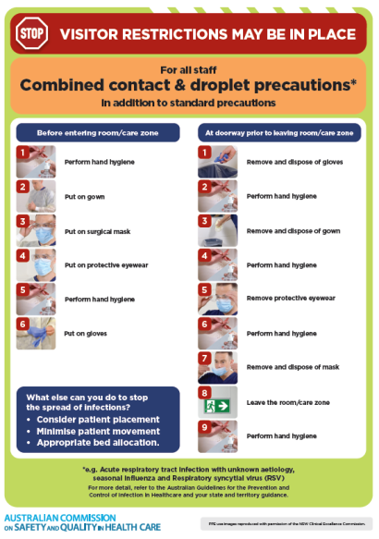](https://www.safetyandquality.gov.au/publications-and-resources/resource-library/infection-prevention-and-control-poster-combined-contact-and-droplet-precautions)
* ***Poster – Combined airborne and contact precautions*** <https://www.safetyandquality.gov.au/publications-and-resources/resource-library/poster-combined-airborne-and-contact-precautions>   
  [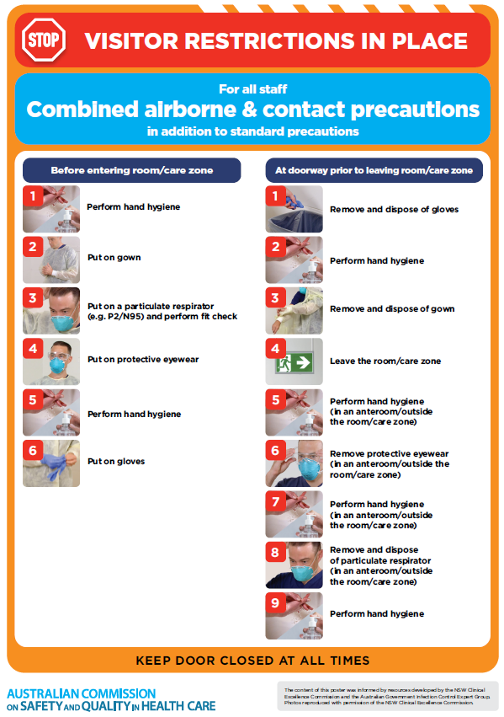](https://www.safetyandquality.gov.au/publications-and-resources/resource-library/poster-combined-airborne-and-contact-precautions)
* ***Environmental Cleaning and Infection Prevention and Control*** [www.safetyandquality.gov.au/environmental-cleaning](http://www.safetyandquality.gov.au/environmental-cleaning)
* ***COVID-19 infection prevention and control risk management – Guidance*** <https://www.safetyandquality.gov.au/publications-and-resources/resource-library/covid-19-infection-prevention-and-control-risk-management-guidance>
* ***Safe care for people with cognitive impairment during COVID-19***<https://www.safetyandquality.gov.au/our-work/cognitive-impairment/cognitive-impairment-and-covid-19>
* ***Stop COVID-19: Break the chain of infection*** posterhttps://www.safetyandquality.gov.au/publications-and-resources/resource-library/break-chain-infection-poster-a3  
  **[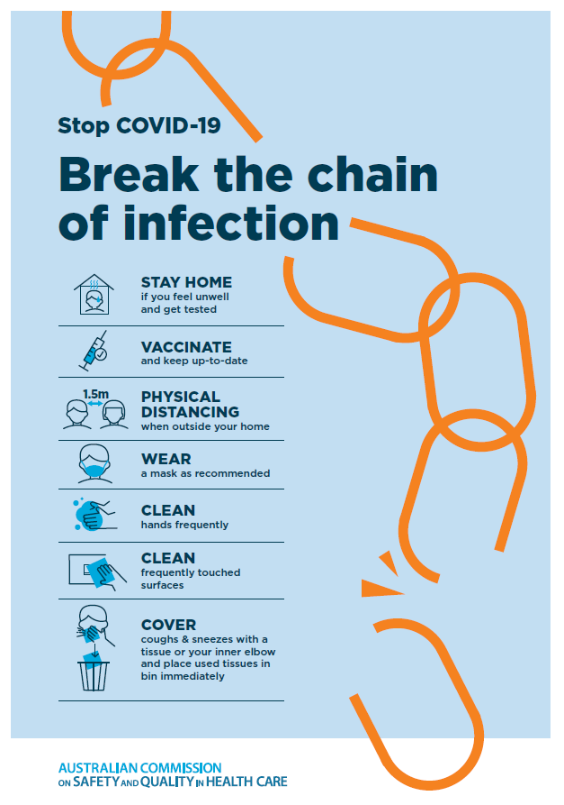](https://www.safetyandquality.gov.au/publications-and-resources/resource-library/break-chain-poster-a3https:/www.safetyandquality.gov.au/publications-and-resources/resource-library/break-chain-poster-a3)**
* ***COVID-19 and face masks – Information for consumers*** <https://www.safetyandquality.gov.au/publications-and-resources/resource-library/covid-19-and-face-masks-information-consumers>

[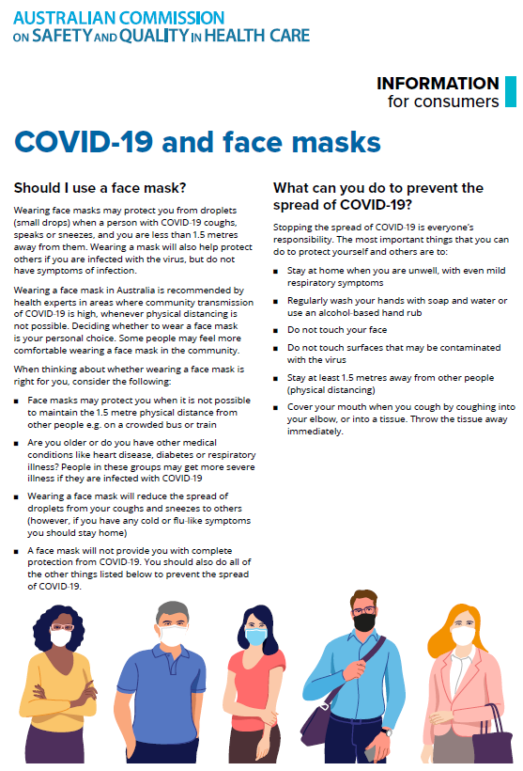](https://www.safetyandquality.gov.au/sites/default/files/2020-07/covid-19_and_face_masks_-_information_for_consumers.pdf)

*National COVID-19 Clinical Evidence Taskforce*

<https://covid19evidence.net.au/>

The National COVID-19 Clinical Evidence Taskforce is a collaboration of peak health professional bodies across Australia whose members are providing clinical care to people with COVID-19. The taskforce is undertaking continuous evidence surveillance to identify and rapidly synthesise emerging research in order to provide national, **evidence-based guidelines and clinical flowcharts for the clinical care of people with COVID-19**. The guidelines address questions that are specific to managing COVID-19 and cover the full disease course across mild, moderate, severe and critical illness. These are ‘living’ guidelines, updated with new research in near real-time in order to give reliable, up-to-the minute advice to clinicians providing frontline care in this unprecedented global health crisis.

*COVID-19 Critical Intelligence Unit*

<https://www.aci.health.nsw.gov.au/covid-19/critical-intelligence-unit>

The Agency for Clinical Innovation (ACI) in New South Wales has developed this page summarising rapid, evidence-based advice during the COVID-19 pandemic. Its operations focus on systems intelligence, clinical intelligence and evidence integration. The content includes a daily evidence digest, a COVID status monitor, a risk monitoring dashboard and evidence checks on a discrete topic or question relating to the current COVID-19 pandemic. There is also a ‘Living evidence’ section summarising key studies and emerging evidence on **COVID-19 vaccines** and **SARS-CoV-2 variants**. The most recent updates include:

* ***Current and emerging patient safety issues during COVID-19*** – What is the evidence on the current and emerging patient safety issues arising from the COVID-19 pandemic?
* ***Bivalent COVID-19 vaccines*** – What is the available regulatory and research evidence for bivalent COVID-19 vaccines?
* ***Surgery post COVID-19*** – What is the evidence for the timing of surgery, and outcomes following surgery, for people who have recovered from COVID-19?
* ***Paxlovid*** – What is the evidence for Paxlovid for treatment of COVID-19?
* ***Molnupiravir*** –What is the evidence for and regulatory context of molnupiravir for treatment of COVID-19?
* ***Eating disorders and COVID-19*** – What is the impact of the COVID-19 pandemic on the prevalence of eating disorders?
* ***Long COVID –*** What is the evidence on the prevalence, presentation and management of long-COVID?
* ***Oseltamivir (Tamiflu) use in healthcare settings*** – What is the evidence that use of oseltamivir in healthcare workers with a symptomatic influenza diagnosis result in an earlier return to work and reduced absenteeism? What is the evidence that use of oseltamivir in adults and children with symptomatic influenza reduces influenza transmission in health care settings?
* ***Alternative models of care for acute medical conditions*** – What is the evidence on alternative models of care for managing patients with acute medical conditions outside of emergency or inpatient hospital settings?
* ***Exercise and long COVID*** – Is exercise helpful in individuals with long COVID? Is post-exertional symptom exacerbation a risk in long COVID?
* ***Influenza and seasonal prophylaxis with oseltamivir*** – What is the place or evidence for seasonal influenza prophylaxis (such as taking oseltamivir for 10 to 12 weeks continuously) in healthcare and aged care settings?
* ***Rapid access models of care for respiratory illnesses*** – What is the evidence for rapid access models of care for respiratory illnesses, especially during winter seasons, in emergency departments?
* ***Post-acute sequelae of COVID-19*** – What is the evidence on the post-acute sequelae of COVID-19?
* ***Emerging variants*** – What is the available evidence for emerging variants?
* ***Chest pain or dyspnoea following COVID-19 vaccination*** – What is evidence for chest pain or dyspnoea following COVID-19 vaccination?
* ***Cardiac investigations and elective surgery post-COVID-19*** – What is evidence for cardiac investigations and elective surgery post-COVID-19?
* ***Breathlessness post COVID-19*** – How to determine those patients who present with ongoing breathlessness in need of urgent review or intervention due to suspected pulmonary embolus?
* ***COVID-19 pandemic and influenza*** – What is the evidence for COVID-19 pandemic and influenza?
* ***Budesonide and aspirin for pregnant women with COVID-19 –*** What is the evidence for the use of Budesonide for pregnant women with COVID-19? What is the evidence for aspirin prophylaxis for pre-eclampsia in pregnant women with a COVID-19 infection?
* ***COVID-19 vaccines in Australia*** – What is the evidence on COVID-19 vaccines in Australia?
* ***COVID-19 pandemic and wellbeing of critical care and other healthcare workers*** – Evidence in brief on the impact of the COVID-19 pandemic on the wellbeing of critical care and other healthcare workers.
* ***Disease modifying treatments for COVID-19 in children*** – What is the evidence for disease modifying treatments for COVID-19 in children?
* ***Mask type for COVID-19 positive wearer*** – What is the evidence for different mask types for COVID-19 positive wearers?
* ***Post acute and subacute COVID-19 care*** – What published advice and models of care are available regarding post-acute and subacute care for COVID-19 patients?
* ***Hospital visitor policies*** – What is the evidence for hospital visitor policies during and outside of the COVID-19 pandemic?
* ***Surgical masks, eye protection and PPE guidance*** –What is the evidence for surgical masks in the endemic phase in hospitals and for eyewear to protect against COVID-19?

**Disclaimer**

On the Radar is an information resource of the Australian Commission on Safety and Quality in Health Care. The Commission is not responsible for the content of, nor does it endorse, any articles or sites listed. The Commission accepts no liability for the information or advice provided by these external links. Links are provided on the basis that users make their own decisions about the accuracy, currency and reliability of the information contained therein. Any opinions expressed are not necessarily those of the Australian Commission on Safety and Quality in Health Care.