# Australian Commission on Safety and Quality logotypeOn the Radar

Issue 598

17 April 2023

*On the Radar* is a summary of some of the recent publications in the areas of safety and quality in health care. Inclusion in this document is not an endorsement or recommendation of any publication or provider. Access to particular documents may depend on whether they are Open Access or not, and/or your individual or institutional access to subscription sites/services. Material that may require subscription is included as it is considered relevant.

*On the Radar* is available online, via email or as a PDF or Word document from <https://www.safetyandquality.gov.au/publications-and-resources/newsletters/radar>

If you would like to receive *On the Radar* via email, you can subscribe on our website <https://www.safetyandquality.gov.au/publications-and-resources/newsletters>  
or by emailing us at H[Umail@safetyandquality.gov.auU](mailto:mail@safetyandquality.gov.au).   
You can also send feedback and comments to H[Umail@safetyandquality.gov.auU](mailto:mail@safetyandquality.gov.au).

For information about the Commission and its programs and publications, please visit <https://www.safetyandquality.gov.au>

You can also follow us on Twitter @ACSQHC.

**On the Radar**

Editor: Dr Niall Johnson [niall.johnson@safetyandquality.gov.au](mailto:niall.johnson@safetyandquality.gov.au)

Contributors: Niall Johnson, Amy Forsyth

**Draft Psychotropic Medicines in Cognitive Disability or Impairment Clinical Care Standard**

<https://www.safetyandquality.gov.au/standards/clinical-care-standards/consultations-clinical-care-standards>

[](https://www.safetyandquality.gov.au/standards/clinical-care-standards/consultations-clinical-care-standards)

Did you know that more than 61% of Australian aged care residents take one or more psychotropic medicines? Or that they are frequently prescribed for people with intellectual disability?

The Commission’s draft *Psychotropic Medicines in Cognitive Disability or Impairment Clinical Care Standard* describes the key components of care that people of all ages living with cognitive disability or impairment can expect to receive in all healthcare settings to reduce the inappropriate use of psychotropic medicines.

**Public consultation is now open**

The Commission is seeking feedback from consumers, clinicians, health services and anyone with an interest in cognitive disability, cognitive impairment, aged care or disability services. An Easy Read version of the consultation is also available.

[Share your feedback](https://www.safetyandquality.gov.au/standards/clinical-care-standards/consultations-clinical-care-standards) on the draft standard and supporting resources using the online survey.

This public consultation will be open until **Monday, 8 May 2023**.

**Access the Easy Read survey**

See our Easy Read survey for people with lived experience of cognitive disability or impairment at <https://www.safetyandquality.gov.au/standards/clinical-care-standards/psychotropic-medicines-cognitive-impairment-and-disability-clinical-care-standard/easy-read-survey-about-psychotropic-medicines>

**More information**

Visit <https://www.safetyandquality.gov.au/psychotropics-ccs> or email our Clinical Care Standards team at [CCS@safetyandquality.gov.au](mailto:CCS@safetyandquality.gov.au)

**Reports**

*Safety risk of air embolus associated with central venous catheters used for haemodialysis treatment*

Independent report by the Healthcare Safety Investigation Branch NI-003826

Healthcare Safety Investigation Branch

Reading: HSIB; 2023. p. 75.

|  |  |
| --- | --- |
| DOI | <https://www.hsib.org.uk/investigations-and-reports/safety-risks-associated-with-central-venous-catheters-used-for-haemodialysis-treatment/> |
| Notes | This report from the UK’s Healthcare Safety Investigation Branch covers an investigation into the use of tunnelled haemodialysis central venous catheters, which are a type of central line. The report notes that ‘The uncapping and unclamping of a haemodialysis catheter (without attaching a syringe), by a user not familiar with the medical device, task or the equipment required, may allow air to get into a person’s bloodstream, resulting in an air embolus. A haemodialysis catheter has a wide bore (internal diameter) compared to other types of central line, to allow a high volume of blood to flow through. It is this wide bore that increases the risk of a large air embolus, compared with narrower catheters.’ The reference event that precipitated this investigation saw a patient have a cardiac arrest caused by an air embolus after her haemodialysis catheter was uncapped, unclamped, and left open to air. The report makes a number of findings, recommendation and “safety observations”. |

*Notifiable Data Breaches Report: July to December 2022*

Office of the Australian Information Commissioner

Sydney: OAIC; 2023.

|  |  |
| --- | --- |
| URL | <https://www.oaic.gov.au/privacy/notifiable-data-breaches/notifiable-data-breaches-publications/notifiable-data-breaches-report-july-to-december-2022> |
| Notes | The latest report on notifiable data breaches from the Office of the Australian Information Commissioner (OAIC) reveals that once again that ‘health service providers’ is one of the major sources of such data breaches. While ‘malicious or criminal attack’ was the major category of breaches in the sector, human error was more common than in other sectors. Human errors here may include:   * Unauthorised disclosure (unintended release or publication) * Failure to use BCC when sending email * Insecure disposal * Personal information sent to wrong recipient (email, mail or other) * Loss of paperwork/data storage device * Unauthorised disclosure (failure to redact) * Unauthorised disclosure (verbal).   [Chart 16 from the  Notifiable Data Breaches Report: July to December 2022. Source of data breach notifications – top industry sectors.](https://www.oaic.gov.au/privacy/notifiable-data-breaches/notifiable-data-breaches-publications/notifiable-data-breaches-report-july-to-december-2022) |

*How Primary Care Physicians Experience Telehealth: An International Comparison*

Findings from the 2022 Commonwealth Fund International Health Policy Survey of Primary Care Physicians

Gunja MZ, Gumas ED, Williams II RD

New York: The Commonwealth Fund; 2023.

|  |  |
| --- | --- |
| URL | <https://www.commonwealthfund.org/publications/issue-briefs/2023/apr/primary-care-physicians-telehealth-2022-international-survey> |
| Notes | This latest international survey from the Commonwealth Fund in the USA examined how primary care physicians/GPs had experienced telehealth. In many nations the COVID-19 pandemic saw a rapid expansion of the use of telehealth. This iteration of the Commonwealth Fund’s survey of healthcare in a number of comparable nations surveyed primary care physicians about their experiences with telehealth. The results from Australian respondents to the survey include:   * The vast majority using telehealth to see at least some of their patients, with only 15 reporting no telehealth use * 77% finding it easy to implement telehealth * 90% reporting telehealth improved the timeliness of care * 86% reporting that telehealth allowed their practice to offset potential financial losses related to the COVID-19 pandemic * 72% said it allowed their practice to assess mental and behavioural health needs effectively “to a great extent” or “to some extent” * 86% said they were “very satisfied” or “somewhat satisfied” with practicing telehealth.   There have been a number of reviews and commentaries on the use of telehealth. These include:   * Smyth L, Roushdy S, Jeyasingham J, Whitbread J, O’Brien P, Lloyd C, et al. Clinician perspectives on rapid transition to telehealth during COVID-19 in Australia – a qualitative study. Australian Health Review. 2023;47(1):92-99. <https://doi.org/10.1071/AH22037> * Hatef E, Wilson RF, Hannum SM, Zhang A, Kharrazi H, Weiner JP, et al. Use of Telehealth During the COVID-19 Era. Systematic Review. Rockville MD: Agency for Healthcare Research and Quality;; 2023. p. 1063. <https://effectivehealthcare.ahrq.gov/products/virtual-health-covid/research> * Tang M, Chernew ME, Mehrotra A. How Emerging Telehealth Models Challenge Policymaking. The Milbank Quarterly. 2022;100(3):650-672. <https://doi.org/10.1111/1468-0009.12584> * Sutarsa IN, Kasim R, Steward B, Bain-Donohue S, Slimings C, Hall Dykgraaf S, et al. Implications of telehealth services for healthcare delivery and access in rural and remote communities: perceptions of patients and general practitioners. Australian Journal of Primary Health. 2022;28(6):522-528. [https://doi.org/10.1071/PY21162](https://doi.org/10.1071/PY21162u) * Sturgiss E, Desborough J, Hall Dykgraaf S, Matenge S, Dut G, Davis S, et al. Digital health to support primary care provision during a global pandemic. Australian Health Review. 2022;46(3):269-272. <https://doi.org/10.1071/AH21263> * Snoswell CL, Caffery LJ, Haydon HM, Banbury A, Smith AC. Implications of increased telehealth use on organisations providing mental health services during COVID-19. Australian Health Review. 2022;46(3):381-382. <https://doi.org/10.1071/AH22088> * Jackson C. Telehealth, care access and workforce – are the stars finally aligning? Australian Health Review. 2022;46(3):260-261. <https://doi.org/10.1071/AH22127> * Tran M, Haddock R. Towards a sustainable funding model for telehealth in Australia. Deeble Institute Issues Brief No. 43. Canberra: Australian Healthcare and Hospitals Association; 2021. p. 45. <https://ahha.asn.au/publication/health-policy-issue-briefs/deeble-issues-brief-no-43-towards-sustainable-funding-model> * Jayawardana D, Gannon B. Use of telehealth mental health services during the COVID-19 pandemic. Australian Health Review. 2021;45(4):442-446. <https://doi.org/10.1071/AH20325> * 10. Bollen C, Haddock R. Providing telehealth in general practice during COVID-19 and beyond. Deeble Institute Perspectives Brief No. 10. Canberra: Australian Healthcare and Hospitals Association; 2020. p. 9. <https://ahha.asn.au/sites/default/files/docs/policy-issue/perspectives_brief_no_10._providing_telehealth_in_general_practice_0.pdf> |

**Journal articles**

*Is primary care a patient-safe setting? Prevalence, severity, nature, and causes of adverse events: numerous and mostly avoidable*

Garzón González G, Alonso Safont T, Zamarrón Fraile E, Cañada Dorado A, Luaces Gayan A, Conejos Míquel D, et al

International Journal for Quality in Health Care. 2023:mzad019.

|  |  |
| --- | --- |
| DOI | <https://doi.org/10.1093/intqhc/mzad019> |
| Notes | Primary care is where much health care is delivered. However, the extent of safety and quality issues in primary care has not been examined as they have been in acute care. This paper reports on a Spanish study that reviewed adverse events in ‘all 262 primary healthcare centres in the Madrid region (Spain) during the last quarter of 2018’. The study reviewed 1,797 clinical records and reported that ‘The prevalence of adverse events over the study period was 5.0%[confidence interval (CI) 95%:4.0%‒6.0%], with higher values in women (5.7%;CI95%:4.6%‒6.8%;P=0.10) and patients over 75 years of age (10.3%;CI95%:8.9%‒11.7%;P<0.001). The overall occurrence per hundred consultations was estimated to be 1.58% (CI95%:1.28%‒1.94%).’ In their conclusion, the authors observe ‘About three out of four such events were considered to be avoidable and one out of 13 were severe. Prescription errors, drug administration errors by patients, and clinical assessment errors were the most frequent types of adverse events.’ |

For information on the Commission’s work on primary health care, see <https://www.safetyandquality.gov.au/our-work/primary-health-care>

*Australian Health Review*

Volume 47, Number 2, April 2023

|  |  |
| --- | --- |
| URL | <https://www.publish.csiro.au/ah/issue/11456> |
| Notes | A new issue of *Australian Health Review* has been published. Articles in this issue of *Australian Health Review* include:   * Contemporary **challenges for primary care** (Stephen Duckett and Jeremy Hunt) * Investing in **health system resilience** (Jane Hall and Philip Haywood) * Factors associated with **Pharmaceutical Benefits Advisory Committee decisions for listing medicines for diabetes** and its associated complications (Mohammad M. Haque, Mutsa Gumbie, Megan Gu and Gnanadarsha Dissanayake) * **Change in costs to funders of maternity care** over time: an analysis of Queensland births (Bonnie Eklom, Sally Tracy and Emily Callander) * The financial implications of investigating **false-positive and true-positive mammograms** in a national breast cancer screening program (Jason Soon, Nehmat Houssami, Michelle Clemson, Darren Lockie, Rachel Farber, Alexandra Barratt, Adam Elshaug and Kirsten Howard) * Use and cost of Medicare Benefits Schedule and Pharmaceutical Benefits Scheme services following **inpatient rehabilitation for acquired disability** in Australia (Samantha J Borg, David N Borg, Michele M Foster, Ryan Bell, Jessica Bowley and Timothy Geraghty) * Medicare reimbursed **telehealth exercise physiology services** were underutilised through the coronavirus (COVID-19) pandemic: an ecological study (Riley C C Brown, Jeff S Coombes, Centaine L Snoswell, Jaimon T Kelly and Shelley E Keating) * Promoting the **personal importation of therapeutic goods**: recent legislative amendments to advertising regulations may impact consumer access and understanding (Christopher Rudge and Narcyz Ghinea) * Is Australia’s lack of national clinical leadership hampering efforts with the **oral health policy** agenda? (Tan Minh Nguyen, Amit Arora, Sneha Sethi, Danielle Justine Gavanescu, Ruth Heredia, Ben Scully, Clare Lin and Martin Hall) * **Health policy evaluation in rural and remote Australia**: a qualitative exploration and lessons from the Northern Territory (Kate Raymond, Sally Nathan, Reema Harrison and Lois Meyer) * **Potential therapeutic value of new drugs approved** in Australia: a retrospective cohort study (Joel Lexchin) * Healthcare practitioner use of **real-time prescription monitoring tools**: an online survey (Dimi Hoppe, Chaojie (George) Liu and Hanan Khalil) * **Opioid dispensing** 2008–18: a Queensland perspective (Benita Suckling, Champika Pattullo, Peter Donovan, Marcus Gallagher, Asad Patanwala and Jonathan Penm) * Emergency clinician perceptions of **patients who present frequently to the emergency department**: a snapshot of current practice (Viola Korczak, Hueiming Liu, Kendall Bein, Thomas Lung, Stephen Jan and Michael Dinh) * Patterns of **intensive care unit emergencies** (Alex Yartsev and Feibi Yang) * Exploring the delivery of **phase II cardiac rehabilitation services in rural and remote Australia**: a scoping review (Katina Corones-Watkins, Marie Cooke, Michelle Butland and Amanda McGuire) * **Demographic changes in Australia’s regulated health professions**: 6-year trends (Sarah Anderson, Eva Saar, Jacinta Evans, Michael Rasmussen, Sunita Bapuji Bayyavarapu, Penelope Ann Elizabeth Main, Samantha Stark and Helen Townley) * **Hepatitis B immune status of staff** in smaller acute healthcare facilities (Alex Hoskins, Leon James Worth, Michael James Malloy, Katherine Walker, Ann Bull and Noleen Bennett) * Accurate calculations of **out-of-pocket costs for mental healthcare consultations** (Jeffrey C L Looi and Stephen J. Robson) |

*International Journal for Quality in Health Care*

Volume 35, Issue 1, 2023

|  |  |
| --- | --- |
| URL | <https://academic.oup.com/intqhc/issue/35/1> |
| Notes | A new issue of the *International Journal for Quality in Health Care* has been published. Many of the papers in this issue have been referred to in previous editions of *On the Radar* (when they were released online). Articles in this issue of the *International Journal for Quality in Health Care* include:   * **Discharge to post–acute care and other predictors of prolonged length of stay during the initial COVID-19 surge**: a single site analysis (Jessica C O’neil, Benjamin P Geisler, Donna Rusinak, Ingrid V Bassett, Virginia A Triant, Rachael Mckenzie, Melissa L Mattison, Amy W Baughman) * **Burden of stroke and its risk factors** in Yunnan Province of China, 1990–2017 (Lu Liu, Yixing Yang, Yuan Zhao, Tai Zhang) * The effect of **applying telehealth education to home care of infants** after congenital heart disease surgery (Qi-Liang Zhang, Shi-Hao Lin, Wen-Hao Lin, Qiang Chen, Hua Cao) * **Documentation quality of patient-directed discharge** and early warning interactions in an adult inpatient service (Maniraj Jeyaraju, Cristiana Grace Salvatori, Nivya George, Sarah Ann Schmalzle) * Is evidence of effectiveness a driver for **clinical decision support selection**? A qualitative descriptive study of senior hospital staff (Melissa T Baysari, Bethany A Van Dort, Kristian Stanceski, Andrew Hargreaves, Wu Yi Zheng, Maria Moran, Richard Day, Ling Li, Johanna Westbrook, Sarah Hilmer) * Implementing a screening algorithm for **early recognition of sepsis in hospitalized children**: a quality improvement project (Yael Feinstein, Slava Kogan, Jacob Dreiher, Ayelet Noham, S Harosh, J Lecht, T Sror, N Cohen, E Bar-Yosef, E Hershkowitz, I Lazar, Y Schonmann, D Greenberg, D Danino) * **Scaling up quality in an anesthesia practice** (R P Dutton, T H Swygert, M Maloney, M Azam, D K Jones, O Lounsbury, A S Shukla, P Taheri) * Benefit of **linking hospital resource information and patient-level stroke registry data** (Tara Purvis, Dominique A Cadilhac, Kelvin Hill, Adele K Gibbs, Jot Ghuliani, Sandy Middleton, Monique F Kilkenny) * **Reducing last-minute cancellations** of elective urological surgery—effectiveness of specialist nurse preoperative assessment (Martina Spazzapan, Pinky Javier, Yasmin Abu-Ghanem, David Dryhurst, Nicholas Faure Walker, Rahul Lunawat, Nkwam Nkwam, Ali Tasleem) * Editorial: An invitation to **join the IJQHC reviewer community**—a call for peer-reviewers (Linda Velta Graudins, David Greenfiel) * The **double use of PROMs to improve patient–provider communication and to compare providers**: a potential conflict? (Werner Vach, Marcel Jakob, George Luta) * **Community pantries**: a health service of great quality for the most affected ones (Dalmacito A Cordero Jr) * **Hospital accreditation**: an umbrella review (Katherine Lewis, Reece Hinchcliff) |

*Pediatric Quality & Safety*

Volume 8, Number 2, March/April 2023

|  |  |
| --- | --- |
| URL | <https://journals.lww.com/pqs/toc/2023/03000> |
| Notes | A new issue of *Pediatric Quality & Safety* has been published. Articles in this issue of *Pediatric Quality & Safety* include:   * Developing a **“Sepsis Never Event” Measure** for Our Hospital-wide Improvement Initiative (Elise Rolison, Carter Smith, Beth Wathen, Halden Scott, Sarah Nickels, Justin M Lockwood) * Reduced **Computed Tomography for Appendicitis in Children** after Implementation of Next-day Surgery Clinic Follow-up (Sydney Ryan, Nanette C Dudley, Jeff E Schunk, Cindy Weng, David E Skarda, Eric W Glissmeyer) * Developing the Key Driver Diagram by Analyzing **Home Central Line Caregiver Proficiency** Factors (Chris I Wong, Natalie Henrich, Constance M Barysauskas, Margaret Conway, Marie D Desrochers, R M Mahan, A L Billett) * **Care Bundle to Improve Oxygen Maintenance** and Events (Sandesh Shivananda, Sumesh Thomas, Sourabh Dutta, Christoph Fusch, Connie Williams, Kanekal Suresh Gautham) * **Recognizing** **Nonaccidental Trauma in a Pediatric Tertiary Hospital**: A Quality Improvement Imperative (H Michelle Greene, Megan M Letson, Sandra P Spencer, Kevin Dolan, Jeanette Foster, Kristin G Crichton) * Evaluating Demographic Data to Improve Confidence in **Equity Analytics in a Children’s Hospital** (Anna M Straus, Alissa Hayes, Jodi Simon, Andrea Sims, Karen Skerlong, Michele Wilmoth, Michael T Bigham) * Moving from **Vaccine Hesitancy to Acceptance**: Engaging Underrepresented Employees in a Pediatric Academic Medical Center (Jean A Connor, Francis Fynn-Thompson, J J Horgan, D Luff, P A Hickey, V L Ward) * Determinants of **Blood Culture Use in Critically Ill Children**: A Multicenter Qualitative Study (Charlotte Z Woods-Hill, Maria N Nelson, Whitney Eriksen, Katharine A Rendle, Rinad S Beidas, Christopher P Bonafide, Michelle R Brajcich, Aaron M Milstone, Judy A Shea) * **Timely Recognition of Abusive Injuries (TRAIN)**: Results from a Statewide Quality Improvement Collaborative (Kristin Garton Crichton, Sandra Spencer, Robert Shapiro, Paul McPherson, Eugene Izsak, Lolita M McDavid, Carrie Baker, Jonathan D Thackeray, for the TRAIN Collaborative) * **Vial-splitting and Repackaging into Aliquot-specific Syringes**: A Cost-effective and Waste-decreasing Strategy for Sugammadex (Sebastian Amaya, Sidhant Kalsotra, Nguyen K Tram, Joseph D Tobias, Vanessa A. Olbrecht) |

*Health Affairs*

Volume 42, Number 4, April 2023

|  |  |
| --- | --- |
| URL | <https://www.healthaffairs.org/toc/hlthaff/42/4> |
| Notes | A new issue of *Health Affairs* has been published with the themes ‘**Medicare, Hospitals, Prevention & More**’. Articles in this issue of *Health Affairs* include:   * A Promising Tool For Overcoming **Dental Anxiety** (Charlotte Huff) * Differences In Use Of Services And Quality Of Care In **Medicare Advantage And Traditional Medicare**, 2010 And 2017 (Bruce E Landon, Alan M Zaslavsky, Timothy S Anderson, J Souza, V Curto, and J Z Ayanian) * **Access Problems And Cost Concerns Of Younger Medicare Beneficiaries** Exceeded Those Of Older Beneficiaries In 2019 (J. Wyatt Koma, Jean Fuglesten Biniek, Juliette Cubanski, and Tricia Neuman) * **Reducing Medicare Advantage Benchmarks** Will Decrease Plan Generosity, But Those Effects Will Likely Be Modest (Michael E Chernew, Keaton Miller, Amil Petrin, and Robert J Town) * Increased **Medicare Advantage** Penetration Is Associated With Lower Postacute Care Use For Traditional Medicare Patients (Fangli Geng, Derek Lake, David J Meyers, L J Resnik, J M Teno, P Gozalo, and D C Grabowski) * **Hospital Survival In Rural Markets**: Closures, Mergers, And Profitability (Caitlin Carroll, Rhiannon Euhus, Nancy Beaulieu, and Michael E Chernew) * Widespread **Third-Party Tracking On Hospital Websites** Poses Privacy Risks For Patients And Legal Liability For Hospitals (Ari B Friedman, Raina M Merchant, Amey Maley, Karim Farhat, Kristen Smith, Jackson Felkins, Rachel E Gonzales, Lujo Bauer, and Matthew S McCoy) * The Relationships Among Cash Prices, Negotiated Rates, And Chargemaster Prices For **Shoppable Hospital Services** (Yang Wang, Mark Katz Meiselbach, John S. Cox, Gerard F Anderson, and Ge Bai) * Trustee Compensation And Charity Care Provision In **US Nonprofit Hospitals** (Ge Bai, Sebahattin Demirkan, Hossein Zare, and G F Anderson) * **Patient Cost Exposure And Use Of Preventive Care** Among ACA-Compliant Individual Plans (Alexandra E Makhoul, Jeremy B Hatcher, Lina Sulieman, Darren Johnson, and David M Anderson) * **Geographic Variation In Effective Contraceptive Use** Among Medicaid Recipients In 2018 (Maria I Rodriguez, Thomas H A Meath, Kelsey Watson, Ashley Daly, Kyle Tracy, and K John McConnell) * Estimated **Uncovered Costs For HIV Preexposure Prophylaxis** In The US, 2018 (R A Bonacci, M Van Handel, R Huggins, S Inusah, and D K Smith) * **Medicaid Reimbursement For Psychiatric Services**: Comparisons Across States And With Medicare (Jane M Zhu, Stephanie Renfro, Kelsey Watson, Ashmira Deshmukh, and K John McConnell) * **Public Reporting Of Hospital Quality Measures Has Not Led To Overall Quality Improvement**: Evidence From Germany (Esra Eren Bayindir and Jonas Schreyögg) * **Video Telemedicine Experiences In COVID-**19 Were Positive, But Physicians And Patients Prefer In-Person Care For The Future (Gillian K SteelFisher, C L McMurtry, H Caporello, K M Lubell, L M Koonin, A J Neri, E N Ben-Porath, A Mehrotra, E McGowan, L C Espino, and M L Barnett) * **Personalized Letters And Emails Increased Marketplace Enrollment** Among Households Eligible For Zero-Premium Plans (Andrew Feher, Isaac Menashe, Jennifer Miller, and Emory Wolf) |

*BMJ Quality & Safety* online first articles

|  |  |
| --- | --- |
| URL | <https://qualitysafety.bmj.com/content/early/recent> |
| Notes | *BMJ Quality &Safety* has published a number of ‘online first’ articles, including:   * Editorial: Learning **how and why complex improvement interventions work**: insights from implementation science (Paul Wilson, Roman Kislov) * Types and effects of **feedback for emergency ambulance staff**: a systematic mixed studies review and meta-analysis (Caitlin Wilson, Gillian Janes, Rebecca Lawton, Jonathan Benn) * Evaluating equity in performance of an electronic health record-based 6-month mortality risk model to trigger **palliative care consultation**: a retrospective model validation analysis (Stephanie Teeple, Corey Chivers, Kristin A Linn, Scott D Halpern, Nwamaka Eneanya, Michael Draugelis, Katherine Courtright) |

*International Journal for Quality in Health Care* online first articles

|  |  |
| --- | --- |
| URL | <https://academic.oup.com/intqhc/advance-articles> |
| Notes | *International Journal for Quality in Health Care* has published a number of ‘online first’ articles, including:   * **Patient-reported outcomes for quality of care among pediatric patients (**Mio Sakuma, Takeshi Morimoto) * **Appropriateness of lumbar spine radiography** and factors influencing imaging ordering patterns: paving the path towards value-driven healthcare (Yi Xiang Tay, Ling Ling Chan, Shin Ru Than, Gek Hsiang Lim, Mark Bangwei Tan, May San Mak, Wenlu Hou, Jeremy Choon Peng Wee, Yeong Huei Ng, Robert Chun Chen) * **Is primary care a patient-safe setting?** Prevalence, severity, nature, and causes of adverse events: numerous and mostly avoidable. (Gerardo Garzón González, Tamara Alonso Safont, Ester Zamarrón Fraile, Asunción Cañada Dorado, Arancha Luaces Gayan, , Dolores Conejos Míquel, Cristina Villanueva Sanz, Oscar Aguado Arroyo, José Juan Jurado Balbuena, Marta Castelo Jurado, Purificación Magán Tapia, Aurora Barberá Martín, María José Toribio Vicente, Mercedes Drake Canela, Diego San José Saras, Inmaculada Mediavilla Herrera) * Effect analysis of multi-department cooperation on improving the **etiological submission rate before antibiotic treatment** (YiQun Lao, Tang QiJiang, Juan Zeng, WeiWei Gong, YuYing Shen) * A Prospective Randomised Controlled Study of the Effect of **Standardised Nursing Intervention for Cancer Pain on the Quality of Life of Patients** (Bing Wang, Xiangjun Tao, Jing Zhao, Xiaojuan Liu) |

**Online resources**

***[UK] NICE Guidelines and Quality Standards***

<https://www.nice.org.uk/guidance>

The UK’s National Institute for Health and Care Excellence (NICE) has published new (or updated) guidelines and quality standards. The latest reviews or updates include:

* NICE Guideline NG101 ***Early and locally advanced breast cancer****: diagnosis and management* <https://www.nice.org.uk/guidance/ng101>

***[USA] AHRQ Perspectives on Safety***

<https://psnet.ahrq.gov/psnet-collection/perspectives>

The US Agency for Healthcare Research and Quality (AHRQ) publishes occasional Perspectives on Safety essays. Recent essays include:

* ***Maternal Safety and Perinatal Mental Health***   
  <https://psnet.ahrq.gov/perspective/maternal-safety-and-perinatal-mental-health>
* ***Impact of System Failures on Healthcare Workers*** <https://psnet.ahrq.gov/perspective/impact-system-failures-healthcare-workers>

***[Canada] Pandemic Recovery and Resilience Self-Assessment and Toolkit***

[**https://www.healthcareexcellence.ca/en/resources/pandemic-recovery-and-resilience-self-assessment-and-toolkit/**](https://www.healthcareexcellence.ca/en/resources/pandemic-recovery-and-resilience-self-assessment-and-toolkit/)

Healthcare Excellence Canada has produced this resource to ‘guide healthcare leaders and policymakers to renew health systems strained by the pandemic and better prepare for future health emergencies.’ The toolkit focuses on nine areas:

* health human resources
* backlogs of services
* regional system integration
* ongoing pandemic response and managing surge capacity
* equity in population health
* mental health and substance use
* care of older adults
* virtual care
* patient partnership and engagement.

**COVID-19 resources**

https://www.safetyandquality.gov.au/covid-19

The Australian Commission on Safety and Quality in Health Care has developed a number of resources to assist healthcare organisations, facilities and clinicians. These and other material on COVID-19 are available at <https://www.safetyandquality.gov.au/covid-19>

These resources include:

* ***OVID-19 infection prevention and control risk management*** This primer provides an overview of three widely used tools for investigating and responding to patient safety events and near misses. Tools covered in this primer include incident reporting systems, Root Cause Analysis (RCA), and Failure Modes and Effects Analysis (FMEA).   
  <https://www.safetyandquality.gov.au/publications-and-resources/resource-library/covid-19-infection-prevention-and-control-risk-management-guidance>
* ***Poster – Combined contact and droplet precautions*** <https://www.safetyandquality.gov.au/publications-and-resources/resource-library/infection-prevention-and-control-poster-combined-contact-and-droplet-precautions>  
  [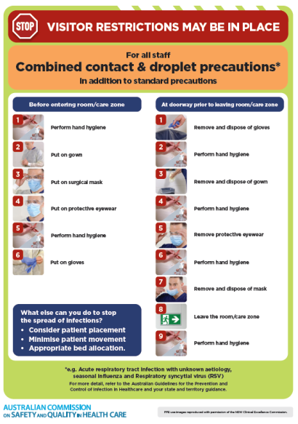](https://www.safetyandquality.gov.au/publications-and-resources/resource-library/infection-prevention-and-control-poster-combined-contact-and-droplet-precautions)
* ***Poster – Combined airborne and contact precautions*** <https://www.safetyandquality.gov.au/publications-and-resources/resource-library/poster-combined-airborne-and-contact-precautions>   
  [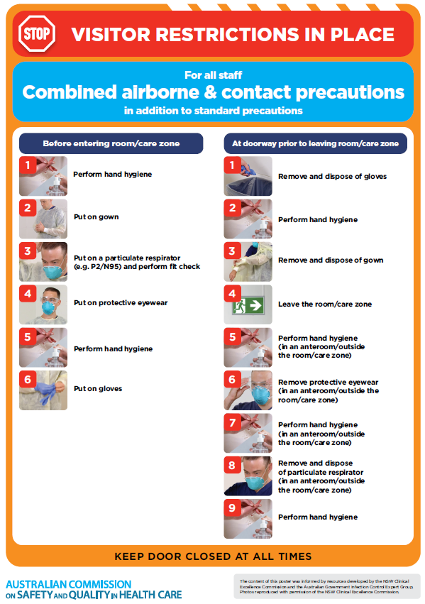](https://www.safetyandquality.gov.au/publications-and-resources/resource-library/poster-combined-airborne-and-contact-precautions)
* ***Environmental Cleaning and Infection Prevention and Control*** [www.safetyandquality.gov.au/environmental-cleaning](http://www.safetyandquality.gov.au/environmental-cleaning)
* ***COVID-19 infection prevention and control risk management – Guidance*** <https://www.safetyandquality.gov.au/publications-and-resources/resource-library/covid-19-infection-prevention-and-control-risk-management-guidance>
* ***Safe care for people with cognitive impairment during COVID-19***<https://www.safetyandquality.gov.au/our-work/cognitive-impairment/cognitive-impairment-and-covid-19>
* ***Stop COVID-19: Break the chain of infection*** posterhttps://www.safetyandquality.gov.au/publications-and-resources/resource-library/break-chain-infection-poster-a3  
  **[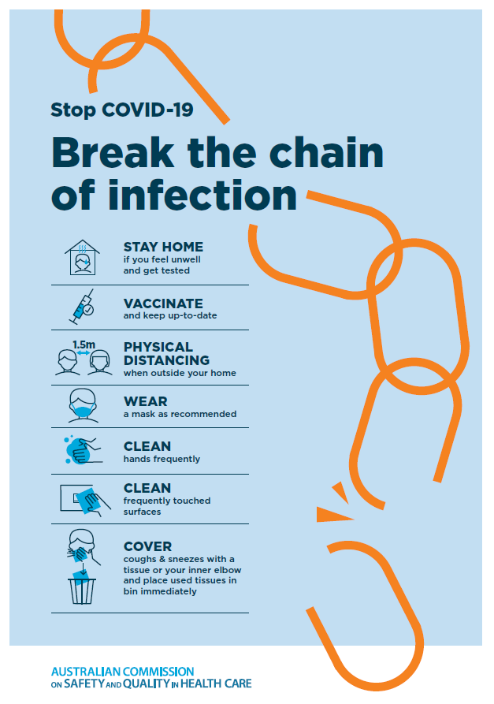](https://www.safetyandquality.gov.au/publications-and-resources/resource-library/break-chain-poster-a3https:/www.safetyandquality.gov.au/publications-and-resources/resource-library/break-chain-poster-a3)**
* ***COVID-19 and face masks – Information for consumers*** <https://www.safetyandquality.gov.au/publications-and-resources/resource-library/covid-19-and-face-masks-information-consumers>

[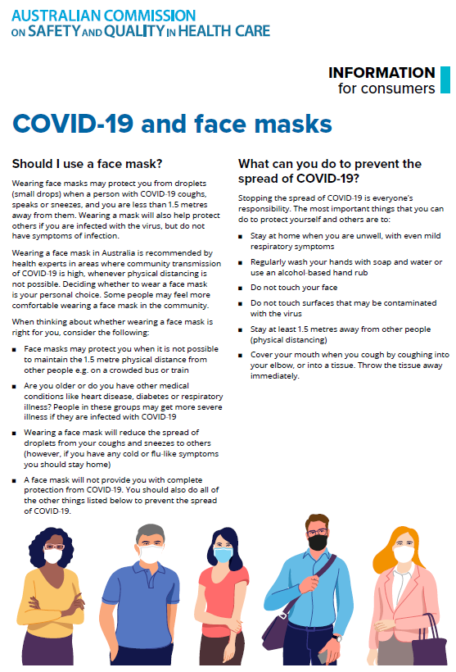](https://www.safetyandquality.gov.au/sites/default/files/2020-07/covid-19_and_face_masks_-_information_for_consumers.pdf)

*National COVID-19 Clinical Evidence Taskforce*

<https://covid19evidence.net.au/>

The National COVID-19 Clinical Evidence Taskforce is a collaboration of peak health professional bodies across Australia whose members are providing clinical care to people with COVID-19. The taskforce is undertaking continuous evidence surveillance to identify and rapidly synthesise emerging research in order to provide national, **evidence-based guidelines and clinical flowcharts for the clinical care of people with COVID-19**. The guidelines address questions that are specific to managing COVID-19 and cover the full disease course across mild, moderate, severe and critical illness. These are ‘living’ guidelines, updated with new research in near real-time in order to give reliable, up-to-the minute advice to clinicians providing frontline care in this unprecedented global health crisis.

*COVID-19 Critical Intelligence Unit*

<https://www.aci.health.nsw.gov.au/covid-19/critical-intelligence-unit>

The Agency for Clinical Innovation (ACI) in New South Wales has developed this page summarising rapid, evidence-based advice during the COVID-19 pandemic. Its operations focus on systems intelligence, clinical intelligence and evidence integration. The content includes a daily evidence digest, a COVID status monitor, a risk monitoring dashboard and evidence checks on a discrete topic or question relating to the current COVID-19 pandemic. There is also a ‘Living evidence’ section summarising key studies and emerging evidence on **COVID-19 vaccines** and **SARS-CoV-2 variants**. The most recent updates include:

* ***SARS-CoV-2 variants - retired living evidence*** – What is the evidence on SARS-CoV-2 variants that are under monitoring by the World Health Organization?
* ***COVID-19 vaccines - retired living evidence*** – What is the evidence on COVID-19 vaccine effectiveness and safety?
* ***Current and emerging patient safety issues during COVID-19*** – What is the evidence on the current and emerging patient safety issues arising from the COVID-19 pandemic?
* ***Bivalent COVID-19 vaccines*** – What is the available regulatory and research evidence for bivalent COVID-19 vaccines?
* ***Surgery post COVID-19*** – What is the evidence for the timing of surgery, and outcomes following surgery, for people who have recovered from COVID-19?
* ***Paxlovid*** – What is the evidence for Paxlovid for treatment of COVID-19?
* ***Molnupiravir*** –What is the evidence for and regulatory context of molnupiravir for treatment of COVID-19?
* ***Eating disorders and COVID-19*** – What is the impact of the COVID-19 pandemic on the prevalence of eating disorders?
* ***Long COVID –*** What is the evidence on the prevalence, presentation and management of long-COVID?
* ***Oseltamivir (Tamiflu) use in healthcare settings*** – What is the evidence that use of oseltamivir in healthcare workers with a symptomatic influenza diagnosis result in an earlier return to work and reduced absenteeism? What is the evidence that use of oseltamivir in adults and children with symptomatic influenza reduces influenza transmission in health care settings?
* ***Alternative models of care for acute medical conditions*** – What is the evidence on alternative models of care for managing patients with acute medical conditions outside of emergency or inpatient hospital settings?
* ***Exercise and long COVID*** – Is exercise helpful in individuals with long COVID? Is post-exertional symptom exacerbation a risk in long COVID?
* ***Influenza and seasonal prophylaxis with oseltamivir*** – What is the place or evidence for seasonal influenza prophylaxis (such as taking oseltamivir for 10 to 12 weeks continuously) in healthcare and aged care settings?
* ***Rapid access models of care for respiratory illnesses*** – What is the evidence for rapid access models of care for respiratory illnesses, especially during winter seasons, in emergency departments?
* ***Post-acute sequelae of COVID-19*** – What is the evidence on the post-acute sequelae of COVID-19?
* ***Emerging variants*** – What is the available evidence for emerging variants?
* ***Chest pain or dyspnoea following COVID-19 vaccination*** – What is evidence for chest pain or dyspnoea following COVID-19 vaccination?
* ***Cardiac investigations and elective surgery post-COVID-19*** – What is evidence for cardiac investigations and elective surgery post-COVID-19?
* ***Breathlessness post COVID-19*** – How to determine those patients who present with ongoing breathlessness in need of urgent review or intervention due to suspected pulmonary embolus?
* ***COVID-19 pandemic and influenza*** – What is the evidence for COVID-19 pandemic and influenza?
* ***Budesonide and aspirin for pregnant women with COVID-19 –*** What is the evidence for the use of Budesonide for pregnant women with COVID-19? What is the evidence for aspirin prophylaxis for pre-eclampsia in pregnant women with a COVID-19 infection?
* ***COVID-19 vaccines in Australia*** – What is the evidence on COVID-19 vaccines in Australia?
* ***COVID-19 pandemic and wellbeing of critical care and other healthcare workers*** – Evidence in brief on the impact of the COVID-19 pandemic on the wellbeing of critical care and other healthcare workers.
* ***Disease modifying treatments for COVID-19 in children*** – What is the evidence for disease modifying treatments for COVID-19 in children?
* ***Mask type for COVID-19 positive wearer*** – What is the evidence for different mask types for COVID-19 positive wearers?
* ***Post acute and subacute COVID-19 care*** – What published advice and models of care are available regarding post-acute and subacute care for COVID-19 patients?
* ***Hospital visitor policies*** – What is the evidence for hospital visitor policies during and outside of the COVID-19 pandemic?
* ***Surgical masks, eye protection and PPE guidance*** –What is the evidence for surgical masks in the endemic phase in hospitals and for eyewear to protect against COVID-19?

**Disclaimer**

On the Radar is an information resource of the Australian Commission on Safety and Quality in Health Care. The Commission is not responsible for the content of, nor does it endorse, any articles or sites listed. The Commission accepts no liability for the information or advice provided by these external links. Links are provided on the basis that users make their own decisions about the accuracy, currency and reliability of the information contained therein. Any opinions expressed are not necessarily those of the Australian Commission on Safety and Quality in Health Care.