# Australian Commission on Safety and Quality logotypeOn the Radar

Issue 599

24 April 2023

*On the Radar* is a summary of some of the recent publications in the areas of safety and quality in health care. Inclusion in this document is not an endorsement or recommendation of any publication or provider. Access to particular documents may depend on whether they are Open Access or not, and/or your individual or institutional access to subscription sites/services. Material that may require subscription is included as it is considered relevant.

*On the Radar* is available online, via email or as a PDF or Word document from <https://www.safetyandquality.gov.au/publications-and-resources/newsletters/radar>

If you would like to receive *On the Radar* via email, you can subscribe on our website <https://www.safetyandquality.gov.au/publications-and-resources/newsletters>  
or by emailing us at H[Umail@safetyandquality.gov.auU](mailto:mail@safetyandquality.gov.au).   
You can also send feedback and comments to H[Umail@safetyandquality.gov.auU](mailto:mail@safetyandquality.gov.au).

For information about the Commission and its programs and publications, please visit <https://www.safetyandquality.gov.au>

You can also follow us on Twitter @ACSQHC.

**On the Radar**

Editor: Dr Niall Johnson [niall.johnson@safetyandquality.gov.au](mailto:niall.johnson@safetyandquality.gov.au)

Contributors: Niall Johnson

**Journal articles**

*Surgical interhospital transfer mortality: national analysis*

Murshed I, Gupta AK, Camilos AN, Sabab A, Bacchi S, Kovoor JG, et al

British Journal of Surgery. 2023;110(5):591-598.

|  |  |
| --- | --- |
| DOI | <https://doi.org/10.1093/bjs/znad042> |
| Notes | This Australian study published in the *British Journal of Surgery* used data from the Australian and New Zealand Audit of Surgical Mortality (ANZASM) to examine interhospital transfer patient mortality. The data extracted from ANZASM covered all surgical patient mortality in most of Australia (but not New South Wales) that underwent interhospital transfer between 1 January 2010 and 31 December 2019. Of the 8679 patients, ‘2171 (25.0 per cent) had 3259 clinical management issues identified’. Thematic analysis found ‘Prominent themes were operative design (n = 466, 14.3 per cent), decision to operate (n = 425, 13.0 per cent), medical conditions (n = 344, 10.6 per cent), diagnosis (n = 326, 10 per cent), transfer (n = 293, 10.0 per cent), intraoperative issues (n = 278, 8.5 per cent), inadequate assessment (n = 238, 7.3 per cent), communication (n = 224, 6.9 per cent), delay in recognizing complications (n = 180, 5.5 per cent), coagulopathy (n = 151, 4.6 per cent), insufficient monitoring (n = 127, 3.9 per cent), infection (n = 107, 3.3 per cent), and hospital resources (n = 100, 3.1 per cent). Assessors considered 58.4 per cent of clinical management issues (n = 1903) probably or definitely preventable.’ |

*Impact of sleep deficiency on surgical performance: a prospective assessment*

Quan SF, Landrigan CP, Barger LK, Buie JD, Dominguez C, Iyer JM, et al

Journal of Clinical Sleep Medicine. 2023;19(4):673-683.

|  |  |
| --- | --- |
| DOI | <https://doi.org/10.5664/jcsm.10406> |
| Notes | Paper reporting on a study of 60 surgeons from academic and community departments of surgery or obstetrics and gynaecology from height hospitals in the USA in order to ‘explore the effect of sleep deprivation on patient safety, operating room communication, medical errors, and adverse events’. The authors report that ‘Sleep deficiency in attending surgeons was not associated with greater errors during procedures performed during the next day. However, procedure time was increased, suggesting that surgeons were able to compensate for sleep loss by working more slowly.’ However, non-technical skills, including situational awareness, decision-making, and communication/teamwork, were seen to be reduced. |

*Barriers and facilitators to improving patient safety learning systems: a systematic review of qualitative studies and meta-synthesis*

Hassan Assem M, Kednapa T, Sunita M, Daniel M, Mohamed AA, Amr Assem M, et al.

BMJ Open Quality. 2023;12(2):e002134.

|  |  |
| --- | --- |
| DOI | <https://doi.org/10.1136/bmjoq-2022-002134> |
| Notes | Paper from a Canadian systematic review of the literature on patient safety learning systems (PSLS). The review sought to ‘o summarise the barriers and facilitators perceived by hospital staff and physicians to influence the reporting, analysis, learning and feedback within PSLS in hospitals.’ Using data from 22 studies, the review found that ‘Multiple barriers and facilitators to uptake of PSLS exist.’  Barriers identified included ‘inadequate organisational support with shortage of resources, lack of training, weak safety culture, lack of accountability, defective policies, blame and a punitive environment, complex system, lack of experience and lack of feedback.’  Facilitators or enabling factors identified included ‘continuous training, a balance between accountability and responsibility, leaders as role models, anonymous reporting, user-friendly systems, well-structured analysis teams, tangible improvement.’ |

*BMJ Quality & Safety*

Volume 32, Issue 5, May 2023

|  |  |
| --- | --- |
| URL | <https://qualitysafety.bmj.com/content/32/5> |
| Notes | A new issue of *BMJ Quality & Safety* has been published. Many of the papers in this issue have been referred to in previous editions of *On the Radar* (when they were released online). Articles in this issue of *BMJ Quality & Safety* include:   * Editorial: **Nurse staffing and patient safety in acute hospitals**: Cassandra calls again? (Peter Griffiths, Chiara Dall'Ora) * Editorial: **Hip fracture in the COVID-19 era**: what can we say about care and patient outcomes (Alex Bottle, Alex Liddle) * Editorial: **Breaking the quality-equity cycle when implementing prevention programmes** (Sheena McHugh, Fiona Riordan, R C Shelton) * Editorial: **Translating evidence into policy and practice**: what do we know already, and what would further research look like? (Paul Cairney, Annette Boaz, Kathryn Oliver) * **Nurse staffing and inpatient mortality** in the English National Health Service: a retrospective longitudinal study (Ben Zaranko, Natalie Jean Sanford, Elaine Kelly, Anne Marie Rafferty, James Bird, Luca Mercuri, Janice Sigsworth, Mary Wells, Carol Propper) * Indirect effect of the COVID-19 pandemic on **hospital mortality in patients with hip fracture**: a competing risk survival analysis using linked administrative data (Fiona Grimm, Antony Johansen, Hannah Knight, Richard Brine, Sarah R Deeny) * Does recruiting patients to **diabetes prevention programmes** via primary care reinforce existing inequalities in care provision between general practices? A retrospective observational study (Beth Parkinson, Emma McManus, Matt Sutton, Rachel Meacock) * Roles and effectiveness of knowledge brokers for **translating clinical practice guidelines in health-related settings**: a systematic review (Amanda J Cross, Terry P Haines, Choon Ean Ooi, Adam La Caze, Sara Karavesovska, Eu Jin Lee, Samuel Siu, Sagar Sareen, Carlos Jones, Michelle Steeper, J S Bell) * How can we champion **diversity, equity and inclusion within Lean Six Sigma**? Practical suggestions for quality improvement (Bharat Kumar, Hilary Mosher, Amany Farag, Melissa Swee) |

*Australian Journal of Primary Health*

Volume 29, Number 2, April 2023

|  |  |
| --- | --- |
| URL | <https://www.publish.csiro.au/py/issue/11376> |
| Notes | A new issue of the *Australian Journal of Primary Health* has been published. This is a special issue on Equity in Primary Health Care Provision: More than 50 years of the Inverse Care Law. Articles in this issue of the *Australian Journal of Primary Health* include:   * **Equity in primary health care provision**: more than 50 years of the inverse care law (Ben Harris-Roxas and Elizabeth Sturgiss) * Improving **cultural competence of healthcare workers in First Nations communities**: a narrative review of implemented educational interventions in 2015–20 (Chris Rissel, Lynette Liddle, Courtney Ryder, Annabelle Wilson, Barbara Richards and Madeleine Bower) * Evaluation of **Aboriginal and Torres Strait Islander smoking cessation interventions with pregnant women** in Australia: utilising a culturally appropriate tool (Moana Tane, Leah C Stevenson, Liz Cameron and Gillian S Gould) * **Equity in primary health care**: the legacy of Julian Tudor Hart and a personal journey he inspired (Felicity Goodyear-Smith) * **Strengthening learning and research in health equity** – opportunities for university departments of primary health care and general practice (Jennifer Reath, Phyllis Lau, Winston Lo, Steven Trankle, Miriam Brooks, Yasin Shahab and Penelope Abbott) * An exploration of **the inverse care law and market forces in Australian primary health care** (Elizabeth Harris and Mark F Harris) * Dialectics, power dynamics, and undercurrents of meaning: using **psychotherapeutic strategies in primary care with trans and gender-diverse clients** (Elizabeth Waldron, Lucy Solonsch and Louise Stone) * **The Deep End GP Pioneer Scheme**: a qualitative evaluation (Safiya Dhanani and David N Blane) * **Aboriginal people’s perceptions of patient-reported outcome measures** in the assessment of diabetes health-related quality of life (Alicia Burgess, Jessica Hawkins, Catherine Kostovski, Michelle Kennedy, Stefania Penkala and Kerith Duncanson) * The M-CHooSe pilot: the acceptability and utilisation of the **nurse-led, general practice clinic** co-located ‘Mater CALD Healthcare Coordinator Service’ for patients from multicultural backgrounds (David Chua, Donata Sackey, Meryl Jones, Michelle Smith, Lauren Ball and Tracey Johnson) * **Health equity for trans and gender-diverse Australians**: addressing the inverse care law through the provision of gender-affirming health care in the primary healthcare setting (Samantha Clune, Janette Collier and Virginia Lewis) |

**Online resources**

***[UK] NICE Guidelines and Quality Standards***

<https://www.nice.org.uk/guidance>

The UK’s National Institute for Health and Care Excellence (NICE) has published new (or updated) guidelines and quality standards. The latest reviews or updates include:

* NICE Guideline NG133 ***Hypertension in pregnancy****: diagnosis and management* <https://www.nice.org.uk/guidance/ng133>

**COVID-19 resources**

https://www.safetyandquality.gov.au/covid-19

The Australian Commission on Safety and Quality in Health Care has developed a number of resources to assist healthcare organisations, facilities and clinicians. These and other material on COVID-19 are available at <https://www.safetyandquality.gov.au/covid-19>

These resources include:

* ***OVID-19 infection prevention and control risk management*** This primer provides an overview of three widely used tools for investigating and responding to patient safety events and near misses. Tools covered in this primer include incident reporting systems, Root Cause Analysis (RCA), and Failure Modes and Effects Analysis (FMEA).   
  <https://www.safetyandquality.gov.au/publications-and-resources/resource-library/covid-19-infection-prevention-and-control-risk-management-guidance>
* ***Poster – Combined contact and droplet precautions*** <https://www.safetyandquality.gov.au/publications-and-resources/resource-library/infection-prevention-and-control-poster-combined-contact-and-droplet-precautions>  
  [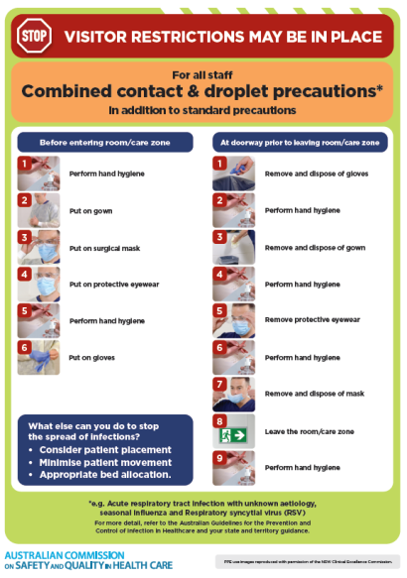](https://www.safetyandquality.gov.au/publications-and-resources/resource-library/infection-prevention-and-control-poster-combined-contact-and-droplet-precautions)
* ***Poster – Combined airborne and contact precautions*** <https://www.safetyandquality.gov.au/publications-and-resources/resource-library/poster-combined-airborne-and-contact-precautions>   
  [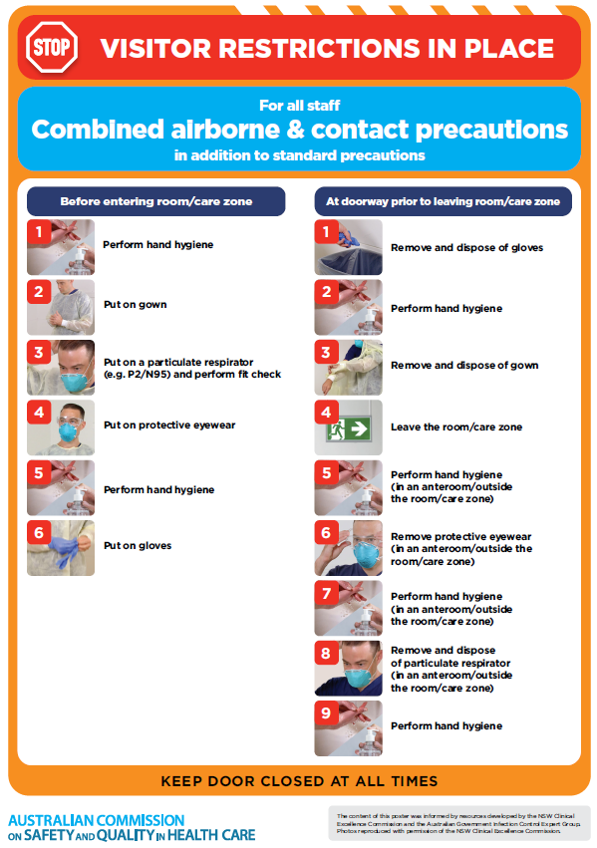](https://www.safetyandquality.gov.au/publications-and-resources/resource-library/poster-combined-airborne-and-contact-precautions)
* ***Environmental Cleaning and Infection Prevention and Control*** [www.safetyandquality.gov.au/environmental-cleaning](http://www.safetyandquality.gov.au/environmental-cleaning)
* ***COVID-19 infection prevention and control risk management – Guidance*** <https://www.safetyandquality.gov.au/publications-and-resources/resource-library/covid-19-infection-prevention-and-control-risk-management-guidance>
* ***Safe care for people with cognitive impairment during COVID-19***<https://www.safetyandquality.gov.au/our-work/cognitive-impairment/cognitive-impairment-and-covid-19>
* ***Stop COVID-19: Break the chain of infection*** posterhttps://www.safetyandquality.gov.au/publications-and-resources/resource-library/break-chain-infection-poster-a3  
  **[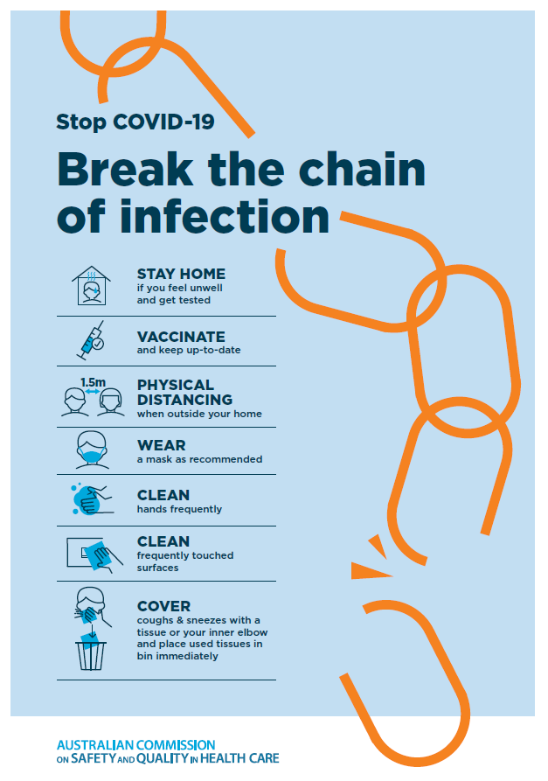](https://www.safetyandquality.gov.au/publications-and-resources/resource-library/break-chain-poster-a3https:/www.safetyandquality.gov.au/publications-and-resources/resource-library/break-chain-poster-a3)**
* ***COVID-19 and face masks – Information for consumers*** <https://www.safetyandquality.gov.au/publications-and-resources/resource-library/covid-19-and-face-masks-information-consumers>

[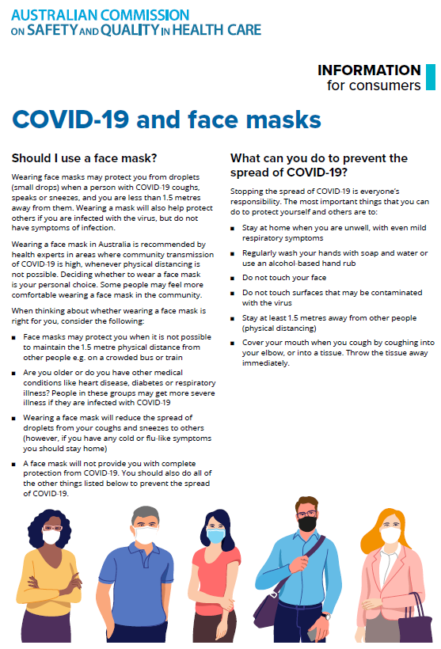](https://www.safetyandquality.gov.au/sites/default/files/2020-07/covid-19_and_face_masks_-_information_for_consumers.pdf)

*National COVID-19 Clinical Evidence Taskforce*

<https://covid19evidence.net.au/>

The National COVID-19 Clinical Evidence Taskforce is a collaboration of peak health professional bodies across Australia whose members are providing clinical care to people with COVID-19. The taskforce is undertaking continuous evidence surveillance to identify and rapidly synthesise emerging research in order to provide national, **evidence-based guidelines and clinical flowcharts for the clinical care of people with COVID-19**. The guidelines address questions that are specific to managing COVID-19 and cover the full disease course across mild, moderate, severe and critical illness. These are ‘living’ guidelines, updated with new research in near real-time in order to give reliable, up-to-the minute advice to clinicians providing frontline care in this unprecedented global health crisis.

*COVID-19 Critical Intelligence Unit*

<https://www.aci.health.nsw.gov.au/covid-19/critical-intelligence-unit>

The Agency for Clinical Innovation (ACI) in New South Wales has developed this page summarising rapid, evidence-based advice during the COVID-19 pandemic. Its operations focus on systems intelligence, clinical intelligence and evidence integration. The content includes a daily evidence digest, a COVID status monitor, a risk monitoring dashboard and evidence checks on a discrete topic or question relating to the current COVID-19 pandemic. There is also a ‘Living evidence’ section summarising key studies and emerging evidence on **COVID-19 vaccines** and **SARS-CoV-2 variants**. The most recent updates include:

* ***SARS-CoV-2 variants - retired living evidence*** – What is the evidence on SARS-CoV-2 variants that are under monitoring by the World Health Organization?
* ***COVID-19 vaccines - retired living evidence*** – What is the evidence on COVID-19 vaccine effectiveness and safety?
* ***Current and emerging patient safety issues during COVID-19*** – What is the evidence on the current and emerging patient safety issues arising from the COVID-19 pandemic?
* ***Bivalent COVID-19 vaccines*** – What is the available regulatory and research evidence for bivalent COVID-19 vaccines?
* ***Surgery post COVID-19*** – What is the evidence for the timing of surgery, and outcomes following surgery, for people who have recovered from COVID-19?
* ***Paxlovid*** – What is the evidence for Paxlovid for treatment of COVID-19?
* ***Molnupiravir*** –What is the evidence for and regulatory context of molnupiravir for treatment of COVID-19?
* ***Eating disorders and COVID-19*** – What is the impact of the COVID-19 pandemic on the prevalence of eating disorders?
* ***Long COVID –*** What is the evidence on the prevalence, presentation and management of long-COVID?
* ***Oseltamivir (Tamiflu) use in healthcare settings*** – What is the evidence that use of oseltamivir in healthcare workers with a symptomatic influenza diagnosis result in an earlier return to work and reduced absenteeism? What is the evidence that use of oseltamivir in adults and children with symptomatic influenza reduces influenza transmission in health care settings?
* ***Alternative models of care for acute medical conditions*** – What is the evidence on alternative models of care for managing patients with acute medical conditions outside of emergency or inpatient hospital settings?
* ***Exercise and long COVID*** – Is exercise helpful in individuals with long COVID? Is post-exertional symptom exacerbation a risk in long COVID?
* ***Influenza and seasonal prophylaxis with oseltamivir*** – What is the place or evidence for seasonal influenza prophylaxis (such as taking oseltamivir for 10 to 12 weeks continuously) in healthcare and aged care settings?
* ***Rapid access models of care for respiratory illnesses*** – What is the evidence for rapid access models of care for respiratory illnesses, especially during winter seasons, in emergency departments?
* ***Post-acute sequelae of COVID-19*** – What is the evidence on the post-acute sequelae of COVID-19?
* ***Emerging variants*** – What is the available evidence for emerging variants?
* ***Chest pain or dyspnoea following COVID-19 vaccination*** – What is evidence for chest pain or dyspnoea following COVID-19 vaccination?
* ***Cardiac investigations and elective surgery post-COVID-19*** – What is evidence for cardiac investigations and elective surgery post-COVID-19?
* ***Breathlessness post COVID-19*** – How to determine those patients who present with ongoing breathlessness in need of urgent review or intervention due to suspected pulmonary embolus?
* ***COVID-19 pandemic and influenza*** – What is the evidence for COVID-19 pandemic and influenza?
* ***Budesonide and aspirin for pregnant women with COVID-19 –*** What is the evidence for the use of Budesonide for pregnant women with COVID-19? What is the evidence for aspirin prophylaxis for pre-eclampsia in pregnant women with a COVID-19 infection?
* ***COVID-19 vaccines in Australia*** – What is the evidence on COVID-19 vaccines in Australia?
* ***COVID-19 pandemic and wellbeing of critical care and other healthcare workers*** – Evidence in brief on the impact of the COVID-19 pandemic on the wellbeing of critical care and other healthcare workers.
* ***Disease modifying treatments for COVID-19 in children*** – What is the evidence for disease modifying treatments for COVID-19 in children?
* ***Mask type for COVID-19 positive wearer*** – What is the evidence for different mask types for COVID-19 positive wearers?
* ***Post acute and subacute COVID-19 care*** – What published advice and models of care are available regarding post-acute and subacute care for COVID-19 patients?
* ***Hospital visitor policies*** – What is the evidence for hospital visitor policies during and outside of the COVID-19 pandemic?
* ***Surgical masks, eye protection and PPE guidance*** –What is the evidence for surgical masks in the endemic phase in hospitals and for eyewear to protect against COVID-19?

**Disclaimer**

On the Radar is an information resource of the Australian Commission on Safety and Quality in Health Care. The Commission is not responsible for the content of, nor does it endorse, any articles or sites listed. The Commission accepts no liability for the information or advice provided by these external links. Links are provided on the basis that users make their own decisions about the accuracy, currency and reliability of the information contained therein. Any opinions expressed are not necessarily those of the Australian Commission on Safety and Quality in Health Care.